Hospital Management System Project Report

- Student Details:
Name: Keshav Singh
Roll Number: 24f3002937
E-mail: 24f3002937@ds.study.iitm.ac.in
About me: I am a student enrolled in IIT Madras BS in data science course and also in NIT Delhi B. Tech in VLSI. This is my first project in the field of Web App Development and it has ignited in me a great interest and passion towards this field.

- Project Details:
Project Title:
Build a Hospital Management System (HMS) web application that allows Admins, Doctors, and Patients to interact with the system based on their roles.
Approach:
This app was built using Flask as the backend framework. The database is built using SQL Alchemy. The frontend is built using basic HTML and CSS. It allows patients to register, login and book, cancel and reschedule appointments. The doctors to login and view their scheduled appointments. There exists an admin which can add doctors in the database, can edit patient’s and doctors’ details, can schedule appointments, edit and cancel them.

- AI/LLM Declaration
I used ChatGPT (GPT-5) to reduce logic redundancy, integrate Java Script (as it is part of MAD-2), creating documentation for project and very limited use in debugging.
The extent of AI/LLM usage is around 20%, limited to code suggestions and documentation formatting.
All final implementation logic were done manually.

- Technologies and Frameworks used:

Technology / Library | Purpose
Flask | Core backend web framework
SQL Alchemy | Object Relational Mapper for SQLite database
SQLite | Lightweight local database for storing user data
Jinja2 | Template engine for rendering dynamic HTML pages
Bootstrap 5 | Frontend styling and responsive design
Werkzeug | password hashing utilities

- Database Schema / ER Diagram

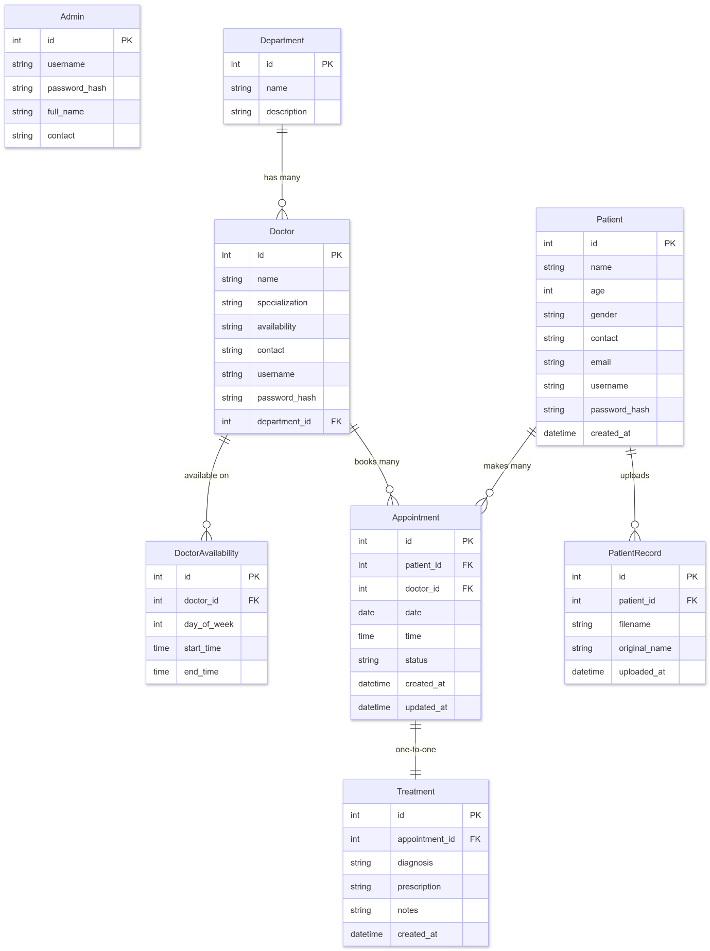

- API resource endpoint:
Endpoint | Method | Description
/ | GET | Home login page
/auth/login | GET | Select role login
/auth/register | GET | Patient registration form
/auth/register | POST | Create patient account
/admin/dashboard | GET | Admin dashboard view
/admin/dashboard | POST | Admin login
/doctor/dashboard | GET | Doctor dashboard view
/doctor/dashboard | POST | Doctor login
/patient/dashboard | GET | Patient dashboard view
/patient/dashboard | POST | Patient login
/patient/appointment/book | POST | Book new appointment
/patient/appointment/reschedule/<appt_id> | POST | Reschedule appointment
/patient/appointment/cancel/<appt_id> | POST | Cancel appointment
/admin/doctor/add | POST | Add new doctor
/admin/doctor/edit/<doc_id> | POST | Edit doctor details
/admin/doctor/delete/<doc_id> | POST | Delete doctor
/admin/appointment/create | POST | Create appointment
/admin/appointment/edit/<appt_id> | POST | Edit appointment
/admin/appointment/delete/<appt_id> | POST | Delete appointment
/admin/appointment/status/<appt_id> | POST | Change appointment status
/admin/doctor/<doc_id>/appointments | GET | Doctor appointments list
/admin/patient/<patient_id>/appointments | GET | Patient appointments list
/doctor/appointment/complete/<appt_id> | POST | Complete appointment
/doctor/patient/<patient_id>/history | GET | Patient treatment history
/doctor/patient/<patient_id>/records | GET | Patient medical records
/patient/profile/update | POST | Update patient profile
/admin/patient/edit/<patient_id> | POST | Edit patient details
/logout | GET | Logout all users
- Architecture and Features:

Architecture Overview:
app.py - main Flask application entry point
/models – database models using SQL Alchemy.
/templates - Jinja2 HTML templates
/static - Uploaded patient records

Implemented features:
- Role-based login authentication system
- Patient registration and profile management
- Doctor profile and availability management
- Appointment booking and scheduling system
- Appointment rescheduling and cancellation
- Admin doctor and patient management
- Real-time doctor availability checking
- Conflict-free appointment validation system
- Medical record file upload system
- Doctor treatment and prescription entry
- Patient treatment history viewing
- Admin appointment monitoring and control
- Secure password hashing and storage
- Session-based user authentication system

- Video Presentation
Drive Link:
https://drive.google.com/file/d/1TfixIV5eWtZxMbivWDqEllhEUGl9Ge8a/view?usp=drive_link

