MCSA

Topics
- Introduction to windows server
- Active Directory
- Network and Interface management.
- Security and Firewall and Certifications
- Joining machine to the Domain and managing them
- User and Group management
- RDP and Remote Management
- Storage and Disks services management
- Files and Folders permissions
- Storage sharing management
- File server and Resources Management
- Backup Management
- DHCP
- DNS
- Group Policy GPO
- Software Deployment
- WDS
- WSUS
- NAP
- Hyper-V
- Domain and Trust
- Routing between and inside MS server
- Fail over cluster and load Balancing.
- Monitoring performance tools
- Run Navigations
- CMD and PowerShell Basics
- Server Core Management
- Print server.
- Web server
- AD Federation Service
- FSMO
- ADC

1
Introduction to windows server
What can we do with windows server?
- Apply multiple services like DHCP, DNS, WEB Server, File server, print server, etc.
- Managing organization computers installing OS, updating software, managing policies and resources.
- May help to make a connection between multiple branches and manage them.
Types of windows servers:
- Windows Server Standard
- General purpose edition.
- Used for physical or lightly virtualized environments.
- License allows 2 VMs + 1 Hyper-V host.
- Windows Server Datacenter
- For highly virtualized/datacenter/cloud environments.
- Allows unlimited VMs.
- Includes advanced features like Storage Spaces Direct, Shielded VMs, Software-defined Networking (SDN).

- Windows Server Essentials
- Simplified edition for small businesses (up to 25 users, 50 devices).
- Easier management interface.
- Many features stripped down.
- Windows Server Hyper-V
- A free, stripped-down version that only runs Hyper-V (no GUI, just a hypervisor).
- Used purely for virtualization.
- Think of it like “VMware ESXi but from Microsoft.”
- Windows Server Storage Editions
- Specialized editions optimized for storage solutions.
- Often used in SAN/NAS devices or OEM appliances.
types by Installation Mode:
- Server with Desktop Experience: Full GUI, Heavier, bigger attack surface.
- Server Core: no GUI, just CLI + PowerShell, Lower resource usage, smaller attack surface, Recommended for production.
- Nano Server: Introduced in Windows Server 2016, A very minimal, headless installation option (smaller even than Server Core), No GUI, no local login, managed entirely by PowerShell Remoting, WMI, or remote tools, Super lightweight: tiny footprint, fewer updates, smaller attack surface.
Windows server versions:
- 2003: Better Active Directory + backups.
- 2008: Server Core + Hyper-V added.
- 2012: Cloud focus + Storage Spaces + ReFS.
- 2016: Nano Server + Containers + stronger security.
- 2019: Hybrid cloud + Linux support + Admin Center.
- 2022: Security-first + Azure integration + SMB compression.

Windows server components:
- Server manager:
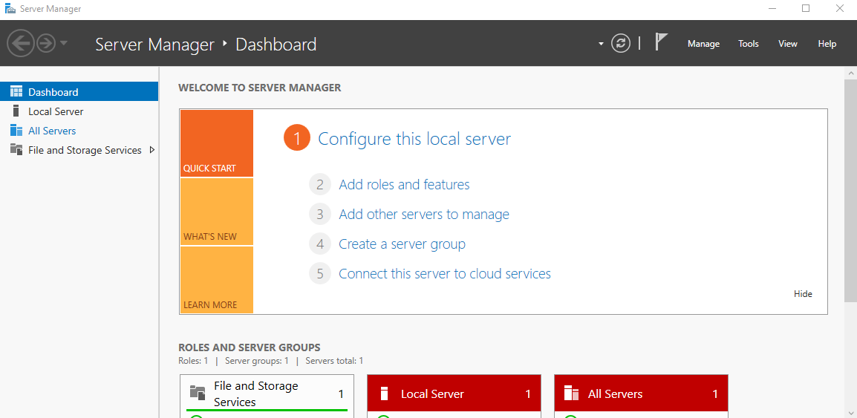
The most important tool in the windows server where you can manage everything from here roles, users, firewall, and active directory.

It has several tools and settings that manage the server like

- Local server settings:
It has several settings to manage the server, and it shows the events happened in the server
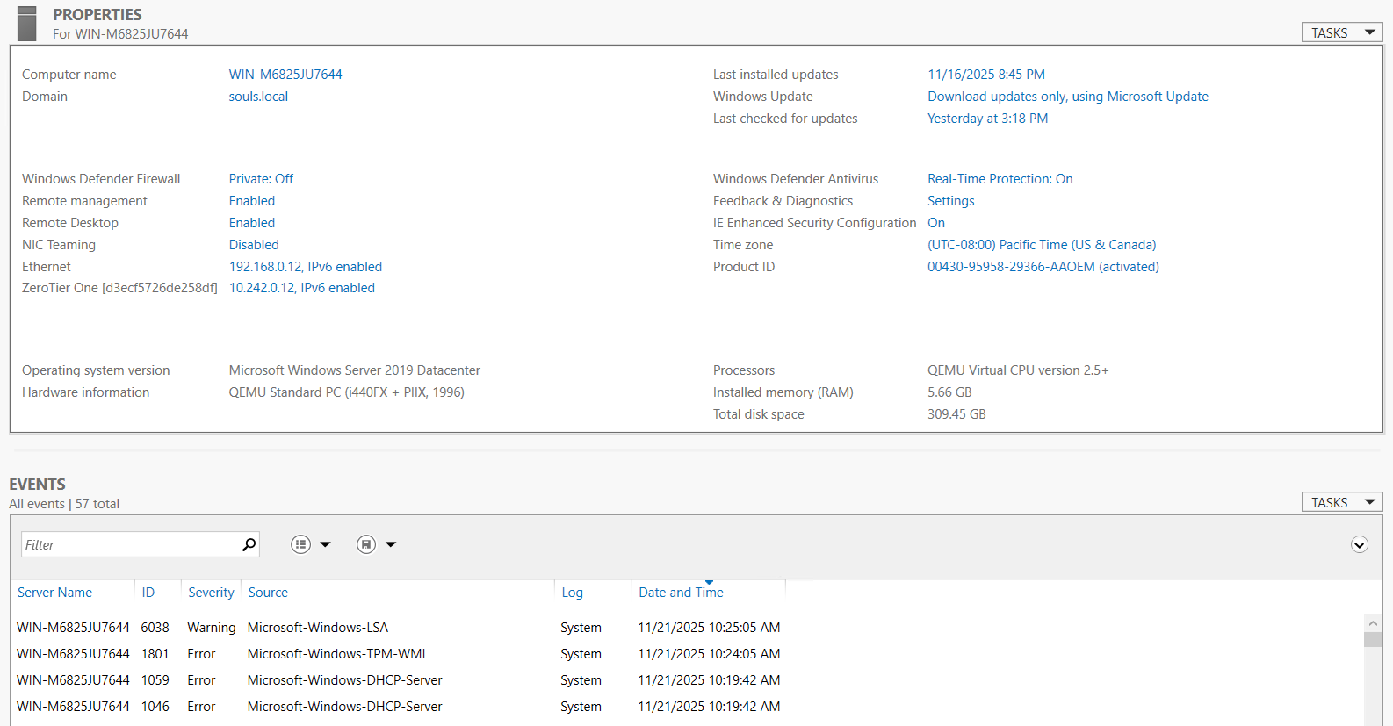

- Server configuration:
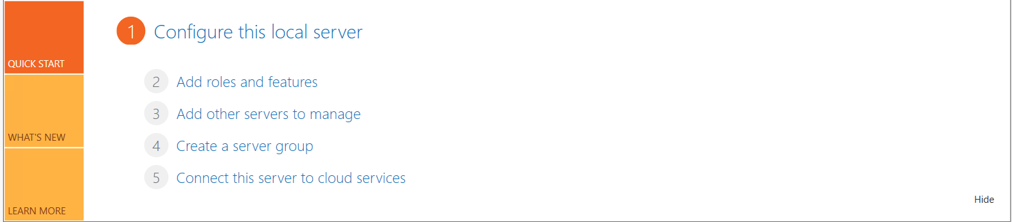

- Roles management:
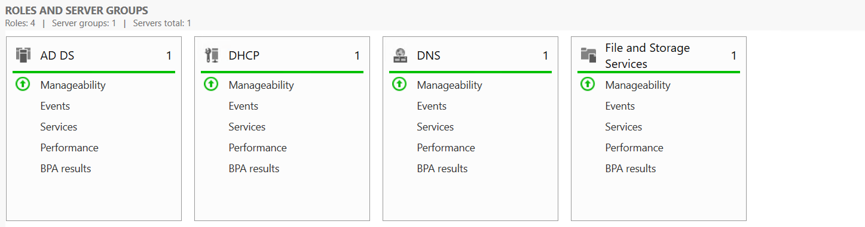

2

Active Directory

What is active directory?
Active Directory is Microsoft’s centralized directory service that stores users, computers, groups, and all network resources in one place.
It lets you manage authentication, permissions, and policies across the entire Windows domain from a single control point.

Active directory installation:
Before installing it, we must make sure that the administrator’s account has a password.
- We go to the server configurations section in the server manager.
And press on Add roles and features

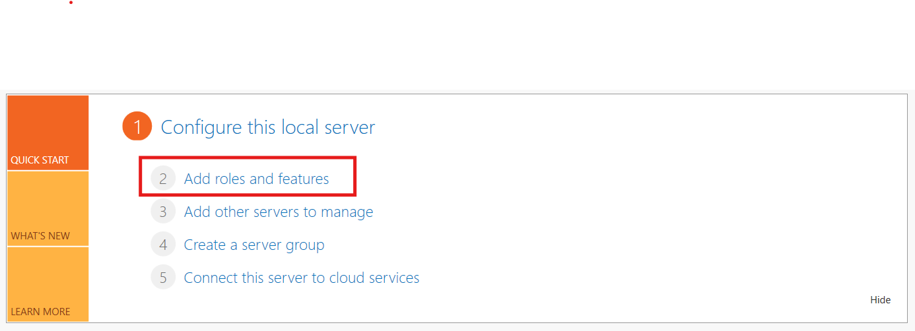

- A window will show up has some options and setup for installing roles and features we go and choose the “Active directory domain service” role.
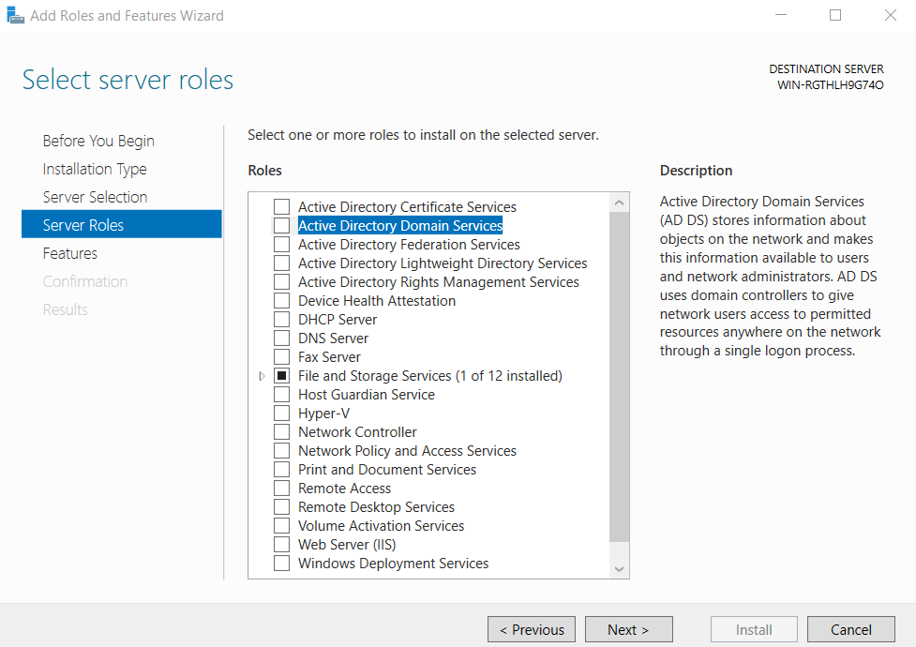

We must precede the steps until we install it and then we go configure it.

- Then we go to the notifications we will see a choice to set up the active directory
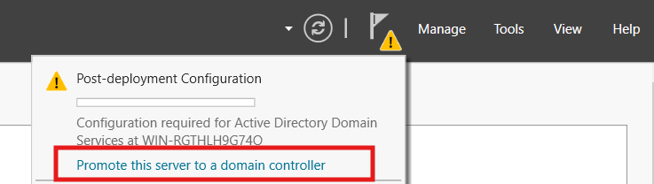

- In this step we will set up server configuration before we finally can work with active directory.
- Create a forest and domain
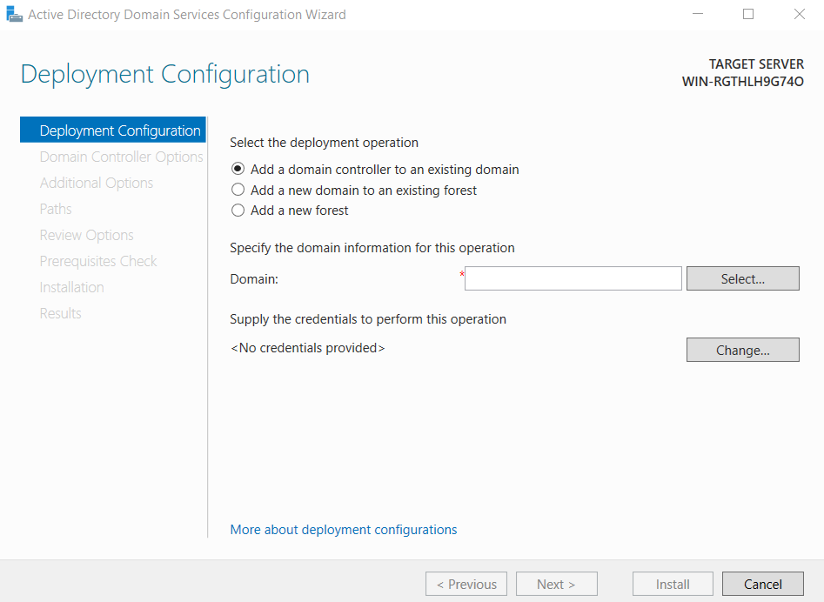
In this step we will choose one of three choices
- Add a domain controller to an existing domain: we go with this choice if we already have a domain, but we want to add an additional controller.
- Add a new domain to an existing forest: we go with this if we want to add a domain to an existing forest.
- Add a new forest: we go with this choice if we are starting from zero, no forest, no domain, in our case we will go with it.
After selecting our choice, we will have enter the root domain name which also will be the forest name
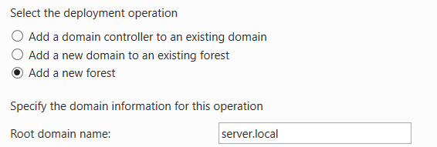
The name must have 2 parts
Second-Level Domain (SLD).Top-Level Domain (TLD)
in our case server → SLD local → TLD
server.local

- Choosing the functional lever and recovery password
Functional Level (ADFL) defines what features your domain or forest can use based on the minimum Windows Server version of your Domain Controllers.
DSRM (Directory Services Restore Mode) is a special boot mode for Domain Controllers that lets you repair or restore the AD database offline. It starts the server without Active Directory services so you can safely fix corruption or restore backups.
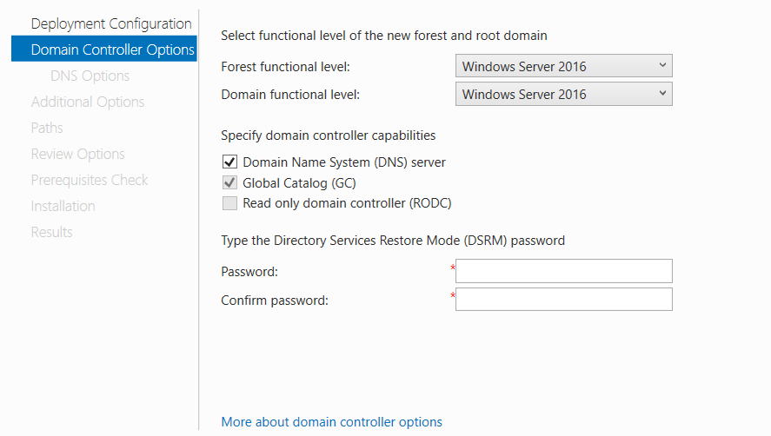

- Then we choose the NetBIOS name
NetBIOS is the short, 15-character Windows network name used by older systems for identifying computers or domains.

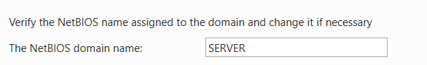

- Then after going through some checks if everything is ok you will be able to install the AD.
- After the restart the server has the active directory installed and working.

3

Network and Interface management
Ino order to manage the network in the windows server we must reach the adapters management windows so we can configure them.
There are many ways to reach the adapters management window

- Using RUN [windows+R] and then type ncpa.cpl
- or using control Pannel
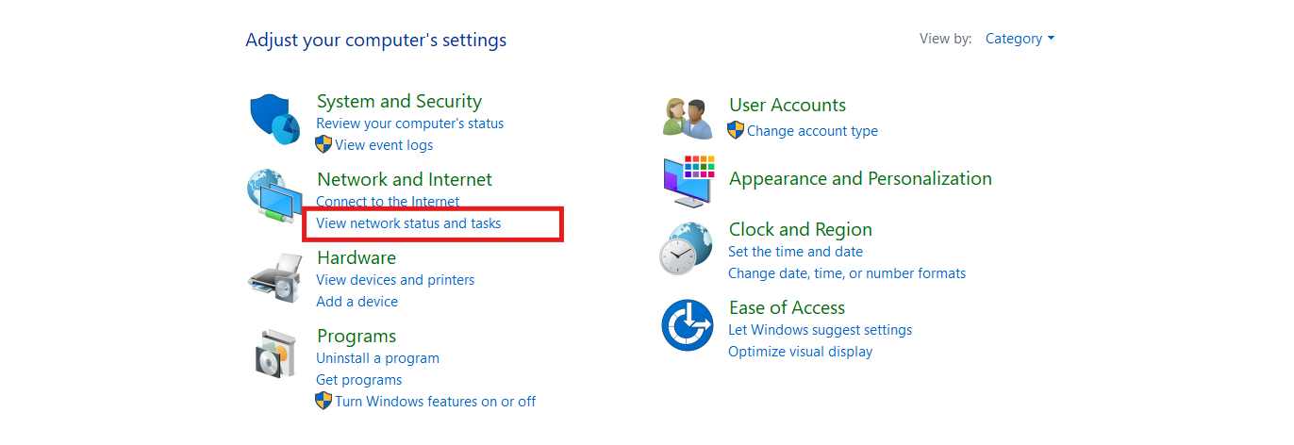
Control Pannel View Network status Change adapter sittings
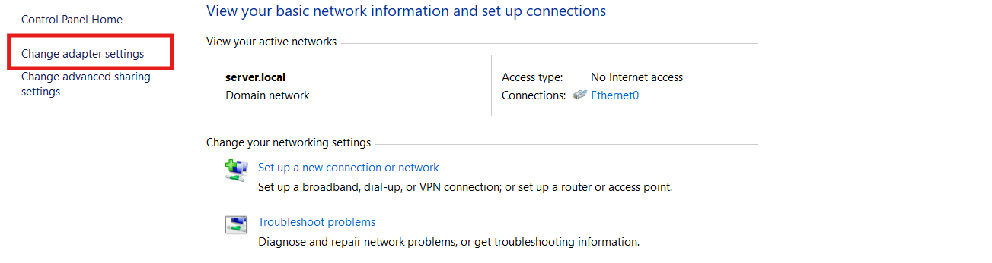

Or simply print this in control Pannel path
Control Panel\Network and Internet\Network Connections

And finally, we are in the adapter management window
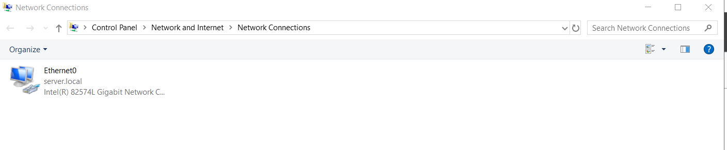
Here we can change the adapters properties and configurations like IP and update or install adapters drivers

NDIS: The Network Driver Interface Specification
NDIS is the core component that connects the Windows networking stack to the network hardware.
Think of it as the “translator” between:
- The NIC driver
- The Windows network protocols (TCP/IP, SMB, etc.)
Key responsibilities:
- Managing NIC drivers
- Controlling data flow between protocols and hardware
- Handling offloading features (checksum offload, LSO, RSS)
- Supporting multiple protocols on one NIC
- Ensuring stability and isolation (one faulty driver doesn't break the entire system)
NDIS is what allows Windows to support:
- Physical adapters
- Virtual adapters
- VPN adapters
- Hyper-V switches
- Bluetooth PAN
- Wi-Fi
All using the same interface.

1.3 Physical NICs vs Virtual NICs
Windows Server supports two broad categories of network interfaces:
1.3.1 Physical NICs
These are the hardware network adapters installed in the server. They provide:
- Actual physical connectivity
- Real link speed (1Gbps, 10Gbps, 25Gbps…)
- Hardware offloading
- PCIe-level performance
1.3.2 Virtual NICs
Created by virtualization layers or software, such as:
- Hyper-V (vNICs assigned to VMs)
- Virtual switches
- VPN adapters
- Containers
- Wi-Fi Direct
- NIC teaming logical interfaces
Virtual NICs allow:
- Multiple systems (VMs) to share the same physical NIC
- VLAN tagging
- Network isolation
- Flexible topologies
From the OS perspective, virtual NICs behave exactly like physical ones.

Some network commands

Ipconfig

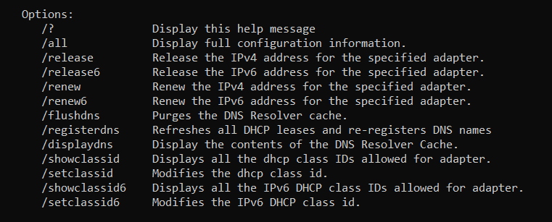

And there are more commands discussed in the cmd/powershell documentation
commands like:
getmac – show MAC addresses
Network Testing
- ping <ip or host>
- tracert <host> – trace route
- pathping <host> – traceroute + packet loss
- nslookup – DNS queries
- telnet <ip> <port> – test port availability
Routing
- route print – routing table
- route add <network> mask <mask> <gateway>
- route delete <network>
Firewall
- netsh advfirewall show allprofiles
- netsh advfirewall firewall show rule name=all
Connections
- netstat -ano – list connections + ports + PIDs
- netstat -r – routing table
- arp -a – ARP table

4
Security and Firewall and Certifications
Windows server has a simple firewall which protect the machine from attack come from out for example it blocks the ICMP messages by default
The window firewall has tools that control the packet going out or in the machine according to the address or port or service by applying rules on the packet

We can go to firewall manager through control panel or searching

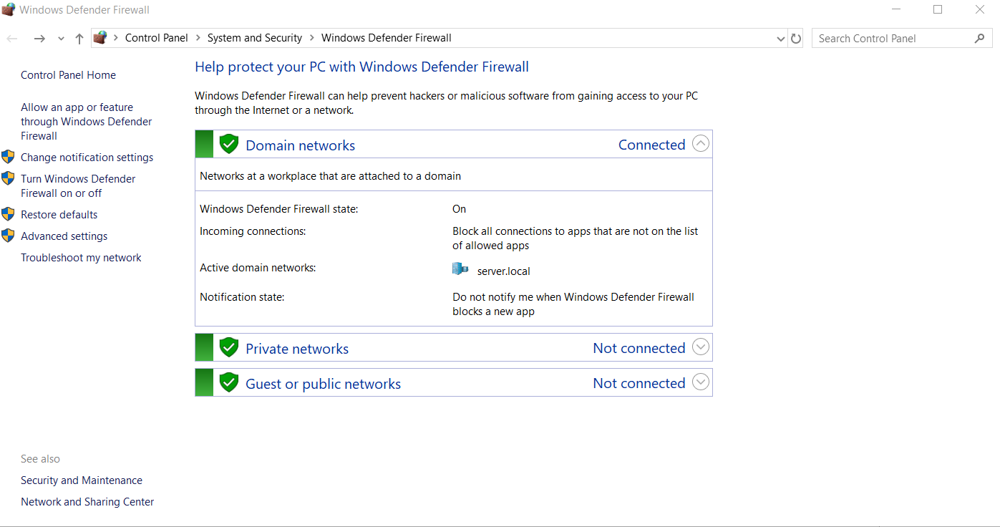

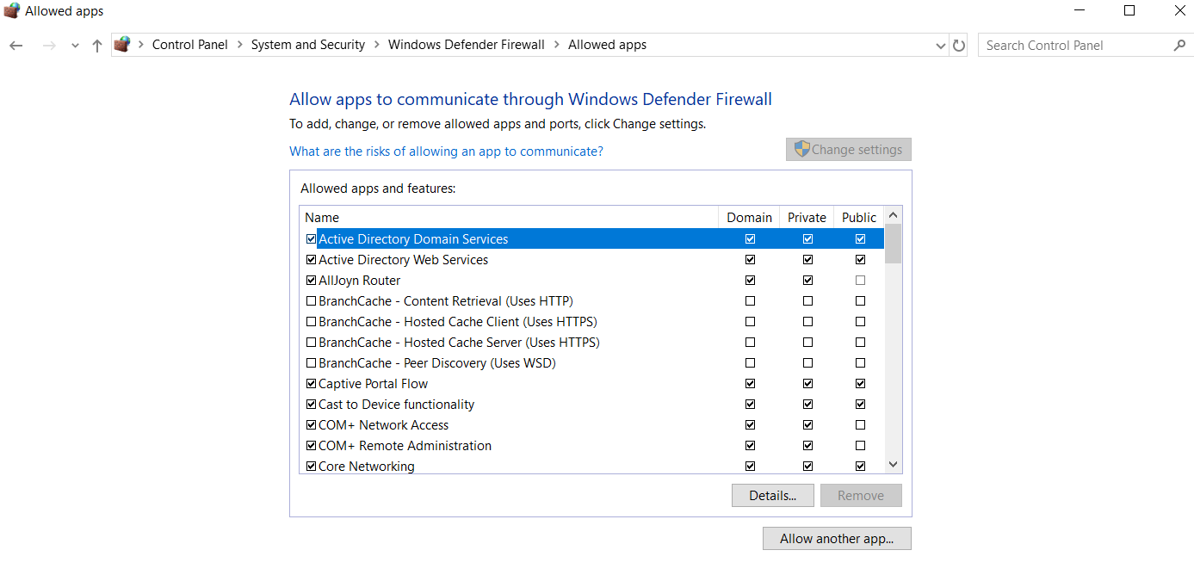
From here we can see the firewall status and configure it like allowing or blocking apps from passing the firewall

As well as we can control the firewall status
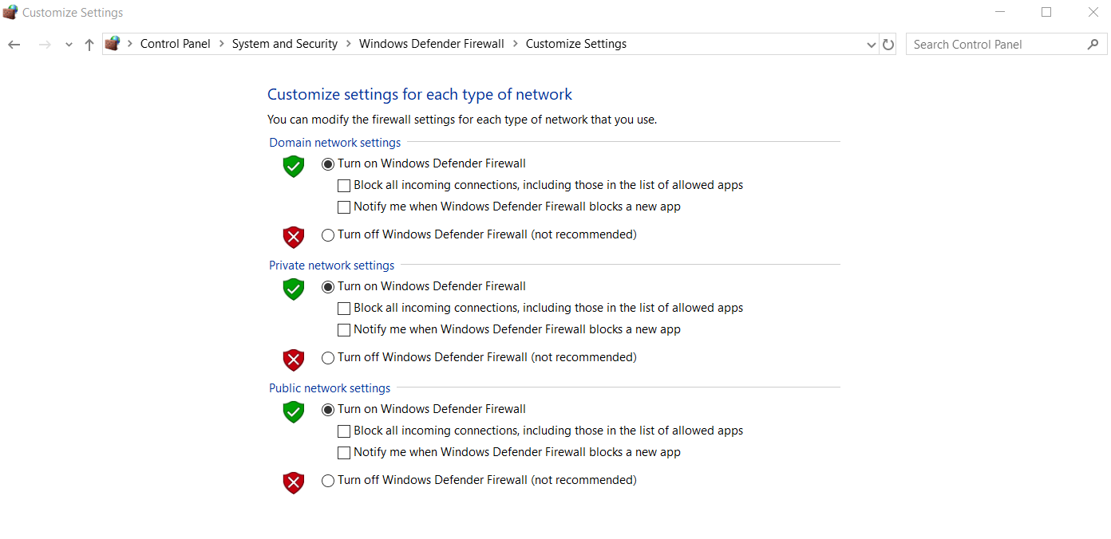
Also we can do Advanced packet filtering using the Advanced Security Sittings Tool
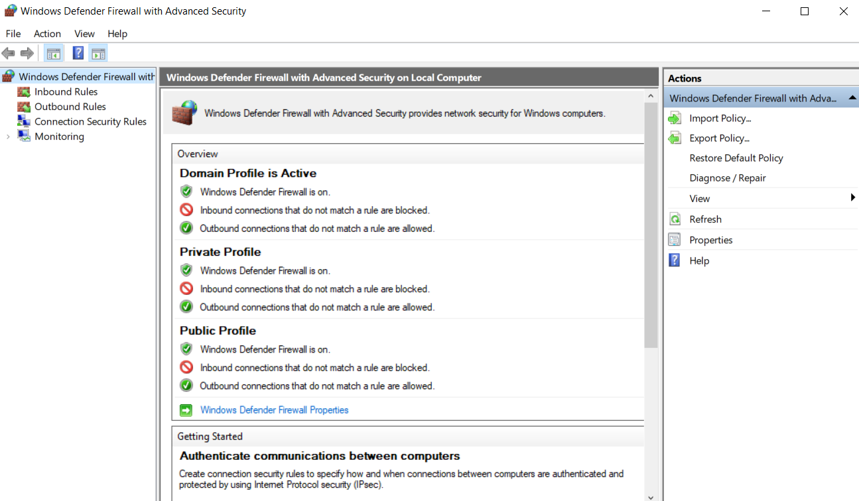
We can do that by applying rules on the outgoing and incoming packets to apply control and security on the connection.

5

Joining machine to the Domain and managing them
To manage the computers in domain using the windows server we must make them join the domain, so they be under the control of the Domain controller

There are 2 ways to make the computer join the domain

- The Regular way which is done using the GUI.
- The second way is used when the computer isn’t connected to the network, and it connect Automatically once its connected.

To make the computer join the domain we should first go to the adapters settings and make one of the DNS IP the windows server IP so it can deal with the hostname in the server record.

And after we can precede to the steps.

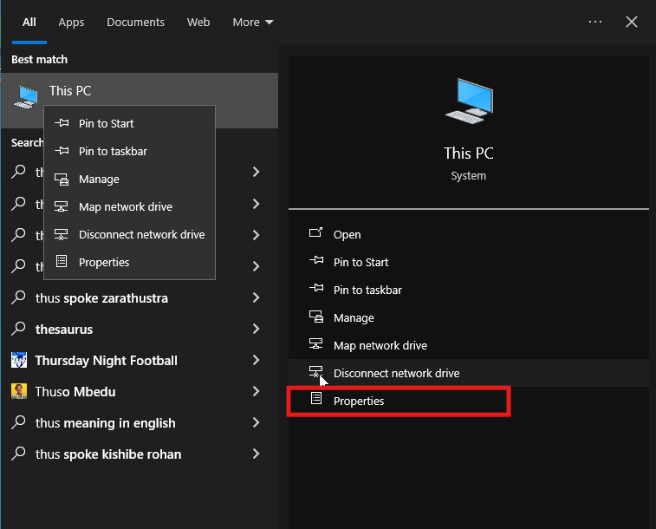
- Computer Properties

- Rename the PC
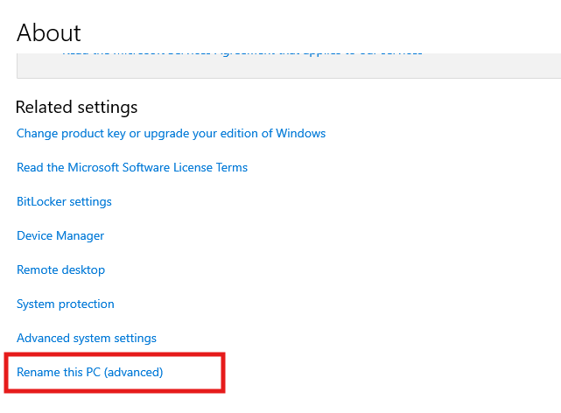
- Change the computer state
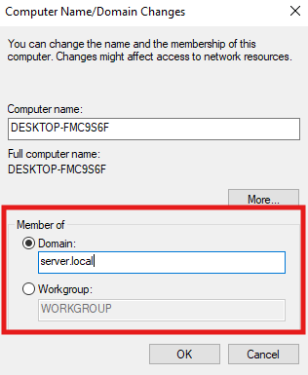
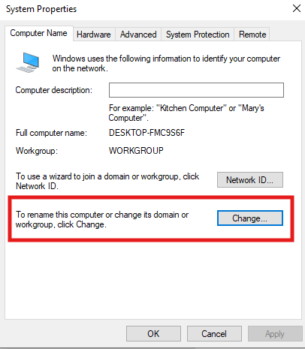
We change the computer state from Workgroup to Domain and put the domain of the windows server and then we enter the username and the password of the administrator and ding ding ding the computer is joined to the domain.

The second way is done using the CMD in case the computer is not connected to the network and want it to join the domain once its connected.

We write one command in the windows server and the another in the machine we want to it join

Server command
DJoin Provision /Domain [server domain] /Machine [machine name] /SaveFile [file saving location]
A file will be generated containing server information we will use it on the machine to make it join using the command
DJoin /EequestODJ /LoadFile [file location] /WindowsPath %windir% /localOS

6

User and Group management
There are 2 types of users and groups
- Local
- Domain
First, we will start with local users groups

These users are created on the machine itself without needing to join a domain they are useful with the Workgroup when multiple people working one the computer without needing to join a domain.

We can show them
Using the RUN and write lusrmgr.msc

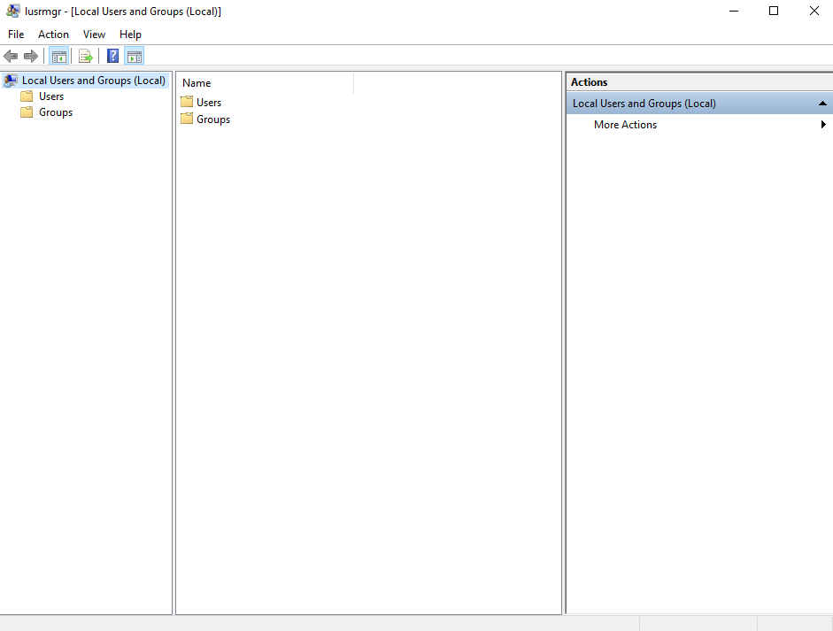

- Domain users groups
They are users created in the domain controller and they are used to access the domain resources under the Policy control of the Active Directory.

We can show them through the local server manager through the tool and then Active Directory Users and Computers.
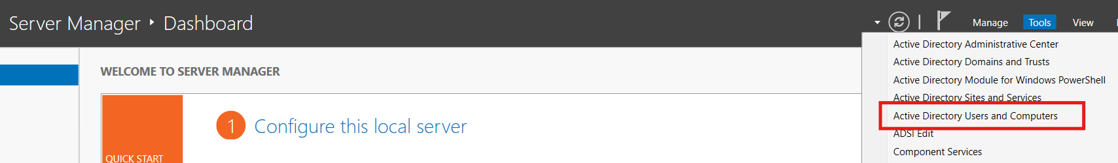

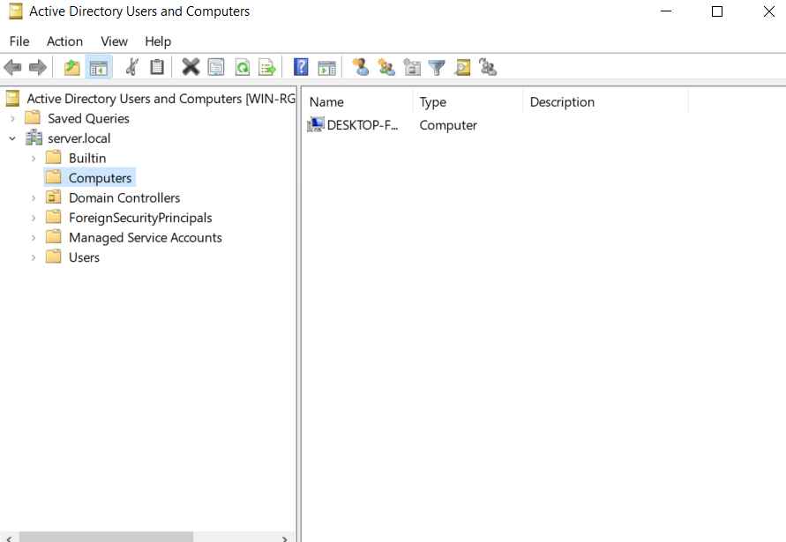

From this panel we can manage the users and groups as well as computers

First, we will start with users

User Configuration and properties window

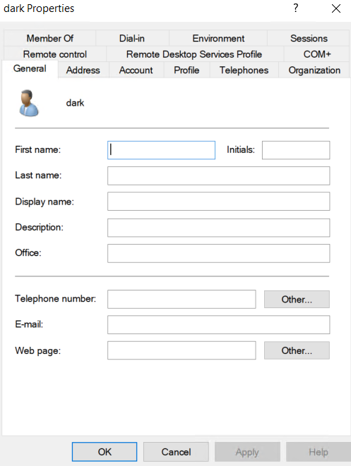

Here we can configure and reach most of the user properties.

And there are a lot of sections and theses sections are

- GENERAL TAB
This tab is about basic identity information. It doesn’t affect login permissions, but it does affect address books, Outlook, and organizational visibility.
1. First name / Last name
- Pure identity metadata.
- Shows in Outlook’s Global Address List (GAL).
- Useful for searching users in AD, Exchange, Teams, etc.
2. Display name
- The name shown everywhere (login screen, Exchange, Teams).
- If empty, AD combines First + Last automatically.
3. Description
- Admin notes like:
  - “IT Support - Night Shift”
  - “Intern - Exp 2024”
- Has no technical function but helps admins understand who’s who.
4. Office
- Physical location or office number.
- Shows in corporate address books.
5. Telephone number / E-mail / Web page
- Again, metadata for:
  - Outlook Address Book
  - Company directories
  - Internal apps
This tab is cosmetic and organizational—no permissions are set here.

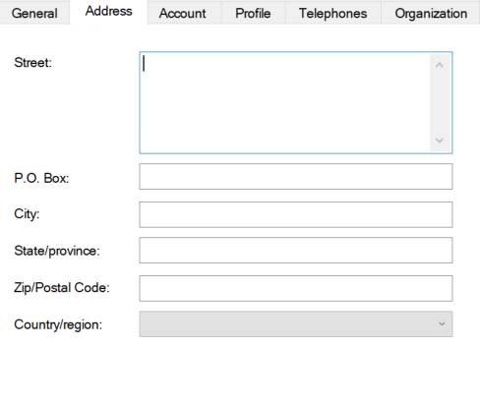
- ADDRESS TAB
All physical contact info.
- Street
- PO Box
- City
- State
- Country
Used mostly by HR systems, Exchange address book, or documentation.

- ACCOUNT TAB
This is where the real power sits.
Everything related to login identity, password, domain access, and restrictions.
Key fields:
1. User logon name (UPN)
- Format: user@domain.local
- Used for modern logins (Azure, 365, Remote Desktop).
2. User logon name (pre-Windows 2000)
- Format: DOMAIN\user
- Old apps still depend on this.
3. Logon Hours
- Restrict when they can login.
4. Log on to…
- Limit the user to specific domain-joined computers.
5. Account options
Examples:
- Password never expires
- User cannot change password
- Account is disabled
- Smart card required for interactive login
This tab = your bread and butter as a system admin.

- PROFILE TAB
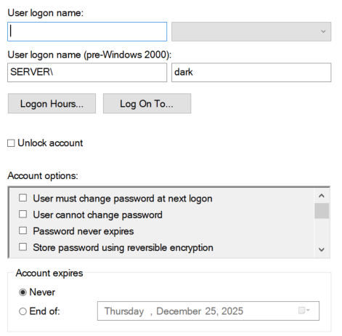
User-specific environment setup.
Items:
1. Profile Path
Roaming profiles: loads user profile from server.
2. Logon Script
A .bat, .cmd, or .ps1 script that runs at login.
Common uses:
- Map network drives
- Apply registry settings
- Configure printers
3. Home folder
Assign a personal network storage folder:
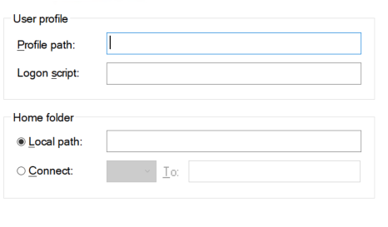
- H: drive → \\server\users\dark
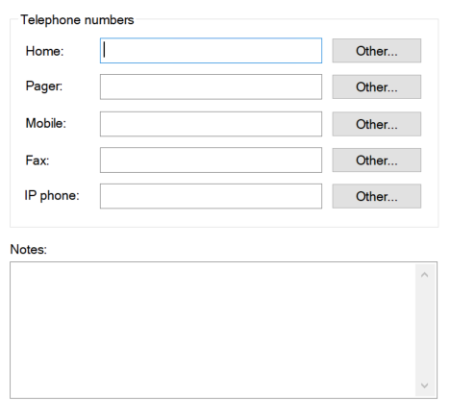
- TELEPHONES TAB
Internal organizational info:
- Home
- Pager
- Mobile
- Fax
Used by Outlook / Teams directories.

- ORGANIZATION TAB
Defines the user’s position inside the company hierarchy.
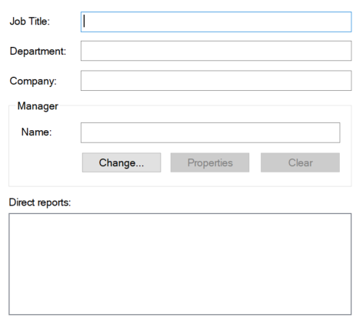
Fields:
- Title
- Department
- Company
- Manager
- Direct reports (auto-filled)
Used heavily in:
- Exchange (address book)
- Teams org charts
- HR sync tools

- REMOTE DESKTOP SERVICES PROFILE TAB
Controls how this user behaves on RDS / Terminal Services.
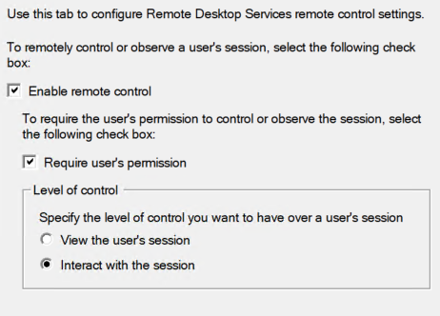
Settings include:
- RDS profile path
- Remote App home folder
- Time limits for sessions
- Reconnection settings

Only relevant if you have Remote Desktop Server (RDS) in your network.

- REMOTE CONTROL TAB
Allows admins to “shadow” the user’s session on an RDS server.
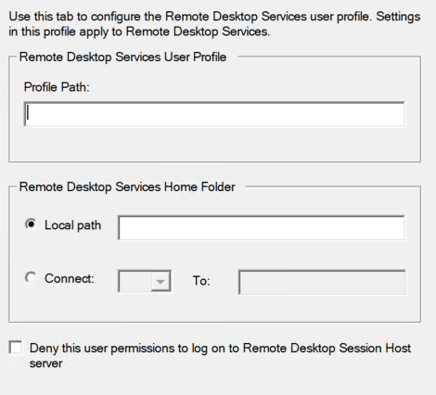
Options like:
- View only
- Interact
- Prompt for consent
Not used for normal client PCs.
- REMOTE DESKTOP SERVICES PROFILE TAB
More detailed RDS config:
- Environment settings
- Session start programs
- Folder redirection
Again: RDS-only.

- DIAL-IN TAB
Old-school VPN and modem dial-in permissions.
Key option:
- “Allow/Deny remote access”
This is mostly legacy, but still used with NPS (Network Policy Server).

- MEMBER OF TAB
Shows all security and distribution groups the user belongs to.
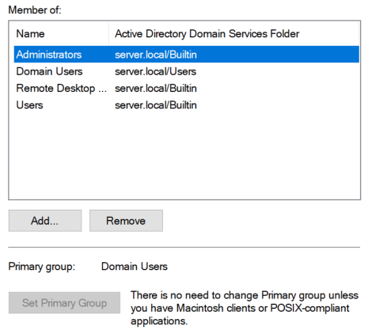
This tab controls:
- File access permissions
- Folder access
- Group Policy
- Application access

This is one of the most important tabs you'll ever use.
- COM+ TAB (COM+ Profiles)
Used by applications that rely on Microsoft’s COM+ framework.
Most admins never touch it unless running legacy enterprise software.
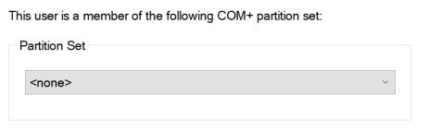

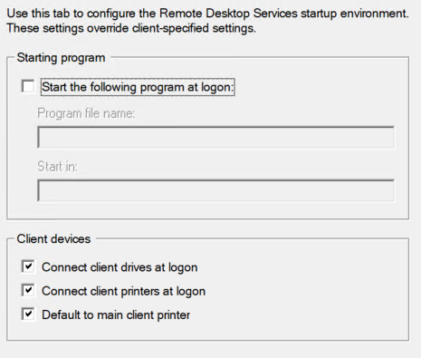
- ENVIRONMENT TAB
Used for Terminal Server environment settings:
- Startup program
- Client device redirection (clipboard, printers)
Again, relevant only to RDS.

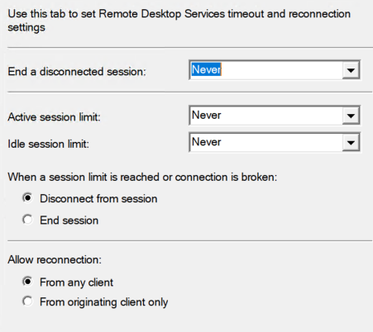
- SESSIONS TAB
RDS session limits:
- Idle timeouts
- Active session limits
- Disconnect timers

Groups also have window for showing and configuring properties
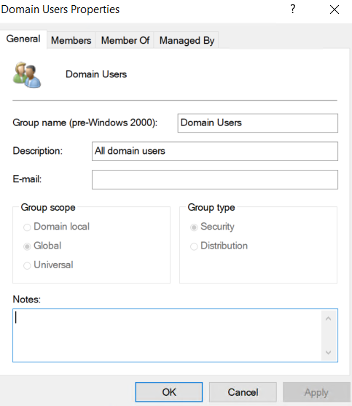
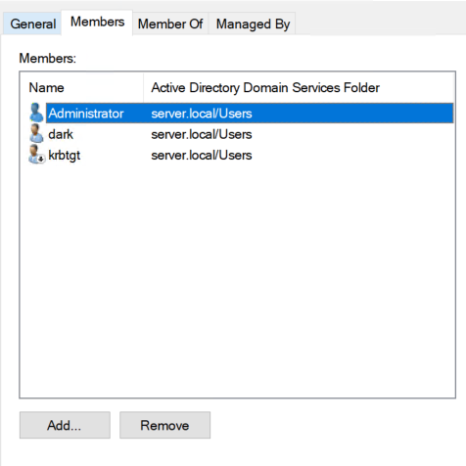
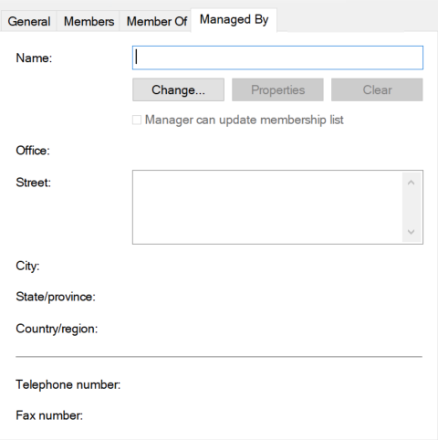
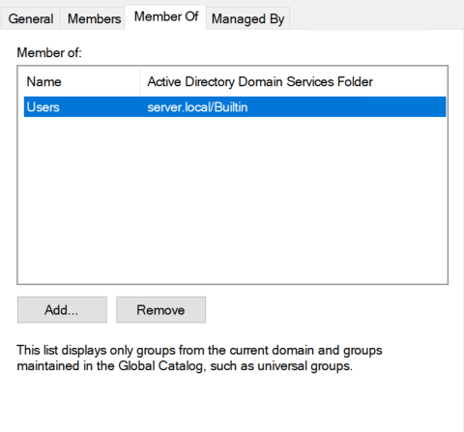

We also have computer management panels

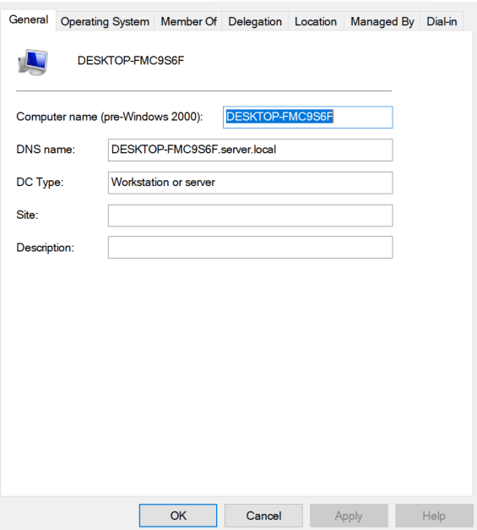

OU (Organizational Unit) — Simple Explanation
OU = a folder inside Active Directory used to organize and manage objects.
That’s it.
But if you want a bit more depth (still simple):
What is an OU?
An Organizational Unit (OU) is:
- A container inside Active Directory
- Used to organize users, groups, computers, and other OUs
- Allows you to apply Group Policies (GPOs) to specific parts of the domain
- Helps you delegate administrative control (give someone control over only one OU)
Think of it like:
A folder in your domain where you group things logically:
- OU: HR
- OU: IT
- OU: Students
- OU: Servers
- OU: Laptops
Why do we use OUs?
- To keep AD organized
- To apply GPOs only to specific people or computers
- To give admin Rights to a specific section without giving full domain access

8

Storage and Disks services management

Disk Interface Types in Windows Server

Modern Windows Server environments rely on a variety of disk interface technologies, each designed to balance performance, reliability, scalability, and cost. Understanding these disk types is fundamental for effective storage planning, performance optimization, and troubleshooting in enterprise environments.

1. SCSI (Small Computer System Interface)
SCSI is one of the oldest and most established storage interface standards in server environments. Although traditional parallel SCSI is largely deprecated today, its architecture evolved into modern enterprise-grade technologies.
Key characteristics:
- Supports multiple devices on a single bus.
- Provides high reliability and strong command queuing.
- Historically used in servers before SATA/SAS dominance.
Advantages:
- Stable, mature protocol.
- Good command handling and error control.
Limitations:
- Parallel SCSI cables have distance and interference limitations.
- Largely replaced by Serial Attached SCSI (SAS).

2. SAS (Serial Attached SCSI)
SAS is the modern successor to SCSI and is widely used in professional servers and storage arrays.
Key characteristics:
- Point-to-point serial communication for higher speed and reliability.
- Supports dual-port disks (important for high-availability environments).
- Compatible with SATA drives in most SAS backplanes.
Advantages:
- High performance (up to 24 Gbps on SAS-4).
- Supports many disks with expanders.
- Enterprise-grade durability and MTBF.
Typical use cases:
- Datacenters
- Virtualization hosts
- Database servers
- Hyper-converged infrastructure (HCI)

3. SATA (Serial ATA)
SATA is a consumer-grade disk interface that is also used in budget-friendly server setups.
Key characteristics:
- Lower cost than SAS.
- Provides reasonable performance for non-critical workloads.
Advantages:
- Affordable.
- Adequate for general storage, backups, or low-IOPS applications.
Limitations:
- Single-port (no multipathing).
- Lower endurance and reliability compared to SAS.
- Not suitable for high concurrency workloads.

4. NVMe (Non-Volatile Memory Express)
NVMe is a modern storage protocol designed specifically for flash SSDs. It communicates directly over PCIe, bypassing the limitations of SATA and SAS.
Key characteristics:
- Extremely high throughput and low latency.
- Supports thousands of parallel queues.
- Ideal for high-performance and latency-sensitive workloads.
Advantages:
- Far superior performance compared to SAS/SATA.
- Scales exceptionally with multi-core processors.
- Perfect for virtualization, analytics, AI, and heavy databases.
Limitations:
- Higher cost.
- Requires PCIe slots or NVMe-compatible backplanes.

5. USB Storage: USB storage is not typically used in production servers but is common for:
- OS installation
- Offline backups
- Emergency recovery
- File transfer
Characteristics:
- Hot-swappable
- Portable
- Lower performance compared to internal storage

6. iSCSI (Internet SCSI): iSCSI allows servers to connect to remote block storage over an IP network.
Key characteristics:
- Uses standard Ethernet infrastructure.
- Appears to Windows as a locally-attached disk.
- Supports multipathing for redundancy.
Advantages:
- Flexible and cost-effective SAN solution.
- Easy to scale.
- Works with virtualization clusters (Hyper-V, VMware).
Limitations:
- Dependent on network performance.
- Requires proper QoS and segmentation for stability.

7. Fibre Channel (FC): Fibre Channel is a high-speed storage networking technology used in enterprise SAN environments.
Key characteristics:
- Extremely reliable and high-performance.
- Requires dedicated switches, HBAs, and cabling (not Ethernet).
Advantages:
- Low latency.
- Excellent for large-scale enterprise workloads.
- Highly predictable performance.
Limitations:
- Expensive.
- Requires specialized hardware and skills.
Basic Disks vs Dynamic Disks

Windows Server supports two primary disk types: Basic Disks and Dynamic Disks. Both store data, but they differ significantly in structure, flexibility, and the types of volumes they support. Understanding these differences is crucial for managing storage effectively, designing fault-tolerant solutions, and performing advanced disk operations.

1. Basic Disks
Basic disks are the traditional and most used disk type in Windows-based systems. They follow the standard partitioning model (MBR or GPT) and provide straightforward, stable storage suitable for most scenarios.
Characteristics
- Uses MBR or GPT partition tables.
- Supports up to 128 partitions on GPT disks and 4 primary partitions on MBR disks.
- Simple structure — each partition = one volume.
- Compatible with all major OSes, hypervisors, and disk tools.
Supported Volume Types
- Primary partitions
- Extended partitions & logical drives (only on MBR)
- Simple volumes
Typical Use Cases
- Standard server installations, Boot/system disks
- Simple data storage
- USB/external storage
- Virtual machines using VHD/VHDX files
Advantages
- High reliability, Easy to manage
- Fully compatible with all OS tools, imaging systems, and recovery utilities
- Good for boot volumes
Limitations
- Cannot create advanced RAID volumes without hardware support
- Less flexible for resizing/expanding compared to dynamic disks
- No multi-disk volume support (except Storage Spaces)
Basic disks are the default and recommended option in most modern deployments unless advanced disk features are required.
2. Dynamic Disks
Dynamic disks provide more advanced features by replacing the traditional partitioning system with a Logical Disk Manager (LDM) database. This enables the creation of complex and multi-disk volumes directly within Windows Server.
Characteristics
- Uses LDM (Logical Disk Manager) metadata instead of standard MBR/GPT partitioning.
- Supports advanced volume types across multiple disks.
- Allows flexible online resizing and volume expansion.
Supported Volume Types
1. Simple Volume
A single region on one disk (similar to a basic partition).
2. Spanned Volume
Combines space from multiple disks into one large volume.
- No redundancy, Failure of one disk destroys the entire volume
3. Striped Volume (RAID 0)
Data is striped across multiple disks for performance.
- High speed, No redundancy
4. Mirrored Volume (RAID 1)
Data is duplicated between two disks.
- Provides redundancy, Used for system-critical data
5. RAID-5 Volume
Parity-based fault tolerance across three or more disks.
- Efficient redundancy, good balance between performance and protection
Typical Use Cases
- Servers without hardware RAID
- Older environments before Storage Spaces
- Systems needing software-level RAID (RAID 1 or RAID 5)
- Large, spanned volumes for non-critical data
Advantages
- RAID features built-in, Ability to extend volumes over multiple disks
- Online volume resizing, No need for special controllers
Limitations
- Not supported on USB or external drives
- Not widely supported on VMs (not recommended)
- Cannot be used as boot disks in some configurations
- LDM corruption can break volumes
Dynamic disks are powerful but have been mostly replaced by Storage Spaces in modern Windows Server versions.

What Are Storage Spaces?

Storage Spaces is a storage virtualization technology in Windows Server that allows you to combine multiple physical disks into flexible, fault-tolerant, and scalable virtual storage volumes.
You can think of it as Microsoft’s modern software-defined replacement for Dynamic Disks and hardware RAID.
Windows takes a group of physical disks → creates a pool → and from that pool it creates virtual disks with different resiliency levels (mirror, parity, etc.).
It is widely used in:
- Windows Server
- Hyper-V
- Storage servers
- Failover clusters
- Azure Stack HCI

Why Storage Spaces Exists
Traditional storage had limitations:
- Hardware RAID is expensive
- Dynamic Disks are outdated
- Expanding or modifying storage was difficult
- High availability required specialized hardware
Storage Spaces solves these issues by making storage:
✔ Flexible, Scalable, Software-defined, Resilient, Easy to manage

Key Concepts of Storage Spaces
1. Storage Pool
A storage pool is a collection of physical disks grouped together into one logical storage resource.
Think of it as combining multiple disks into one big bucket.
- You can add or remove disks.
- Windows manages the pool dynamically.
- Multiple virtual disks can be created from one pool.

2. Virtual Disk (Storage Space)
A virtual disk is a logical volume created from the storage pool.
It appears to the OS just like a normal disk (C:, D:, etc.), but underneath, data is distributed across multiple physical drives.

3. Resiliency Types (Software RAID)
Storage Spaces supports several resiliency models:
• Simple (No Resiliency)
- Like RAID 0
- Maximum performance
- No fault tolerance
- Not for production servers
• Two-way Mirror
- Like RAID 1
- Data copied to two disks
- Can survive one disk failure
• Three-way Mirror
- Like RAID 10 triple mirror
- Data stored across three disks
- Can survive two disk failures
• Parity
- Similar to RAID 5 or RAID 6
- Optimized for large sequential data
- One or two-disk fault tolerance
- Good for backup servers and archives

4. Thin vs Fixed Provisioning
Thin Provisioning
- Virtual disk uses only the space that data actually occupies
- Grows as needed
- Saves storage
- Ideal for large but not fully-used volumes
Fixed Provisioning
- Full size allocated immediately, Better performance
- Used for high-performance environments (VM storage)

When we plug a storage device on if it was new it surly will not appear as in the files or as a partition so we should configure it before we use it.
And we can configure it using disk manager and we can show this tool

RUN diskmgmt.msc
Or
Server manager Tools Computer management

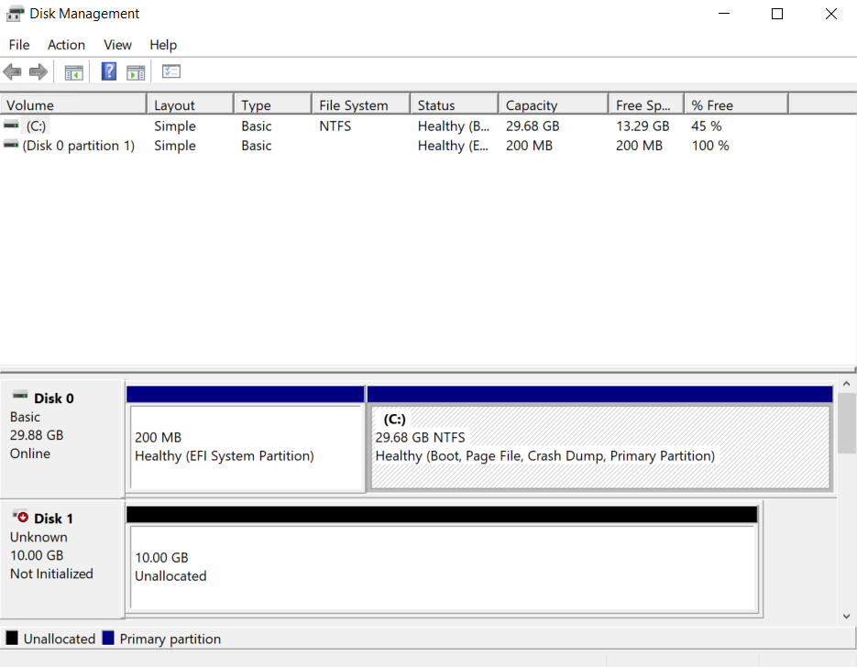

We have to go through few steps to make the disk work and make partition.

- Initialize disk
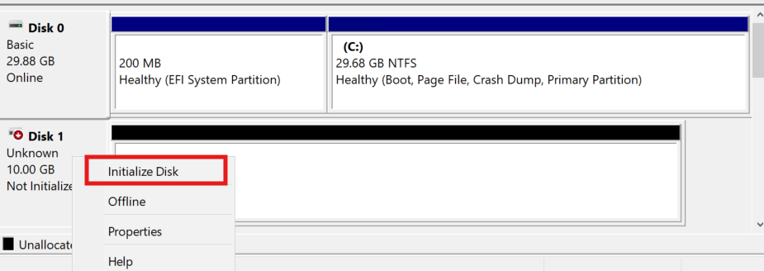

We can init it on MBR or GPT
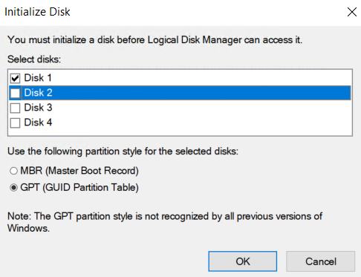

- Bring it online if it not already is online after initialization

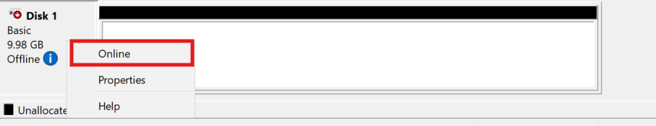

- Allocate it as a partition and there are a lot of types of allocation
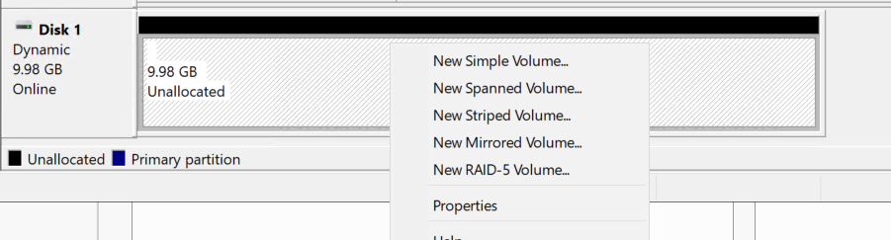

1. New Simple Volume
What it is:
A basic volume on a single disk — similar to a regular partition.
Characteristics:
- Uses space from one disk only.
- No performance improvement.
- No redundancy.
Use case:
General storage, single-disk servers, small data partitions.

2. New Spanned Volume
What it is:
A volume that combines unallocated space from multiple disks into one big volume.
How it works:
Windows stores data sequentially across the disks — fills disk 1 → then disk 2 → etc.
Pros:
- You can create a large volume even with mismatched disk sizes.
Cons:
- Zero redundancy.
- If any one disk fails → entire volume is lost.
Use case:
Non-critical archival data, temporary storage.

3. New Striped Volume (RAID 0)
What it is:
Data is striped (split) across two or more disks.
Pros:
- Very high read/write performance.
- Excellent for speed-sensitive workloads.
Cons:
- No redundancy.
- If one disk fails → all data is lost.
Use case:
High-speed temp storage, scratch disks, non-critical workloads.

4. New Mirrored Volume (RAID 1)
What it is:
Data is duplicated on two disks.
Pros:
- High redundancy — can survive one disk failure.
- Good read performance.
Cons:
- Storage cost: You lose 50% of total capacity.
Use case:
Critical system data, OS volumes, logs, small servers needing simple redundancy.

5. New RAID-5 Volume
What it is:
Data and parity are striped across three or more disks.
Pros:
- Fault tolerance: Can survive one disk failure.
- Better storage efficiency than mirroring.
- Good for large data sets.
Cons:
- Write performance is slower because of parity calculations.
- Requires 3+ disks.
Use case:
File servers, backups, general-purpose storage when you want good capacity and fault tolerance.

9

Files and Folders permissions
In windows server there are 2 types of permissions
- NTFS Permissions.
- Share Permissions.

NTFS (New Technology File System) is the foundation of Windows file security. Every file and folder stored on an NTFS-formatted volume is governed by a detailed access control model that determines who can read, modify, or manage the object. This chapter explains that model fully.

The NTFS Security Architecture
ACL, DACL, SACL, and ACE

NTFS permissions are based on Access Control Lists (ACLs). Each file or folder contains two main ACLs:

• DACL (Discretionary Access Control List)
- Defines who can access the object and what permissions they have.
- Contains one or more ACE (Access Control Entries).
- If the DACL is empty → only SYSTEM and Administrators can access the file.
- If DACL is missing (rare) → Everyone has full access.
• SACL (System Access Control List)
- Controls auditing, not access.
- Defines what access attempts should be logged in the Security Event Log.
- Used for compliance, security monitoring, and incident investigation.
• ACE (Access Control Entry)
- The building block inside ACLs.
- Each ACE represents:
  - A security principal (user/group)
  - A permission (read, write, delete…)
  - A type (Allow or Deny)
  - Inheritance flags

Standard NTFS Permissions
Windows provides six “standard” permissions that administrators use most of the time. They are combinations of many advanced permissions.
Below is the formal definition and the real-world meaning.

Full Control
Allows:
- Read, write, modify, delete
- Change permissions
- Take ownership

Modify
Allows:
- Read, Write, Delete, Create files/folders, Modify existing items
Cannot:
- Change permissions, Take ownership

Read & Execute
Allows:
- Read file/folder, Execute applications (.exe, .bat, .ps1)

List Folder Contents
Allows:
- View folder names, Navigate into them, See structure
Important:
This permission applies to folders only.

2.2.5 Read
Allows:
- View file contents, View attributes, View permissions (but not change them)

Write
Allows:
- Create new files
- Create new folders
- Modify existing files only if Modify is combined

2.3 Advanced NTFS Permissions
These are the "low-level" building blocks that make up the standard sets above.
You should explain each clearly:
- Traverse Folder / Execute File: Allows navigating through folders even without listing them, Required to run executables.
- List Folder / Read Data: List folder names, Read file content
- Read Attributes: Read basic file metadata (Read-only, Archive…).
- Read Extended Attributes: Read additional metadata created by apps.
- Create Files / Write Data: Create new files in a folder, Append data to existing files
- Create Folders / Append Data: Create subfolders within a directory
- Write Attributes: Change file attributes (make read-only, hidden, etc.)
- Write Extended Attributes: Modify extra application-level metadata
- Delete: Delete file or folder
- Delete Subfolders and Files: Allows deletion inside a folder even if user cannot delete the parent folder.
- Read Permissions: View existing ACLs
- Change Permissions: Modify DACL entries
- Take Ownership: Take control of the object, Owner becomes the ultimate controller of the file

Permission Inheritance

What Inheritance Means
- Permissions applied on a parent folder automatically propagate to child objects.
- Makes managing large file structures realistic.

Breaking Inheritance
Options:
- Convert inherited permissions into explicit
→ Keeps existing permissions but stops future changes.
- Remove all inherited permissions
→ Clean, empty ACL (common for confidential folders like HR or Finance)
Block Inheritance vs Deny
Explain that Deny should be used rarely.
Breaking inheritance is cleaner and more predictable.

Effective Access (Critical Section)

How Effective Access Works
Windows calculates final permissions by combining:
- Group memberships
- User permissions
- Inherited ACEs
- Explicit ACEs
- Deny entries
- Special permissions
Rules
- Explicit Deny > Everything
- Inherited Deny > Inherited Allow
- Explicit Allow > Inherited Allow
Effective Access Tool
Found in:
Security → Advanced → Effective Access tab
Shows the actual permission a user ends up with.
Used heavily in troubleshooting.

Share Permissions
Share permissions exist because:
- NTFS permissions only apply on local access.
- Shared folders require another layer of control for network users.
- Administrators may want simpler, high-level restrictions at the share level.
- It allows setting broad restrictions without modifying NTFS ACLs.
Example:
You may want a folder to be read-only for all network users, regardless of NTFS permissions.

3.2 Types of Share Permissions
Windows Server provides three permission levels for SMB shares:

3.2.1 Read
Allows:
- View folder names and file attributes, Open files (read-only), execute programs
Cannot:
- Modify files, Create new items, Delete anything

3.2.2 Change
Allows everything in Read plus:
- Create files/folders, modify existing files, Delete files/folders
Cannot:
- Change permissions, Take ownership

3.2.3 Full Control
Allows:
- All Change operations, change share permissions, Take ownership

How to show file or folder permissions:
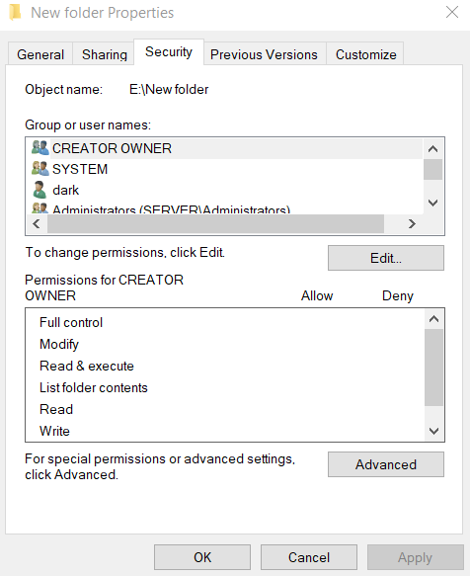
File/Folder Properties Security
This show NTFS Permissions

File/Folder Properties Security advanced settings permissions
This show share Permissions
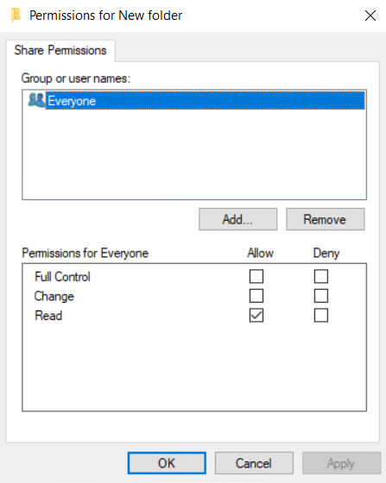

Auditing & Monitoring Access
Auditing allows administrators to track and record how users interact with files, folders, and other secured objects. While permissions control who can do what, auditing records who actually did what — or attempted to.
This capability is essential for:
- Security investigations
- Compliance (ISO, HIPAA, GDPR, SOC2)
- Insider threat detection
- Troubleshooting unauthorized access
- Tracking deletion or modification of critical files
Auditing is controlled through the System Access Control List (SACL) and Group Policy settings.

Understanding Auditing Components

SACL (System Access Control List) The SACL defines:
- Which actions should be monitored
- Which users or groups are audited
- Whether successful or failed attempts are logged
Unlike the DACL, the SACL does not affect access — only logging.

Audit Policy: Windows uses Group Policy to determine:
- What audit categories are enabled
- Whether success, failure, or both events are recorded
- Level of detail (basic vs advanced auditing)

Audit Types: Windows supports several auditing categories, but for file permissions the most relevant are:

Audit Object Access: This must be enabled to audit:
- File/folder access, Registry access, Printer access, Shared folder access
Audit Directory Service Access: Used for Active Directory object changes (not file systems).
Audit Handle Manipulation: Logs when a file handle is opened or closed — extremely detailed.
Audit Permission Changes: Tracks changes to ACLs or ownership.
Audit File Deletion: Tracks file/folder deletion events.
Enabling File Access Auditing
To audit file access, two steps are required.
Step 1 — Enable Audit Policy (via Group Policy)
Navigate to:
Computer Configuration
→ Policies
→ Windows Settings
→ Security Settings
→ Local Policies
→ Audit Policy
Enable:
- Audit object access – Success
- Audit object access – Failure
For advanced auditing:
Advanced Audit Policy Configuration
→ Object Access
Enable:
- File System – Success
- File System – Failure

Step 2 — Configure the SACL on the File/Folder
- Right-click the folder → Properties
- Security tab → Advanced
- Go to Auditing tab
- Add a principal (e.g., “Everyone”, “Domain Users”, or specific groups)
- Select which actions to audit:
  - Read data, Write data, Delete, Modify permissions, Take ownership, Create files/folders, Execute, Many more…

Understanding Audit Log Entries
Audit results are recorded in:
Event Viewer → Windows Logs → Security
Relevant event IDs:
Event ID | Meaning
4663 | Attempted access to a file or folder
4656 | Handle requested to an object
4660 | Object deleted
4670 | Permissions on an object were changed
4658 | Handle closed
4724 | Password reset (AD-related)
5140 | Network share accessed
5145 | User attempted to access a file via SMB
What you can learn from logs:
- Which user accessed a file
- When they accessed it
- Whether access was successful or denied
- What exact permission they attempted (Read, Write, Delete…)
- If the file was deleted, renamed, or modified
- What computer they accessed it from
- How often access was repeated
This is powerful for real-world investigations.

8.5 Common Real-World Auditing Scenarios
8.5.1 Detecting Unauthorized File Access
Useful for sensitive departments:
- HR, Finance, Executive data, Security teams
You audit:
- Read, Write, Modify, Delete
Investigating File Deletion
Enable auditing for:
- Delete, Delete subfolders and files
Check logs for:
- Event ID 4660
- Event ID 4663

Detecting Permission Changes
Auditing:
- Change permissions
- Take ownership
Event ID:
- 4670 (permission changes)
Monitoring Ransomware Behavior
Ransomware typically:
- Reads large numbers of files
- Writes encrypted versions
- Deletes originals
Auditing Write/Delete can help detect patterns.
Performance and Storage Considerations
Auditing can cause:
- Increased CPU usage
- Rapid growth in security log size
- Slower access on heavily audited folders
Recommendations:
- Never audit entire drives
- Use separate event log servers (SIEM)
- Limit auditing to critical folders
- Use Advanced Auditing policies for granularity

10

Storage sharing management
There are many ways to share a folder or storage one of the ways

Is simple sharing which is done through the folder properties and then on the share

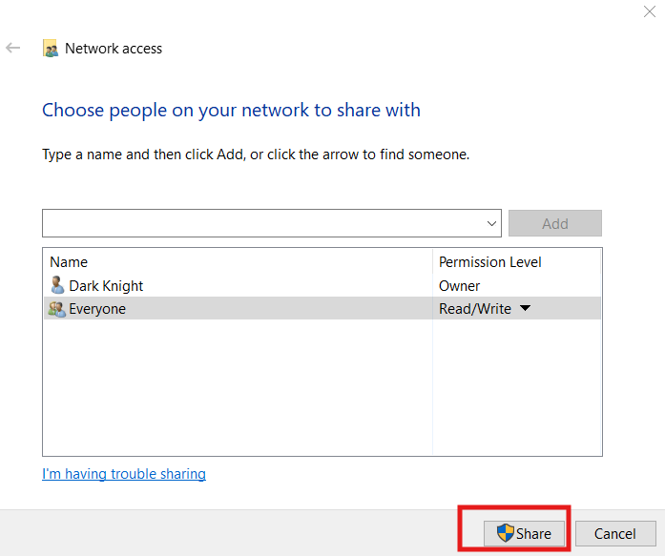
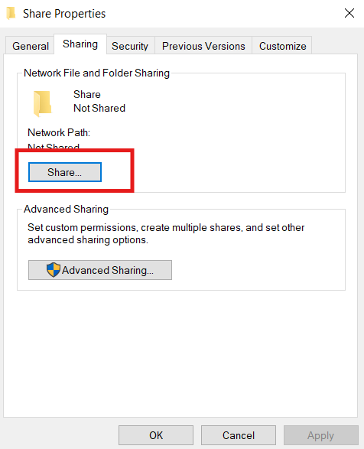

The second way is the iscsi
But before we work with it we must install the role in the server
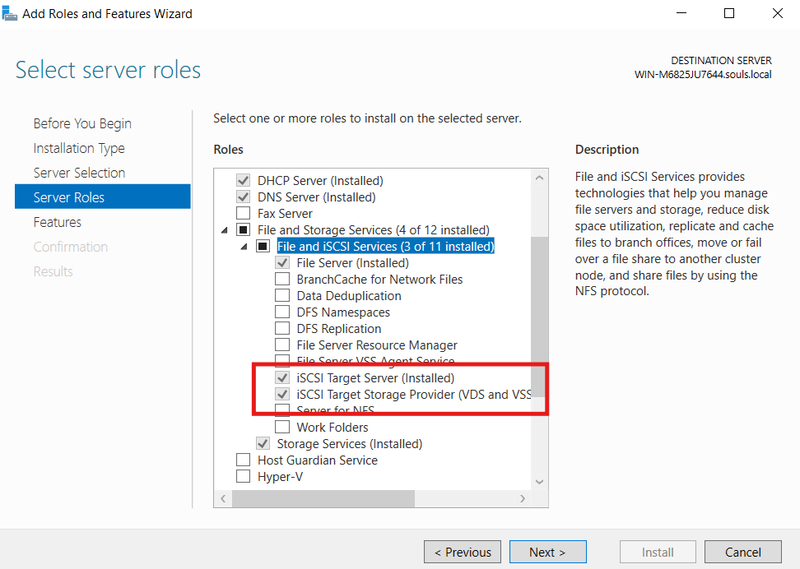
And then open it from the file and storage services
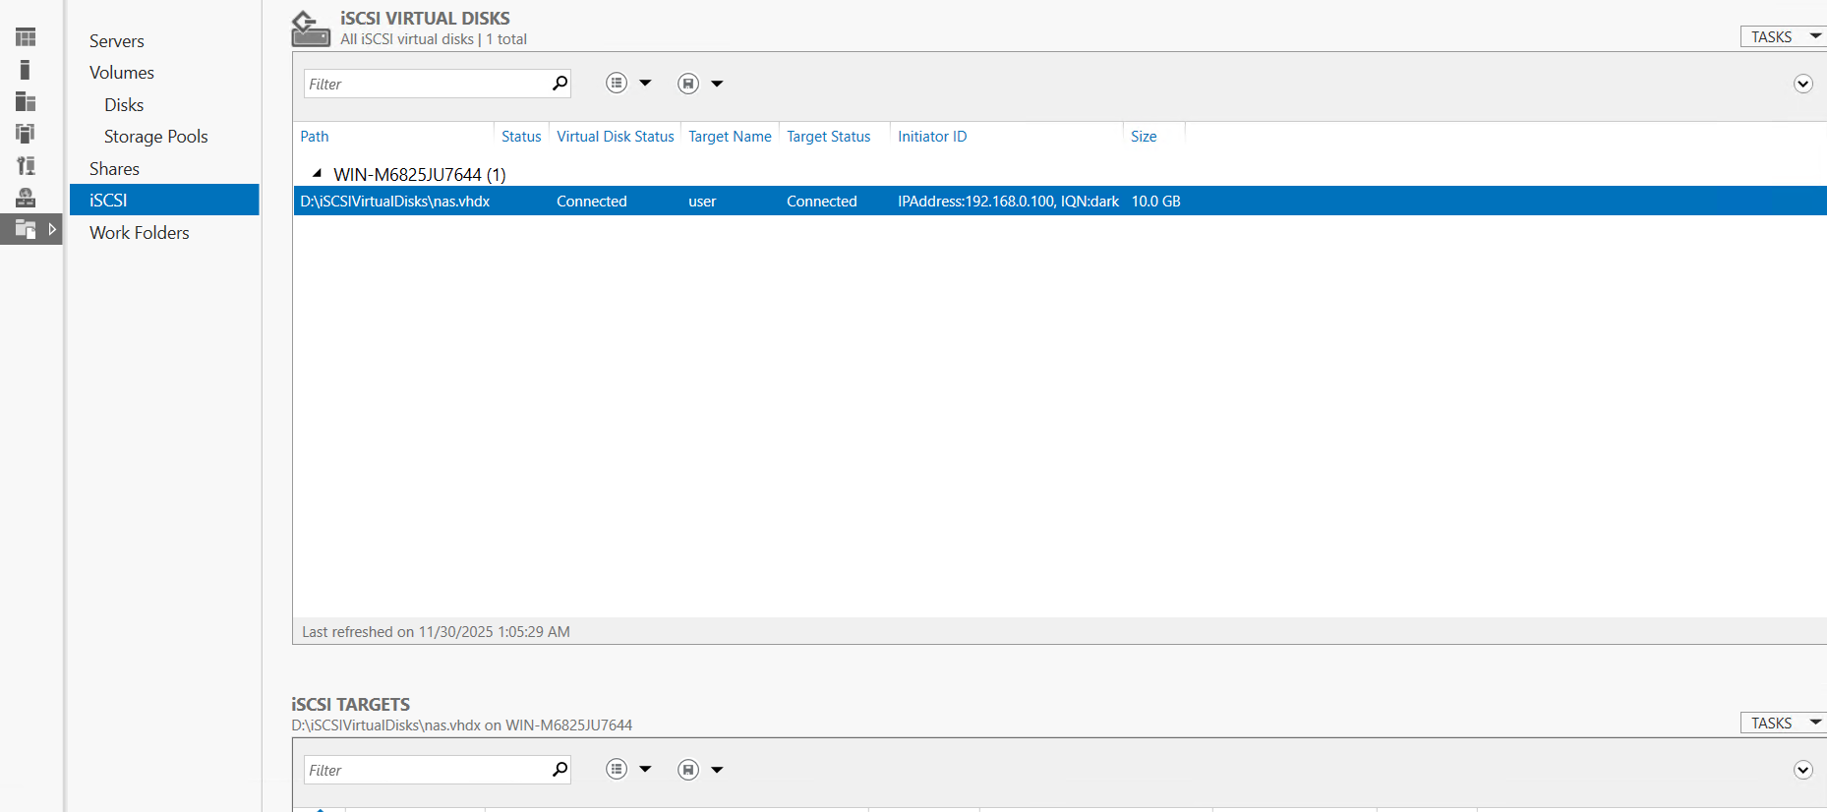

And then we follow the steps and make a virtual disk and share it as iscsi
And we can reach it using the iscsi initiator.
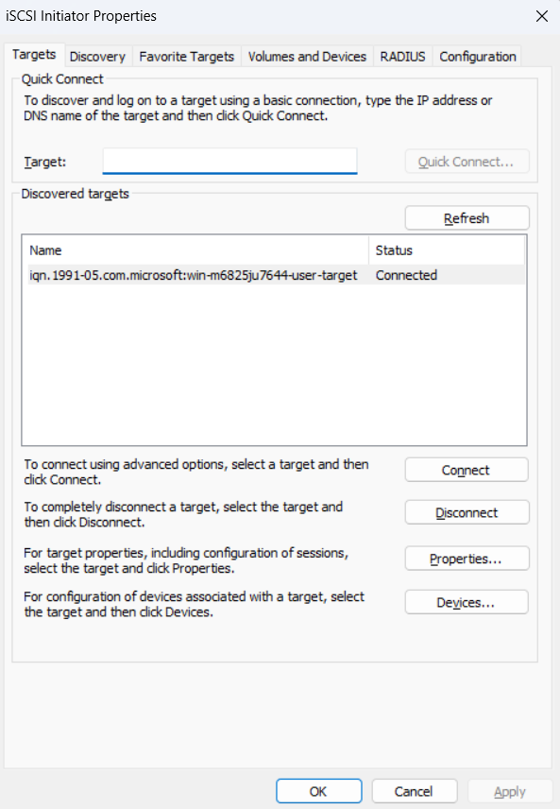

Disk Quota:
Disk Quotas in Windows Server are a storage control mechanism that lets you limit how much disk space each user can consume on an NTFS volume.

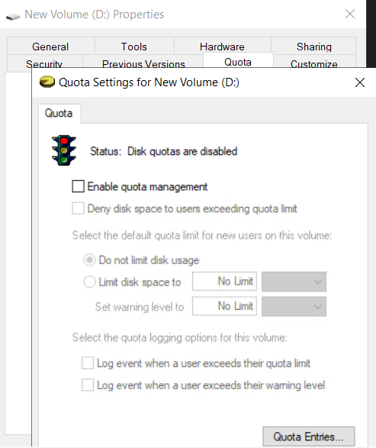
We can activate this service on a partition not a folder
How to enable it?
We go to the partition properties Disk Quota

Shadow copy
Shadow Copy — also called Previous Versions — is a Windows Server feature that creates point-in-time snapshots of files and folders on a volume without interrupting users or applications.
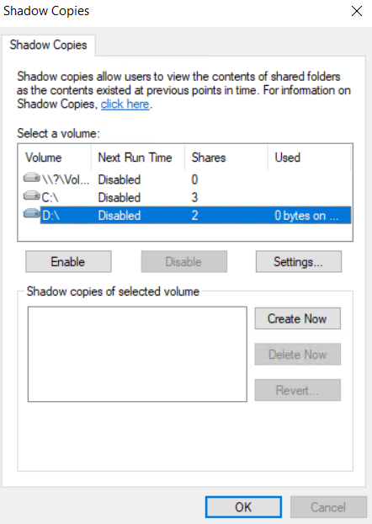
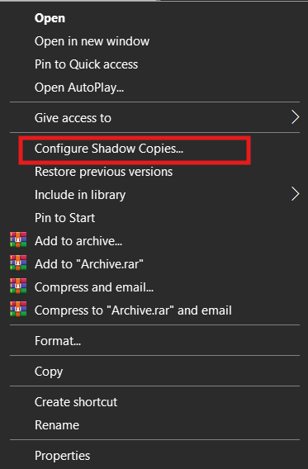

Offline Files (Caching)
How to activate it
From the control panel
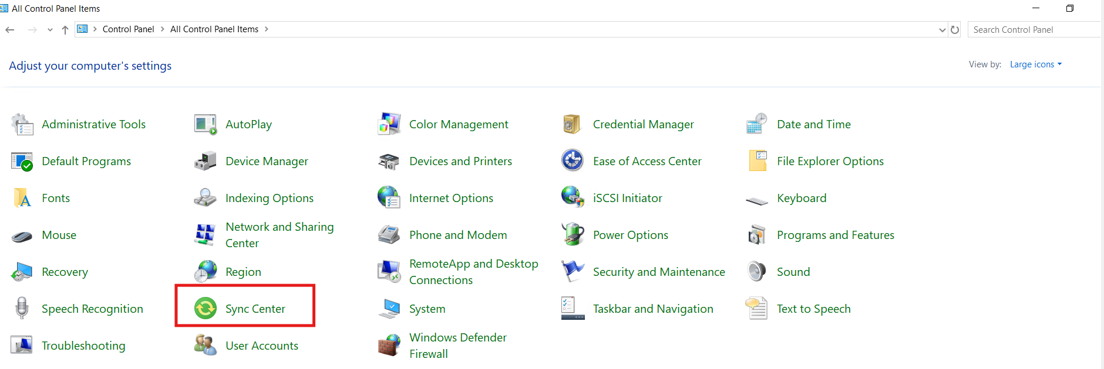
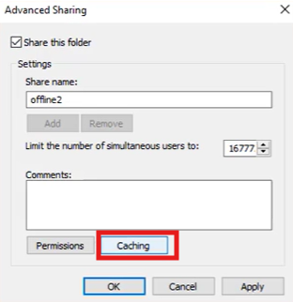
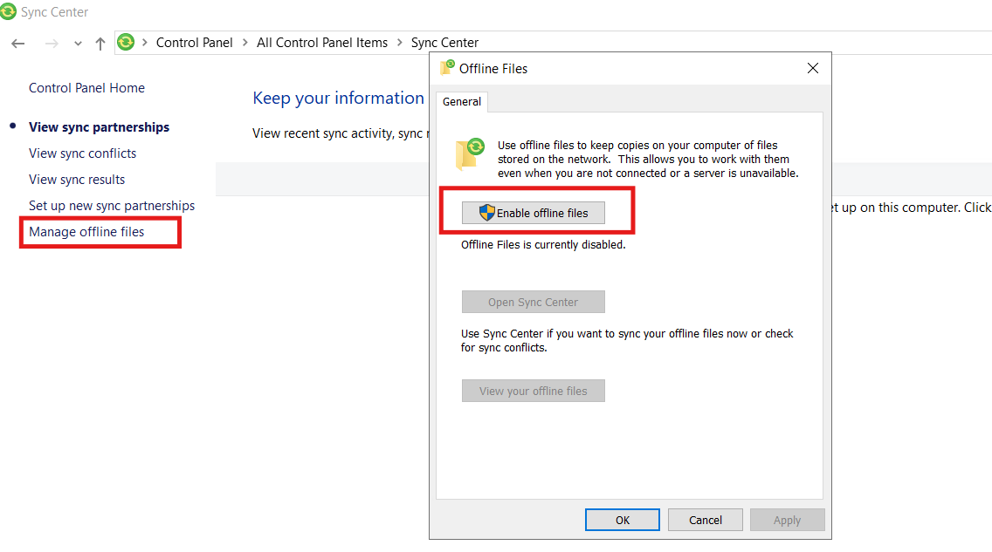
From the sharing we go to advanced sharing for the
Folder and activate caching

11

File server and Resources Management (FSRM)

A Windows Server role/service used to control, monitor, and manage file storage on your file servers.
Think of it as your police station for storage:
- It controls what users can store
- It stops them from filling your disk with nonsense
- It sends alerts and reports
- It enforces quotas
- It finds sensitive data
- It monitors file usage patterns
Perfect for file servers in companies, schools, and shared environments.

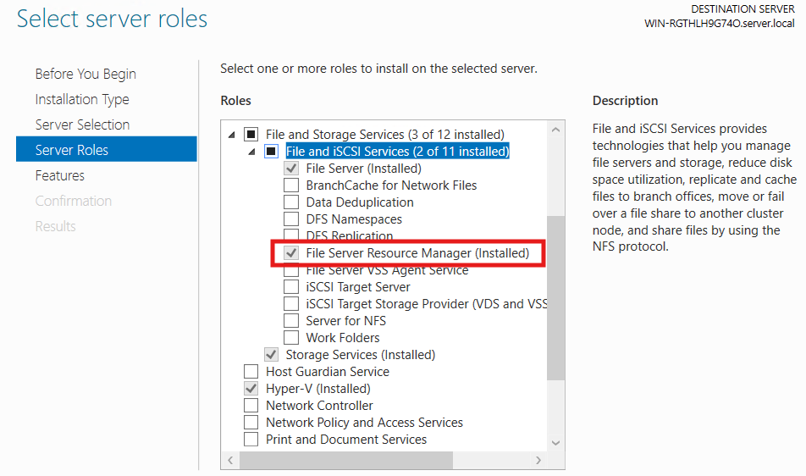
To install it we must install the role

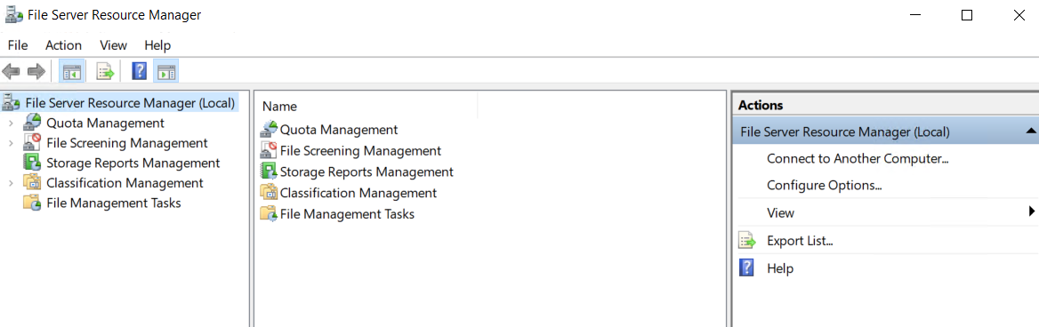
1. Quota Management: Control how much storage a folder can use.
What it lets you do:
- Create storage limits (quotas) for folders
- Prevent users from filling the server
- Send alerts when space is nearly full
- Automatically run scripts when a threshold is reached
- Apply quota templates to multiple folders easily
Real examples:
- Give each user a 10GB home folder
- Limit a shared drive to 200GB
- Trigger an email alert at 85% usage
Why it’s important:
Prevents storage exhaustion. Saves you from that “why is the server full again?” nightmare.

2. File Screening Management
Purpose: Control what types of files users can save.
What it lets you do:
- Block file extensions (mp3, mp4, iso, exe…etc)
- Allow only certain types (docx, pdf, xlsx…)
- Warn you if someone tries to store forbidden files
- Use built-in screen templates or create your own
Two modes:
- Active Screening:
Blocks the file instantly.
- Passive Screening:
Allows the file but logs the attempt.

3. Storage Reports Management: Generate detailed reports about how storage is being used.
Types of reports (very useful):
- Duplicate files report – shows wasted space
- Large files report – find space hogs
- File screening violations – who tried to store blocked files
- Quota usage – which departments/users are near limit
- Files by owner – track who owns what
- File type distribution – see what types of files fill your server

4. Classification Management: Automatically categorize files based on rules.
What can it classify:
- Files containing sensitive words (“confidential,” “salary,” etc)
- Old files, File types, Owner, Custom metadata (tags)
How it works:
You define rules → FSRM scans files → Adds classification labels.
Why it’s important:
Useful for:
- Compliance (GDPR, ISO requirements)
- Data governance
- Automatic archiving
- Security tagging

5. File Management Tasks: Take automated actions on files based on rules or classification.
What you can automate:
- Move old files to an archive folder
- Delete temporary files older than 30 days
- Encrypt sensitive files
- Run a script on certain file types
- Expire log files automatically
Why it’s important:
This is the automation engine.
It saves admins from manually cleaning up storage.
BONUS: Actions Pane (Right Side)
This is not a service but important:
- Connect to Another Computer: Manage remote servers
- Configure Options: Set email alerts, SMTP, report schedules, file classifier options
- Export List: Export data from any view
- Help: Documentation

1. Quota Management:
It has two parts
The Quota itself and the Quota template
The Quota template defines the size of the Quota and what happens if the user uses more space than the defined in the quota.
We can choose one of the [redefined quota templates or create a new one.
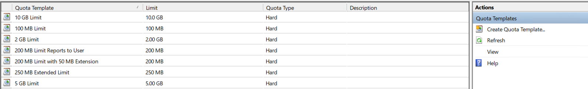

What specifications can we put in our quota template:
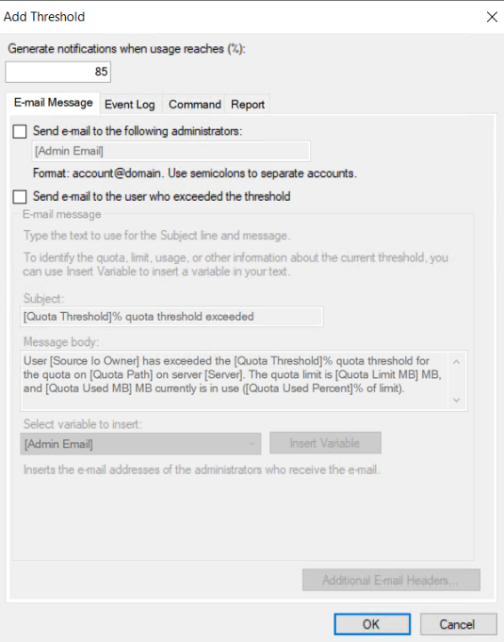
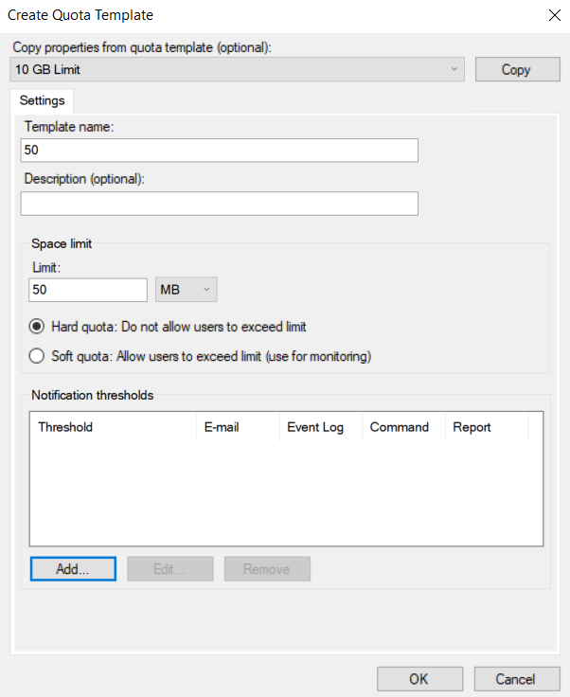
And after it we can make a quota using one of the templates to define the size and the threshold

2. File Screening Management
It consists of three parts
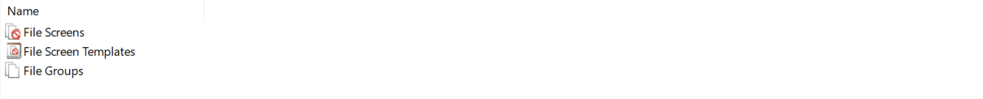
File screen defines what file is going to have the screen on

File screen template defines the files groups and the mode of the file screen
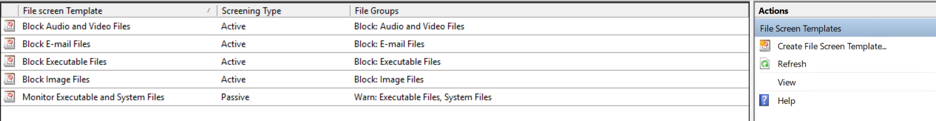
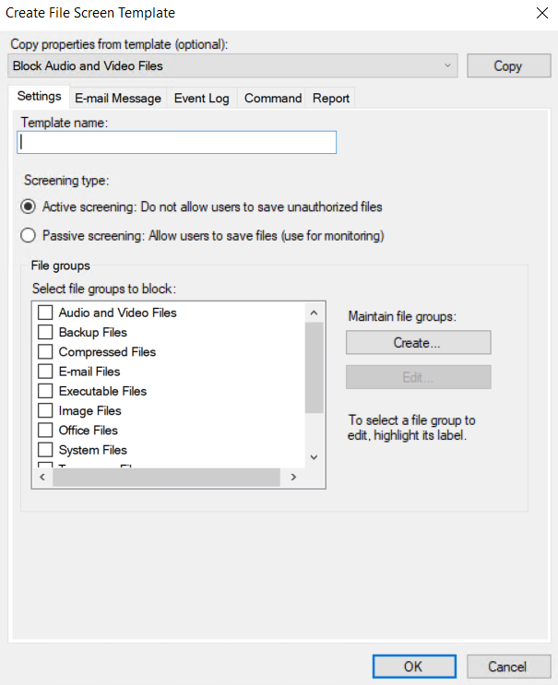

File Group defines the types of file in on group to make assignment of the easier
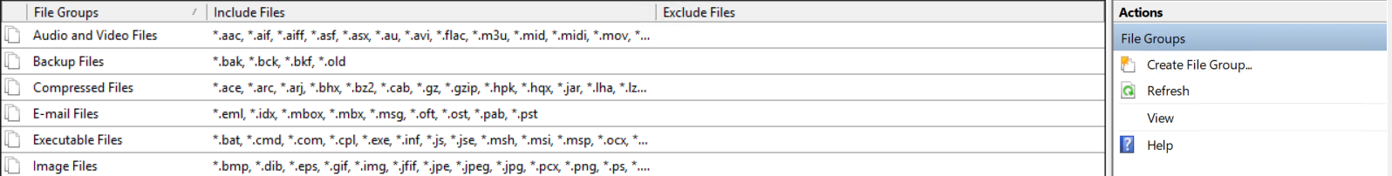
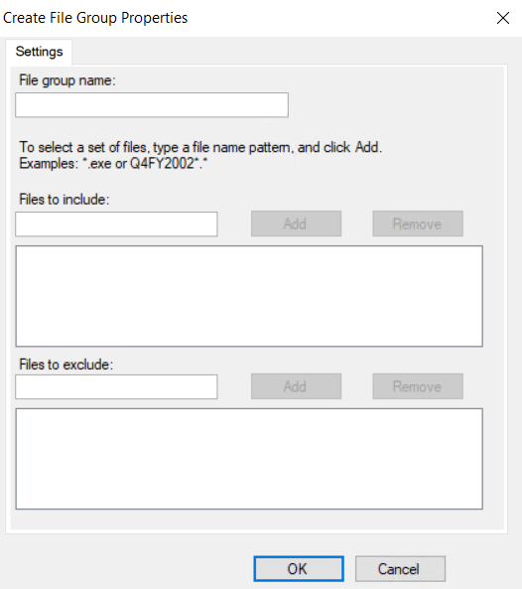
The Exclude has priority on include
if the file is included its blocked
other wise excluded or not added in both its allowed

Storage Reports Management:
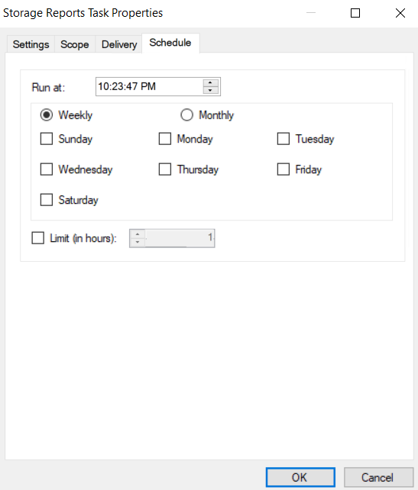
We can generate a report instantly or schedule one
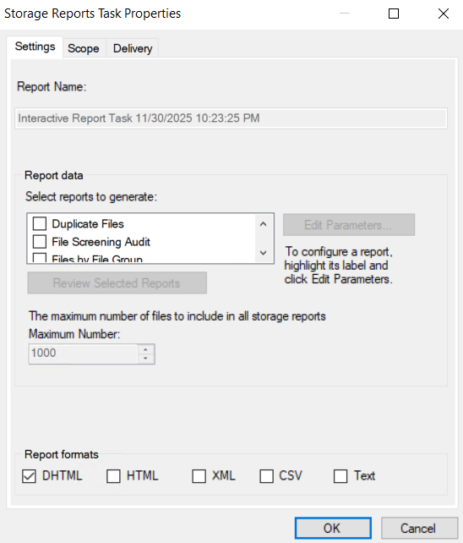
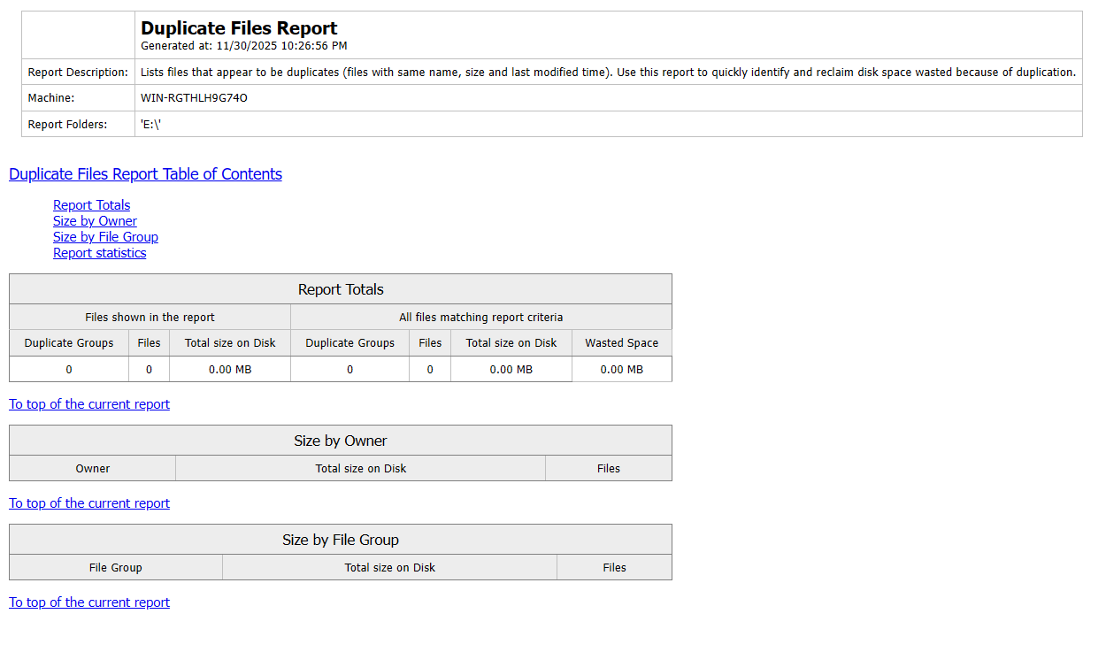

Classification Management:
1. Classification Properties
These are the labels, the metadata fields, or the tags that can be assigned to files.
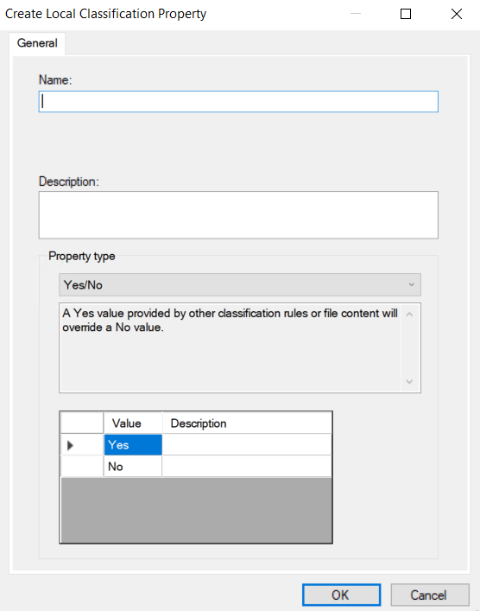
🔵 1. Yes/No: A simple true/false value.
Think of it like a switch.
2. Date-time: Stores a specific date and time.
Used for tracking file lifecycle.
3. Number: A numeric value (integer or decimal).
Useful for rules with thresholds.
4. Multiple Choice List:
A list where you can select more than one option.
This is basically a multi-tag system.
5. Ordered List: A list with priority or ranking, in a fixed order.
The order matters.
6. Single Choice: A list where only one option can be selected.
Only ONE category can be applied.
7. String: Free-text value.
You type anything you want — no limits.
8. Multi-string: Like String, but you can store multiple text values.
Used when a file needs multiple text tags.
2. Classification Rules
Rules define how files get tagged with the properties you created above.
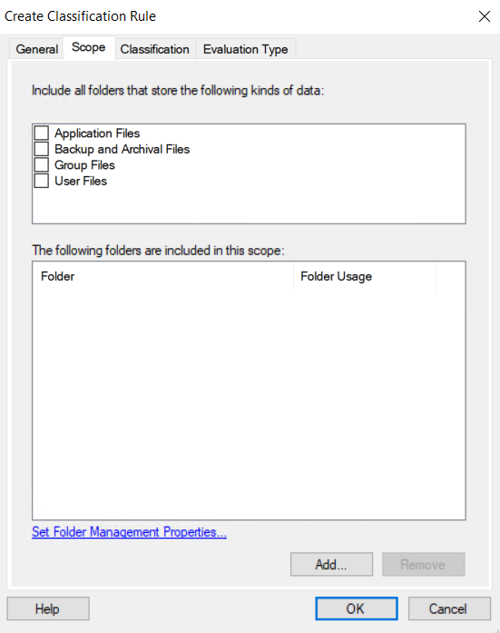
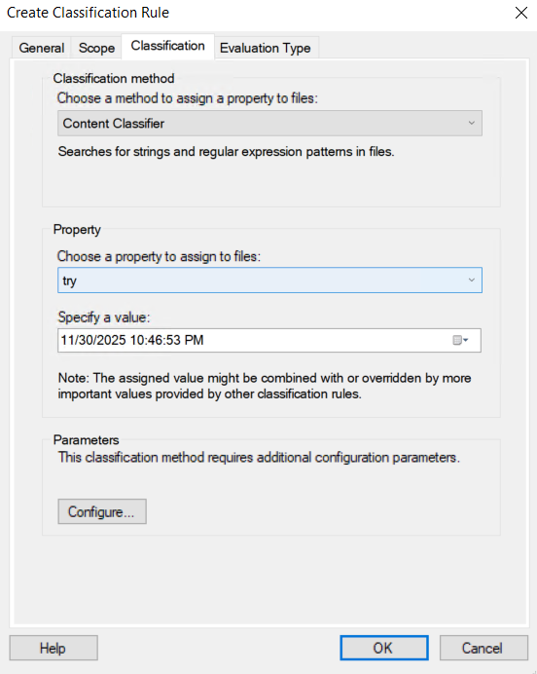
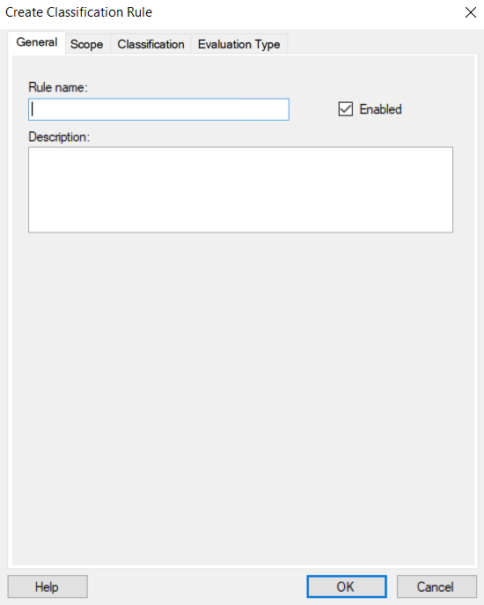
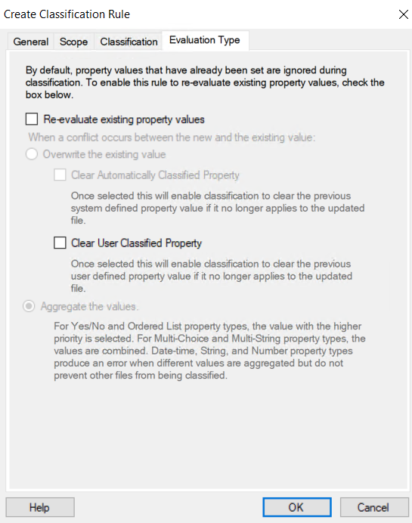

12
Backup Management
Things temrs to know:

Recovery Time Objective (RTO): How much time until the system go back active after the desaster.

Recovery Point Objective (RPO): What point the system will be back on after the desaster recovery.

High Availability (HA): Availabilty of the system if a component stops like a sevrer or a network device

Disaster Recovery (DR): How the system will be recovered and from where.

Bare Metal Backup:
It takes backup of all the system including
- Recovery Partitions - C Partition - System State - HyperV
- other things related the to the system in other partitions

Full Backup:
it takes backup of all the server

Windows backup server
It’s a feature we can install in windows server and by using it we can backup

- Disk
- Folder
- File
- System state

We can install it using serevr manager
The feature name is
Windows server backup

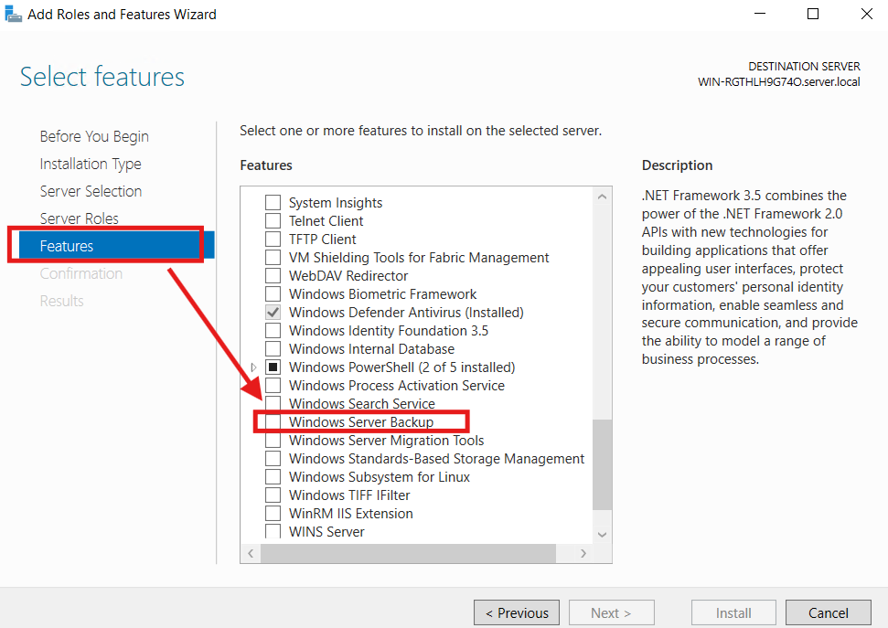

We can navigate it from tools or by searching
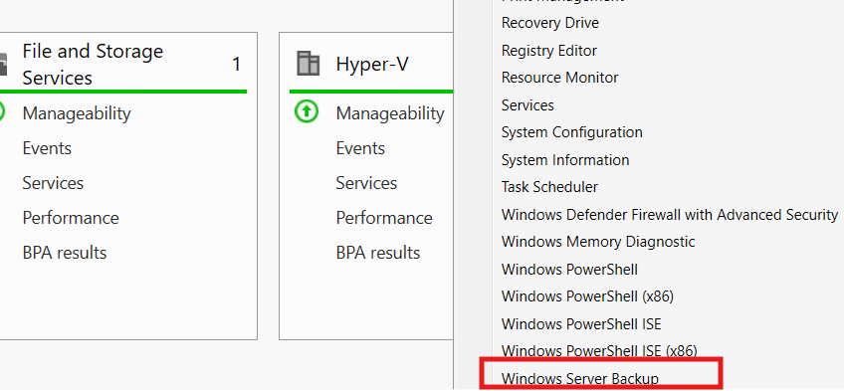
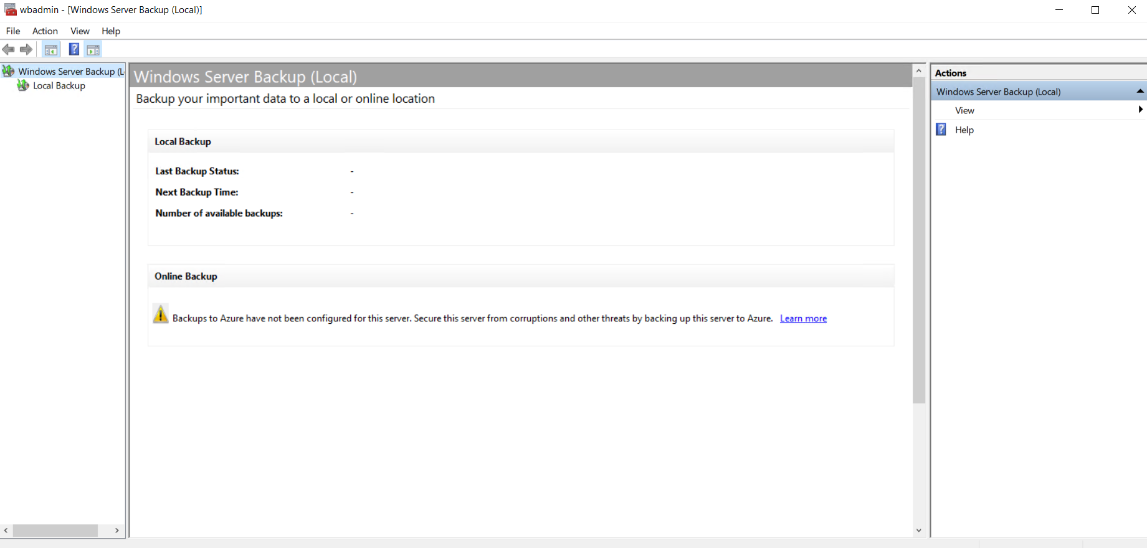

We have multiple options of operating to choose from
- Backup Schedule: scheduled backup
- Backup once: immediate backup (manual)
- Recovery
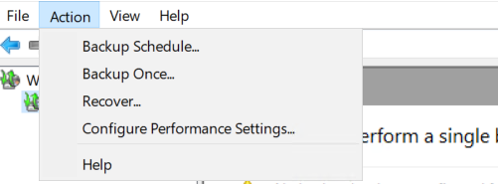

Backup Schedule:
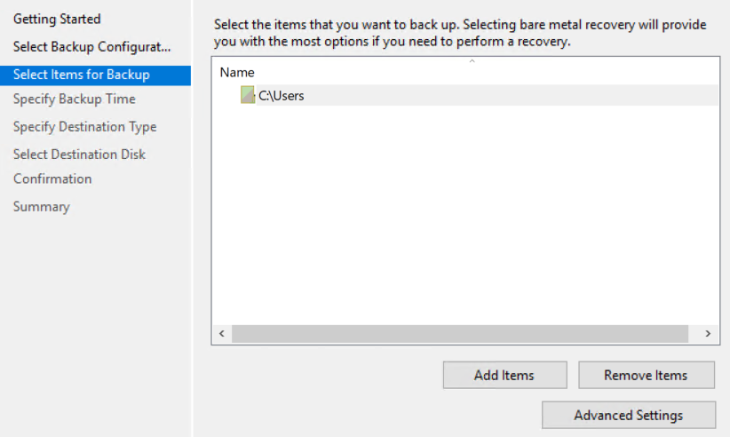
In this operation we can define what time we want the backup to run and the period between the backup and another and other options like the destination and what we want to take back up for
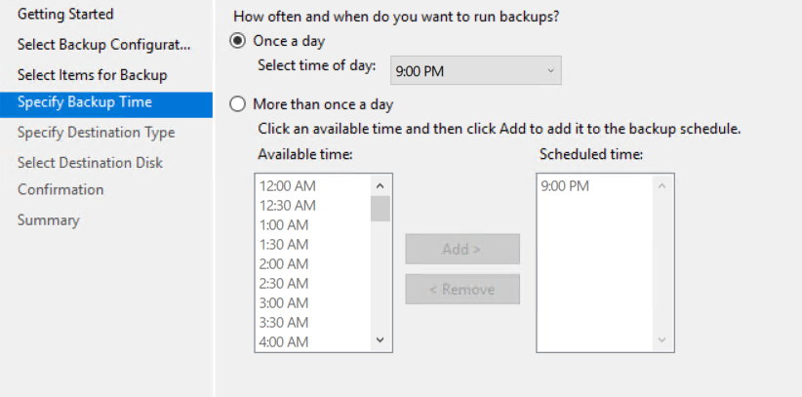
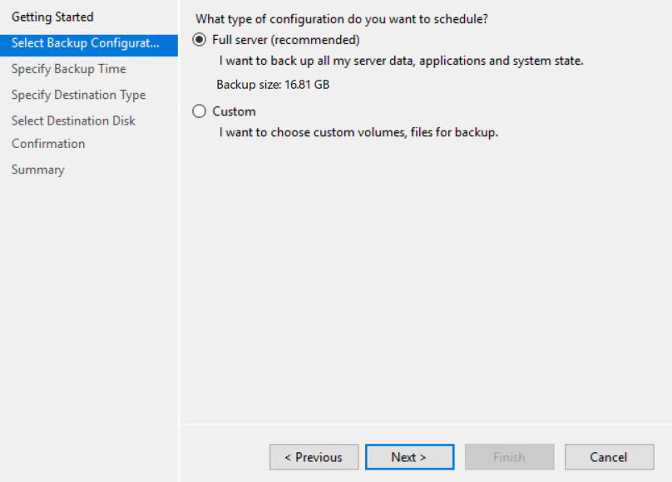
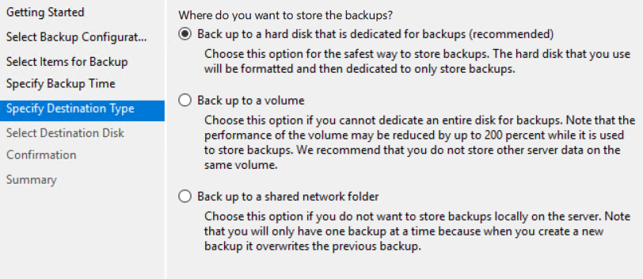

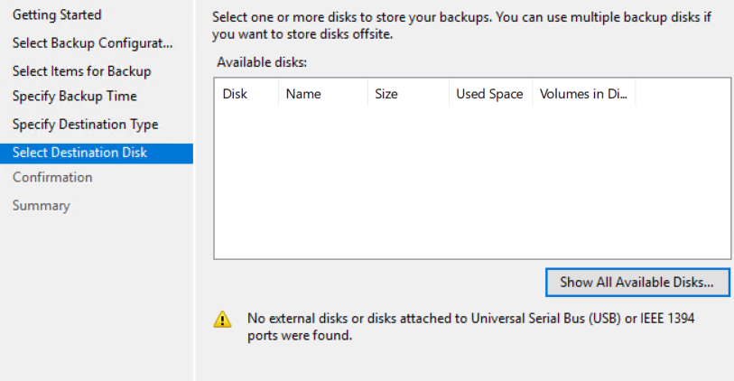
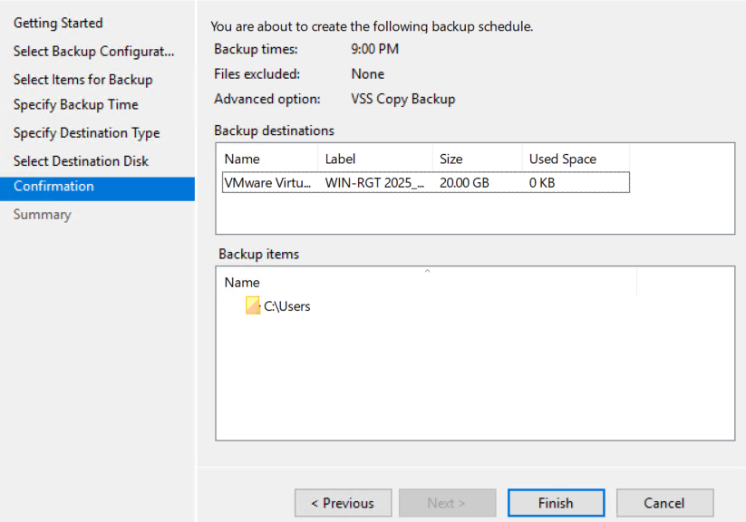

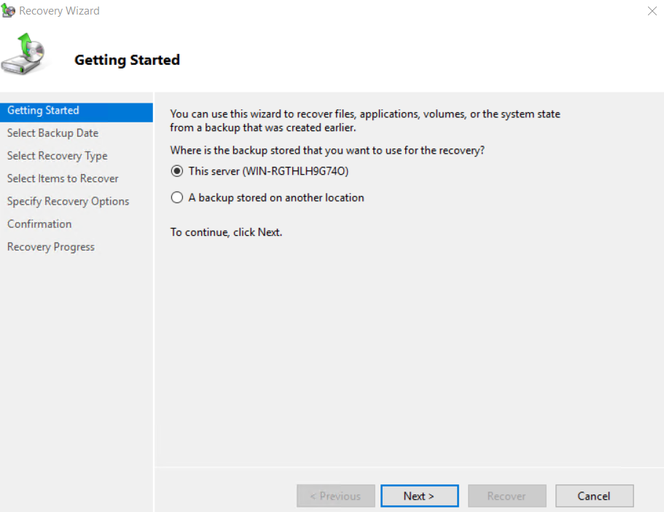
Recovery:

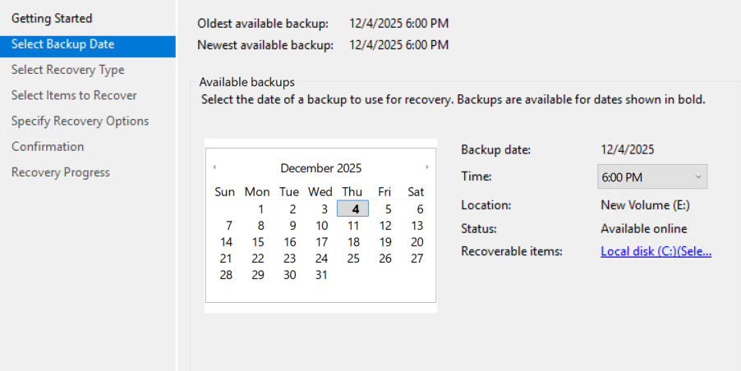

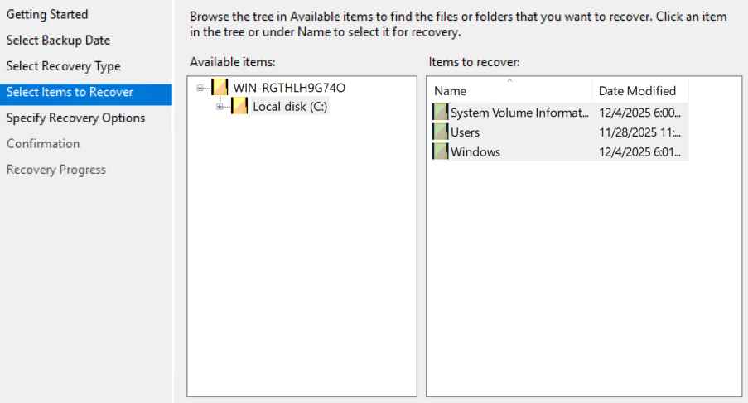
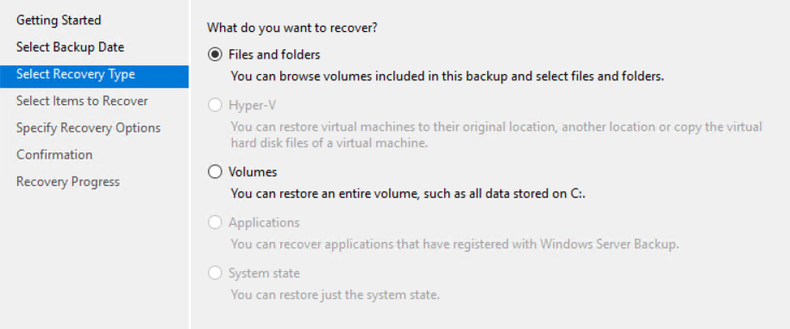

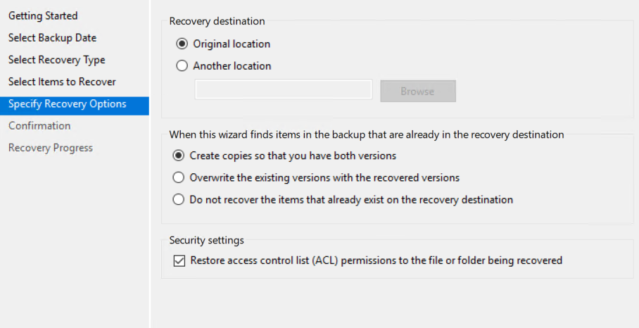

12

DHCP
We can download this role from server manager so we can work with it
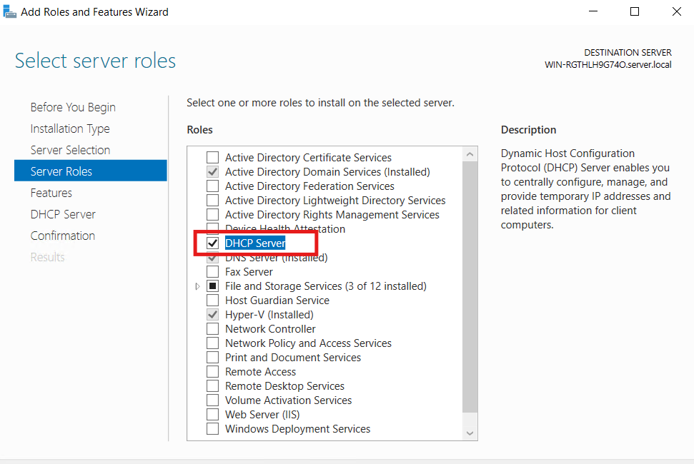

After installation is completed, we must finish configurations
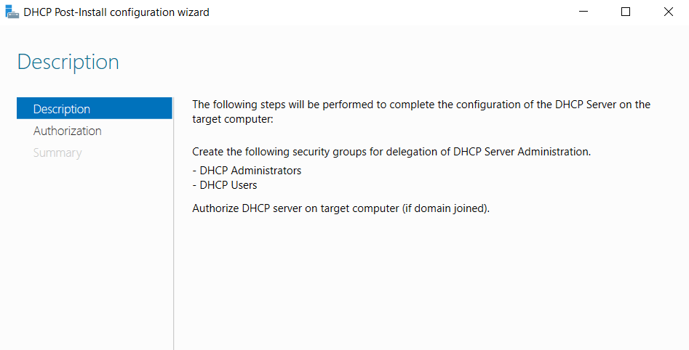
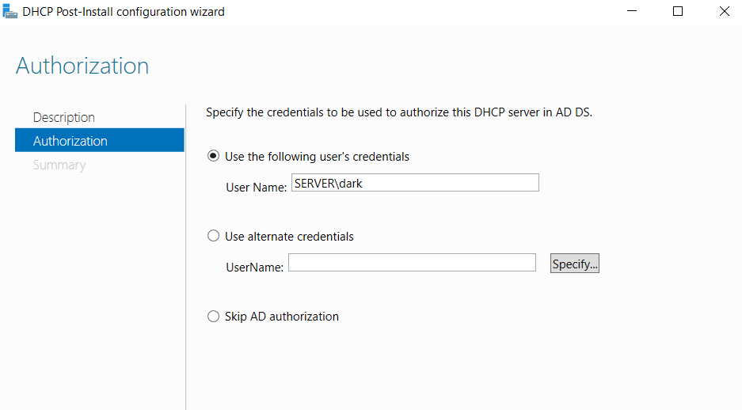

This screen is asking which user account should authorize the DHCP server in Active Directory, because only authorized servers are allowed to give IP addresses in a domain.
Authorization prevents rogue DHCP servers from handing out IPs and breaking the network.

We can navigate the DHCP service window using the tools in the server manager

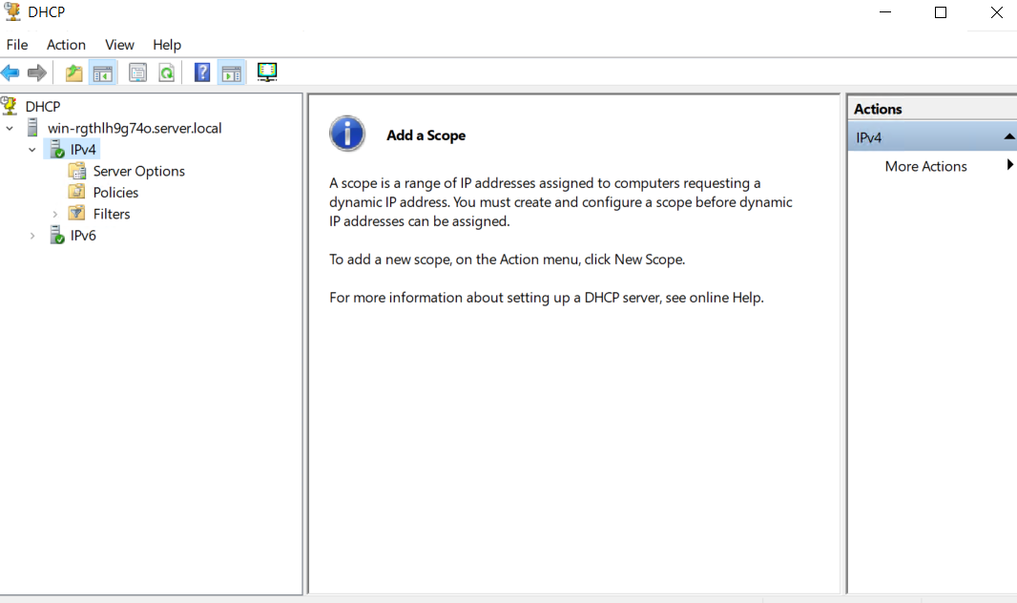

Server Options: These are global DHCP options that apply to every scope on the DHCP server unless a scope overrides them.
Think of them like default settings for all clients.
Examples:
- DNS server for all scopes
- Default gateway
- Domain name

Policies
DHCP Policies let you apply DHCP settings only to specific types of clients, based on rules you choose.
They are basically conditional DHCP rules.
Examples of policies:
- Give IPs from a different range to laptops vs servers
- Apply different DNS options to devices by MAC prefix
- Assign VoIP phones their own gateway and VLAN
- Give longer lease time to domain-joined machines

How to make a scope:

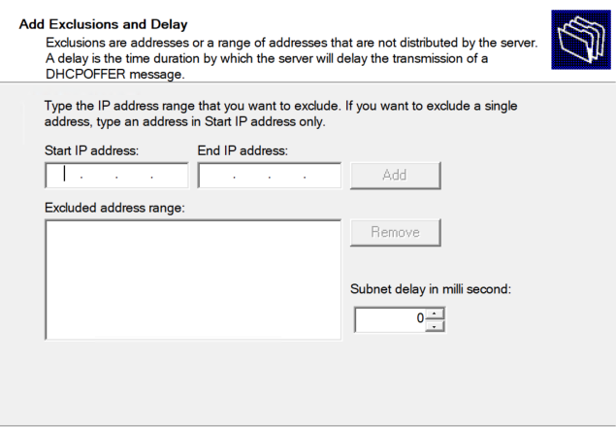
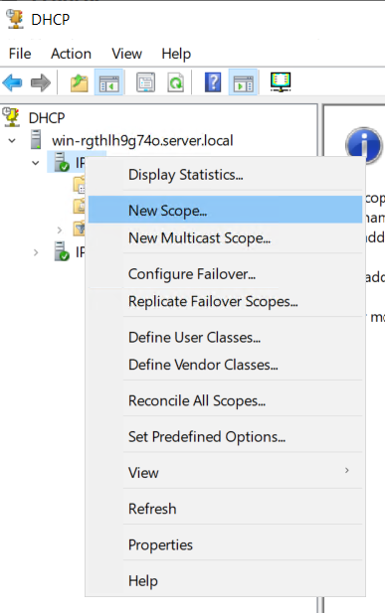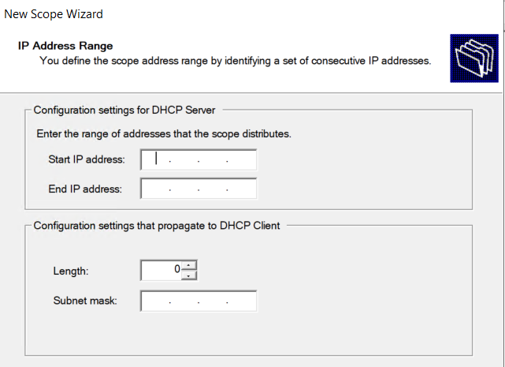
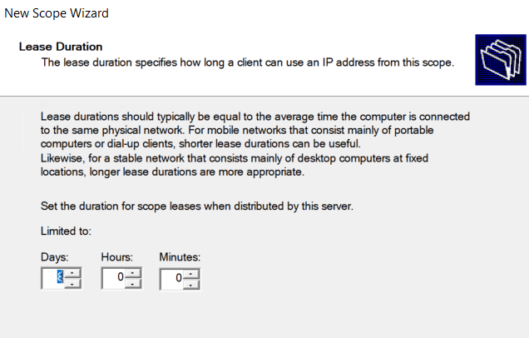

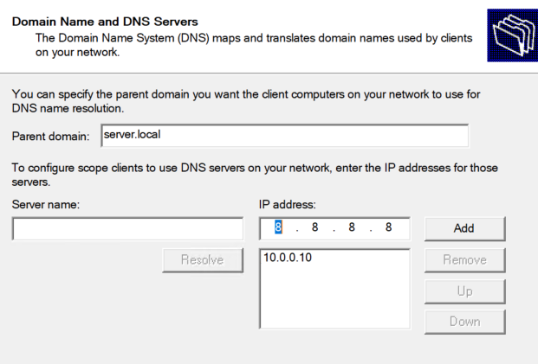
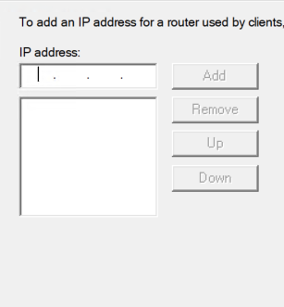
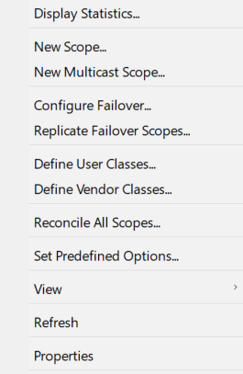
What we can also do:

Configure Failover…
Used to set up DHCP redundancy between two DHCP servers.
Why?
If one server dies, clients can still get IP addresses.
Two modes:
- Load Balance: Both servers share 50/50 workload
- Hot Standby: One active, one backup

Replicate Failover Scopes
Copies all scope settings from the primary DHCP server to the partner in a failover relationship.
Useful when:
- You update a scope
- You add reservations
- You change options
Ensures both DHCP servers stay in sync.

Define User Classes: Allows DHCP to treat some devices differently based on a class identifier.
Use cases:
- Separate settings for laptops vs desktops
- Special config for guests
- Different DNS for management devices
Clients must send a user-class ID to match this.

Define Vendor Classes: Used to target DHCP options to specific vendors.
Examples:
- Cisco IP phones
- Microsoft devices
- PXE boot devices
- VoIP equipment
Perfect when you want DHCP to configure vendor-specific info (e.g., option 150 for Cisco phones).

Reconcile All Scopes: Fixes mismatches between:
- The DHCP database
- The actual scope state
Used when:
- DHCP service crashes
- Server was restored
- Database becomes inconsistent
It ensures DHCP’s internal database is correct.

Set Predefined Options: Lets you add custom DHCP options not included by default.
Examples:
- Option 66 / 67 for PXE booting
- Option 150 for Cisco VoIP
- Option 43 for WiFi controllers
Advanced admins use this for special equipment.

14

DNS
Things to know about DNS

DNS uses the port 53 in both TCP UDP

The Core DNS Query Types

- Recursive Query: The client tells the DNS server: “Give me the final answer — no referrals, no excuses.”
The DNS server must fully resolve the name or return an error.
- Iterative Query: The DNS server replies: “I don’t have the final answer, but here’s a DNS server closer to the truth.”
It returns referrals instead of resolving everything.

Other types

Non-Recursive Query: The client/server says: “Don’t perform recursion — answer only if you already know it.”
If not known, the server returns a referral, not a final answer.

Reverse Lookup (PTR Query): Resolves an IP address back into a hostname using the reverse lookup zone, used for logging, email verification, and troubleshooting.

Truncated Query (TC Flag): Happens when a DNS response is too large to fit in UDP packets, The client retries the query using TCP with full data.

DNS Zones in Windows Server
This is a critical MCSA topic — include all of these:
Primary Zone
- Holds the original read-write copy of the dataset.
- Administrators can create, edit, and delete records.
- Stored as a DNS file (.dns) unless AD-integrated.
Secondary Zone
- Read-only copy of another server’s zone.
- Obtains data via zone transfer (AXFR / IXFR).
- Used to reduce WAN load or provide redundancy.
Stub Zone
- Contains only three record types: SOA, NS, and glue A records.
- Used for fast referral to authoritative servers.
- Excellent for multi-site companies.
Active Directory–Integrated Zone
- Stores DNS data inside Active Directory (NTDS.dit).
- Supports multi-master replication.
- Secure dynamic updates are available.

DNS Zone Transfers (Simplified for MCSA)
DNS zone transfers keep DNS data synchronized between a Primary DNS server and one or more Secondary DNS servers. The Secondary holds a read-only copy of the zone and updates it from the Primary.

Why Zone Transfers Are Needed
- Provide redundancy if the primary DNS server fails.
- Distribute DNS load across multiple servers.
- Keep DNS records consistent across locations.

How Zone Transfers Work
- The Secondary periodically checks the SOA serial number.
- If the serial changed, it requests updated data from the Primary.
- Updates are sent using AXFR or IXFR.

Types of Zone Transfers
AXFR – Full Zone Transfer
- Transfers the entire zone file.
- Used for new secondary zones or when incremental transfer isn’t available.
IXFR – Incremental Zone Transfer
- Transfers only the changes since the last update.
- More efficient and faster than AXFR.

What Triggers a Zone Transfer
- Change in SOA serial number.
- Secondary server refresh interval.
- Manual "Transfer from Master" command.
- DNS NOTIFY (primary tells secondaries that changes happened).

Security of Zone Transfers
- Should be allowed only to specific IP addresses.
- Prevents attackers from downloading your entire DNS zone.
- AD-integrated zones use Active Directory replication instead of zone transfers.

DNS Resource Records (RRs)
Resource Records are the individual entries inside a DNS zone. Each record holds specific information about hosts, services, or the zone itself. Windows Server relies on these records for name resolution and Active Directory functionality.

Common DNS Record Types

A Record (Address Record): Maps a hostname to an IPv4 address.
Example: server01 → 192.168.1.10

AAAA Record: Maps a hostname to an IPv6 address.
Used in modern networks alongside A records.

CNAME Record (Canonical Name): Creates an alias for another hostname.
Useful when multiple names point to the same server.

PTR Record (Pointer Record): Used for reverse lookup: IP → hostname.
Stored in reverse lookup zones.

MX Record (Mail Exchange): Specifies the mail server responsible for receiving emails for a domain, Often set with priority values.

NS Record (Name Server): Identifies the authoritative DNS servers for the zone.
Stored in both forward and reverse zones.

SOA Record (Start of Authority): Defines the main server for the zone and contains settings like:
Serial number, Refresh interval, Retry interval, Expire time, Default TTL

SRV Record (Service Locator): Maps service names to the servers that provide them, Critical for Active Directory (e.g., locating domain controllers).
Example: _ldap._tcp.dc._msdcs.domain.local

TXT Record
Stores text information such as verification keys, SPF records, or security configurations.

6.2 Which Records Matter Most in Windows Server
For MCSA-level understanding:
- A, AAAA, and CNAME → standard name resolution
- PTR → reverse lookup and logging
- SOA and NS → zone structure
- SRV → Active Directory operations
- MX → email routing
- TXT → cloud verification and SPF

The DNS role is automatically while installing AD
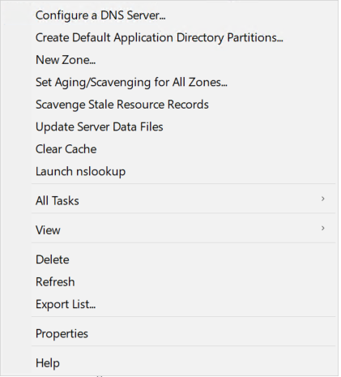
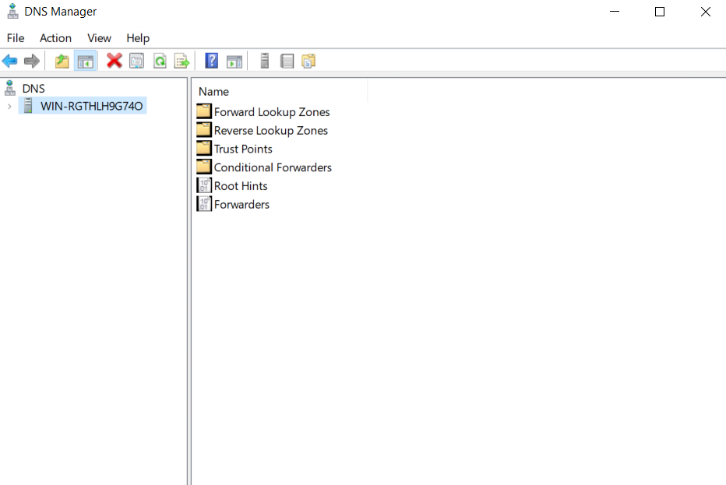
What we can do on the DNS server
1. Configure a DNS Server: A wizard that helps you set up:
- Forwarders
- Root hints
- Basic zone configuration
Useful after initial installation.

2. Create Default Application Directory Partitions; Creates DNS partitions in Active Directory for:
- ForestDNSZones
- DomainDNSZones
These partitions store AD-integrated DNS zones and replicate across DCs.
Most admins never touch this manually unless you're fixing replication problems.

3. New Zone: Creates a top-level DNS zone, not a child zone.
This is NOT what you want for proxmox.server.local.

4. Set Aging/Scavenging for All Zones: Controls automatic cleanup of old DNS records.
- “Aging” = mark old records
- “Scavenging” = delete stale records
Used to prevent DHCP environments from filling DNS with junk.

5. Scavenge Stale Resource Records: Manually trigger a scavenging run.
Useful while troubleshooting DHCP/DNS cleanup.

6. Update Server Data Files: For Standard Primary zones (file-based, not AD-integrated).
Forces DNS to write the latest changes to the .dns files on disk.
AD-integrated zones do this automatically.

7. Clear Cache: Clears the DNS server’s cache (not client cache).
Good for testing — forces DNS server to re-query authoritative sources.

8. Launch nslookup: Opens the nslookup tool directly from DNS Manager.
Useful for quick testing.

9. All Tasks: Contains advanced options like:
- Restart DNS service
- Pause/resume zones
- Reload server data

10. View: Controls what is displayed in DNS Manager (advanced mode, filtering, etc.)

11. Export List…: Exports all visible items to a text file or CSV.
Useful for documentation or audits.

12. Properties: Shows configuration for:
- Forward lookup zones container
- Server settings (if clicked on server name)

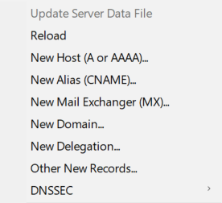
What we can do to the zone

1 New Host (A or AAAA)
Used to map: Name → IP (A record)

2 New Alias (CNAME): Creates a pointer to another DNS name.
vpn → firewall.server.local

3 New Mail Exchanger (MX): Adds an MX record for email servers.
server.local mail handled by: → mail.server.local (priority 10)
Used only if you run a mail server (Exchange, Postfix, etc.)

4 New Domain: This is the child zone creator, Creates a zone INSIDE a zone:
server.local
└── proxmox
Which becomes: proxmox.server.local

5 New Delegation: Used when you want another DNS to manage a child zone.
proxmox.server.local is managed by DNS server at 192.168.0.20
You would create delegation if:
- You have many DNS servers
- You want subdomains to be controlled by different teams
- You’re designing enterprise-level DNS architecture
6 New Records: This is the advanced record menu.
Here you can create:
- PTR (reverse lookup)
- SRV (services like LDAP, Kerberos, SIP)
- TXT (SPF, DKIM, verification)
- NS records
- SOA changes
- NAPTR (rare)
- CERT, etc.
For example, SRV records for Active Directory:
_ldap._tcp.dc._msdcs.server.local
TXT records for cloud services:
google-site-verification=xxxxx

7 DNSSEC: Advanced DNS security settings such as:
- Zone signing
- Key management
- Trust anchors
Not required for homelab unless you're doing DNSSEC experiments.

DNS server properties
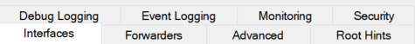
Interfaces: Controls which network interfaces the DNS server listens on.
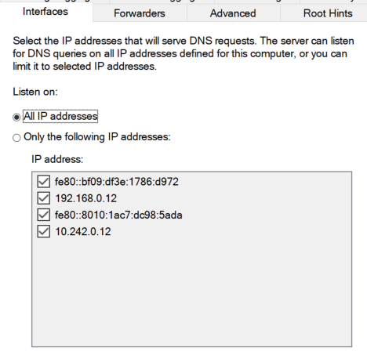
Options:
- All IP addresses (default)
- Only the following IP addresses

Forwarders: Defines where your DNS server sends queries it cannot resolve.
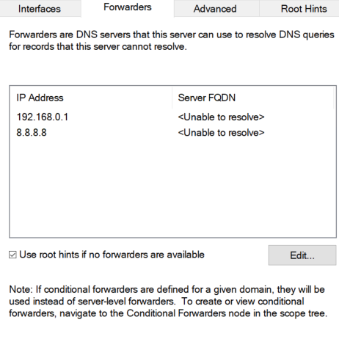
Advanced: This tab contains powerful behavior settings.
Key options (summarized clearly):
✔ Enable round robin If multiple A records exist → DNS rotates responses for basic load balancing.
✔ Enable netmask ordering: Clients receive the closest network IP first.
✔ Secure cache against pollution: Prevents malicious or fake DNS data from entering cache, ALWAYS keep this enabled. (Security best practice)
✔ Disable recursion: Turns off DNS recursion:
If recursion is OFF → server will not query forwarders or root hints.
✔ BIND secondaries
Allows compatibility with BIND-style secondary DNS servers.
✔ Fail on load; If a zone fails to load, DNS server logs an event and stops the zone.
Mostly for troubleshooting.
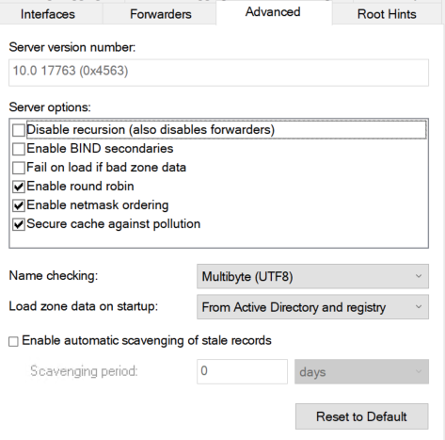
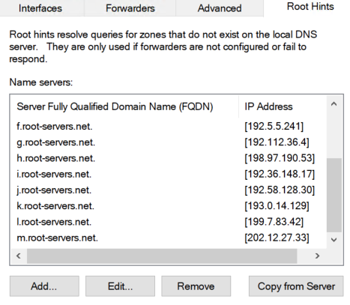
Root Hints:
contains the list of public internet root DNS servers.
Used ONLY when:
- No forwarders exist
- Server needs to resolve internet names
- Recursion is enabled
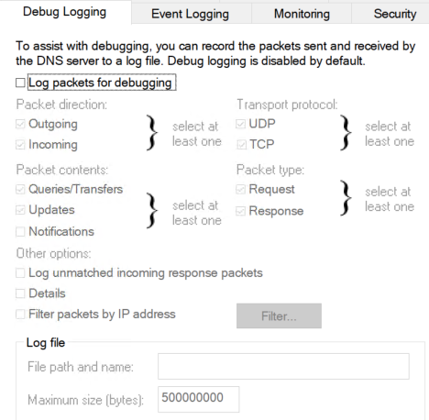
Debug Logging: FULL detailed DNS query logging.
Logs:
Incoming queries, Outgoing queries,
Zone transfers, Packet details
Used for:
Troubleshooting, Security investigations
Warning: This can generate large logs.

Event Logging: Controls how much DNS information appears in Windows Event Viewer.
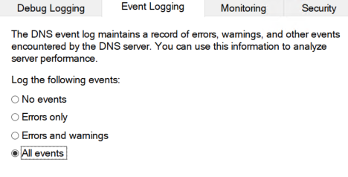
Levels:
- No events
- Errors only
- Errors + warnings
- All events (most detailed)
Use standard: Errors & warnings

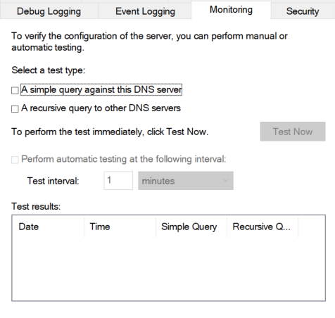
Monitoring:
Tests whether your DNS server is working correctly.
Two tests:
Simple query: Tests if DNS answers from cache.
Recursive query: Tests if DNS can resolve external names
Green = Good
Red = DNS resolution problem
Useful quick health check.

Security: Controls ACLs (permissions) on the DNS server.
You can grant/deny:
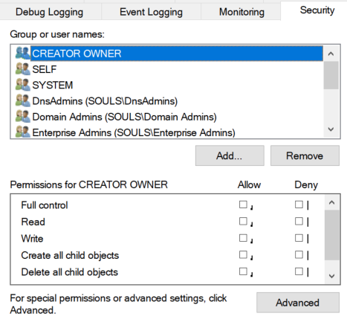
- Read
- Write
- Create child objects
- Manage DNS zones
Applies mostly in large AD environments:
- DNS Admins
- Domain Admins
- Read-only DNS servers
In small labs, you rarely touch this tab.

Zone operations
General Tab: This is the “identity card” of the zone.
Contains:
✔ Zone Type
- Primary Zone
Stored locally (file or AD-integrated). You can edit it.
- Secondary Zone
Read-only copy of another DNS server’s zone.
- Stub Zone
Contains only NS + SOA + A records for the authoritative server.
✔ Status: Running or paused.
✔ Replication Scope (for AD-integrated zones)
- To all DNS servers in the forest
- To all DNS servers in the domain
- To all domain controllers in the domain
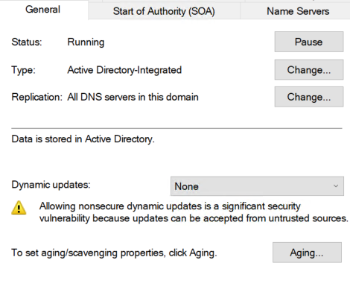
- Controls how widely the zone replicates inside Active Directory.
✔ Dynamic Updates
- None
- Nonsecure and secure
- Secure only (recommended in AD)

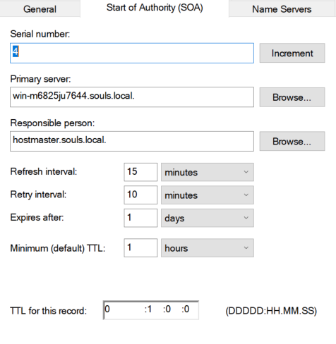
Start of Authority (SOA) TabThe SOA record defines the official “parent” DNS server and replication instructions.

✔ Serial Number:
Used by secondary DNS servers to detect updates.
Each change increments this.
✔ Primary Server: The master DNS server for this zone
✔ Responsible Person: Used historically for admin email.
✔ Refresh Interval: How often secondary servers check for updates Typical:1 hour
✔ Retry Interval: If the refresh check fails, retry after: 10 minutes
✔ Expiry: If no contact with primary server for this long, zone becomes invalid.
✔ Minimum TTL: Default TTL for negative responses.
In short: SOA controls how DNS servers sync and how long cached results live.
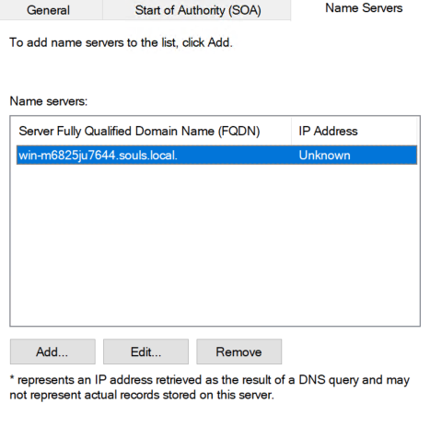
Name Servers Tab:
Lists all authoritative DNS servers for this zone.
Each entry includes: Server hostname, IP address
This is where you define redundant DNS servers.
Why important?
- Multi-DNS environment
- Load balancing
Redundancy
If a server is missing from this list, clients may not discover it properly.
WINS Tab
Used only for legacy NetBIOS name resolution.
If enabled, DNS queries can be forwarded to a WINS server to resolve:
NETBIOSNAME → IP
Modern networks rarely use this anymore — but still appears for backward compatibility.
If you don’t have old Windows 98/2000 machines → disable it.

Zone Transfers Tab: Controls how and if this zone can be transferred to other DNS servers.
Options:
✔ None: No DNS server can copy this zone.
(Default for AD-integrated zones)
✔ Only to servers listed on the Name Servers tab
✔ To specific IP addresses: Allows a custom list of secondary DNS servers.
Used for:
- High availability
- Load balancing
- Secondary DNS servers (Linux BIND, etc.)
This tab is critical if you ever build multi-site DNS.

Security Tab: Controls permissions on the zone, not the DNS server.
ACLs can allow/deny:
- Creating records
- Editing records
- Deleting records
- Reading records
- Controlling the zone
Common principals:
- Authenticated Users
- DNS Admins
- Domain Admins
- SYSTEM
This tab matters a lot in Active Directory, especially with Secure Dynamic Updates.

15

Group Policy GPO

1.1 What is Group Policy: Group Policy is a centralized management technology in Windows Server that allows administrators to define, enforce, and control configuration settings for: Users, Computers, Applications, Security policies
All from one place, across the entire domain.

1.2 Why Group Policy Exists (The Real Reason)
Without GPO:
- Users change system settings
- Security becomes inconsistent
- Admins manually configure machines
- Troubleshooting becomes chaos
With GPO: Standardization, Security enforcement, Automation, Scalability

2.1 Core Components: Group Policy consists of two main parts:
2.1.1 Group Policy Container (GPC)
- Stored in Active Directory
- Contains: GPO name, Version number, Links (OU, Domain, Site)
- Used by AD to locate the GPO
Stored in AD database

2.1.2 Group Policy Template (GPT)
- Stored in SYSVOL
- Contains: Actual policy settings, Scripts, Administrative Templates (ADMX)
Path: \\domain\SYSVOL\domain\Policies\{GUID}
👉 If SYSVOL replication is broken, GPOs break. Period.

3.1 GPO Scope Levels
GPOs can be applied at four levels: Local, Site. Domain, Organizational Unit (OU)

3.2 Processing Order (LSDOU Rule)
This must be memorized:
Local → Site → Domain → OU
- Last applied policy wins
- OU policies override Domain policies
- Domain policies override Site policies

4.1 What is a GPO?
A GPO is a collection of policy settings that can be:
- Linked to a Site
- Linked to a Domain
- Linked to an OU

4.2 Default GPOs (Know These)
- Default Domain Policy
  - Password policy
  - Account lockout policy
  - Kerberos policy
⚠️ Best practice:
Do NOT put random settings here.

- Default Domain Controllers Policy
  - Security settings for DCs
  - User rights assignments
  - Audit policies

  - Computer Configuration
Applies to: The machine, Before user login
Examples:
Firewall rules, Windows Update settings, Services configuration, Security baselines

5.2 User Configuration
Applies to: The user account, After login
Examples:
Desktop restrictions, Folder redirection, Login scripts, Control Panel restrictions

6.1 When GPOs Apply
- At system startup
- At user login
- Background refresh every 90 minutes (+ random offset)

6.2 Force Update
Command: gpupdate /force

6.3 Resultant Set of Policy (RSoP)
Shows what policies actually applied.
Tools:
- rsop.msc
- gpresult /r
- Group Policy Modeling (GPMC)

7.1 GPO Links
- One GPO → multiple OUs
- Multiple GPOs → one OU
Order matters.

  - Enforced (No Override)
Forces GPO to apply, Lower-level OUs cannot override
Use sparingly (this is a hammer).
7.3 Block Inheritance
- Prevents parent GPOs from applying
- Enforced GPOs still apply

8.1 Security Filtering
Controls who the GPO applies to.
Uses: Users, Computers, Groups
Permissions required: Read, Apply Group Policy

8.2 WMI Filtering
Controls where the GPO applies.
Examples:
- Windows version, Laptop vs Desktop, RAM size
Example WMI:
SELECT * FROM Win32_OperatingSystem WHERE Version LIKE "10.%"
⚠️ Overuse = slow logins.

9.1 What Are Administrative Templates (ADMX) Files?
- Define policy settings
- Control registry-based policies
Stored in:
- Central Store (recommended)
\\domain\SYSVOL\domain\Policies\PolicyDefinitions
9.2 Registry vs Policy
- Policy setting → enforced
- Preference setting → configurable, user-changeable

10. Group Policy Preferences (GPP)
Used for:
Drive mapping, Printers, Registry keys, Scheduled tasks, Environment variables
Preferences do not enforce — users can change them.

11. Scripts in Group Policy
Types:
Startup scripts, Shutdown scripts, Logon scripts, Logoff scripts
Languages:
PowerShell, Batch, VBScript (legacy)

12.1 Common Problems
- SYSVOL not replicating
- Wrong OU placement
- Block inheritance misused
- Security filtering wrong
- Slow login due to WMI filters

12.2 Troubleshooting Tools
- gpresult /h report.html
- Event Viewer:
  - GroupPolicy
  - System
- GPMC → Group Policy Results

13. Best Practices (Real-World)
- One purpose per GPO
- Clear naming convention
- Avoid Default Domain Policy edits
- Use OUs correctly (no “Users” and “Computers” container)
- Test in lab before production
- Document everything (you’re doing this right now)

14. Practical Lab Ideas (Highly Recommended)
Add a Lab Section in your document:
- Disable Control Panel via User GPO
- Enforce password policy
- Map network drive using GPP
- Deploy a firewall rule
- Use security filtering for IT group only
- Test RSoP output
How to navigate it
We can navigate it either by search or by Run

By search: group Policy Management
By Run: gpmc.msc
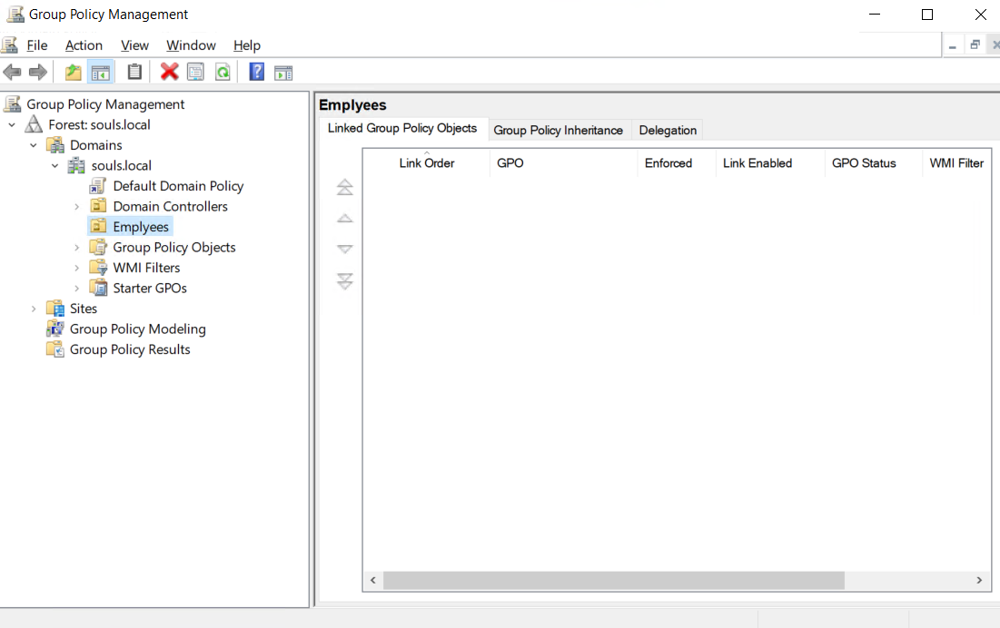

1. Forest: souls.local: This is the highest logical boundary you’re working in.
- A Forest is the top-level AD container
- Can contain:
  - Multiple domains
  - Multiple trees
  - Trust relationships
In most environments (and labs), you manage GPO per domain, not per forest.
Think of the forest as the country, domains as cities.

2. Domains: This node lists all domains inside the forest.
Each domain has:
Its own users, Its own computers, Its own GPOs, Its own security boundaries
You usually work inside one domain, not here.

3. souls.local (The Domain Node): This is where real GPO work happens.
Everything under this node affects all domain members unless filtered or blocked.

3.1 Default Domain Policy: This is a special system GPO.
Used for:
- Password policy, Account lockout policy, Kerberos policy
Hard rule (write this in bold in your document):
Do NOT put random policies here , Why?
- It affects every user and computer
- Microsoft assumes it contains only security baseline settings

3.2 Domain Controllers: This is an Organizational Unit (OU).
Contains:
- All Domain Controllers: Only DCs should live here (nothing else)
Linked to:
- Default Domain Controllers Policy
Used for:
DC security, User rights assignments, Audit policies, Logon rights
Treat this OU like a restricted military zone.

3.3 Employees (Custom OU): This is your design, not Microsoft’s.
Purpose:
- Logical grouping of users and/or computers
- Targeted GPO application
GPOs should be linked here, not at the domain level whenever possible.

3.4 Group Policy Objects: This is the GPO storage warehouse.
Important concept:
- GPOs live here
- They do nothing until linked
You can:
- Create new GPOs
- Edit GPOs
- Backup / restore GPOs
- Copy GPOs
- Delegate permissions
📌 A GPO here is like a loaded gun with the safety on — harmless until linked.
3.5 WMI Filters: Used for conditional GPO application.
Allows GPOs to apply only if:
- OS version matches
- Hardware conditions match
- Laptop vs desktop
- RAM size
- Architecture (x86 / x64)
Example:
Apply this GPO only to Windows 10
Warning:
- WMI filters slow login
- Overuse = bad user experience
Use only when security filtering isn’t enough.

3.6 Starter GPOs: Templates for creating standardized GPOs.
Purpose:
- Enforce consistency
- Speed up GPO creation
- Reduce human error
Used in:
- Enterprises
- Baseline security deployments
You don’t link Starter GPOs.
You create new GPOs from them.

4. Sites: Based on Active Directory Sites and Services.
Used for:
- Physical network locations
- WAN optimization
- Branch offices
Rarely used for GPO unless:
- Large enterprise
- Multiple geographic locations
Most admins never touch this in small/medium environments.

5. Group Policy Modeling: This is simulation mode.
Used for:
- “What if” scenarios
- Planning changes safely
- Predicting policy results
You can simulate:
- User
- Computer
- OU
- Security filtering
- WMI filtering
No changes are applied.
This is pure theory testing.

6. Group Policy Results: This is reality mode.
Shows:
- What policies actually applied
- What was denied
- Why something didn’t apply
Under the hood:
- Uses RSoP data
- Pulls info from the target machine
This is your first stop when troubleshooting GPO issues.

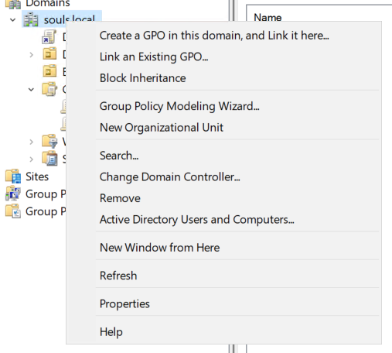
Domain Right-Click Menu (Simple Explanation)

Create a GPO in this domain, and Link it here
- Creates a new policy
- Applies it to everyone in the domain
Use only for policies that must affect all users & computers
Otherwise, use OUs

Link an Existing GPO
- Takes a GPO you already made
- Applies it to this domain
Safe if you know exactly what the GPO does

Block Inheritance
- Stops parent policies from applying
Enforced policies still apply
Used to protect special OUs, not for random fixes

Group Policy Modeling Wizard
- Simulates what policies would apply
- Makes no real changes
Use before deploying risky GPOs
New Organizational Unit
- Creates an OU
- Best place to apply GPOs
This is where good GPO design starts

Active Directory Users and Computers
- Opens ADUC from here
Just a shortcut

OU Right-Click Menu
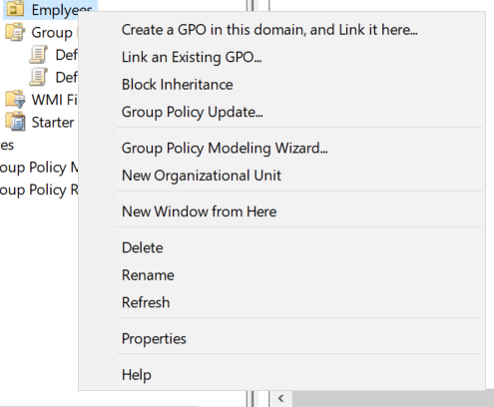

Group Policy Update
- Forces GPO update on all computers in this OU
- Same as running gpupdate /force
Use after changing a GPO
Can slow machines for a moment

Properties
- Shows:
  - Linked GPOs
  - Order
  - Inheritance
Use to check why a policy applies or not

New Organizational Unit
- Creates a child OU
- Helps organize users and apply targeted GPOs
Core of good GPO design

Group Policy Objects – Right Click (Simple)

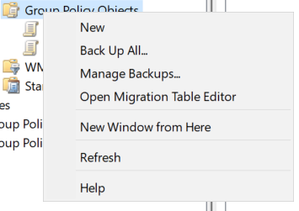
New
- Create a new GPO
- Not applied yet

Back Up All…
- Save all GPOs
Do before big changes

Manage Backups…
- Restore broken or deleted GPOs

Open Migration Table Editor
- Used when moving GPOs to another domain
Advanced, usually ignored

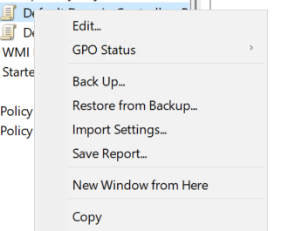
Single GPO – Right Click (Simple)

Edit
- Opens GPO editor
- Where you configure policies
This is the “work” button

GPO Status
- Enable / Disable:
  - Computer settings
  - User settings
Use when:
- You need only one side
- You want to stop part of the GPO

Back Up… Backup this GPO only
Do before editing important policies

Restore from Backup… Replace current GPO with a backup
Overwrites current settings

Import Settings… Copy settings from another GPO
Fast way to reuse configurations

Save Report… Export GPO settings (HTML / XML)
For documentation and audits

Copy Duplicate this GPO
Safe way to test changes

Group Policy Management Editor

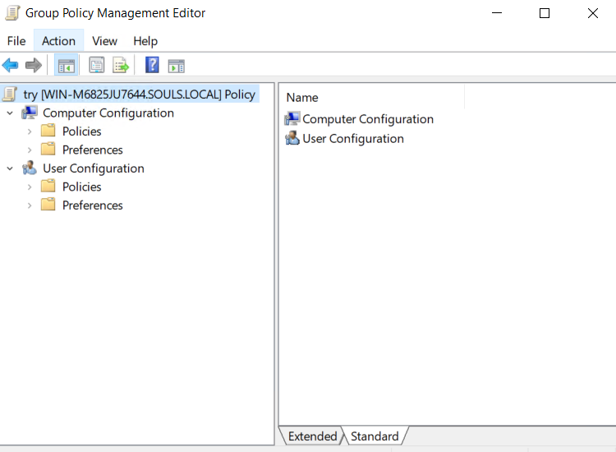

Computer Configuration
- Applies to the computer
- Runs before user login
Use for:
- Security settings
- Windows Update
- Firewall
- Services

User Configuration
- Applies to the user
- Runs after login
Use for:
- Desktop restrictions
- Control Panel limits
- Scripts
- User environment

Policies
- Enforced settings
- User cannot change them
Real security & control live here

Preferences
- Not enforced
- User can change them later
Use for:
- Drive mapping
- Printers
- Registry tweaks

Very important rule:
If you want to force → use Policies
If you want to assist → use Preferences

One-line memory trick:
- Computer = machine rules
- User = people rules

GPO Sub-Folders

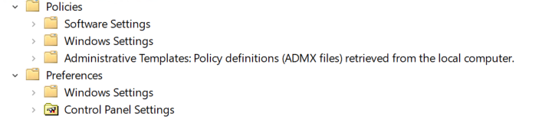

Policies

Software Settings
- Used to deploy software
- MSI-based installations
Rare today, but still exists

Windows Settings
- Core system policies
Includes:
- Security Settings
- Scripts
- Account policies
- Audit policies
This is very important

Administrative Templates
- Registry-based policies
- Most common GPO settings live here
Examples:
- Disable Control Panel
- Windows Update behavior
- USB restrictions
You’ll spend most of your time here

Preferences
Windows Settings
- Helpful, not enforced
Used for:
- Drive mapping
- Registry values
- Scheduled tasks
- Environment variables

Control Panel Settings
- User convenience settings
Examples:
- Printers
- Power options
- Local users (computer side)

Computer Configuration → Sub-Sub Folders (

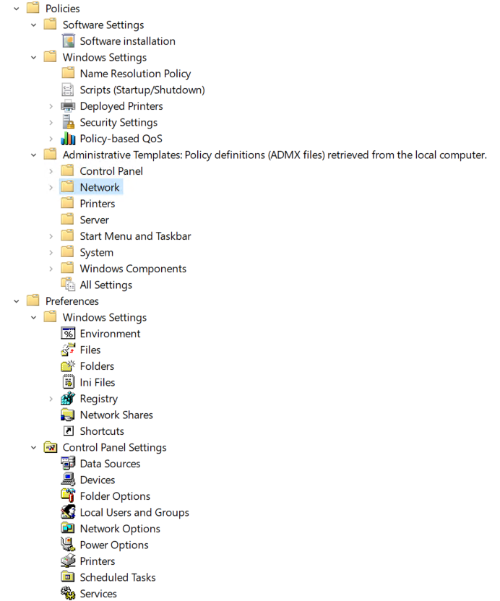

Policies
Software Settings
Software Installation
- Deploy MSI software
- Auto-install on startup
Old but still valid

Windows Settings
Name Resolution Policy
- Controls DNS behavior
- Used with DirectAccess / advanced DNS
Rare in small networks

Scripts (Startup/Shutdown): Run scripts when PC starts or shuts down
Use for:
- Cleanup
- Automation

Deployed Printers: Push printers to computers
Less common today

Security Settings
Used for:
- Password policy
- User rights
- Firewall
- Audit policy
- Local security
This is core sysadmin territory

Policy-based QoS
- Controls network traffic priority
Use for:
- VoIP
- Critical apps
Advanced / enterprise

Administrative Templates

Control Panel
- Restrict Control Panel access

Network
- Network and firewall behavior

Printers
- Printer restrictions

Server
- Server-specific behavior

Start Menu and Taskbar
- UI restrictions

System
- OS-level behavior
- Device access
- Power policies

Windows Components
- Huge section
- Windows Update, Defender, Edge, etc.
You’ll spend a lot of time here

All Settings
- Flat list of all policies
Use for:
- Fast search

Preferences
Windows Settings
- Helpful automation
Includes:
- Environment variables
- Files / folders
- Registry
- Network shares
- Shortcuts
Not enforced

Control Panel Settings
- System configuration help
Includes:
- Local users
- Services
- Scheduled tasks
- Power options
Very useful for automation

User Configuration → Sub-Sub Folders

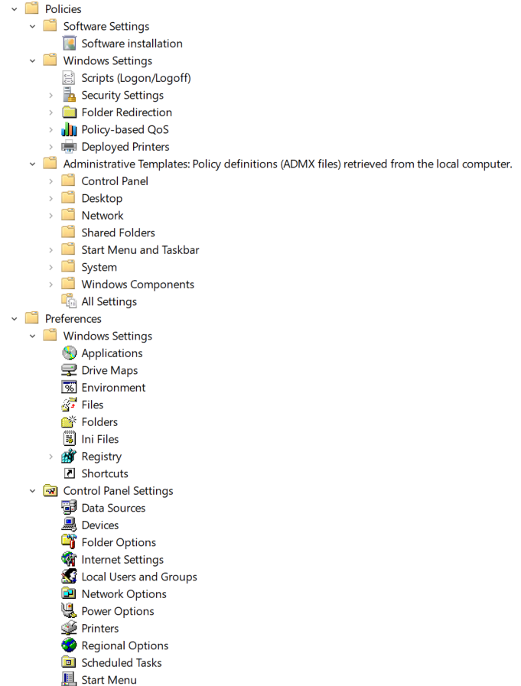

Policies → Windows Settings
Scripts (Logon/Logoff)
- Run scripts when user logs in or out
Use for:
- Mapping drives
- Setting environment stuff

Folder Redirection: Redirects user folders (Desktop, Documents) to a server
Why it matters:
- Central storage
- Easy backup
- Roaming users

Administrative Templates
Desktop
- Control desktop behavior
- Hide icons
- Block wallpaper change

Shared Folders
- Control access to shared folders via UI

Preferences → Windows Settings
Applications
- Configure app settings (not install)

Drive Maps
- Automatically map network drives for users

Preferences → Control Panel Settings
Internet Settings
- Control proxy & browser settings

Regional Options
- Language, time, region settings

Start Menu: Customize Start Menu layout

16

Software Deployment
This policy is in computer policies and user policies

And it’s only work with .msi extension apps

To apply it we should make a policy and add the software installation to the policy

And the path we add should be a network path not a local path
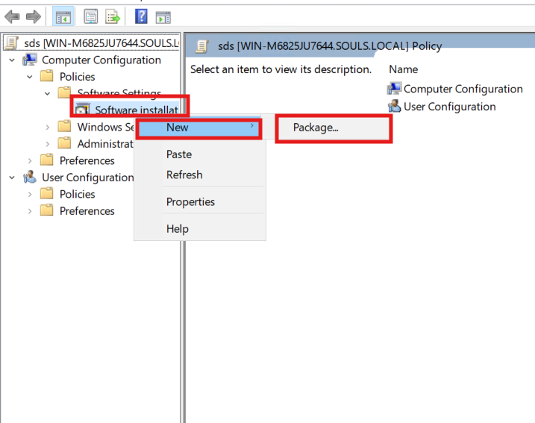
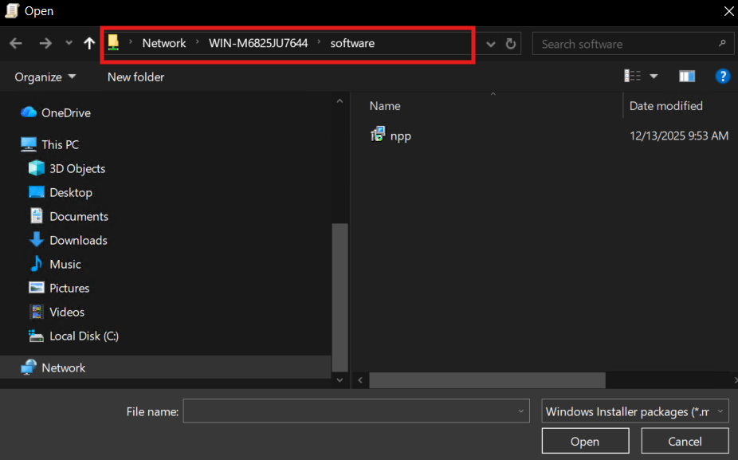

After adding the network path for the app we do the same thing for the user policies
And then we go to the targeted computer and run the command gpupdate /force
And after the restart it will be installed

There are two types of deployment
- Assigned: Install without user integration
- Published: needs the user to install it (only work in user policies)

17

WDS

Windows Deployment Services (WDS)
1) What is WDS: is a Windows Server role that enables network-based OS deployment using PXE boot.
Instead of installing Windows manually from USB/DVD, clients boot from the network, download a boot environment (WinPE), then install Windows from images stored on the server.
WDS is:
- A deployment transport + image storage system.
- Great for deploying Windows at scale (labs, enterprises, schools).

2) Why WDS exists (use cases)
Typical scenarios:
- Deploy Windows 10/11 to many PCs quickly.
- Deploy Windows Server to bare-metal servers.
- Re-image machines after failure or malware.
- Standardize OS builds (same image for everyone).
- Support “zero touch / low touch” deployment when integrated with MDT.

3) Core Concepts (must understand)
3.1 PXE Boot
PXE = Preboot eXecution Environment.
Client uses NIC firmware to boot from network:
- Client broadcasts DHCP Discover (asks for IP + PXE info)
- Receives IP + boot server info
- Downloads a Network Boot Program (NBP) (like wdsmgfw.efi or pxeboot.n12)
- Downloads boot image (WinPE) via TFTP
- WinPE starts, connects to WDS, and installs selected image
Big point: PXE depends on DHCP + TFTP + correct UEFI/BIOS boot files.

3.2 Boot Image vs Install Image (critical difference)
Boot Image
- A WinPE environment (boot.wim)
- Purpose: start the deployment wizard and connect to WDS
- Example source: from Windows ISO: \sources\boot.wim
Install Image
- The actual Windows OS image (install.wim or install.esd)
- Purpose: what gets applied to disk
- Example source: from Windows ISO: \sources\install.wim
If boot image is broken → client won’t reach the deploy wizard.
If install image is missing/invalid → you can boot but can’t install.

3.3 Image Groups
WDS stores install images inside Image Groups.
- Think of it like folders / categories for organization.
- Helps manage multiple OS versions (Win10, Win11, Server 2019, Server 2022).

4) Requirements and Dependencies
4.1 Server requirements
- Windows Server with WDS role installed
- NTFS volume with enough storage (images can be large)
- Stable network access
4.2 Network requirements
- DHCP reachable by clients
- DNS recommended (especially in domains)
- Proper routing if clients are not in the same subnet
4.3 Domain vs Workgroup
- WDS works in Workgroup, but Domain integration is better
- Domain helps with permissions, naming rules, and automation

5) WDS Architecture (How components work together)
WDS main components:
- WDS Server service: controls deployment logic and image management
- TFTP service: used to send boot files during PXE
- WDSPXE provider: responds to PXE clients (the “PXE listener” part)
- RemoteInstall folder: default storage location for boot/install images
Important folder:
- RemoteInstall\Boot\ (boot files and architecture folders)
- RemoteInstall\Images\ (install images grouped)

6) DHCP, PXE Options (what you MUST explain clearly)
Scenario A: DHCP and WDS on the same server
Usually simplest.
- WDS can be configured to not listen on DHCP ports or coexist properly.
Scenario B: DHCP and WDS on different servers (common in real networks)
You must handle PXE info delivery.
Options you’ll see:
Option 66 / 67 (older style – not always recommended)
- Option 66: Boot Server Host Name (WDS server IP/hostname)
- Option 67: Bootfile Name (e.g. boot\x64\wdsnbp.com)
Warning: Option 67 is tricky with UEFI vs BIOS because boot filenames differ.
IP Helper (best practice in routed networks)
On routers/L3 switches you configure IP Helper Address (DHCP relay) pointing to:
- DHCP server
- WDS server (PXE)
This avoids messy options and works better in mixed environments.

7) BIOS vs UEFI (this is where many people fail)
Clients boot differently depending on firmware type:
- Legacy BIOS uses NBP files like wdsnbp.com or pxeboot.n12
- UEFI x64 uses wdsmgfw.efi
- Secure Boot may block unsigned bootloaders in some cases
Best practice: In your documentation, create a small table mapping firmware → boot file.

8) Deployment Types
8.1 Manual / Interactive Deployment
Client boots PXE → chooses image → installs manually (basic lab usage).
8.2 Unattended Deployment
You use an Answer File (unattend.xml) to automate:
- Disk partitioning
- Locale/language
- Product key
- Domain join
- Admin user creation
- Post-install settings
WDS supports unattended files at different stages:
- For WinPE phase (boot phase)
- For OS specialization / OOBE phase (installation phase)
8.3 WDS + MDT (recommended for real enterprise)
WDS provides PXE + WinPE boot.
MDT provides:
- Task sequences
- Driver injection
- App deployment
- Advanced automation and rules
If you want to sound like a pro in your doc, add:
“WDS alone is imaging; MDT turns it into a real deployment framework.”

9) Drivers in WDS (what matters)
WDS can inject drivers into boot images and install images:
- Boot image drivers: mainly NIC + storage drivers so WinPE can see network/disk
- Install image drivers: hardware support after OS installs
Common issues:
- Client boots but cannot connect to WDS → missing NIC driver in boot.wim
- Disk not detected → missing storage/RAID/NVMe driver

10) Security, Control, and Policies
10.1 PXE response settings
You can configure WDS to:
- Respond to all clients
- Respond only to known clients
- Require admin approval for unknown clients
Known clients can be prestaged in AD with GUID/UUID.
10.2 Permissions
- Control who can add images
- Control who can deploy which images

To install it we do that from the role manager and install it.

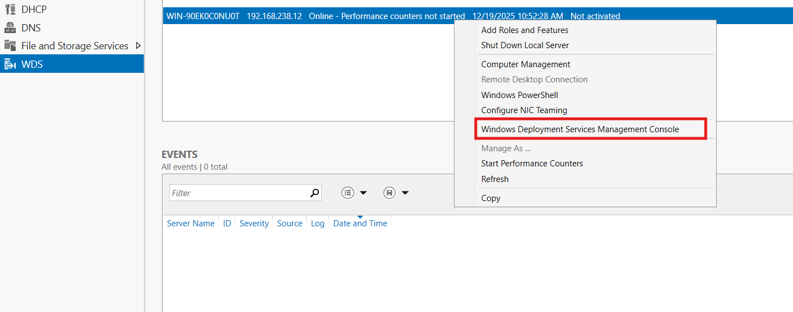

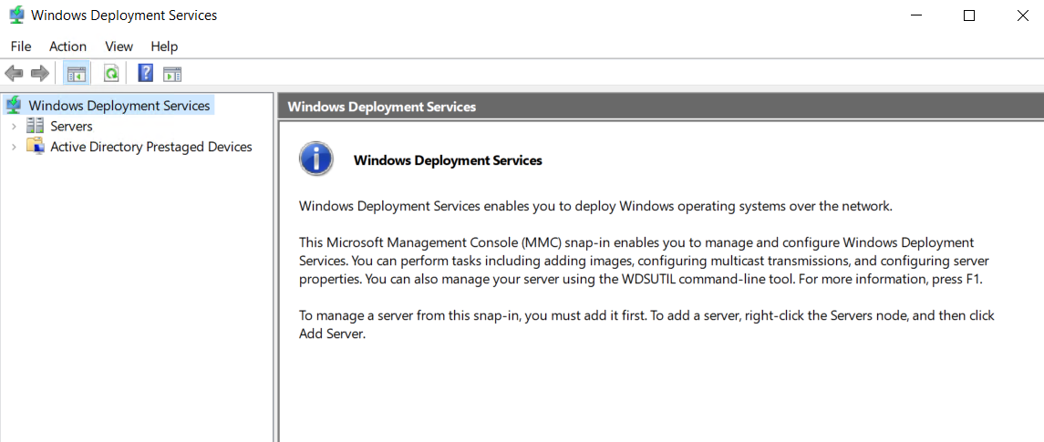

Before we work on the service we have to configure it and set it up

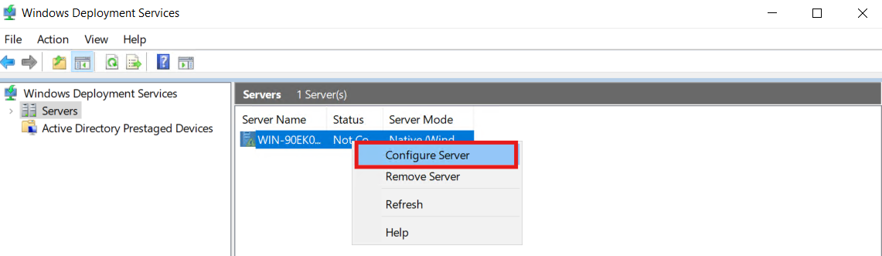
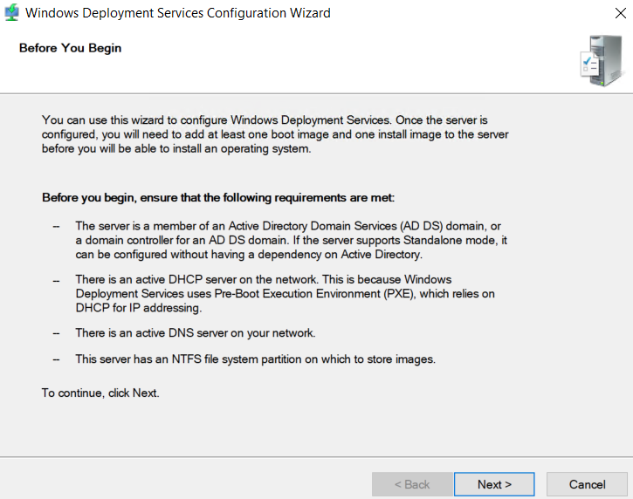

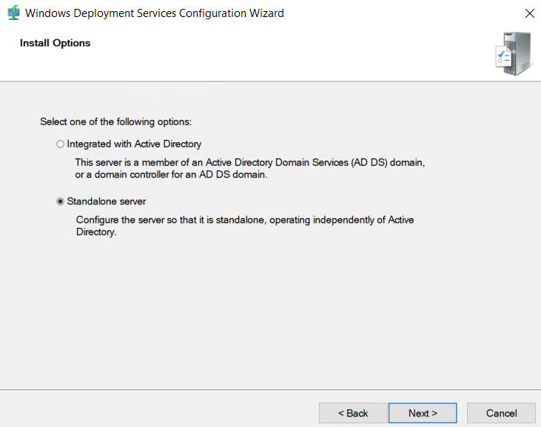

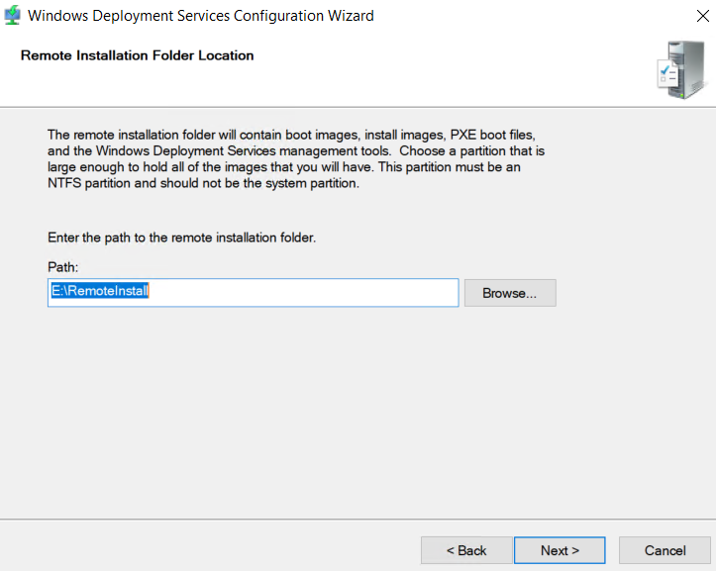
It’s preferred not to be on the C partition

After configuring it we must start it
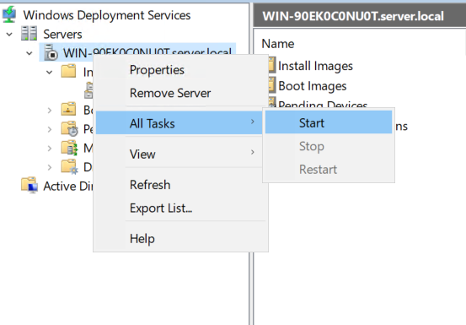

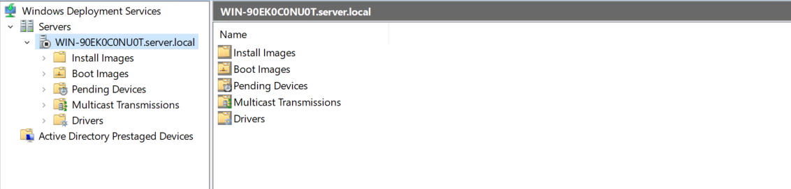

Install Images
What it is: Contains the Windows operating system images that will be installed on computers.
- Images imported from install.wim (Windows 10, Windows 11, Windows Server, etc.)
- Images are organized inside Image Groups

Boot Images
What it is: Contains WinPE boot images used to start the deployment.
In simple words: This is what allows a computer to boot from the network and open the installation screen.
- Boot images (usually boot.wim)
- Separate boot images can exist for:
- Different architectures (x64)
- Different driver requirements

Pending Devices
What it is:
Shows computers that tried to boot using PXE but are waiting for admin approval.
In simple words:
This folder controls who is allowed to install Windows from the network.

Multicast Transmissions
What it is:
Manages deploying Windows to many computers at the same time.
In simple words:
Used when installing Windows on multiple PCs together to save network bandwidth.

Drivers
What it is:
Stores hardware drivers used during installation.
In simple words:
This folder helps Windows recognize the network card and hard disk during setup.

Active Directory Prestaged Devices
What it is:
Contains computers that were added in advance in Active Directory.
In simple words:
Only known and approved computers can install Windows automatically.

We have to add 2 files for the img file to the WDS
The boot.wim and install.wim in the Directory source

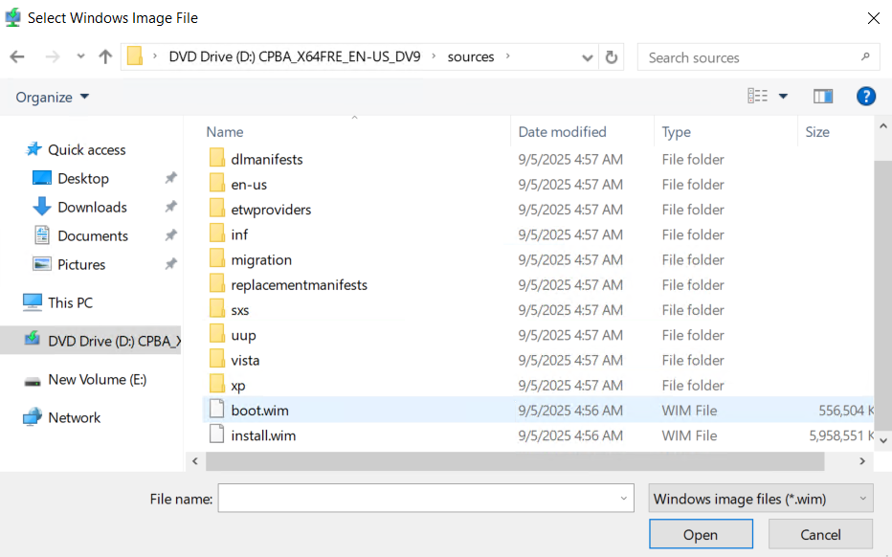
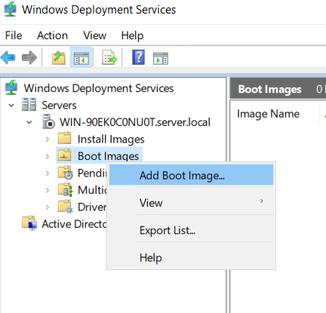
Adding boot.wim

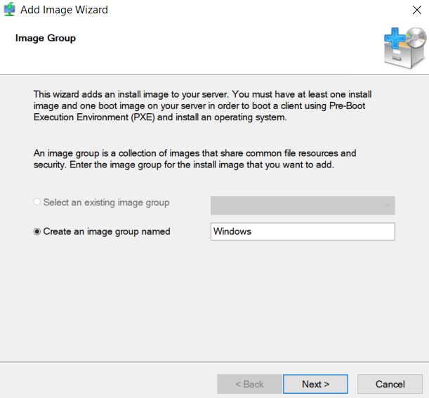
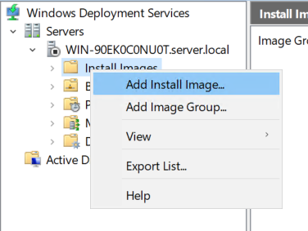
Adding Install.wim

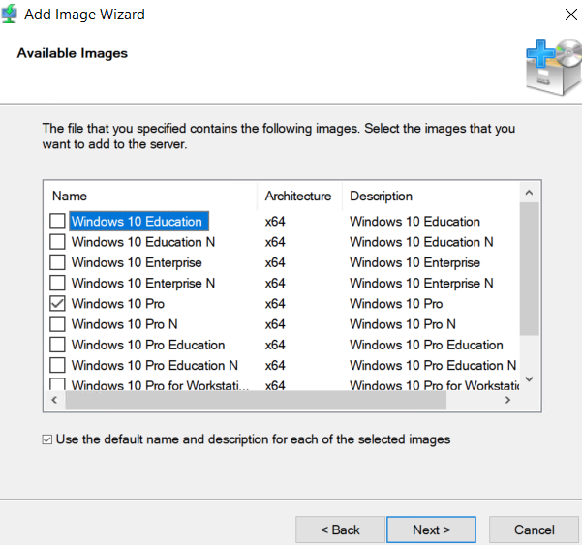

19

WSUS

1. Introduction
WSUS stands for Windows Server Update Services. It is a Microsoft server role that gives administrators the ability to manage, distribute, and control Windows updates across devices in a network. Instead of each computer downloading updates individually from Microsoft over the internet, WSUS downloads updates once and then distributes them internally. This saves bandwidth, gives full control over when and which updates are installed, and helps maintain security compliance.
In simple words:
WSUS is your local update authority — you decide what updates are allowed and when machines receive them.

2. Why WSUS is Used
WSUS is widely used in companies for centralized update management. It ensures all computers stay updated, patched, and secure. It prevents chaos caused by automatic updates installing at bad times, reduces internet usage by caching updates locally, and gives administrators complete approval control. WSUS also allows you to delay or test updates before applying them to production systems. This is especially important for servers where stability matters more than having the newest patches instantly.

3. WSUS Architecture Overview
WSUS sits between Microsoft Update and your internal devices. The server downloads updates from Microsoft Update. Clients connect to WSUS instead of the internet, report their update status, and receive approved updates. WSUS stores update metadata in a database and update files on disk. The server communicates using HTTP or HTTPS, commonly port 8530 for HTTP and 8531 for HTTPS.
Data flow can be described like this:
Microsoft Update → WSUS Server (stores updates) → Clients (install updates)

4. Requirements Before Installation
WSUS runs on Windows Server (2016, 2019, 2022, etc.). It requires .NET, IIS, and a database (either Windows Internal Database or a full SQL database). Disk space is the most important part — updates consume a lot of space over time. A minimum of 30-50GB is fine for labs, but in real environments it is wiser to allocate at least 150GB or more depending on how many products you support. WSUS works best when updates are stored on a separate drive such as D:\WSUS\Updates.

5. Installing WSUS (High Level Steps)
- Open Server Manager and select “Add Roles and Features”.
- Choose the WSUS role and include the required features.
- Select where update files will be stored (preferably a non-system drive).
- Choose the database option (WID for small environments, SQL for larger).
- Complete installation and launch WSUS Configuration Wizard.
- Select products you need to update (Windows version, Office, etc.).
- Select update classifications you want (security updates, critical, etc.).
- Configure synchronization settings and perform the first sync.
The first synchronization may take a long time depending on how many products and classifications you selected. Choosing everything is a common rookie mistake — select only what your environment actually uses.

6. Configuring WSUS Properly
After installation, configure WSUS based on requirements.
Select only the Windows versions and Microsoft products deployed in your network. Avoid selecting every product or you will fill the disk quickly.
Next, choose classifications such as Security Updates, Critical Updates, Definition Updates, and Feature Packs. Driver updates are optional; many administrators disable driver updates because they sometimes cause device issues.
Configure synchronization schedule to automatically sync daily or weekly. WSUS can sync manually or automatically depending on preference.

7. Connecting Clients to WSUS using Group Policy
Clients do not use WSUS automatically; they must be pointed to WSUS using Group Policy.
Steps:
Open Group Policy Management → Create/modify a GPO → Navigate to:
Computer Configuration → Administrative Templates → Windows Components → Windows Update → “Specify intranet Microsoft update service location”
Enter the WSUS server address, for example:
http://WSUS-SERVER:8530
Enable Automatic Updates and choose how updates should install (for example, auto download and schedule installation). You may also configure policies to prevent automatic restarts during working hours, which is useful for servers and production machines.
After applying the policy run:
gpupdate /force
wuauclt /detectnow (Windows 8 and below)
For modern systems use:
usoclient startscan
Clients will then appear in WSUS and start reporting their update status.

8. Update Approval Strategy
Updates do not install automatically unless approved. The recommended real-world strategy is to use update ring groups. Create a “Test Group” where updates are applied first. If no issues appear, approve them for the main user machines. Servers should usually receive updates last during maintenance windows to avoid downtime or service interruption.
Flow example:
Test Machines → If stable → Approve for Workstations → Approve for Servers
This gives control, reduces failures, and protects production environments.

9. WSUS Maintenance (Critical Part Most Admins Ignore)
WSUS fills up and slows down if not maintained. Over time, old and superseded updates pile up. You must periodically run the cleanup wizard, decline superseded updates, and compress the database.
Maintenance tasks include:
• Running the WSUS Cleanup Wizard monthly
• Declining superseded and expired updates
• Reindexing the WSUS database if performance becomes slow
• Removing unneeded products and classifications
• Ensuring disk space is available
If WSUS behaves weird, resets help:
wsusutil.exe reset
wsusutil.exe deleteunneededrevisions
Ignoring maintenance results in slow performance and clients failing to update.

10. Reporting and Monitoring
WSUS can generate compliance reports showing machines that are fully updated, partially updated, or missing patches. These reports help in audits, security compliance, and identifying machines that are failing to fetch updates. WSUS console gives a clear overview of which updates are approved, needed, failed, or waiting to be installed.

Installation and configuring process
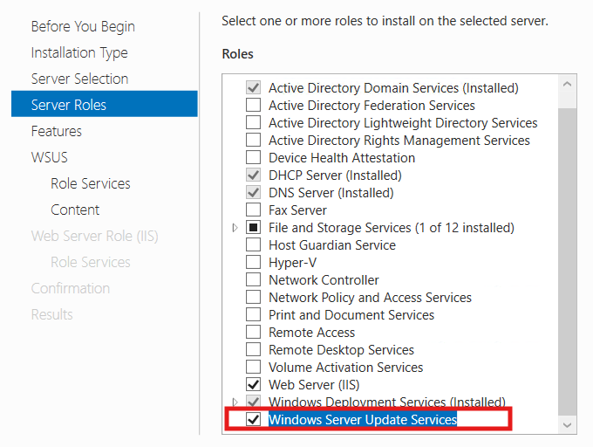

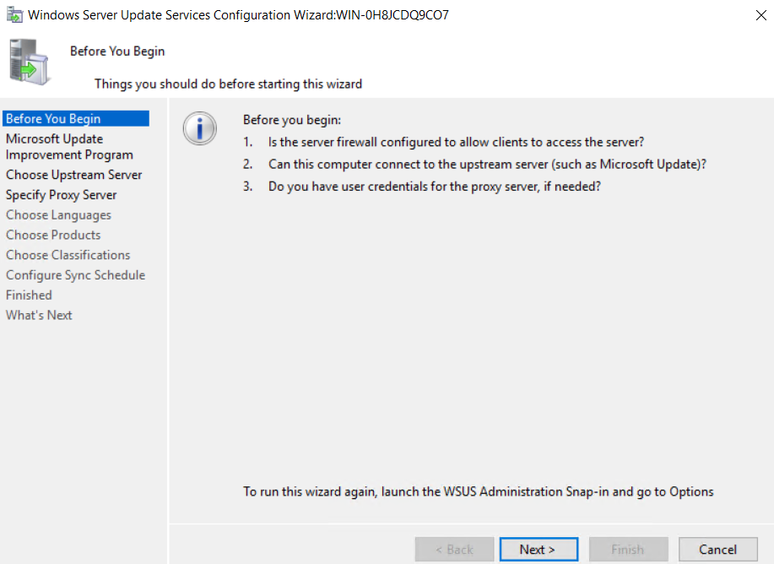
Startup configuration
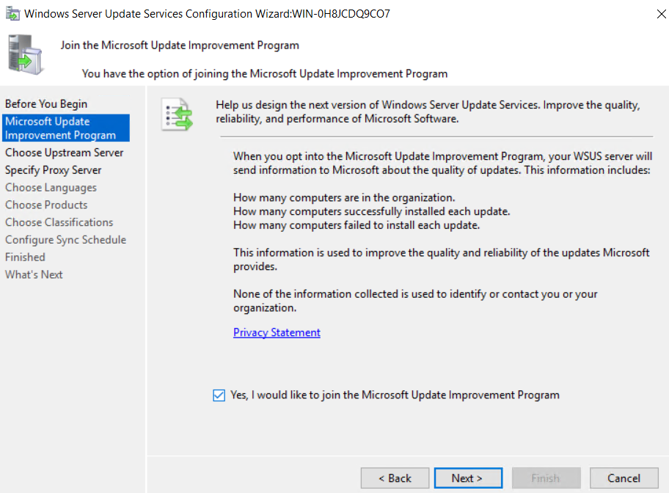
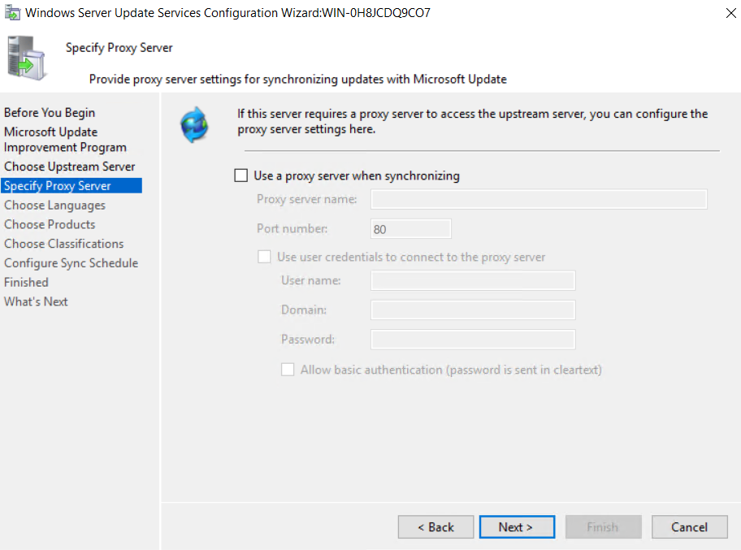
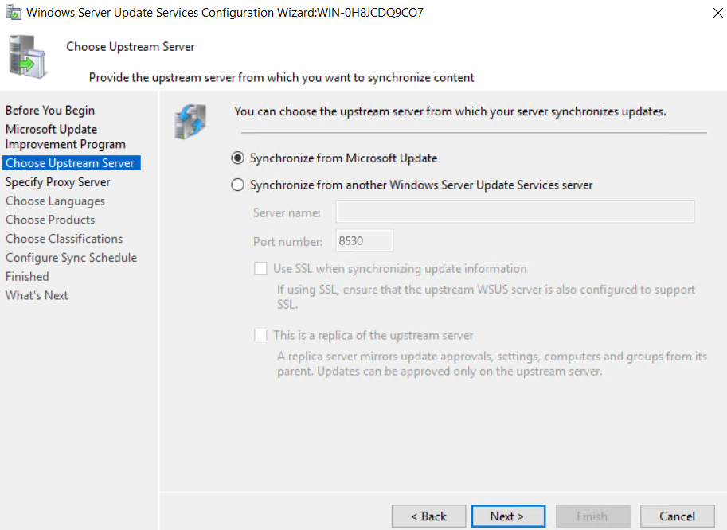

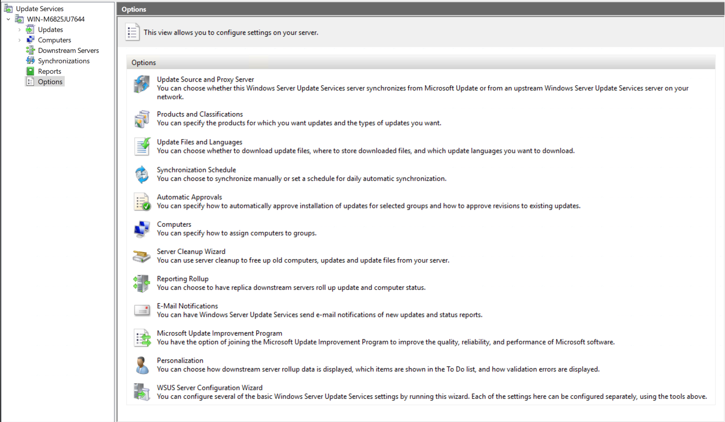

1. Update Source and Proxy Server: This is where you decide from where WSUS gets updates:
- Microsoft Update (Internet) → WSUS downloads directly from Microsoft.
- Upstream WSUS server → Used in organizations with hierarchy (Main ➝ Branch servers).
- You can also configure a proxy here if Internet requires authentication.
Use case: If you have multiple branches, one WSUS pulls from Microsoft, others sync from it to save bandwidth.

2. Products and Classifications: Select what products and update types to download.
- Products: Windows versions, Office, SQL, Exchange, Edge, etc.
- Classifications: Security updates, critical updates, drivers, definitions, service packs…
Why it matters: If you blindly select everything, your disk dies slowly inside. Pick only what your environment uses.

3. Update Files and Languages
Controls what languages and how files download/stored.
- Choose which languages to download (Arabic/English etc.).
- Define whether updates are stored locally or download only after approval.

4. Synchronization Schedule
Manage when and how updates sync.
- Manual or scheduled (daily/weekly).
- You can set automatic sync at specific times.
Logic: Most admins schedule at night to avoid bandwidth fights with users watching YouTube 😄

5. Automatic Approvals
Define rules to automatically approve certain updates.
Examples:
- Automatically approve Security Updates for Server Group.
- Approve Definition Updates for Windows Defender immediately.
Risk: Automatic approval = easy life, but a bad update could break systems — use with strategy.
6. Computers
Controls how WSUS groups computers.
Two modes:
- Server-Side Targeting – You manually place PCs into groups.
- Client-Side Targeting – GPO assigns PCs to WSUS groups automatically.
Example groups: Servers, Workstations, Dev machines.

7. Server Cleanup Wizard
Removes:
- Old/unused updates
- Unneeded update files
- Declined/superseded updates
- Computers not connected for long time
Run it regularly — WSUS without cleanup becomes a junkyard.

8. Reporting Rollup
Used if you have multiple WSUS servers.
- Downstream servers send status reports to main WSUS.
- Helps centralized monitoring.
Enterprises love this — one dashboard to rule them all.

9. E-Mail Notifications
Set WSUS to send email alerts about:
- New updates available
- Sync failures
- Report summaries
Good for admins — WSUS screams before clients do.

10. Microsoft Update Improvement Program
Optional participation in Microsoft telemetry program.
- Helps Microsoft improve update quality.
- Safe to ignore if privacy sensitive.
Nothing functional changes whether on/off.

11. Personalization
Customizes how WSUS console displays things:
- What shows in To-Do list
- Validation error display
- Rollup behavior
Mostly UI preference — not vital for functionality.

12. WSUS Server Configuration Wizard
A guided setup tool.
It helps new admins configure:
- Update source
- Products & classifications
- Language settings
- Sync schedule

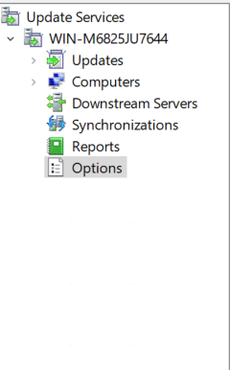

1. WIN-M6825JU7644 (Your WSUS Server Name)
This is your WSUS server instance/root node.
Under it you manage:
- Updates
- Client computers
- Synchronization
- Reports
- Options
Think of it as the main home directory.

2. Updates: This section contains all updates that WSUS knows about.
You can:
- View updates (Critical, Security, Drivers…)
- Approve updates for groups
- Decline unneeded updates
- Check which computers installed/failed
- Filter updates by state (needed, failed, superseded)
Every update request passes through here.
This is where you control what reaches your clients.

3. Computers: This section lists all devices connected to WSUS.
You can:
- See each device status
- Place computers into groups (Servers, Workstations…)
- Track who installed what update
- Monitor compliance
Works together with GPO targeting to automatically group machines.
If a machine appears here, WSUS is working — congratulations.

4. Downstream Servers: Only used when you have multiple WSUS servers.
Example scenarios:
- Headquarters WSUS → Branch office WSUS (downstream)
- Downstream may synchronize approvals or updates
- Useful for large enterprises
If you're running a lab or single-server environment, this might remain empty.
5. Synchronizations
This is like the WSUS sync dashboard.
Here you can:
- Check last sync status
- Start sync manually
- See errors or connection issues
- View number of updates downloaded
If something breaks — you check here first.

6. Reports
Provides detailed WSUS reporting and status tracking.
You can generate reports like:
- Update status summary
- Computer update status
- Installed/needed updates
- Compliance statistics
Useful when you're the admin and your boss asks:
"Are our systems fully patched or vulnerable?"
Just pull a report.
7. Options
This is the brain of WSUS configuration.
Inside you configure:
- Update source (Microsoft or Upstream)
- Products & Classifications
- Languages
- Sync schedule
- Approvals
- Cleanup Wizard
- Email notifications
Think of Options as "Settings of the whole WSUS server".

19

NAP
Network Access Protection (NAP)
1. Definition
Network Access Protection is a Microsoft security framework used to control network access based on the health status of connecting devices. It checks whether computers comply with security requirements (such as antivirus, firewall, and updates) before allowing them into the network.

2. Purpose of NAP
The goal of NAP is to prevent insecure or compromised devices from accessing internal systems. It ensures that only machines meeting the organization’s security standards are given full access. Devices that fail compliance checks are either denied or given limited access until they are fixed.

3. How NAP Works
When a device connects to the network, it sends a health report to the Network Policy Server (NPS). This report is evaluated against configured health policies.
If the device is compliant, it receives normal access.
If not, it is placed into a restricted network where it can only reach resources meant for remediation (update servers, antivirus servers, etc.). Once issues are resolved, the device may request access again and be granted full permissions.

4. Core Components
- NAP Client Agent – runs on client devices, gathers health information, and reports it.
- Network Policy Server (NPS) – evaluates health reports and decides access.
- Health Policies – define what is considered "healthy" (e.g., firewall enabled).
- Remediation Servers – systems that provide updates and fixes to non-compliant devices.
- NAP Enforcement Mechanisms – decide how access is controlled.

5. NAP Enforcement Types
NAP enforces security by controlling how a client connects. There are multiple enforcement methods:
DHCP Enforcement:
Clients receive IP configuration based on health status. Non-compliant devices are assigned to a restricted subnet.
VPN Enforcement:
Client health is checked when connecting through a VPN. Only compliant devices can establish a secure VPN session.
802.1X Enforcement:
Used in wired/wireless networks. Switches or access points authenticate devices and validate their health before granting access.
IPsec Enforcement:
The strongest method. Communication is permitted only between devices that are verified as healthy.
Terminal Services Gateway Enforcement:
Controls remote desktop access based on compliance.
Installation and setup
