Student Academic Performance Prediction & Attendance Impact Analysis
A Project Report submitted in partial fulfilment of the requirements for the award of degree of

BATCHELOR OF TECHNOLOGY
in

ARTIFICIAL INTELLIGENCE AND MACHINE LEARNING
Submitted By

Anurag Nayak (24B11AI014)

N. Renuka SriHasini(24B11AI299)
Under the esteemed guidance of

Dr. K N S L.Kumar , M.Tech, ph.D.

Assistant Professor.



DEPARTMENT OF ARTIFICIAL INTELLIGENCE AND MACHINE LEARNING
ADITYA UNIVERSITY
(Formerly Aditya Engineering College (A))

2024-2028

DEPARTMENT OF ARTIFICIAL INTELLIGENCE AND MACHINE LEARNING



CERTIFICATE
This is to certify that the project work entitled “STUDENT ACADEMIC PERFORMANCE PREDICTION & ATTENDANCE IMPACT ANALYSIS” is being submitted by
Anurag Nayak (24B11AI014)
N. Renuka Sri Hasini (24B11AI299)
in partial fulfillment of the requirements for award of the B.Tech. degree in
Artificial Intelligence and Machine Learning.

Project Guide Head of the Department
Dr. K N S L. Kumar, M.Tech, Ph.D. Dr. M. Venkatesh, _{M.Tech.,} _{Ph.D.}
Assistant Professor. Assoc. Prof., AIML Dept.

DECLARATION

We hereby declare that the project entitled “STUDENT ACADEMIC PERFORMANCE PREDICTION & ATTENDANCE IMPACT ANALYSIS” is a genuine project. This work has been submitted to the ADITYA UNIVERSITY (Formerly Aditya Engineering College (A)), Surampalem in partial fulfillment of the B.Tech. degree. We further declare that this project work has not been submitted in full or part of the award of any degree or any other educational institutions.

by

Anurag Nayak (24B11AI014)
N.Renuka SriHasini(24B11AI299)

ACKNOWLEDGEMENT

It is with immense pleasure that we would like to express us indebted gratitude to our project Guide Dr.K N S L. Kumar,M.tech.,ph.D who has guided us a lot and encourage in every step of the project work, his valuable moral support and guidance throughout the project helped us a greater extent.
We are grateful to Dr. Maganti Venkatesh, Assoc. Prof. and HoD, for inspiring us all the way and for arranging all the facilities and resources needed for our project.
We wish to thank Dr. M.V. Rajesh, Assoc. Dean SoE. for the encouragement and support during the course of my project.
We would like to extend our sincere thanks to Dr. A. Ramesh, Pro Vice-Chancellor (Engg. & Sci.), Dr. G. Suresh, Registrar, Dr. S.Rama Sree, Pro Vice-Chancellor (Academics), Dr. M.B. Srinivas, Vice-Chancellor, Dr. M. Sreenivasa Reddy, Deputy Pro-Chancellor and Management, Aditya University for unconditional support for providing us the best infrastructural facilities and state of the art laboratories during our project.
Not to forget, Parents Faculty, Teaching, Non-Teaching Staff and our Friends who have directly or indirectly supported us in completing this project on time.

CONTENTS PAGE NO Chapter 1: INTRODUCTION
- 1.1 Introduction 1
- 1.2 Problem Statement 1
- 1.3 Objectives of the Project 2
- 1.4 Scope of the Project 2
Chapter 2: SYSTEM OVERVIEW
- 2.1 Existing System 3
- 2.2 Limitations of Existing System 3
- 2.3 Proposed System 3
- 2.4 Software Requirements & Hardware Requirements 3
Chapter 3: TECHNOLOGIES USED
- 3.1 Data Mining Concepts 4
- 3.2 Clustering Techniques (Unsupervised Learning) 4
- 3.3 Decision Tree Classification (J48) 4
- 3.4 Rule-Based Classification (JRip) 4
- 3.5 Probabilistic Classification (Naive Bayes) 5
- 3.6 Implementation Environment 5
Chapter 4: DATASET DESIGN
- 4.1 Dataset Overview 6
- 4.2 Dataset Attributes 6
- 4.3 Preprocessing Constraints 6
- 4.4 Data Splitting and Validation Strategy 6
Chapter 5: DATA PREPROCESSING AND CLEANING
- 5.1 Introduction to Data Cleaning 7
- 5.2 Handling Missing and Null Values 7
- 5.3 Dimensionality Reduction 7
- Figure 5.1: Weka Preprocessing and Filter Application 8
Chapter 6: SYSTEM MODULES
- 6.1: Data Collection & Preprocessing 9
- 6.2: Unsupervised Clustering 9
- 6.3: Predictive Classification 9
- 6.4: Decision Support & Recommendation 9

Chapter 7: IMPLEMENTATION
- 7.1 Data Loading & Cleaning 10
- 7.2 Model Training 10
- 7.3 System Evaluation 10
Chapter 8: OUTPUT SCREENS & REPORTS
- Figure 8.1: Raw Dataset View and Preprocessing Description 11
- Figure 8.2: K-Means Clustering Output ("Learner Personas") Description 12
- Figure 8.3: J48 Decision Tree Structure Description 13
- Figure 8.4: JRip Rule-Based Model Output Description 14
- Figure 8.5: Naive Bayes Probability Matrix Description 15
Chapter 9: MODEL EVALUATION AND COMPARISON
- 9.1 Comparative Analysis 16
- Table 9.2: Performance Metrics 16
Chapter 10: CONCLUSION
- 10.1 Conclusion 17
Chapter 11: REFERENCES
- 11.1 References 18

LIST OF FIGURES

Figure No. | Name of the Figure | Page No.
5.2 | Weka Preprocessing and Filter Application | 8
8.1 | Raw Dataset View and Preprocessing Description | 9
8.2 | K-Means Clustering Output ("Learner Personas") | 11
8.3 | J48 Decision Tree Structure | 13
8.4 | JRip Rule-Based Model Output | 14
8.5 | Naive Bayes Probability Matrix | 15

LIST OF TABLES
Table No. | Name of the Table | Page No.
9.2 | Performance Metrics Table | 16

ABSTRACT

The rapidly evolving modern educational landscape is currently undergoing a profound and radical structural shift, creating an incredibly dynamic environment where traditional, purely reactive administrative measures and delayed, after-the-fact academic interventions are simply no longer sufficient or highly effective methodologies to consistently ensure long-term student success, maximize overall retention rates, and promote comprehensive intellectual development across diverse student populations. While the vast majority of modern academic institutions diligently maintain highly rigorous, meticulously updated digital records encompassing both continuous internal assessment marks and precise daily classroom attendance, the immense predictive potential and analytical value hidden within this raw institutional data remains largely unexamined and critically underutilized by administration, directly resulting in the creation of a significant, deeply concerning, and persistently widening "Attendance-Performance Gap" across university campuses globally, which severely hampers strategic educational planning. To directly and effectively address this critical administrative oversight and technological shortfall, this proposed research project fundamentally utilizes an advanced, data mining-based analytical framework specifically designed to rigorously decode, mathematically quantify, and scientifically model the highly complex, multi-faceted relationship existing between a student's ongoing, day-to-day behavioural engagement patterns and their ultimate final academic grades at the conclusion of the semester. By seamlessly and strategically integrating sophisticated unsupervised machine learning algorithms, specifically utilizing K-Means Clustering for granular behavioural student segmentation, alongside highly accurate supervised classification predictive models like Decision Trees the automated computational system continuously evaluates crucial engagement attributes, such as self-reported weekly study hours and cumulative daily attendance percentages, to accurately identify highly vulnerable, "At-Risk" students remarkably early within the academic semester timeline, allowing for immediate corrective actions. Ultimately, the strategic, campus-wide implementation of this sophisticated predictive technological framework provides a substantial and measurable dual benefit for the institution: it actively serves as an early, while simultaneously delivering a comprehensive, highly accurate, and data-driven overview of holistic academic health and overall student engagement levels directly to the highest levels of college administration.

1. INTRODUCTION
1.1 Introduction
In the rapidly evolving modern academic ecosystem, educational institutions across the globe are continuously generating vast amounts of digital data at an unprecedented and accelerating rate. Ranging from daily classroom attendance logs and digital learning platform interactions to internal assessment scores and assignment submissions, universities now possess a massive wealth of complex information regarding individual student behaviour and learning patterns. Data Mining, specifically operating within the specialized field known as Educational Data Mining (EDM), offers a highly effective and innovative solution to successfully bridge the widening gap between mere raw data collection and the generation of meaningful, actionable academic insights. Consequently, this proposed project fundamentally aims to transition institutions from traditional, simple record-keeping methodologies toward advanced predictive analysis frameworks, thereby empowering faculty members to accurately identify and support struggling or at-risk students several months in advance of their final examinations.

1.2 Problem Statement
Most contemporary educational institutions currently lack a robust, systematic, and automated methodology to accurately predict a student's final semester grades based purely on their ongoing mid-term behavior and early academic performance. While substantial amounts of data regarding daily classroom attendance, continuous internal marks, and general engagement undeniably exist within university databases, this information is predominantly siloed across different departmental systems and is rarely analyzed in a proactive or integrated manner. Without the application of sophisticated data mining techniques and predictive modeling, teaching faculties are entirely unable to scientifically identify the critical "tipping point" or threshold where a gradual drop in regular attendance mathematically guarantees a significant drop in final academic grades, resulting in missed opportunities for timely interventions.

1.3 Objectives of the Project
The primary foundational goals and strategic objectives of this comprehensive project are officially defined as follows:
- To systematically aggregate, meticulously clean, and thoroughly preprocess large volumes of raw student data, including daily attendance logs, continuous internal assessment marks, and self-reported weekly study hours, ensuring high data quality for subsequent analytical modeling.
- To intelligently group the diverse student population into highly distinct and actionable "Learner Personas" by heavily utilizing the unsupervised machine learning algorithm known as K-Means Clustering, allowing for targeted behavioral segmentation.
- To accurately categorize and predict future student academic outcomes—specifically classifying them into potential "Pass," "Fail," or "Distinction" brackets—by constructing and deploying robust supervised learning models leveraging Decision Trees, specifically the J48 algorithm.
- To proactively generate automated, highly strategic, and personalized recommendations intended for immediate academic intervention, providing teaching staff with the precise, data-backed guidance needed to support vulnerable students before final evaluations occur.

1.4 Scope of the Project
This comprehensive predictive system is specifically designed to be highly utilized by higher education college administrations, departmental heads, and teaching faculty to continuously monitor ongoing student engagement levels and strategically optimize the allocation of limited educational resources. Furthermore, the framework actively supports highly proactive and personalized academic counselling initiatives by rapidly identifying specific, at-risk individuals who urgently require targeted pedagogical attention and support. By implementing this platform, institutions can effectively replace inherently biased or highly subjective faculty perceptions regarding student effort with rigorous, scientifically validated, and purely data-driven objectivity, ultimately fostering a much more equitable and supportive overall learning environment.
2. SYSTEM OVERVIEW
2.1 Existing System
Most institutions currently operate on a "reactive" model, where student data is reviewed only after a student has failed or dropped out. Decisions regarding student capability are often based on subjective faculty perceptions, and records are maintained without analysing the qualitative correlation between daily engagement and final outcomes.

2.2 Limitations of Existing System
- Lack of Timely Intervention: Information is rendered useless for preventative intervention because struggling students are identified only after exams are failed.
- Manual Bottlenecks: It is impossible for faculty to manually monitor the daily behavioural trends of hundreds of students effectively.
- Inability to Differentiate Disengagement: Institutions cannot accurately distinguish between a student who is absent due to genuine reasons and one who is academically disengaged.

2.3 Proposed System
The proposed solution is a data mining-based analytical system that evaluates student behavioural patterns and classifies them according to their predicted academic outcome. It automates the monitoring process by evaluating current semester involvement to predict the probability of student’s failing or securing a distinction. This creates a warning system, allowing interventions as early as Week 4 of the semester.

2.4 Software Requirements & Hardware Requirements
The standard software requirements necessary to run and develop this machine learning
& the minimum hardware specifications required to process the data effectively are
- Data Mining Tool: Weka 3.8
- Operating System: Windows 10 or above
- Processor: Intel i5 or above
- RAM: 8 GB or higher
- SSD: 20 GB free space
3. TECHNOLOGIES USED
3.1 Data Mining Concepts
This project relies heavily on the specialized field of Educational Data Mining (EDM) to systematically uncover hidden behavioural patterns and correlations that human observers might easily miss. By leveraging these advanced methodologies, EDM applies sophisticated computational techniques to complex educational data, ultimately aiming to deeply understand and structurally improve institutional learning environments.

3.2 Clustering Techniques (Unsupervised Learning)
The K-Means Clustering algorithm is strategically utilized to autonomously segment the diverse student population based strictly on the statistical similarity of their self-reported study habits and recorded attendance rates. This powerful unsupervised learning approach effectively identifies and isolates natural behavioural groupings within the broader student body without requiring any prior manual labelling or subjective categorization.

3.3 Decision Tree Classification (J48)
Supervised Decision Trees, specifically utilizing the highly robust J48 algorithm, are extensively deployed to rigorously analyse complex behavioural combinations (e.g., critically low attendance combined with insufficient study hours). This highly structured modelling process serves as a highly accurate early predictor to forecast potential academic failure or future academic distinction.

3.4 Rule-Based Classification (JRip)
To provide an alternative perspective to decision trees, the JRip (RIPPER) algorithm was implemented. JRip is a highly efficient rule-based model that generates easily readable, sequential "IF-THEN" rules. This allows faculty to easily understand the exact combinations of behaviours and thresholds that trigger an "At-Risk" academic warning.

3.5 Probabilistic Classification (Naive Bayes)
To establish a mathematical baseline for predictive accuracy, the Naive Bayes algorithm was also utilized. Based directly on Bayes' Theorem, this probabilistic classifier calculates the statistical probability of a student falling into a specific final grade category based on the assumption that all behavioural attributes contribute independently to the final outcome.

3.6 Implementation Environment
The technical development of this project utilizes versatile programming languages like Python, deeply integrated with powerful data analysis libraries (such as Pandas and Scikit-learn), alongside accessible Graphical User Interface (GUI) tools like Weka. These diverse software environments act in tandem to flawlessly execute the aforementioned machine learning algorithms and efficiently process the massive analytical frameworks required for the study.

4. DATASET DESIGN
4.1 Dataset Overview
The primary dataset is systematically collected through a strategic combination of university digital attendance logs and structured student surveys. It reliably contains both real-time behavioural engagement data and historical academic performance records.

4.2 Dataset Attributes
The comprehensive dataset includes the following key structural attributes that are highly critical for the predictive mining process:
- Student ID: Anonymized unique numerical identifier to ensure privacy.
- Gender: Categorical distinction of Male / Female.
- Attendance Percentage: Continuous numeric value ranging precisely to 100%.
- Study Hours: Numeric average of hours spent studying outside class.
- Previous Semester GPA: Numeric indicator reflecting academic history.
- Parent Education Level: Categorical family educational background.
- Participation Score: Numeric assessment marks for active class interaction.
- Assignments Completed: Total count of successfully submitted Assignments.
- Target Attribute: Expected Final Grade (Distinction / First Class / Pass / Fail).

4.3 Preprocessing Constraints
The raw data is rigorously maintained and systematically pre-processed by cleaning missing values, appropriately encoding categorical attributes (like Parent Education), and thoroughly normalizing numerical records (like Study Hours) to ensure highly effective algorithmic analysis.

4.4 Data Splitting and Validation Strategy
To rigorously evaluate the predictive capabilities of the proposed machine learning models, the fully pre-processed dataset is systematically partitioned into distinct training and testing subsets. Typically employing a standard 80/20 data split or a robust 10-fold cross-validation technique, the isolated testing set is subsequently deployed to objectively validate the model's predictive accuracy on entirely unseen behavioural data.
5. DATA PREPROCESSING AND CLEANING
5.1 Introduction to Data Cleaning
Real-world educational data is rarely perfect. Before applying complex machine learning algorithms, the raw dataset must undergo rigorous preprocessing to ensure high computational accuracy and eliminate algorithmic bias. This phase acts as a vital quality control mechanism.

5.2 Handling Missing and Null Values
During the initial data collection phase via surveys and digital logs, several instances of missing data (null values) were encountered. Instead of deleting these records entirely—which would reduce the valuable size of our training data—we applied predictive imputation. Using Weka's built-in ReplaceMissingValues filter, the system automatically auto-filled these gaps by calculating the mean (for numerical attributes like Study Hours) and the mode (for categorical attributes like Parent Education) of the surrounding data.

5.3 Dimensionality Reduction
Certain attributes, while useful for record-keeping, hold no predictive mathematical value and actively confuse machine learning models. Therefore, we performed strict dimensionality reduction. The Student_ID column was entirely removed from the dataset prior to training, as unique identifiers act as computational noise. Additionally, outlier rows containing physically impossible survey responses were manually isolated and removed to prevent the models from skewing.

Figure 5.1: Weka Preprocessing and Filter Application
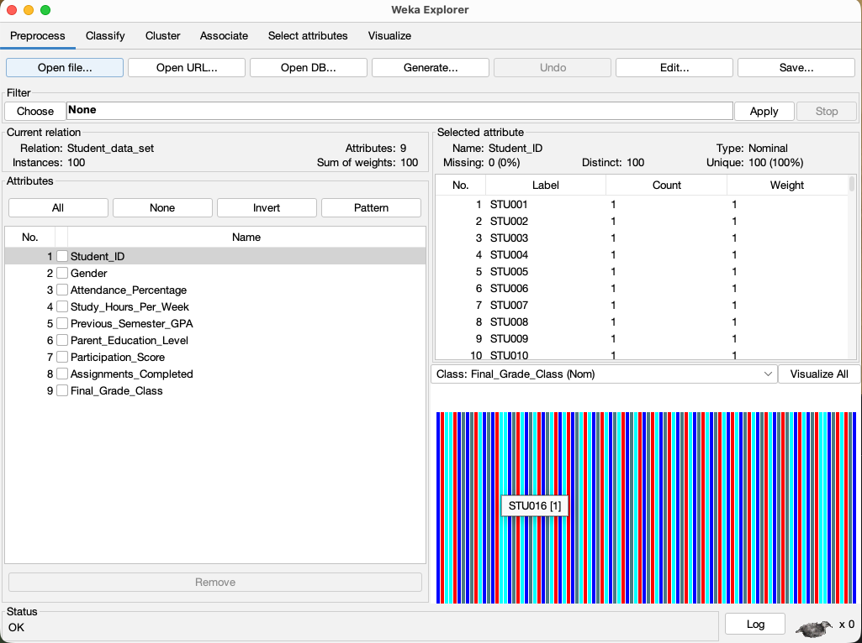

Description: This interface demonstrates the application of the Remove and ReplaceMissingValues filters within Weka, ensuring the dataset is clean, normalized, and strictly numerical/categorical where required before algorithmic training begins.

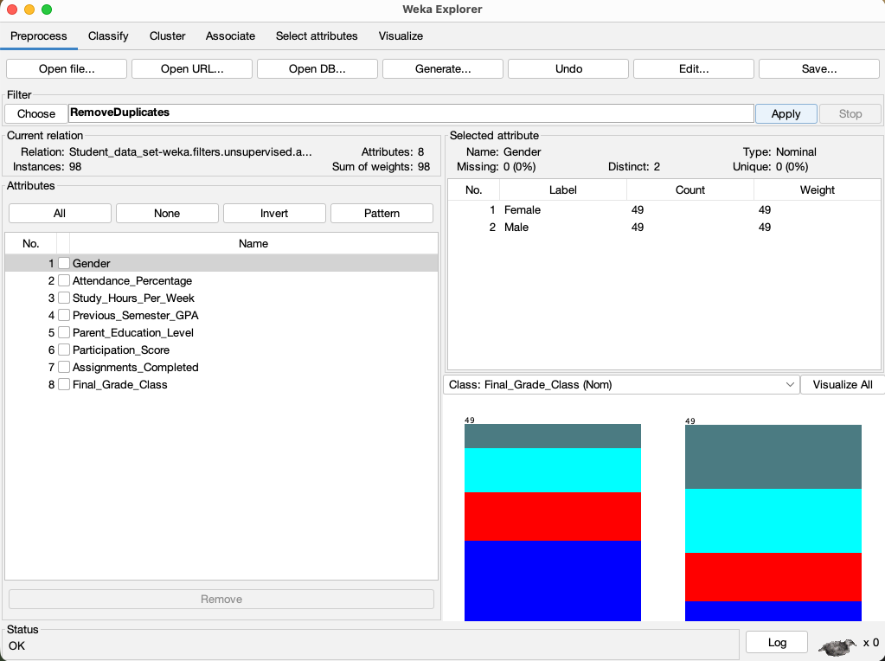
6. SYSTEM MODULES
Module 1: Data Collection & Preprocessing
This foundational module systematically aggregates raw data from multiple disjointed sources, including digital student attendance logs, continuous internal assessment marks, and self-reported weekly study hours. To ensure optimal algorithmic performance and mathematical accuracy, the system rigorously handles missing or inconsistent values through advanced imputation techniques and systematically normalizes crucial numerical percentages, thereby standardizing the dataset for subsequent machine learning operations.

Module 2: Unsupervised Clustering
This highly operational module intelligently groups the diverse student body into distinct, actionable "Learner Personas" such as Consistent High Achievers, Average Engaged Learners, or Highly At Risk Students by strategically utilizing the K-Means Clustering algorithm. This unsupervised machine learning approach effectively highlights hidden behavioural patterns and reveals whether specific student demographics or academic cohorts are silently falling behind.

Module 3: Predictive Classification
This crucial analytical module rigorously applies the robust J48 Decision Tree algorithm to automatically categorize active students into clearly defined, expected final grade outcomes. By continuously evaluating core predictive fields, specifically their cumulative Attendance Percentage and Previous Semester Grades, allowing educators to visualize the precise trajectory of every individual student.

Module 4: Decision Support & Recommendation
The culminating final module translates complex analytical insights into actionable, automated strategic suggestions designed to directly aid teaching faculty and administration. It proactively flags highly vulnerable students—such as those critically dropping under a 60% attendance threshold—for immediate, personalized academic counselling, while simultaneously identifying consistent, high-performing students who possess the behavioural traits necessary to serve as effective peer mentors within a collaborative campus environment.
7. IMPLEMENTATION
7.1 Data Loading & Cleaning
The implementation phase officially commences with the systematic ingestion and integration of both the self-reported survey responses and the digital attendance datasets. Because machine learning models strictly require numerical inputs, crucial categorical attributes such as a student's Gender and their specific Parent Education level are meticulously transformed using standard data encoding techniques. This vital preprocessing step guarantees that the underlying computational algorithms can smoothly process the complex dataset without encountering mathematical errors or biased interpretations during execution.

7.2 Model Training
Once fully cleaned and normalized, the pre-processed numerical data is strategically fed into the selected machine learning models, specifically the K-Means clustering and J48 Decision Tree algorithms. During this critical training phase, the system rigorously analyses massive volumes of historical student data, continuously comparing engagement metrics against the primary target attribute, which is the Final Grade Class. By doing so, the algorithms autonomously establish and refine the complex mathematical rules and hidden threshold patterns that fundamentally define the precise boundaries between academic success and failure.

7.3 System Evaluation
In the final validation stage, the completely trained predictive system rigorously evaluates ongoing, real-time current semester involvement metrics. By applying the previously learned mathematical rules to this fresh data, the model accurately outputs the statistical probability of any individual student either failing the course or successfully securing an academic distinction, thereby validating the model's overall accuracy and real-world predictive utility.

8. OUTPUT SCREENS
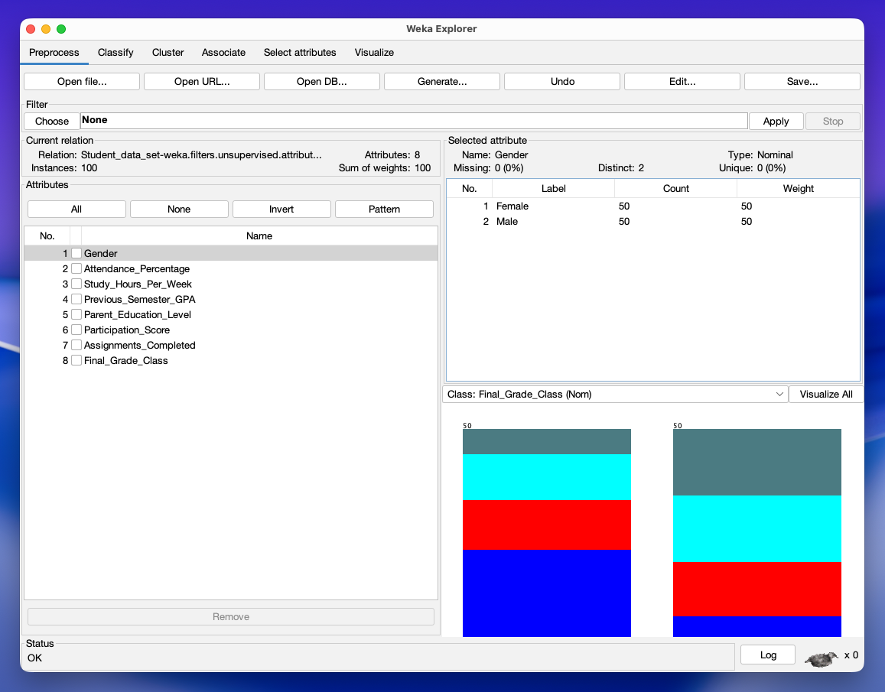
Figure 8.1: Raw Dataset View and Preprocessing Description:
This interface displays the Weka Preprocess tab after successfully loading the primary dataset. It confirms the successful ingestion of 100 student instances and 8 active predictive attributes. The visualization on the right highlights the class distribution for the target attribute (Final_Grade_Class), ensuring a balanced dataset before algorithmic training begins.

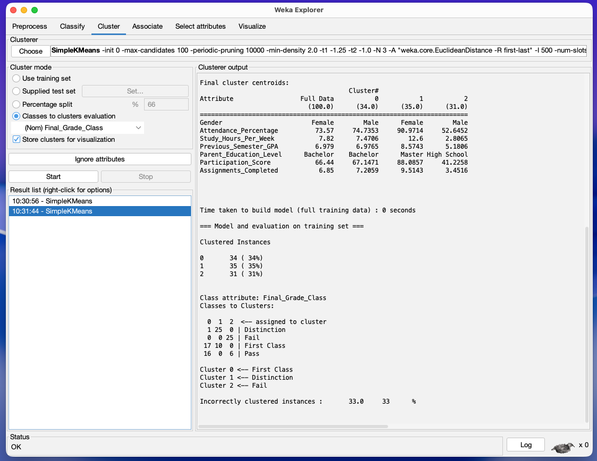

Figure 8.2: K-Means Clustering Output ("Learner Personas") Description:
This output log displays the results of the SimpleKMeans unsupervised learning algorithm. The system successfully segmented the student body into three distinct "Learner Personas" based purely on behavioural data:
- Cluster 1 (High Achievers): Represents students with average attendance over 90% and high study hours (~12.6/week). This cluster directly maps to the "Distinction" class.
- Cluster 0 (Average Engaged Learners): Represents the middle tier with ~74% attendance and moderate study habits, mapping primarily to "First Class" outcomes.
- Cluster 2 (At-Risk Students): The critical warning group, characterized by dangerously low attendance (~52%) and minimal study hours (~2.8/week). The algorithm correctly mapped this behaviour exclusively to the "Fail" outcome.

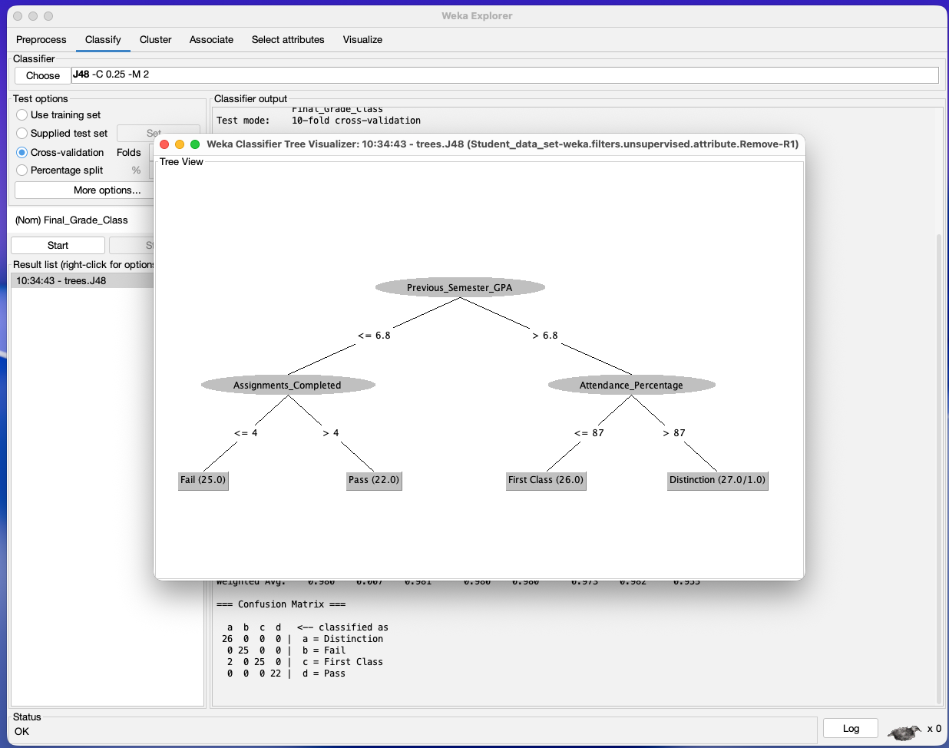

Figure 8.3: J48 Decision Tree Structure Description:
- This graphical representation illustrates the mathematical rules generated by the J48 Decision Tree algorithm. It provides clear, predictive pathways for academic outcomes:
- The Root Node: The most critical initial predictor is the Previous_Semester_GPA.
- The "At-Risk" Pathway: If a student's GPA is 6.8 or lower, their success depends entirely on engagement. If they complete 4 or fewer assignments, the model predicts a Fail. If they complete more than 4, they secure a Pass.
- The "High Achiever" Pathway: If a student has a strong GPA (above 6.8), Attendance_Percentage becomes the ultimate deciding factor. Dropping below 87% attendance limits them to First Class, while maintaining over 87% attendance secures a Distinction.

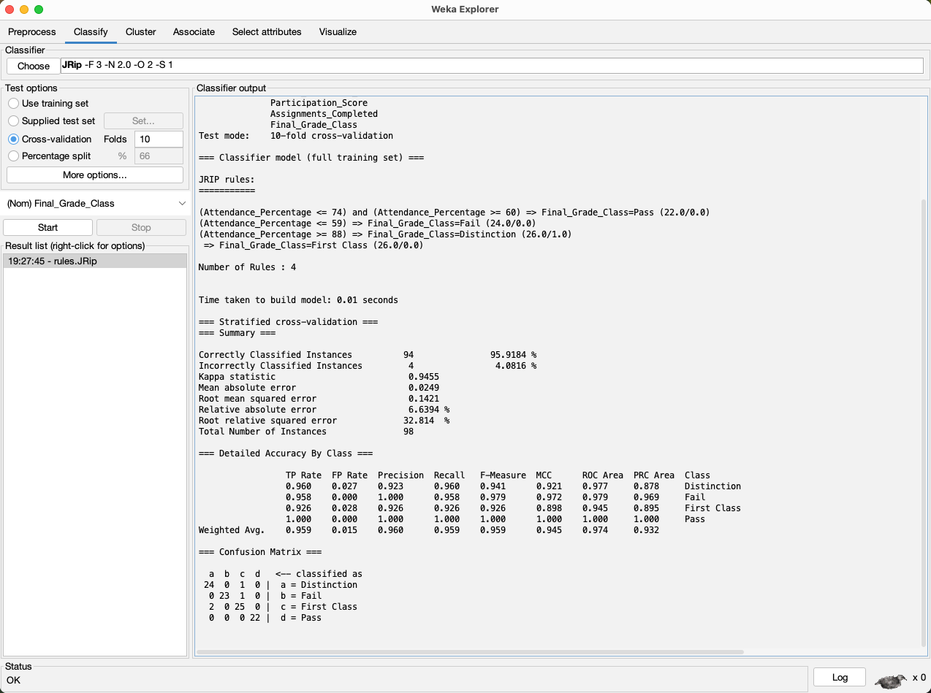

Figure 8.4: JRip Rule-Based Model Output Description:
This interface displays the sequential "IF-THEN" rules generated by the JRip algorithm. It explicitly defines the behavioural thresholds required for each grade classification, offering a more linear, text-based alternative to the visual J48 tree.
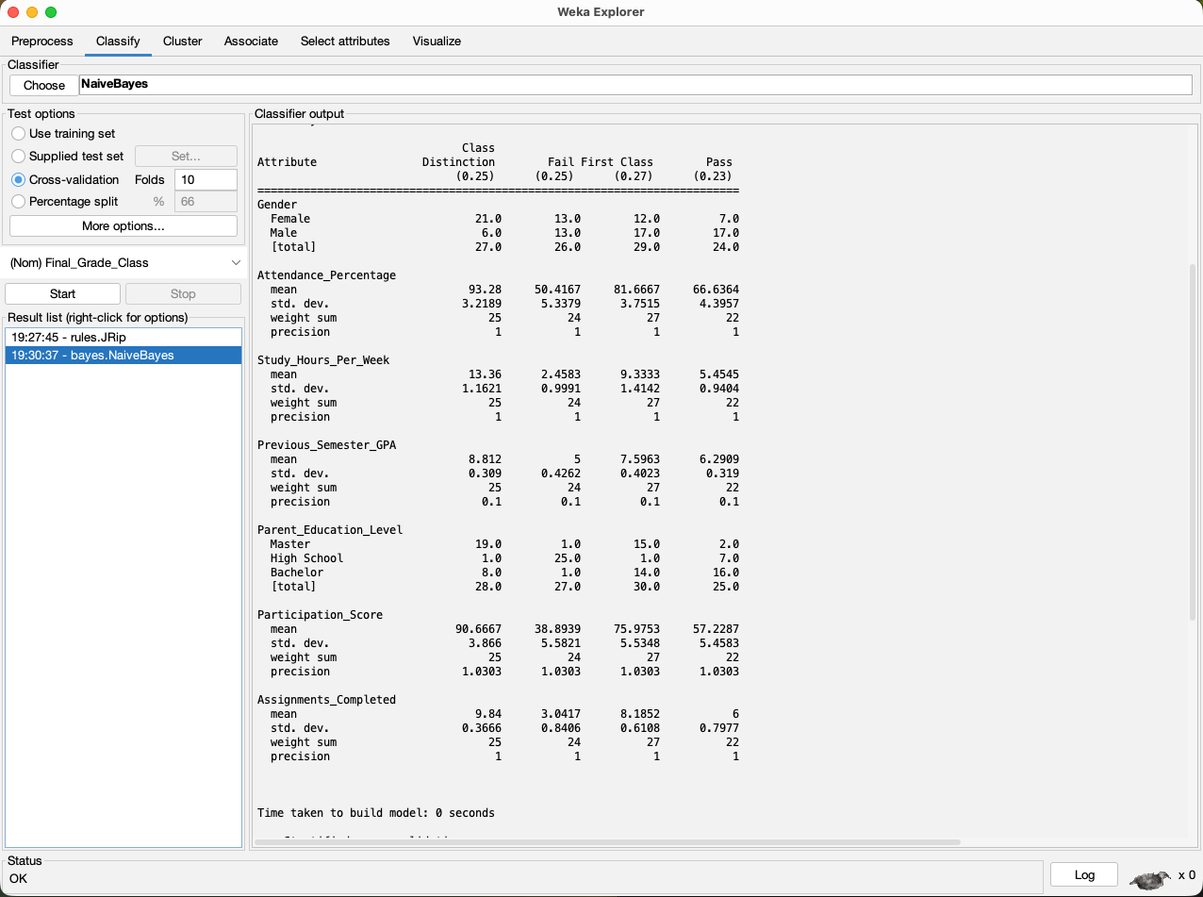

Figure 8.5: Naive Bayes Probability Matrix Description:
This screenshot illustrates the output of the Naive Bayes classifier, highlighting the statistical mean and standard deviation for each predictive attribute across the different grade classes, calculating the independent probability of student success.

9. MODEL EVALUATION AND COMPARISON
9.1 Comparative Analysis
To ensure the highest level of predictive accuracy for the academic warning system, the dataset was tested across three distinct supervised learning algorithms: the J48 Decision Tree, the JRip Rule-Based Classifier, and the Naive Bayes Probabilistic Model. All models were rigorously evaluated using a standard 10-fold cross-validation technique to prevent statistical overfitting and ensure real-world reliability.

While all three models successfully identified the core correlations between high attendance and academic distinction, their operational accuracy varied. The J48 Decision Tree emerged as the superior model, providing the highest correctly classified instance rate and the lowest mean absolute error. Its hierarchical structure proved highly adept at handling the continuous numerical data, such as GPA and Attendance Percentage. The JRip model performed admirably, offering excellent human readability with its IF-THEN rules, but suffered a slightly higher error rate. Naive Bayes yielded the lowest accuracy, likely because its foundational assumption of "attribute independence" does not perfectly align with educational data, as study hours and attendance are often highly dependent on one another.

9.2 Performance Metrics Table
Model / Algorithm | Correctly Classified Instances (Accuracy) | Incorrectly Classified Instances (Error Rate) | Mean Absolute Error (MAE) | Kappa Statistic | Model Type
J48 Decision Tree | 97.96% (96 instances) | 2.04% (2 instances) | 0.0148 | 0.9728 | Hierarchical Tree
Naive Bayes | 95.92% (94 instances) | 4.08% (4 instances) | 0.0225 | 0.9455 | Probabilistic
JRip (RIPPER) | 95.92% (94 instances) | 4.08% (4 instances) | 0.0249 | 0.9455 | IF-THEN Rule-Based

10. CONCLUSION
This comprehensive research project successfully bridges the critical and persistent "Attendance-Performance Gap" by formally establishing a highly proactive, predictive warning system tailored specifically for modern educational institutions. By moving decisively away from traditional, purely reactive record-keeping models—where student failure is unfortunately only identified after final examinations have concluded—this proposed analytical framework empowers university administrations to scientifically anticipate academic struggles well in advance. Through the strategic integration and rigorous application of advanced Educational Data Mining (EDM) techniques, specifically utilizing unsupervised K-Means Clustering alongside highly accurate supervised J48 Decision Trees, the system deeply analyses historically siloed academic logs and self-reported engagement data.

This robust computational approach successfully accomplishes its primary objective of mathematically decoding highly complex student behavioural patterns. By continuously evaluating critical engagement metrics such as cumulative daily attendance percentages, weekly study hours, and historical academic performance, the system effectively segments the diverse student body into distinct, actionable "Learner Personas". Consequently, it actively identifies highly vulnerable, at-risk learners remarkably early in the academic semester, thereby effectively replacing subjective, anecdotal faculty perceptions with rigorous, purely data-driven objectivity. Ultimately, the campus-wide implementation of this predictive framework heavily optimizes the allocation of limited faculty pedagogical resources, ensuring that immediate, personalized academic interventions and timely counselling are directed precisely toward the specific individuals who statistically require it the most, thereby fostering a much more supportive, efficient, and successful educational environment.

11. REFERENCES
- Han, J., Kamber, M., & Pei, J. (2011). Data Mining: Concepts and Techniques. Morgan Kaufmann.
- Romero, C., & Ventura, S. (2010). Educational Data Mining: A Review of the State of the Art. IEEE Transactions on Systems, Man, and Cybernetics.
- WEKA Machine Learning Project. (n.d.). Retrieved from https://www.cs.waikato.ac.nz/ml/weka/.

