STUDENT COURSE REGISTRATION SYSTEM
A Project Report submitted in partial fulfilment of the requirements for the award of degree of

BATCHELOR OF TECHNOLOGY
in

ARTIFICIAL INTELLIGENCE AND MACHINE LEARNING
Submitted By

Anurag Nayak (24B11AI014)
Gavara Neha (24B11AI120)

N. Renuka SriHasini (24B11AI299)

Byreddy SivaGanesh (24B11CS060)

Koliki Murali Krishna (24B11CS213)
Under the esteemed guidance of

Mrs. S. Saikala

Technical Trainer, Thub.

DEPARTMENT OF ARTIFICIAL INTELLIGENCE AND MACHINE LEARNING
ADITYA UNIVERSITY
(Formerly Aditya Engineering College (A))

2024-2028

DEPARTMENT OF ARTIFICIAL INTELLIGENCE AND MACHINE LEARNING



CERTIFICATE
This is to certify that the project work entitled “STUDENT COURSE REGISTRATION SYSTEM” is being submitted by
Anurag Nayak (24B11AI014)
Gavara Neha (24B11AI120)
N. Renuka Sri Hasini (24B11AI299)
BYREDDY SIVAGANESH (24B11CS060)
KOLIKI MURALI KRISHNA (24B11CS213)
in partial fulfillment of the requirements for award of the B.Tech. degree in
Artificial Intelligence and Machine Learning.

Project Guide Head of the Department
Ms S.Saikala, Dr. M. Venkatesh, _{M.Tech.,} _{Ph.D.}
Technical Trainer, Assoc. Prof., AIML Dept.
Technical Hub

DECLARATION

We hereby declare that the project entitled “STUDENT COURSE REGISTRATION SYSTEM” is a genuine project. This work has been submitted to the ADITYA UNIVERSITY (Formerly Aditya Engineering College (A)), Surampalem in partial fulfilment of the B.Tech. degree. We further declare that this project work has not been submitted in full or part of the award of any degree or any other educational institutions.

by

Anurag Nayak (24B11AI014)
Gavara Neha (24B11AI120)
N. Renuka Sri Hasini (24B11AI299)
BYREDDY SIVAGANESH (24B11CS060)
KOLIKI MURALI KRISHNA (24B11CS213)

ACKNOWLEDGEMENT

It is with immense pleasure that we would like to express us indebted gratitude to our project Guide Ms S.Saikala who has guided us a lot and encourage in every step of the project work, his valuable moral support and guidance throughout the project helped us a greater extent.
We are grateful to Dr. Maganti Venkatesh, Assoc. Prof. and HoD, for inspiring us all the way and for arranging all the facilities and resources needed for our project.
We wish to thank Dr. M.V. Rajesh, Assoc. Dean SoE. for the encouragement and support during the course of my project.
We would like to extend our sincere thanks to Dr. A. Ramesh, Pro Vice-Chancellor (Engg. & Sci.), Dr. G. Suresh, Registrar, Dr. S.Rama Sree, Pro Vice-Chancellor (Academics), Dr. M.B. Srinivas, Vice-Chancellor, Dr. M. Sreenivasa Reddy, Deputy Pro-Chancellor and Management, Aditya University for unconditional support for providing us the best infrastructural facilities and state of the art laboratories during our project.
Not to forget, Parents Faculty, Teaching, Non-Teaching Staff and our Friends who have directly or indirectly supported us in completing this project on time.
ABSTRACT
Modern educational institutions face increasing challenges in managing course registration efficiently, where success depends on accurate enrollment handling, student data management, course availability tracking, and system reliability. However, many institutions still rely on manual or semi-automated methods, which often lead to duplicate registrations, data inconsistencies, delays, and lack of real-time visibility, creating an “Efficiency-Management Gap.” This gap makes it difficult to ensure accurate course allocation and smooth academic operations.

The Student Course Registration System (SCRS) addresses this gap by utilizing structured database techniques to manage relationships between students, courses, and registrations. The system analyzes enrollment patterns, course availability, and student selections to ensure efficient and error-free registration processes.

By transitioning from manual methods to an automated system, SCRS provides real-time access to course data and enables accurate tracking of registrations. Database-driven operations ensure data consistency, prevent duplicate enrollments, and maintain integrity through the use of primary and foreign key relationships. The system also supports efficient retrieval and management of student and course information.

The application identifies important factors such as course demand, student enrollment trends, and registration efficiency, helping administrators make better academic decisions. It improves overall system performance by ensuring secure data handling, faster processing, and user-friendly interaction.

Technology: Java Swing GUI + Hibernate (JPA) + MySQL relational database + JDBC connectivity, implementing a structured and scalable course management system.

CONTENTS PAGE NO
Chapter 1: INTRODUCTION
1.1 Introduction 1
1.2 Problem Statement 1
1.3 Objectives of the Project 1
1.4 Scope of the Project 2
Chapter 2: SYSTEM OVERVIEW
2.1 Existing System 3
2.2 Proposed System 3
Chapter 3: TECHNOLOGIES USED AND SYSTEM STRUCTURE
3.1 Java 4
3.2 Java Swing 4
3.3 Mysql 4
3.4 Hibernate(JPA) 4
3.5 Maven (Build Tool) 4
Chapter 4: DATABASE DESIGN
4.1 Database Table 5
4.2 Table Structure 5
4.3 Keys and Constraints 6
4.4 Table Relationships 7
Chapter 5: SYSTEM MODULES 8
Chapter 6: IMPLEMENTATION 9
6.1 Input Validation 9
6.2 Exception Handling 9
6.3 Data Processing 9
6.4 Hibernate Mapping 9
6.5 Result Generation 9
Chapter 7: OUTPUT SCREENS
7.1 Login Screen 10
7.2 Admin Dashboard 11
7.3 Student Dashboard 12
7.4 Course Registration 12

Chapter 8: CONCLUSION 23
Chapter 9: FUTURE ENHANCEMENTS 25
Chapter 10: REFERENCES 26

LIST OF FIGURES
FIGURE NO. NAME OF THE FIGURE PAGE NO
1 Login Screen 13
2 Admin Dashboard 14
3 Student Dashboard 15
4 Available Courses Screen 16
5 Course Registration Screen 17
6 Registered Courses (My Schedule) 18
7 Add Student (Admin Module) 19
8 Add Course (Admin Module) 20
9 View Enrollments Screen 21
10 Drop Course Functionality 22

LIST OF TABLES
TABLE NO. NAME OF THE TABLE PAGE NO
1 Students Table Structure 5
2 Teachers Table Structure 5
3 Courses Table Structure 5
4 Enrolment Table Structure 5
5 Users (Login) Table 6
6 Sample Student Data 7
7 Sample Course Data 7

CHAPTER 1: INTRODUCTION
1.1 Introduction
Educational institutions handle large amounts of data related to students, courses, and registrations on a regular basis. Managing these processes manually can be time-consuming and may lead to errors, data redundancy, and inefficiency.

The Student Course Registration System (SCRS) is designed to automate and simplify the course registration process. It provides a structured and user-friendly platform for managing student records, course details, and enrollments. The system ensures accurate data handling and improves the overall efficiency of academic operations.

1.2 Problem Statement
Traditional course registration systems based on manual methods or basic spreadsheets create several challenges such as duplication of data, errors in course allocation, and difficulty in tracking student enrollments. These issues lead to delays and inefficiency in managing academic records.

Due to these limitations, administrators and students face problems in registering, updating, and managing courses effectively. Therefore, there is a need for an automated system that ensures accurate data management, prevents duplicate registrations, and provides a centralized platform for course handling.

1.3 Objectives
• To develop a desktop-based Student Course Registration System
• To store and manage student and course information efficiently
• To allow students to register, update, and delete course registrations
• To prevent duplicate course registrations
• To provide secure and organized data storage using a database
• To improve accuracy, efficiency, and ease of course management

1.4 Scope
The system is designed for colleges and universities to efficiently manage student course registration and academic records. It includes functionalities such as student management, course management, course registration, updating and deleting registrations, and maintaining organized records in a centralized database system..

CHAPTER 2. SYSTEM OVERVIEW
2.1 Existing System
In many educational institutions, course registration is still handled manually or through basic spreadsheet systems. These methods do not provide real-time course availability, efficient record management, or proper validation of student registrations. As a result, managing large volumes of student and course data becomes difficult and inefficient.

2.2 Limitations of Existing System
• Time-consuming registration and record maintenance
• High chances of duplicate course registrations
• Errors in course allocation and student data
• Difficulty in tracking enrolled courses
• Lack of centralized and secure data management

2.3 Proposed System
The Student Course Registration System (SCRS) provides an automated solution for managing student registrations, course details, and enrolments. It integrates all functionalities into a single desktop application using Java Swing GUI connected to a

MySQL database through JDBC/Hibernate.
• Java (Core Java, Swing)
• Hibernate (JPA) / JDBC
• MySQL 8.0 (Relational Database)
• IntelliJ IDEA / Eclipse / NetBeans (IDE)
• Windows 10 or above (Operating System)
2.5 Hardware Requirements
• Processor: Intel i3 or above
• RAM: Minimum 4GB
• Storage: 250GB HDD/SSD
• Display: 1366×768 resolution

CHAPTER 3. TECHNOLOGIES USED
3.1 Java
Java is a platform-independent programming language used for developing the core logic of the application. It supports object-oriented programming, which helps in creating modular, reusable, and scalable code. Java also provides strong exception handling and security features.

3.2 Java Swing
Java Swing is used to design the graphical user interface (GUI) of the application. It provides components such as JFrame, JPanel, JButton, JTextField, JTable, which are used to build interactive screens like login, dashboard, course registration, and student management.

3.3 MySQL
MySQL is a relational database management system used to store and manage structured data such as student details, course information, and registration records. It supports efficient querying, indexing, and maintains relationships using primary and foreign keys.

3.4 Hibernate (JPA)
Hibernate (JPA) is used for object-relational mapping (ORM), which simplifies database operations by mapping Java objects to database tables. It reduces the need for writing complex SQL queries.

JDBC (Java Database Connectivity) is used to establish a connection between the Java application and the MySQL database, allowing execution of SQL queries and retrieval of results.

3.5 Maven (Build Tool)
ETL (Extract, Transform, Load) process is used to prepare hotel operational data for application processing. It involves extracting raw data from user forms and database tables, cleaning it by validating input fields and handling null values, and transforming it into structured records suitable for storage and retrieval operations.
CHAPTER 4. DATABASE DESIGN
4.1 Database Table
The system consists of four main tables: Student, Teacher, Course, and Enrolment. These tables are related to each other to manage course registration efficiently.

4.2 Student Table Structure
Column Name Data Type
Roll_no VARCHAR(20) Primary Key (Student ID)
Name VARCHAR(100) Student name
password VARCHAR(50) Student login password

Table 4.2: Teacher Table Structure
Column Name Data Type
emp_id VARCHAR(20) Primary Key (Teacher ID)
name VARCHAR(100) Teacher name
lastname VARCHAR(50) Teacher login password

Table 4.3: Course Table Structure
Column Name Data Type
course_id VARCHAR(20) Primary Key
course_name VARCHAR(100) Name of the course

Table 4.4: Enrollment Table Structure
Column Name Data Type
student_id VARCHAR(20) Foreign Key (Student Table)
course_id VARCHAR(20) Foreign Key (Course Table)

4.3 Keys and Constraints
4.3.1 Primary Key
Student → roll_no
Teacher → emp_id
Course → course_id

• Foreign Keys:
•Enrollment.student_id → Student.roll_no
•Enrollment.course_id → Course.course_id
4.3.2 Constraints
The database enforces constraints to maintain data integrity and consistency:
• Primary Key Constraints:
•Student → roll_no
•Teacher → emp_id
•Course → course_id
• Foreign Key Constraints:
•Enrollment.student_id references Student.roll_no
•Enrollment.course_id references Course.course_id
• Unique Constraints:
•Course.course_id must be unique
•Student.roll_no must be unique
• Not Null Constraints:
•Student name, Course name, and IDs cannot be null

Table 4.5: Sample Student Data
roll_no name password
24B11AI014 Anurag Nayak webcap
24B11AI299 N. Renuka webcap

Table 4.6: Sample Teacher Data
emp_id name password
T01 Admin admin123
T02 Faculty1 fac123

Table 4.7: Sample Course Data
course_id course_name
CS101 Introduction to Java
CS102 Advanced Data Structures
DB201 Database Systems

Table 4.8: Sample Enrollment Data
student_id course_id
24B11AI014 CS101
24B11AI299 CS102
24B11AI014 DB201
24B11AI299 CS101

4.4 Table Relationships
• One Teacher manages multiple Courses (1:N)
• One Student can register for multiple Courses
• One Course can have multiple Students
This creates a Many-to-Many relationship between Student and Course, handled using the Enrolment table

CHAPTER 5. SYSTEM MODULES
Module 1 Student Management
This module manages student information such as name, roll number, and login credentials. It allows administrators to add, update, and delete student records. The system maintains a centralized database of students, ensuring secure storage and easy retrieval of data.

Module 2 Course Management
This module handles course-related operations including adding new courses, updating course details, and deleting courses. It stores course information such as course ID and course name. It helps administrators manage available courses efficiently and track course availability.

Module 3 Registration Management
This module allows students to register for courses and manage their enrolments. Students can view available courses, select courses, and drop registered courses when needed. The system prevents duplicate registrations and ensures proper course allocation.

Module 4 Authentication Module
This module provides secure login functionality for both students and administrators. It verifies user credentials and allows access based on roles. It also includes features like password management and logout functionality.
Module 5 Database Management

This module handles all database operations such as storing, retrieving, and updating data. It ensures data integrity using primary and foreign keys and maintains relationships between students, courses, and enrolments.

CHAPTER 6. IMPLEMENTATION
6.1 Input Validation
The system validates student and course inputs before storing them in the database. It ensures that fields such as roll number, course ID, and user credentials are not empty or invalid. Duplicate course registrations are prevented, and only valid course selections are allowed. This helps maintain data accuracy and consistency.

6.2 Exception Handling
Exception handling is used to manage invalid inputs, database connection issues, and runtime errors. It prevents application crashes and ensures smooth functioning. Proper error messages are displayed to guide users in correcting mistakes, improving system reliability.

6.3 Data Processing and Transformation
The system processes student and course data by checking available courses, managing enrolments, and updating registration records. It ensures that students can only register once for a course and can drop courses when needed. Data is handled efficiently to provide quick response and accurate results

6.4 Model Implementation
The project is implemented using Java classes such as Student, Teacher, Course, and Enrolment. Hibernate (JPA) is used for object-relational mapping to connect Java objects with database tables.

6.5 Result Generation
The system produces outputs such as student dashboards, course lists, and registration details. It displays available courses, registered courses, and allows actions like register and drop. These outputs help users interact with the system efficiently and complete course registration smoothly.

CHAPTER 7. OUTPUT SCREENS
The following section presents the output screens of the University Course Registration System. These screenshots illustrate the working of various modules such as user authentication, student dashboard, course registration, and administrative operations.

Each screen represents a specific functional component of the system and demonstrates how users interact with the application. The outputs validate that the system is successfully implemented with features like role-based login, course enrolment, course management, and real-time data updates.

7.1: Student Login Screen
This screen allows students to log into the system by selecting the Student role. Users must enter their User ID and Password to access their account. The system validates credentials and prevents unauthorized access. Upon successful login, the student is redirected to the dashboard.

7.2: Teacher (Admin) Login Screen
This screen enables teachers or administrators to log in by selecting the Teacher role. The user must enter valid credentials to access the system.

For demonstration purposes, the default admin credentials used are:
User ID: T01
Password: admin123

The system performs role-based authentication and grants access only to authorized users. After successful login, the admin can manage students and courses.

7.3: Student Dashboard
This screen represents the main dashboard for students after login. It provides an overview of course-related information including:
•Total number of courses
•Number of registered courses
•Available courses
The dashboard is divided into two sections:
•Available Courses: Displays courses open for registration
•My Schedule: Displays registered courses
Students can register or drop courses and manage their profile using this interface.

7.4: Course Registration Screen
This screen allows students to select a course from the available list and register using the “Register Selected” button. The system ensures that duplicate registrations are prevented and updates the student’s schedule immediately after successful registration.

7.5: Course Drop Screen
This screen enables students to drop previously registered courses using the “Drop Selected” button. The system updates the database accordingly and reflects the changes instantly on the dashboard.

7.6: Change Password Screen
This screen allows users to securely update their password. The user must enter:
• Old password
• New password
• Confirm new password
The system validates the old password and ensures that the new password matches the confirmation before updating.

7.7: Admin Dashboard
This screen provides an overview for the administrator. It displays:
• Total number of students
• Total number of courses
The admin can navigate between student and course management sections, making it easier to monitor and control system operations.

7.8: Student Management Screen
This screen allows the admin to view and manage student records. Features include:
• Viewing student list
• Searching students by roll number
• Refreshing data
• Loading additional records
This helps maintain accurate and updated student information.

7.9: Course Management Screen
This screen allows the admin to manage courses. The admin can:
• Add new courses
• Remove existing courses
• View available course list
The Add Course functionality requires entering Course ID and Course Name, which are then stored in the database

Figure 7.1: University portal/: Student Login Screen
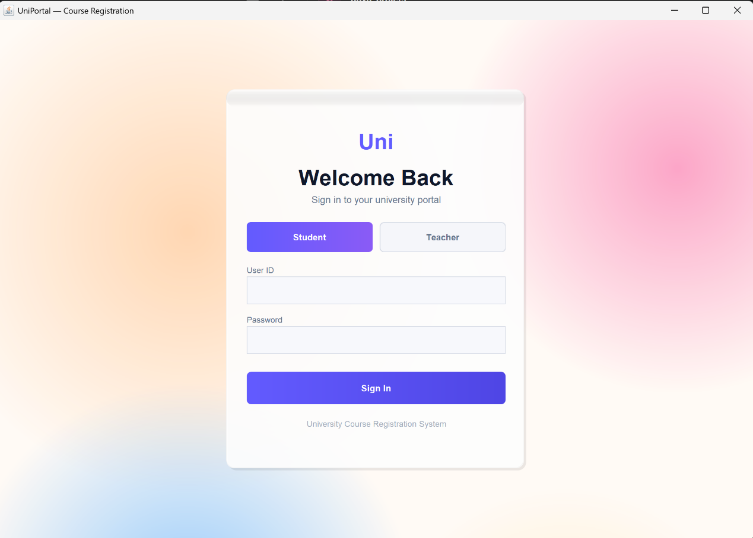

This screen allows students to log into the system using their credentials. Users must select the Student role, enter their User ID (Roll Number), and provide the password to access the system.

For demonstration purposes, the login credentials used are:
User_ID: Student Roll Number
Password: webcap

After entering the required details, the user clicks on the Sign In button. The system validates the credentials and grants access only if the entered details are correct. Upon successful login, the student is redirected to the dashboard.

Figure 7.2: Teacher (Admin) Login Screen
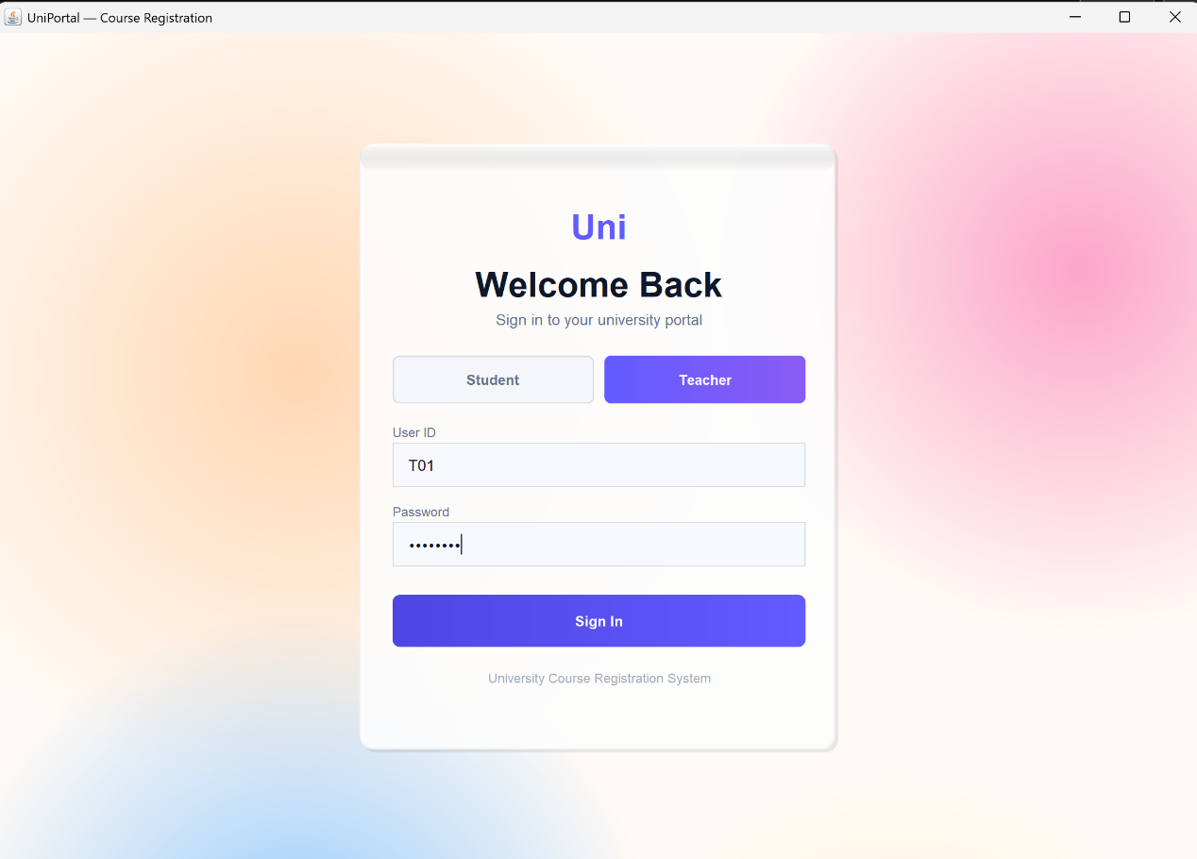
This screen enables teachers or administrators to log in by selecting the Teacher role. The user must enter valid credentials, including User ID and Password, to access the system.

For demonstration purposes, the default admin credentials used are:
User ID: T01
Password: admin123

The system verifies these credentials using role-based authentication and grants access only to authorized users. Upon successful login, the admin can manage students, courses, and enrollment details efficiently.

Figure 7.3: Student Dashboard
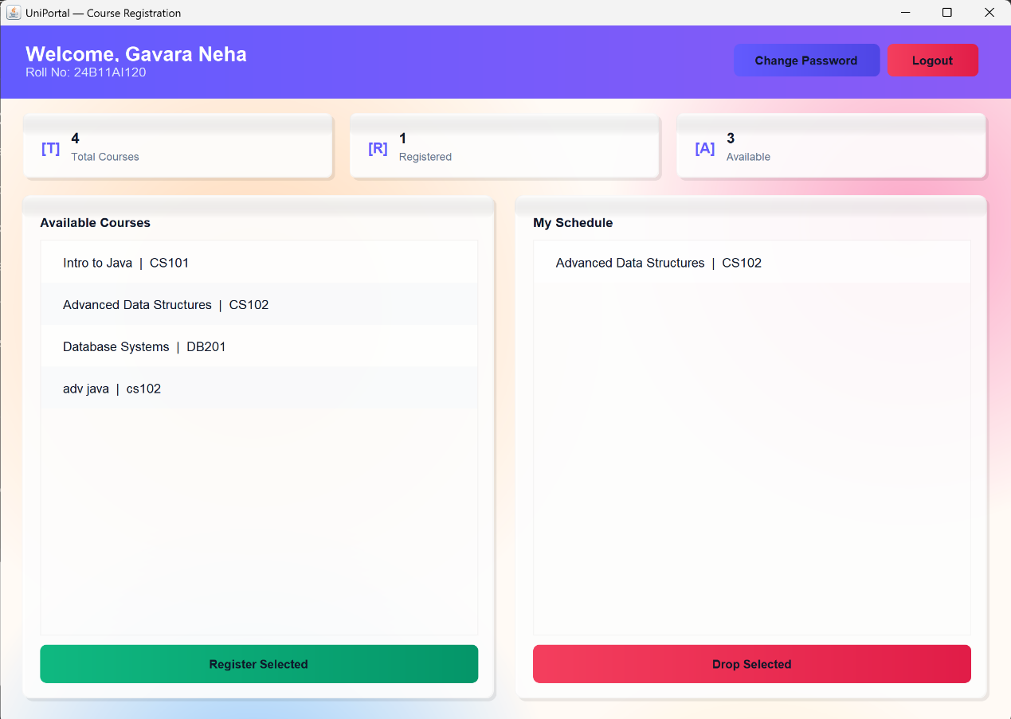

This screen represents the Student Dashboard of the University Course Registration System. After successful login, the student is redirected to this dashboard, which provides an overview of course-related information.

The dashboard displays key details such as:
• Total Courses available in the system
• Registered Courses count
• Available Courses that can be enrolled
The interface is divided into two main sections:
• Available Courses: Displays the list of courses that the student can register for
• My Schedule: Shows the courses in which the student is currently enrolled
Students can perform actions such as:
• Register for a course using the “Register Selected” button
• Drop an enrolled course using the “Drop Selected” button

Figure 7.4: Course Registration Screen
This screen allows students to select a course from the available list and register using the “Register Selected” button. The system ensures that duplicate registrations are prevented and updates the student’s schedule immediately after successful registration.

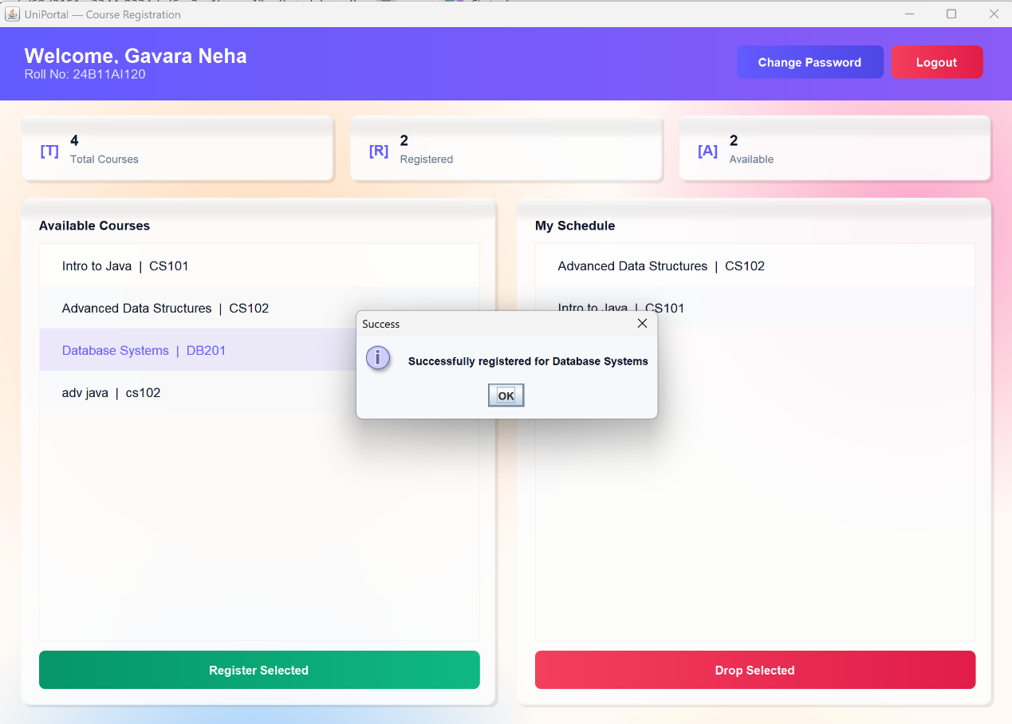

This screen allows students to view the list of available courses and register for desired subjects. The student selects a course from the Available Courses section and clicks on the “Register Selected” button to enrol.

Once a course is successfully registered, a confirmation message is displayed indicating successful enrolment. The system prevents duplicate registrations and automatically updates the My Schedule section with the newly registered course.
Additionally, the screen displays key information such as total courses, registered courses, and available courses, providing a clear overview of the student’s academic status.

Figure 7.5: Course Drop Screen
This screen enables students to drop previously registered courses using the “Drop Selected” button. The system updates the database accordingly and reflects the changes instantly on the dashboard.

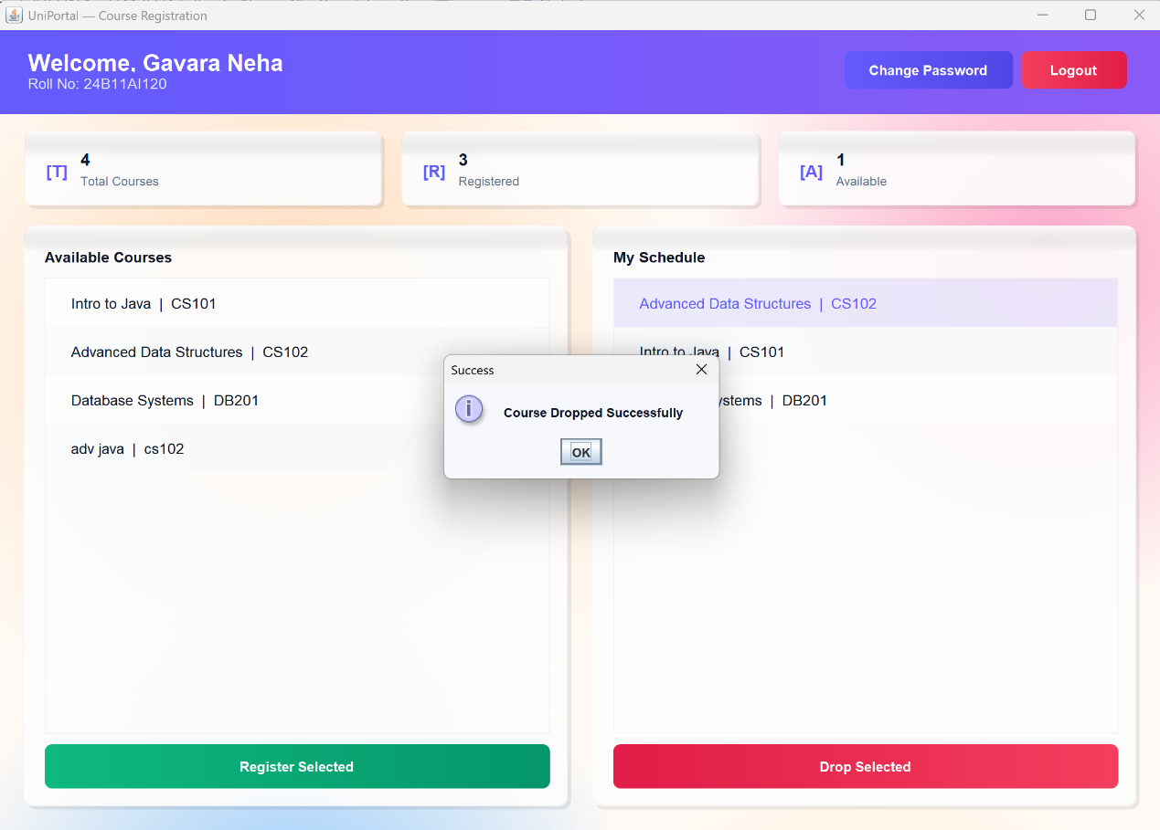

This screen allows students to drop courses that they have previously registered. The student selects a course from the My Schedule section and clicks on the “Drop Selected” button to remove it from their enrolled courses
After successful removal, a confirmation message is displayed indicating that the course has been dropped successfully. The system updates the database immediately and reflects the changes in both the My Schedule and Available Courses sections.
Additionally, the dashboard counters such as registered and available courses are updated dynamically, ensuring that the student always has an accurate view of their course status.

Figure 7.6: Change Password Screen
This screen allows users (students/admins) to securely update their account password. The user is required to enter the Old Password, New Password, and Confirm New Password in the respective fields.

The system validates the entered old password and ensures that the new password and confirm password fields match before updating. If the validation is successful, the password is updated in the database and a confirmation message is displayed.
This feature enhances system security by allowing users to periodically change their passwords and protect their accounts from unauthorized access.
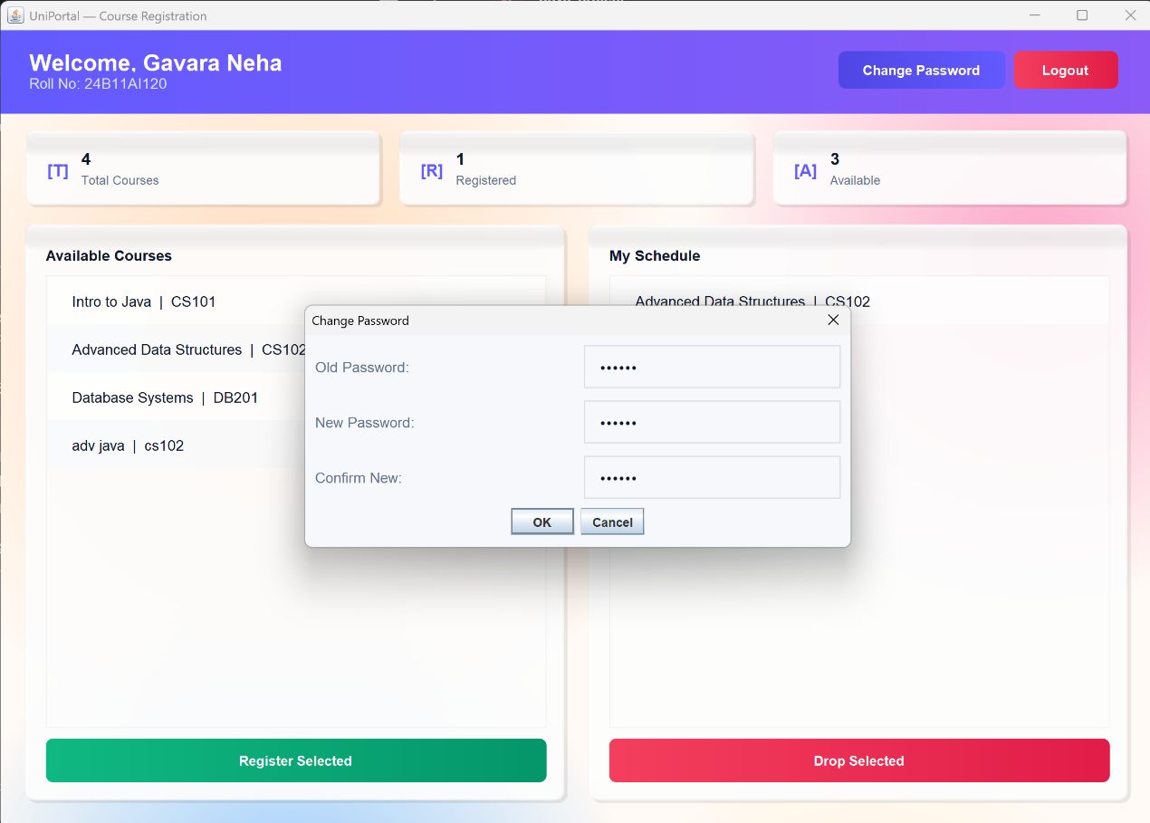

This screen allows users to securely update their password. The user must enter:
• Old password
• New password
• Confirm new password

The system validates the old password and ensures that the new password matches the confirmation before updating.

Figure 7.7: Admin Dashboard
This screen provides an overview for the administrator. It displays:
• Total number of students
• Total number of courses
The admin can navigate between student and course management sections, making it easier to monitor and control system operations.
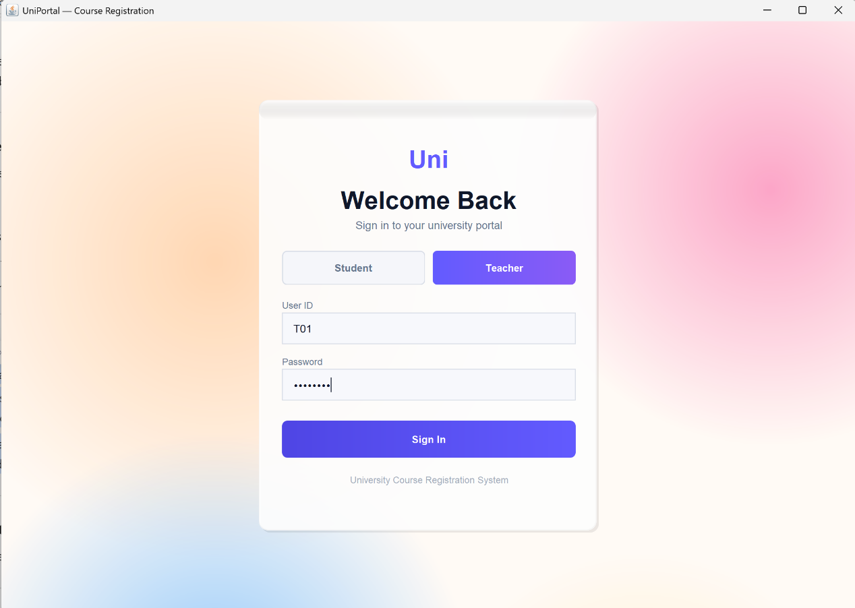

This screen provides a centralized overview for the administrator after successful login. It displays key system information such as:
• Total number of students
• Total number of courses
The admin can easily navigate between different sections like Student Management and Course Management using the available options on the dashboard

Figure 7.8: Student Management Screen
This screen allows the admin to view and manage student records. Features include:
• Viewing student list
• Searching students by roll number
• Refreshing data
• Loading additional records
This helps maintain accurate and updated student information.
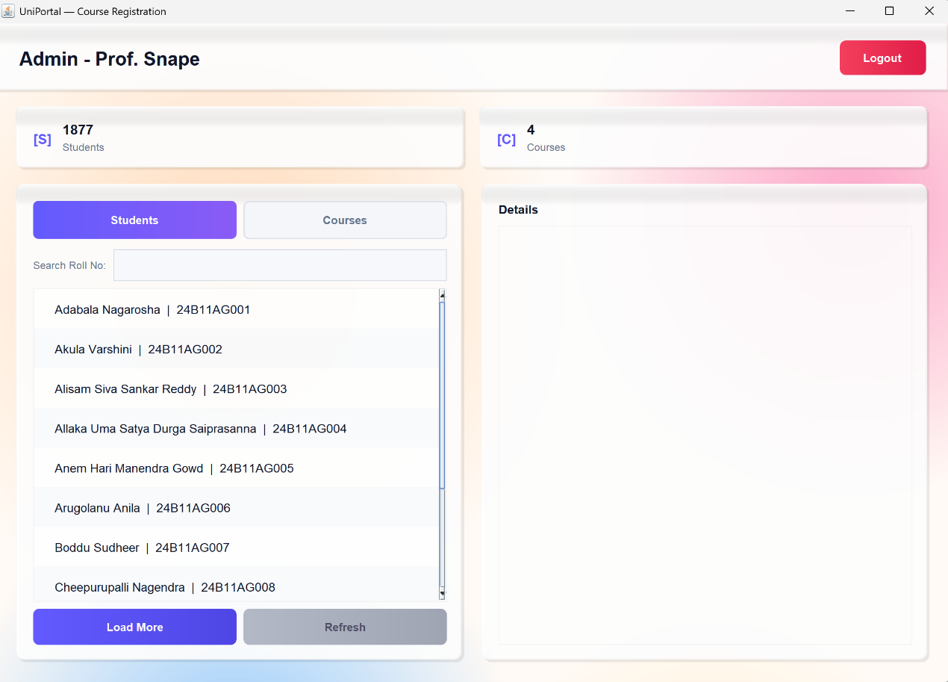

This screen enables the administrator to view and manage student records efficiently. It provides a structured interface to monitor student information and perform basic management operations.
This module helps maintain accurate, organized, and up-to-date student data, improving overall system management and usability.

Figure 7.9: Course Management Screen
This screen allows the admin to manage courses. The admin can:
• Add new courses
• Remove existing courses
• View available course list
The Add Course functionality requires entering Course ID and Course Name, which are then stored in the database.

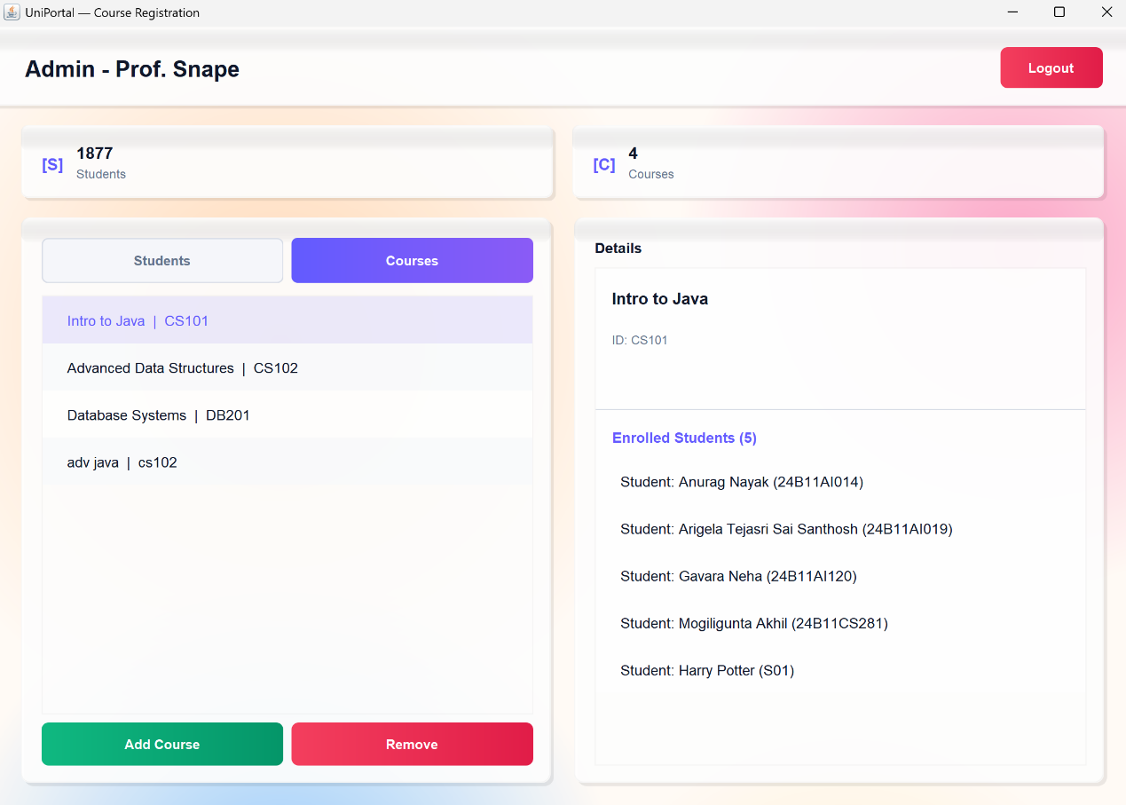

This screen enables the administrator to efficiently manage all course-related activities within the system. It provides a user-friendly interface for handling course data and monitoring student enrollments.

The admin can perform the following operations:
• Add new courses by entering Course ID and Course Name
• Remove existing courses from the system
• View the list of all available courses
• Select a course to view detailed information
The screen also displays summary information such as the total number of students and courses, giving a quick overview of system data.

When a course is selected, detailed information is shown in the Details panel, including course name, course ID, and the list of students enrolled in that course. This helps the administrator track course participation and manage academic records effectively.
The Add Course functionality allows the admin to insert new course details into the database, while the Remove option deletes selected courses and updates the system instantly.

This module ensures efficient course administration, maintains data consistency, and provides better control over the course registration system.

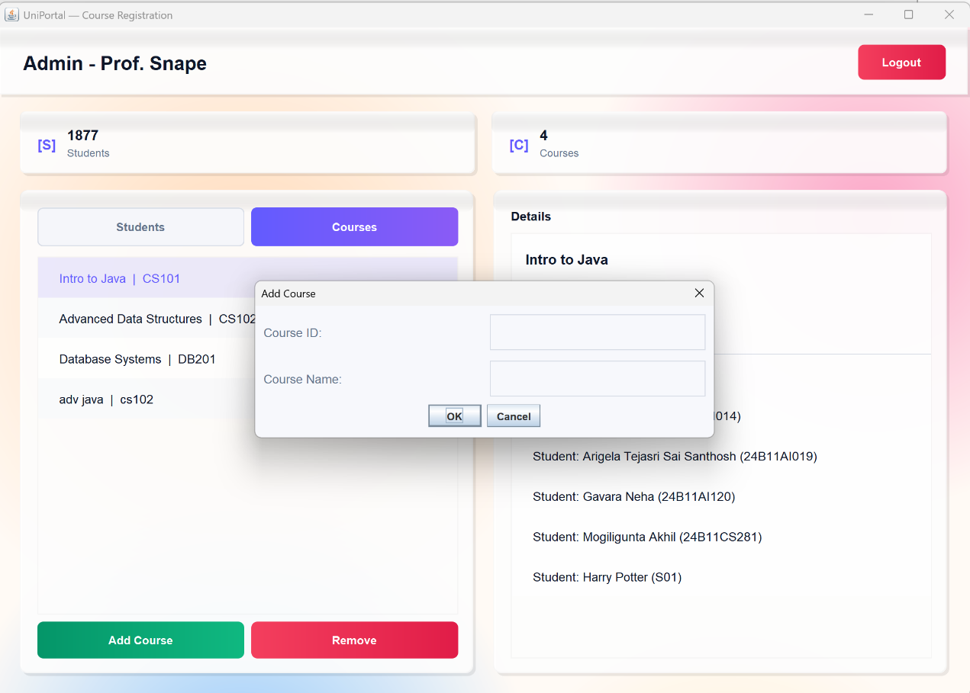

CHAPTER 8. CONCLUSION
The Student Course Registration System successfully automates the process of course enrolment, management, and administration using Java-based technologies. It replaces traditional manual systems with a digital solution that ensures accuracy, efficiency, and real-time data handling. By integrating Java Swing for GUI, JDBC for database connectivity, and object-oriented programming concepts, the system provides a structured and reliable desktop application.

The system allows students to conveniently log in, view available courses, register for selected courses, and drop courses when required. Real-time updates ensure that course availability and student schedules are always synchronized. The implementation of input validation and exception handling improves system reliability by preventing invalid data entry and handling runtime errors effectively.

From the administrator’s perspective, the system provides complete control over student and course data. Admins can manage student records, add or remove courses, and monitor enrolments through an interactive dashboard. Features such as search functionality, dynamic data loading, and refresh options enhance usability and performance, especially when dealing with large datasets.

Security is maintained through role-based authentication and password management features, ensuring that only authorized users can access specific functionalities. The use of MVC architecture helps in separating the presentation layer from business logic, making the application easier to maintain, test, and extend.

The project also demonstrates practical implementation of software engineering principles, including modular design, database normalization, and user-friendly interface development. It covers the complete software development lifecycle, from requirement analysis and system design to implementation and testing.

Overall, this project highlights the effectiveness of Java in developing real-world academic management systems. The modular and scalable design allows future enhancements such as web-based deployment, mobile application integration, cloud storage, and advanced analytics. This system serves as a strong foundation for building enterprise-level solutions in the education domain and provides valuable hands-on experience in developing full-fledged applications.

CHAPTER 9. Future Enhancements
The current system provides a robust desktop-based solution for course registration. However, several enhancements can be implemented to improve functionality, scalability, and user experience:

•Web-Based Portal Integration – Extend the system into a web application so that students and administrators can access it from browsers without installing software.

•Mobile Application Support – Develop Android/iOS applications to allow students to register or drop courses anytime, anywhere.

•Online Payment Integration – Integrate payment gateways for course fee payment, enabling secure online transactions.

•Email/SMS Notifications – Implement automated notifications for course registration confirmation, updates, and important announcements.

•Timetable Management System – Add scheduling features to avoid time conflicts between selected courses.

•Report Generation – Provide downloadable reports for students, courses, and enrollments for administrative analysis.

•Cloud Deployment – Deploy the application on cloud platforms like AWS or Google Cloud for better scalability, backup, and multi-user access.

•AI-Based Course Recommendation – Suggest courses to students based on their academic history, preferences, and performance.

These enhancements will transform the current desktop application into a more scalable, secure, and intelligent system. They also enable better accessibility, improved user experience, and readiness for real-world university-level deployment.

CHAPTER 10. REFERENCES
1.Java Official Documentation – https://docs.oracle.com/en/java/
2.Hibernate ORM Documentation –https://hibernate.org/orm/documentation/
3.JPA Documentation – https://jakarta.ee/specifications/persistence/
4.MySQL Official Documentation –https://dev.mysql.com/doc/
5.Stack Overflow –https://stackoverflow.com/questions/tagged/java
6.Java point – Java, Swing Tutorials –https://www.javatpoint.com/java-tutorial

