SyncStar — Real-Time Multi-Game Platform
A Project Report submitted in partial fulfilment of the requirements for the award of degree of

BATCHELOR OF TECHNOLOGY
in

ARTIFICIAL INTELLIGENCE AND MACHINE LEARNING
Submitted By

Anurag Nayak (24B11AI014)

N. Renuka SriHasini(24B11AI299)
Under the esteemed guidance of

Mrs. P Venkata Bala Annapurna

Assistant Professor.



DEPARTMENT OF ARTIFICIAL INTELLIGENCE AND MACHINE LEARNING
ADITYA UNIVERSITY
(Formerly Aditya Engineering College (A))

2024-2028

DEPARTMENT OF ARTIFICIAL INTELLIGENCE AND MACHINE LEARNING



CERTIFICATE
This is to certify that the project work entitled “SyncStar — Real-Time Multi-Game Platform” is being submitted by
Anurag Nayak (24B11AI014)
N. Renuka Sri Hasini (24B11AI299)
in partial fulfillment of the requirements for award of the B.Tech. degree in
Artificial Intelligence and Machine Learning.

Project Guide Head of the Department
Mrs. P Venkata Bala Annapurna, M.Tech. Dr. M. Venkatesh, _{M.Tech.,} _{Ph.D.}
Assistant Professor. Assoc. Prof., AIML Dept.

DECLARATION

We hereby declare that the project entitled “SyncStar — Real-Time Multi-Game Platform” is a genuine project. This work has been submitted to the ADITYA UNIVERSITY (Formerly Aditya Engineering College (A)), Surampalem in partial fulfillment of the B.Tech. degree. We further declare that this project work has not been submitted in full or part of the award of any degree or any other educational institutions.

by

Anurag Nayak (24B11AI014)
N.Renuka SriHasini(24B11AI299)

ACKNOWLEDGEMENT

It is with immense pleasure that we would like to express us indebted gratitude to our project Guide Mrs. P Venkata Bala Annapurna who has guided us a lot and encourage in every step of the project work, his valuable moral support and guidance throughout the project helped us a greater extent.
We are grateful to Dr. Maganti Venkatesh, Assoc. Prof. and HoD, for inspiring us all the way and for arranging all the facilities and resources needed for our project.
We wish to thank Dr. M.V. Rajesh, Assoc. Dean SoE. for the encouragement and support during the course of my project.
We would like to extend our sincere thanks to Dr. A. Ramesh, Pro Vice-Chancellor (Engg. & Sci.), Dr. G. Suresh, Registrar, Dr. S.Rama Sree, Pro Vice-Chancellor (Academics), Dr. M.B. Srinivas, Vice-Chancellor, Dr. M. Sreenivasa Reddy, Deputy Pro-Chancellor and Management, Aditya University for unconditional support for providing us the best infrastructural facilities and state of the art laboratories during our project.
Not to forget, Parents Faculty, Teaching, Non-Teaching Staff and our Friends who have directly or indirectly supported us in completing this project on time.
ABSTRACT
SyncStar (originally designated as PlaySync in early architectures) is a high-performance, real-time multiplayer collaborative platform meticulously engineered using the MERN stack (MongoDB, Express.js, React, and Node.js) in conjunction with Socket.io. The primary objective of the system is to democratize and streamline instant digital collaboration. By eliminating the friction of traditional sign-up processes and mandatory account creation, SyncStar allows users to spontaneously generate secure, private rooms for real-time whiteboard interaction and live messaging. This makes it an highly accessible solution for rapid brainstorming, remote tutoring, and agile team meetings.

At its technical core, the project centres on the robust implementation of WebSockets to establish persistent, bidirectional communication channels between the server and multiple clients. This architecture drastically reduces latency, enabling complex features such as synchronized multi-user drawing with varied toolsets (pens, erasers, colour palettes), instant chat broadcasting, and live user presence indicators that dynamically track participant state.

To guarantee data integrity and continuity, the platform leverages MongoDB as its primary database. By utilizing Mongoose models, the system efficiently archives room metadata and chat logs, ensuring that collaborative sessions are accurately documented, securely stored, and easily retrievable for late-joining users or future reference. The frontend architecture, powered by React 19, emphasizes a decoupled, component-driven approach that ensures smooth performance even during high-frequency drawing events.

Furthermore, the application features a modern, responsive user interface, heavily utilizing a "glassmorphism" aesthetic to provide a clean, intuitive user experience across various device sizes. Ultimately, SyncStar serves as a comprehensive and scalable framework for real-time web applications, demonstrating the powerful synergy between RESTful APIs, event-driven WebSocket synchronization, and modern frontend design principles
CONTENTS PAGE NO
Chapter 1: INTRODUCTION
1.1 Introduction 1
1.2 Problem Statement 1
1.3 Objectives of the Project 2
1.4 Scope of the Project 2
Chapter 2: SYSTEM OVERVIEW
2.1 High-Level Architecture 3
2.2 Real-Time Communication Bridge 3
Chapter 3: TECHNOLOGIES USED AND SYSTEM STRUCTURE
3.1 Core Technology Stack 5
3.2 Technology Layer Specifics 5
3.3 Project Structure 6
Chapter 4: DATABASE DESIGN
4.1 Storage Mechanisms 7
4.2 Document Structures 7
4.3 Database Architecture and Flow 9
Chapter 5: SYSTEM MODULES
5.1 Room Management Module 10
5.2 Collaborative Whiteboard Module 10
5.3 Live Chat Module 11
5.4 User Presence Module 11
Chapter 6: IMPLEMENTATION
6.1 Frontend Implementation 12
6.2 Backend Implementation 13
Chapter 7: OUTPUT SCREENS
Figure 7.1: Application Home Screen (Room Creation/Join) 14
Figure 7.2: Active Room displaying Collaborative Whiteboard 14
Figure 7.3: Real-Time Chat Interface demonstrating Data Persistence 15
Chapter 8: CONCLUSION
8.1 Summary 16
8.2 Future Scope 17

Chapter 9: REFERENCES
9.1 References 18
Chapter 10: APPENDIX
10.1 Database Connection Configuration (Node.js) 19

CHAPTER 1: INTRODUCTION
1.1 Introduction
In the modern digital landscape, the demand for seamless, low-latency remote collaboration has become increasingly essential for both educational and professional environments. SyncStar addresses this critical need by providing an instant, highly accessible web-based platform specifically engineered for users to communicate, brainstorm, and visualize ideas without technical barriers. From a technical perspective, the application utilizes a robust, decoupled architecture where a high-performance React 19 (Vite) frontend seamlessly interacts with a scalable Node.js and Express backend. This separation of concerns ensures maintainability and rapid rendering speeds. Furthermore, the core user experience is deliberately designed around a sleek "glassmorphism" aesthetic, providing a modern, immersive, and highly responsive user interface that adapts gracefully across various devices and screen sizes.

1.2 Problem Statement
Traditional collaborative tools and digital whiteboarding applications often impose significant barriers to entry, requiring tedious account creation processes, mandatory software downloads, and complex room-sharing logistics that stifle spontaneous collaboration. Consequently, there is a distinct lack of lightweight, fully web-native solutions that empower users to generate a functional collaborative workspace instantaneously. This friction frequently deters users who simply need a quick, temporary space for ad-hoc meetings, rapid prototyping, or remote tutoring sessions. SyncStar directly eliminates this onboarding friction by providing instant, secure room generation without requiring user login credentials, profile setups, or personal data collection, thereby democratizing access to real-time digital teamwork.

1.3 Objectives of the Project
The primary objectives driving the development of the SyncStar platform encompass both functional user-facing features and underlying technical milestones. These include: Developing a secure, instant room-generation system that automatically produces unique, shareable codes to facilitate private, isolated collaborative sessions.
Implementing a highly interactive collaborative whiteboard component featuring real-time drawing mechanics, precision erasing tools, dynamic color palette selection, and adjustable line width controls.

Ensuring ultra-low latency, real-time synchronization by utilizing WebSockets, which guarantees that all whiteboard modifications and chat messages update instantly across all connected clients.

Providing highly reliable data persistence and retrieval mechanisms for active room states and historical chat logs by leveraging the flexibility of MongoDB.
Establishing a responsive frontend design that maintains operational fluidity and visual stability even under the strain of high-frequency event broadcasting during intense drawing sessions.

1.4 Scope of the Project
The scope of this project encompasses the end-to-end development, integration, and deployment of a full-stack web application utilizing the MERN stack architecture alongside real-time communication protocols. The project is executed through clearly delineated team contributions to ensure specialized focus and efficient parallel development. N.Renuka Srihasini serves as the Front-end Developer & UI/UX Designer, holding primary responsibility for architecting the visual and interactive DOM elements utilizing React 19 and Tailwind CSS, while ensuring cross-browser compatibility and strict responsive design constraints are met. Anurag Nayak serves as the Back-end Developer and overarching system architect, tasked with engineering the server-side API logic using Node.js and Express, designing the database schemas via Mongoose, and crucially, constructing the robust Socket.io server infrastructure required to handle concurrent, bidirectional data streams between users.

CHAPTER 2: SYSTEM OVERVIEW
2.1 High-Level Architecture
SyncStar employs a meticulously designed clean architecture that places a strong emphasis on the strict separation of concerns, specifically dividing the codebase into distinct /server (API/Sockets) and /client (React UI) directories. This architectural decision ensures high maintainability, modularity, and scalability as the platform evolves and new features are integrated. The system fundamentally operates on a robust client-server model, acting as the structural foundation for all data exchange. In this topology, multiple autonomous React 19 frontends, acting as the clients, concurrently establish persistent connections to a single, highly centralized Node.js server environment.

The frontend layer is entirely responsible for rendering the visually engaging glassmorphism user interface, interpreting user inputs, and managing localized component state. Conversely, the centralized Node.js server acts as the authoritative single source of truth for the entire application. It efficiently processes all incoming HTTP REST API requests, orchestrates database interactions with MongoDB via Mongoose, and manages the complex web of real-time network traffic. This decoupled approach allows frontend and backend development to occur in parallel without restrictive interdependencies, drastically reducing integration conflicts and streamlining the overall deployment pipeline.

2.2 Real-Time Communication Bridge
The core interactive functionality of the SyncStar platform is entirely reliant on the implementation of WebSockets, which bypass the traditional, high-latency HTTP request-response cycle in favor of full-duplex, persistent communication channels. The Back-end Developer successfully engineered a highly optimized communication bridge designed specifically to allow multiple concurrent users to interact within the same isolated virtual room simultaneously, without experiencing noticeable network lag or performance degradation.

This bidirectional bridge heavily leverages the Socket.io library, serving as the engine to instantly broadcast and synchronize granular drawing events—such as precise pen movements, eraser strokes, color palette selections, and line width adjustments—across all connected clients in a given room. When a user interacts with the canvas, their client emits a continuous stream of X and Y coordinate data, which the server rapidly processes and rebroadcasts to all other peers in the active session. Furthermore, advanced state management protocols are implemented to ensure that the dynamic whiteboard coordinates are accurately mapped and rendered, regardless of the individual users' device screen sizes. Beyond drawing synchronization, this real-time infrastructure meticulously tracks live user presence, instantly updating visual indicators and colorful avatars whenever participants join, drop connection, or leave the collaborative session.

CHAPTER 3: TECHNOLOGIES USED AND SYSTEM STRUCTURE
3.1 Core Technology Stack
The SyncStar application is built upon a robust, modern technology framework tailored for high-performance web applications. The architecture is logically divided into specific technological layers to ensure maximum scalability, separation of concerns, and maintainability.

Table 3.1: Technical Stack Specifications
| Layer | Technology Implemented |
| Frontend | React 19 , Tailwind CSS, |
| Backend | Node.js, Express.js |
| Real-Time Engine | Socket.io |
| Database | MongoDB (Mongoose) |

3.2 Technology Layer Specifics
Frontend (Client-Side): The user interface is developed using React 19, initialized via the Vite build tool for highly optimized, rapid development server performance. It employs a strict component-driven architecture managed by React Router for seamless single-page application (SPA) navigation. Tailwind CSS is utilized as the primary utility-first CSS framework to rapidly implement the responsive, "glassmorphism" design aesthetic.

Backend (Server-Side): The server infrastructure is powered by the Node.js runtime environment working in tandem with the Express.js web application framework. This combination acts as a robust, non-blocking foundation for handling RESTful API requests, managing cross-origin resource sharing (CORS), and orchestrating backend business logic securely.

Real-Time Engine: Socket.io is utilized as the dedicated engine to facilitate real-time, bidirectional, and event-based communication. Bypassing standard HTTP limitations, it acts as the critical backbone for both the collaborative whiteboard module and the live chat interface, ensuring that granular state changes are instantly broadcasted to all connected clients with minimal latency.

Database Integration: MongoDB, a scalable NoSQL database, serves as the primary data storage solution. Mongoose is employed as the Object Data Modelling (ODM) library, providing a rigorous, schema-based solution to model the application data. This ensures reliable persistence and retrieval of room configurations, session states, and historical chat logs.

3.3 Project Structure
To maintain a clean, navigable, and scalable codebase, the project files are explicitly organized into distinct client and server directories. This structure directly reflects the separation of concerns inherent in the application's decoupled client-server architecture.
project/
├── server/ # Node.js backend environment
│ ├── server.js # Express configuration and Socket.io initialization
│ ├── models/Room.js # Mongoose schema for database storage
│ ├── .env # Environment variables for secure configuration
│ └── package.json # Backend dependencies and execution scripts
├── client/ # React frontend environment
│ ├── src/
│ │ ├── pages/ # Main route views (Home, Room)
│ │ ├── components/ # Modular UI elements (Whiteboard, Chat, UserList)
│ │ ├── socket.js # Client-side Socket.io configuration and connection
│ │ └── App.jsx # Application entry point and Router setup
│ └── package.json # Frontend dependencies and build scripts
└── README.md # Comprehensive project documentation

CHAPTER4: DATABASE DESIGN
4.1 Storage Mechanisms
Data persistence for the SyncStar platform is meticulously handled by MongoDB, a highly scalable, document-oriented NoSQL database. MongoDB was explicitly chosen for this project because its architecture naturally aligns with the JSON-based data structures utilized natively by both the React frontend and the Node.js backend. This technological synergy allows for rapid, seamless data transfer across the stack without the computational overhead of complex object-relational mapping (ORM) typical of traditional SQL databases.

To enforce strict data integrity and predictable structure within this flexible NoSQL environment, the backend application leverages Mongoose. Mongoose is an advanced Object Data Modeling (ODM) library for MongoDB and Node.js. It provides a rigorous, schema-based solution to model the application data. The backend features Mongoose schemas designed explicitly for data storage; these schemas dictate the exact data types, default values, and strict validation rules for every piece of information entering the database. This robust validation layer ensures that malformed or incomplete data cannot corrupt the system, which is an absolute necessity for maintaining the stability of a high-frequency, real-time collaborative application.

4.2 Document Structures
The database is intentionally architected to be lightweight, prioritizing lightning-fast read and write operations. It explicitly manages two primary collections that form the backbone of the platform's persistence layer:
Rooms Collection: This collection is responsible for managing the lifecycle of every collaborative session. Each document within this collection represents an isolated virtual workspace. The documents contain:

roomId: A uniquely generated, alphanumeric string that serves as the primary identifier and the shareable connection code for end-users.

createdAt: A centralized timestamp automatically generated by Mongoose upon document creation. This is vital for system auditing and provides the foundation for potentially implementing Time-To-Live (TTL) indexes to automatically purge inactive or stale rooms to save server space.

isActive: A boolean flag that actively tracks whether a collaborative session is currently live, allowing the server to manage active socket connections efficiently.

Chats Collection: While drawing data is ephemeral, all chat logs are saved permanently to MongoDB using dedicated Mongoose models. This persistence mechanism allows users to retrieve and see the full conversation history upon joining a room, even if they join late. These documents are structured to store:

roomId: Acting as a foreign-key equivalent, this string explicitly links a specific message to its parent room, guaranteeing strict data isolation between concurrent collaborative sessions.

userName: The temporary display name inputted by the user, providing clear attribution to the message payload.

message: The actual text content string transmitted by the client.

timestamp: The exact server-side time the message was received. This is critically used to sort the chat history chronologically when queried by the frontend interface.

Table 4.1: Database Collections Structure
Collection | Primary Fields | Data Types | Purpose
rooms | roomId, createdAt, isActive | String, Date, Boolean | Tracks and manages active collaboration sessions and their lifecycles.
chats | roomId, userName, message, timestamp | String, String, String, Date | Persists conversation history for retrieval and chronological display.

4.3 Database Architecture and Flow
To visually represent the data relationships, collections, and the flow of information between the application logic and the MongoDB cluster, the following diagram illustrates the schematic structure of the SyncStar database layer.

Figure 4.1: Entity-Relationship Diagram of the SyncStar Database Collections
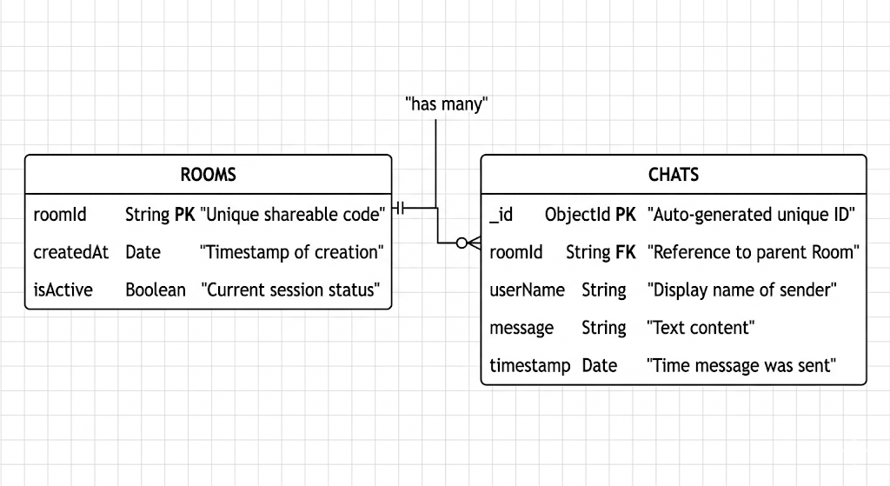

CHAPTER 5: SYSTEM MODULES
5.1 Room Management Module
The Room Management Module acts as the primary gateway and session control layer for the entire SyncStar platform. To fulfill the project's objective of frictionless, instant entry, users can generate a unique, alphanumeric room code directly from the frontend Home page without navigating through a traditional user authentication or login process. Upon requesting a new room, the Node.js backend initializes a new document within the MongoDB database, recording the unique ID, setting its active status, and logging the creation timestamp. For secondary users attempting to join an existing collaborative session, this module executes real-time validation queries against the database to verify that the inputted room code exists and corresponds to an active session. If the validation is successful, React Router seamlessly transitions the user's view to the isolated workspace environment. Conversely, if the code is invalid, the module handles the error gracefully, providing immediate visual feedback to the user on the client side.

5.2 Collaborative Whiteboard Module
Serving as the visual centerpiece of the platform, the Collaborative Whiteboard Module orchestrates the complex interactions between the frontend HTML5 Canvas and the backend real-time engine. The module captures granular user inputs—specifically mouse tracking and touch screen events—and translates them into highly precise X and Y coordinate data arrays. To maintain high rendering performance and prevent network network congestion during rapid, continuous drawing motions, the frontend limits the frequency of data transmission before emitting the coordinate packets via Socket.io. The backend subsequently acts as a high-speed relay, broadcasting these precise drawing events, alongside active tool states (such as selected hex colors, varied stroke widths, and active eraser modes), to all other connected peers in the specified room. The React component is heavily optimized to render these incoming, high-frequency data streams instantly, guaranteeing a fluid, latency-free drawing experience.

5.3 Live Chat Module
The Live Chat Module establishes a robust, persistent communication channel that operates concurrently with the visual whiteboard canvas. To provide a comprehensive messaging experience, this component employs a dual-layer data fetching architecture. When a user initially connects to a room, the React frontend executes an HTTP GET request to the dedicated REST API endpoint (GET /api/rooms/:roomId/chats). This retrieves the complete, historical chat log from the MongoDB database, allowing late-joining users to catch up on prior context. Following this initial load, the module seamlessly switches to an event-driven WebSocket model. When a participant sends a new message, the payload is immediately broadcasted via Socket.io to all active clients for instantaneous rendering in the UI, while the server simultaneously and asynchronously writes the message document to the database to ensure unbroken data persistence.

5.4 User Presence Module
To foster a sense of shared digital space and provide vital situational awareness, the User Presence Module actively tracks, manages, and broadcasts the localized connection states of all participants within a given room. The backend server listens for specific socket connection and disconnection events. When a new client joins the room's socket channel, the server emits a broadcast event that triggers the React state to update the active participant array dynamically. Similarly, intentional exits or unexpected network disconnections instantly remove the user from the active roster. The frontend application translates this localized state data into a visual representation of the room's current occupants, rendering a dynamic list featuring auto-generated, colorful user avatars and real-time online status indicators that blend seamlessly into the application's modern glassmorphism aesthetic.

CHAPTER 6: IMPLEMENTATION
6.1 Frontend Implementation
The frontend of the SyncStar platform is meticulously engineered using React 19, bootstrapped with the Vite build tool. Vite was selected over traditional bundlers to provide lightning-fast Hot Module Replacement (HMR) during development and highly optimized static asset generation for production. The application's core architecture heavily relies on modern functional components and React Hooks—specifically useState for localized data tracking, useEffect for managing component lifecycles and socket event listeners, and useRef to directly manipulate the DOM, which is strictly required for interacting with the HTML5 Canvas API in the Whiteboard component.

To ensure visual consistency and high performance, the user interface strictly adheres to a modern "glassmorphism" design system. This aesthetic is achieved by deeply integrating Tailwind CSS utility classes, utilizing semi-transparent background colors combined with backdrop-filter: blur() properties to create a frosted glass effect that is natively responsive across mobile and desktop viewports.

Logically, the application employs React Router DOM for seamless client-side routing, dividing the user flow into top-level page views: the Home page (responsible for validating and generating unique session IDs) and the Room page (the active workspace). Inside the Room view, the UI is further modularized into single-responsibility components: the Whiteboard canvas, the Chat messaging interface, and the UserList presence panel. To establish the critical real-time link, a dedicated Socket.io client instance is instantiated globally. The developer securely configured environment variables (e.g., VITE_SERVER_URL for Vite-based setups) to dynamically point the socket connections to the correct local host during development or the secure HTTPS endpoint upon final deployment.

6.2 Backend Implementation
The backend infrastructure serves as the highly concurrent, centralized hub for the SyncStar platform, built upon the non-blocking Node.js runtime environment and the Express.js framework. The primary entry point, server.js, acts as the master initialization script. It first instantiates the Express application, immediately configuring essential middleware such as express.json() for parsing incoming request bodies and CORS (Cross-Origin Resource Sharing) to explicitly whitelist the frontend domains, thereby preventing unauthorized external access to the API.

Crucially, this script then initializes the Socket.io server engine, binding it directly to the native Node HTTP server instance. This binding is required to seamlessly "upgrade" standard HTTP requests into persistent WebSocket connections. The backend developer architected complex, event-driven socket listeners (io.on('connection')). Once connected, custom logic dictates that users are placed into isolated communication channels using the socket.join(roomId) method. This allows the server to execute highly efficient, targeted broadcasting (socket.to(roomId).emit(...)) of drawing coordinates and chat payloads only to peers within that specific room, dramatically reducing unnecessary network overhead.

Furthermore, the backend developer was responsible for the strict, secure configuration of environment variables via the dotenv package, ensuring that sensitive credentials like the MongoDB Atlas URI and external port bindings (process.env.PORT) are never exposed in the source code. A critical architectural decision was also dictated for the deployment pipeline: Because WebSocket technology inherently requires a continuous, stateful, and long-lived TCP connection, traditional serverless deployment platforms (such as Vercel, which terminate idle functions after a few seconds) are fundamentally incompatible. Therefore, the implementation explicitly requires deployment on Container-as-a-Service (CaaS) or Platform-as-a-Service (PaaS) providers like Render, Railway, or Fly.io. These platforms provision persistent virtual environments capable of sustaining the continuous, low-latency bidirectional streams required by the real-time engine.

CHAPTER 7: OUTPUT SCREENS
Figure 7.1: Application Home Screen (Room Creation/Join)
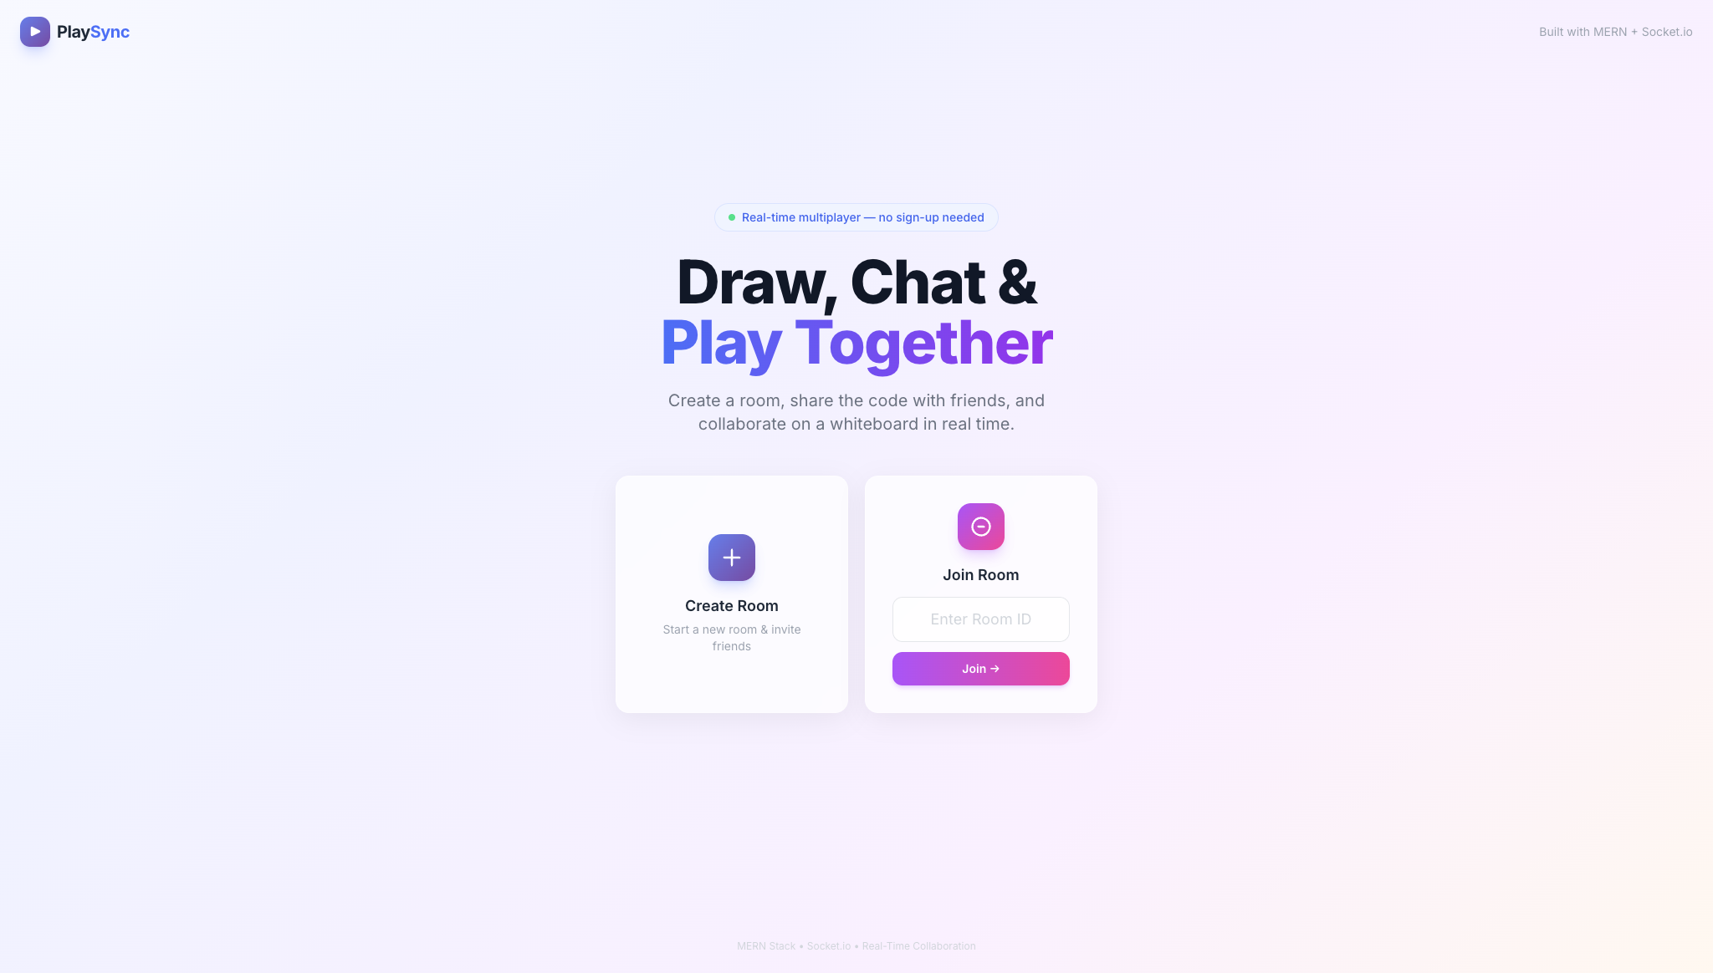
Figure 7.2: Active Room displaying Collaborative Whiteboard and User Presence
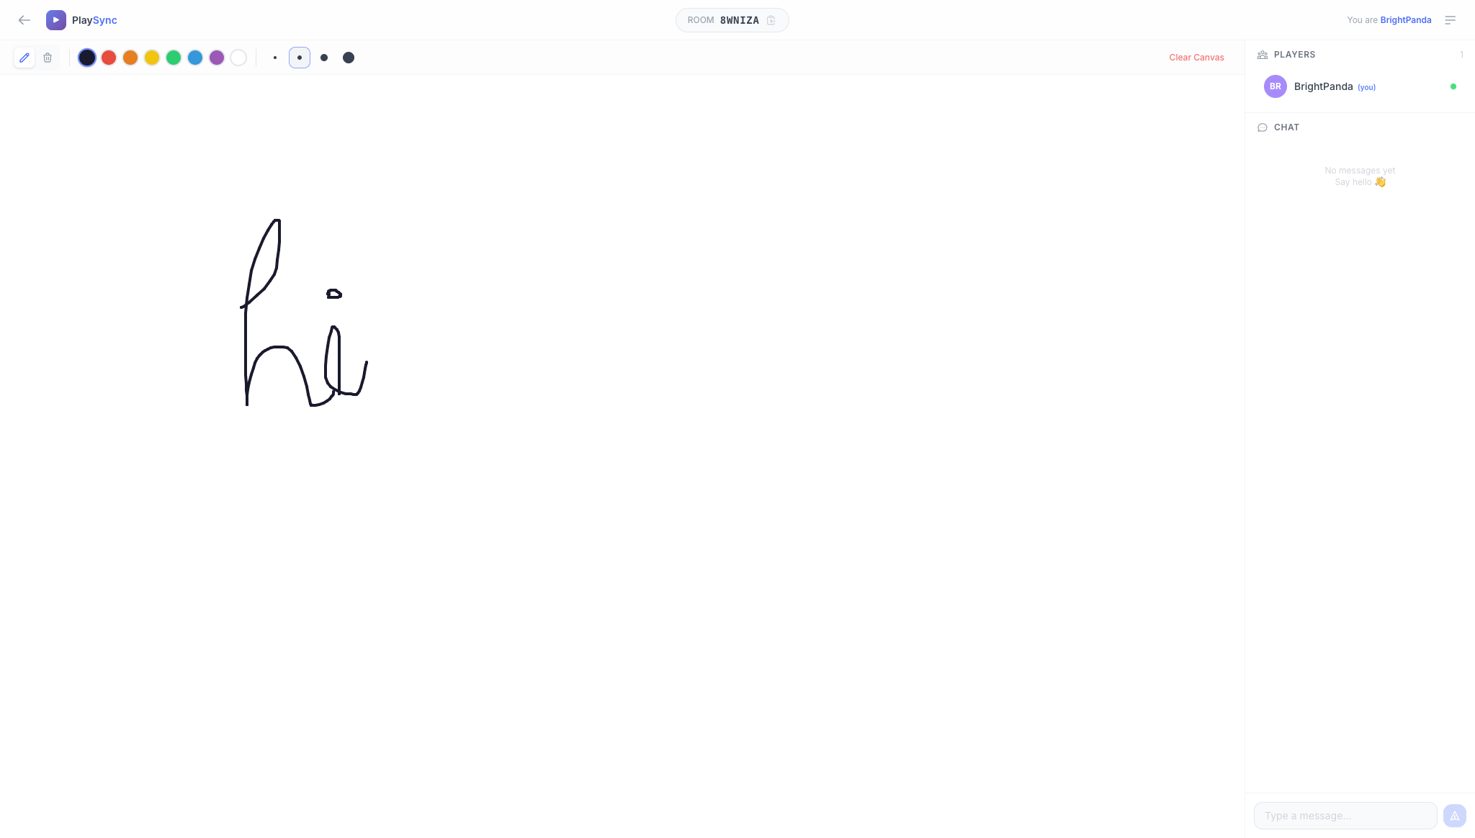

Figure 7.3: Real-Time Chat Interface demonstrating Data Persistence
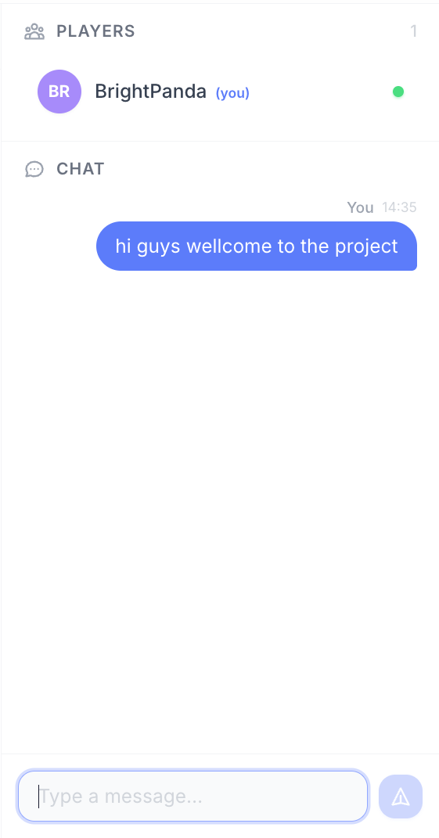

CHAPTER 8: CONCLUSION
8.1 Summary
SyncStar successfully demonstrates the robust capabilities and high-performance potential of integrating the complete MERN stack architecture with advanced WebSocket technology. Throughout its development lifecycle, the project successfully achieved its primary objective of constructing a highly responsive, frictionless, real-time collaboration environment. By intentionally engineering the system to bypass traditional, cumbersome sign-up barriers and mandatory account creations, SyncStar effectively democratizes access to digital workspaces, allowing users to initiate collaborative sessions instantaneously. The seamless synergy between the React 19 frontend and the Node.js/Express backend, facilitated by the low-latency Socket.io communication bridge, ensures that complex actions—such as synchronized, multi-user canvas drawing and live chat broadcasting—occur instantaneously across multiple distributed clients. Furthermore, the reliable integration of MongoDB provides essential data persistence for chat logs and room metadata without compromising the application's rendering speed. Ultimately, the platform serves as a highly functional, modern workspace that effectively facilitates instant digital teamwork, proving that complex real-time web applications can be both powerful and incredibly user-friendly when built upon well-structured, decoupled architectural patterns.

8.2 Future Scope
While the current iteration of SyncStar provides a comprehensive and stable foundation for real-time digital collaboration, the system's highly modular architecture allows for significant and scalable future enhancements. A primary avenue for expansion is the integration of secure OAuth 2.0 authentication protocols (such as Google or GitHub login integrations). While the platform will strictly retain its signature guest-access model to ensure low friction, providing optional user profiles would allow individuals to save personalized settings, maintain an ongoing directory of their previously created rooms, and securely archive private chat histories across devices.

Furthermore, the platform's communication capabilities could be drastically elevated by implementing WebRTC (Web Real-Time Communication). Utilizing this peer-to-peer technology would allow the introduction of live audio and video conferencing directly alongside the interactive whiteboard, transforming SyncStar into a comprehensive virtual meeting suite capable of rivaling enterprise solutions. Additionally, to improve the practical utility of the application for professional and academic environments, a robust offline export functionality should be developed. By utilizing advanced client-side rendering libraries, users would be able to capture, format, and export their completed whiteboard canvases directly into high-resolution PDF documents or standard PNG image files for offline distribution, grading, or permanent record-keeping. Finally, expanding the frontend whiteboard toolkit to include pre-defined geometric shapes, draggable text boxes, and direct image upload capabilities would further enrich the collaborative user experience.

REFERENCES
Node.js Official Documentation. Available at: https://nodejs.org/
React Web Framework. Available at: https://react.dev/
Socket.io Real-time engine. Available at: https://socket.io/
MongoDB Database. Available at: https://www.mongodb.com/

