CNN-Based Regression for Automated Aedes aegypti Egg Counting and Risk Categorization in Dengue Entomological Surveillance

Jorge Josué Chamorro Cayetano  Facultad de Ciencias e Ingeniería  Pontificia Universidad Católica del Perú (PUCP)  San Miguel, Lima, Peru  jchamorro@pucp.edu.pe | Adhemir Rodrigo Carbajal Satalaya  Facultad de Ciencias e Ingeniería  Pontificia Universidad Católica del Perú (PUCP)  San Miguel, Lima, Peru  rodrigo.carbajals@pucp.edu.pe | Gonzalo Ipanaque Lizarbe  Facultad de Ciencias e Ingeniería  Pontificia Universidad Católica del Perú (PUCP)  San Miguel, Lima, Peru  gonzalo.ipanaque@pucp.edu.pe | Pedro Gabriel Chavez Gonzalez  Facultad de Ciencias e Ingeniería  Pontificia Universidad Católica del Perú (PUCP)  San Miguel, Lima, Peru  a20210466@pucp.edu.pe | Nassim Hamed Ramirez Valenzuela  Facultad de Ciencias e Ingeniería  Pontificia Universidad Católica del Perú (PUCP)  San Miguel, Lima, Peru  a20193265@pucp.edu.pe

Abstract—Manual counting of Aedes aegypti eggs in ovitraps is laborious and error-prone, and instance-detection methods lose accuracy on small, dense, overlapping objects. This work compares three ImageNet-pretrained CNNs (ResNet-50, InceptionV3, EfficientNet-B3) adapted to direct count regression, with a post-hoc mapping to four project-defined risk categories. Over 247 annotated images and five independent runs per architecture trained with Huber Loss, ResNet-50 achieved the lowest mean absolute error (MAE = 14.12 ± 1.73 eggs). In the final test run, ResNet-50 and InceptionV3 reached 80.8% category accuracy and EfficientNet-B3 69.2%, with no non-adjacent confusions under the project thresholds; re-mapped to Peruvian Ministry of Health (MINSA) bands, ResNet-50 remained the most accurate. EfficientNet-B3 gave the closest estimate on the highest-density test image (339 vs. 382 eggs) but underestimated risk categories most often. These are preliminary results of a project developed between March and July 2026.
Index Terms—Aedes aegypti, ovitraps, egg counting, convolutional neural networks, regression, entomological surveillance, dengue.

Introduction
Dengue has become a crisis in the Andean and Southern Cone regions of Latin America, where health systems are strained and calls have been made to strengthen surveillance and vector control [1]. Peru reported 222,620 cases (139,366 confirmed) and 381 deaths from January 1 to July 29, 2023 [2], and 160,757 cases in the first 15 weeks of 2024, against 42,511 in the same period of 2023 [1]. A Health Emergency was declared on February 28, 2024; children and adolescents accounted for about 29.6% of cases and 13.6% of deaths, and official figures likely underestimate the true burden because of underreporting [3]. Routine dengue case reporting across the Americas is subject to delays that must be corrected to obtain accurate counts [4], and the cost of a non-fatal episode treated in the formal health system ranges from US$15.0 to US$9,386.1 across 56 studies [5].
Ovitrap surveillance uses egg numbers to compute infestation indices [6], but counting the eggs under a magnifying lens or microscope is tedious, slow and error-prone [6], [7]. Automated alternatives have relied on detection: on 10 microscopic and 10 macroscopic images, EggCountAI (Mask R-CNN) reached 98.88% and 96.06% accuracy [7], and Vicente et al. evaluated Faster R-CNN, SABL and FoveaBox on a dataset of field and laboratory eggs [6]. Detectors must individualize each egg, whereas small objects carry limited spatial and contextual information and are affected by low resolution, occlusion and background interference [8]. Clustered eggs (Fig. 1b), common in laboratory mass production, raise the error: on the 543-egg image of [6], the best detector counted 335.
In the literature reviewed for this work (IEEE Xplore and Scopus, 2022–2026), we did not identify a study that compares transfer-learning backbones under direct count regression for ovitrap eggs while reporting the direction of risk-category errors. This work addresses that gap with a comparative evaluation of three encoders under a unified regression formulation trained with Huber Loss, assessed by mean error, category accuracy, direction of category errors, and behavior at extreme density. Our images are a working copy of the public set of [6], where FoveaBox reached a mean MAE of 9.21 and RMSE of 23.63 under 10-fold cross-validation; these figures are not directly comparable with ours, obtained on a single fixed split.
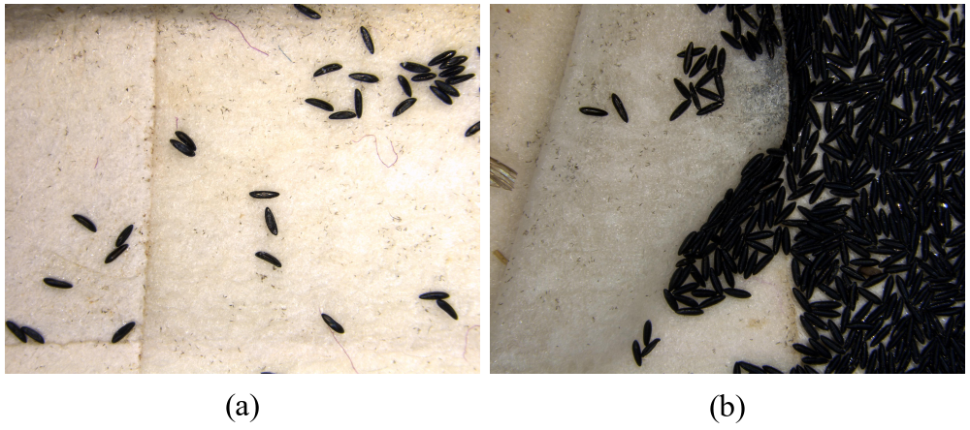
- Aedes aegypti eggs in two project images: (a) sparse, 34 annotated eggs; (b) clustered, 382 annotated eggs. Source: repository files 56.jpg and 144.jpg, from the public set of [6].

Problem Statement and Objectives
Table I summarizes the problem tree of this research, with the source backing each stated fact; Table II presents the SMART objectives, each mitigating one root cause.
- PROBLEM TREE. SOURCE: OWN ELABORATION; CITATIONS SUPPORT THE STATED FACTS, AND THE LINKS BETWEEN COMPONENTS ARE THE AUTHORS' INFERENCE.
Component | Description
Cause C1 | Manual egg counting under a microscope is laborious and prone to human error [7].
Cause C2 | Detection methods lose accuracy on small, clustered or occluded objects [8], including dense eggs [6].
Cause C3 | Strained regional health systems; surveillance and vector control need strengthening [1].
Central problem | In high-density ovitrap samples, the manual egg count that public health staff use to report entomological risk [9] is slow and imprecise [6], [7], which can delay alerts and vector-control actions.
Effect E1 | Delays in routine case reporting hinder timely outbreak response [4].
Effect E2 | Increased cases and deaths, with children and adolescents accounting for about 29.6% of cases [3].
Effect E3 | Economic burden on the health system and affected households [5].
- GENERAL AND SPECIFIC (SMART) OBJECTIVES, MARCH-JULY 2026. SOURCE: OWN ELABORATION; EACH SO CORRESPONDS ONE-TO-ONE TO A ROOT CAUSE IN TABLE I.
Objective | Description
General | To comparatively evaluate three pretrained CNN architectures adapted to a direct count-regression scheme, applied to ovitrap egg images for Aedes aegypti entomological surveillance, in order to provide public health staff with a risk-category estimate that reduces the risk of underestimation in epidemiological alerts.
SO1 (C1) | Implement an automated regression-based count estimation pipeline, without human intervention and with non-negative predictions, by July 2026.
SO2 (C2) | Train and evaluate the three architectures in two phases with Huber Loss, with five runs per architecture (15 total), quantifying MAE, RMSE and MdAE, between June and July 2026.
SO3 (C3) | Determine, via confusion matrices and the maximum-density case, the direction of each architecture's risk-category errors, as input for strained surveillance services, in July 2026.

Methodology

Dataset
We used "dengue-ruehm" (247 images, 12,507 annotated eggs, single class "ovo", CC BY 4.0), a co-author's working copy on Roboflow Universe of the public-domain set of Vicente et al. [6]. All images were taken with a laboratory stereomicroscope, and the set combines field-collected and laboratory-reared eggs [6]. True count N was obtained by aggregating bounding boxes per image. Split: 70/20/10%, fixed seed (SEED = 42).

Architecture and Training
The three encoders share an identical regression head (GAP, linear layer, final ReLU), guaranteeing non-negative predictions. Training in two phases: 10 epochs with the encoder frozen (lr = 1e-3) and up to 50 with the last third of the encoder's top-level blocks unfrozen (lr = 1e-4), with ReduceLROnPlateau and early stopping (patience = 10). Given the skewness of the counts (median 18, maximum 543), Huber Loss (delta = 1.0) was used instead of MSE.

Evaluation
Each architecture was trained over five independent runs to measure stability; test-set MAE, RMSE and MdAE are reported as mean ± sample standard deviation. Predictions were mapped via a deterministic rule to four project-defined categories per image: Low (<10), Medium (10–49), High (50–99) and Very High (≥100). These are not the official Egg Density Index (IDH), which MINSA defines as total eggs over positive ovitraps in an area, with bands at 5, 20 and 40; MINSA also sets per-ovitrap hotspot bands at 60, 120 and 150 [9]. Category accuracy and error direction were computed on the 26-image test set of the final run (4 Low, 15 Medium, 4 High and 3 Very High images).

Preliminary Results
Fig. 2 and Table III summarize the results across the five runs per architecture. ResNet-50 obtained the lowest error on all three metrics, while InceptionV3 had the worst averages and the widest MAE and RMSE dispersion; EfficientNet-B3 was intermediate.
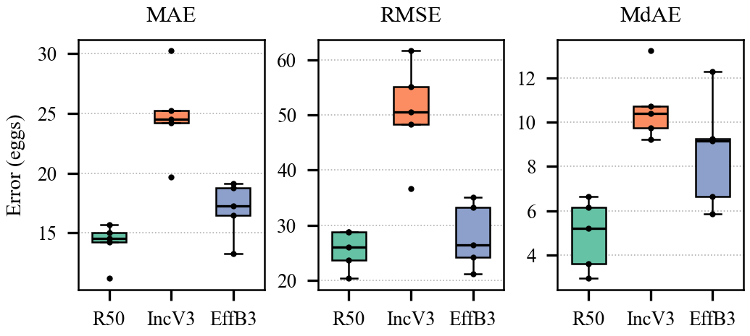
- Distribution of MAE, RMSE and MdAE over five independent runs (R50: ResNet-50; IncV3: InceptionV3; EffB3: EfficientNet-B3). Source: own elaboration from the project repository results.
- SUMMARY OF RESULTS. ERROR METRICS: TEST-SET MEAN ± SD OVER FIVE RUNS; *: FINAL RUN, 26 TEST IMAGES, PROJECT THRESHOLDS. SOURCE: PROJECT REPOSITORY.
Metric | ResNet-50 | InceptionV3 | EfficientNet-B3
MAE (eggs) | 14.12 ± 1.73 | 24.78 ± 3.77 | 16.98 ± 2.33
RMSE (eggs) | 25.58 ± 3.60 | 50.45 ± 9.20 | 28.05 ± 5.94
MdAE (eggs) | 4.91 ± 1.60 | 10.66 ± 1.55 | 8.64 ± 2.53
Category accuracy* | 80.8% | 80.8% | 69.2%
Underestimated categories* | 4 | 1 | 8
Non-adjacent errors* | 0 | 0 | 0
Prediction for N = 382* | 267.9 | 133.1 | 339.3

On the highest-density test image (382 true eggs), InceptionV3 underestimated the count by 65% (133), ResNet-50 by 30% (268) and EfficientNet-B3 by 11% (339), yet all three still assigned it to the Very High category (Fig. 3). At the category level (Fig. 4), ResNet-50 and InceptionV3 each classified 21 of 26 test images correctly and EfficientNet-B3 18 of 26, with no non-adjacent confusions. All eight EfficientNet-B3 errors were underestimations (six Medium→Low and two High→Medium), compared with four for ResNet-50 and one for InceptionV3, whose errors were mostly overestimations (four of five). All three models placed the three Very High test images correctly, so at these thresholds they differ at extreme density in the count, not in the alert level. Re-mapped to the MINSA bands [9], taking each image as one positive ovitrap (an approximation), accuracy was 80.8%, 65.4% and 53.8% (ResNet-50, InceptionV3, EfficientNet-B3) at 5/20/40, with 0, 0 and 2 non-adjacent errors, and 88.5%, 80.8% and 84.6% at 60/120/150, with 0, 2 and 1. ResNet-50 stayed the most accurate, but alert-level findings depend on the thresholds.
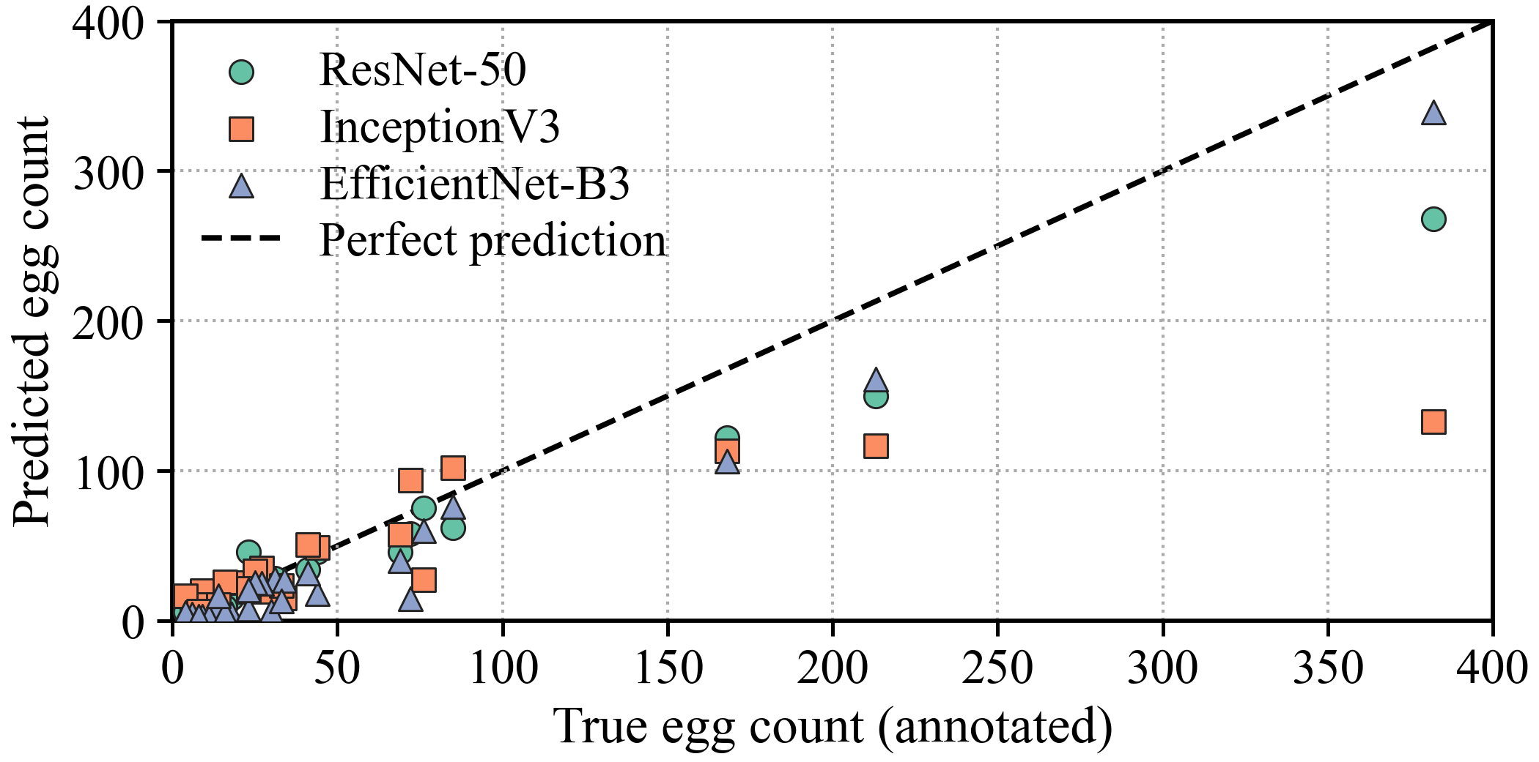
- True vs. predicted egg count on the 26-image test set (final run). Source: own elaboration from the project repository predictions.
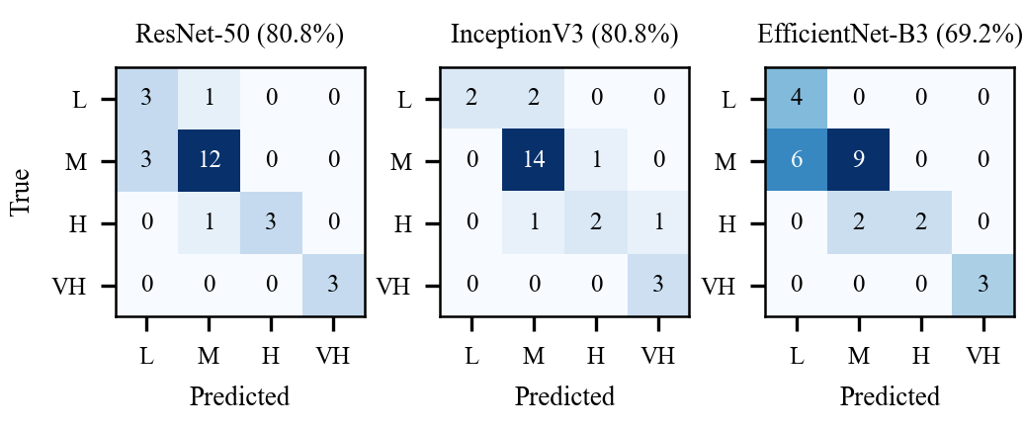
- Risk-category confusion matrices on the test set (final run). L, M, H, VH: Low, Medium, High, Very High; category accuracy in parentheses. Source: own elaboration from the project repository predictions.

Discussion and Limitations
No architecture dominates all criteria. ResNet-50 offers the best balance in this study: the lowest mean errors, the smallest MAE and RMSE dispersion, and the highest category accuracy (tied with InceptionV3 under the project thresholds) with few underestimations. Against EfficientNet-B3, however, only the MdAE gap was significant (Welch, five runs per model: MdAE p = 0.03, MAE p = 0.06, RMSE p = 0.45). EfficientNet-B3 tracked the single highest-density image best but underestimated categories most often under the project thresholds, and InceptionV3 had the widest MAE and RMSE dispersion. Authors' interpretation: since underestimating an epidemic can result in insufficient control efforts [4], we consider underestimating a risk category more harmful than overestimating it in an alert setting, so the current evidence does not support preferring EfficientNet-B3; its extreme-density advantage should be confirmed on more high-density images. Limitations: only 247 images and three Very High test images, all taken under a laboratory stereomicroscope (the densest ones traceable to [6] are laboratory-reared eggs); category results from a single final run; and a post-hoc mapping with project thresholds rather than a learning objective.

Conclusion and Future Work
A preliminary comparison of three CNNs for regression-based Aedes aegypti egg counting and risk categorization was presented. ResNet-50 achieved the lowest mean errors and the highest category accuracy under all three threshold sets (tied with InceptionV3 under the project's), whereas EfficientNet-B3 was closest on the single highest-density image but underestimated categories most often under the project thresholds. Future work includes more high-density and smartphone field images, validation against the area-level IDH, density maps for severe overlap, and classification of biological egg viability.

Data Availability and Acknowledgment
Source code, including the threshold re-mapping: https://github.com/darkJCdark/cnn-ordinal-classifier-egg-ovitrap . Dataset working copy (CC BY 4.0): https://universe.roboflow.com/rodrigo-carbajal/dengue-ruehm . Public-domain source set [6]: https://universe.roboflow.com/micheli-vicente-9p46w/aedes01 . Claude (Anthropic) was used to draft and edit the text and to compute the threshold re-mapping and significance tests; the authors reviewed the content and take responsibility for it.

References
- E. Ortiz-Prado, J. S. Izquierdo-Condoy, and J. Vásconez-González, "Urgent response needed: Addressing the dengue crisis in the Andean and Southern Cone Latin American regions," Am. J. Trop. Med. Hyg., vol. 111, no. 4, pp. 714-718, 2024. doi: 10.4269/ajtmh.24-0178
- C. V. Munayco et al., "Notes from the field: Dengue outbreak — Peru, 2023," MMWR Morb. Mortal. Wkly. Rep., vol. 73, no. 4, pp. 86-88, 2024. doi: 10.15585/mmwr.mm7304a4
- H. Ashfaq, H. Ashraf, M. Butt, and A. Ashfaq, "Dengue crisis escalates in Peru in 2024: A call for immediate action," Disaster Med. Public Health Prep., vol. 19, p. e84, 2025. doi: 10.1017/dmp.2025.50 [Letter to the Editor].
- K. M. Susong, A. Lim, K. Joshi, J. Clarke, K. Sherratt, and O. J. Brady, "Quantifying, understanding, and correcting for delays in routine dengue case reporting in the Americas," Am. J. Trop. Med. Hyg., vol. 115, no. 2, pp. 348-357, 2026. doi: 10.4269/ajtmh.26-0020
- D. Leelavanich, I. Dorigatti, and H. C. Turner, "The economic burden of dengue: A systematic literature review of unit costs for non-fatal episodes treated in the formal healthcare system," BMC Infect. Dis., vol. 26, p. 320, 2026. doi: 10.1186/s12879-025-12451-8
- M. N. O. Vicente et al., "Aedes aegypti egg counting with neural networks for object detection," Rev. Inform. Teor. Apl., vol. 32, no. 1, pp. 287-293, 2025. doi: 10.22456/2175-2745.143494
- N. Javed, A. J. López-Denman, P. N. Paradkar, and A. Bhatti, "EggCountAI: a convolutional neural network-based software for counting of Aedes aegypti mosquito eggs," Parasit. Vectors, vol. 16, no. 1, p. 341, 2023. doi: 10.1186/s13071-023-05956-1
- M. Nikouei et al., "Small object detection: A comprehensive survey on challenges, techniques and real-world applications," Intell. Syst. Appl., vol. 27, p. 200561, 2025. doi: 10.1016/j.iswa.2025.200561 [Survey].
- Ministerio de Salud del Perú, "Protocolo sanitario de urgencia para el reforzamiento de la vigilancia entomológica del vector Aedes aegypti mediante el uso de ovitrampas para establecimientos de salud," PSU N° 11-MINSA/DVMSP/DGSP (R.M. N° 010-2015/MINSA), Lima, 2016 [Official norm, not indexed].

