A NEW METHOD FOR CONTRAST ENHANCEMENT OF AN IMAGE
R. Vorobel, roman.vorobel@gmail.com

Physico-Mechanical Institute of NAS of Ukraine, Lviv; Lodz University, Poland

Introduction. In low-level image processing systems image enhancement is one of the most important issues [1]. Its purpose is to improve the quality of low contrast images. A lot of methods for image enhancement can be divided on two classes: global and local. Frequency methods are used for the first class and spatial domain methods – for the second class. For example, the methods of local contrast improving [2-3] belong to the second class. But they have low effectiveness. We had been developing method of this class.
Basic method for local contrast transformation. Gordon’s method [2] and Beghdadi’s modification [2] are well-known in image processing. They are three steps methods. At the first step image local contrast is evaluated
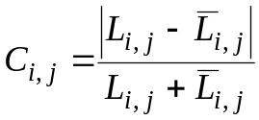,
where
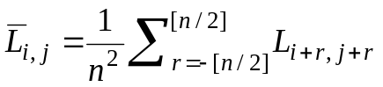.
At the second step nonlinear enhancement of this contrast 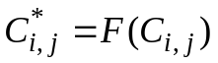 is realized, for which nonlinear functions 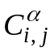, 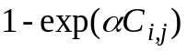, 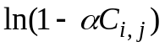, 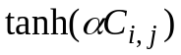 and another are used. We assume that transformation function satisfies such conditions:
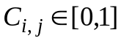, 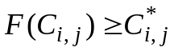, 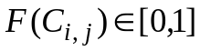.
At the last step new enhancement image is restored by the formulas
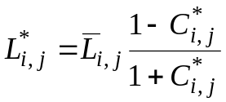 if 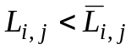 and if 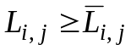.
But low effectiveness for contrast improving is a disadvantage of this approach.
New method for image contrast enhancement. We propose to use another image model, where calculate not a local contrast but its logical complement – as a measure of similarity, defined as
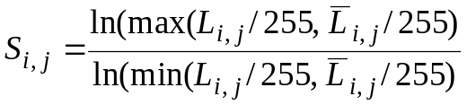, (1)
and similar three step method for image contrast enhancement. We evaluate similarity 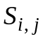 (1) on the first step.
Then we decrease this similarity by non linear power intensification 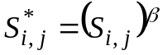, where 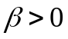, with property
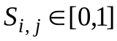, 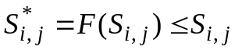, 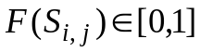
and form the similarity estimation with the sign of difference between values 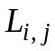 and 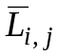 using expression
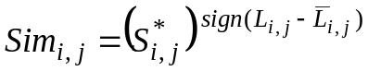.
At the last step we form restored image with enhanced local contrast by formula
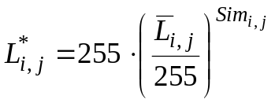.
Conclusion. Practical analysis confirmed the efficiency of proposed method for contrast enhancement of an image.

References

1. Vorobel R.A. Logarithmic image processing. Kyiv: Naukova Dumka. – 2012. – 231 p. (In Ukrainian).
2. Gordon R., Rangayan. Feature enhancement of film mammograms using fixed and adaptive neighborhood // Applied Optics. 1984. – Vol. 23. – P. 560-564.
3. Beghdadi A., Negrate A.L. Contrast enhancement technique based on local detection of edges // CVGIP. – 1989. – Vol. 46. – P. 162-174.

