PARAMETRIC ALGEBRAIC MODELS FOR IMAGE PROCESSING
R. Vorobel, roman.vorobel@gmail.com,

Physico-Mechanical Institute NAS of Ukraine, Lviv; Lodz University, Poland

Introduction. Practical implementation of different pattern recognition methods demands image preprocessing. The aim of preprocessing is to normalize a brightness distribution, to minimize a noise level and to establishment the necessary object contrast. Rank filtration and brightness equalization that presents object features uniformly are used for this purpose. The filtration is based on calculation of maximum. However this process can be substantially enhanced using the models of logarithmic image processing (LIP) that is based on human light perception Weber-Fechner law. Image preprocessing can be combined with filtration by building image processing algebra where addition is similar to maximum operation. Therefore the aim of the paper is to construct LIP parametric models that implement arithmetic operations with the given above features.
The Hamacher triangular norm and its parameterization. To reach the aim of the work we use an approach of construction algebras with logarithmic-type operations described in [2]. We select the nonlinear function 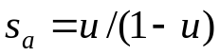 as an additive generator of Hamacher triangular s-norm [1]. We use the known property of a nonlinear strictly increasing bijection 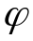 – 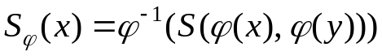 for triangular s-norm S. We chose as direct power transform 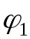 and inverse power transform 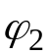. For these two cases we build the real vector space algebraic structures based on an additive generator of Hamacher triangular s-norm, which are different models of LIP.
A parametric LIP model based on the generator 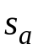 and the transformation 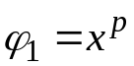. Using the approach proposed in paper [2] we determine that 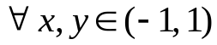 and 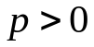 the addition operation is defined by the following relation:
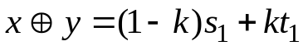, where 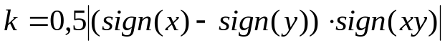,
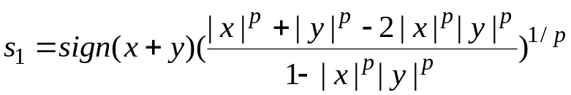,
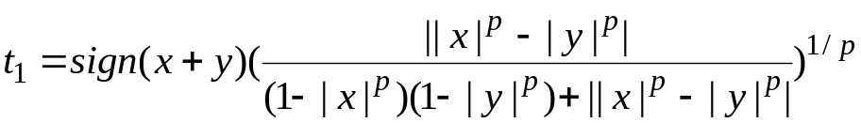.
The multiplication by scalar operation is defined by the formula: 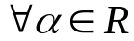, 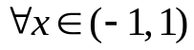
.
Note, that 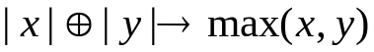 when 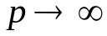.
A parametric LIP model based on the generator and the transformation 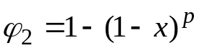. і the addition operation is defined by the following relation: 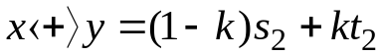, 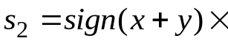
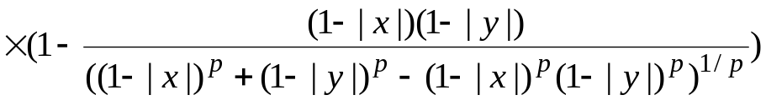,
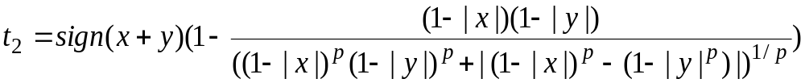.
The multiplication by scalar operation is defined by the formula: , :
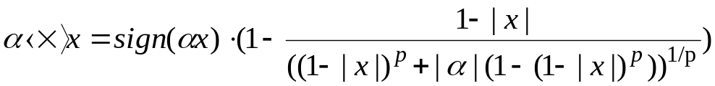.
Conclusion. Proposed LIP model confirmed they efficiency.

References
1. Klement E.P., Mesiar R., Pap E. Triangular Norms. Kluwer Academic Publishers. Dordrecht-Boston-London. 2000. – 385 p.
2. Vorobel R.A. Construction of logarithmic type algebras. Information Extraction and Processing. 2010. Issue 32(108). P. 131-143.

