ANALYSIS OF TIME RELIABILITY INDICES
FOR SYMMETRIC RAMIFIED SYSTEMS
A.Sydor, sydor_ar@polynet.lviv.ua, Lviv Polytechnic National University

Let us consider a symmetric complicated system, ramified to level 3, with Rayleigh distributed output elements (Fig. 1), where a₁ elements of level 1 are subordinate to the element of level 0, a₂ elements of level 2 are subordinate to every element of level 1, a₃ elements of level 3 are subordinate to every element of level 2. a₁ is a coefficient of ramification to level 1, a₂ is a coefficient of ramification to level 2 and a₃ is a coefficient of ramification to level 3.
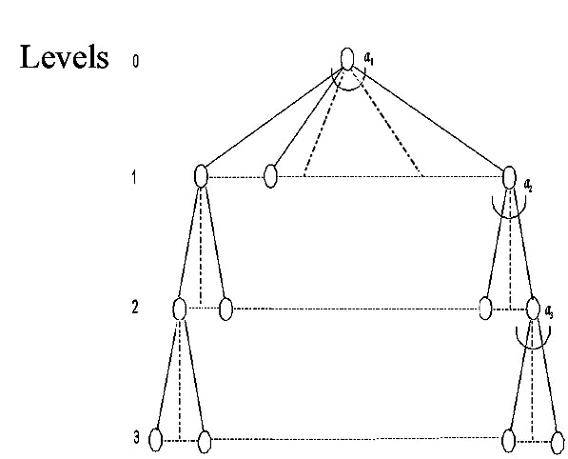
Fig. 1 A symmetric system ramified to level 3
We use T_{3R}(x₃) to denote the average duration of the system’s stay in a state of x₃ operating output elements on condition that lifetime of ageing output elements is circumscribed by the Rayleigh distribution. It is calculated in case of x₃>0 by the next equation:
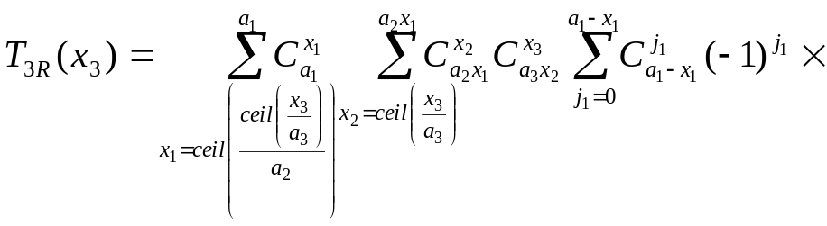
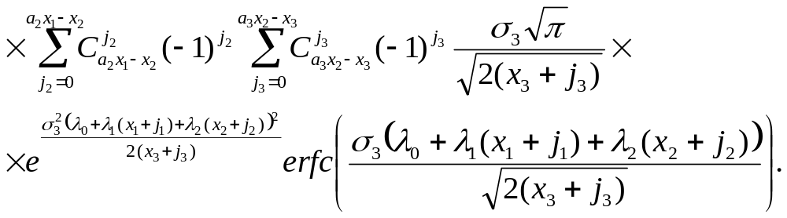
The sum of average durations of the system’s stay in states over count of output elements from k to a total number of output elements of the system is equal to the average duration of the system’s stay in the prescribed availability condition k.
Let T_{Г3R}(k) be the average duration of the system’s stay in the availability condition k provided that the lifetime of ageing output elements is circumscribed by the Rayleigh distribution. We obtain:
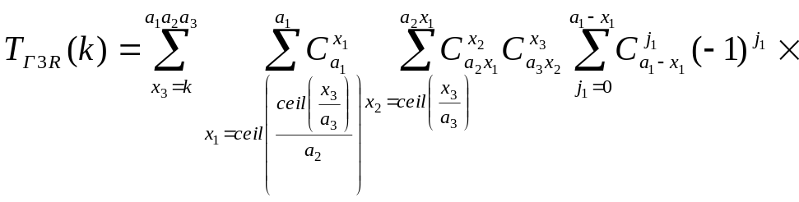
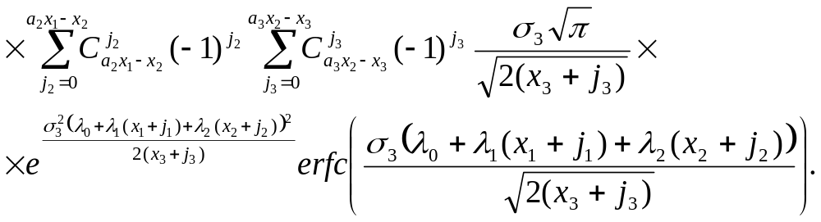
Prediction of reliability parameters at stages of design of symmetric ramified systems makes possible to evaluate their time reliability indices.

REFERENCES
[1] Sydor A. “A choice of lifetime distribution functions for elements of hierarchical ramified systems”, Proceedings of the VII th International Conference CADSM 2003 “The Experience of Designing and Application of CAD Systems in Microelectronics”. Lviv – Slavske, 2003, pp. 262-263.

