INFORMATION TECHNOLOGY IN THE MATHEMATICAL MODELING OF THE DIFFRACTION PROBLEM OF ELECTROMAGNETIC WAVES ON PRE-FRACTAL STRUCTURES.
Nesvit K. V., e-mail: nesvit.k@gmail.com, Karazin Kharkiv National University
Information technology (IT) focused on the study of the most efficient methods for solving various problems. With present-day conditions in mind, the antennas technology is one of the most rapidly developing areas of electronics. Broadband antenna which can cover the frequency range the entire spectrum of radio wave must have a fractal shape. This is shown while performed mathematical calculations. Further research in the field has led to a wide practical use of fractal antennas in mobile devices.
The model which is considered in this paper is an approximation of a real fractal antenna in 2D. In the study of antennas, fractal antenna theory is a relatively new area. This makes the numerical analysis of the diffraction problems of TM modes on pre-fractal strips an interesting and a vital challenge for today’s industrial needs.
Mathematical modeling of the diffraction and scattering problem on pre-fractal structures leads to the solution of Maxwell's equations, which are reduced to the solution of difficult boundary-value problems for the Helmholtz equation.
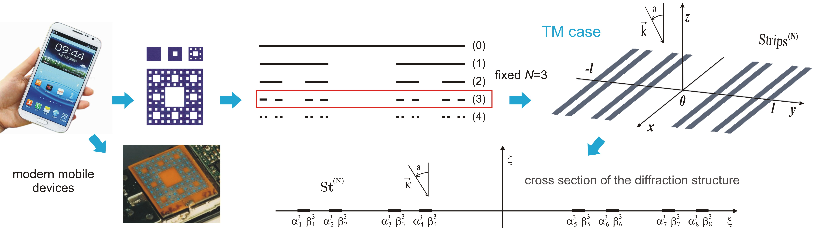
Fig. 1. Schematic of the considered diffraction structure.
We need to find the total field which results from the scattering of H polarized monochromatic plane wave on considered diffraction structure.
To lead the boundary-value problem into singular integral equations (SIEs) with supplemented conditions it is necessary to use specific parametric representations of the singular integral operator. Thus, mathematical model describes the solution for diffraction problem on pre-Cantor grating and is based on SIEs with supplemented conditions (1).
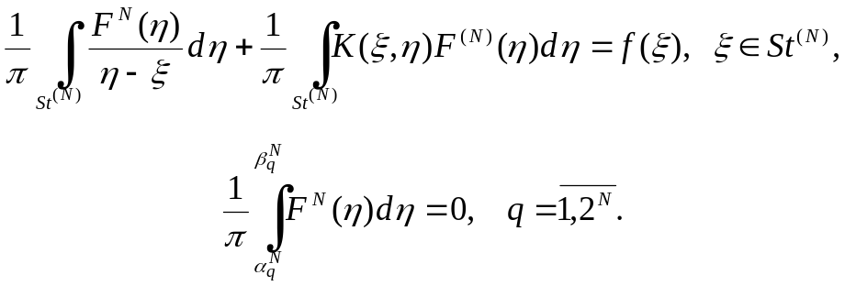
The most important step is numerical experiment which depicted some interesting phenomena. We build a discrete mathematical model based on specific quadrature formulas of interpolation type with the equidistant grid of the polynomial of order (n-1) for integrals with singular singularity and integrals of smooth functions. And the next step is to get the system of linear algebraic equations with the help of an efficient numerical discrete singularities method. Solutions of this system are the values of unknown functions in the node points. Furthermore, we derive the expressions for far field radiation patterns (RPs) of the scattered and diffracted fields.
The RP or antenna pattern is the graphical representation of the radiation properties of the antenna as a function of space. Different numerical examples can be presented to illustrate the capability of pre-fractal antenna for RPs with a prescribed wide nulls locations and depths.
What would to answer the question about the efficient choose of the grating for our tasks, we'll calculate a radio spectrum for general and pre-fractal gratings. Subsequently, deduce that an antenna is narrowband, broadband or wide frequency. These types of antennas are historical as development of radio engineering and are inseparable characteristics for further investigations in this area.

