IDENTIFICATION OF OPTIMAL BOUNDARY CONDITION FOR BIHARMONIC EQUANION IN IRREGULAR CONFIGURATION REGIONS

L.V. Voloshko, lyubov@voloshko.com,
Dnipropetrovsk National University Oles Honchar

V. L. Voloshko, viktorvoloshko@rambler.ru,
Dnipropetrovsk National University Oles Honchar

Optimization problems of mathematical physics are important and developing branch in contemporary applied mathematics. Nevertheless, boundary value problem for inhomogeneous biharmonic equation in domain of irregular shape is scantily explored at the current moment. So, let’s consider such kind of problem.
First of all, let the boundary value problem for inhomogeneous biharmonic equation be presented. It is considered in a simply-connected two-dimensional region  of irregular configuration, bounded with a smooth closed contour . Solution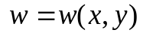 for the following equation
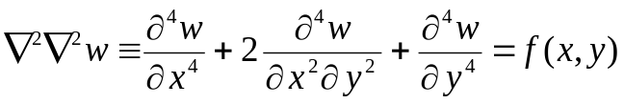, 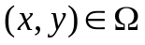, (1)
under the boundary conditions
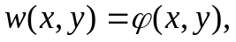 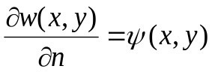, 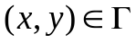, (2)
should be found. Here n representing the outward normal to at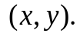 The right-hand side functions in equations (1) and (2) are supposed to be continuous in their domains.
The solution of this problem was found [1] as
where G1 and G2 – influence functions of right-hand side parts.
Computing results for solution problem (1) − (2) showed high accuracy level. That is why we can use it for solution of much complicated problems, which require construction of iteration process. And linear problem will be solved on every iteration of this process.
Let’s consider formulation of one of these problems:
, ,
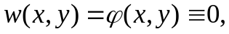 , ,
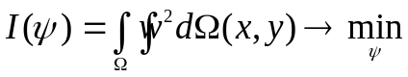 (3)
It is known fact that biharmonic equation describes plate flexure under the lateral load f(x,y). Let’s take function of boundary points shifting 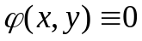. Then we will find function of boundary points angle (the way of plate fixing on the contour) so that the sum of solutions square in all domain is to be aimed to minimum. It is evidently that considered problem is reduced to optimization of functional (3) by the function 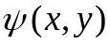. It can be solved with the help of some version of gradient method. In this method we will use solution of the problem (1) − (2) for making approximations to the unknown function .
The results obtained will be greatly useful for plate calculations in practice.

- Волощко Л. В. Розв’язок крайової задачі для неоднорідного бігармонічного рівняння і постановка зворотної коефіцієнтної задачі.// «Питання прикладної математики і математичного моделювання», Видавництво ДНУ, 2012р., С. 65 – 71.;

