Technology improving the ranking of web-site
through the use of internal links
Т.М. Basyuk, btaras@rambler.ru, Lviv Polytechnic National University
It is known that internal links provide a means of redistributing static weight (PageRank) between pages website thereby increasing their rank, thereby increasing relevance during the search. Namely, during the "internal redirect" from one page to another is transferred to the static weight, but not complete, and at 0.85 (taken damping). All calculations in different schemes of internal redirects are performed for several iterations until the difference between successive calculations will not be sufficiently small. Then consider that the calculated static weight is transferred to the links in this referral scheme. In the case of promotion resources necessary condition is to increase the static weight pages (articles) containing basic resources.
In general, external links to most projects affixed to the main page, given that, to increase the ranking of resources necessary condition is redistribution of static weight on the inside of the main resource page that contains the article. This scheme in general will have a species is represented in Fig. 1, where the static weight of the pages resource defined with Page Weight Online (http://www.page-weight.ru).
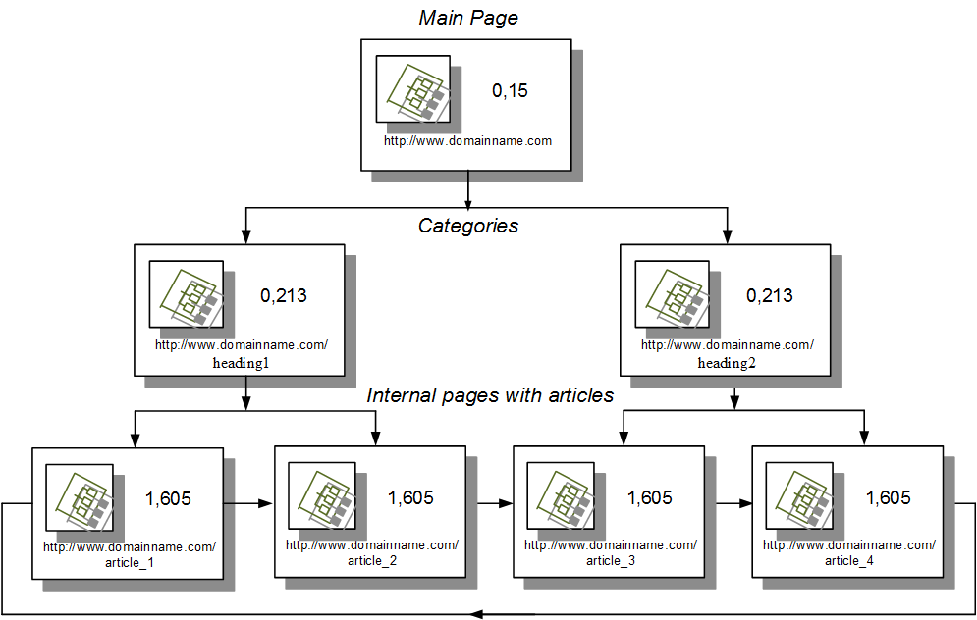
Fig.1. Figure redirect page resource
As shown in Fig. 1, the arrows show the direction of internal links, and static resource weight changed in favor of pages with articles, reducing the static weight of the front page and its heading. Further weight gain can be achieved by the establishment of a resource on the front page of several external backlinks.
Given the above information, the best option to promote your website with articles on the slope is the location of external backlinks not at home, and on top of the appropriate resources. In this case, the scheme takes the form (Fig. 2).
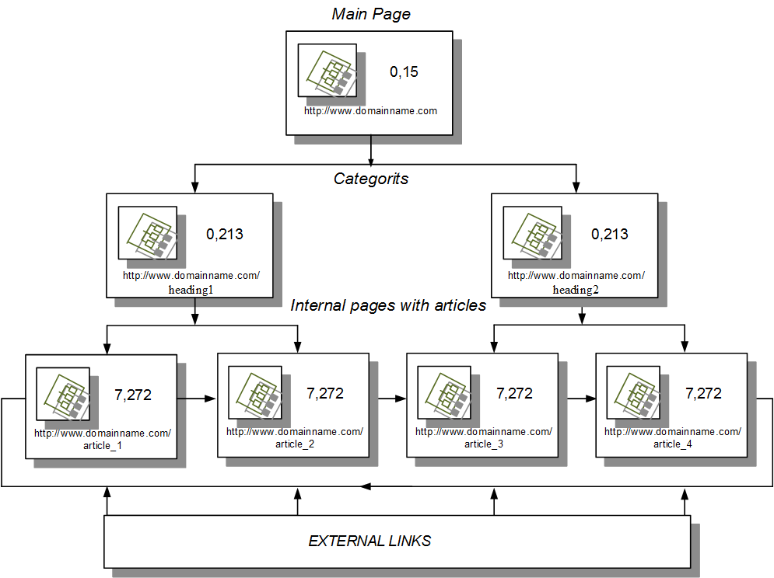
Fig.2. Installation of external links to pages with articles
The implementation of this scheme within a real project done by placing a small block of links at the bottom of the page (prompts the user to similar topic material) and placing references in the text of articles, which improves transition and increases the number of pages viewed by on. This figure takes into account depth review search engine rankings in the preparation of the corresponding resource. In summary, we can conclude that to improve the ranking of efficient resource use, organization of new links to pages with texts than to search for the perfect set of values ​​for the internal factors that are essentially challenging multi-criteria optimization.

