EDDY CURRENTS MODELING BY BOUNDARY ELEMENTS METHOD
IN ORTHOTROPIC CONDUCTING COMPOSITES
V.A. Pashchenko, 31NATA@ukr.net
Oles Honchar Dnipropetrovsk National University

Among approaches to computer modeling of characteristics spatial-time distributions the boundary elements method (BEM) is prefeble since it reduces dimensions number by one calculating on part of domain boundary only.
If fundamental solution is Green’s function for infinite domain then initial and boundary conditions are replaced by system of elementary sources. For each of them reintering problem is solved and whole solution is received by summing.
The purpose of thesis is computer modeling of real and imaginary constituents of Cartesian’s *-components (*=x,y) of normalized eddy currents density in surface layer of orthotropic composites by using of suitable elementary sources system and of BEM in irrelative coordinates. Eddy currents values are seted interactively by user who pickes out time excitations of antenna with plan horizontal apertures as ring, ellipse, rectangle and so on.
For (x₀,y₀,0)-point source of external current with density J_{m}f(τ)(|f(τ)|≤1). Cartesian’s *-component (*=x,y) of normalized eddy currents density j*<x,y,z,t> in orthotropic composite (z≤h) is equal to
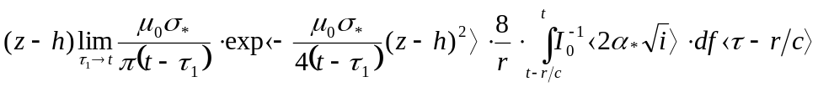 (1)
where 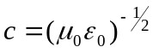 - light velocity, 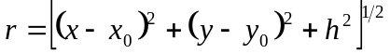– removal of surface (x,y,h)-point, 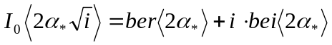 - imaginary argument Bessel’s function 0-th order, 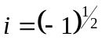, 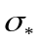-conductivity along *-coordinate (*-x,y). Used in theory of skin-effect Thomson’s function 0-th order are decomposed as
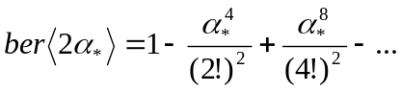, 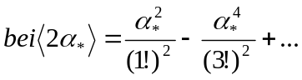 . 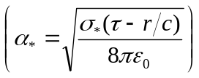
Transition to irrelative coordinates are performed separately for Cartesian’s *-component (*-x,y) by following replacement with concordant discretization:
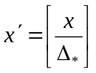, 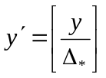, 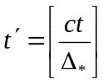, 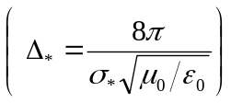
where [ ]-sign of roundoff to nearest whole number.
By discretization step 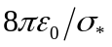 for normalized external current density  expressions for *-component (*-x,y) of normalized eddy currents density
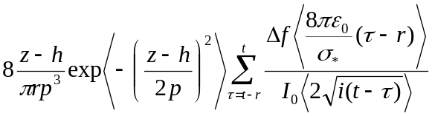,
are distincted, whereis first difference sign, 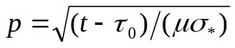 – experimental modeling parameter that increases under growing of partial capacity.
Under removel along composite surface from putting point of field particle the reduction of normalized eddy currents density is determinated by imaginary argument Bessel’s function. Its module growes impetuously taking value ~3, if
t–r=1 , ~13 under t–r=4 and so on. Consequently influence of field particle become little neglectly under removel ~4 steps of concordant discretization. Such distance must to separate representative discretes that are centres of ellipse boundary elements with halfaxises by ~2 steps of concordant discretization.
If point source is excitated by complex signal g(t)+ih(t), then modeling of real and imaginary constituents of Cartesian’s *-component (*-x,y) of normalized eddy currents density is performed with the help of following expressions:
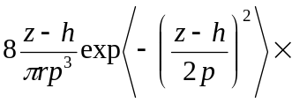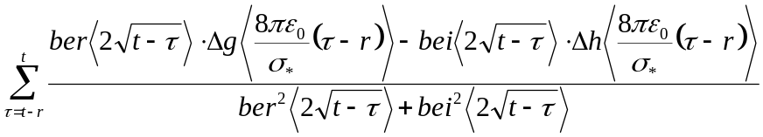,
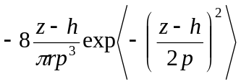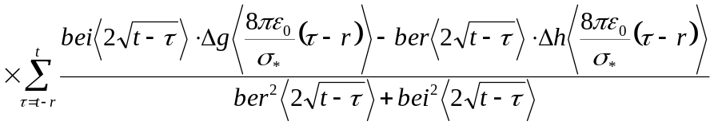.
In conclusion results are summed for all point sources.

