SPATIO-TEMPORAL INTERPOLATION METHOD
IN THE VIDEO STREAMING PROBLEM

V. Moroz, volodymyr.moroz@gmail.com
Odessa National University, Ukraine

The inter-frame prediction modified algorithm with the motion compensation based on the multi-resolution wavelet analysis is proposed. Segmentation and optical flow tracking is used for predicting of the inter-frame image. For the motion compensated prediction the algorithm roughly matches the wavelet low scale domain blocks and then the matching is doing more precisely by extract the additional information about motion objects in the higher scale wavelet domains. It helps to increase the prediction quality. Furthermore, to compensate the edge artifacts the non-homogeneous double cross search of the spatio-temporal frame information is used.
In practice, instead of the classical interpolation, the motion compensation interpolation is used. The motion compensation interpolation is based on the image analysis that is, detecting of the moving objects, and then tracking them by estimation of their velocity from frame to frame. Assuming that the object motion can be expressed in terms of a velocity vector in the spatial-temporal domain, the velocity estimation problem leads to the measurement of the velocity vector magnitude and its direction.
The faithful estimation of the velocity vectors can be found as a projection of the optic flow equation to the multi-resolution wavelets. There is the fast algorithm that computes the optic flow in the wavelet segments is proposed. The main drawback of such kind of algorithms is that the small objects as well as the fast moving objects can be lost when the wavelet filtration with the large-scale blocks is used.
Taking into account that frame brightness profile 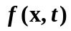 is smooth in time function and almost unchangeable inside the couple of frames, the total increment can written as
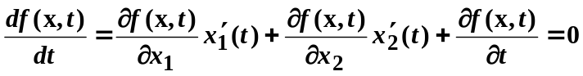 (1)
Then, the optical flow expression that joint together the time t with both the velocity vector and brightness level in any arbitrary frame image point becomes
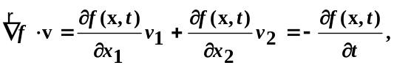 (2)
where 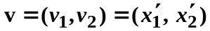is a velocity vector, 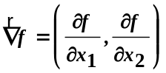 is a gradient of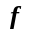.
If brightness profile is smooth in time function then is a smooth vector-function of x, and it can be approximated by staircase function with the small enough step. The accurate estimate of the velocity vector can be found as a projection of the optic flow equation to the multi-resolution wavelets.
Let us consider the mother wavelet
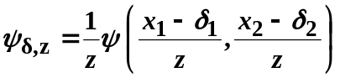. (3)
We assume that the shift of the processing image during the time is small enough related to the wavelet scaling size, which is z. The size z is determined with suggestion that the matching mean square error is small enough when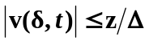, and the value 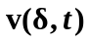 is almost unchangeable inside the scale of 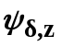. Computing the inner product of the optical flow (2) and the wavelet (3), and afterward using partial integration we get
, (4)
where 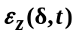 is an approximation error inside the scale of .
The video stream is a sequence of the frames with some inter-frame gap. In up-conversion mode the frame rate is enhanced as much as 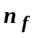 times, then it is required to find the derivative in the right side of (4) for the time moment 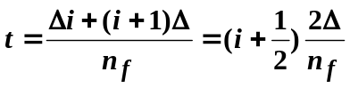. Let us suppose that 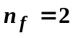. The wavelet optical flow can be found taking into account that the derivative 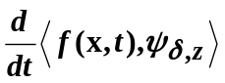 in (4) for the instant of time 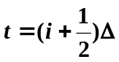 can be determine with the second order error using the finite difference equation
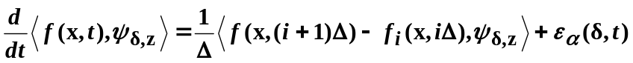 (5)
Therefore, (4) with (5) can be rewritten as
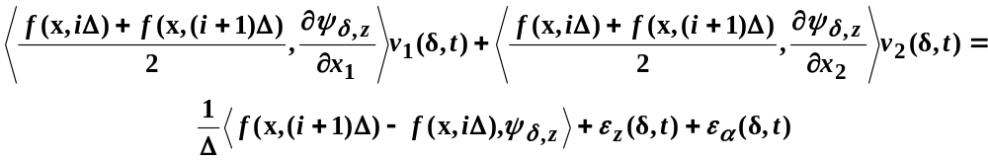
where 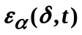 is the second order error.
Two last terms, i.e., 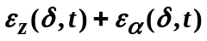, can be neglected when either the velocity is almost unchangeable inside the appropriate wavelet scale, or, at least, the velocity is small enough. Hence, as last equation shows, finding of the projection of the optical flow to the multi-resolution wavelet allows us instead of the velocity vector estimation inside the large scales, to estimate it precisely inside the sequence of the gently diminished scales. As a consequence, the matching problem can be solved with less error.

