**UDC 550.34+519.2**

**INFORMATION TECHNOLOGY OF STATISTICAL PROCESSING OF MAGNETOTELLURIC SENSING DATA**

**A.A.Koldunova, a post-graduate student; T.G.Emelyanenko, Ph.D., associate professor**

E-mail: [anastasia.prada.koldunova@gmail.com](mailto:anastasia.prada.koldunova@gmail.com), [emelyanenko@ua.fm](mailto:emelyanenko@ua.fm)

*Oles Gonchar Dnepropetrovsk National University*

Seismology as a science, which emerged in the mid-19th century, attracted scientists from different fields of science. For the past century there have been a lot of disputes and disagreements between experts. They questioned one of the main objectives, earthquake prediction. Because of this, it opened up new opportunities and challenges in other fields, such as programming, relevant to the study of earthquake precursors. Magnetovariational observation has been actively used for several decades.

The aim was to create an information technology of automated data processing; the data used for processing is magnetotelluric sounding - Wiese-Parkinson vectors (4 components Au, Bu, Av, Bv) The main objective was to test the components of the Weise vectors for randomness, as well as the presence of correlation between them and the variations of the magnetic field (Kp index).

This lead to the creation of an information technology GeoProject, which implements the criteria of checking for the presence of a trend (the criterion of increased and decreased series, sign test); were counted Spearman and Kendall correlation coefficients, autocovariance function and Pearson variation coefficient.

The input data consists of text files in folders of corresponding period. Since the data were provided for three years obtained at four stations (MIZ, ESA, KAK, KNZ) in Japan near Tohoku obtained for different frequencies, GeoProject configured so that the user needs only to position correctly the input data files: folders to certain years with the appropriate names must be placed in the same catalog for GeoProject.exe. Each folder contains txt-files whose names consist of the name of the station and of the period (eg, «KAK_0035_0.txt» - is KAK station data at a frequency of 35.0 c) and also file is «Kp.txt». So, having in catalog «... \ geo processing \» the executable file «GeoProject.exe» and folders "2009", "2011" and "2012" as a result we get 3 xlsx-file «2009.xlsx» «2011 . xlsx »and«2012.xlsx »in the same directory. Kind of the resulting file is shown in the figure.

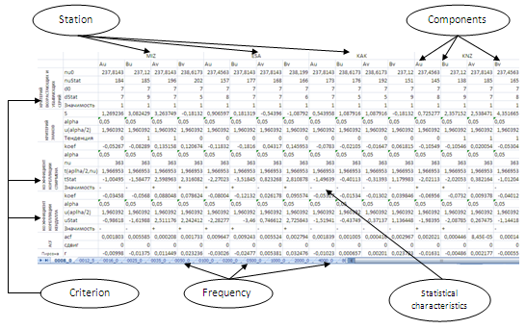

Performed analysis did not rule out the possibility of having no stationarity in the ranks of values of the vectors Vise for Japanese observatories. In the case of presence, of dependence geodynamic processes that change the electrical conductivity of the crust and mantle can explain it. As a result, we have that components of vectors may depend on magnetic activity. Since these variations are dependent on magnetic activity, interfere with release of precursory signals on the time series of the components of induction, in the future we plan to remove these variations, which poses new challenges for the study of magnetotelluric data.

**Acknowledgements**

The authors express their gratitude to the staff of the S.I. Subbotin Institute of Geophysics National Academy of Sciences of Ukraine (Bldg. 32, Akademika Palladina av., Kyiv, Ukraine) – Rokityanskiy I.I., Tereshina A.V., Babak V.I., Savchenko T.S. – for the provision of data and collaboration.

**The references**

1. **Колдунова А.А.** Статистическая обработка вариаций вектора индукции Японии с целью поиска электромагнитных предвестников землетрясений /А.А.Колдунова, Т.Г.Емельяненко // SMSDP-2013, Kyiv, 16-17 October 2013 – K. NAU. – 2013. – P. 208-217