# Readme.txt

This is the backend API program that is required for the UI to connect.

Before you start the program, it is assumed you have a Postgres DB running and have the credential for the admin postgres user.

You MUST configure the connection string located at the appsettings.json.

"ConnectionStrings": {

"DefaultConnection": "Host=localhost;Database=medinet;Username=postgres;Password=password"

},

Start the application using IIS Express in development mode. If the database is not created, the entity framework (code first) will create the medinet database and 2 tables:

1. User
2. Photo

Test if the API is working. For example:

<https://localhost:44323/api/users>

<https://localhost:44323/api/photos>

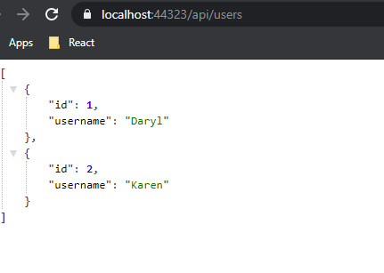

You can also upload an image file using Postman.

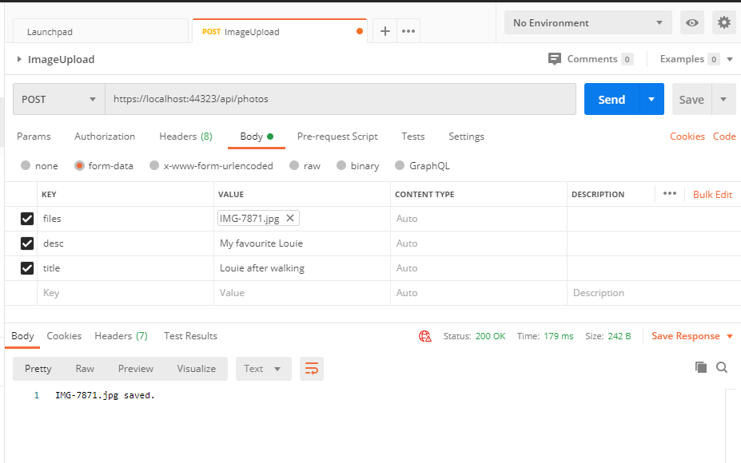

When the API is running, read the Readme.txt for the ReatJs and ensure you update the BASE_URL which [**http://localhost:44323**](http://localhost:44323).