**Formative Feedback** - **Documentation**

Your report demonstrates an initial attempt/plan at the documentation of what you have achieved and how. The plan appears very detailed suggesting a very thorough approach to the report. You now need to focus on describing **how** the required features of the assessment are implemented.

# I also felt you could also do the following for an improved and concise documentation of your web app.

1. Include images from your app where necessary to help the reader.
2. It would be nice to include justifications for your design approach if any. e.g.:-

* *A slideshow is a standard feature on most confectionary business sites [references], so I thought it would be a sensible idea to include it …*
* *I have kept the navigation bar at the top of the page to make it easy to find… (user experience considerations). Why have you chosen to include sub menus?*
* *Like confectionary business websites, I have set out my menu page in a way that allows the user to see all the product types [references]…*
* etc.
* 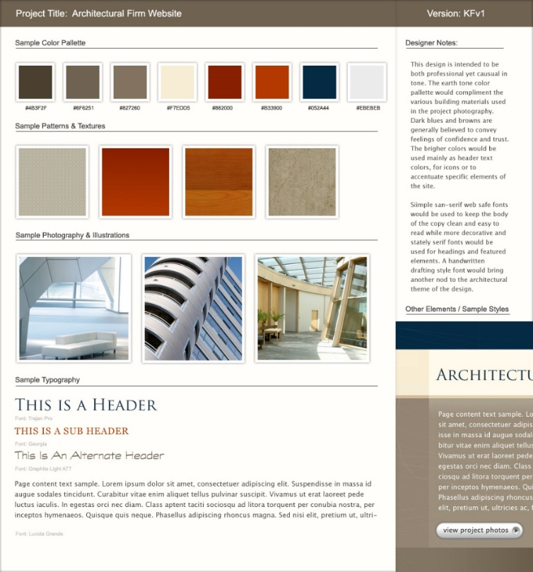Put together your sitemap, wireframes, as well as a moodboard to illustrate your visual ideas of the website i.e. colour pallet, imagery style, typography etc. (as shown in the example below) and add design notes around it.

1. You should include the URL to your application on the UDON server and test the URL consistently before handing-in in your report

**Website**

* The markup and layout of content is off to a very good start; you should include code comments more consistently.

* Consider moving the script element into the head element.

* The implementation of the custom presentation demonstrates very good understanding of JavaScript language elements and local storage API.

Reconsider the choice of icons used in the application. For instance, the register icon appears like an edit icon rather than a form icon.

You now need to focus on implementing other required features of the website including but not limited to the thumbnail image animation, etc.

**Recorded video**

* As a recorded video has not been submitted, I unable to provide any feedback on this part of the work.

Well done, good luck with the rest of it.