Clarification on Product & Analytics Role - 2026

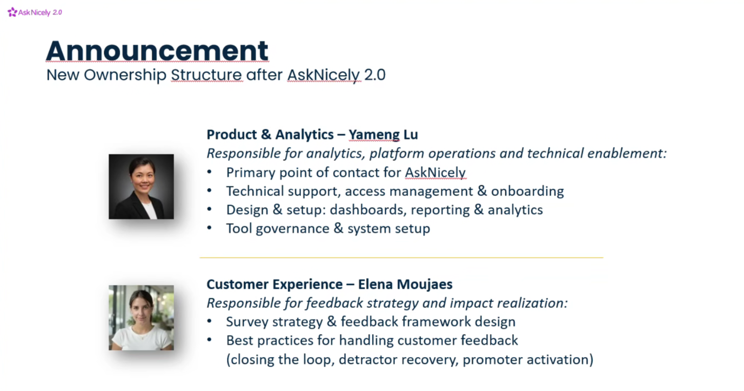

Understanding the new role
- Analytics & Reporting
  - “Design & setup: dashboards, reporting & analytics”
  - Interpretation: This is squarely within your current analytics skill set, creating dashboards, building reporting pipelines, and supporting data analysis.
- Platform Operations & Technical Enablement
  - “Tool governance & system setup”
  - Interpretation: You’d be ensuring that the tool AskNicely is set up correctly, access is managed, and they’re compliant with internal standards. This is more operational than pure analytics.
- Primary Point of Contact for Technical Support
  - “AskNicely Technical support, access management & onboarding”
  - Interpretation: This is closer to a product operations / enablement role, helping users adopt the platform, troubleshoot issues, and manage access. You’re not necessarily doing product management (defining strategy, roadmap), but you are the go-to person for technical support and onboarding, so a mix of operational and analytical responsibilities.
My goal is to grow toward a Staff/Principal-level role in Analytics. In my recent yearly review 2025, the feedback emphasized

- Increase Visibility: Increase visibility as the primary Customer Satisfaction data expert across the organization. Seek out strategic partners that can reinforce our efforts and spread influence across organization.

- Strategic Focus: Increase scope beyond survey-based responses which will also engage new stakeholder groups that are less domain-specific.

One initiative I am particularly excited about exploring was building a more advanced Customer Intelligence Engine - build an internal AI-powered tool that automatically analyzes and classifies open-text customer feedback (proposal attached). I see this as a strong next step in expanding our data strategy at Enpal and increasing cross-functional influence.
Project Proposal: Customer Intelligence Engine
Objective:
Management has expressed a clear need for a more structured, data-driven understanding of customer feedback. We want to build an internal AI-powered tool that automatically analyzes and classifies open-text customer feedback.
Business Owner: Elena Moujaes
Techincal Owner: Yameng Lu
Main Stakeholder:
- Business Development
- Operations
- CX (Customer Experience) Team
Divisions: PV, Heat, Energy, Enpal.pro
These stakeholders will use the output for performance analysis, prioritization of initiatives and management reporting.
The goal is to:
- Convert unstructured feedback into structured data
- Identify key pain points and positive drivers
- Enable topic-based analysis over time
- Allow team-level performance insights (e.g. Sales teams)
Process:
- The AI should automatically analyze open-text responses
- Extract relevant topics / keywords mentioned by the customer
- Tag each feedback entry with one or multiple standardized topics
- detect sentiment per topic (e.g. Installation = positive, Service = negative)
Pain Point & Strength Analysis
For a selected time period:
- What are the most frequently mentioned negative topics?
- What are the most frequently mentioned positive topics?
- What is the relative share of each topic?
- Which topics are driving low CSAT / NPS?
Trend Analysis Over Time
- How often a topic is mentioned over time (weekly / monthly)
- Topic trends (e.g. “Service availability” mentions increasing?)
- Sentiment trends per topic
- Example:
  - Topic “Installation Quality” mentioned 120 times in January → 80 times in February
  - Negative sentiment decreasing from 40% → 25%
Level:
- Per survey template
- Across all survey templates
- per Team or Individual (based on the custom data from AskNicely)
The output should:
- Store topic tags as structured data fields
- Allow filtering by: Topic, Sentiment, Survey template, Custom Data
- The AI should continuously learn / adapt
- Manual override / correction option (if misclassified)
