Performance review
  - Yameng Lu, 2025
Current level: BI3

Assessment: exceeding expectations
Title changed to: Senior Analytics Engineer
Salary increase to: € 88.000

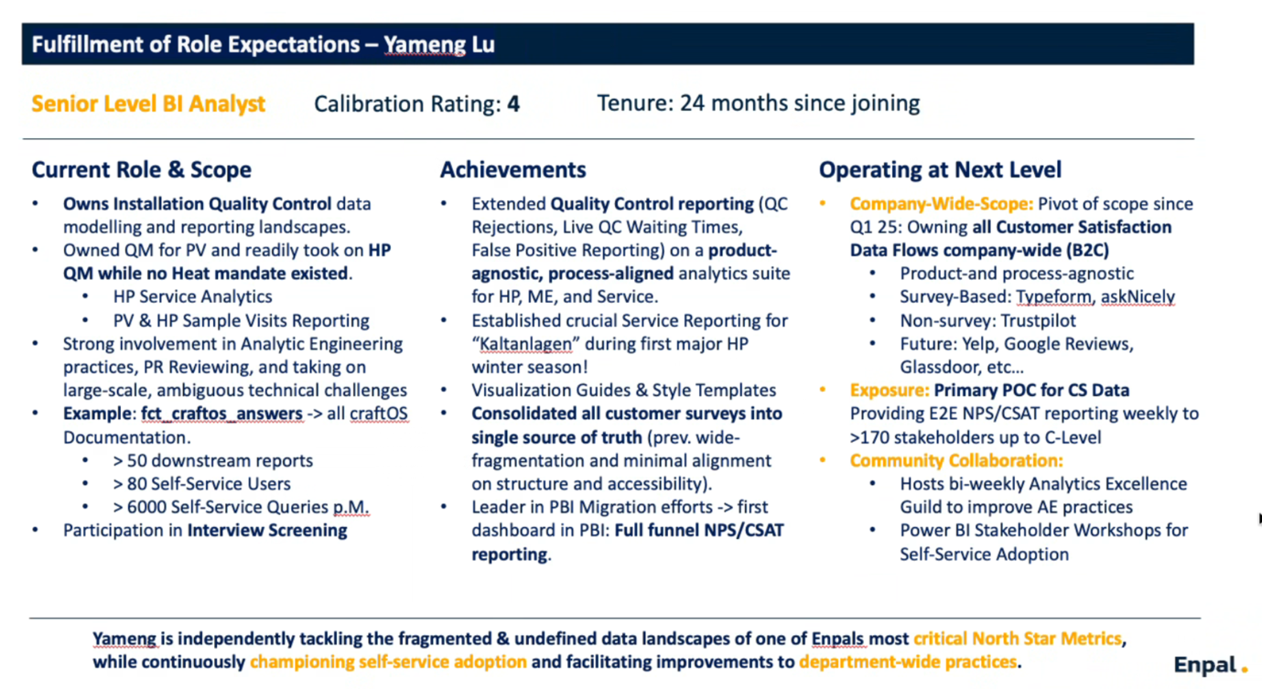

Career growth
This section focuses on building skills and expanding impact. It is filled by your manager to set you up for success and growth.
Key achievements:
- Customer Satisfaction (CS) Data Centralization & Strategy: Designed and implemented a centralized data repository, integrating multiple sources (Typeform, SimpleSurvey, AskNicely, Trustpilot) to create a single source of truth. This ensured data consistency and enabled more accurate business decisions.
- Community & Ownership: Manages main Data Guilds and Workshops within the Data/BI department. Demonstrates high independence leading to ownership of technical implementation (e.g., AskNicely integration with Salesforce).
- Quality Platform Implementation: Developed and maintained a comprehensive dashboard suite covering all PV Quality stages and the heat pump quality dashboard , enabling proactive quality monitoring.

Improvement areas
- Confidence and Senior Engagement: Should continue to build confidence for autonomous decision-making and engage senior leaders directly with confidence. Pro-actively searching for business sponsors and creating alliances.
- Technical Design: Acquiring further technical depth to build long-standing, extendable, and scalable data architecture from integration to exposure of data products.

Growth opportunities
- Increase Visibility: Increase visibility as the primary Customer Satisfaction data expert across the organization. Seek out strategic partners that can reinforce our efforts and spread influence across organization.
- Strategic Focus: Continue to pursue the next 10 months of data strategy on one of Enpal’s key focus points. Increase scope beyond survey-based responses which will also engage new stakeholder groups that are less domain-specific.

Feedback summary
This section contains the written feedback your colleagues entered for you in the 360 review. Use this to reflect on your impact, your relationships, your strengths and blind spots.

Overall feedback for Yameng Lu

Keep
- Transform ambiguous stakeholder requests into actionable solutions through curiosity, clarifying questions, and follow-through
- Take ownership of projects, resolve blockers proactively, and follow up regularly to accelerate delivery
- Maintain approachable, empathetic communication style that makes collaboration easy and productive
- Lead strategic BI initiatives that unify data, standardize KPIs, and drive actionable insights organization-wide
- Set high standards for analytical excellence and professional execution

Do more
- Communicate project timelines clearly and proactively manage expectations when competing priorities affect delivery
- Deepen product knowledge to anticipate data implications and build more intuitive dashboards
- Research existing data infrastructure and integration history before implementing new solutions
- Increase visibility as the primary Customer Satisfaction data expert across the organization
- Engage senior leaders directly with confidence; reduce reliance on manager support for stakeholder interactions

Do less
- Reduce time on ad-hoc requests; prioritize high-impact initiatives and delegate lower-value tasks

