Vedrix POS — SCCS Barcode Catalog
Upload the SCCS lookup number. The barcode image is the matching UPC-A scanner code.
2 Piece Bone-In Box  Krunch Box Bone-In  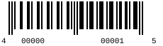  SCCS lookup: 40000000001  UPC-A scan: 400000000015 | 3 Piece Bone-In Box  Krunch Box Bone-In  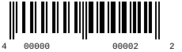  SCCS lookup: 40000000002  UPC-A scan: 400000000022
4 Piece Bone-In Box  Krunch Box Bone-In  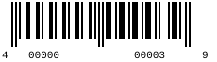  SCCS lookup: 40000000003  UPC-A scan: 400000000039 | 2 Piece Chicken w/ Biscuit  Chicken & Biscuit  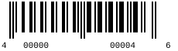  SCCS lookup: 40000000004  UPC-A scan: 400000000046
3 Piece Chicken w/ Biscuit  Chicken & Biscuit  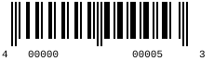  SCCS lookup: 40000000005  UPC-A scan: 400000000053 | 4 Piece Chicken w/ Biscuit  Chicken & Biscuit  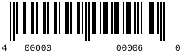  SCCS lookup: 40000000006  UPC-A scan: 400000000060
3 Piece Tender Box  Krunch Box Tenders  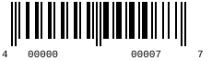  SCCS lookup: 40000000007  UPC-A scan: 400000000077 | 4 Piece Tender Box  Krunch Box Tenders  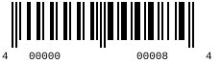  SCCS lookup: 40000000008  UPC-A scan: 400000000084
6 Piece Tender Box  Krunch Box Tenders  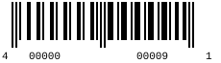  SCCS lookup: 40000000009  UPC-A scan: 400000000091 | 3 Piece Tender w/ Biscuit  Tender & Biscuit  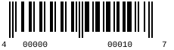  SCCS lookup: 40000000010  UPC-A scan: 400000000107
4 Piece Tender w/ Biscuit  Tender & Biscuit  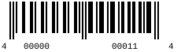  SCCS lookup: 40000000011  UPC-A scan: 400000000114 | 6 Piece Tender w/ Biscuit  Tender & Biscuit  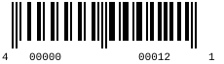  SCCS lookup: 40000000012  UPC-A scan: 400000000121
5 Piece Wings  Wings  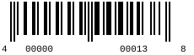  SCCS lookup: 40000000013  UPC-A scan: 400000000138 | 10 Piece Wings  Wings  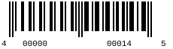  SCCS lookup: 40000000014  UPC-A scan: 400000000145
20 Piece Wings  Wings  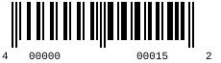  SCCS lookup: 40000000015  UPC-A scan: 400000000152 | 5 Piece Shrimp w/ Biscuit  Shrimp  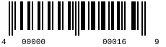  SCCS lookup: 40000000016  UPC-A scan: 400000000169
10 Piece Shrimp w/ Biscuit  Shrimp  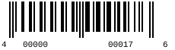  SCCS lookup: 40000000017  UPC-A scan: 400000000176 | Chicken Sandwich  Sandwiches  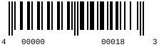  SCCS lookup: 40000000018  UPC-A scan: 400000000183
Chicken Sandwich Combo  Sandwiches  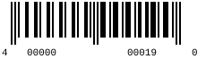  SCCS lookup: 40000000019  UPC-A scan: 400000000190 | Family Chicken & Tenders  Family Meals  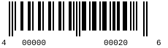  SCCS lookup: 40000000020  UPC-A scan: 400000000206
Family Chicken Only  Family Meals  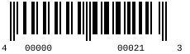  SCCS lookup: 40000000021  UPC-A scan: 400000000213 | Family Tenders Only  Family Meals  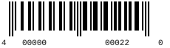  SCCS lookup: 40000000022  UPC-A scan: 400000000220
Honey Butter Biscuit (1)  Biscuits  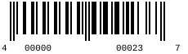  SCCS lookup: 40000000023  UPC-A scan: 400000000237 | Honey Butter Biscuits (2)  Biscuits  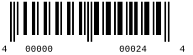  SCCS lookup: 40000000024  UPC-A scan: 400000000244
Honey Butter Biscuits (6)  Biscuits  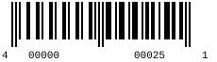  SCCS lookup: 40000000025  UPC-A scan: 400000000251 | Wedges Small  Sides  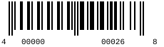  SCCS lookup: 40000000026  UPC-A scan: 400000000268
Wedges Large  Sides  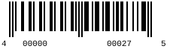  SCCS lookup: 40000000027  UPC-A scan: 400000000275 | Wedges Family  Sides  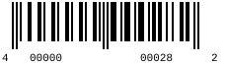  SCCS lookup: 40000000028  UPC-A scan: 400000000282
Mashed Potatoes Small  Sides  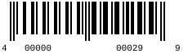  SCCS lookup: 40000000029  UPC-A scan: 400000000299 | Mashed Potatoes Large  Sides  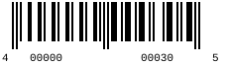  SCCS lookup: 40000000030  UPC-A scan: 400000000305
Red Beans & Rice Small  Sides  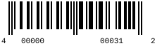  SCCS lookup: 40000000031  UPC-A scan: 400000000312 | Red Beans & Rice Large  Sides  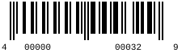  SCCS lookup: 40000000032  UPC-A scan: 400000000329
Mac n Cheese Small  Sides  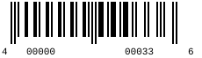  SCCS lookup: 40000000033  UPC-A scan: 400000000336 | Mac n Cheese Large  Sides  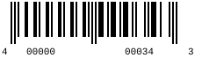  SCCS lookup: 40000000034  UPC-A scan: 400000000343
Jambalaya Small  Sides  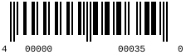  SCCS lookup: 40000000035  UPC-A scan: 400000000350 | Jambalaya Large  Sides  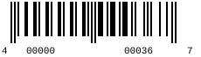  SCCS lookup: 40000000036  UPC-A scan: 400000000367
Leg  A La Carte  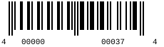  SCCS lookup: 40000000037  UPC-A scan: 400000000374 | Thigh  A La Carte  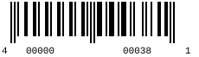  SCCS lookup: 40000000038  UPC-A scan: 400000000381
Wing  A La Carte  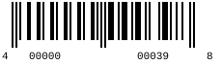  SCCS lookup: 40000000039  UPC-A scan: 400000000398 | Tender  A La Carte  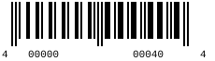  SCCS lookup: 40000000040  UPC-A scan: 400000000404
Only Chicken 8 Piece  Only Chicken  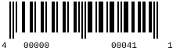  SCCS lookup: 40000000041  UPC-A scan: 400000000411 | Only Chicken 12 Piece  Only Chicken  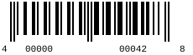  SCCS lookup: 40000000042  UPC-A scan: 400000000428
Only Chicken 16 Piece  Only Chicken  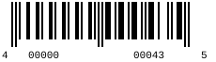  SCCS lookup: 40000000043  UPC-A scan: 400000000435 | Only Tenders 8 Piece  Only Tenders  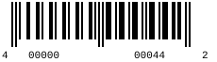  SCCS lookup: 40000000044  UPC-A scan: 400000000442
Only Tenders 12 Piece  Only Tenders  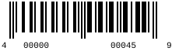  SCCS lookup: 40000000045  UPC-A scan: 400000000459 | Only Tenders 16 Piece  Only Tenders  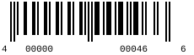  SCCS lookup: 40000000046  UPC-A scan: 400000000466
6 Nuggets w/ Biscuit  Nuggets  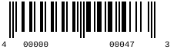  SCCS lookup: 40000000047  UPC-A scan: 400000000473 | 10 Nuggets w/ Biscuit  Nuggets  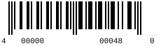  SCCS lookup: 40000000048  UPC-A scan: 400000000480
6 Nuggets Krunch Box  Nuggets  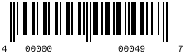  SCCS lookup: 40000000049  UPC-A scan: 400000000497 | 10 Nuggets Krunch Box  Nuggets  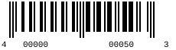  SCCS lookup: 40000000050  UPC-A scan: 400000000503
6 Nuggets  Nuggets  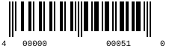  SCCS lookup: 40000000051  UPC-A scan: 400000000510 | 10 Nuggets  Nuggets  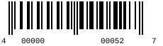  SCCS lookup: 40000000052  UPC-A scan: 400000000527
Corn Dog  Misc  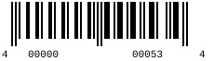  SCCS lookup: 40000000053  UPC-A scan: 400000000534 | Egg Roll  Misc  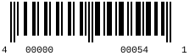  SCCS lookup: 40000000054  UPC-A scan: 400000000541

