**Data Warehousing with IBM Cloud Db2 Warehouse**

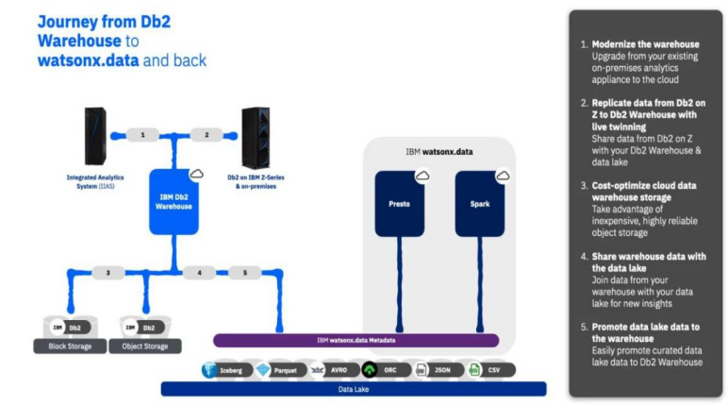

**PHASE 3: Development Part 1**

**GIVEN STATEMENT:**

In this part you will begin building your project.

Start building the data warehouse using IBM Cloud Db2 Warehouse.

Define the schema and structure of the data warehouse tables.Identify data sources (e.g., CSV files, databases) and design a strategy to integrate them into the data warehouse.

I understand the importance of your project, and I'm here to help. To get started with your big data analysis project using IBM Cloud Databases, follow these steps:

**1. Create an IBM Cloud Account:**

If you don't have an IBM Cloud account, sign up for one. You can do this by visiting the [IBM Cloud website] (**https://cloud.ibm.com/registration**) and following the registration process.

**2. Connect to Db2 Warehouse:**

Once you've provisioned Db2 Warehouse, you'll need to connect to it using an appropriate client tool. IBM offers several tools for this purpose:

a. **Db2 Warehouse Console:** You can access Db2 Warehouse through the web-based console for querying and managing your data.

b. **IBM Data Studio:** IBM Data Studio is a more comprehensive tool that provides database development, administration, and query capabilities.

c. **CLI and JDBC/ODBC Drivers:** You can use command-line interfaces, or you can connect to Db2 Warehouse using JDBC (Java Database Connectivity) or ODBC (Open Database Connectivity) drivers.

**For Db2:**

* Log in to your IBM Cloud account.
* From the IBM Cloud dashboard, click on the "Create Resource" button.
* In the catalog, select "Databases" and then "Db2".
* Follow the on-screen instructions to configure your Db2 database instance, including specifying the instance name, region, and other settings.
* Create the instance.

**4. Develop Queries or Scripts:** After setting up your database instance, you can start developing queries or scripts to explore and analyze your dataset. The type of queries and scripts you write will depend on the nature of your dataset and your analysis goals.

**Creating Service Credentials the IBM DB2 database**

* In the resource list screen of IBM Cloud, click on the DB2 service (displayed under Services and software category) that you created
* From the service page, select the menu option "**Service Credentials**" to create / access the credentials of the db2 database

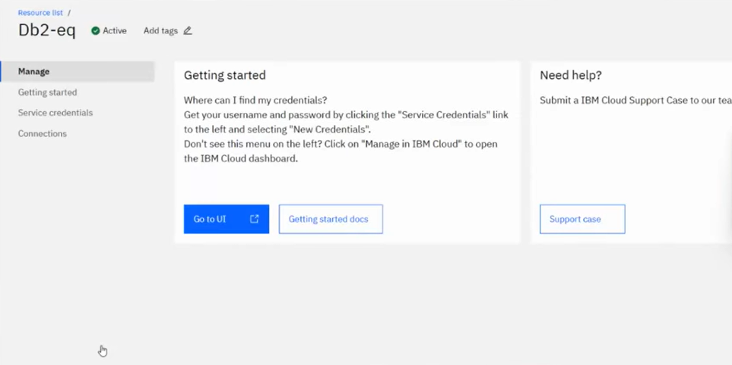

* Click on **New Credential** button in the Service Credential page to create a new credential
* Provide the any name for service credential (e.g. **appCred**) and click on **Add**

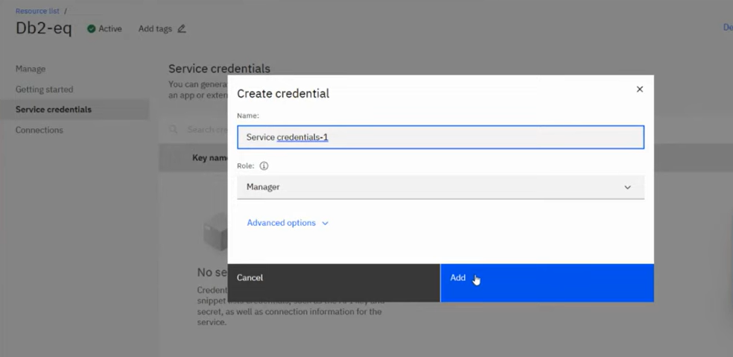

New credential gets created and is displayed. Expand the newly to created credential to get the all the details that is required for client application to connect to the database. Note down the value for the following properties separately, which we will use it later to configure our application to connect to this database.

|  |  |
| --- | --- |
| **Property Name** | **Value** |
| **Database name** | *<database> [e.g. bludb]* |
| **Host name** | *<hostname>* |
| **Port** | *<port>* |
| **User Name** | *<username>* |
| **Password** | *<password>* |

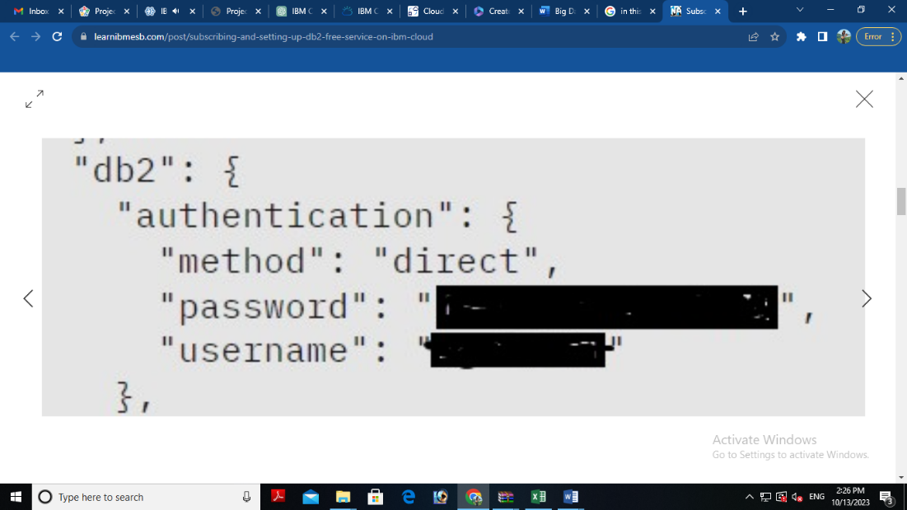 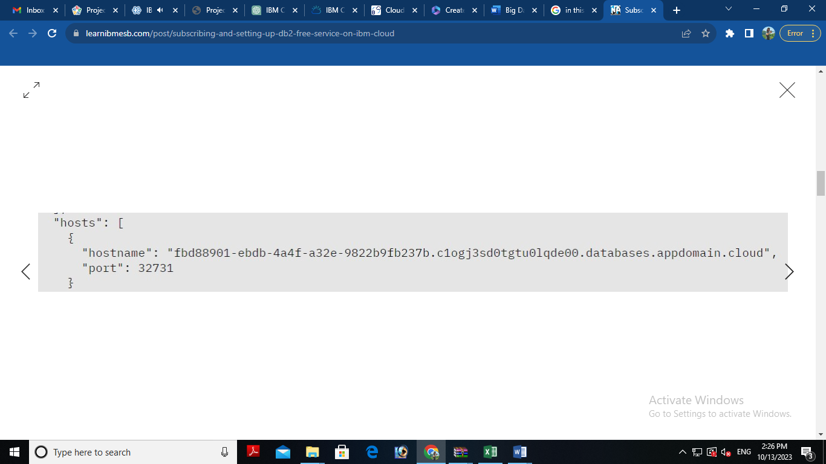

## **3. Setting up IBM DB2 database**

* In the resource list screen of IBM Cloud, click on the DB2 service (displayed under Services and software category) that you created, if the page is not already opened.
* From the service page, select the menu option "**Manage**" and click on Go to UI to launch the DB2 console

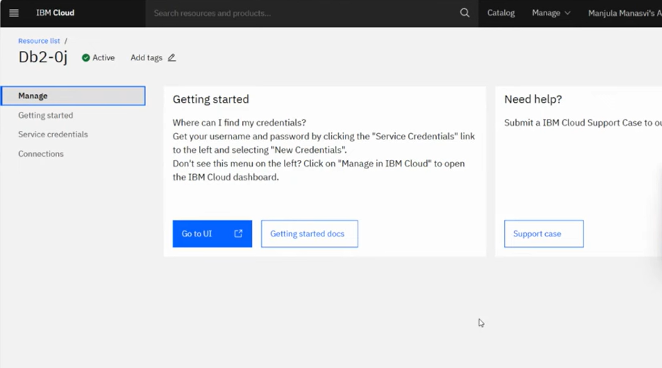

* IBM DB2 on cloud console is opened. To create database objects, click on SQL menu option from the left-side menu.

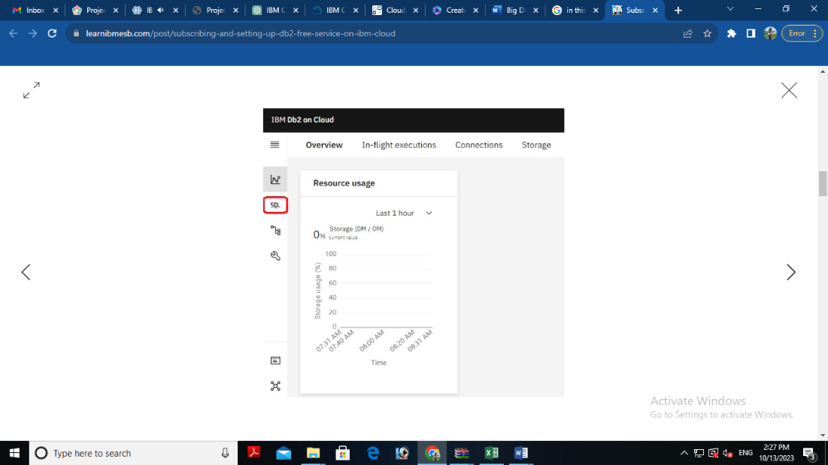

* SQL editor is opened up for you. Type the query that you want to execute in the SQL editor .Determine the relationships between tables. This involves defining primary keys in one table that correspond to foreign keys in another table and click **Run all**

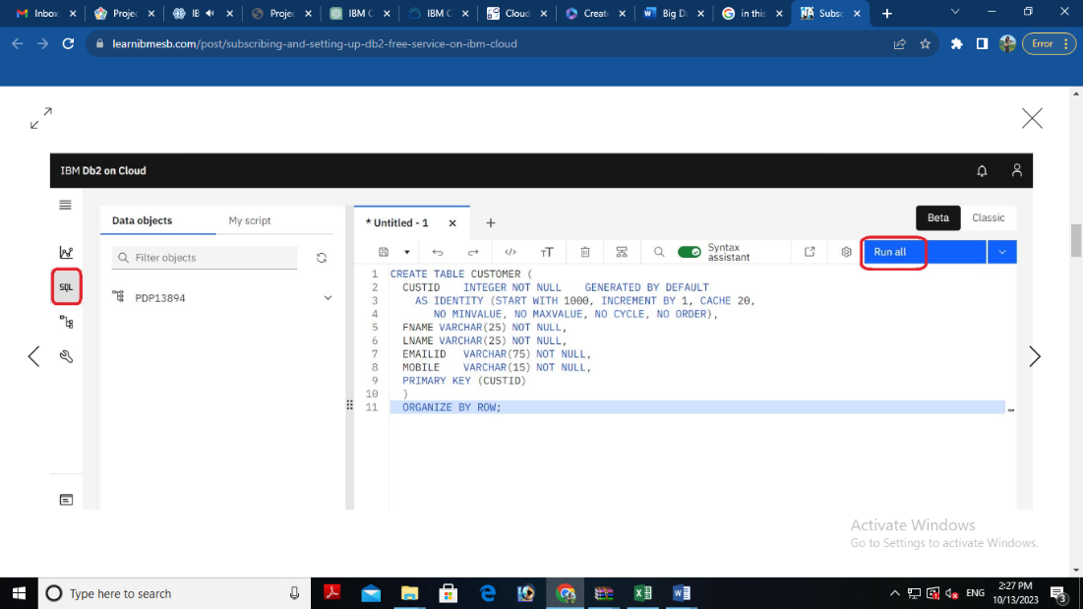

* The status of the query execution is displayed at the bottom of the SQL editor as shown below

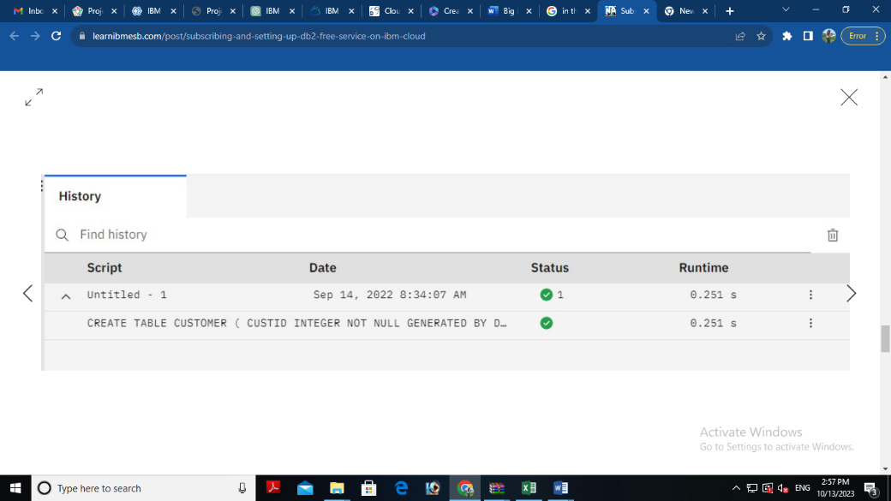

The above steps can be followed to create any more database objects in future.

**CSV Files:** Many organizations store structured data in CSV (Comma-Separated Values) files. Identify the location and structure of these files.

Uploading the .csv file into the table that we have created using SQL query

**SQL Queries**

CREATE TABLE STUDENT (sid int NOT NULL PRIMARY key,

name varchar(20) NOT null, mobile int NOT null, gender char(1) NOT null);

SELECT FROM Student;

INSERT INTO Student (sid, name, mobile, gender) values (1, 'MANJU, 24561, "F");

INSERT INTO Student (sid, name, mobile, gender) values (1, 'MANJU, 24561, "F");

INSERT INTO Student (sid, name, mobile, gender)

VALUES

(2, 'Srimathi', 24561, 'F'),

(3, 'Divya', 24561, 'F'),

(4, 'Balaji', 24561, 'M'),

(5, Ajay', 24561, 'M'),

(6, Mohan, 12345, 'M'),

(7, 'Karthik', 12345, 'F');

SELECT FROM Student;

UPDATE Student SET gender 'M' WHERE sid=7;

UPDATE Student SET mobile 77777 WHERE name = 'Ajay';

SELECT sid, name FROM Student WHERE mobile= 24561;

COMMIT;

DELETE FROM Student WHERE sid7;

ALTER TABLE Student ADD COLUMN address varchar(20);

SELECT count(*) FROM Student;

SELECT max(sid) FROM Student;

SELECT in(sid) FROM Student;

SELECT sid, name FROM student ORDER BY mobile;

SELECT name FROM student WHERE sid BETWEEN 1 AND 3;

CREATE TABLE Department (did int NOT NULL PRIMARY KEY, dname varchar (20)):

SELECT FROM Department:

INSERT INTO DEPARTMENT (did, dname) values (1. Physics'):

INSERT INTO DEPARTMENT (did, dname) values (2, 'Chemistry');

INSERT INTO DEPARTMENT (did, dname) values (8, "Maths):

SELECT tl.sid, tl.name, t2.did, t2.dname FROM Student 1 INNER JOIN

Department t2 ON tl.sid- t2.did

SELECT tl.sid, tl.name, t2.did, t2.dname FROM Student tl left JOIN

Department t2 ON tl.sid = t2.did

SELECT tl.sid, tl.name, t2.did, t2.dname FROM student tl right JOIN

Department t2 ON tl.sid = t2.did