**FPT ACADEMY INTERNATIONAL**



**FPT – APTECH COMPUTER EDUCATION**

CENTRAL ZOO

|  |  |  |  |
| --- | --- | --- | --- |
| **Center Name** | | FPT – Aptech – HCM2  Address: 590 Cach Mang Thang Tam, District 3,  Ho Chi Minh City | |
| **Instructor** |  | Ms. Le Mong Thuy |  |
| **Class** |  | T1.2110.E1 |  |
| **Group** |  | 7 |  |
| **Group members** | | **Name** | **Student ID** |
|  |  | Hoàng Ngọc Minh Quý | Student1345168 |
|  |  | Dương Khai Cường | Student1341576 |
|  |  | Nguyễn Đình Đức Huy  Huỳnh Nhật Trung | Student1345440 |
| **Duration** | Start date | 13 - Jan - 2022 |  |
| End date | 27 - Feb - 2022 |  |

**This is to certify that**

**Mr.:**

Hoàng Ngọc Minh Quý

Dương Khai Cường

Nguyễn Đình Đức Huy

Huỳnh Nhật Trung

**has successfully designed & developed**

eProject: CENTRAL zoo website

**Submitted by:**

Hoàng Ngọc Minh Quý

**Date of issue:**

13-01-2022

**Authorized Signature:**

# ACKNOWLEDGMENT

On behalf of all the members of group 1, I would like to thank you all for the hard works, supports to make this eproject complete successfully. Especially, Ms. Le Mong Thuy, our teacher, helped us a lot from the day that we started to study at FPT Aptech. With this eProject, she has guided us with her enthusiasm and rigor, because of her guiding, we would be able to finish this project. Besides, I want to thank all the team members of group 1, each of the team members has been working continuously for 6 weeks in order to complete this project. The last but not least, we would like to say thank you to our family for always supporting us, creating the best conditions for us to focus on the project, and putting faith in the dreams we pursue.

# SYNOPSIS

We need to create a website that meets all the requirement of our customer, CENTRAL zoo is a webpage about animal that not only provide the information but also have the location and can help you to book the ticket. We have a big collection about museum on the world and inside Viet Nam. The main purpose of this website is to reach to the customer, who have interest in travel and looking for history that they can live with their passion. Come to HKN Group, customer can also be a member that has a lot of discount and special offer.

# PROBLEM DEFINITION

The Web site is to be created based on the following requirements.

1. The Home Page should be created making use of Sections with a suitable logo
2. The look and feel of the project must be made user-friendly and uniformity in the color combination must be maintained.
3. About us, Contact Us (address and map) must be added, its location displayed using GeoLocation API on the maps.
4. Animal information can be added in the categorized like birds, animals, water animals, and so on.
5. Safari option is there for which dummy booking option can be added.
6. A gallery of animals and birds must be added to the website.
7. Timings of the zoo must be added.
8. Navigation of the project must be made smooth.
9. Events organized (Informative for the audience and for the welfare of the animals) must be noted.
10. Feedback and query can be added in the website.

# CUSTOMER'S REQUIREMENTS SPECIFICATIONS (CRS)

**Client: CENTRAL zoo.**

History/ Project Objective: CENTRAL zoo

The CENTRAL zoo is one of the biggest zoos in the town. The land area of the zoo is 33 acres. The CENTRAL zoo was established in the year 1980 with 10-acre land but lately, it was modified and land area was also added in the year 2000. Proper residing space for all types of animals has been made and maintains human security at a high rate. A proper supply of food for all the animals is maintained and checked at regular intervals. You need to develop a website for the CENTRAL zoo which will provide information about all the animals (like species, animal classification) which are kept along with their image.

The website is to be developed for the Windows Platform using HTML5, JavaScript, and Geolocation. The site should work well in all leading browsers including Chrome, IE, Firefox, etc.

**Input to the system:**

* + - * Search for the animal information, events, and location.
      * Assistance with proper transportation by airplane and bus on site.
      * It is allowed to download all of the information about the place you are interested in.

**Output from the system:**

* + - * A menu will categorize all the website functions.
      * Detailed information about the zoo (year of establishment, related story about it ...)
      * Clip or image will be public in the gallery.
      * Classification of domestic and foreign regions.
      * Sort by geographical location
      * Support with flight or vehicle information.
      * Support in organizing the tour.

**Process**:

* + - * Validate data input from users.

**Expected delivery date:**

* + - * 27 - Feb - 2022

**List of deliverables:**

* + - * Document Word.
      * User Guide.
      * Source code.

Hardware/ Software Requirements:

* **For developer**

**Hardware**

* + Intel Pentium 166 or better.
  + 64 Megabytes of RAM or higher.

**Software**

* + Notepad/HTML editor
  + Dreamweaver
  + IE 5.0/ Netscape 6.0
  + Web browsers such as IE, Chrome, or Firefox are supporting HTML5, CSS3, and Javascript.
* **For web users**

**Hardware**

* + Intel Pentium 4 processor or higher
  + 512 Megabytes of RAM or higher

**Software**

* + Windows XP OS or higher
  + Web browsers such as IE, Chrome, or Firefox are supporting HTML5, CSS3, and Javascript.

# SCOPE OF THE WORK (IN BRIEF)

After a long and detailed discussion, our group has decided to create a website containing the following web pages:

1. ***Homepage***: Display information about HKN group, information of museum.
2. ***Gallery***: Display the picture.
3. ***Safari***: Display all available museums on the world and Viêt Nam.
4. ***Event***: Display the information about the company, clients’ reviews, and about us.
5. ***Feedback***: Display all comments and the score of the user.
6. ***Contact us***: Display the address of the company, allow customers to request any information

# Architecture and design of the system

Webpage request



Requested Page

**RENDERING**

**ENGINE**

**CSS CODE**

**HTML CODE**

**WEB SERVER**

**WEB BROWSER**

**CLIENT**

**SERVER**

# Diagram of the website

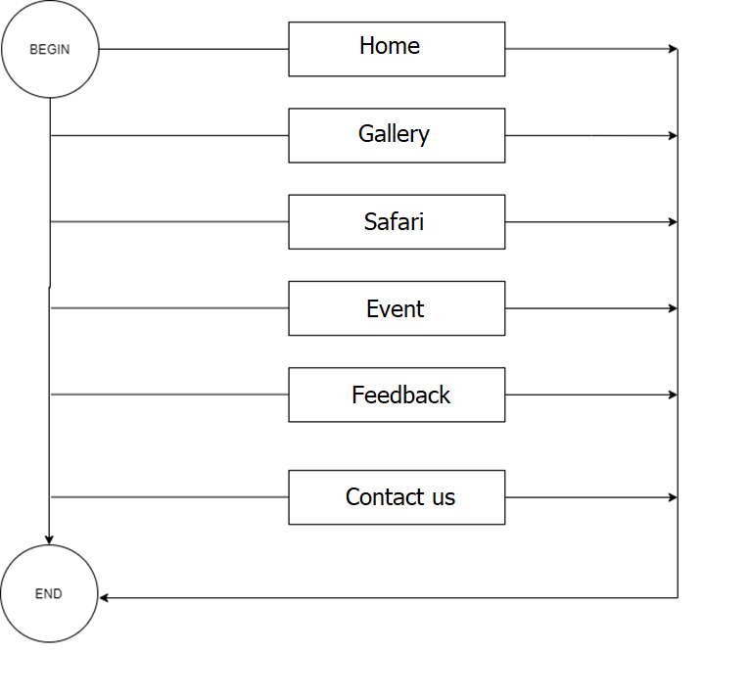



# TASK SHEET REVIEW 1

|  |  |  |  |  |  |  |  |  |
| --- | --- | --- | --- | --- | --- | --- | --- | --- |
| **Project Ref. No.:**  **eP/Advertisement Portal Management**  **System/01** | |  | **Project Title:** | **Activity Plan Prepared By:** | **Date of Preparation of Activity Plan:** | | | |
| **Sr.**  **No.** | **Task** |  | **Actual**  **Start Date** | **Actual Days** | **Team**  **Mate Names** | **Status** |
| 1 | Problem Statement |  | Zoo | Quý | 14-Jan-22 | 1 | Quý | Completed |
| 2 | Analysis of HKN Tourist requirements about the website |  | 14-Jan-22 | 1 | Quý | Completed |
| 3 | The scope of the work (in brief) |  | 14-Jan-22 | 1 | Quý | Completed |
| 4 | Architecture and design of the system |  | 14-Jan-22 | 1 | Quý | Completed |
| 5 | Diagram of the website |  | 14-Jan-22 | 1 | Quý | Completed |
| 6 | Task Sheet |  | 14-Jan-22 | 1 | Quý | Completed |

|  |  |
| --- | --- |
| **Date:** | |
| Signature of Instructor:  **Ms. Le Mong Thuy** | Signature of Team Leader:    **Hoang Ngoc Minh Quy** |

# SITE MAP

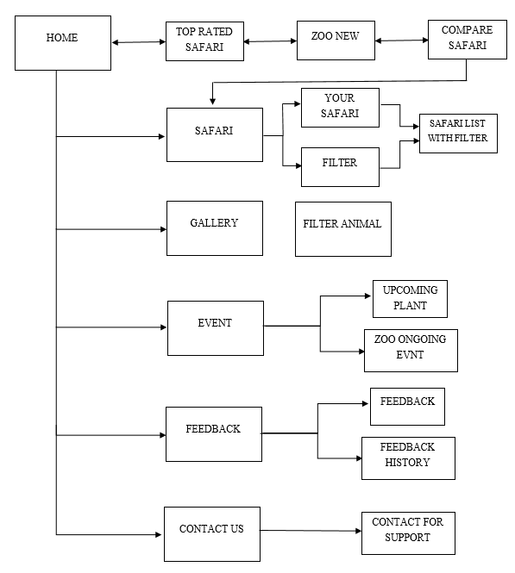

|  |
| --- |
|  |

# HOME

**HEADER**

**(NAVIGATION BAR)**

**SLIDE IMAGES AND COMPARE SAFARI**

**TOP RATED SAFARI**

**ZOO NEW**

**EPROJECT MEMBER**

**FOOTER**

**GALLERY**

**Categorize**

**(Filter)**

**Your Image**

**HEADER**

**(NAVIGATION BAR)**

**FOOTER**

**SAFARI**

**YOUR SAFARI**

**FILTER**

**SAFARI LIST**

**WITH FILTER**

**HEADER**

**(NAVIGATION BAR)**

**FOOTER**

**EVENT**

**IMAGE**

**TEXT**

**FOOTER**

**NAVIGATION BAR**

**EVENT**

**FEEDBACK**

**SLIDER**

**HEADER**

**(NAVIGATION BAR)**

**FOOTER**

**FEEDBACK HISTORY**

**CONTACT US**

**SLIDER**

**HEADER**

**(NAVIGATION BAR)**

**FOOTER**

**TEAM MEMBER**

**MAP LOCATION**

**CONTACT FORM**

# TASK SHEET REVIEW 2

|  |  |  |  |  |  |  |  |
| --- | --- | --- | --- | --- | --- | --- | --- |
| **Project Ref. No.:**  **eP/Advertisement**  **Portal Management System/01** | | **Project Title:** | **Activity Plan Prepared By:** | **Date of Preparation of Activity Plan:** | | | |
| **Sr.**  **No.** | **Task** | **Actual Start Date** | **Actual Days** | **Team Mate Names** | **Status** |
| 1 | Site map | Zoo | Quý | 18-Jan-22 | 1 | Quý, Cường, Trung, Huy | Completed |
| 2 | Mock of the website | 18-Jan-22 | 2 | Quý, Cường, Trung, Huy | Completed |
| 3 | Task sheet | 18-Jan-22 | 2 | Quý | Completed |

|  |  |
| --- | --- |
| **Date:** | |
| Signature of Instructor:  **Ms. Le Mong Thuy** | Signature of Team Leader:  **Hoang Ngoc Minh Quy** |