An Investigation into the Application of Edge Detection to Detect Cells

# Aim

The aim of this experiment is to contrast and compare the suitability of various edge detection algorithms and their application in serological testing for anti-nuclear antibodies. The edge detection methods that will be investigated in this experiment are as follows: Simple gradient, Roberts, Sobel. Laplacian and Laplacian of Gaussian. The results of each will then be compared using Receiver Operator Check analysis so that a conclusion can be drawn.

# Method

In order to perform edge detection, first a single image matrix must be produced from the colour images provided as the colour images comprise of 3 separate red, green, blue (RGB) matrices. This is done by taking only the green channel of the image as the cells being detected fluoresce green. After an image matrix has been created smoothing can be applied if required and an edge detection algorithm can be applied.

## First Order Derivative Edge Detection

First order derivative edge detection approximates the gradient of an image, after the gradient of an image has been calculate the areas of change within the image are then apparent. These areas of change are normally associated with edges therefore by thresholding the gradient values with a suitable threshold the edges of the image can be found.

### Simple Gradient (Difference):

Simple gradient first calculates the vertical gradient and horizontal gradient of the image, to calculate the vertical gradient the image is convolved with and to calculate the horizontal gradient convolve the image with . After getting both the horizontal and vertical gradient an approximation for the image gradient can be made by finding the magnitude of the two gradient matrices using . Before applying simple gradient detection the image is convolved with a Gaussian matrix in order to smooth and remove noise from the image. This makes the detection the same as the first order derivative of Gaussian.

### Sobel:

Sobel utilises a three by three matrices to approximate horizontal and vertical gradients, this has the advantage of there being a centre to the matrices which retains the positioning of the gradients instead of shifting the positions which happens when using a 2x2 matrix. The image is then convolved with the matrix to find the horizontal gradient image and with to find the vertical gradient image. The image gradient can then be approximated using the same technique described in simple gradient.

### Roberts:

The Roberts edge detection method approximates the gradient of an image by first finding the differences between diagonally adjacent pixels. This is done using two 2x2 matrices and convolving them with the original image to form and . These are both gradient components of the image which are finally used to calculate a gradient magnitude with .

## Second Order Derivative Edge Detection

Second order derivative edge detection approximates the rate of change of gradient in a given image, after this has been found the point at which there is a crossing from negative to positive change can be detected, this represents an edge in the image. As each time a derivative is taken noise in the image is amplified second order derivative edge detection is considered bad for noisy images unless smoothing is applied.

### Laplacian

Laplacian edge detection utilises only a single matrix in order to approximate changes in gradient of an image. The matrix is convolved with the image matrix to create a matrix representing the change in gradient. The edges are then detected by finding the points where there is a change from negative to positive in the matrix.

### Laplacian of Gaussian

The Laplacian of Gaussian method is similar to the Laplacian method except a Gaussian matrix is first convolved with the edge detection matrix described above. After this has happened the resulting matrix is convolved with the image matrix and edges are found in the same manner as Laplacian. This has the effect of smoothing the image at the same time as applying Laplacian edge detection therefore removing noise from the image and false positives from the edge detection.

## Receiver Operator Characteristic (ROC) Analysis

Once the edge matrix has been calculated then the correctness of the detection method can be determined using ROC analysis. This involves calculating the false positive rate and true positive rate between the approximated image and the expected image by comparing the pixels.

### Thresholding

In order to determine whether a pixel can be considered an edge thresholding is applied to the image after filtering has occurred. This involves setting all pixels between threshold values to black and otherwise setting them to white. Below is a record of the threshold values used as well as details of any Gaussian smoothing applied, these values were chosen in order to give the best visible edge matrix.

|  |  |  |  |  |
| --- | --- | --- | --- | --- |
| Image 1 | Start Threshold | End Threshold | Gaussian Size | Gaussian Deviation |
| Difference | 0 | 0.09 | 3 | 0.5 |
| Laplace | 0 | 0.0175 | - | - |
| LoG | 0.7 | 1 | 9 | 3.5 |
| Roberts | 0 | 0.06 | 3 | 0.5 |
| Sobel | 0 | 0.3 | 3 | 0.5 |
| Image 2 |  |  |  |  |
| Difference | 0 | 0.026 | 4 | 1.5 |
| Laplace | 0 | 0.0175 | - | - |
| LoG | 0.7 | 1 | 9 | 3.5 |
| Roberts | 0 | 0.02 | 6 | 1.5 |
| Sobel | 0 | 0.14 | 3 | 1.5 |
| Image 3 |  |  |  |  |
| Difference | 0 | 0.05 | 7 | 2.5 |
| Laplace | 0 | 0.021 | - | - |
| LoG | 0.65 | 0.8 | 9 | 3.5 |
| Roberts | 0 | 0.045 | 6 | 1.5 |
| Sobel | 0 | 0.31 | 4 | 1.5 |

# Results

The results collected from this experiment consist of ROC graphs showing the performance of different types of edge detection techniques for each image given. As well as this the average distance from the perfect result has been computed in order to more easily compare techniques.

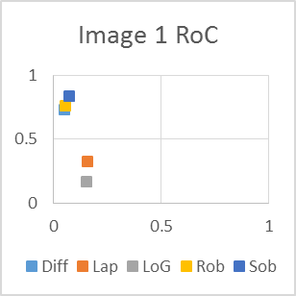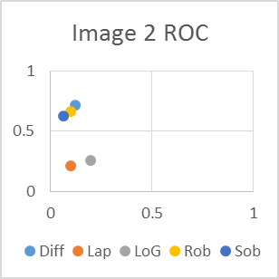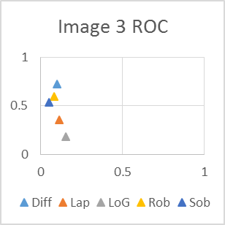

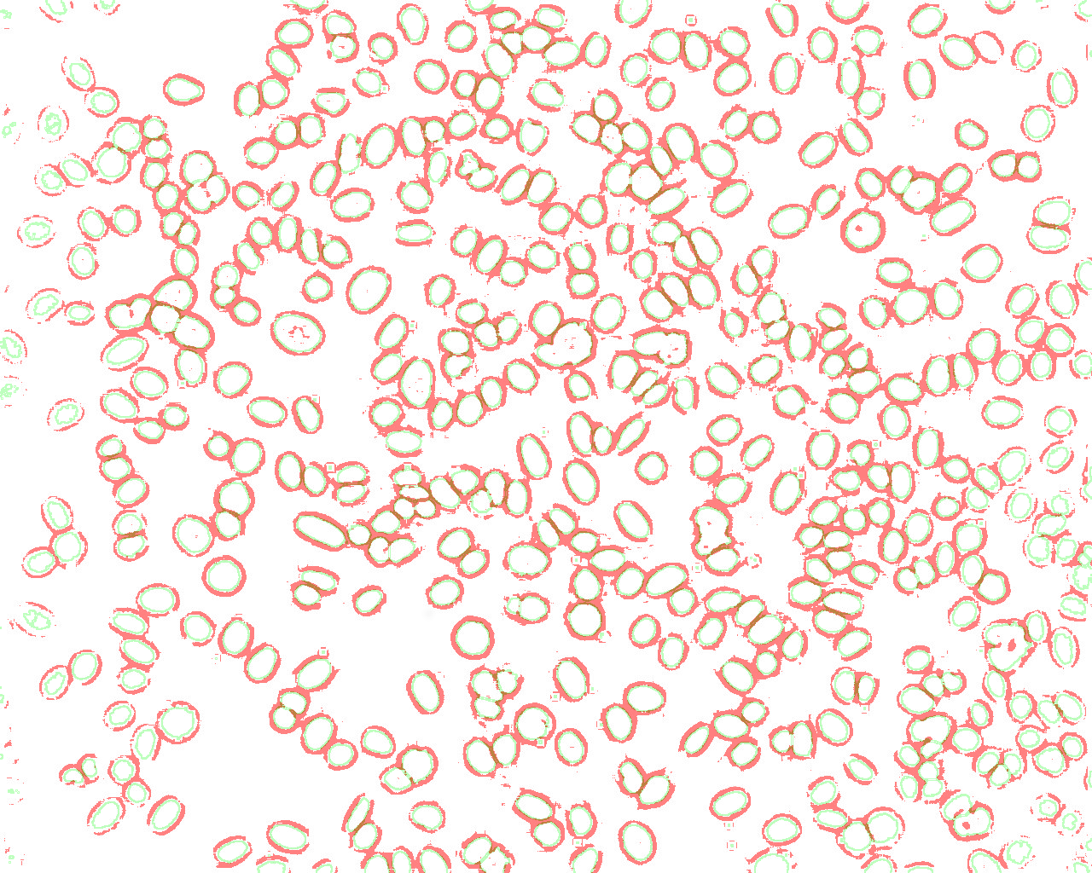

|  |  |
| --- | --- |
| Filter | Distance Average* |
| Difference | 0.292549 |
| Laplacian | 0.714515 |
| Laplacian of Gaussian | 0.815416 |
| Roberts | 0.33479 |
| Sobel | 0.340892 |

*Average Distance is the average Distance to (0,1)

Below is a magnified section of an image with Laplacian of Gaussian superimposed on the correct edges.

hfhgf

# Thoughts

When doing this experiment, we have found that according to ROC analysis, the best method of edge filtering is the Difference filter. Roberts and Sobel all are not far behind, and the best ROC score was with Sobel filter on image 1.  
The discrepancy between the images comes from different levels of noise in the images. The Laplacian was poor according to the ROC, and from looking at the image. The Laplacian of Gaussian is more of a special case however, as the edges it produces are very clear, but it gets a low ROC score.

As we can see from the graphs, there is a low false positive rate for all of the filter types – but this is to be expected because edges are small, so to get any sort of useful data when detecting edges, the false positive rate should be small. Secondly, we can see what was confirmed by the average distance score – there are two groups of scores, the Difference, Roberts and Sobel, and the Laplacian and Laplacian of Gaussian.

Laplacian is very sensitive to noise – which is why is has such a low RoC score.

The Laplacian of Gaussian is a little different, it detects a different part of the edge, as we can see above in the red/green image. The green parts of the image show where the edges are, and the red parts show where we detect the edges to be. This difference is why LoG gets a very poor ROC score, even though it produces arguably the best images.

# Conclusion

In conclusion, all of the first order edge detection methods perform roughly equally, but they all have different sensitivity to noise. For example, Image 1 has much lower noise levels than 2 and 3, which means that the Sobel filter performs the best. The difference filter performs well consistently, and the Roberts filter is between the two.

The second order edge detection methods are very sensitive to noise, which is why basic Laplacian has a very low ROC score. Laplacian of Gaussian is a visibly good filter, and we believe that it produced the clearest edges. This however is not reflected in ROC analysis as the edges are out of place when compared to the correct edges.