# Compartment model for epidemiology

# Abstract

This paper looks at a compartment model for epidemiology and analyzes the different relationships between the variables in the model. Finally, it draws conclusions of the impact the variables have on the model.

# Model

The population is divided into compartments, with the assumption that every individual has the same characteristics. There is a total of five compartments: susceptible (S), exposed (E), infected(I), recovered (R), and diseased (D).

$$S→E→I→R / D$$

The model is described as ordinary differential equations with the following variables:

* $β :$ how often a susceptible-infected result in exposure.
* $σ :$ the rate an exposed becomes infected.
* $γ :$ the rate an infected recover.
* $δ :$ the rate that a case that recovers dies.
* $ν :$ vaccination ($ν=0$).
* $S :$ initial susceptible.
* $E :$ initial exposed.
* $I :$ initial infected.
* $R :$ initial recovered.
* $D :$ initial deaths.

These variables are related through the following ordinary differential equations:

$$\frac{dS}{dt}=-β\frac{SI}{N}-νS$$

$$\frac{dE}{dt}=β\frac{SI}{N}-σE$$

$$\frac{dI}{dt}=σE-γI$$

$$\frac{dR}{dt}=γI+νS-γδI$$

$$\frac{dD}{dt}=γδI$$

$$N=S+E+I+R+D$$

# Analysis

In the analysis the initial population size is $N=100.000$, and will start with one patient zero for all simulations.

In the first simulation a susceptible-infected exposure has the probability of 80% to become exposed. Once exposed, at any unit of time the case has a chance of 15% to become infected. This given an average time until infection of 6.66 days. There is a probability of 10% to recover per unit of time, whereas 5% of those cases result in death. This means it takes an average of 10 days to recover.

This gives the following initial conditions for the system: $β=0.8, σ=0.15, γ=0.1, δ=0.05$ at $t=0$.

Running this simulation for 120 days gives the following result:

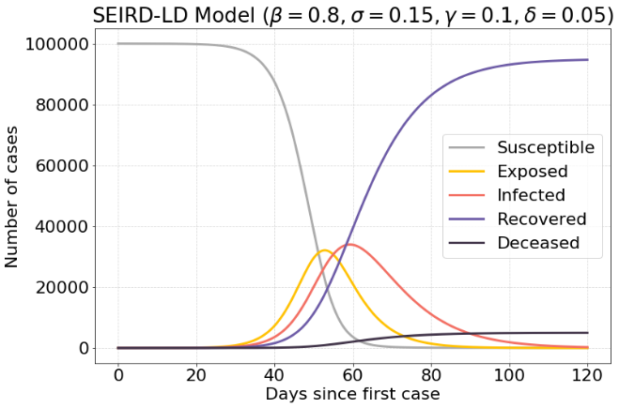

Figure 1) Normal initial condition.

With these initial conditions there are a maximum of around 37.000 infected. Over time the population will move from susceptible (S) to recovered (R). This means that 0.

If the value of $σ$ is increased, meaning that exposed people will get infected faster, there is an increase in maximum infected cases. There are about 39.000 infected cases.

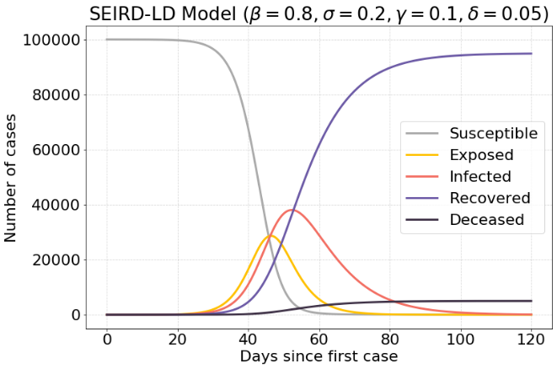

Figure 2) Increased infection rate $σ$.

If a lower value of $σ$ is used, the resulting infections are spread out a lot more over time. There are about 19.500 infected cases.

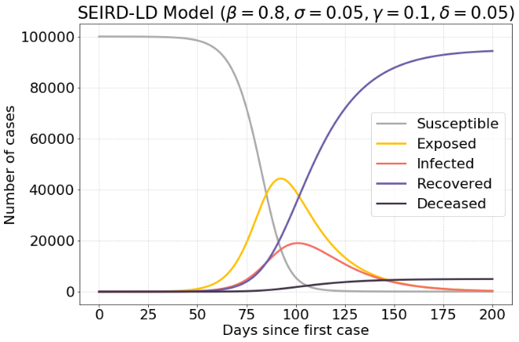

Figure 3) Decreased infection rate $σ$.

Another interesting factor is the recovery rate $γ$. If the recovery rate increased, there will be a lot less people infected at any given moment. There are about 21.000 infected cases.

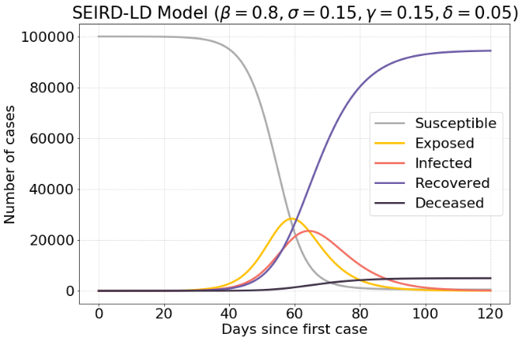

Figure 4) Increased recovery rate $γ$.

If it takes longer to recover, a massive surge is seen in the infected cases. There are about 50.000 infected cases, which is half of the population.

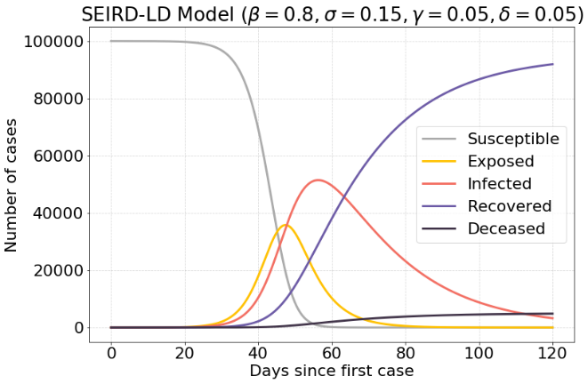

Figure 5) Decreased recovery rate $γ$.

The following model has an increased exposure rate $β$, which means that exposed case are infected faster. This results in 41.000 infected cases.

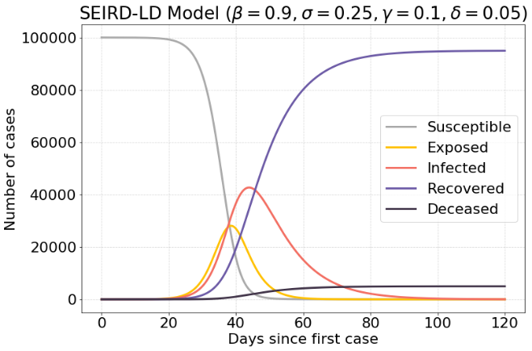

Figure 6) Increased exposure rate $β$.

# Lockdown

The following model is the same model as in the previous section. However, after a period of time a lockdown will be in effect. This is modeled by settings $β$ to a very low value during a brief period of time $t$.

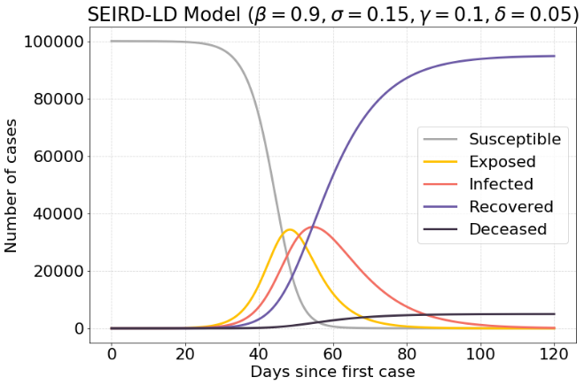

Figure 7) No lockdown

Without the lockdown there is a maximum of 38.000 infected cases, while with a good timed lockdown, there are 20.000 infected cases. This is a reduction of 47.37%.

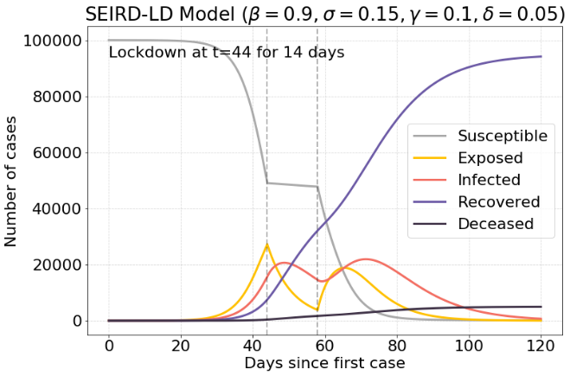

Figure 8) Lockdown