**AIDE MEMOIRE**

**Implementation Support Missions**

**Private Sector Development (PSD) Re-engagement Phase II Program (Som-PREPII)**

**(P125550)**

**(December 16, 2012 – March 5, 2013)**

# INTRODUCTION AND ACKNOWLEDGEMENTS

Four Implementation Support Missions were conducted between December 16 and March 5, 2013. This Aide Memoire reports on the outcomes from these missions.

1. **Investment Climate – One-Stop Business Start-up Centers (OSBCs) (December 16-25, 2012)**

**Objective:** (i) Embark on the first phase of the implementation of the OSBC and produce a comprehensive Assessment Report of the business start-up system of Somaliland.

**Mission:** Dobromir Christow (Operations Officer, AFTFE), Michael Engman (Sr. Economist/TTL, AFTFE), Najeeb Hashi (Regional Coordinator, AFTFE), Apex Consulting implementation team: Labib Al-Hadrami (Project Director), David Charles Walke (International Business Registration Adviser), Wail Al-Jirafi (Process Re-engineering Expert), Taha Al-Moyad (ICT/Mapping Expert), Ahmed Hersi (Local Capacity Building Expert) and Liban Mohammed (Local Communications Expert).

1. **Investment Climate – Enterprise Survey (January 6-11, 2013)**

**Objectives:** (i) Train Kimetrica supervisors, local supervisory staff, enumerators and Ministry of Planning and Development (MOP) liaisons in implementation of the Enterprise survey; (ii) finalize sample design and draw sample in coordination with Kimetrica’s sampling expert; (iii) update the MOP on the Somaliland Enterprise Survey status.

**Mission:** Joshua Wimpey (PSD Analyst, FGIEA), Kimetrica Implementation Team: Geoff Greenwell (Team Leader), Sarah Hassan (Survey Supervisor), and David Megill (Sampling Specialist).

**3.) Public-Private-Partnership (PPPs) – Berbera Port (February 4-9, 2013)**

**Objective:** (i) Conclude on recommendations provided by the Consultants Maritime Transport Business Solutions (MTBS) in their Strategic Economic Assessment (SEA) of Berbera Port and agree on the way forward for implementation.

**Mission**: Reynaldo Bench (Senior Ports Specialist, TWITR), Michael Engman (Sr. Economist/TTL, AFTFE).

**4.) Semi-Annual Project Review, Financial Sector, PPPs – Solid Waste, Value Chains (Gums/Resins and Fisheries), Somaliland Business Fund (February 24 – March 5, 2013)**

**Objectives:**  (i) Conduct the Semi-Annual Review of the Som-PREPII project with the Government of Somaliland (GoSl); (ii) **Financial Sector** - Discuss with the MOP, the Bank of Somaliland (BOS) and other financial sector stakeholders implementation under the financial sector component of the project as well as the planning for forthcoming activities in addition to discussing arrangements for the passage of the commercial banking act and setting up a fully staffed bank supervision unit at the BOS; (iii) **Value Chains** - Meet with the Ministry of Environment (MOE), implementing partners and other local counterparts to review status of project progress; (iv) **PPPs – Solid Waste Management** (SWM) – Meet with the IPE Global consultants in charge of providing advisory services on private sector development in solid waste management, and review the progress made; and; (v) deliver a workshop on waste composting/bio-digesting in Somaliland; (vi) **SBF** - Meet with the MOP and Ministry of Commerce (MOC) to review status of project progress and issues; (vii) review the status of the Somaliland Business Fund (SBF) including the Landell Mills team, grant agreement procedures, governance structure, monitoring and evaluation system, progress and content of SBF applications, timing/deadline for proposals, disbursements and accounting systems; (viii) Meet sample of application enterprises as well as local grant fund donors to discuss common issues and progress.

**Mission:** Michael Engman (Senior Economist), Austin Mwape (Resident Advisor/Financial Sector Consultant), Jan Drozdz (Senior Water and Sanitation Specialist), Pieter Smuts (Consultant/Composting Expert), Mohamed Saad (Local Consultant/Solid Waste), David Phillips (Matching Grant and Start-Up Fund Consultant), Najeeb Hashi (Regional Coordinator) and Jade Ndiaye (Extended Term Consultant). The mission was supported by relevant implementing partners – IPE Global, Landell Mills and SOFRECO.

Janerose Lubisia (Temp, AFCE2) and Nancy Visavilwa (Executive Assistant, AFCE4) provided support from Nairobi for all of the above-mentioned missions.

The mission team would like to thank GoSl for its generous support and guidance during the mission. The mission team met with HE. Abdirahman Abdillahi Ismail (Saylici), Vice-President of the Republic of Somaliland; Dr. Sa’ad Ali Shire, Minister of Planning and Development; Mr Hersi Ali Hassan, Minister of Presidential Affairs; Mr. Abdillahi Jama Osman, Minister of Fishery and Marine Resources; Mr. Abdirazak Khalif Ahmed, Minister of Commerce, Industry and Tourism; Mr. Osman Sahardeed, State Minister for Finance; Mr. Mohamed Saeed Mohamoud, Minister of Environment and Rural Development; Dr. Mohamed Nur Arale (Durr), Minister of Interior, Mr. Hussein Abdi Dualeh, Minister of Mining, Energy and Water Resources; Prof. Farah Elmi Mohamoud, Minister of Agriculture; Dr. Abdi Aw Dahir, Minister of Livestock and Engr. Hussein Mohamoud Je’er, former Mayor of Hargeisa City. The mission would also like to thank the Chamber of Commerce; private sector representatives of the Fisheries and the Gums/Resins Associations as well as the Somaliland Solid Waste Management Association and its members. A list of key meeting contacts is provided in Annex A.

# CONTEXT

The PSD Re-engagement Phase II Program (Som-PREPII) is a four-year program (2011-2015) initially targeting Somaliland with the objective to improve access to markets and generate employment in key productive and service sectors. The component-level objectives of the Som-PREP II Program cover:

1. **Investment Climate:** Improve the investment climate and strengthen public-private dialogue through the establishment of One-Stop Business Start-up Centers (OSBCs), preparation of a Doing Business in Hargeisa report, drafting of a PSD Strategy and completion of an enterprise survey;
2. **Financial Sector:** Strengthen banking supervision and legal framework consistent with international standards and best practices;
3. **Value Chains:** Develop institutions and markets in support of enterprise employment and growth in gums and resins and fisheries sectors;
4. **PPPs – Ports and Solid Waste:** Develop an enabling environment for PPPs for investment, services expansion and quality improvements in private provision of solid waste management and port services;
5. **Somaliland Business Fund:** Provide MSME financing to the private sector to improve firm performance and generate employment; and
6. **Economic Sector Work:** Determine the principal constraints to private sector lead growth and job creation with a particular focus on the key economic sectors of gums and resins, livestock and fisheries, together with private sector provision of key infrastructure services through a political economy study.

# KEY FINDINGS AND IMPLEMENTATION PROGRESS

## A. Investment Climate

***OSBC:*** The first implementation mission for the OSBC sub-component focused on five critical reform implementation areas: (1) establishing a Project Management Unit (PMU) comprising World Bank staff, GoSl and Apex; (2) policy, legal and institutional analysis; (3) information and communications technology (ICT) assessment; (4) “as-is” mapping for business registration process in Hargeisa, Berbera and Burao; (5) training needs assessment.

During the mission, progress was noted on all of the above-listed reform areas. The GoSl reconfirmed its reform commitment by stating its readiness to establish a GoSl-led PMU comprising selected senior officials of the respective Ministries, Departments and Agencies (MDAs). Despite the fact that this is a Bank Executed program, the establishment of the local PMU is a critical step towards facilitating client buy-in and ownership and keeping reform momentum.

In the area of policy, legal and institutional reform, it was established that a major policy and institutional reform needs to take place in order to align all policies and processes into a transparent, uniform and standardized model. It was also found that a number of critical policies and regulations, including provisions in the Companies Act are missing or are not being followed or enforced, leading to de-facto interpretations, ineffective administrative practices and discretion on behalf of the MDAs involved in the business registration, taxation and operation process.

The ICT Assessment, the process mapping and the training needs assessment established that the different MDAs are in different stages of ICT development, process synchronization and training needs. It is also important to note that a number of MDAs are severely understaffed and will need a solid increase in staff positions in order to be able to carry out current functions and operate the new system. For example, the Legal Department of the Attorney General (AG), which is in charge of company registration for the whole of Somaliland, has two people staffed – one Director and one Officer.

On the municipal level, however, local authorities have more staff, better ICT systems, reliable database and inspectors/enforcement unit who can reach out to local businesses. Nevertheless, the local authorities are highly motivated and organized, because they collect local revenues from businesses through the local business license/occupancy permit requirement, which is a de-facto annual tax on businesses involved in commercial activity on the territory of a given municipality. However, the local and the national authorities do not exchange any information regarding business entities, business density, formalization or any other type of information showing link between the MDA involved in business regulation in Somaliland.

***Enterprise Survey****:* The mission agreed on a sample design and sampling methodology for the enterprise survey which incorporates the additional geographic region of Wachale, a critical international trading hub on the border of Ethiopia. A reporting format, including frequency of reporting, was agreed upon as well as data-entry protocol and a delivery schedule. Translation of all survey materials was completed. Three supervisors and 18 enumerators were trained over four days on the implementation of the enterprise survey, including piloting of the survey instrument with local businesses. Full data delivery is expected at the beginning of April.

The mission also shared with the MOP case study terms of reference on the following topics: (i) remittance company operations; (ii) diaspora investment; (iii) government institutions and mechanisms for private sector development; and (iv) clan dynamics. The terms of reference were reviewed by the GoSl and comments were provided. Revised terms of reference will be shared with the GoSl, with a team expected to be fully recruited by the end of the second quarter.

**B. Financial Sector**

Services of a resident advisor on bank licensing, supervision and regulation were procured in April 2012. The advisor has since been working with senior BOS officials to strengthen the institutional framework for banking and financial services supervision and regulation, including the training of officials on basic and foundational knowledge on bank supervision. So far eight training sessions have since been conducted, covering both senior and technical level officials from the central bank. The Inter-Agency Working Group on financial sector legal review and policy development was constituted in December 2012 following the signing of the framing memorandum of understanding (MOU) by all key stakeholders. The Working Group has scheduled its inaugural meeting for later during March 2013.

Parallel to these efforts, the BOS Act and Islamic Banking Act were enacted in July and September 2012, respectively, and a bank supervision function established by BOS in December 2012 under the direction of the deputy governor. This is the first and crucial step towards inaugurating supervision activities at the Central Bank. However, the conventional banking bill remains pending in the House of Representatives since October 2012. As such some institutional weaknesses remain in Somaliland that require strengthening by the authorities. The foregoing notwithstanding, in the absence of a comprehensive legal and regulatory framework, a transitional policy framework for bank licensing and regulation was developed and approved by the Board of the Bank of Somaliland in December 2012. Bank of Somaliland is now required to formulate a credible framework of migrating existing informal and unregulated financial service providers onto a formal and regulated platform preferably over a two to three year transitional period. This transitional period would also include the facilitation of formal information gathering on operators in the financial services sector.

In addition to the above, arrangements towards planned study tours have progressed well with the Central Banks identified as priority destinations for learning and experience sharing, Central Bank of Kenya in Nairobi and Bank Negara Malaysia in Kuala Lumpur. The Central Bank of Kenya has already indicated its willingness to accommodate the study tour team during the month of April 2013. The Malaysian authorities are yet to confirm the arrangements.

In the near future, the authorities are encouraged to focus attention on the following few and vital actions:

* *Formulation of a credible transitional framework of migrating existing informal and unregulated financial service providers onto a formal and regulated platform:* The authorities are urged to reach out and engage with existing financial services providers seeking to establish formal operations in Somaliland and obtain agreement on a transition path towards BOS regulation and supervision, preferably over a two to three year transitional period covering 2014 and 2015.
* *Enactment of the BCFI Bill:* Concerted efforts are required to be exerted by the authorities to ensure the swift enactment of the BCFI Bill which has been pending before the House of Representatives for a while now; even though the BOS transitional policy is expected to fill in the lack of a comprehensive legal and regulatory framework for banking and financial services in Somaliland;
* *Immediate appointment of the head of bank supervision:* Appointment of the head of bank supervision at BOS needs to be made immediately. This action will supplement BOS’s commitment to expedite employment during 2013 of fresh graduates in business, finance, economics and accountancy for the lower portfolios in the banking supervision unit at the central bank;
* *Development of computer and other technology supplies requirements for banking supervision:* Development of terms of reference and procurement of services of an experienced technology expert to support BOS to devise technical and functional requirements for computer and other IT requirements for the banking supervision unit will be addressed during 2013. Procurement and delivery of the computers and other supplies is expected to be completed during 2014; and
* *Demonstration of the internalization of lessons learned from the targeted study tours:* Appropriately constitute study teams and undertake study tours to Kenya and Malaysia with a view to reflecting lessons learned and experiences gained in the design and operation of financial sector policy in Somaliland. This activity is scheduled to be completed during 2013.

**C. Value Chain Support**

***Fisheries:*** The Bank team noted the considerable progress of the Ministry and consultant teams over the past several months, including the completion of a coastal survey of fishing communities along 750 kilometers of the Somaliland coast, the stocktaking of fisheries associations and businesses, the preparation of a training needs assessment and the completion of a training course for Ministry staff and two database training courses completed for fishing businesses and associations.

While consultant tasks are proceeding and collaboration with the Ministry is good, with frequent interaction, there is still room for improved coordination as the consultant reports that the Ministry focal point for their work has not been sufficiently available for tasks requiring his attention. An example was the considerable delay in addressing the recommendations for training as a result of the training needs assessment referred to above. The Bank team suggested that one of the Ministry’s new hires could be mentored to perform in this role. The Minister indicated the issue will be considered and will revert to the consultant. It was also agreed that to prevent any confusion, all discussion between the Ministry staff and the consulting team would include the consultant team leader.

Regarding the question of the selection of international vs. local consultants for training purposes, it was agreed that the selection would be based solely on a competitive selection in line with World Bank guidelines, so that the most appropriate individuals could be selected, regardless of nationality. A deadline would be established and no CVs would be accepted after that date. It was also agreed that a train-the-trainers program would be put in place so that a cadre of trainers could be developed.

The training assessment was reviewed with the Minister and ministry team. The team clarified that responsibilities allocated to the Ministry and to the consultant, respectively, were meant to set forth the roles and obligations of each side but that the intention is for all issues to be mutually agreed, to the satisfaction of the Ministry. An example is the question of the destination of the fisheries study tour. While the consultant suggested Lake Victoria as a useful example given the similarity of issues with regard to infrastructure and building business associations, the Ministry expressed its belief that Yemen would be a more desirable location, given its geographic proximity across the same sea, the Ministry’s interest in finding out more about the Yemeni fisheries and its interest in collaboration. It was agreed that the fisheries expert would provide a more extensive analysis of both alternatives, for further consideration.

Other areas discussed included the need for more marketing research to support the fish awareness campaign and to evaluate the effectiveness of the newsletter produced by the consultant. In response to a request, the Bank team also informed the Ministry that the program budget would not support purchase of furniture or additional computers for the Ministry.

***Gums and Resins:*** The Bank team noted component progress made since September 2012, including the completion of a stocktaking of associations and the initiation of the gums/resins tree census, and the conduct of two missions to the Sanaag region. A training needs assessment and gums marketing study are currently in progress. The mission also noted the considerable progress made under the auspices of the Minister of Environment to improve collaboration between the consultant and Ministry staff. Both the consultant and the Minister agree that collaboration is now greatly improved and has facilitated closer collaboration.

The Bank team noted, however, its continued concern for the role of the many disparate producer associations, and it was agreed with the Minister that a key factor in the success of the value chain program will be the establishment of a single business association that would represent the interests of the entire value chain, including producers as well as traders and exporters. The Minister agreed that he would now focus attention on discussions with a limited number of key individuals of each type of sector participant in order to initiate such an association.

**D. PPPs**

***Solid Waste Management:*** The mission met with the IPE Global representatives and reviewed the progress made in advisory services. Out of six tasks, only Activity 1 (Capacity Building is SWM contractors and SLWMA) is substantially behind schedule due to a change in a key expert, while all other activities will be completed or implemented within 30 days of initial targets. In order to accelerate the implementation of their services, and to work closer with the City of Hargeisa and SWM contractors, IPE Global proposed to reorganize their staff.

The mission briefed the new Deputy Mayor and the Hargeisa City Council members on the past technical assistance in solid waste sector, present shortcomings and the realistic way forward. New Council members seemed to understand the critical nature of the need to comprehensively manage PPP contracts.

The mission noted that the level of interest in PPP for solid waste sector activities has risen from two municipalities in 2010 to at least six municipalities in 2012. It is reasonable to expect the increased private sector competition which should drive improvements in performance and quality of services.

The mission delivered a workshop on the market potential for composting and bio-gas on March 3, 2013 which included participants from GoSl, NGOs, City Council, students and the private sector. Approximately 30 delegates attended the workshop. During the workshop several possible options such as small scale composting and biogas production with a possible electricity generation in Berbera were discussed. Also discussed were potentials for household composting and biogas generation for energy production (cooking) and a pilot project for biogas generation at the Hargeisa Abattoir.

IPE Global has been tasked with carrying out a waste characterization study to provide information regarding the composition of solid waste which is necessary for recycling, composting and biogas initiatives. IPE Global is following up with GoSl, industry and investors to move the recycling program forward.

Progress is ongoing in the operationalization of the Solid Waste Management Association (SLWMA) and IPE Global is carrying out assisting in legalizing the Association and in promoting of such a representing body.

***Ports***: In view of a travel ban to Somaliland effective January 29- February 21, representatives of the GoSl took the opportunity of a scheduled visit of a presidential delegation to the United Kingdom to meet with the Country Director and the Ports mission in Nairobi. The principal objective of the meetings between the mission and the MOP, Ministry of Foreign Affairs and the permanent Somaliland representative in Kenya was to conclude on the recommendations provided by the Consultants (MTBS) in their SEA of Berbera Port and, consequently, agree on the way forward for implementation.

The draft final SEA report was submitted for peer review by external and internal parties, including Berbera Port Authority Management and Government officials. All comments received were compiled and the report was amended where appropriate. The main recommendations of the report include:

* Private sector participation shall be analyzed in depth on the basis of robust full business case for commercial activities with Cargo Handling operations and Marine services in two separate units
* Procurement of additional cargo handling equipment;
* Replacement of the old existing tug boat (preferably by two modern units);
* Strengthening of Berbera Port Authority;
* Upgrading and equipping of Port Training Facilities in Berbera;
* Organization and execution of a Study Tour on the Port Sector.

During the meeting it could also be clarified that the next phase of implementation would focus mainly on the design of private sector participation of Berbera Port Management and Operations and that relevant investments are expected to be performed in that same frame. It was confirmed during a follow-on meeting with Berbera Port Management on March 3rd that further funding from donors would be required to finance the next phase of activities under the component.

## E. Somaliland Business Fund

The Fund Management Unit (FMU) is now operating and has effectively processed an unexpectedly large number of applications (1,349) and shortlisted 167 projects. The first approvals were for 59 small grants on February 26, 2013, valued at about $2.1 million covering a broad range of subsectors, particularly agriculture, forestry and fishing projects, followed by manufacturing. They will provide about 630 new jobs. Of the awards 40% are in locations outside Hargeisa, and 20% for women owners. A shortlist of 37 large grants is currently undergoing full business plan processing. The projected grant schedule after the first awards is for the large grant awards (which may be valued at $2 to 3 million) in May 2013. A second round of small and large grants will be launched in June 2013 for awards by the end of 2013, and, depending on funds availability, possible additional rounds in 2014. At the current rate it is expected that the total $11 million of funding will be fully committed by early 2014.

While the above is good performance it would be desirable to try to encourage more viable projects in the gums and resins sector (which would require more group (consortium) proposals based on value chains) and more projects in the technical and business services sectors such as quality improvement programs and repair and maintenance facilities which are central to the development of domestic capacity.

*Policy and procedure*

A number of outstanding operational policy issues were ironed out immediately before and during the mission. These have included the final arrangements for and authority of the Grant Advisory Panel (GAP) (which has now convened), the installation of the M&E system, a security vetting procedure, and issues of copayments, advance payments, project ownership and multiple applications. The GAP chairman has stated that the GAP should not be a recourse for appeals in the case of operational disputes, the role of which should rest with the FMU. The Grant Manual has been approved but will remain subject to continuous review both in the Bank and in Somaliland, as circumstances on the ground require. Material changes to the main text will be agreed between the FMU and the Bank.

*Funding and contractual Issues*

Discussions are ongoing between the Bank and the FMU contractor (LML) on the capacity and level of effort of the FMU, and possible budget revisions, going forward bearing in mind the workload that will result from the injection of GBP 5 million of funds by DFID in December 2012.

**F. Semi-Annual Review of Program Progress/Monitoring and Evaluation (M&E)**

On March 4th the task team undertook a semi-annual review of the SomPREPII Program with the GoSl and Program donors (DANIDA) covering activities from July-December 2012 as well as recent developments. The minutes of the Semi Annual Review and accompanying presentation providing an update on activities completed and ongoing is attached under Annex E. Following explanation of the activities completed, the GoSl expressed satisfaction with progress of the project.

**M&E:** In light of baseline data received from the “Doing Business” survey and initial data collection under the Som-PREPII project components, the results and performance framework and its targets were revised and shared with the GoSl during the semi-annual review. The revised results and performance framework are attached in Annex B.

**G. Implementation Arrangements**

1. **Government of Somaliland**

***Project Steering Committee (PSC):*** GoSl will establish a PSC to provide overall strategic guidance for the program. The task team requests that GoSl provide a formal letter confirming the establishment of the PSC.

**2.) World Bank Project Management Arrangements and MDTF Status**

***Project Office Lease Arrangements:*** The Project is awaiting final approval to sign a lease with FAO to lease four office rooms and other facilities in their compound in Hargeisa. The issue of insurance is outstanding and there has been no breakthrough. FAO and WBG’s lawyers are currently discussing the issue.

***World Bank Staff:*** It was agreed that recruitment of an ETC would commence once the project office lease is signed. The World Bank is also looking to recruit a Public Relations expert who will be based in Hargeisa.

***World Bank Local Consultancies:*** The World Bank has one active contract for a local consultant supporting the Solid Waste activity. Additional hires will be considered when the project office lease has been signed.

**Current MDTF Status:** The MDTF has currently obtained signed funding commitments to a total of $20.3 million, comprising an approximate $11.6 million contribution from DFID and a $2.2 million contribution from the World Bank State and Peace-Building (SPF) Trust Fund and $6.5 million from the Danish International Development Agency (DANIDA). Deposited funds currently amount to approximately $17.2 million (total contributions less disbursements and administration charges totaling $3.1 million). It is anticipated that further funding will need to be mobilized to ensure that the SBF mechanisms have the minimum levels to ensure cost-effective impact and to cover an estimated $3.6 million shortfall on funding for the other project components. Discussions are ongoing with MDTF funders on potential additional allocations.

# AGREEMENTS REACHED

1. **Investment Climate**

* The WB team, Apex and GoSl have agreed that the team can proceed with finalizing the first deliverable - Assessment Report of the business start-up system of Somaliland, including the following areas:

1. Establishing Project Management Unit (PMU), comprising of WB staff, GoSl and Apex;
2. Policy, legal and institutional analysis;
3. ICT Assessment;
4. “As-is” mapping for Business registration process in Hargeisa, Berbera and Burao;
5. Training Needs Assessment.

* The Assessment report will also include reform options, based on the field observations and proposed reform road-map. The finalized report will be presented and discussed with the GoSl PMU and related stakeholders, and is expected to lead to the second implementation phase – policy reform, ICT procurement and installment, and training and roll-out of the business registration system for the OSBC.
* Both parties agreed that the system will be first tested in Hargeisa, before being rolled-out to Berbera and Burao. The policy, process and ICT review and recommendations will be conducted in line with the international best practice and adjusted to the Somaliland specifics.
* It was agreed that a new mission will take place by March 2013 to present the Assessment Report to the GoSl and the PMU, collect inputs, and reflect feedback before moving to the second implementation phase.

1. **Value Chains**

**Gums/Resins:**

* It was agreed that selection of consultants for training purposes would be based solely on a competitive selection in line with World Bank guidelines. Moreover, a train-the-trainers program will be put in place so that a cadre of trainers could be developed.
* Further analysis will be provided regarding alternative locations (e.g. Yemen) for the fisheries study tour

**Fisheries:**

* It was agreed that a key factor in the success of the value chain program will be the establishment of a single business association that would represent the interests of the entire value chain, including producers as well as traders and exporters.

1. **PPPs – Ports**

Based on the description provided about the present situation and options for the way forward and upon request of the Minister of National Planning, the parties agreed that the team will provide following:

* An executive summary of the SEA of Berbera Port and the main conclusions and recommendations;
* A short note to be shared amongst members of the government, especially with the line Ministry (Vice Presidency) in charge of Berbera Port describing the present situation and envisaged way forward.

1. **Somaliland Business Fund**

* It was agreed that the FMU will be responsible for recourse for appeals in the case of operational disputes rather than the GAP.

# NEXT STEPS

The table below presents steps to be completed by the end of the next quarter.

|  |  |  |  |  |
| --- | --- | --- | --- | --- |
|  | **Action Description** | **Timeframe for Completion** | **Component** | **Responsible Entity/Official** |
| 1 | Assessment Report Finalized | 3/15/2013 | OSBC | Apex |
| 2 | Proposed Policy Changes and ICT Specifications | 3/20/2013 | OSBC | Apex |
| 3 | Finalization and approval of OSBC design | 3/31/2013 | OSBC | Apex/GoSl |
| 4 | Completion of Enterprise Survey Data Delivery | 4/1/2013 | Enterprise Survey | Kimetrica |
| 5 | Formal Request sent by the GoSl for completion of Private Sector Development Strategy | 4/1/2013 | PSD Strategy | GoSl |
| 6 | Facilitation of commencement of Inter Agency Working Group meetings | 3/23/2013 | Financial Sector | GoSl |
| 7 | Recruitment of IT consultant for bank supervision solution | 5/01/2013 | Financial Sector | Benjamin Musuku/GoSl |
| 8 | Study Tour to Central Bank of Kenya | 4/30/2013 | Financial Sector | Benjamin Musuku/GoSl |
| 9 | Completion of more comprehensive comments to BCFl to align it with international best practice | 4/30/2013 | Financial Sector | Benjamin Musuku |
| 10 | Mainstreaming/fitting the Transitional Policy | TBD - enactment of BCFI is condition precedent | Financial Sector | Benjamin Musuku/GoSl |
| 11 | Development of Operational manuals for the Supervision Unit | On site – 5/31/2013  Off site –  6/30/2013 | Financial Sector | Benjamin Musuku |
| 12 | Conduct the census of owners and fields in major gums producing areas | 6/30/2013 | VC– Gums and Resins | SOFRECO |
| 13 | Complete Market Study and training needs assessment with Training plan | 6/30/2013 | VC – Gums and Resins | SOFRECO |
| 14 | Develop a strategy and policy framework for R&D | 6/30/2013 | VC – Gums and Resins | SOFRECO |
| 15 | Design a Management Information System (MIS) | 6/30/2013 | VC – Gums and Resins | SOFRECO |
| 16 | Develop and deliver training to collectors | 6/30/2013 | VC – Gums and Resins | SOFRECO |
| 17 | Launch the development of a manual on grading and hygiene standards | 6/30/2013 | VC – Gums and Resins | SOFRECO |
| 18 | Further assistance to applicants for the SBF | 6/30/2013 | VC– Gums and Resins | SOFRECO |
| 19 | Complete Fish Market and Marketing Study | 6/30/2013 | VC– Fisheries | SOFRECO |
| 20 | Complete Fish Quality Control Study and Training | 6/30/2013 | VC– Fisheries | SOFRECO |
| 21 | Launch awareness campaign for fish | 6/30/2013 | VC– Fisheries | SOFRECO |
| 22 | Launch extensive training program | 6/30/2013 | VC– Fisheries | SOFRECO |
| 23 | Further assistance to applicants for the SBF | 6/30/2013 | VC– Fisheries | SOFRECO |
| 24 | Identify alternative livelihoods opportunities | 6/30/2013 | VC– Fisheries | SOFRECO |
| 25 | Strategic Directions to be finalized and approved | 05/31/2013 | SWM | GoSl/Municipality of Hargeisa |
| 26 | Release recommendations for revising and strengthening the municipal by-laws | 05/31/2013 | SWM | IPE Global/ Municipality of Hargeisa |
| 27 | Appointment of the focal person responsible for SWM | 04/30/2013 | SWM | Municipality of Hargeisa |
| 28 | Performance inspectors to be appointed and trained | 03/31/2013 | SWM | Municipality of Hargeisa/IPE |
| 29 | Launch of waste collection and disposal awareness campaign | 03/31/2013 | SWM | IPE Global |
| 30 | Finalization and wide release of the report on recycling potential and follow up with GoSl, industry and investors | 04/30/2013 | SWM | IPE Global |
| 31 | Completion and release of the ESMPs for solid waste collection and disposal | 04/30/2013 | SWM | IPE Global |
| 32 | Completion of the Financial and Technical Analysis of the PPP in SWM | 05/31/2013 | SWM | IPE Global |
| 33 | Final SEA Report delivered to GoSl | 3/15/2013 | Berbera Port | World Bank |
| 34 | Award small grants (first round) | 3/11/2013 | SBF | Landell Mills |
| 35 | Award large grants (first round) | 5/31/2013 | SBF | Landell Mills |
| 36 | Diaspora outreach events | 4/1/2013-5/15/2013 | SBF | Landell Mills/World Bank |
| 37 | Next round of applications for small and large grants | 6/30/2013 | SBF | Landell Mills/grant applicants |

### ANNEX A: LIST OF MEETING CONTACTS

|  |  |  |  |
| --- | --- | --- | --- |
|  | **Name** | **Title** | **Organization** |
|  | HE. Abdirahman Abdillahi Ismail (Saylici) | Vice President | Republic of Somaliland |
|  | Dr. Sa’ad Ali shire | Minister | Ministry of Planning and Development |
|  | Mr Hersi Ali Hassan | Minister | Presidential Affairs |
|  | Mr. Osman Sahardeed | State Minister | Finance |
|  | Mr. Abdillahi Jama Osman | Minister | Fishery and Marine Resources |
|  | Mr. Abdirazak Khalif Ahmed | Minister | Commerce, Industry and Tourism |
|  | Mr. Abib Ahmed Ali | Director General | Commerce, Industry and Tourism |
|  | Mr. Mohamed Saeed Mohamoud | Minister | Environment and Rural Development |
|  | Prof. Farah Elmi Mohamoud | Minister | Agriculture |
|  | Engr. Ali Omar Mohamed | General Manager | Berbera Port |
|  | Mr. Barkhad Omar Ali | Director Legal Department Attorney General | Attorney General’s Office |
|  | Mr. Abdi Dirir Abdi | Governor | Bank of Somaliland |
|  | Mr. Omer Yusuf Booh | Deputy Governor | Bank of Somaliland |
|  | Mr. Mohamed Elmi Aden | Director General | Ministry of Fisheries and Marine Resources |
|  | Mr. Abdillahi Hassan Adan | Director General | Bank of Somaliland |
|  | Mr. Abdirashid Ahmed Gulied | Director General | Ministry of Planning and Development |
|  | Engr. Hussein Mohamoud Jeér | Mayor | Hargeisa |
|  | Mrs. Khadra Haji Ismail | Acting Mayor | Gabiley |
|  | Mr. Sam Omar Ghedi | Director, Fishery | Fishery and Marine Resources |
|  | Mr. Adam Ilmi Ahmed | Director of Commerce | Ministry of Commerce |
|  | Mohamed Suleiman Elmi | Director of Planning and Statistics Department | Ministry of Commerce, Industry and Tourism |
|  | Dr. Saeed Ahmed Hassan | President | Gollis University, Hargeisa |
|  | Mr. Mohamed Shukri | Deputy Chairman | Chamber of Commerce |
|  | Mr. Yusuf Mursal | Manager |  |
|  | Mr Abdulrahman Mohamed Yusuf | Senior Technical Advisor of BPA General Manager | BPA |
|  | Mr. Jama Roble Hersi | Interim Chairman | SLWMA and Maandeeq Company |
|  | Abdilahi Adan Ali | CoH, Councilor | Abdilahi Adan Ali |
|  | Abdi Ali Yusuf | CoH, Councilor | Abdi Ali Yusuf |
|  | Ilyaas Aw Husein Jama | CoH, Councilor | Ilyaas Aw Husein Jama |
|  | Ahmed Dahir Ahmed | CoH, Councilor | Ahmed Dahir Ahmed |
|  | Salebaan Dahir Abdilahi | CoH, Councilor | Salebaan Dahir Abdilahi |
|  | Ismail Jama Hirsi | CoH, Councilor | Ismail Jama Hirsi |
|  | Abdilahi Aw Adan | CoH, Councilor | Abdilahi Aw Adan |
|  | Abdirizak Farah Hasan | CoH, Councilor | Abdirizak Farah Hasan |
|  | Khadar Ibrahim Ahmed | CoH,Councilor | Khadar Ibrahim Ahmed |
|  | Ahmed Siyad Muhumed | CoH, Councilor | Ahmed Siyad Muhumed |
|  | Abdirahman Aideed | CoH,Councilor | Abdirahman Aideed |
|  | Mustafe Osman | CoH,Councilor | Mustafe Osman |
|  | Khaalid Awad | CoH,Councilor | Khaalid Awad |
|  | Jamaal Abdi | CoH, GIS Department | Jamaal Abdi |
|  | Jama Roble Mandeeq /Chairman | SLWMA, Chairman | Jama Roble Mandeeq /Chairman |
|  | Iid Ali | DHIS | Iid Ali |
|  | Abdi Nuh | DHIS | Abdi Nuh |
|  | Yusuf Mursal | DHIS | Yusuf Mursal |
|  | Omer Issa. | KEEPS | Omer Issa. |
|  | Ismail Abdi Egah | KEEPS | Ismail Abdi Egah |
|  | Hasan Bulbul | Sabowanag | Hasan Bulbul |
|  | Ali Abby | Tabsan | Ali Abby |
|  | Hibaq A Kosar | Shaqadoon, Communications Specialist | Hibaq A Kosar |
|  | Nuh Arre | Shaqadoon | Nuh Arre |
|  | Mustafe Othman | Shaqadoon | Mustafe Othman |
|  | Mohamed H Nur | Shaqadoon | Mohamed H Nur |
|  | Se’eed Ahmed | Sonyo/ Aesthetic Committee | Se’eed Ahmed |
|  | Nafisa | Nagaad | Nafisa |
|  | Mohamed Nur (Gis) | UN Habitat | Mohamed Nur (Gis) |
|  | Asia Ahmed | WHO | Asia Ahmed |
|  | Nura Magan | Caritas Country Representative | Nura Magan |
|  | Abdi | Caritas | Abdi |
|  | Mohamed Yusuf | Caritas | Mohamed Yusuf |
|  | Abdulahi Ahmed | WASH Consultant | Abdulahi Ahmed |
|  | Ibrahim Omar | Berbera Compost | Ibrahim Omar |
|  | Hassan Jama | Dubar Compost | Hassan Jama |

### ANNEX B: SOM-PREP II – RESULTS AND PERFORMANCE MONITORING FRAMEWORK (REVISED)

**Program Objective: To improve access to markets and generate new employment in key productive and service sectors.**

|  |  |  |  |  |
| --- | --- | --- | --- | --- |
| **PROGRAM COMPONENTS and OUTCOMES** | | | | |
| **OBJECTIVES** | **ACTIVITIES AND OUTPUTS** | | **RISKS** | **OUTCOMES/INDICATOR** |
| **Component - Financial Sector Development** | | | | |
| Strengthen bank supervision legal framework consistent with international standards and best practices together with Islamic banking aspects | * Updated drafts bills for banking supervision and the central bank | Timely government and parliamentary action | | * Commercial banking legal and regulatory framework established and operational * Operational Supervision Department in Bank of Somaliland: (i) Supervision Reports Prepared, (ii) BOS publicly issues bank supervision licensing and prudential requirements by July 1, 2013 * At least two formal bank licenses issued by BOS by end of 2014 (from 0 in 2011) |
| * Establish prudential reporting and regulatory framework supervisory practice | Timely establishment and resourcing of a banking supervision function at the Bank of Somaliland (BOS) | |
| **Component - Value Chain Development: Gums and Resins** | | | | |
| Improve worker skills and enterprise operational capacity | * Number of gums and resins collectors reached by training in value addition and improved tree tapping methods by 2014 | Tree workers, owners and traders may not be interested. | | * Number of gums/resins collectors applying improved harvesting methods as a result of the project increases from 0 in 2011 to 250 by end of 2014 * Number of value chain participants who are members of a new association or similar organization representing the entire value chain increases from 0 in 2011 to 30 by end of 2014 * Number of exporters that promote products internationally (trade fairs, etc.) increases from 0 in 2011 to 5 by end of 2014 * 20% of gums exported conforming to new grading/classification system increases from 0 in 2011 to 20 by end of 2014 |
| Improve capacity of the government to support the industry | * Census of gum trees, owners and users finalized by 2014 * Grading and classification system established by 2014 | Disputes over ownership delays progress. | |
| Build capacity of business associations to support industry | * Stocktaking of membership, activities and capacity of industry associations conducted by 2014 | Associations not interested and Quarrels between associations delay progress | |
| **Component - Value Chain Development: Fisheries** | | | | |
| Improve capacity of the government to support the industry | * Baseline Socio-economic assessment of fishery villages, markets conducted by 2014 * Number of fishermen and vessels registered by 2014 * Inspection standards, procedures and data management established, and manual produced by 2014 * Health Inspectors at central and regional trained and de-centralized monitoring capacity strengthened by 2014 | | Policies and fishing quotas may be ignored by fishermen;  Inspectors may not be able to enforce new policies; shop owners may be resistant | * Number of fishermen using improved techniques resulting from the project increases from 0 in 2011 to 250 by end of 2014 * Number of fisherman and vessels officially registered increases from 0 to 700 and 250, respectively by end of 2014 * Increase of 20% in fish sales in Hargeisa, of which 20% are processed in accordance with new hygienic standards by end of 2014 |
| **OBJECTIVES** | **ACTIVITIES AND OUTPUTS** | | **RISKS** | **OUTCOMES** |
| Improve fisherman skill and support services | * Training of fishermen in improved fishing techniques, onboard catch identification, sorting and classification, proper hygienic handling by end 2014 * Training in mechanical repair conducted by end 2014 | | Risk that fishermen may not be interested or that new skills not sufficiently assimilated; resistance to new practices | *See above* |
| Improve Capacity of Industry Associations | * Stocktaking of membership, activities and capacity of industry associations by end 2014 * Capacity developed to represent industry stakeholders for lobbying government, donors and other international organizations by end 2014 * Capacity to deliver training to members enhanced by end 2014 | | Associations may not be able or interested to use skills to boost capacity; |
| **Component - Investment Climate Reform** | | | | |
| Lower cost, # of steps and reduce time to start a business | * Doing Business Survey completed * Enterprise Survey conducted. * Regulations and Procedures Manual developed; * Improving the Business Start Up system through creation of One Stop Shop | | Government commitment to streamline and decentralize process. | * New businesses registered from 400 in 2011 to 900 by end of 2014 * Cost of starting a business reduced by 50% in 2014 * Number of procedures/steps required to start a business from 11 in 2011 to 6 by end of 2014 * Number of days it takes to start a business from 29 days in 2011 to 15 days by end of 2014 * New “One Stop Offices” established in Hargeisa, Berbera and Burao. From 0 in 2011 to 3 by end of 2014 |

|  |  |  |  |
| --- | --- | --- | --- |
| **OBJECTIVES** | **ACTIVITIES AND OUTPUTS** | **RISKS** | **OUTCOMES** |

|  |  |  |  |
| --- | --- | --- | --- |
| **Component - Matching Grant and Start-up Funds** | | | |
| Support for enterprise development and capacity building | * Administrative Management Reports on pipeline development and disbursements received on time. [1] * Number of MSMEs participating in business development capacity building activities to access matching grants * Proportion of grants successfully disbursed. * Number of grants with specific focus on women and youth employment. * Number of Enterprises supported by the Business Fund is not less than 200 by end of project. | * Lack of appropriate grant proposals received * Poorly executed proposals do not meet objectives. * Parallel, uncoordinated activities distort market | * At least 50 new products or processes launched by supported enterprises by end of 2014 * At least 20 new products or processes reaching new export markets by end of 2014 * Increase in sales revenues in supported enterprises, from 0 in 2011 to 10% by end of 2014 * Jobs created in supported enterprises of which 1/3 for women and 1/3 for youth (non-additive) from 0 in 2011 to 1800 by end of 2014 * Amount of private sector investment catalyzed through Matching Grant and Start-Up Fund under the program, from 0 in 2011 to not less than US$ 22 million by end of 2014 * Proportion of direct female beneficiaries of new projects from 0 in 2011 to 33%[2] by end of 2014, of which: 60 are owners, 600 are employees |
| **Component - Solid Waste** | | | |
| To expand private sector involvement in solid waste service delivery. | * Financial and technical analysis of public-private partnerships (PPP) for solid waste submitted * Number of persons reached by the communication campaign * Presentation of options for recycling of plastic presented to the Municipality * Environmental and Social Management Plans (ESMPs) for the collection and disposal of waste prepared. * Strategic Directions document endorsed by the Government * Number of people participating in capacity building workshops for the solid waste industry at large | * Government commitment to fulfill contractual obligations under PPPs * Government commitment to provide/secure enabling environment and infrastructure (i.e. access roads, etc) * Customers’ affordability and willingness to pay * Effectiveness of the TA Consultants | * Number of PPPs/ waste companies operating in Hargeisa. Baseline: 2 PPPs in solid waste in 2011 to 4 by end 2014 * Number of jobs created under the Solid Waste PPPs (of which for women), from 350 in 2011 to 700 jobs, of which 10% for women by end 2014. Supplemental Information: 350 jobs existing in 2011. * Volume of solid waste collected, from 200 t/day in 2011 to 300t/day by end 2014 * Area covered by solid waste collection services in Hargeisa from 5 districts partially (70%) covered in 2011 to 5 districts fully covered by end 2014 * Number of people with access to solid waste collection from 520 000 (population) in 2012 to 680 000 (30% increase) by end 2014 * Number of Direct Project Beneficiaries, of which female from 260 000 women in 2012 to 340 000 at end project. |
| * Component - Ports Development | | | |
| Identify PPP solutions for the Development of the Port | * Strategic Economic Assessment Report finalized. * Ports Authority Staff trained | * Port decides to proceed with other forms of investment and operational partnerships | * Strategic Investment Plan for Berbera Port established and presented to International Financiers. |

### ANNEX C: SOLID WASTE MANAGEMENT

The main objectives of the mission included: (i) meet with IPE Global consultants to review their progress to date; (ii) meet with the new mayor, deputy mayor and council members of Hargeisa to advise them on contractual options for improving collection performance of the PPPs; (iii) review progress toward operationalization of the Somaliland Waste Management Association (SLWMA); (iv) participate in the workshop on Recycling Potential presented by IPE Global; (v) deliver a workshop on waste composting/bio-gas potential in Somaliland; and (vi) assess the response to the Somaliland Business Fund by solid waste sector participants.

IPE Global ongoing support

The mission met with the IPE representatives who presented a review of the progress made from September 2012 to date. While some components are on schedule (such as evaluation of recycling marketing potential) other items required ongoing attention.

Briefing on solid waste sector

A briefing session with the new Deputy Mayor and the City Council members was held regarding the various activities undertaken in the solid waste sector to date (see the list of participants below).

Composting and Biogas Study

A workshop on the potential for Composting and Bio-gas was led by the Composting Consultant on March 3, 2013. Interest was expressed by participants in the production of compost and biogas. The report on composting was presented and copies of the report were forwarded to the various parties. Approximately 30 people attended the workshop.

Somaliland Waste Management Association.

The mission met with the Acting Chairman, Jama Roble Mandeeq to discuss the benefit of establishing a Secretariat for the SLWMA for the purpose of managing Association administration, planning, membership growth and conferences. It was stressed that there is a need for private sector members to financially support the SLWMA until it is able to implement a sustainable model. Chairman Jama completely agreed and called a meeting of the executive committee for February 7, 2013.

IPE Global Workshop on Recycling Potential

Mr. Momin Khondakar, recycling expert for IPE Global held a workshop in Hargeisa on January 28, 2013 to present his initial findings on the potential to recover valuable materials from the solid waste stream for export to Dubai, potential re-manufacture in-country and possible low technology applications for plastic bags. Materials of most initial interest include cardboard, plastic bottles and metals.

Meeting with the Minister of Planning and Development

The mission shared with the Minister of Planning and Development the assessment of the status of IPE Global activities to date, concern for current lack of core municipal staff on contract administration and oversight, and the expectations of increases in PPP in the sector of collection, disposal and recycling. The Minister suggested a workshop for the new municipal officials and a workshop focused on business development for recycling initiatives.

Next Steps

The next 4 to 5 months will be critical for the solid waste sector in Somaliland due to the following IPE Global activities in Hargeisa:

* Commencement and continuation of the awareness campaign;
* Finalization and wide release of the report on recycling potential and follow up with GoSl, industry and investors;
* Completion and release of the ESMPs for solid waste collection and disposal;
* Release of recommendations for revising and strengthening the municipal by-laws;
* Completion of the financial and technical analysis of the PPP in solid waste management;
* Capacity building with the city and four collection contractors in Hargeisa;
* Solid waste characterization study on the composition and generation rate of solid waste in Somaliland;
* Completion and approval of the solid waste sector strategic directions document;
* Assistance to applicants for SBF.

### ANNEX D: SOMALILAND BUSINESS FUND

**A.1 Operations**

**A.1.1 Start date and main milestones achieved**

The FMU manager (Denis Dunn) arrived in July 2012 and detailed discussions were held with the Bank team about fund policy and procedures. The FMU team was in place by mid- September (but see A3.2) when the first call for proposals was issued. FMU capacity consists of one fund manager and five staff (fund analysts and administrative staff) assisted from time to time by outside advisors.

After a period of promotion and outreach in September/October an unexpectedly large number of applications (1,349) was received. Following a lengthy process of registration of applications and assessment of concept notes an initial short list of 167 subprojects was drawn up in December consisting of 43 large ($50,000 to $150,000), and 124 small (< $50,000) grants. Further selection based on evaluation of business proposals reduced the number of small grants to 59 in February, and full applicant documentation was in place at the end of February. The initial meeting of the Grant Advisory Panel on Feb 26, 2013 endorsed the first batch of 59 grants. A press conference was held to announce the selection result on March 2. A security vetting process (see A2.4) allowed all to be brought forward for awards, and an award ceremony is to be held March 11. The large grant applications shortlisted (now reduced from 43 to 37) are currently following a more detailed evaluation process in which perhaps about 20 will in the end go forward for awards.

**A.1.2 Data on grant Applications and Awards**

The total number of first round awards (for small grants) will be 59, valued at $2.1 million (average $36,000), and employing an estimated 630 additional workers. The breakdown of applications and awards up to the end of February 2013 by main categories is as follows:

|  |  |  |  |
| --- | --- | --- | --- |
| **SBF** | | | |
| **Progress to end Feb 2013** | | | |
|  | **Initial Applicant list** | **Shortlist**  **(small & large grants)** | **Award list**  **(small grants only)** |
|  |
| Total number | 1,349 | 167 | 59 |
| Employment |  |  | 630 |
| Total value ($ million) | 78.2 | 9.7 | 2.1 |
| Grant Size: % small | 75 | 74 |  |
| Value ($) of above as % | 46 | 45 |  |
| Subsector (three largest %) ** | 42 | 32 | 31 |
| Value ($) % three subsectors | 40 | 33 | 31 |
| Location (% outside Hargeisa) | 45 | 50 | 40 |
| Value ($) % outside Hargeisa | 44 | 52 | 41 |
| Gender of principal (% women) | 13 | 16 | 20 |
| Type of applicant (group) % |  | 6 | 2 |

** Agribusiness, forestry, fishing

*By subsector*. At all selection stages the major subsectors were projects in agribusiness, , livestock and fishing which accounted for 43%, 32% and 31% of applications at succeeding stages, implying that the quality of proposals was lower than that for other subsectors (such as manufacturing and renewable energy whose proportion increased).

*By number, location and gender*. The initial application list numbered 1,349 with an estimated value of $78 million, of which 75% were small grant applications and 45% from outside Hargeisa. 13% had women owners. At the shortlist stage (after evaluation of ‘concept notes’ there were 167 applicants ($9.7 million) of which 74% were for small grants and half the total located outside Hargeisa. The shortlist had 16% of women owners. At the award list stage (for small grants only) there were 59 project ($2.1 million) of which 40% was located outside Hargeisa. These results imply that women owned projects are of higher quality than the average while projects outside Hargeisa were generally of lower quality than the average, but in neither case was there a major difference.

*By type of applicant (group of individual).* Unexpectedly few group applications were made (6% of the short list and 2% of the small grant award list) despite lengthy past efforts to encourage them, largely because of the well-known problems of getting effective (and low cost) cooperation between producers (especially in the gums and resins and the fisheries sectors). Discussions were held with the VC consultants on how to bring forward more and better quality group proposals from the gums and resins and the fisheries sectors, for group training and equipment such as common facilities repair shops and refrigeration units. The FMU is encouraged to engage more with the VC specialists to try to achieve this and possibly to use the option of a special call for proposals.

*By type of project (services vs. equipment).*The majority of projects were in the agriculture livestock, fisheries, manufacturing and energy sectors. Unexpectedly few applications for business service projects have been made, with almost all applications being primarily for fixed equipment (sometimes combined with associated TA and training). The few include on the service supply side an internet system project and on the service demand side projects for quality certification and market promotion. The lack of demand for business and technical services for productivity improvement may reflect the early stage nature of many businesses which have not yet embarked on productivity improvement efforts. Nevertheless these are key areas since they promote the development of domestic technical capacity. The FMU is encouraged to find ways of promoting this sector further, in particular identifying repair and maintenance services projects.

**A1.3 timeline of future operations:**

Following the first round which will have lasted 8 months from September 2012 to May 2013, the second round of small and large grant applications is now expected to be launched in June and the overall selection and award process to be completed by October 2013 for small grants and December 2013 for large grants assuming that the FMU is operating at full capacity. A further call for small grants may be launched in October 2013, depending on the continuing availability of funds.

The award rounds are running about 8 weeks behind the original schedule. The delay is mainly caused by the need to process the large number of grant applications received, but also by laborious discussions with LML over operating policies and procedures such as the M&E system and the grant manual. The absence of a deputy project manager, despite the hiring of three local staff, has added to the delay.

Despite the delays, on the basis of the likely projected value of round one awards for large and small grants (probably about $5 million) there is a possibility that two rounds plus a third small grant round will be adequate to use up all the currently available funds (about $11 million) provided by DANIDA, DFID and the Bank. This means that the disbursements could get back on schedule. However, to meet this timeline while following up the monitoring and disbursement needs of ongoing projects would require an addition to operational capacity. (See A3).

**A.2 Progress in Policy and Procedure Issues**

**A2.1 The Grant Manual**

The manual (including the M&E system) was approved in January 2012. It is however expected to be reviewed on an ongoing basis and amended where appropriate with Bank approval. Three peer reviewers within the Bank have been appointed. Some amendments resulting from discussions during the mission are proposed in the following paragraphs.

**A2.2 Monitoring & Evaluation.**

Because of substantial delays in its design and implementation the FMU’s M&E system is only now being rolled out. During the mission M&E indicators in accordance with the project results matrix indicators were finally established in discussions with the FMU. The indicators, targets and baselines have now been included as an annex to the grant agreements to be signed between the FMU and the grantees. This will provide a database for measurement of achievement by the SBF.

**A2.3TheGrant Advisory Panel (GAP)**

The first meeting of the GAP settled the membership at seven. These were the Ministers of Planning, Commerce, Agriculture and Livestock. Non-Government members consisted of the President of Gollis University, the CEO of SLNMA and the Executive Director of the Nagad Network. The Chairman of the GAP has proposed that the GAP does not review any disputes over grant procedure or decisions, but that this remains the role solely of the FMU. The Chairman has also proposed that applicant files presented for review should be anonymous, to ensure that the GAP is seen to be unbiased. The Fund manager accepted this with reservations as the opinion of the GAP on applicant character and reputation would have been valuable. In accordance with the principle that the GAP Chairman takes responsibility for the policies of the GAP, these changes will now be included in the GAP terms of reference and incorporated into the Grant Manual.

Discussion of individual proposals by the GAP was inevitably brief because of the need to cover 59 applicants. The first meeting was a ‘pilot’ for future meetings. There was no opposition to any of the 59 shortlisted enterprises although there were some concerns raised. These included in particular the possibility of excess capacity in some products (such as printing) and the possibility that the grants to specific enterprises could provoke unfair competition. The FMU should continue to actively engage these issues in future meetings (e.g. in the case of the upcoming GAP meeting to consider the large grants) and explain the development rationale for temporary public intervention in the market.

**A2.4‘No Objections’ and vetting Procedure**

The first security vetting took place during the mission using the services of the Government. The agency involved made both local and overseas checks where possible. The owner-managers of all enterprises on the short list of 96 (59 small and 37 large grant applications) were cleared within the stipulated period after five applications underwent additional time for checking. The procedure seems to work very effectively and will be adopted from now on. The Bank’s ‘no objection’ was accordingly issued so that grant awards can proceed immediately in the case of the small grants and after the completion of due diligence work in the case of the large grants.

**A2.5 Multiple Project applications**

The Grant Manual currently provides for a maximum of one large and two small grants awards related to a single applicant (a maximum combined grant value of $250,000). As a result of discussions with the FMU it was decided to clarify this provision in order to address the likelihood that several qualifying projects might reasonably be proposed by the same business owner individually or within a group of partners or shareholders. It is proposed that the rule is amended and included in the Grant Manual as follows:

“One grant will be awardable per business project, with FMU manager discretion for a second, follow-up grant.”

**A2.6Other issues**

*Due diligence:* The due diligence process is taking place after the shortlist stage and proceeding effectively considering the unexpectedly heavy workload from applications in the first round which has reduced the time available. For the large grants and as many of the small grants as possible the FMU is planning to conduct site visits prior to grant award to verify that the reality on the ground conforms with the proposal or business plan in terms of location, appropriateness of site, type of facilities and existing equipment, management competence, labor availability and other issues. Further site visits are to be conducted for purposes of verifying that the supported project has been satisfactorily implemented. A site visit report format is to be included in the applicant files.

*Government-based applicants:* Applications have been received and questions arisen on proposals from enterprises whose principals include officials connected with the Government. Provided that the enterprises are in private ownership or control, in accordance with the Grant Manual, this is acceptable from the point of view of the Business Fund. (The issue, if any, from the point of view of Government could be considered by the GAP).

*Advance payments:* The Grant Manual contains a provision for advance payments of up to 20% of an agreed grant. The purpose of this is to assist enterprise owners who are unable to access temporary bridging finance to go ahead with their projects. However advances carry greater risks than reimbursements and this has resulted in reluctance by the FMU to offer this facility going forward. Ways of mitigating the risk were discussed and a request for clarification of which agent bears the risk of possible misuse of awarded grants has been sent to the procurement and legal departments of the Bank.

### ANNEX E: SEMI ANNUAL PROGRESS REVIEW MEETING MINUTES

**Private Sector Development (PSD) Re-engagement Program Phase II**

Government of Somaliland Semi Annual Review

March 4, 2013

Hargeisa Ministry of Planning Office

**Participants**:

**Government of Somaliland (GoSl):** Dr. Saad Ali Shire (Minister of Planning and Development), Mr. Abdillahi Jama Osman (Minister for Fisheries and Marine Resources), Mr. Mohamoud Said Mohamed (Minister for Environment and Rural Development), Prof. Farah Elmi Mohamoud (Minister of Agriculture), Dr. Abdi Aw Dahir (Minister of Livestock), Mr. Abdi Dirir Abdi (Governor of the Central Bank), Mr. Adan Ilmi Ahmed (Director of Commerce, Ministry of Commerce), Mr. Sam Ghedi; Director of Planning (Ministry of Fisheries and Marine Resources).

**DANIDA:** Søren Rasmussen (Head of Office/Programme Coordinator)

**World Bank:** Michael Engman (Senior Economist), Austin Mwape (Resident Advisor/Financial Sector Consultant), Jan Drozdz (Senior Water and Sanitation Specialist), David Phillips (Matching Grant and Start-Up Fund Consultant), Najeeb Hashi (Regional Coordinator) and Jade Ndiaye (Extended Term Consultant).

1. A Semi-Annual Review of the program conducted by the GoSl and program donors (DANIDA) took place on March 4, 2013. The meeting was chaired by Michael Engman, Task Team Leader for the PSD Re-engagement Program Phase II in Somaliland. The agenda items were the following:
   1. Som-PREPII General Project Updates;
   2. Program component activities from July-December 2012, including review of targets, project status and next steps.

A summary of the above-listed items follows.

1. **Som-PREP II General Project Updates:** General project updates were provided, focusing on the additional 5 million pounds sterling (USD $8 million) in funding from DFID to finance grants under the Somaliland Business Fund. It was explained that the project is now funded to USD $20 million.
2. **Review of key program component activities from January-June 2012:** A presentation was given as attached in Annex E.1 covering each program component – (1) investment climate; (2) financial sector; (3) value chains; (4) public-private partnership in ports and solid waste; (5) matching grant/ start-up fund; (6) research and analytical work (political economy study). An update on the status of the program budget was also provided. Issues raised by the GoSl and the World Bank included the following:

* **One-Stop Business Start-up Center Targets**: The Minister of Planning and Development highlighted the importance of the OSBC component to the project overall and stressed the need for a more ambitious target with regard to the cost for starting a business (previous target was 1,682% of income per capita reduced from 2,365.2% of income per capita). Following discussions with the World Bank’s M&E expert, targets for the OSBC component were revised as reflected in the attached presentation in Annex E.1 and revised performance indicator matrix.
* **Private Sector Development (PSD) Strategy:** The World Bank explained that the PSD Strategy was put on hold until the GoSl indicates its commitment and interest to move forward. An outline/framework of the PSD Strategy was provided to the GoSl during the review meeting. The World Bank requests that the GoSl send a formal request to the project TTL to initiate work activities.
* **Financial Sector Passage of the Banking Credit and Financial Institutions Bill (BCFI)**: The GoSl discussed passage of the BCFI Bill, which is currently in Parliament. It was explained that the timetable for passage of the Bill is not known and that passage would be contentious as the Somaliland Constitution states that interest is not allowed. The World Bank indicated that if the BCFI is not passed, activities under the Financial Sector component would be carried out under the transitional policy for banking and supervision.
* **Identification of Project challenges –** The GoSl expressed it satisfaction with the progress of the Som-PREPII project and asked the World Bank task team to identify what challenges have been encountered so far in the implementation of the project and what could be done differently.

1. **Next Steps/Action Items**

|  |  |  |
| --- | --- | --- |
|  | **Action Description** | **Timeframe** |
| 1. | GoSl send formal request for PSD Strategy | April 1, 2013 |
| 2. | Next Scheduled Semi-Annual Review Meeting | July/August 2013 |

### ANNEX E.1: SEMI ANNUAL PROGRESS REVIEW PRESENTATION

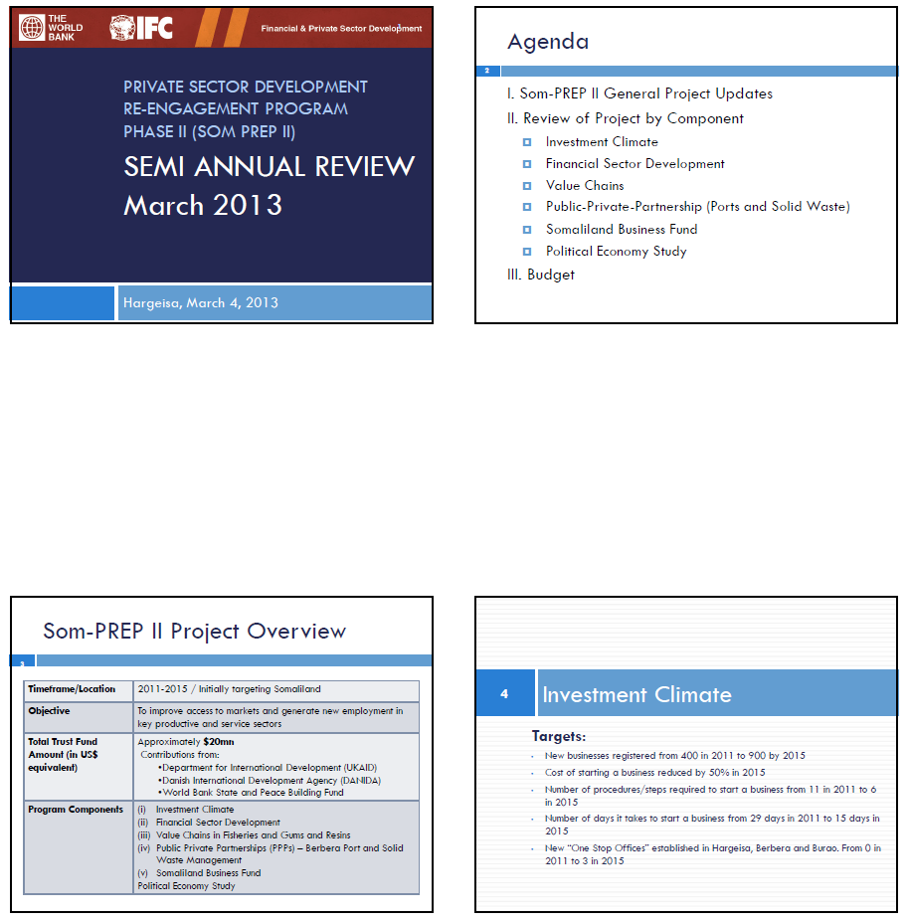

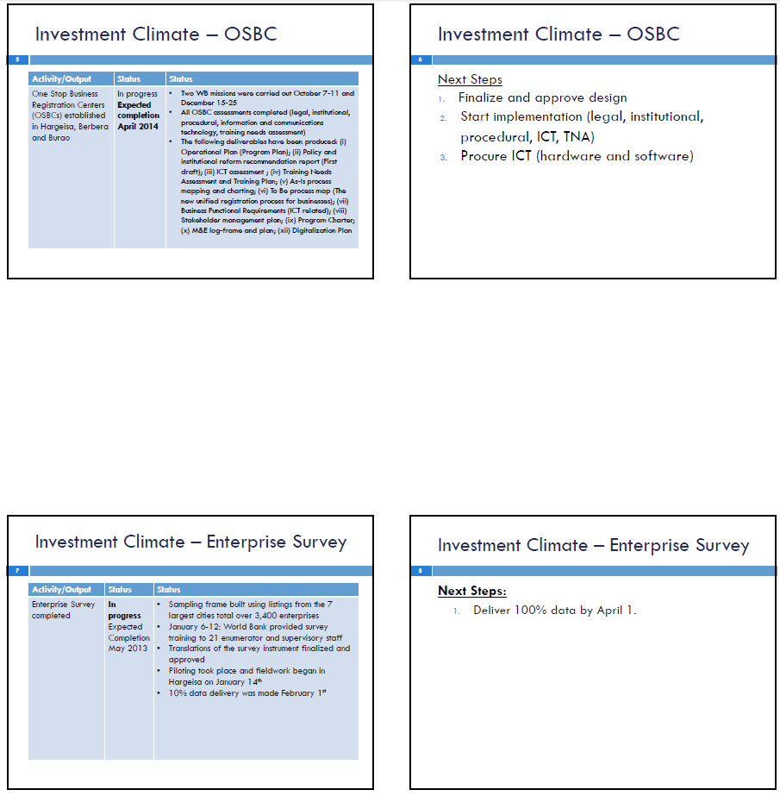

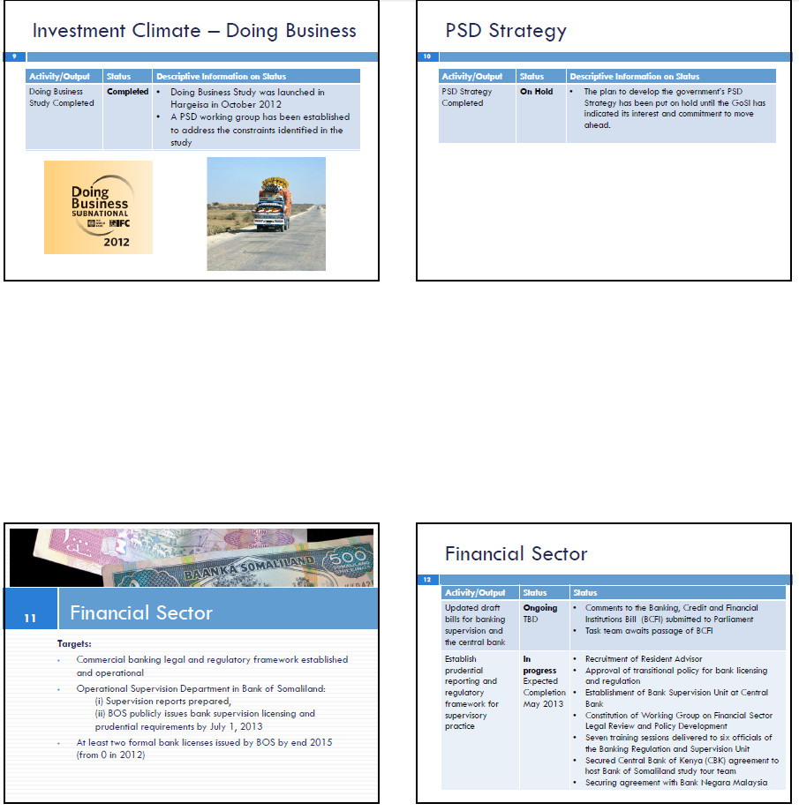

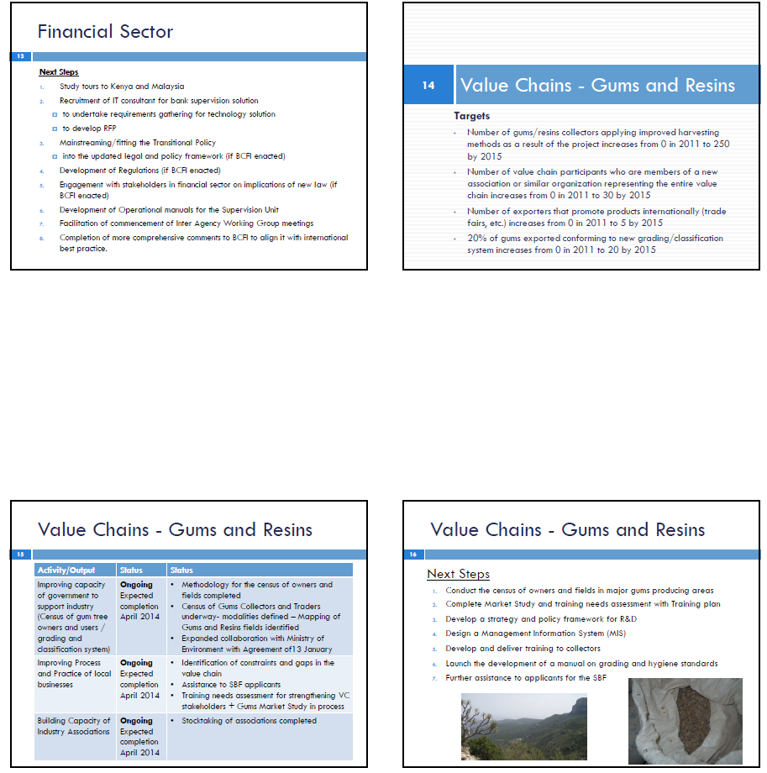

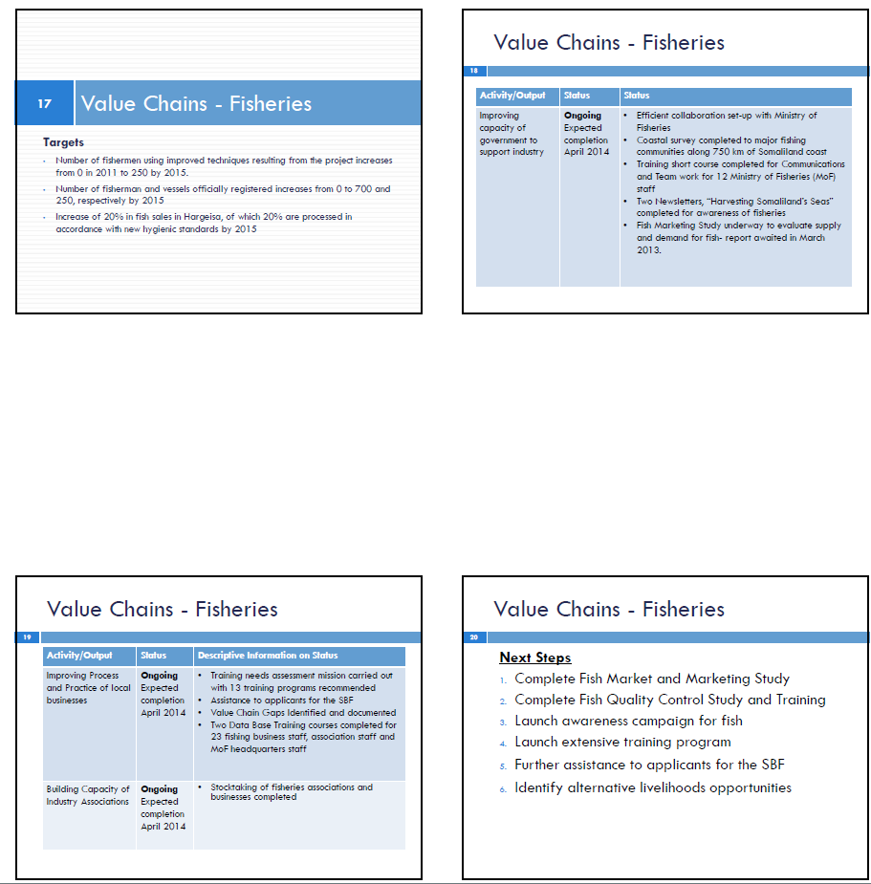

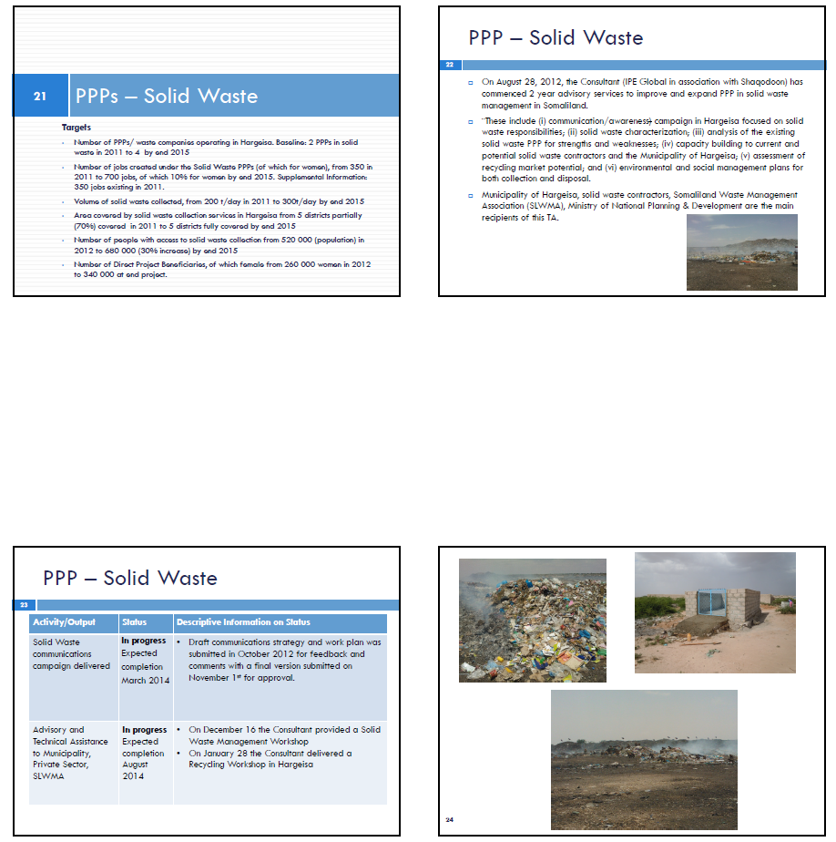

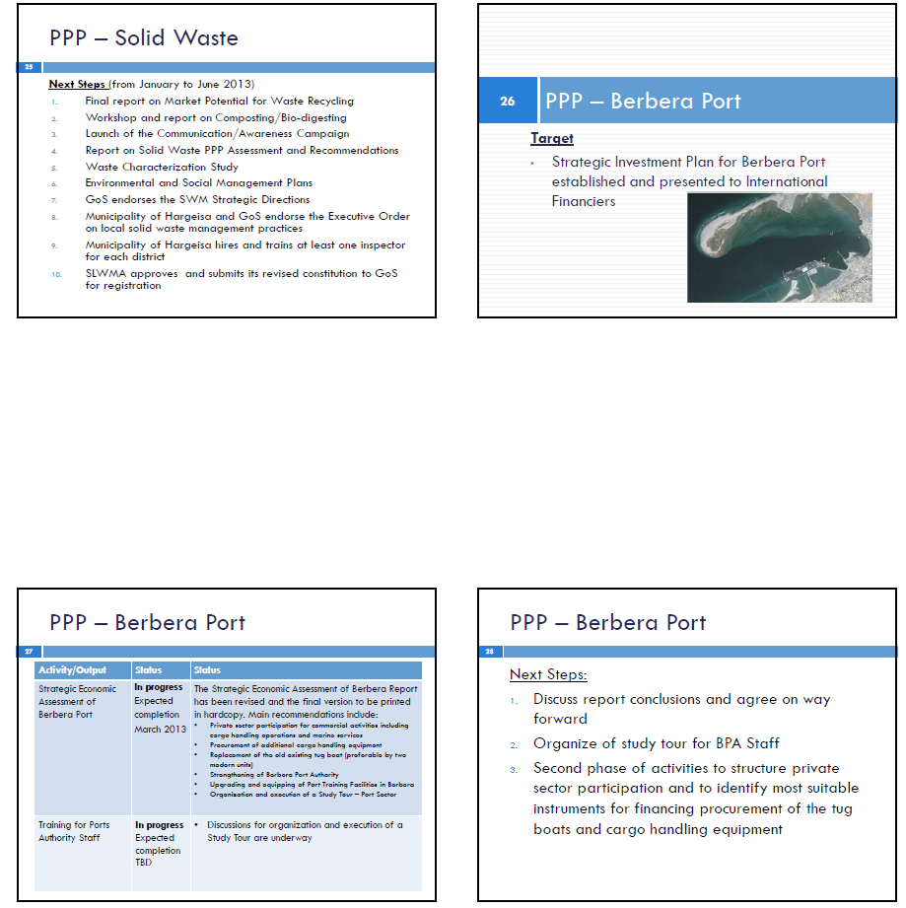

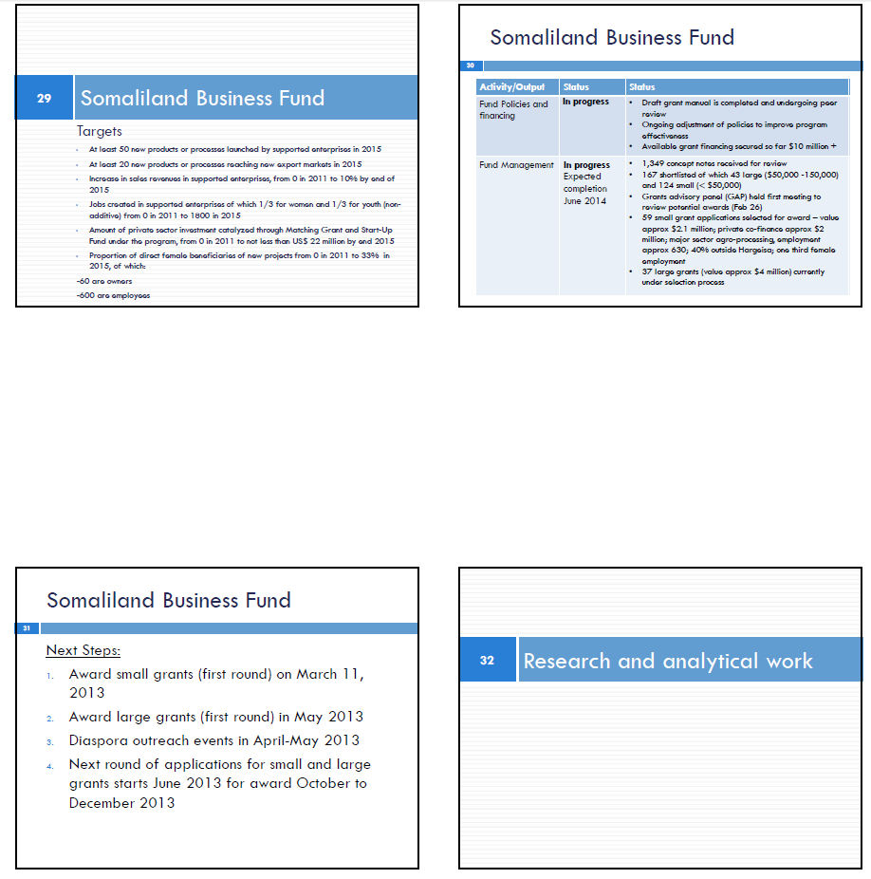

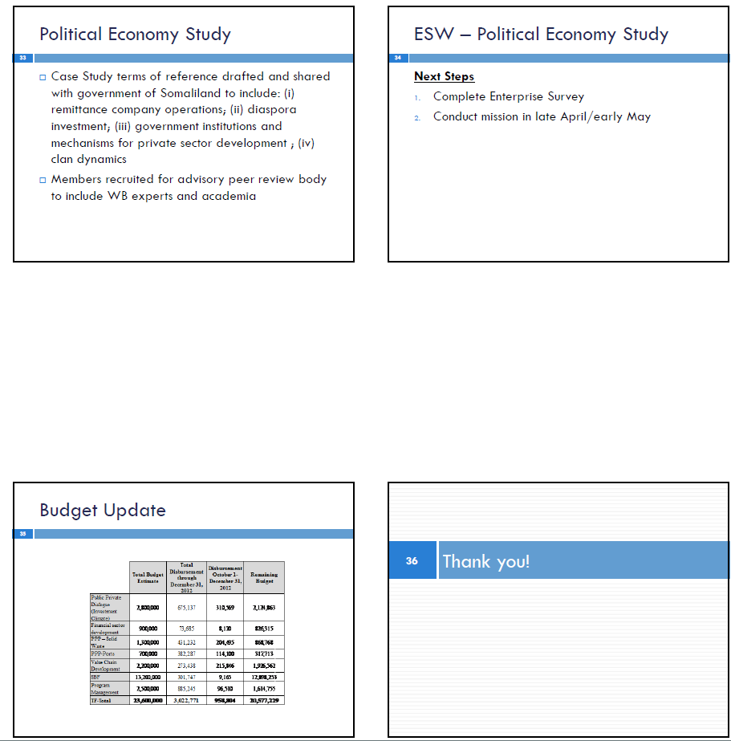

**ANNEX F: ACTIVITY STATUS MATRIX**

|  |  |  |
| --- | --- | --- |
| **Activities and Outputs** | **Status**  **(Completed/In Progress)** | **Sub-activities/Descriptive Information on Status** |
| 1. **Investment Climate** | | |
| One Stop Business Registration Centers (OSBCs) established in Hargeisa, Berbera and Burao | **In progress**  Expected Completion  April 2014 | -Two WB missions were carried out October 7-11 and December 15-25  -All OSBC assessments completed (legal, institutional, procedural, information and communications technology, training needs assessment)  -The following deliverables have been produced: (i) Operational Plan (Program Plan); (ii) Policy and institutional reform recommendation report (First draft); (iii) ICT assessment ; (iv) Training Needs Assessment and Training Plan; (v) As-Is process mapping and charting; (vi) To Be process map (The new unified registration process for businesses); (vii) Business Functional Requirements (ICT related); (viii) Stakeholder management plan; (ix) Program Charter; (x) M&E log-frame and plan; (xii) Digitalization Plan |
| Enterprise Survey Conducted | **In progress**  Expected Completion  May 2013 | -Sampling frame built using listings from the 7 largest cities total over 3,400 enterprises  -January 6-12: World Bank provided survey training to 21 enumerator and supervisory staff  -Translations of the survey instrument finalized and approved  -Piloting took place and fieldwork began in Hargeisa on January 14th  -10% data delivery was made February 1st  -100% data delivery expected by April 1, 2013 |
| Doing Business Survey Completed | **Completed** | The study was launched on October 10, 2012 |
| PSD Strategy Developed | **On Hold** | The plan to develop the government’s PSD Strategy has been put on hold until the GoSl has indicated its interest and commitment to move ahead. |
| 1. **Financial Sector** | | |
| Updated draft bills for banking supervision and the central bank | **In progress**  Expected Completion TBD | -Comments to the Banking, Credit and Financial Institutions Bill (BCFI) submitted to Parliament  -Task team awaits passage of BCFI |
| Establish prudential reporting and regulatory framework for supervisory practice | **In progress**  Expected Completion May 2013 | -Recruitment of Resident Advisor  -Approval of transitional policy for bank licensing and regulation  -Establishment of Bank Supervision Unit at Central Bank  -Constitution of Working Group on Financial Sector Legal Review and Policy Development  -Seven training sessions delivered to six officials of the Banking Regulation and Supervision Unit  -Secured Central Bank of Kenya (CBK) agreement to host Bank of Somaliland study tour team  -Securing agreement with Bank Negara Malaysia |
| 1. **Value Chains** | | |
| **Gums/Resins** | | |
| Capacity building support to the GoSl (training, workshops, study tours) | **In progress**  Expected completion April 2014 | -Methodology for the census of owners and fields completed  -Census of Gums Collectors and Traders underway- modalities defined – Mapping of Gums and Resins fields identified  -Expanded collaboration with Ministry of Environment with Agreement of13 January |
| Improving process and practice of local businesses through development of field manuals, training, improved packing, storage and handling procedures and development of strategy/policy frameworks | **In progress**  Expected completion April 2014 | -Identification of constraints and gaps in the value chain  -Assistance to SBF applicants  -Training needs assessment for strengthening VC stakeholders + Gums Market Study in process |
| Building capacity of Industry Associations by improving their ability to represent industry stakeholders for lobbying government, donors and other international organizations as well as advising on global marketing strategy | **In progress**  Expected completion April 2014 | -Stocktaking of associations completed |
| **Fisheries** | | |
| Capacity building support to the Ministry of Fisheries on key issues related to the Value Chain to include technical advisory work, and stakeholder consultations | **In progress**  Expected completion April 2014 | -Efficient collaboration set-up with Ministry of Fisheries  -Coastal survey completed to major fishing communities along 750 km of Somaliland coast  -Training short course completed for Communications and Team work for 12 Ministry of Fisheries (MoF) staff  -Two Newsletters, “Harvesting Somaliland’s Seas” completed for awareness of fisheries  -Fish Marketing Study underway to evaluate supply and demand for fish- report awaited in March 2013. |
| Improving process and practice of local businesses through development of field manuals, training, improved packing, storage and handling procedures and development of strategy/policy frameworks | **In progress**  Expected completion April 2014 | -Training needs assessment mission carried out with 13 training programs recommended  -Assistance to applicants for the SBF  -Value Chain Gaps Identified and documented  -Two Data Base Training courses completed for 23 fishing business staff, association staff and MoF headquarters staff |
| Building capacity of Industry Associations by improving their ability to represent industry stakeholders for lobbying government, donors and other international organizations as well as advising on global marketing strategy | **In progress**  Expected completion April 2014 | -Stocktaking of associations completed |
| 1. **PPPs – Solid Waste and Ports** | | |
| **PPPs - Solid Waste Management (SWM)** | | |
| Advisory support through the auspices of the Somaliland-wide Solid Waste Management Association(SLWMA) towards improving and expanding private sector participation in SWM | **In progress**  Expected completion  August 2014 | -On December 16 the Consultant provided a Solid Waste Management Workshop  -On January 28 the Consultant delivered a Recycling Workshop in Hargeisa |
| Solid Waste communications campaign delivered | **In progress**  Expected completion March 2014 | -Draft communications strategy and work plan was submitted in October 2012 for feedback and comments with a final version submitted on November 1st for approval. |
| Financial and technical analysis of experience of solid waste PPPs in Hargeisa | **In progress**  Expected completion  August 2014 | -Not yet started, expected start date is May 2013 |
| Advisory assistance to the Municipality of Hargeisa related to operational and management issues associated with PPP contracts | **In progress**  Expected completion  August 2014 | -Ongoing, capacity building workshops scheduled in August 2013 |
| Evaluation of market potential for recycling secondary materials | **In progress**  Expected Completion  August 2014 | -Presentation of options for recycling of plastic presented to the Municipality in January 2013 |
| Environmental Management Plans (EMPs) for the collection and disposal of waste prepared | **In progress**  Expected completion  August 2014 | -Not yet started |
| **PPPs - Ports** | | |
| Strategic Economic Assessment (SEA) Report Finalized | **In progress**  Expected Completion March 2013 | A draft SEA of Berbera Port has been submitted to the GoSl for review. The final report will be delivered by March 15, 2013. |
| Training of Ports Authority Staff | **In progress**  Expected Completion TBD | On-going discussions with government and the task team regarding a study tour to Rotterdam. |
| 1. **SBF** | | |
| Fund Policies and Financing | **In Progrss** | -Draft grant manual is completed and undergoing peer review  -Ongoing adjustment of policies to improve program effectiveness  -Available grant financing secured so far $10 million + |
| Fund Management | **In progress**  Expected completion  June 2014 | -1,349 concept notes received for review  -167 shortlisted of which 43 large ($50,000 -150,000) and 124 small (< $50,000)  -Grants advisory panel (GAP) held first meeting to review potential awards (Feb 26)  -59 small grant applications selected for award – value approx $2.1 million; private co-finance approx $2 million; major sector agro-processing, employment approx 630; 40% outside Hargeisa; one third female employment  -37 large grants (value approx $4 million) currently under selection process |
| 1. **Political Economy Study** | | |
| Completed Study | **In Progress**  Expected completion  December 2013 | -Case Study terms of reference drafted and shared with government of Somaliland to include: (i) remittance company operations; (ii) diaspora investment; (iii) government institutions and mechanisms for private sector development ; (iv) clan dynamics  -Members recruited for advisory peer review body to include WB experts and academia |

1. The quarterly Administrative Management Reports will include progress information on outreach and information for the call of proposals, receipt of proposals and shortlisting and award of grants, grant size, geographic distribution and disbursements. They will also include baselines and indicative targets for the agreed outcome indicators for each of the awarded sub-projects. In addition, information will be provided on expected benefits for end users (people benefitting from new/ improved products and services) which will feed into the end-of-project beneficiary survey. The Fund management team will establish results monitoring mechanisms specific to measure outcomes for each sub-project.
2. An end-of project beneficiary survey for the Matching Grants component will assess the qualitative aspects and provide detailed information of the development impact of benefits to end users of new products and services launched (such as value for money and improved quality of life), the profitability of supported enterprises and improvements of jobs, such as increased labor income.