
Basic Quiz Application
Web Technologies

June 19, 2026
Malik Umar awan, khizar rehman, sheikh m taha ahmed
F2024376083, F2024376070, F2024376165



Student Name: | Malik Umar Awan, Khizar Rehman, Sheikh M Taha Ahmed
Student ID: | F2024376083, F2024376070, F2024376165
Program Title: | BS Artificial Intelligence Web Technologies
Assignment Title: | Web Technologies Project: Basic Quiz Application
Date of Submission: | 19/06/2026
Submitted to: | Professor. Shehan Latif

Project Report: Basic Quiz Application

Introduction:
The Basic Quiz Application is a web-based interactive quiz system designed to test users' knowledge on web technologies. It presents 10 multiple-choice questions, tracks the user's score, provides immediate feedback, and displays a detailed summary at the end. The application is built using HTML, CSS, and JavaScript, and includes advanced features such as a timer, progress bar, shuffled questions, and a review section.
This project was developed as part of the Web Technologies course (IT-291) to demonstrate practical skills in front-end web development.

Objective:
The main objectives of this project are:
- To create an interactive quiz application with 10 multiple-choice questions.
- To implement a scoring system that tracks correct answers in real-time.
- To provide immediate visual feedback (green for correct, red for wrong).
- To include a 30-second timer for each question.
- To shuffle both questions and options for a unique experience each time.
- To display a results summary with score, percentage, and performance message.
- To allow users to review all their answers with correct answers shown.
- To save the user's highest score using browser local Storage.
- To make the application responsive for desktop and mobile devices.

Tools / Technologies Used:
Technology | Purpose
HTML5 | Structure and content of the web page.
CSS3 | Styling, animations, and responsive design.
JavaScript (ES6) | Quiz logic, DOM manipulation, event handling.
VS Code | Code editor.
GitHub | Version control and hosting.
GitHub Pages | Live hosting of the website.
Live Server | Local development preview.

Features of the Project:
Core Features:
- 10 Multiple-Choice Questions: Questions on HTML, CSS, and JavaScript.
- Shuffle Questions: Questions appear in random order.
- Shuffle Options: Answer options appear in random order.
- 30-Second Timer: Each question has a time limit.
- Auto-Fail on Timeout: If time runs out, the question is marked wrong.
- Progress Bar: Visual indicator of quiz completion.
- Real-Time Score Tracking: Score updates instantly.
- Correct Feedback: Correct answers turn green.
- Wrong Feedback: Wrong answers turn red, correct answer is shown.
- Results Summary: Shows final score, percentage, and performance message.
- Performance Message: Personalized message based on score.
- High Score Tracking: Best score saved in browser local Storage.
- Review Answers: Shows all questions with user answers and correct answers.
- Restart Quiz: Reset and play again.
- Responsive Design: Works on desktop, tablet, and mobile.
- Professional Styling: Gradient background, shadows, rounded corners.

Screenshots / Output:

Main (First Question) Display:
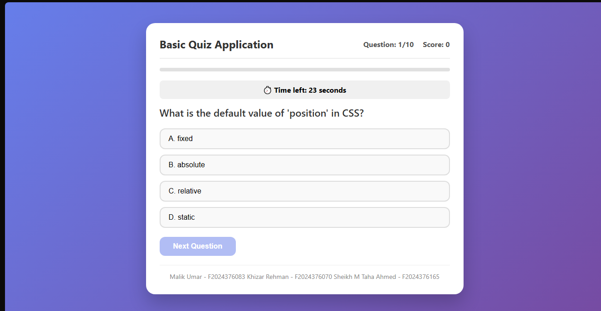

Timer Warning:
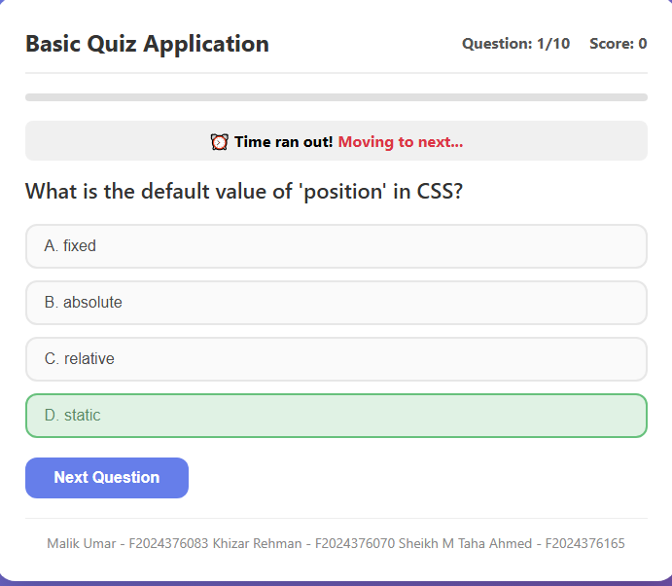

Correct Answer Feedback:
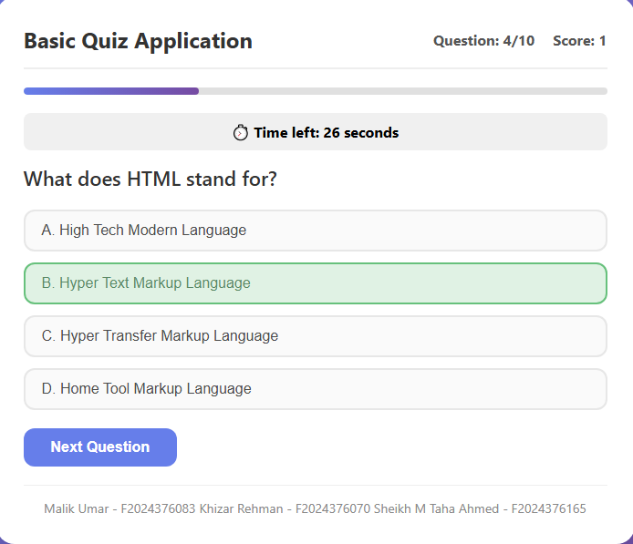

Wrong Answer Feedback:
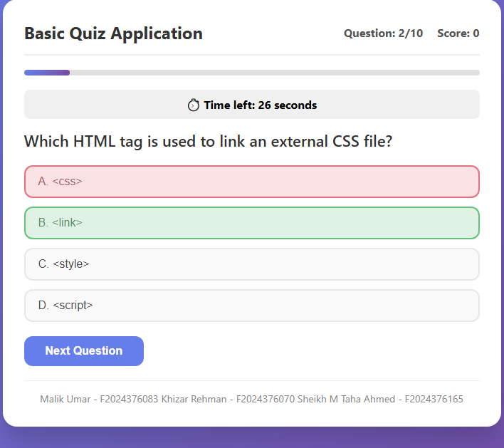

Results Summary:
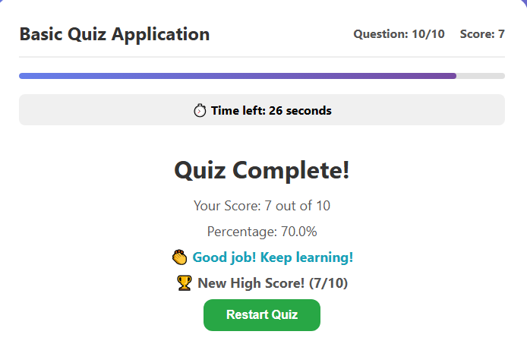

Review Answers Section:
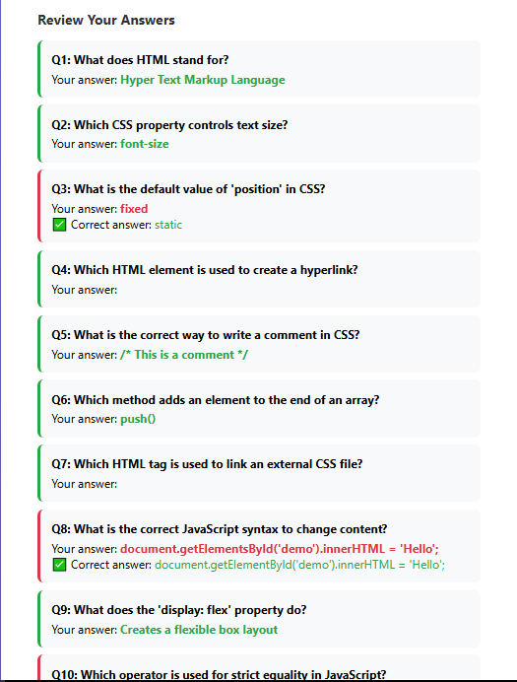

Mobile View:
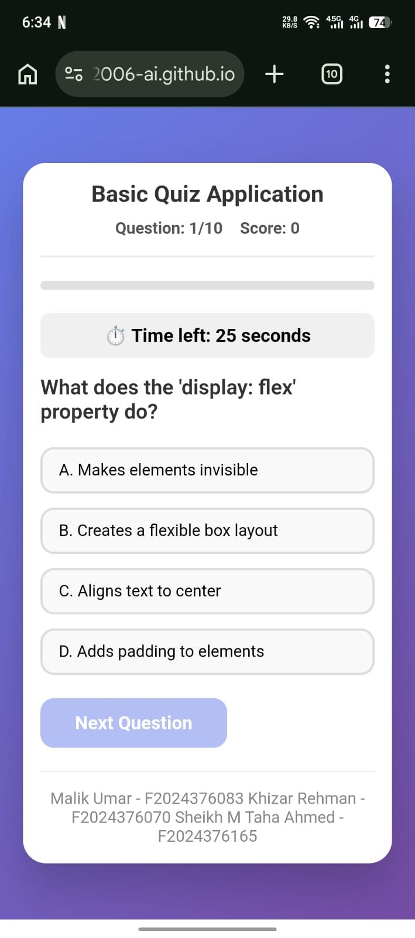

Algorithm / Flowchart:
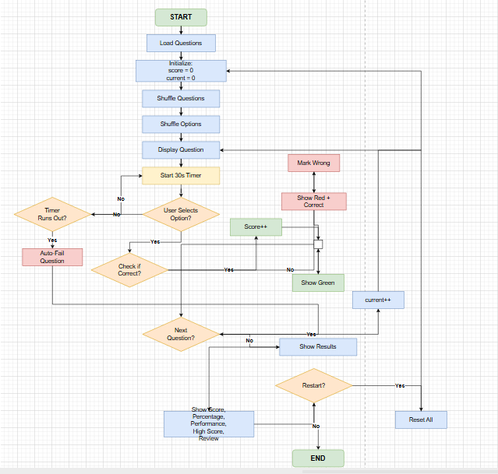

1. Start
- User opens the quiz application.
2. Load Questions
- Load 10 questions from the questions array.
3. Initialize Variables
- score = 0
- current Question = 0
- answered = false
- quiz Completed = false
4. Shuffle Questions
- Randomize the order of questions.
5. Shuffle Options
- Randomize the order of options for each question.
6. Display Question
- Show the question, 4 options, question number, and progress bar.
7. Start Timer
- Start a 30-second countdown.
8. Wait for User Action
If User Selects an Option:
- Correct: Highlight GREEN → Increase score.
- Wrong: Highlight RED → Show correct answer in GREEN.
- Store user's answer.
- Stop timer.
- Enable "Next" button.
If Timer Runs Out:
- Auto-fail the question.
- Show correct answer.
- Enable "Next" button.
9. Move to Next Question
- Click "Next" button.
- If questions remain → Go to Step 6.
- If all questions done → Go to Step 10.
10. Show Results
- Display:
  - Final Score
  - Percentage
  - Performance Message (Excellent/Good/Practice/Better Luck)
11. Show High Score
- Check local Storage.
- Save new high score if higher.
- Display best score.
12. Show Review
- Display all questions.
- Show user's answer and correct answer for each.
- Highlight correct (green) and wrong (red).
13. Restart or End
If User Clicks "Restart":
- Reset all variables → Go to Step 3.
If User Closes Page:
- End.

