实习二 卫星位置计算
实习报告
学号： 202016060205 姓名： 王佳琪

- 目的
了解星历的定义及其中每个参数的意义，掌握卫星在地心地固系（earth centered earth fixed ,ECEF）坐标的计算方法。
- 实习要求
通过实验，学生要能够验证掌握卫星星历的意义及卫星位置的计算方法等卫星导航定位的基本理论。要求学生提前查找资料（通过网络），掌握卫星星历的意义，提前预习GPS卫星位置计算的过程；通过卫星星历及位置数据开发卫星位置计算程序，验证基本理论；最后撰写实验报告。
- 实习基本原理
（填写）卫星导航定位以其高精度、全天候、高效率、多功能、操作简便、应用广泛等特点著称。利用卫星信号定位，其前提是必须已知卫星在空间的瞬时位置。卫星位置的计算是根据卫星电文（如表四-1所示）所提供的轨道参数按一定的公式（如表四-2所示）进行计算的。

- 实习内容及结果
- 卫星位置解算参数的意义
（逐个填写，无数据的空白参数不用说明）
_{0e} | 星历的基准时间单位：秒
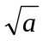 | 轨道半长轴的平方根单位：米
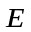 | 轨道离心率单位：无量纲
I₀ | 倾角（在_{0e}时）单位：rad 弧度
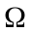₀ | 升交点经度（在每星期历元上）单位：rad 弧度
 | 近地点幅角（在_{0e}时）单位：rad 弧度
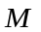₀ | 平均近点角（在_{0e}时）单位：rad 弧度
 | 倾角的变化率单位：rad/s弧度/秒
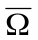 | 升交点经度的变化率单位：rad/s弧度/秒
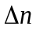 | 对平均角速度的校正值单位：rad/s弧度/秒
C_{uc} | 对纬度幅角余弦的校正值单位：rad 弧度
C_{us} | 对纬度幅角正弦的校正值单位：rad 弧度
C_{rc} | 对轨道半径余弦的校正值单位：米
C_{rs} | 对轨道半径正弦的校正值单位：米
C_{ic} | 对倾角余弦的校正值单位：rad 弧度
C_{is} | 对倾角正弦的校正值单位：rad 弧度

- 带有摄动改正的GPS卫星位置解算步骤
（填写实验步骤）
实验步骤：
首先根据时间系统和轨道基本参数解算出平均近点角，进而改正求出真近点角，再得到升交距角，求出向径、倾角、升交距角的改正数，得到改正后的数值用来计算卫星在轨道平面中的位置，最后进行坐标转换求得ECEF中的坐标。
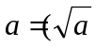)² | 半轴长
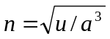+ | 经校正的平均角速度
 | 计算卫星种差
_{k}=-_{0e} | 从星历历元算起的时间
_{k}=₀+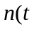_{k}) | 平均近点角
_{k}＝_{k}-sin_{k} | _{k}为偏心近点角，必须用迭代法解出
sin_{k}=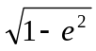sin_{k}/(1-cos_{k)}  cos_{k}=(cos_{k}-)/(1-cos_{k}) | 真近点角
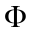_{k}=_{k}+ | 升交距角
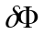_{k}=C_{us}sin(2_{k})+ C_{uc}cos(2_{k}) | 升交距角校正值
r_{k}=C_{rs}sin(2_{k})+ C_{rc}cos(2_{k}) | 向径校正值
i_{k}=C_{is}sin(2_{k})+ C_{ic}cos(2_{k}) | 倾角校正值
_{k}=_{k}+_{k} | 经校正的升交距角
_{k}=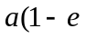cos_{k})+r_{k} | 经校正的向径
_{k}= I₀+()_{k}+i_{k} | 经校正的倾角
_{k}=₀+(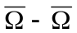_{e})(_{k}) - _{e0e} | 经校正的升交点经度 地球自转角速度
_{p}=_{k}cos_{k} | 在轨道平面中的x位置
_{p}=_{k}sin_{k} | 在轨道平面中的y位置
_{s}=_{p}cos_{k}-_{p}cos_{k}sin_{k} | ECEF x坐标
_{s}=_{p}sin_{k}+_{p}cos_{k}cos_{k} | ECEF y坐标
_{s}＝_{p}sin_{k} | ECEF z坐标

- 卫星位置计算程序
- 粘帖代码
mainwindow.h
#ifndef MAINWINDOW_H
#define MAINWINDOW_H

#include "qlineedit.h"
#include <QMainWindow>

QT_BEGIN_NAMESPACE
namespace Ui { class MainWindow; }
QT_END_NAMESPACE

class MainWindow : public QMainWindow
{
Q_OBJECT

public:
MainWindow(QWidget *parent = nullptr);
~MainWindow();

private slots:

void on_pushButton_clicked();
bool check();
void fillData();
void caculate();
void on_b_fillData_clicked();

void HalfLong();
void TrueAveAngularV();
void SatelliteClockError();
void EphemerisBeginTime();
void AveAnomaly();
void EccAnomaly();
void TruAnomaly();
void UpPFA();
void AdjustedOfUpPFA();
void AdjustedOfRadiusVector();
void AdjustedOfDip();
void TrueUpPFA();
void TrueRadiusVector();
void TrueDip();
void TrueAscendingLongitude();
void pos();
void ECEF();

private:
Ui::MainWindow *ui;
QLineEdit *baseTimeText; // 星历基准时间
QLineEdit *timeText; // 观测时间
QLineEdit *sqrtHalfLongText; //轨道半长轴的平方根
QLineEdit *eccentricityText; //轨道离心率
QLineEdit *dipText; //倾角
QLineEdit *ascendingLongitudeText; //升交点经度
QLineEdit *perigeeArgText; //近地点幅角
QLineEdit *aveApproachAngleText; //平均近点角
QLineEdit *changeRateOfdipText; //倾角变化率
QLineEdit *changeRateOfAscendingLongitudeText; //升交点经度变化率
QLineEdit *adjustedOfAveAngularVText; //平均角速度的校正值
QLineEdit *adjustedOfLatitudeArgCosText; //纬度幅角余弦的校正值
QLineEdit *adjustedOfLatitudeArgSinText; //纬度幅角正弦的校正值
QLineEdit *adjustedOfRadiusCosText; //轨道半径余弦的校正值
QLineEdit *adjustedOfRadiusSinText; //轨道半径正弦的校正值
QLineEdit *adjustedOfDipCosText; //倾角余弦的校正值
QLineEdit *adjustedOfDipSinText; //倾角正弦的校正值
QLineEdit *secondText; // 秒数据
QLineEdit *clockCorrection0Text; // 时钟修正0
QLineEdit *clockCorrection1Text;
QLineEdit *clockCorrection2Text;

QLineEdit *halfLongText;
QLineEdit *trueAveAngularVText;
QLineEdit *satelliteClockErrorText;
QLineEdit *ephemerisBeginTimeText;
QLineEdit *aveAnomalyText;
QLineEdit *eccAnomalyText;
QLineEdit *truAnomalyText;
QLineEdit *upPFAText;
QLineEdit *adjustedOfUpPFAText;
QLineEdit *adjustedOfRadiusVectorText;
QLineEdit *adjustedOfDipText;
QLineEdit *trueUpPFAText;
QLineEdit *trueRadiusVectorText;
QLineEdit *trueDipText;
QLineEdit *trueAscendingLongitudeText;
QLineEdit *posXText;
QLineEdit *posYText;
QLineEdit *ECEFxText;
QLineEdit *ECEFyText;
QLineEdit *ECEFzText;

private:
const double PI = 3.1415926535897932384626;
const double EGC = 3.986005e14; //椭球引力常数
const double RAV = 7.2921151467e-5; //地球自转角速度
double baseTime = 0; //星历基准时间
double time = 0;
double sqrtHalfLong = 0; //轨道半长轴的平方根
double eccentricity = 0; //轨道离心率
double dip = 0; //倾角
double ascendingLongitude = 0; //升交点经度
double perigeeArg = 0; //近地点幅角
double aveApproachAngle = 0; //平均近点角
double changeRateOfdip = 0; //倾角变化率
double changeRateOfAscendingLongitude = 0; //升交点经度变化率
double adjustedOfAveAngularV = 0; //平均角速度的校正值
double adjustedOfLatitudeArgCos = 0; //纬度幅角余弦的校正值
double adjustedOfLatitudeArgSin = 0; //经度幅角正弦的校正值
double adjustedOfRadiusCos = 0; //轨道半径余弦的校正值
double adjustedOfRadiusSin = 0; //轨道半径正弦的校正值
double adjustedOfDipCos = 0; //倾角余弦的校正值
double adjustedOfDipSin = 0; //倾角正弦的校正值
double second = 0;
double clockCorrection0 = 0;
double clockCorrection1 = 0;
double clockCorrection2 = 0;

double halfLong; //半长轴
double trueAveAngularV; //经校正的平均角速度
double satelliteClockError; //卫星钟差
double ephemerisBeginTime; //星历起算时间
double aveAnomaly; //平均近点角
double eccAnomaly; //偏心近点角
double truAnomaly; //真近点角
double upPFA; //升交距角
double adjustedOfUpPFA; //升交距角校正值
double trueUpPFA; //经矫正的升交距角
double adjustedOfRadiusVector;//向径校正值
double trueRadiusVector; //经校正的向径
double adjustedOfDip; //倾角校正值
double trueDip; //经校正的倾角
double trueAscendingLongitude;//经校正的升交点经度

double posX;
double posY;
};
#endif // MAINWINDOW_H
main.cpp
#include "mainwindow.h"

#include <QApplication>

int main(int argc, char *argv[])
{
QApplication a(argc, argv);
MainWindow w;
w.show();
return a.exec();
}
mainwindow.cpp
#include "mainwindow.h"
#include "./ui_mainwindow.h"

#include <QMessageBox>

MainWindow::MainWindow(QWidget *parent)
: QMainWindow(parent)
, ui(new Ui::MainWindow)
{
{
setWindowTitle("卫星位置计算");
setWindowOpacity(0.96);
}
ui->setupUi(this);
timeText = ui->timeText; // 观测时间
baseTimeText = ui->baseTimeText; // 星历基准时间
sqrtHalfLongText = ui->sqrtHalfLongText;// 轨道半长轴平方根
eccentricityText = ui->eccentricityText;// 轨道离心率 0.0053100715158500003
dipText = ui->dipText; // 倾角
ascendingLongitudeText = ui->ascendingLongitudeText; // 升交点经度 -2.9080127721900002
changeRateOfAscendingLongitudeText = ui->changeRateOfAscendingLongitudeText; // 升交点经度变化率
adjustedOfAveAngularVText = ui->adjustedOfAveAngularVText; // 平均角速度的校正值
adjustedOfLatitudeArgCosText = ui->adjustedOfLatitudeArgCosText; // 纬度幅角余弦的校正值
adjustedOfLatitudeArgSinText = ui->adjustedOfLatitudeArgSinText; // 纬度幅角正弦的校正值
adjustedOfRadiusCosText = ui->adjustedOfRadiusCosText; // 轨道半径余弦的校正值
adjustedOfRadiusSinText = ui->adjustedOfRadiusSinText; // 轨道半径正弦的校正值
adjustedOfDipCosText = ui->adjustedOfDipCosText; // 倾角余弦的校正值
adjustedOfDipSinText = ui->adjustedOfDipSinText; // 倾角正弦的校正值
changeRateOfdipText = ui->changeRateOfdipText; // 倾角变化率
perigeeArgText = ui->perigeeArgText; // 近地点幅角 -1.6819446292500000
aveApproachAngleText = ui->aveApproachAngleText; // 平均近点角 1.2263973009600000
secondText = ui->secondText; // 秒数据
clockCorrection0Text = ui->clockCorrection0Text; // 时钟修正0
clockCorrection1Text = ui->clockCorrection1Text;
clockCorrection2Text = ui->clockCorrection2Text;
// 未知量Text
halfLongText = ui->halfLongText;
trueAveAngularVText = ui->trueAveAngularVText;
satelliteClockErrorText = ui->satelliteClockErrorText;
ephemerisBeginTimeText = ui->ephemerisBeginTimeText;
aveAnomalyText = ui->aveAnomalyText;
eccAnomalyText = ui->eccAnomalyText;
truAnomalyText = ui->truAnomalyText;
upPFAText = ui->upPFAText;
adjustedOfUpPFAText = ui->adjustedOfUpPFAText;
adjustedOfRadiusVectorText = ui->adjustedOfRadiusVectorText;
adjustedOfDipText = ui->adjustedOfDipText;
trueUpPFAText = ui->trueUpPFAText;
trueRadiusVectorText = ui->trueRadiusVectorText;
trueDipText = ui->trueDipText;
trueAscendingLongitudeText = ui->trueAscendingLongitudeText;
posXText = ui->posXText;
posYText = ui->posYText;
ECEFxText = ui->ECEFxText;
ECEFyText = ui->ECEFyText;
ECEFzText = ui->ECEFzText;
}

MainWindow::~MainWindow()
{
delete ui;
}

bool MainWindow::check()
{
if(baseTimeText->text().isEmpty()) return false;
else baseTime = baseTimeText->text().toDouble();

if(timeText->text().isEmpty()) return false;
else time = timeText->text().toDouble();

if(sqrtHalfLongText->text().isEmpty()) return false;
else sqrtHalfLong = sqrtHalfLongText->text().toDouble();

if(eccentricityText->text().isEmpty()) return false;
else eccentricity = eccentricityText->text().toDouble();

if(dipText->text().isEmpty()) return false;
else dip = dipText->text().toDouble();

if(ascendingLongitudeText->text().isEmpty()) return false;
else ascendingLongitude = ascendingLongitudeText->text().toDouble();

if(perigeeArgText->text().isEmpty()) return false;
else perigeeArg = perigeeArgText->text().toDouble();

if(aveApproachAngleText->text().isEmpty()) return false;
else aveApproachAngle = aveApproachAngleText->text().toDouble();

if(changeRateOfdipText->text().isEmpty()) return false;
else changeRateOfdip = changeRateOfdipText->text().toDouble();

if(changeRateOfAscendingLongitudeText->text().isEmpty()) return false;
else changeRateOfAscendingLongitude = changeRateOfAscendingLongitudeText->text().toDouble();

if(adjustedOfAveAngularVText->text().isEmpty()) return false;
else adjustedOfAveAngularV = adjustedOfAveAngularVText->text().toDouble();

if(adjustedOfLatitudeArgCosText->text().isEmpty()) return false;
else adjustedOfLatitudeArgCos = adjustedOfLatitudeArgCosText->text().toDouble();

if(adjustedOfLatitudeArgSinText->text().isEmpty()) return false;
else adjustedOfLatitudeArgSin = adjustedOfLatitudeArgSinText->text().toDouble();

if(adjustedOfRadiusCosText->text().isEmpty()) return false;
else adjustedOfRadiusCos = adjustedOfRadiusCosText->text().toDouble();

if(adjustedOfRadiusSinText->text().isEmpty()) return false;
else adjustedOfRadiusSin = adjustedOfRadiusSinText->text().toDouble();

if(adjustedOfDipCosText->text().isEmpty()) return false;
else adjustedOfDipCos = adjustedOfDipCosText->text().toDouble();

if(adjustedOfDipSinText->text().isEmpty()) return false;
else adjustedOfDipSin = adjustedOfDipSinText->text().toDouble();

if(secondText->text().isEmpty()) return false;
else second = secondText->text().toDouble();

if(clockCorrection0Text->text().isEmpty()) return false;
else clockCorrection0 = clockCorrection0Text->text().toDouble();

if(clockCorrection1Text->text().isEmpty()) return false;
else clockCorrection1 = clockCorrection1Text->text().toDouble();

if(clockCorrection2Text->text().isEmpty()) return false;
else clockCorrection2 = clockCorrection2Text->text().toDouble();

return true;
}

void MainWindow::on_pushButton_clicked()
{
if(!check())
{
QString dlgTitle="提示";
QString strInfo="数据未完全填充";
QMessageBox::warning(this, dlgTitle, strInfo);
}
else
{
caculate();
}
}

void MainWindow::caculate()
{
HalfLong();
TrueAveAngularV();
SatelliteClockError();
EphemerisBeginTime();
AveAnomaly();
EccAnomaly();
TruAnomaly();
UpPFA();
AdjustedOfUpPFA();
AdjustedOfRadiusVector();
AdjustedOfDip();
TrueUpPFA();
TrueRadiusVector();
TrueDip();
TrueAscendingLongitude();
pos();
ECEF();
}

void MainWindow::HalfLong() //半轴长
{
halfLong = sqrtHalfLong * sqrtHalfLong;
halfLongText->setText(QString::number(halfLong));
}

void MainWindow::TrueAveAngularV() //校正后的平均角速度
{
trueAveAngularV = sqrt( EGC / pow(halfLong, 3)) + adjustedOfAveAngularV;
trueAveAngularVText->setText(QString::number(trueAveAngularV));
}

void MainWindow::SatelliteClockError() //卫星钟差
{
satelliteClockError = clockCorrection0 + clockCorrection1 * (time - second) + clockCorrection2 * (time - second);
satelliteClockErrorText->setText(QString::number(satelliteClockError));
}

void MainWindow::EphemerisBeginTime() //从星历历元算起的时间
{
ephemerisBeginTime = time - baseTime;
ephemerisBeginTimeText->setText(QString::number(ephemerisBeginTime));
}

void MainWindow::AveAnomaly() //平均近点角
{
aveAnomaly = aveApproachAngle + trueAveAngularV * ephemerisBeginTime;
aveAnomalyText->setText(QString::number(aveAnomaly));
}

void MainWindow::EccAnomaly() //偏心近点角
{
int times = 0;
double last = aveAnomaly;
eccAnomaly = aveAnomaly + eccentricity * sin(last);

while(times<30)
{
last = eccAnomaly;
eccAnomaly = aveAnomaly + eccentricity * sin(last);
times++;
}
eccAnomalyText->setText(QString::number(eccAnomaly));
}

void MainWindow::TruAnomaly() //真近点角
{
double sinTruAnomaly = sqrt(1 - eccentricity * eccentricity) * sin(eccAnomaly) / (1 - eccentricity * cos(eccAnomaly));
double cosTruAnomaly = (cos(eccAnomaly) - eccentricity) / (1 - eccentricity * cos(eccAnomaly));

if (cosTruAnomaly == 0) {
if (sinTruAnomaly > eccentricity)
truAnomaly = PI / 2;
else
truAnomaly = -PI / 2;
} else {
truAnomaly = atan(sinTruAnomaly / cosTruAnomaly);
if (cosTruAnomaly < 0) {
if (sinTruAnomaly >= 0)
truAnomaly += PI;
else
truAnomaly -= PI;
}
}

truAnomalyText->setText(QString::number(truAnomaly));
}

void MainWindow::UpPFA() //升交距角
{
upPFA = truAnomaly + perigeeArg;
upPFAText->setText(QString::number(upPFA));
}

void MainWindow::AdjustedOfUpPFA() //升交距角的校正值
{
adjustedOfUpPFA = adjustedOfLatitudeArgSin * sin(2 * upPFA) + adjustedOfLatitudeArgCos * cos(2 * upPFA);
adjustedOfUpPFAText->setText(QString::number(adjustedOfUpPFA));
}

void MainWindow::AdjustedOfRadiusVector() //向径的校正值
{
adjustedOfRadiusVector = adjustedOfRadiusSin * sin(2 * upPFA) + adjustedOfRadiusCos * cos(2 * upPFA);
adjustedOfRadiusVectorText->setText(QString::number(adjustedOfRadiusVector));
}

void MainWindow::AdjustedOfDip() //倾角的校正值
{
adjustedOfDip = adjustedOfDipSin * sin(2 * upPFA) + adjustedOfDipCos * cos(2 * upPFA);
adjustedOfDipText->setText(QString::number(adjustedOfDip));
}

void MainWindow::TrueUpPFA() //校正后的升交距角
{
trueUpPFA = upPFA + adjustedOfUpPFA;
trueUpPFAText->setText(QString::number(trueUpPFA));
}

void MainWindow::TrueRadiusVector() //校正后的向径
{
trueRadiusVector = halfLong * (1 - eccentricity * cos(eccAnomaly)) + adjustedOfRadiusVector;
trueRadiusVectorText->setText(QString::number(trueRadiusVector));
}

void MainWindow::TrueDip()
{
trueDip = dip + changeRateOfdip * ephemerisBeginTime + adjustedOfDip;
trueDipText->setText(QString::number(trueDip));
}

void MainWindow::TrueAscendingLongitude()
{
trueAscendingLongitude = ascendingLongitude + changeRateOfAscendingLongitude * (time - baseTime) - RAV * time;
trueAscendingLongitudeText->setText(QString::number(trueAscendingLongitude));
}

void MainWindow::pos()
{
posX = trueRadiusVector * cos(trueUpPFA);
posY = trueRadiusVector * sin(trueUpPFA);

posXText->setText(QString::number(posX));
posYText->setText(QString::number(posY));
}

void MainWindow::ECEF()
{
double ECEFx = posX * cos(trueAscendingLongitude) - posY * cos(trueDip) * sin(trueAscendingLongitude);
double ECEFy = posX * sin(trueAscendingLongitude) + posY * cos(trueDip) * cos(trueAscendingLongitude);
double ECEFz = posY * sin(trueDip);

ECEFxText->setText(QString::number(ECEFx));
ECEFyText->setText(QString::number(ECEFy));
ECEFzText->setText(QString::number(ECEFz));
}

void MainWindow::fillData()
{
timeText->setText("4800");
baseTimeText->setText("0.00000000000000000");
sqrtHalfLongText->setText("5153.7127704599998");
clockCorrection0Text->setText("0.00028600683435800001");
clockCorrection1Text->setText("1.7053025658199999e-012");
clockCorrection2Text->setText("0");
adjustedOfAveAngularVText->setText("4.1115998360700002e-009");
aveApproachAngleText->setText("1.2263973009600000");
eccentricityText->setText("0.0053100715158500003");
perigeeArgText->setText("-1.6819446292500000");
adjustedOfLatitudeArgCosText->setText("-5.5264681577700003e-006"); // 纬度幅角余弦的校正值
adjustedOfLatitudeArgSinText->setText("1.1192634701700000e-005"); // 纬度幅角正弦的校正值
adjustedOfRadiusCosText->setText("175.34375000000000"); // 轨道半径余弦的校正值
adjustedOfRadiusSinText->setText("-105.43750000000000"); // 轨道半径正弦的校正值
adjustedOfDipCosText->setText("-9.6857547759999998e-008"); // 倾角余弦的校正值
adjustedOfDipSinText->setText("-7.8231096267699997e-008"); // 倾角正弦的校正值
ascendingLongitudeText->setText("-2.9080127721900002");
changeRateOfAscendingLongitudeText->setText("-7.7124641122299999e-009");
dipText->setText("0.97432927738800001");
changeRateOfdipText->setText("1.8643633724999999e-010");
secondText->setText("0");
}

void MainWindow::on_b_fillData_clicked()
{
fillData();
}

- 粘帖功能结果截图
主页面：
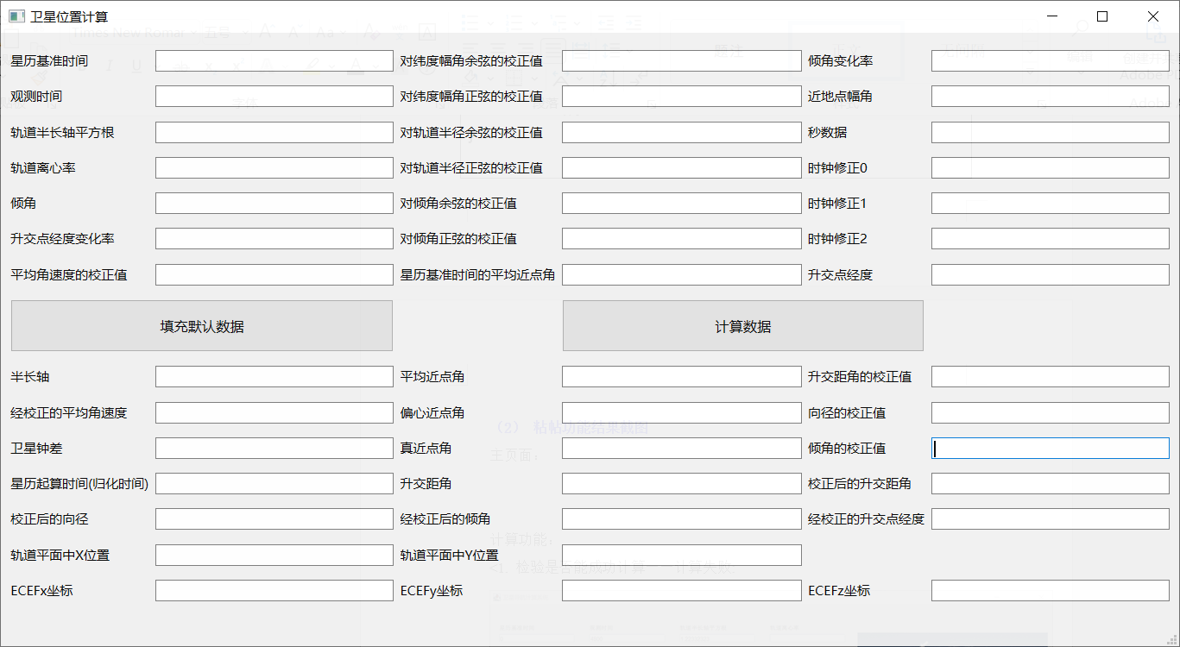

计算功能：
1. 检验是否能成功计算——计算失败:
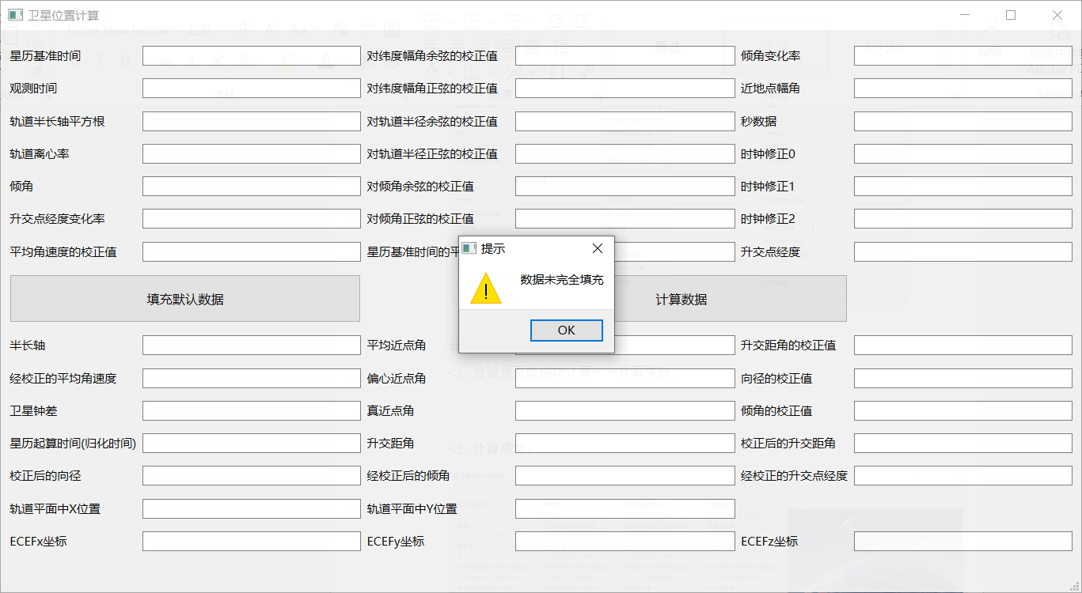

2. 计算成功：
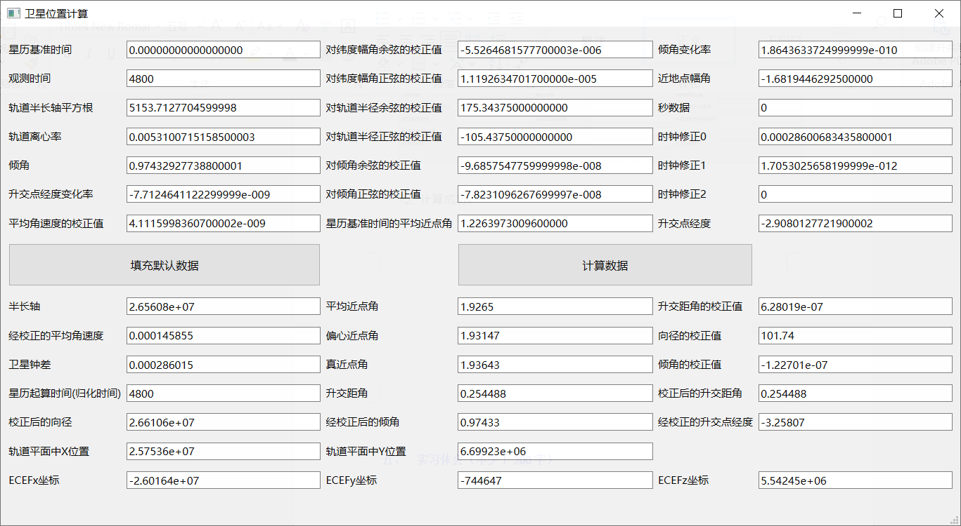

- 实习体会（不少于200字）
本次实验通过自己编写程序实现卫星计算，不仅搞明白了从基本参数到卫星坐标的计算过程，同时也一定程度上锻炼了代码的编写能力，尤其是在细节处理方面。
在编写过程中也出现了许多问题，例如参数含义没有搞明白，计算公式套用错误，带入数据错误等等。实验指导中出现两个，一个代表近地点幅角，一个代表地球自转角速度，而明白公式中需要套用哪一个参数首先需要把公式的含义搞明白。同时还有在计算三个重要参数的改正值时需要用到的正余弦值，不仅正弦和余弦容易搞混，每个参数之间的正余弦也搞混过好几次。
总而言之在明白了计算公式的含义之后，需要做到的便是细心耐心的处理。

