

Digital Signal Processing

Assignment #3 – The Laser guided Missile

Student Name: Darkhan Baibulat

Group Name: TS-1902

Tutor name: Sanzhar Kusdavletov

Date: 16.05.2021

**Nur-Sultan 2021**

**Report:**

This diagram (1.1) shows the laser guidance for a rocket that has a transfer function in open-loop form (Predominant combination between fin and missile). In addition, there is a leading compensator with a transfer function expression.

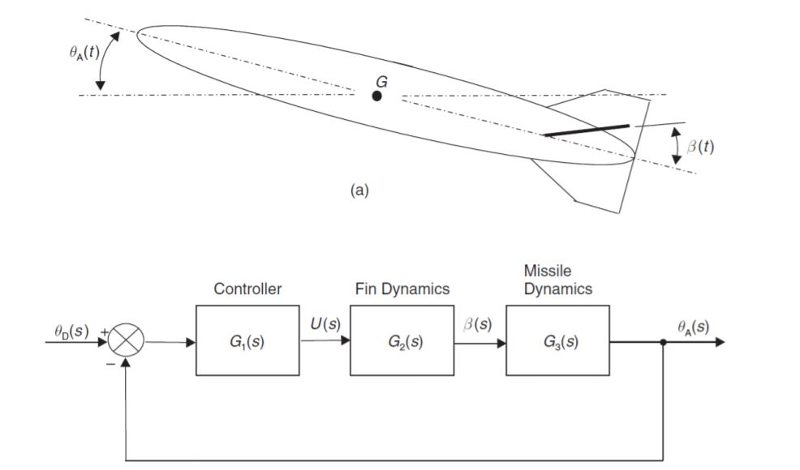

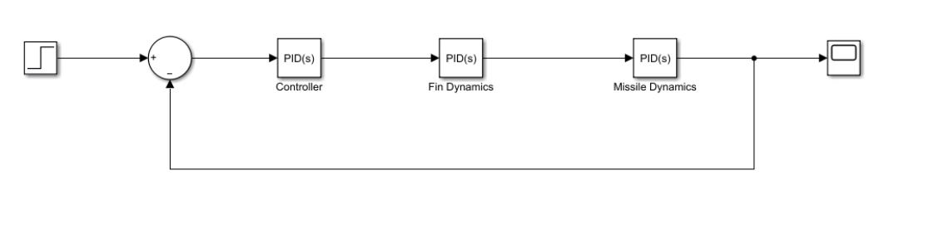1.1 – Laser Guided Missile

It is necessary to emphasize that the PID controllers are separated for Fin Dynamics and Missile dynamics to fully form the point quality of signals for transients. To do this, mark the numerator as 0.8*[s 1] and the denominator for the function 1*[0.0625s 1]. Then, there is an exchange between the ZOH. In addition, the lead compensator must have a fast bypass at a certain frequency used in the rocket, given its pulse of 90 kg/m^2.

Paying attention to these factors, the peak area of a given compensator phase is strongly affected by the change in degree. It tends to depend on the leading compensator as a high-frequency interference.

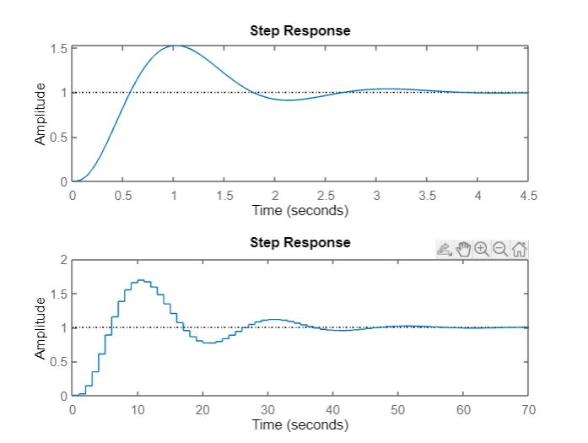

1.2 – Stability of control system step responses

Figure 1.2 marks both graphs as Step response and Step response under the influence of the Derivative function, where the integration between the input signal and the derived signal occurs. In this situation, it is used as a PID. The entire expression is replaced after the transformation of the Z form.

To do this, there is an exchange of continuous-time signals according to the Tustin rule or a Bilinear transformation where there is a transformation of continuous-time discrete and sequential, and the process is vice versa.

It is clearly seen that using the Tustin rule, a close effect occurs for continuous response. There is a general comparison of signal processing by the rule, using this equation:

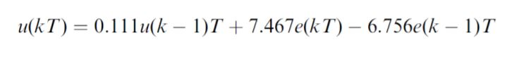

The Tustin rule facilitates and rounds up the time delay of the sampling model. Its filter distributes it in each order and increases the accuracy of the system. After that, it adjusts all the input and output delays of the channel, and then collects them and analyzes them.

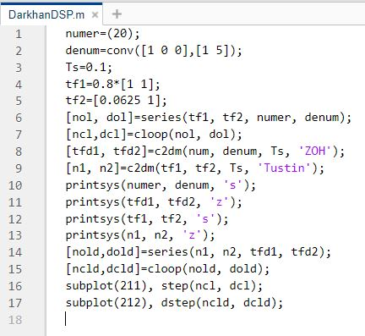

1.3 – Code Rule Step responses

In line 9 of Figure 1.3, a transformation occurs according to the Tustin rule, where two expressions change shape and begin to build two graphs, comparing discrete and linear functions.

By comparing between the two controllers, it is worth noting that using finding them through the Laplace transform, you can see the tuning of these controllers, as well as the Z transform and their gain. They share a common time constant with Stop time. In addition, if the signal transmission coefficient increases, then it is amplified in direct proportion to it.

Thanks to this, we can see the difference between the two graphs that describe these two controllers.

First, it is the speed of the appearance and construction of these graphs. It improves exponentially and is easily given to the control of the processor.

Secondly, the accuracy of information transmission, where they are represented as several numbers and justify the error of signals using interference and noise.

The third point is its flexible use of the controller, where it is possible to rebuild and modify the software hardware.

Consequently, the exchange of information between them, namely signals, occurs gradually and periodically, using the closed loop format transfer function.

**Conclusion:**

In conclusion, it is worth noting the necessary fact that the transformation functions for the rocket have a rather difficult design. Where there is a constant change in time and poles with zeros. In addition, the frequency amplification system for controllers transmitted in two ways, one normal and the other using a derivative, is improved.

They begin to exchange information, where the phase strongly affects the change in the degree of signal quality. It also depends on the leading compensator. There is a special Tustin rule, like the bilinear transformation, for converting functions using linear shifts of discrete time signals. Using filters, using compensator switches. They distort the characteristics of the linear system and change at the expense of the unit system.