**Due Date: April 1, 2020**

**PART I Reading Assignment: Chapter VIII of “An Introduction of Statistical Learning”**

**Answer the following questions based on your reading.**

**Problem 1 (2 Points)** Suppose that the data for study is $\left\{\left(y_{i},{\underline{x}}_{i}\right):i=1, 2, …, n\right\} ,$ where $\underline{x}$ is a p-dimensional prediction vector. In regression analysis, we assume that the model has the form $f\left(X\right)=β_{0}+\sum_{j=1}^{K}{β_{j}×x_{j}}+ε_{j}$. (Hint: Page 314)

**Problem 2 (2 Points)** Suppose that the data for study is $\left\{\left(y_{i},{\underline{x}}_{i}\right):i=1, 2, …, n\right\} ,$ where $\underline{x}$ is a p-dimensional prediction vector. In regression tree analysis, we assume that the model has the form $f\left(X\right)=\sum_{m=1}^{M}{C_{m}×1_{\left(x∈R_{m}\right)}}$. (Hint: Page 314)

**Problem 3 (2 Points) (True/False)** Even if the true function form of the model is well approximately by a linear model, the model built using decision trees is still better than the model built using regression.

False

**Problem 4 (10 Points)** Based on the textbook, Decision Trees for either classification or regression have four advantages over the traditional regression and logistic regression methods:

1. **Trees are very easy to explain to people. In fact, there are even easier to explain than linear regression.**
2. **Some people believe that decision trees more closely mirror human decision-making than other analytical methods.**
3. **Tree can be displays graphically and are easier to interpreted even by a non-expert.**
4. **Trees can easily handle quantitative predictors without the need to create dummy variables.**

* However, it has one major disadvantage that is **Trees have lower prediction accuracy than other tools .**

**Problem 5 (2 Points)** Suppose that $\left\{y_{i}:i=1, 2, …, n\right\}$ be a random sample from a normal population with mean $μ$ and variance $σ^{2}$. The variance of the mean $\overline{y}$ is given by σ2/n. . This means that we can reduce the variance of almost all statistics through averaging.

**PART II Programming (12 Points)**

Data: The data set used is “ASS06_DATA”.

**Problem 1 (6 Points)** Bagging for regression

DO K = 1 to 20;

STEP 01: Randomly select a sample of size 1,460 with replacement.

STEP 02: Build a **regression** model to predict the “HousePrice”

STEP 03: Use the model built in STEP 02 to score all 1,460 observation and keep all the predicted values for each observation

END DO;

STEP 04: Calculate the bagging estimator using the formula

STEP 05: Calculate the error estimator for the bagging estimator in “STEP 04” using the formula $mse= \left[{\sum_{i=1}^{20}{{\left({\hat{f}}_{K}\left(x\right)-{\hat{f}}_{bag}\left(x\right)\right)}^{2}}}/{120}\right]$.

Produce a box plot for all 20 bagging predictions with “predicted” “HousePrice” as the Y-axis.

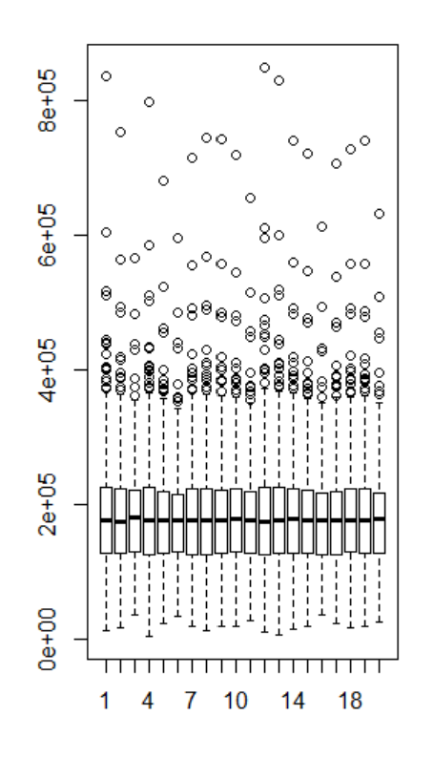

**Problem 2 (6 Points)** Bagging for decision trees

DO K = 1 to 20;

STEP 01: Randomly select a sample of size 1,460 with replacement.

STEP 02: Build a **decision trees** model to predict the “HousePrice”

STEP 03: Use the model built in STEP 02 to score all 1,460 observation and keep all the predicted values for each observation

END DO;

STEP 04: Calculate the bagging estimator using the formula

STEP 05: Calculate the error estimator for the bagging estimator in “STEP 04” using the formula .

Produce a box plot for all 20 bagging predictions with “predicted” “HousePrice” as the Y-axis.

