Comparisons
HL Nodes | MSE | R^2 | Epochs
4 | 2.1943 | .9998 | 146
7 | 2.5041 | .9998 | 6
10 | 2.2732 | .99979 | 23
12 | 2.2496 | .99979 | 74
14 | 2.3014 | .99979 | 59
20 | 2.5932 | .99977 | 11

4 HL Nodes:
MSE 2.1943
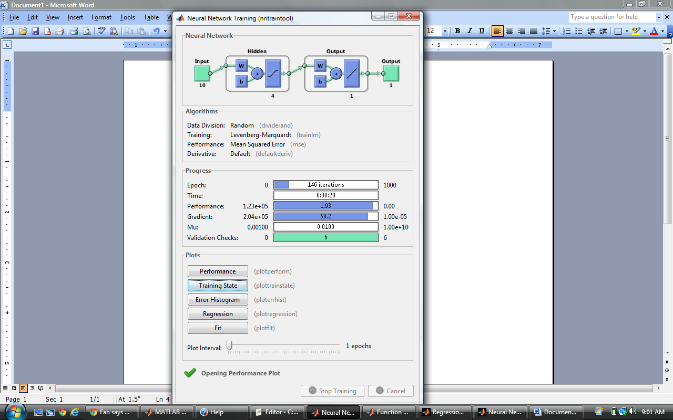

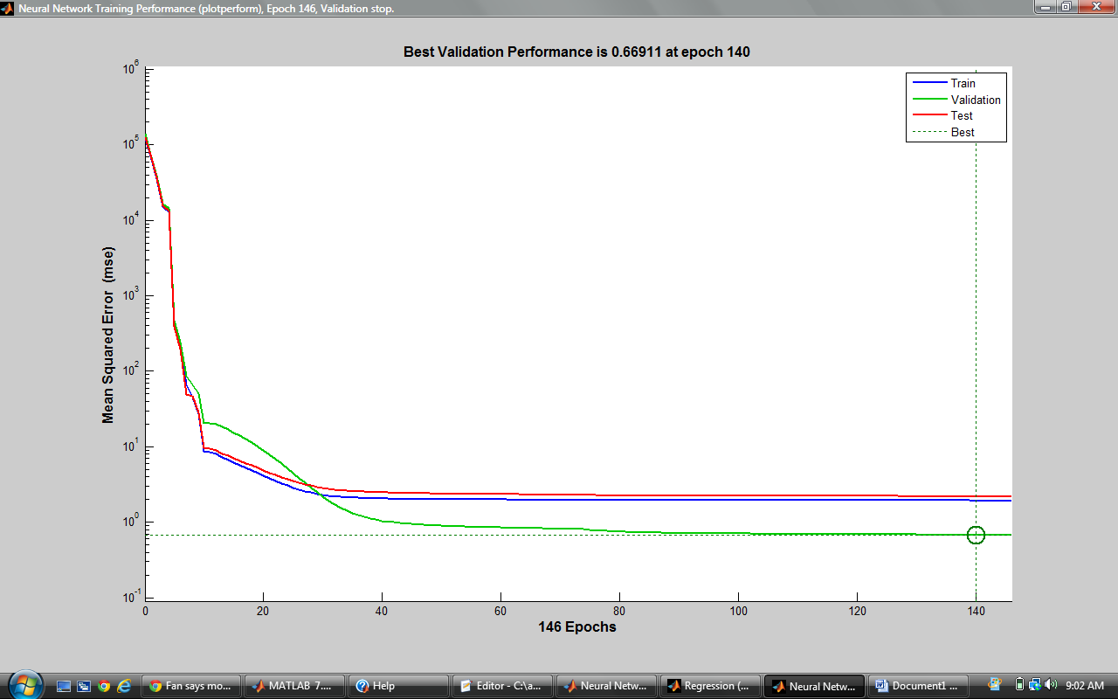

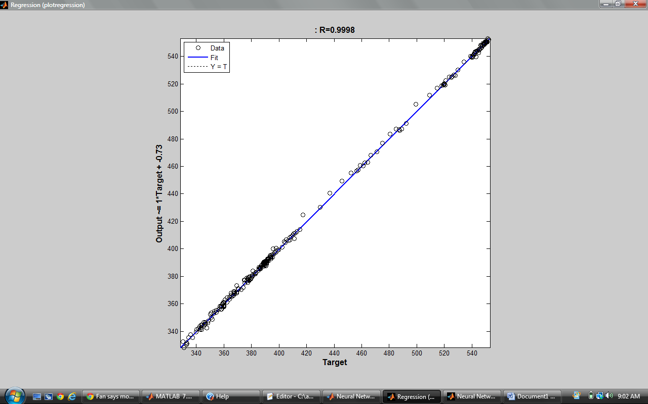

10 HL Nodes:
MSE: 2.2732

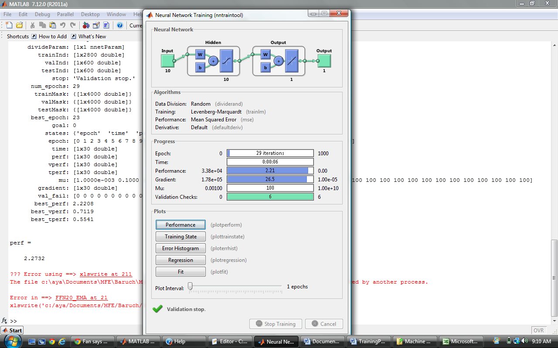

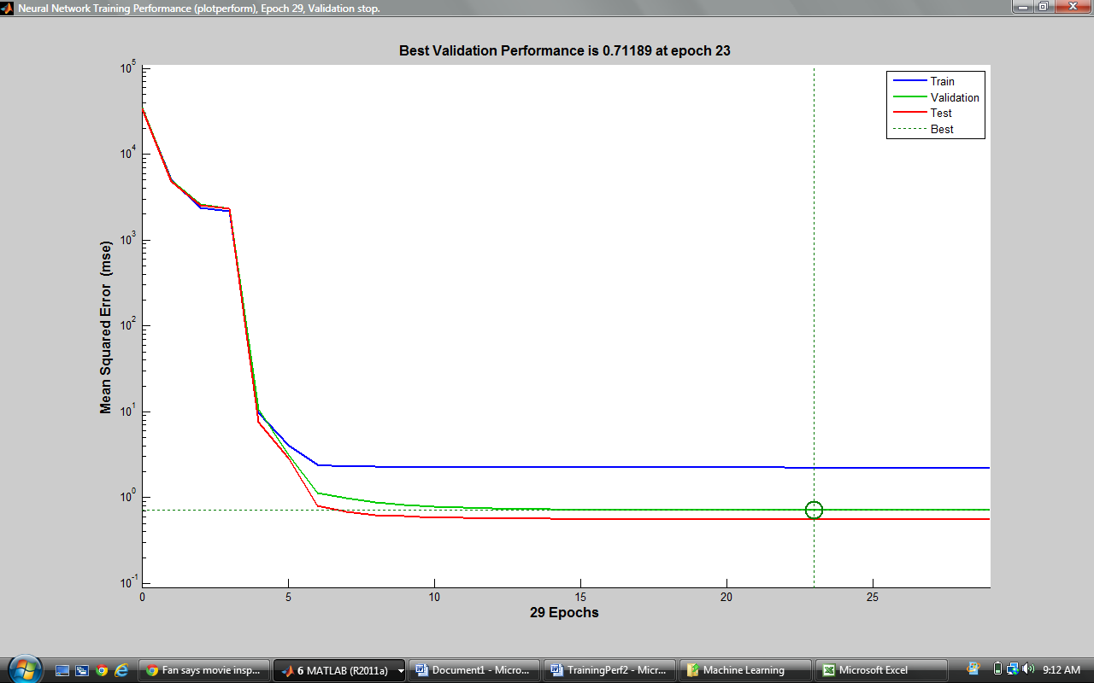

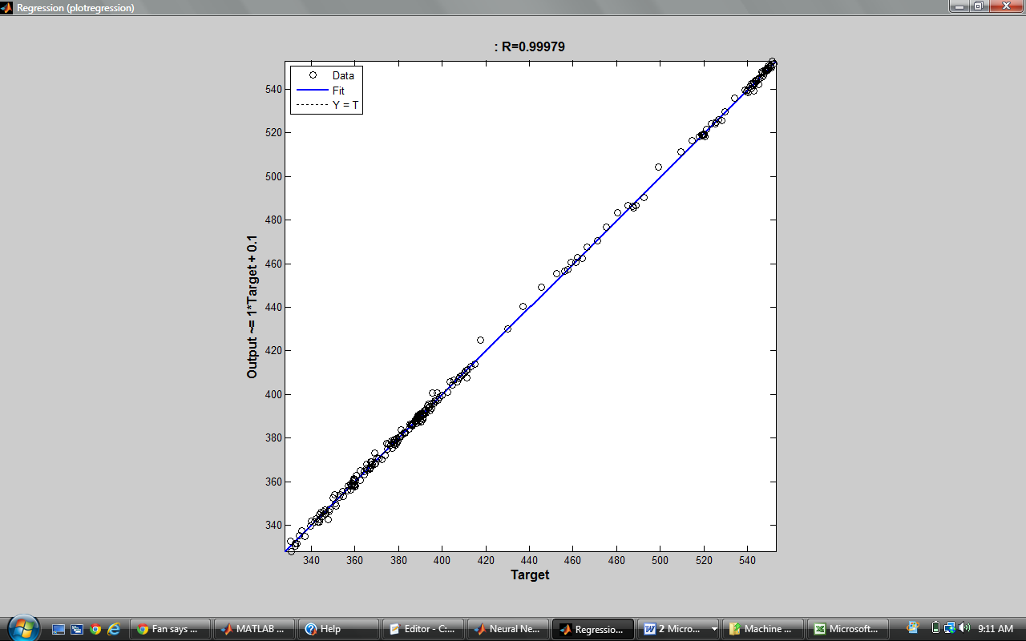

7 HL Nodes:
MSE: 2.5041

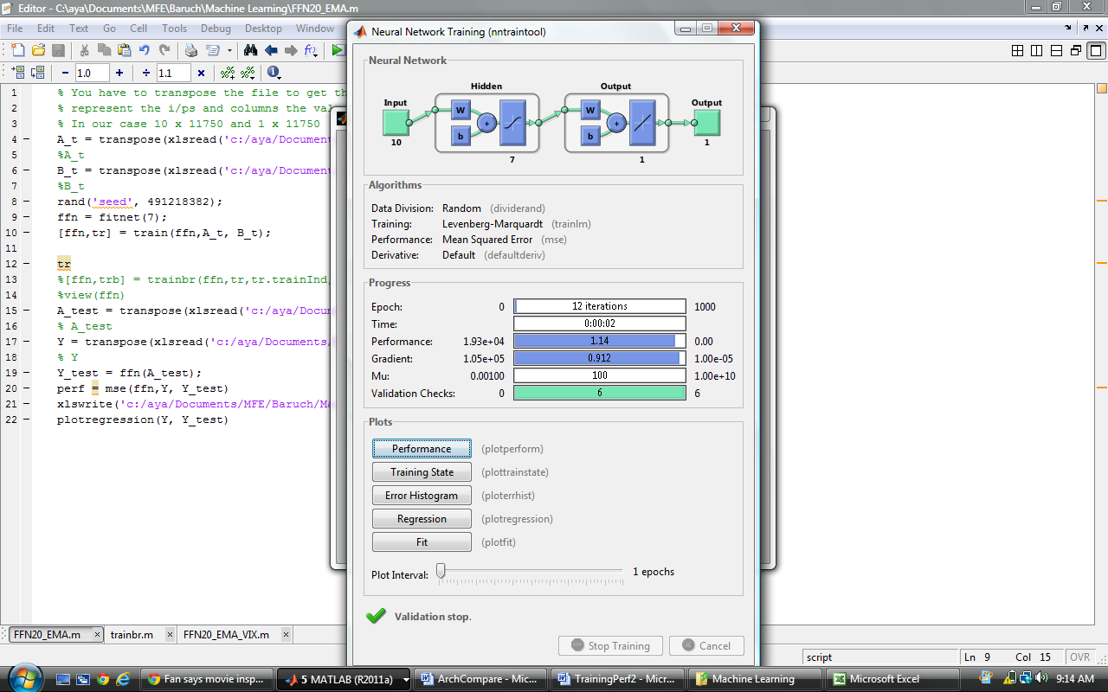

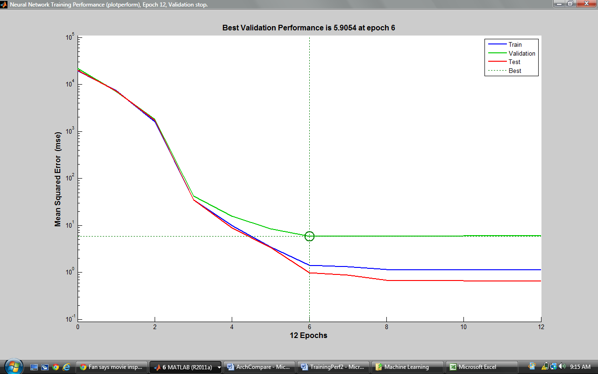

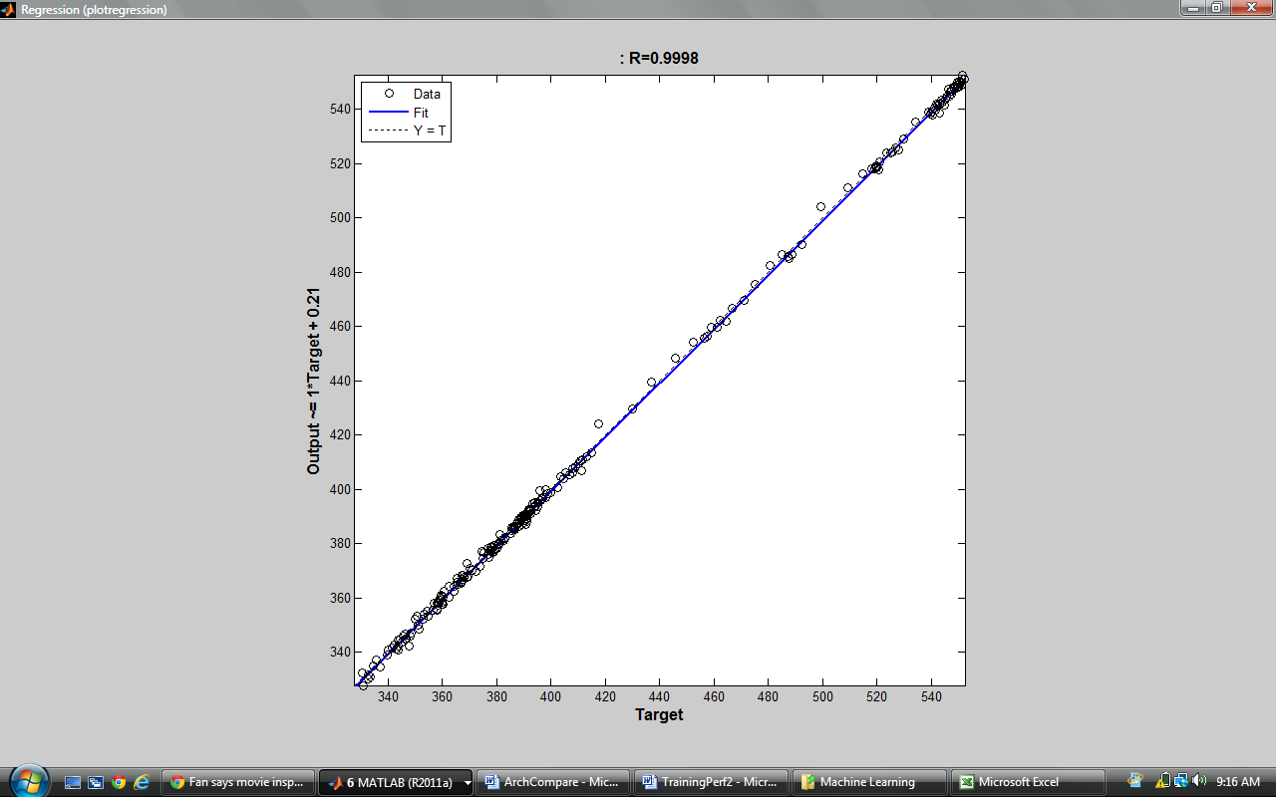

12 HL Nodes
MSE: 2.2496

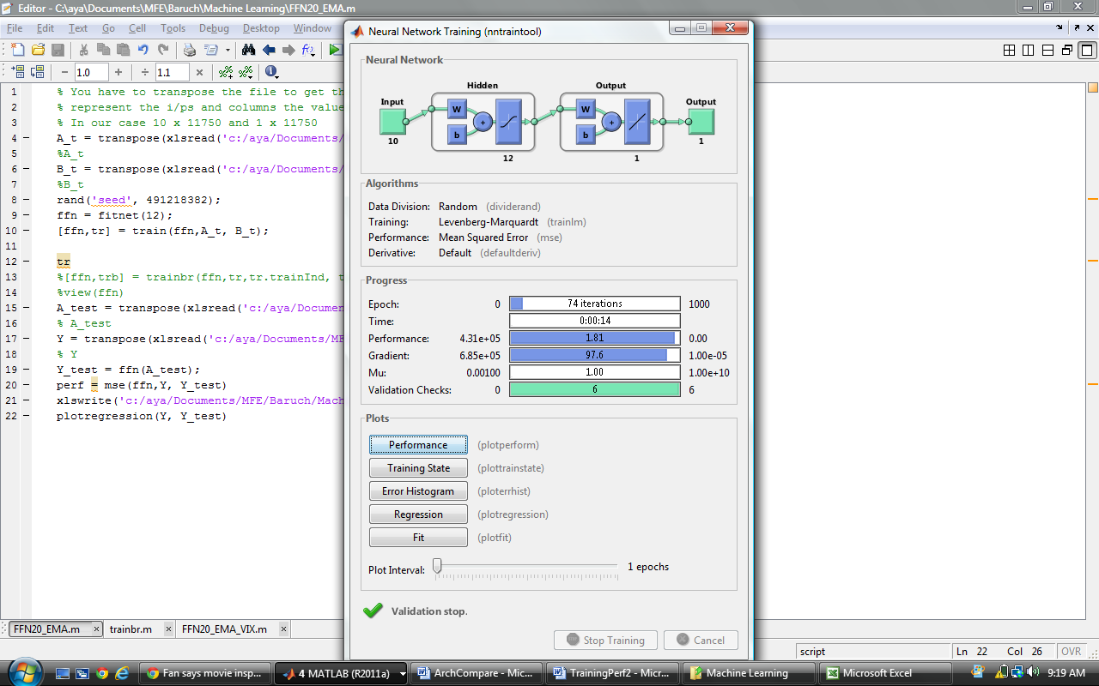

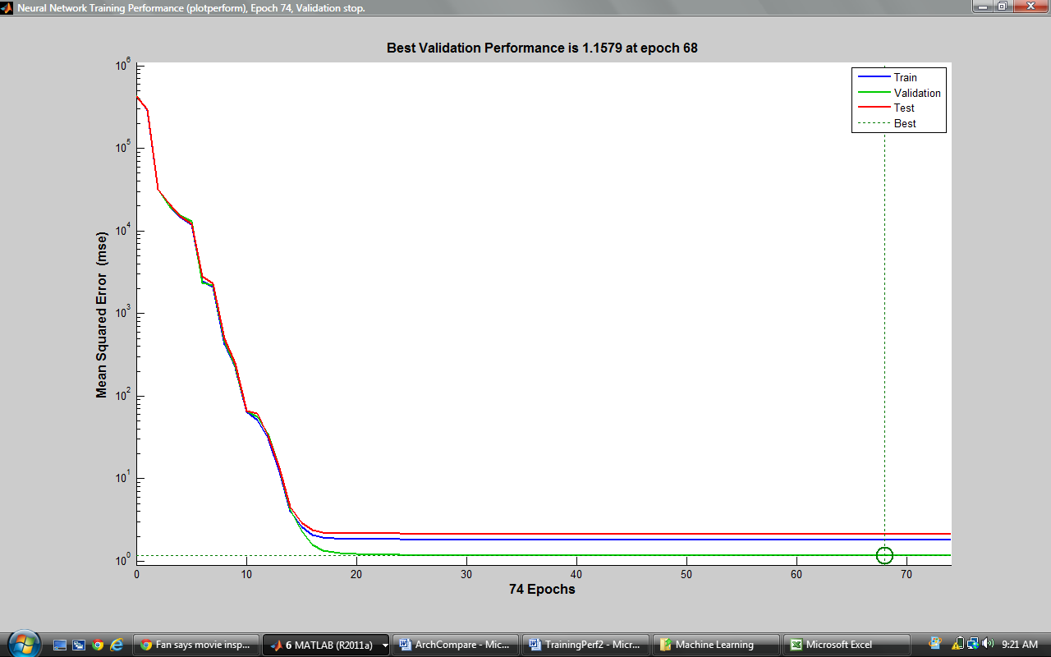

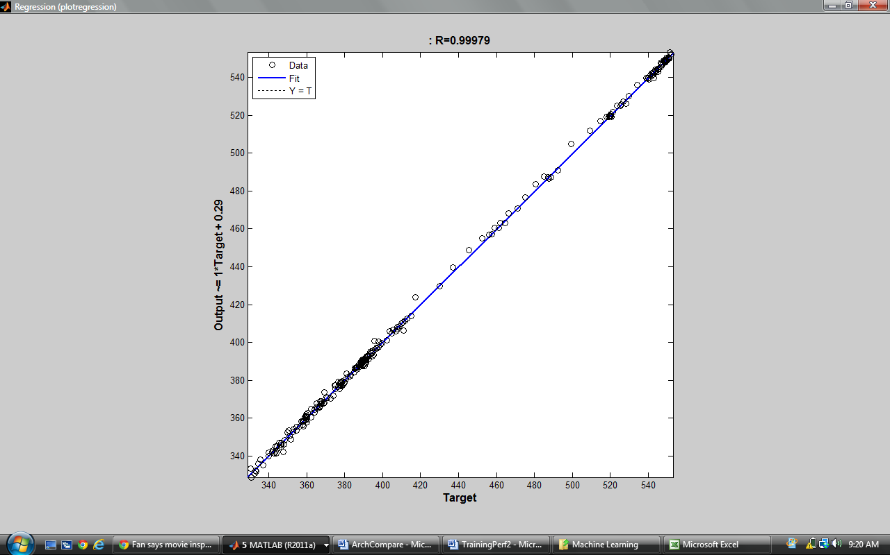

20 HL Nodes:
MSE: 2.5932

