MOTION PLANNING

Q1
PART A
- Configuration space(C) is the set of all configurations a robot can take.{The standard textbook definition (Lozano-Pérez, 1983)}, while a configuration is the smallest set of numbers that fixes where every part of the robot is. So to determine the configuration space for a buggy, we require 3 parameters = (x, y, θ) θ = angle measured from the positive x-axis, while a point robot needs only 2 parameters = (x,y). This is because the robot is assumed to turn instantly(in any direction - so its angle from the positive x-axis doesn’t contribute to its configuration - if a robot can instantly turn to any direction, how does it matter in which direction it is currently pointing towards?), while the buggy cannot do this because of which we need to introduce θ(direction) in which it is pointing) as well.
The planner has to take this in account as well(which all directions can the buggy turn in how much time).
- Max Steer angle = 32 degrees
Wheel base = 2.30m
Derivation for the radius under the assumption of bicycle model of the buggy
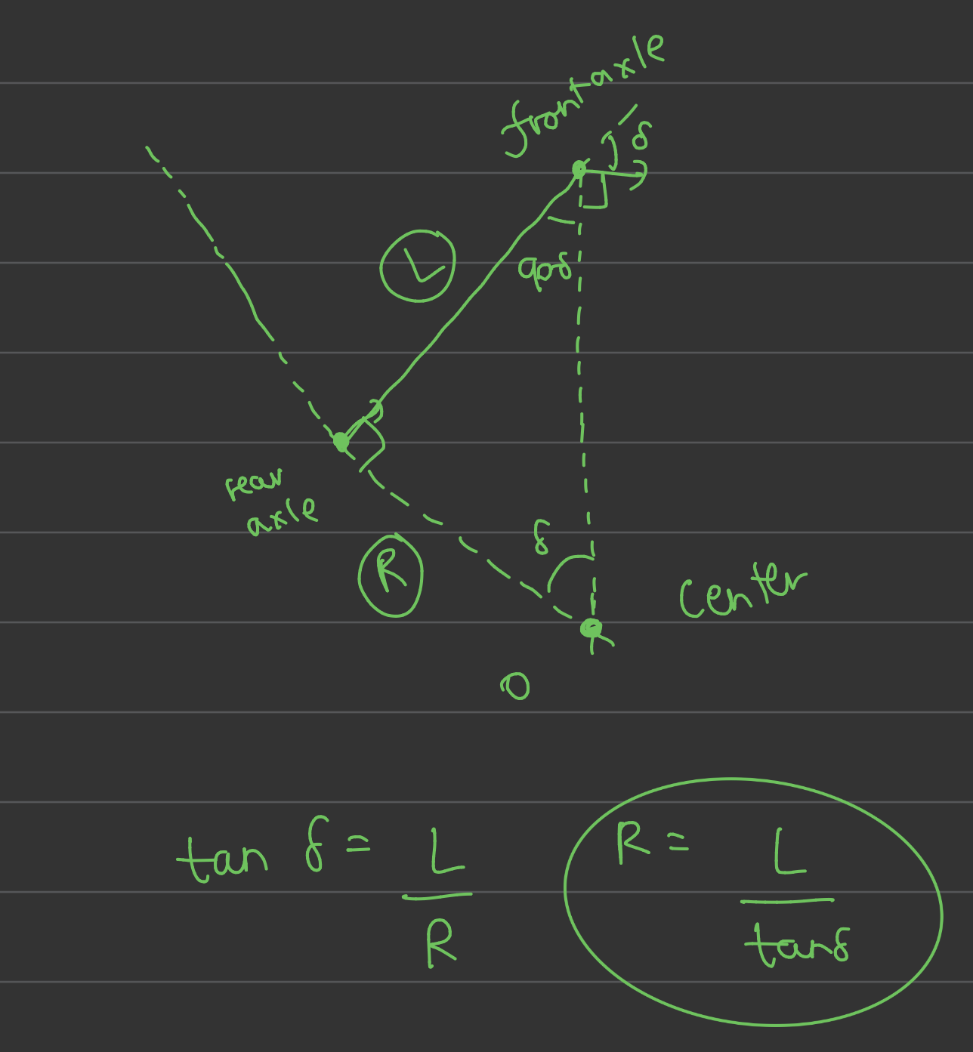
Therefore R = 2.3/tan(32deg) = 3.68m

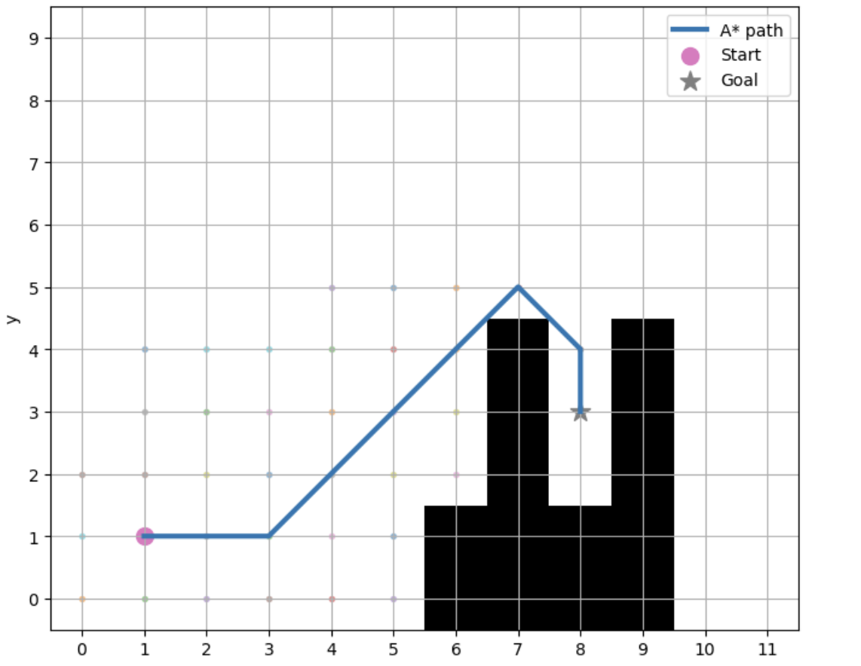
In many places, the buggy is expected to take 90 degree turns instantly which it obviously can’t in real life.

- Normal A* has the configuration space as (x,y) while hybrid A* goes one step further and has the configuration space as (x, y, θ). Instead of considering only the movement from 1 cell to another, it also considers the steering motion(which normal A* doesn’t). This is good for a real life vehicle like a buggy because we need to account for how much can the buggy steer in the given distance(will it be able to make a turn around a given corner in such a short distance?).

