UMIC SeDriCa Recruitment Assignment 2026–27: Report

Personal Information
Name | [fill in]
Roll number | [fill in]
Department | [fill in]
GitHub repository link | [fill in]

# | Subsystem | Questions attempted
1 | Perception | Q1 (mandatory), Q2 (mandatory), Q4 (bonus)
2 | Motion Planning | Q1 (mandatory)

Section A: General / Common Questions

Q A.1: What are your short-term and long-term goals? (150 words or less)
[Your answer]

Q A.2: What motivates you to join UMIC SeDriCa? (150 words or less)
[Your answer]

Q A.3: A campus driving scenario (250 words or less)
[Your answer: the place, why it is difficult, which stage it challenges, one practical way to handle it]

Section B: Subsystem-wise Assignment

Perception
Code: Perception/. Run instructions: Perception/README.md.

Question 1: The road disappears (Mandatory)
Imagine the BFMC car following a painted lane. On a clear stretch, both boundaries are easy to see. A few frames later, a shadow covers part of the road, one boundary fades, and a bright seam offers a convincing but false line. The controller cannot steer from a description such as “the road seems to bend left.” It needs a lane centre at a near row and another at a farther row. Your job is to produce those two image coordinates for each frame, show when the estimate is unreliable, and find out which visual cues survive the difficult frames.
Data and coordinates
Use the three 24-frame sequences in city/lane/clear, city/lane/shadow, and city/lane/missing. Each frame is 480×320 pixels. The image origin is at the upper-left: u increases to the right and v increases downward. At row v_{n}=260, report the horizontal coordinate u_{n} of the lane centre. Do the same at row v_{f}=170 to obtain u_{f}. The centre is halfway between the left and right road boundaries at that row, even when you can see only one boundary. This definition is about the road you intend the car to follow, not the brightest line in the image.
The file city/lane_reference.csv contains the true u_{n} and u_{f} for evaluation. It is not an input to your detector. The provided calibration files are not needed for this question. Work in image coordinates and concentrate on which pixels are useful evidence when the markings weaken.
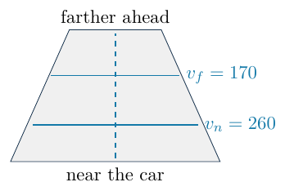
The sketch is a coordinate guide. Measure on the actual frames.
Your work
a. Look before coding. Choose one frame from each sequence and mark the two boundary cues and the centre you would want the car to follow at v_{n} and v_{f}. If a boundary is hidden, mark where you think it continues and explain your evidence. Identify the shadow or seam that could fool a simple white-pixel threshold. This sketch is your first hypothesis, not a label to feed into the code.
Answer
One frame per sequence, annotated by hand: clear 002, shadow 008, missing 009. Blue lines = the two measurement rows (vf = 170, vn = 260), red = path to follow (lane centre), green = boundaries (dashed = where a hidden boundary must continue), orange = bright seam. These are a hypothesis, never fed to the detector.
clear 002
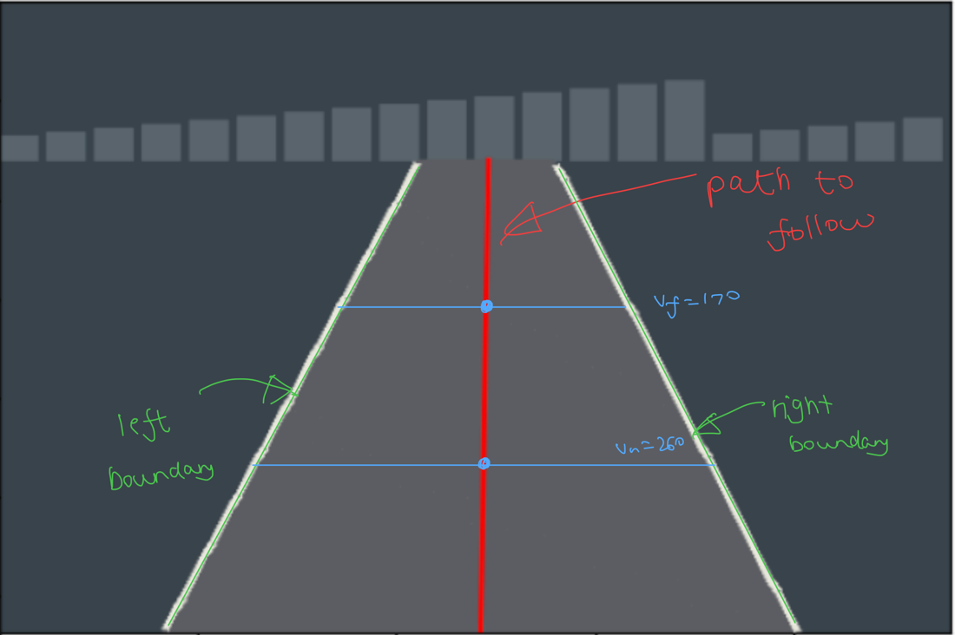
clear 002
shadow 008
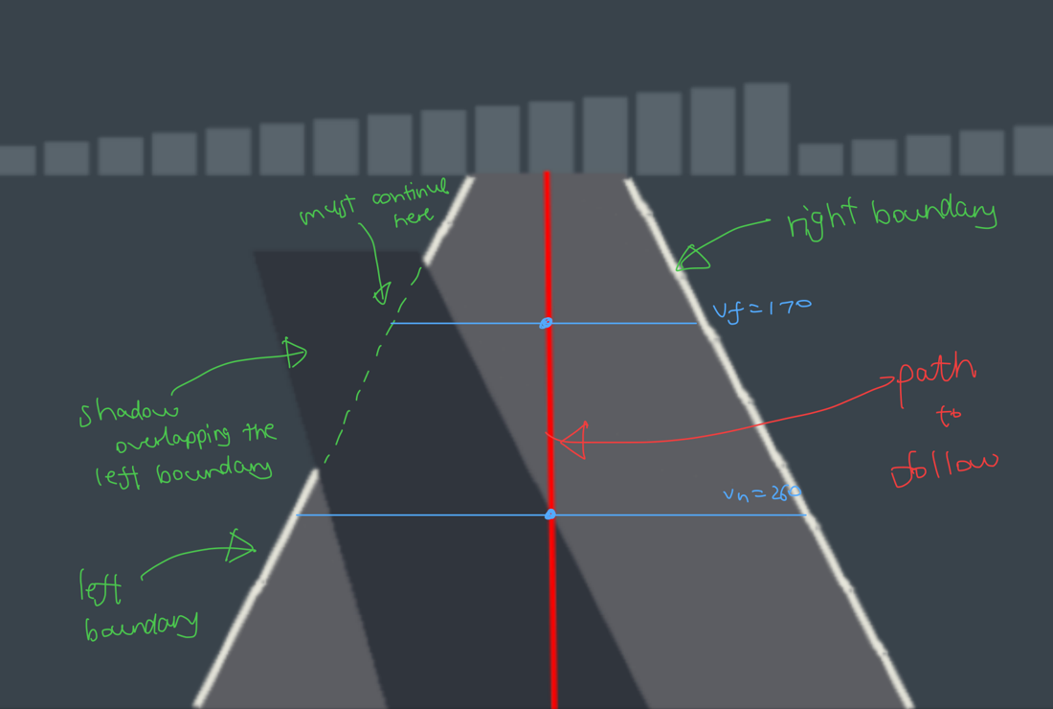
shadow 008
missing 009
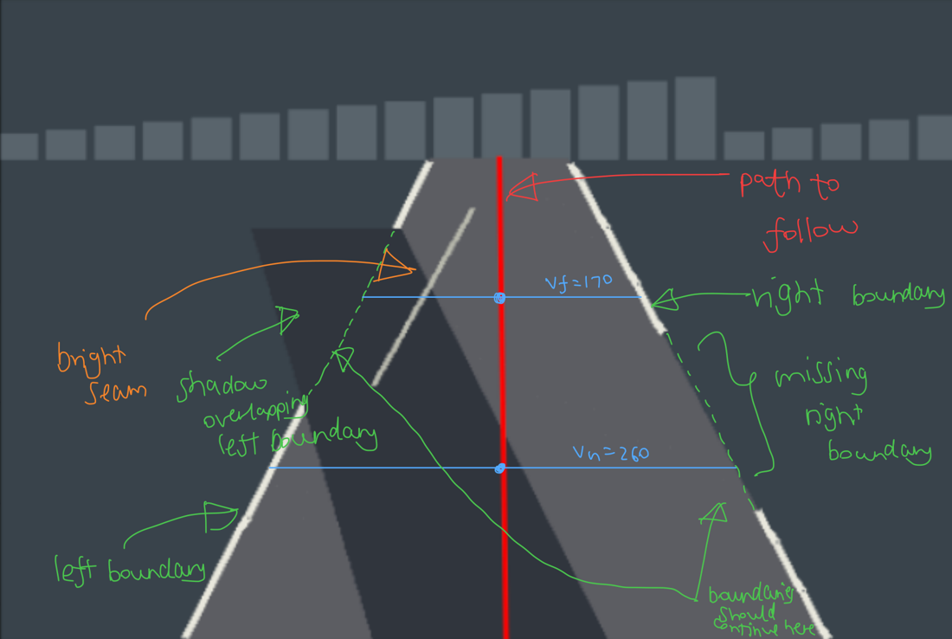
missing 009
What could fool a white-pixel threshold
Brightness = R+G+B: paint ≈ 686, lit road ≈ 282, background / shadow ≈ 160–200, seam ≈ 542.
- Shadow (shadow 008, missing 009): hides the left paint at the far row, so that edge must be continued from the visible part.
- Bright seam (missing 009): looks like a lane edge and sits where the true left edge is hidden. Any threshold below about 560 accepts it.
- Missing paint (missing 009): a gap in the right line, which must be continued.

b. Make a small baseline. Write a function that takes one frame and returns (u_{n},u_{f}), together with a way to say “unknown” for either coordinate. A colour threshold, edge map, line fit, or a combination is enough. State the image region, thresholds, and any assumption about lane width or shape. Run the unchanged baseline on all 72 frames.
Answer
- Region: rows v >= 80.
- Thresholds: white = R+G+B >= 500; shadow = R+G+B < 190.
- Method: left edge = left-most white pixel in u < 240, right edge = right-most in u >= 240; one straight line per side; centre = midpoint of the two lines at vn = 260 and vf = 170.
- Assumptions: edges are straight lines; anything with R+G+B >= 500 is paint.
- Unknown: fewer than 2 edge points on a side gives None.
Workflow of the baseline (what happens to one frame)
frame (480 x 320 RGB)
|
v
[1] keep only the road region: rows v >= 80 (ROI_START_V)
|
v
[2] for every ROI row v, find the white paint on each side b.1 get_white_boundaries
| white pixel = R+G+B >= 500 (baseline threshold)
| left edge = left-most white pixel in the left half (u < 240)
| right edge = right-most white pixel in the right half
| no white pixel on a side -> that row gives no point on that side
v
[3] collect the edge points of all rows -> left points, right points b.3 collect_boundary_points
|
v
[4] fit one straight line per side: u = slope * v + intercept b.4 fit_boundary
| fewer than 2 points -> no line -> unknown (None)
v
[5] read both lines at the two measurement rows b.5 boundary_x
| near row vn = 260 far row vf = 170
| (where the paint is hidden, the fitted line fills the gap in)
v
[6] lane centre = midpoint of the left and the right line b.2 calculate_centre
|
v
output: (un, uf) = lane-centre u at vn and at vf, or None b.9 predict_frame
Side branch: get_dark_mask (b.6) and is_in_shadow (b.8) flag points in shadow (used in part c); get_road_mask (b.7) is for display only.
b.10 runs this on all 72 frames, with no labels.
b.9 · predict_frame — frame in, (un, uf) out
Baseline: white_threshold=500. Revision (part d): 650.
frames run: 72 unknown near: 0 unknown far: 0
clear 002 un = 243.3 uf = 244.5
shadow 008 un = 249.8 uf = 249.0
missing 009 un = 252.9 uf = 256.5

c. Interrogate the evidence. For one difficult frame, display the stages of your baseline as a small panel: the original image, the region of interest, the cue it extracts, and the proposed lane centre. Put the same stages beside a clear frame. Point to the exact pixels that persuade your method, and to the shadow, seam, or missing boundary that persuades it wrongly. If you use a colour space or an edge operator, explain what it made easier to separate in these frames.
Answer
Baseline (threshold 500). Top row: clear 002. Bottom row: missing 009.
Column | Stage
1 | Original image
2 | Road region img[80:, :] with the two measurement rows (crop indexing: original row = crop row + 80)
3 | The cue: accepted white pixels (lime: R+G+B >= 650; magenta: accepted only because the threshold is 500), boundary points (original coordinates), fitted line if a point is in shadow
4 | Proposed lane centre and path
clear 002 (threshold 500): shadow overlap = False, pixels accepted only because the threshold is low = 0
boundary v=170: u=161.5 in shadow: False
boundary v=170: u=327.5 in shadow: False
boundary v=260: u=112.9 in shadow: False
boundary v=260: u=373.8 in shadow: False
centre v=170: u=244.5
centre v=260: u=243.3
missing 009 (threshold 500): shadow overlap = True, pixels accepted only because the threshold is low = 78
boundary v=170: u=180.4 in shadow: True
boundary v=170: u=332.6 in shadow: False
boundary v=260: u=124.8 in shadow: False
boundary v=260: u=381.1 in shadow: False
centre v=170: u=256.5
centre v=260: u=252.9
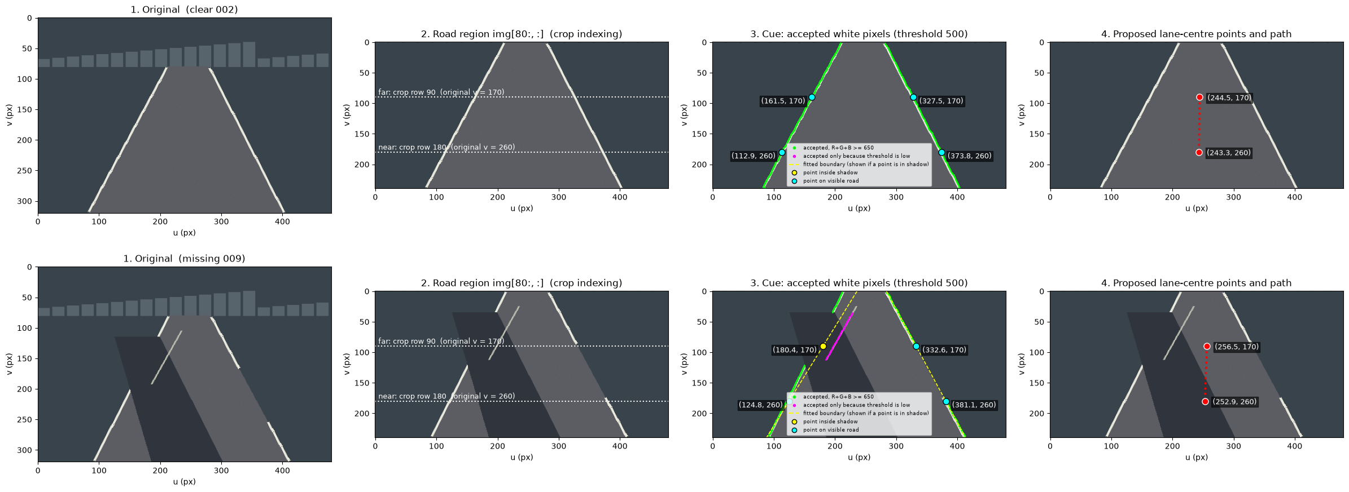
What persuades the method, and what misleads it
- Persuades (lime): the paint is the brightest thing (≈ 686 vs ≈ 282 for the road), so on the clear frame each edge is clean.
- Misleads (magenta): in missing 009 the left paint is hidden by the shadow, so the left-most pixel ≥ 500 is a seam pixel (≈ 542). The fit tilts and the far centre shifts right.
- Missing right paint: harmless, the fitted line continues it.
- Colour space: only R+G+B is used. It separates paint, road and background, but not paint from the seam at threshold 500.

d. Repair a real failure. Choose a failure you observed, such as the shadow, missing boundary, or false seam. Revise your baseline using a cue you can justify. For example, use road width, earlier frames, a restricted search region, or agreement between the near and far rows. If you claim a real-time method, use only the current and earlier frames. Return a confidence value in [0,1] with each estimate, and state the evidence that raises or lowers it. This value is a ranking of trust; it need not be a calibrated probability.
Answer
- Failure (d.2): at threshold 500 the seam is taken as a lane edge on missing frames 04–14 (far-row error up to 6.7 px).
- Cue (d.3, d.4): brightness. Seam ≈ 542 < paint ≈ 686, so a threshold between them rejects the seam.
- Revision (d.5): same pipeline with threshold 650, plus a confidence per estimate.
Failure = unknown, or error > FAIL_TOL_PX (3 px). Reference is read only after predicting.
d.1 · evaluate_all — run every frame, score afterwards, list the failures
d.2 · The failure: baseline (white threshold 500) on all 72 frames
frames run: 72 failing: 11 (tolerance 3.0 px)
unknown near: 0 unknown far: 0
clear mean |error| near: 0.16 px far: 0.17 px
shadow mean |error| near: 0.17 px far: 0.17 px
missing mean |error| near: 1.04 px far: 2.59 px
FAIL missing 4 near err 2.1836182503272994 far err 3.06342203472218
FAIL missing 5 near err 2.313939482102512 far err 3.7373552516719997
FAIL missing 6 near err 2.4193202902200994 far err 4.556435004673631
FAIL missing 7 near err 2.3865923929071187 far err 5.186192749979881
FAIL missing 8 near err 2.2563909013927628 far err 6.131007037263487
FAIL missing 9 near err 2.0673784005980735 far err 6.713849279205277
FAIL missing 10 near err 1.8350681920343561 far err 6.40861250209457
FAIL missing 11 near err 1.334228402517624 far err 5.685101277695679
FAIL missing 12 near err 0.7689930326361321 far err 4.84247328855065
FAIL missing 13 near err 0.33306127013932496 far err 3.8807442266336523
FAIL missing 14 near err 0.28565110116042547 far err 3.0076030849666324
d.3 · The cue: brightness separates the paint from the seam
Histogram of R+G+B over all ROI pixels of the missing frames (log scale). The seam and paint clusters are well separated.
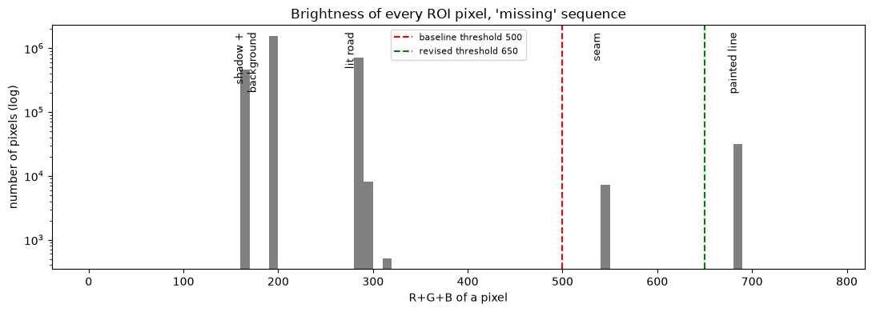
accepted at 650 (paint): n = 7835 R+G+B min 686 median 686 max 686
accepted only at 500 (the seam): n = 728 R+G+B min 542 median 542 max 542
d.4 · Threshold sweep
At 500 or below the seam gets in; at 700 or above the paint is rejected (all unknown). 650 sits between the seam and the paint.
white_threshold | failing frames | unknown values | worst error (px)
750 | 72 | 144 | 0.0
700 | 72 | 144 | 0.0
680 | 0 | 0 | 0.0
650 | 0 | 0 | 0.0
600 | 0 | 0 | 0.0
550 | 0 | 0 | 0.0
500 | 11 | 0 | 6.7
450 | 11 | 0 | 6.7
400 | 11 | 0 | 6.7
d.5 · Revision: threshold 650 and a confidence per estimate
Same detector with threshold 650 (justified by d.3 and d.4), current frame only. conf_near goes with un, conf_far with uf.
$$\text{confidence}=1−0.5×(\text{fraction of the row’s boundaries taken from the fitted line})$$
- On a row, each boundary is either detected directly (white pixel found on that row) or taken from the fitted line (shadow, paint gap).
- Both seen directly: 1.0. One hidden: 0.75. Both hidden: 0.5. Unknown (None): 0.
It ranks trust; it is not a calibrated probability.
d.6 · Run the revised version on all 72 frames
sequence | mean conf near | mean conf far
clear | 1.000 | 1.000
shadow | 0.938 | 0.854
missing | 0.948 | 0.656
confidence 1.00: 95 of 144 estimates
confidence 0.75: 40 of 144 estimates
confidence 0.50: 9 of 144 estimates
confidence 0.00: 0 of 144 estimates
failing frames (unknown or error > 3.0 px): baseline = 11, revised = 0

e. Measure the change. For each sequence and each row, compute mean absolute error in pixels on frames where your method returned a coordinate. Also report the fraction of frames marked unknown. Report both numbers for the baseline and your revision: a method cannot look accurate simply by refusing every hard frame. Use city/lane_reference.csv only after producing predictions. Show two failure frames, including one where a plausible bright line was wrong, and explain what the code did in each case.
The near and far centres need not move together. If your method gives a plausible near centre but an implausible far centre, explain what the car would infer incorrectly and how your confidence rule exposes the disagreement.
Answer
MAE (px) over the frames that returned a coordinate, and the fraction unknown. Baseline = 500, revision = 650. Reference is read only after predicting (evaluate_all, d.1).
e.1 · Baseline vs revision: MAE and unknown fraction
| BASELINE (500) | REVISION (650)
sequence | row | MAE (px) | unknown | MAE (px) | unknown
clear | near (vn=260) | 0.155 | 0.0% | 0.155 | 0.0%
clear | far (vf=170) | 0.173 | 0.0% | 0.173 | 0.0%
shadow | near (vn=260) | 0.170 | 0.0% | 0.239 | 0.0%
shadow | far (vf=170) | 0.171 | 0.0% | 0.248 | 0.0%
missing | near (vn=260) | 1.040 | 0.0% | 0.176 | 0.0%
missing | far (vf=170) | 2.592 | 0.0% | 0.176 | 0.0%
e.2 · Estimated and reference un (and uf) through the missing-line sequence
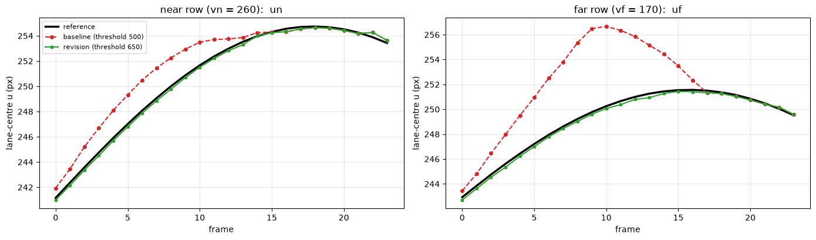
e.3 · Two failure frames
Baseline (500, left) vs revision (650, right). Lime / magenta as in part (c); red = predicted centre, white × = reference (scoring only).
- missing 009: a plausible bright line (the seam) is wrong.
- missing 013: near row fine, far row wrong.
missing 009, threshold 500: magenta pixels = 78, left edge at far row = 180.4
near: predicted 252.94 reference 250.87 error 2.07 px confidence 1.00
far: predicted 256.48 reference 249.77 error 6.71 px confidence 0.75
missing 009, threshold 650: magenta pixels = 0, left edge at far row = 166.6
near: predicted 250.68 reference 250.87 error 0.19 px confidence 1.00
far: predicted 249.60 reference 249.77 error 0.17 px confidence 0.50
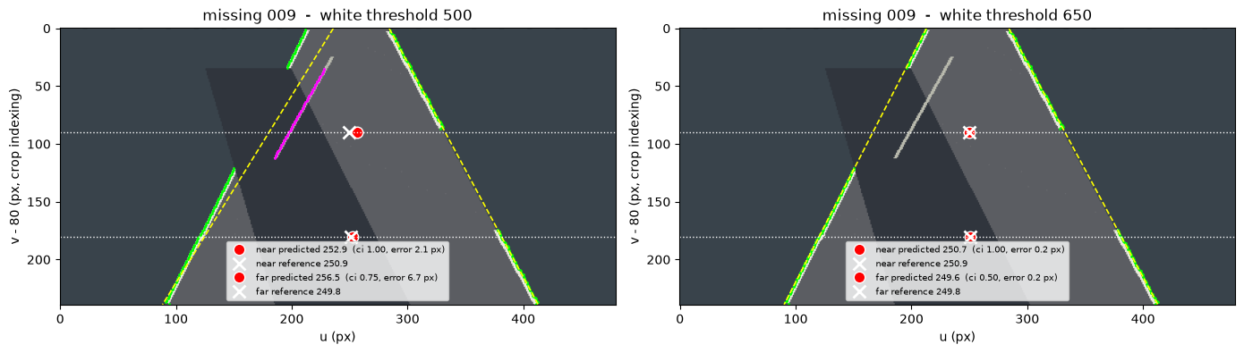
missing 013, threshold 500: magenta pixels = 43, left edge at far row = 176.1
near: predicted 253.86 reference 253.53 error 0.33 px confidence 1.00
far: predicted 255.14 reference 251.26 error 3.88 px confidence 0.75
missing 013, threshold 650: magenta pixels = 0, left edge at far row = 167.8
near: predicted 253.31 reference 253.53 error 0.22 px confidence 1.00
far: predicted 250.94 reference 251.26 error 0.32 px confidence 0.75
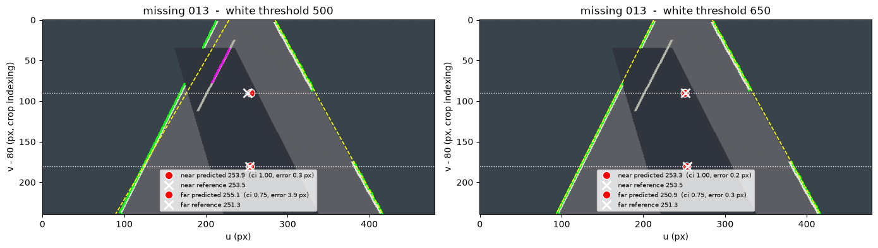
missing 009. The shadow hides the left paint around row 170, so the left-most pixel ≥ 500 is a seam pixel. The fit tilts: far centre 256.5 vs true 249.8 (error 6.7 px), near error 2.1 px. At 650 the seam is never accepted and the error drops to 0.2 px.
missing 013. Near error 0.3 px but far error 3.9 px. The estimated centres (253.9 → 255.1) drift right while the truth (253.5 → 251.3) drifts left, so a controller would infer the wrong heading. The confidence rule only partly flags it (far 0.75 vs near 1.0) and misses the cause, because the seam was directly detected: it measures missing evidence, not false evidence. At 650 the far error is 0.3 px.
e.4 · The change and what it fixed
- Change: white threshold 500 → 650, justified by the brightness gap (seam ≈ 542, paint ≈ 686), plus a confidence value.
- Fixed: missing MAE 1.04 → 0.18 px (near) and 2.59 → 0.18 px (far); the 11 failing frames disappear. Clear is unchanged; no frame is unknown.
- Cost: shadow MAE rises slightly (≈ 0.17 → 0.24 px), likely because 650 rejects soft, dimmed paint pixels (500–650) that the baseline admits (untested). At 700 or more everything is unknown, so 650 relies on the paint staying near 686.
- Limit: the confidence does not detect a wrong line that is directly seen (frame 013). The data are synthetic.

Question 2: A crossing with conflicting evidence (Mandatory)
The same city car is approaching a crossing. In one run the light stays green. In another, it turns red while the car is moving. In a third, a person walks into the crossing. The camera offers imperfect evidence, and a V2X message can still say “green” after the light has changed because the message describes an older moment. Build a small perception-to-decision system that recommends GO, SLOW, or STOP at each frame and records why. The interesting part is not finding one perfect threshold. It is deciding what the car should do when evidence is late, noisy, or contradictory.
Data and coordinates
Use the three 24-frame sequences in city/crossing: clear_green, late_red, and person_crossing. Join each image to its row in city/crossing_evidence.csv using episode and frame. The row gives time_s, speed_mps, distance_to_line_m, two noisy vision scores in [0,1], a v2x_light state, and v2x_sample_time_s. A high red_score favours a red light. A high person_score favours a visible person, who may or may not be in the car's path. Neither score is a calibrated probability or a command to stop. The file city/crossing_reference.csv contains the true light, whether a person is on the crossing, and whether STOP is required. Use it only to evaluate decisions, never as an input to them.
You may use the supplied scores as the baseline. You are welcome to replace one or both with an image measurement such as a colour cue, frame difference, or a small detector, but model training is not expected. Inspect the images even if you use the supplied scores: a number is easier to interpret when you can see the light and the person's position. You can reuse your Question 1 road region to judge whether a person is in the car's path; explain the connection if you do.
Your work
a. Map what the car knows. Annotate one frame from each episode. Draw a signal-flow diagram with the image or vision scores, V2X state and timestamp, current speed, distance to the stop line, and your decision. Explain which observations are direct, which are uncertain, and why a visible person outside the road need not require STOP. The diagram should make clear that the evaluation labels are not available to the running system.
Answer
Signal flow
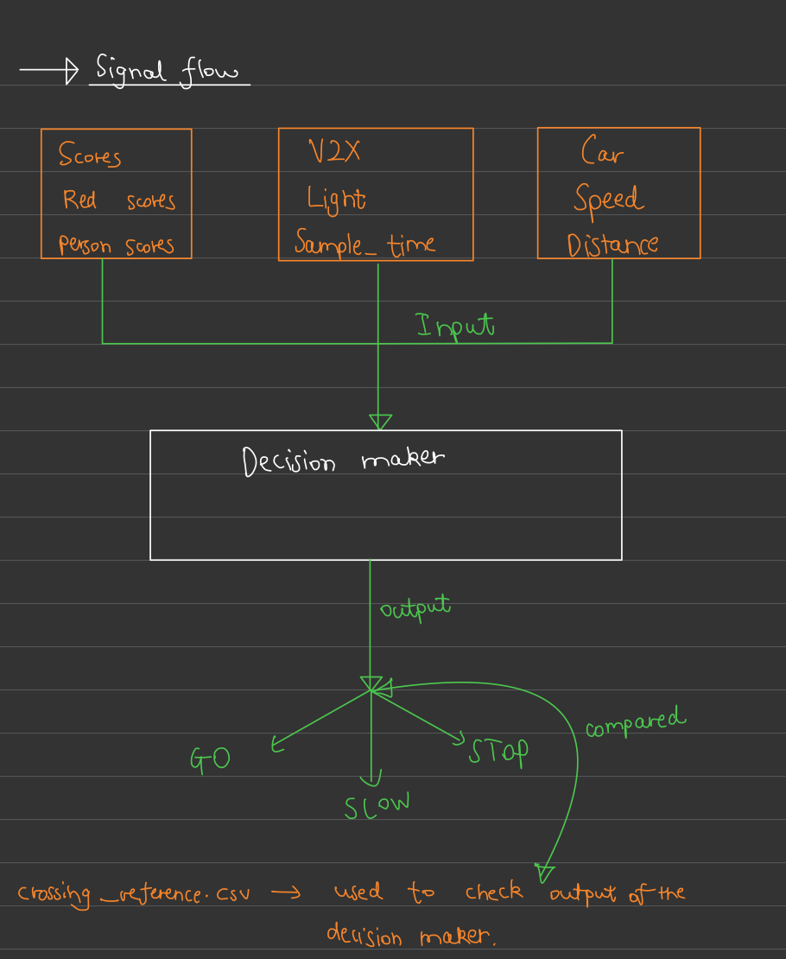
signal_flow
1 · clear_green, frame 14
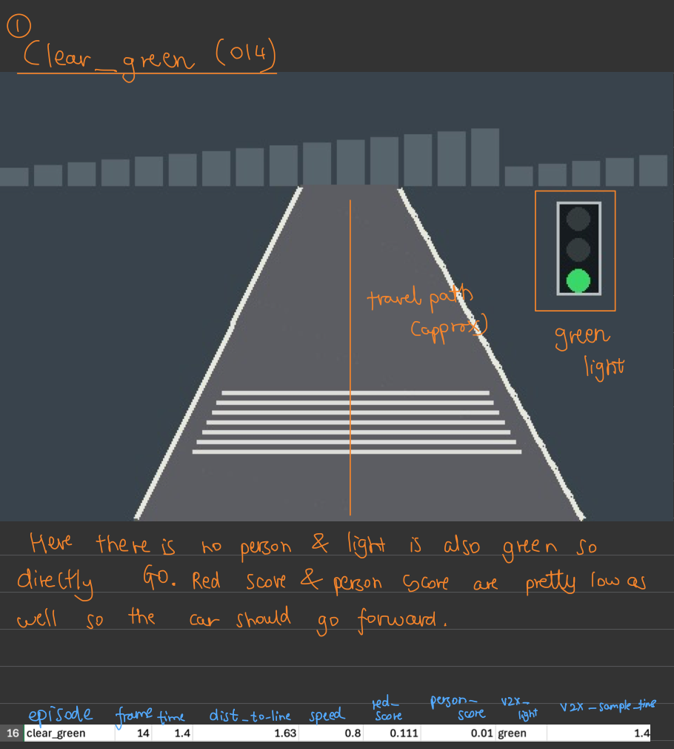
clear_green_014
2 · late_red, frame 20
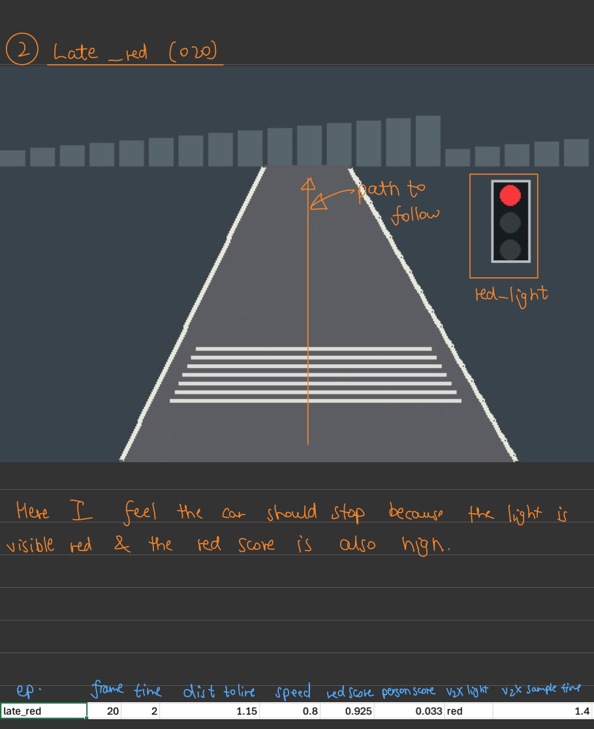
late_red_020
3 · person_crossing, frame 11
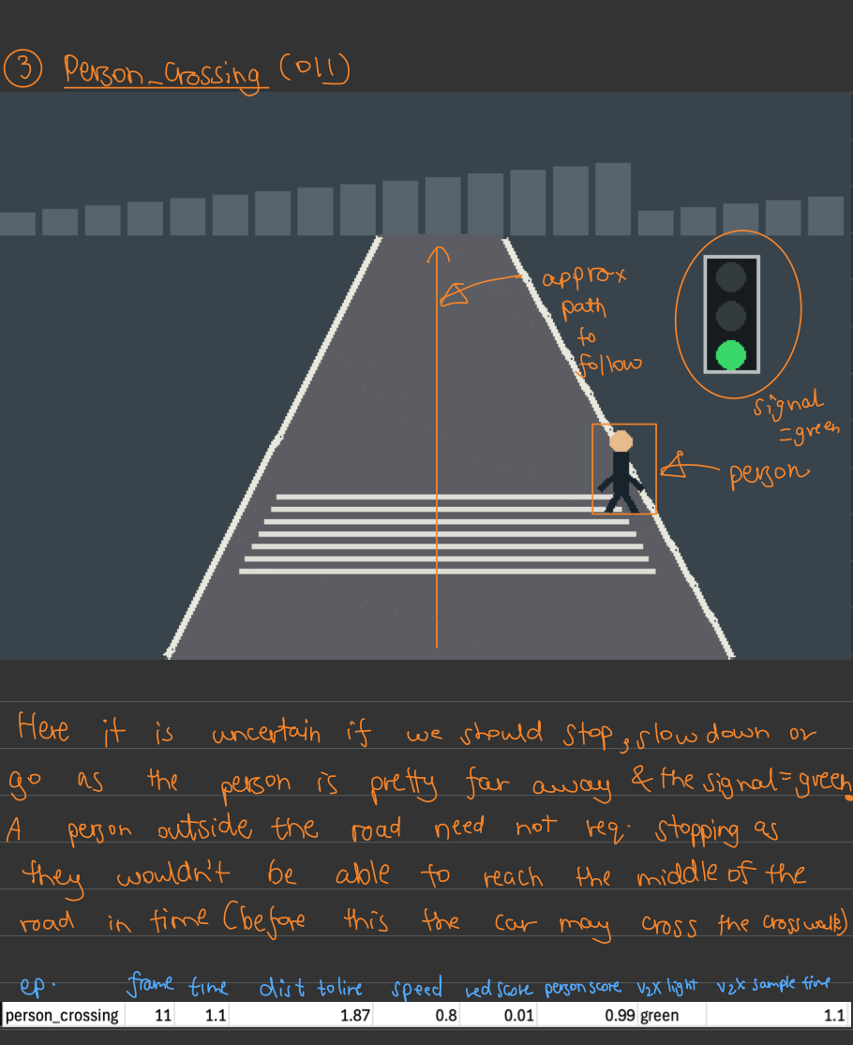
person_crossing_011
What the car knows. Direct: current speed and distance to the stop line (wheel and map data). Uncertain: the vision scores (noisy; a high person_score does not say whether the person is on the road) and the V2X light state (it describes an older moment, so its age matters). The evaluation labels are not an input to the running system. A person standing outside the road need not require STOP: the car only has to slow down in case the person steps in, so the decision depends on whether the person is on the road, not just visible.

b. Make the first rule. Implement a baseline using the supplied scores and V2X messages. For each frame return one of GO, SLOW, or STOP and a short reason string. Define what each state means in your system: for example, SLOW may mean that the car should approach cautiously while the evidence is unresolved. Choose and record your thresholds, then run the same rule on all three episodes. Show a timeline of its decisions beside the inputs.
Answer
Inputs: red_score, person_score, v2x_light. Not used: v2x_sample_time_s (part (c)) and crossing_reference.csv.
Thresholds
Edit these and re-run.
name | value | used for
thv1 | 0.7 | V2X says red: red_score above this → camera agrees → STOP
thv2 | 0.3 | V2X says not red: red_score below this → camera agrees → GO
thv3 | 0.5 | person_score above this → a person is probably there → STOP
Between thv2 and thv1 the camera is unclear, so a disagreement with V2X stays unresolved.
What each state means
- GO — keep going at the optimal speed.
- SLOW (the “GO SLOW” state) — reduce speed to avoid any accident, so the car can easily stop.
- STOP — complete halt (speed = 0).
The rule
The more cautious of the two checks wins (STOP > SLOW > GO); both reasons are kept. - Light: V2X red → STOP if red_score > thv1, else SLOW. Not red → GO if red_score < thv2, else SLOW. - Person: person_score > thv3 → STOP, else GO. This also stops for a person outside the road.
Run on all three episodes
message_age_s is for reference only; the rule doesn’t use it.
decision GO SLOW STOP
episode
clear_green 20 1 3
late_red 8 4 12
person_crossing 9 0 15
<IPython.core.display.Markdown object>
<pandas.io.formats.style.Styler at 0x34cf3d400>
<IPython.core.display.Markdown object>
<pandas.io.formats.style.Styler at 0x30c87fed0>
<IPython.core.display.Markdown object>
<pandas.io.formats.style.Styler at 0x30c87fed0>

c. Account for old messages. For each row compute message age as time_s minus v2x_sample_time_s. Find a frame where the message's state is misleading if its age is ignored. Revise your rule so it handles stale V2X data and disagreement between the camera and the message. Say what the car does while it cannot resolve the disagreement. Keep the baseline and revised timelines so the effect of this change is visible.
Answer
Image-only rule: no scores, no V2X. Coordinates are (row, col), origin top-left. crossing_reference.csv is never used by a rule.
 | part (b) baseline | part (c) revision
Person | person_score vs thv3 | leftmost dark-blue pixel vs right road boundary
Light | v2x_light + red_score | red / green lamp pixels
V2X message | used (misleads when old) | not used
Final | more cautious of light and person (STOP > SLOW > GO) | same
GO keep going · SLOW reduce speed so the car can easily stop · STOP complete halt (speed = 0).
1 · Frame where the old message misleads
age = time_s − v2x_sample_time_s is added in crossing_evidence_with_age.csv. Line 38 is late_red frame 12.
old messages (age > 0): 18 of 72 rows
time_s v2x_light v2x_sample_time_s age red_score person_score
frame
10 1.0 red 1.0 0.0 0.430 0.010
11 1.1 red 1.1 0.0 0.990 0.010
12 1.2 green 0.6 0.6 0.911 0.010
13 1.3 green 0.7 0.6 0.987 0.035
14 1.4 red 1.4 0.0 0.862 0.025
Message age (s) for all 72 frames
age = time_s − v2x_sample_time_s; one row per frame, one column per episode. 0.0 = fresh message, above 0 = old message.
episode clear_green late_red person_crossing
frame
0 0.0 0.0 0.0
1 0.0 0.0 0.0
2 0.0 0.0 0.0
3 0.0 0.0 0.0
4 0.0 0.0 0.0
5 0.5 0.5 0.5
6 0.6 0.6 0.6
7 0.0 0.0 0.0
8 0.0 0.0 0.0
9 0.0 0.0 0.0
10 0.0 0.0 0.0
11 0.0 0.0 0.0
12 0.6 0.6 0.6
13 0.6 0.6 0.6
14 0.0 0.0 0.0
15 0.0 0.0 0.0
16 0.0 0.0 0.0
17 0.0 0.0 0.0
18 0.0 0.0 0.0
19 0.6 0.6 0.6
20 0.6 0.6 0.6
21 0.0 0.0 0.0
22 0.0 0.0 0.0
23 0.0 0.0 0.0
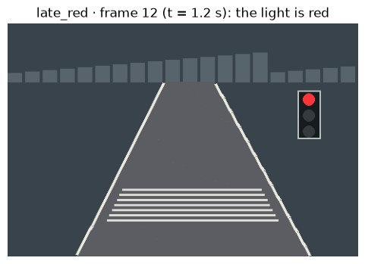
Baseline (part (b) rule) on that row:
V2X says green, sampled at 0.6 s, now 1.2 s -> age 0.6 s; red_score = 0.911
baseline decision: SLOW (conflicting evidence between the light signal and the red_score)
The message says green but is 0.6 s old, and the light is already red (red_score 0.911). The baseline only says SLOW when the car must STOP.
2 · Image measurements
- ROI: only img[80:, :] is used. Rows below are ROI rows (original row − 80).
- dark_blue: the person’s body colour, read at original (220, 350) of person_crossing frame 11. The light housing is a different dark colour, so an exact match ignores it.
- boundary: rightmost white pixel per row, from person_crossing frame 0 (no person).
- Lamps: fixed boxes, red rows 96–112, green rows 140–156 (ROI 16–32 and 60–76), columns 404–420.
dark_blue = [24 35 43] r+g+b = 102
boundary at original rows 200, 223, 300: [341 352 392]
3 · The rule
- Person: no dark-blue pixel → GO. Leftmost dark-blue pixel at or left of the stored boundary → STOP (on the road). Right of it → SLOW (outside, might cross).
- Light: red lamp lit → STOP, green lit → GO, neither → SLOW (fallback).
- Final: the more cautious of the two.
4 · Run on all three episodes
Decision counts per episode
baseline revised
GO SLOW STOP GO SLOW STOP
episode
clear_green 20 1 3 24 0 0
late_red 8 4 12 9 0 15
person_crossing 9 0 15 7 3 14
Decisions per frame
<IPython.core.display.Markdown object>
time_s age_s v2x_light light_seen person foot (ROI row, col) boundary x baseline revised
frame
0 0.0 0.0 green green - - GO GO
1 0.1 0.0 green green - - GO GO
2 0.2 0.0 green green - - GO GO
3 0.3 0.0 green green - - GO GO
4 0.4 0.0 green green - - GO GO
5 0.5 0.5 green green - - GO GO
6 0.6 0.6 green green - - STOP GO
7 0.7 0.0 green green - - STOP GO
8 0.8 0.0 green green - - GO GO
9 0.9 0.0 green green - - STOP GO
10 1.0 0.0 green green - - GO GO
11 1.1 0.0 green green - - GO GO
12 1.2 0.6 green green - - GO GO
13 1.3 0.6 green green - - GO GO
14 1.4 0.0 green green - - GO GO
15 1.5 0.0 green green - - GO GO
16 1.6 0.0 green green - - GO GO
17 1.7 0.0 green green - - GO GO
18 1.8 0.0 green green - - GO GO
19 1.9 0.6 green green - - GO GO
20 2.0 0.6 green green - - GO GO
21 2.1 0.0 green green - - SLOW GO
22 2.2 0.0 green green - - GO GO
23 2.3 0.0 green green - - GO GO
<IPython.core.display.Markdown object>
time_s age_s v2x_light light_seen person foot (ROI row, col) boundary x baseline revised
frame
0 0.0 0.0 green green - - GO GO
1 0.1 0.0 green green - - STOP GO
2 0.2 0.0 green green - - GO GO
3 0.3 0.0 green green - - GO GO
4 0.4 0.0 green green - - GO GO
5 0.5 0.5 green green - - GO GO
6 0.6 0.6 green green - - GO GO
7 0.7 0.0 green green - - GO GO
8 0.8 0.0 green green - - GO GO
9 0.9 0.0 red red - - SLOW STOP
10 1.0 0.0 red red - - SLOW STOP
11 1.1 0.0 red red - - STOP STOP
12 1.2 0.6 green red - - SLOW STOP
13 1.3 0.6 green red - - SLOW STOP
14 1.4 0.0 red red - - STOP STOP
15 1.5 0.0 red red - - STOP STOP
16 1.6 0.0 red red - - STOP STOP
17 1.7 0.0 red red - - STOP STOP
18 1.8 0.0 red red - - STOP STOP
19 1.9 0.6 red red - - STOP STOP
20 2.0 0.6 red red - - STOP STOP
21 2.1 0.0 red red - - STOP STOP
22 2.2 0.0 red red - - STOP STOP
23 2.3 0.0 red red - - STOP STOP
<IPython.core.display.Markdown object>
time_s age_s v2x_light light_seen person foot (ROI row, col) boundary x baseline revised
frame
0 0.0 0.0 green green - - GO GO
1 0.1 0.0 green green - - GO GO
2 0.2 0.0 green green - - GO GO
3 0.3 0.0 green green - - GO GO
4 0.4 0.0 green green - - GO GO
5 0.5 0.5 green green - - GO GO
6 0.6 0.6 green green - - GO GO
7 0.7 0.0 green green (143, 377) 352 STOP SLOW
8 0.8 0.0 green green (143, 367) 352 STOP SLOW
9 0.9 0.0 green green (143, 357) 352 STOP SLOW
10 1.0 0.0 green green (143, 347) 352 STOP STOP
11 1.1 0.0 green green (143, 337) 352 STOP STOP
12 1.2 0.6 green green (143, 327) 352 STOP STOP
13 1.3 0.6 green green (143, 317) 352 STOP STOP
14 1.4 0.0 green green (143, 307) 352 STOP STOP
15 1.5 0.0 green green (143, 297) 352 GO STOP
16 1.6 0.0 green green (143, 287) 352 GO STOP
17 1.7 0.0 green green (143, 277) 352 STOP STOP
18 1.8 0.0 green green (143, 267) 352 STOP STOP
19 1.9 0.6 green green (143, 257) 352 STOP STOP
20 2.0 0.6 green green (143, 247) 352 STOP STOP
21 2.1 0.0 green green (143, 237) 352 STOP STOP
22 2.2 0.0 green green (143, 227) 352 STOP STOP
23 2.3 0.0 green green (143, 217) 352 STOP STOP
Frames where the revised rule differs from the baseline
<pandas.io.formats.style.Styler at 0x176f48c20>
5 · Notes and limits
- V2X is never read, so an old message can’t mislead. If no lamp is lit the car goes SLOW.
- Boundary: the road sways, so the true boundary at the person’s row moves between x = 352 and 364; the frame-0 value can be off by ~12 px.
- Leftmost pixel is the person’s foot (ROI row 143), not the whole body.
- Exact colour: another clothing colour would need a tolerance.

d. Check whether STOP is timely. Assume a total processing and actuation delay τ=0.15 s and comfortable braking magnitude a=0.8 m/s². For a car travelling at v metres per second, the approximate stopping distance is
d_{stop} = vτ + v² / (2a)
At the first STOP request in each episode, compare distance_to_line_m with this distance and state whether comfortable stopping still appears possible. If there is no STOP request, say so. If SLOW comes first, explain which evidence caused the later change. A correct STOP classification that arrives too late is still a failure worth discussing.
Answer
d_stop = v·τ + v²/(2a) with τ = 0.15 s, a = 0.8 m/s², v = speed_mps at the first STOP of each episode. d_stop ≤ distance_to_line_m → can stop comfortably, otherwise can’t. No STOP → “no STOP request”.
[revised] clear_green: no STOP request
[revised] late_red: d_stop = 0.52 m <= distance_to_line = 2.03 m -> can comfortably stop
[revised] person_crossing: d_stop = 0.52 m <= distance_to_line = 1.95 m -> can comfortably stop
[baseline] clear_green: d_stop = 0.52 m <= distance_to_line = 2.27 m -> can comfortably stop
[baseline] late_red: d_stop = 0.52 m <= distance_to_line = 2.67 m -> can comfortably stop
[baseline] person_crossing: d_stop = 0.52 m <= distance_to_line = 2.19 m -> can comfortably stop

e. Test uncertainty. Use a stated random seed to perturb the scores or drop some frames or messages. Keep the perturbation rule the same for baseline and revision, and run at least 20 trials. Using city/crossing_reference.csv only for scoring, count missed-STOP frames and unnecessary-STOP frames. For each episode that requires STOP, report the time from the first required frame to the first STOP request, or “none” if there is no request. Compare the baseline with your revised rule, then show one false alarm and one dangerous delay in the original frames. Explain why they happened.
Rules, a state machine, a running score, or a probabilistic model are all acceptable. If you call a score a probability, say how you checked its meaning. Do not treat an old V2X state as current.
Answer
Same for baseline and revision: fixed seed SEED; each trial drops k frames, k random in 1–36, at k different CSV lines in 2–73 (image and row both lost).
Dropped frame: the car keeps its previous decision of the episode (SLOW if the episode’s first frame is dropped). Decisions are per frame, so they are computed once.
Scoring (reference file, all 72 frames, held decisions): - missed STOP: required, not STOP. unnecessary STOP: not required, STOP. - delay: first required frame → first STOP at or after it, or none (only late_red, person_crossing).
Results of the 20 trials (rows = trials, no drop = nothing dropped)
baseline revised
missed STOP unnecessary STOP delay late_red (s) delay person_crossing (s) missed STOP unnecessary STOP
trial n_dropped
no drop 0 6 7 0.2 0.0 0 0
1 4 6 7 0.2 0.0 0 0
2 8 6 5 0.2 0.0 0 0
3 29 2 5 0.2 0.0 2 0
4 6 6 5 0.2 0.0 0 0
5 33 8 7 0.2 0.0 0 0
6 36 7 6 0.6 0.0 3 0
7 1 6 7 0.2 0.0 0 0
8 18 5 8 0.5 0.0 1 0
9 11 7 6 0.5 0.0 0 0
10 35 5 6 0.2 0.0 0 0
11 9 6 7 0.2 0.0 0 0
12 1 6 7 0.2 0.0 0 0
13 35 8 8 0.6 0.0 4 0
14 18 6 7 0.2 0.0 1 0
15 28 2 2 0.2 0.0 0 0
16 30 7 5 0.2 0.1 1 0
17 30 8 5 0.5 0.0 1 0
18 22 9 7 0.5 0.0 1 0
19 18 7 6 0.2 0.0 0 0
20 29 5 5 0.2 0.0 2 0
Summary over the 20 trials
seed = 42, trials = 20
<pandas.io.formats.style.Styler at 0x176cb0910>
Reading the table
- Unnecessary STOPs: baseline 7 with no drops (121 over 20 trials), revision 0. The baseline STOPs on person_score spikes (clear_green 6, 7, 9; late_red 1) and on a person still outside the road (person_crossing 7–9).
- Missed STOPs: baseline 6 with no drops (122 total): late_red 9, 10, 12, 13 and person_crossing 15, 16. Revision 0 (16 total, all from dropped frames).
- Delay: late_red baseline 0.2 s (up to 0.6 s), revision 0.0 s (up to 0.3 s). person_crossing 0.0–0.1 s for both. “none” never occurs.
One false alarm and one dangerous delay (original frames)
FALSE ALARM · clear_green frame 6: baseline = STOP, revised = GO
person_score = 0.77 (> thv3 = 0.5), red_score = 0.365 (>= thv2 = 0.3), v2x_light = green, message age = 0.6 s
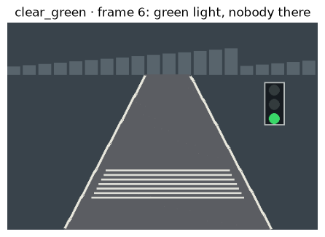
DANGEROUS DELAY · late_red frame 9 (first frame where STOP is required): baseline = SLOW, revised = STOP
red_score = 0.43 (thv1 = 0.7), v2x_light = red, person_score = 0.01; light seen in the image = red
baseline's first STOP in this episode at/after frame 9: 11
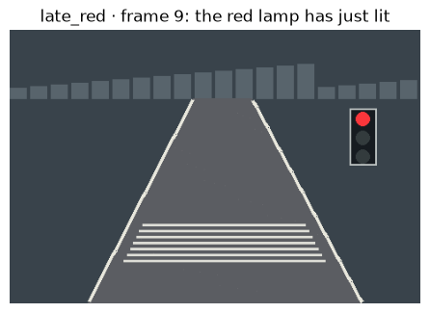
Worst delay of the revised rule: 0.3 s in trial 13 (35 frames dropped)
dropped late_red frames among 9-11: [9, 10, 11]
dropped person_crossing frames among 10-11: [10]
False alarm, clear_green frame 6 (baseline STOP). No person and a green light, so GO is right. person_score is 0.77 > thv3 and any such score means STOP; a score is not a calibrated probability. The image rule finds no dark-blue pixel and no red lamp, so it says GO.
Dangerous delay, late_red frame 9 (baseline SLOW). The red lamp has just lit and V2X says red, but red_score is 0.43 < thv1, so the baseline only slows. It STOPs at frame 11 (0.2 s late), when red_score is 0.99. The image rule sees the lit lamp and STOPs at frame 9. Dropped frames add delay: in trial 13 frames 9–11 are dropped, giving 0.3 s (revision) and 0.6 s (baseline).

Question 4: Which part of the track are we on? (Bonus)
The race car has a short map with eight named places. At two of them, the laser scans are so similar that one observation may point to the wrong place. Odometry, the estimate of whether the car stayed or moved, is also imperfect. A useful localizer should carry several possible places forward, strengthen or weaken them when a new scan arrives, and say when it cannot distinguish them. You will first try a single-scan guess, then build a small belief filter. No SLAM package or robotics course is needed; the route, candidate scans, and update rule are supplied.
Data and coordinates
The route has eight candidate places numbered 0 to 7. localization/route.png sketches it, and localization/route_graph.csv tells you where a stay or move action leads from each place. A move from place 7 wraps to place 0. The input file localization/reference_scans.csv is your map: it gives the expected 31-beam laser fingerprint at each place. It is called “reference” because it is a stored map scan, not because it reveals the answer to the route.
The input file localization/observed_scans.csv contains 12 rows, one per time step. Each row has an odometry message and 31 noisy ranges r_00 through r_30. The beams run from -75° to +75° in 5° steps, and ranges are in metres. Match beams by column name when comparing an observation with a map fingerprint. The file localization/route_reference.csv reveals the true place at each step; keep it out of the localizer and use it only for evaluation.
A place is a discrete location on this route, not a continuous (x,y) pose. The 31 numbers in a scan may resemble more than one place. A belief assigns a probability to each of the eight possibilities, so all eight values sum to one. The challenge is to combine what the scan resembles with where the car could have moved since the previous step. This is a small, inspectable model, not full scan matching or SLAM.
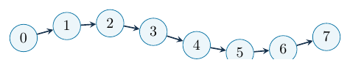
Your work
a. Find the look-alikes. Plot all eight map fingerprints on labelled axes. Name a pair of places whose scans are easy to confuse and identify the beam angles that make them similar or different. Use this observation to explain why “pick the closest scan” may sometimes fail.
Answer
Input: reference_scans.csv only.
All 8 places
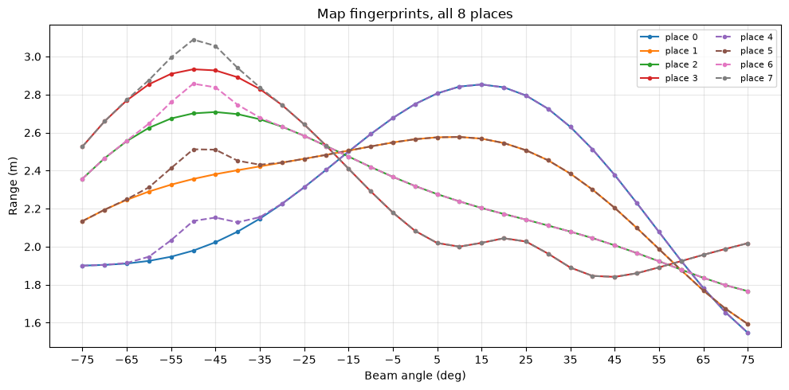
Each place
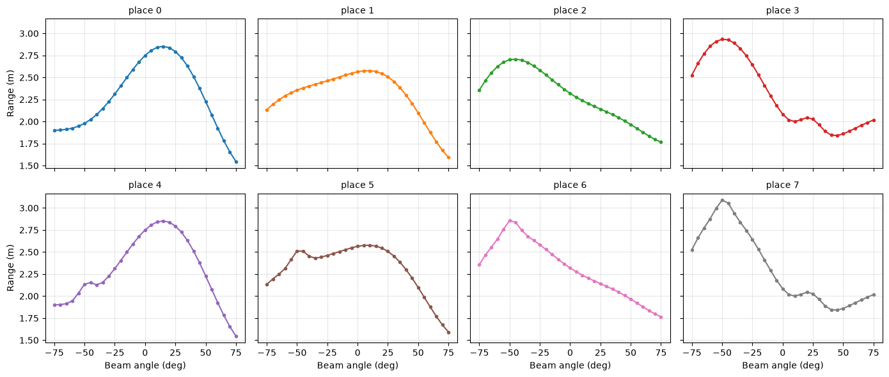
Look-alike pairs (i, i+4) and |difference|
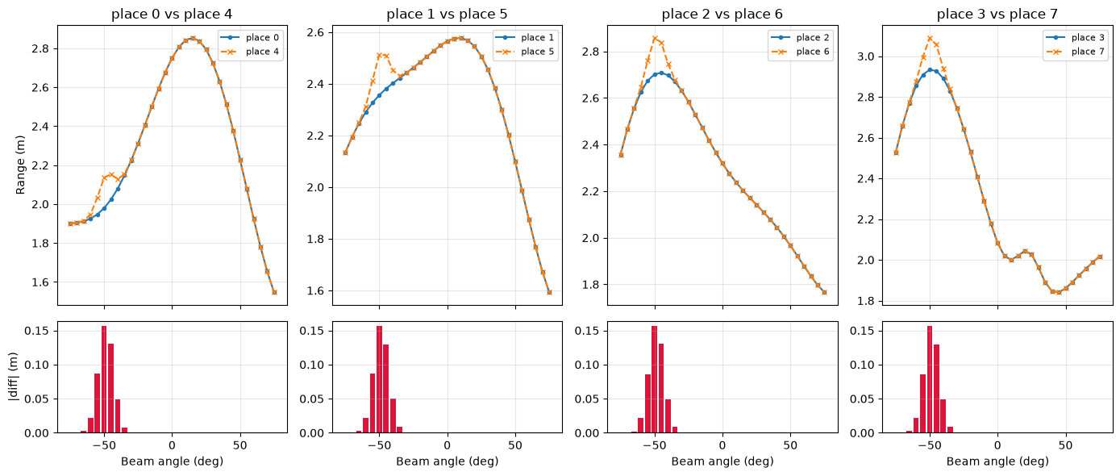
place 0 vs place 4: mean |diff| = 0.015 m, beams differing > 0.05 m: [-55, -50, -45] deg
place 1 vs place 5: mean |diff| = 0.015 m, beams differing > 0.05 m: [-55, -50, -45] deg
place 2 vs place 6: mean |diff| = 0.015 m, beams differing > 0.05 m: [-55, -50, -45] deg
place 3 vs place 7: mean |diff| = 0.015 m, beams differing > 0.05 m: [-55, -50, -45] deg
Why the closest scan can fail
(0,4), (1,5), (2,6) and (3,7) are look-alikes: they differ only on beams −55°, −50°, −45° (up to 0.16 m). A noisy observation can land closer to the wrong twin, so nearest-scan matching alone can fail and other evidence (odometry, earlier belief) is needed.

b. Make the single-scan baseline. For each of the 12 observed scans, choose the closest map fingerprint using a distance measure you define. A mean absolute or squared difference is a valid start. State how you treat missing or unusually large beam errors; one corrupted range should not decide the entire place unless you can justify it. Plot the predicted place against time step and keep these guesses for comparison.
Answer
Least mean absolute error place per time step
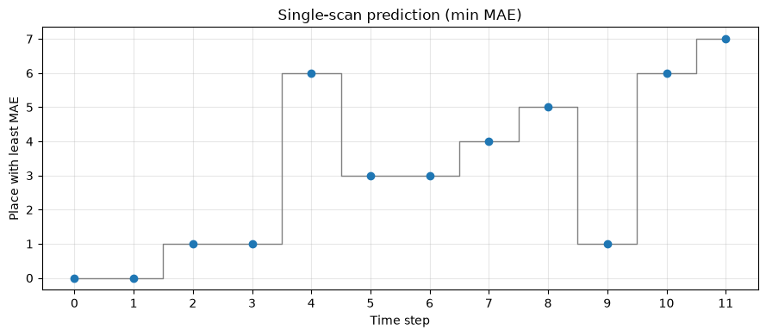
[0, 0, 1, 1, 6, 3, 3, 4, 5, 1, 6, 7]
Time steps 4, 8, 9: mean absolute error vs every place
place 0 place 1 place 2 place 3 place 4 place 5 place 6 place 7
step 4 0.6286 0.4351 0.3129 0.3485 0.6139 0.4204 0.2988 0.3361
step 8 0.5303 0.3854 0.4038 0.4892 0.5155 0.3721 0.3913 0.4791
step 9 0.2354 0.0874 0.2223 0.3767 0.2206 0.0899 0.2370 0.3914
Observed scans at time steps 4, 8, 9
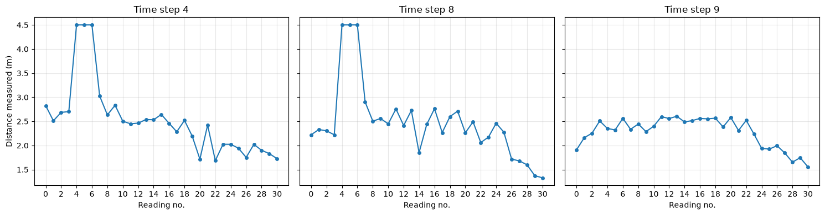
Explanation
- Steps 4, 8: three beams (-55°, -50°, -45°) read exactly 4.5 m, likely the sensor limit (map max ≈ 3.09 m). They are invalid and inflate every place’s error.
- Step 9: place 1 (0.0874) and place 5 (0.0899) nearly tie. This is the look-alike pair, so odometry is needed to decide (expected: 5).
Interpolating the 4.5 m beams
Each 4.5 m reading is replaced by a straight line between the nearest valid beams on either side.
step 4: beams [-55, -50, -45] deg -> [2.784, 2.864, 2.945] m
step 8: beams [-55, -50, -45] deg -> [2.392, 2.562, 2.732] m
place 0 place 1 place 2 place 3 place 4 place 5 place 6 place 7
step 4 0.4703 0.2768 0.1546 0.2028 0.4556 0.2621 0.1405 0.2131
step 8 0.3427 0.1978 0.2435 0.3715 0.3280 0.1859 0.2534 0.3854
step 9 0.2354 0.0874 0.2223 0.3767 0.2206 0.0899 0.2370 0.3914
Least mean absolute error place per time step (after interpolation)
The picks do not change. Steps 4, 8 and 9 stay near-ties between look-alike twins (6 vs 2, 5 vs 1, 1 vs 5).
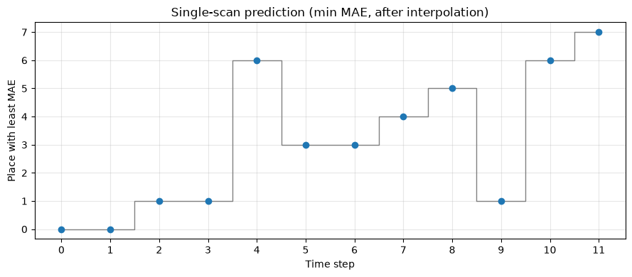
[0, 0, 1, 1, 6, 3, 3, 4, 5, 1, 6, 7]

c. Carry uncertainty through time. Before reading the first scan, assign probability 0.5 to place 0 and 0.5 to place 4, with zero elsewhere. At time step 0, update this prior using the first scan; ignore the row's stay message because there is no previous step to move from. For each later step, use its odometry message to predict where the car might be, then use its scan to update that prediction. Let b_{t}(j) be the probability of place j after the scan at time t and let predicted ${\overset{‾}{b}}_{t}(j)$ be the prediction before that scan:
b̄ₜ(j) = Σᵢ P(j | i, uₜ) bₜ₋₁(i), bₜ(j) = P(zₜ | j) b̄ₜ(j) / Σₖ P(zₜ | k) b̄ₜ(k)
Here u_{t} is the odometry message, z_{t} is the observed scan, P(j| i,u_{t}) is the chance of moving from place i to j, and P(z_{t}| j) measures how well the scan fits place j. For move, start with probability 0.8 of following the graph's move edge and 0.2 of staying. For stay, start with 0.9 for staying and 0.1 for moving. Choose and explain a scan-fit rule, such as giving smaller scan error a higher likelihood. Normalize after every update and check that the eight probabilities sum to one. You may revise the starting numbers after testing, but report both versions.
Answer
Prior 0.5 on places 0 and 4. Each step: predict from odometry (skipped at step 0), then update with the scan.
Scan-fit rule
- E_t(j) = mean over 31 beams of |z_t(k) − r_j(k)|, and L_t(j) = exp(−E_t(j) / 0.15).
- Motion: move = 0.8 next / 0.2 stay; stay = 0.9 stay / 0.1 next (7 → 0).
- Why 0.15: it sets how strict the filter is. A large value (1) makes the scan barely matter (0.905 vs 0.819 for errors 0.10 vs 0.20). A tiny value (0.01) lets one noisy scan decide everything. 0.15 gives 0.513 vs 0.264, favouring the better match without overconfidence.
place 0 place 1 place 2 place 3 place 4 place 5 place 6 \
time step
0 0.502 0.000 0.000 0.000 0.498 0.000 0.000
1 0.495 0.024 0.000 0.000 0.460 0.021 0.000
2 0.050 0.467 0.010 0.000 0.051 0.414 0.008
3 0.025 0.499 0.021 0.000 0.028 0.410 0.017
4 0.001 0.059 0.450 0.015 0.001 0.057 0.405
5 0.000 0.002 0.101 0.425 0.001 0.002 0.096
6 0.001 0.000 0.053 0.480 0.002 0.000 0.055
7 0.443 0.001 0.001 0.006 0.542 0.001 0.001
8 0.039 0.387 0.001 0.001 0.052 0.518 0.001
9 0.015 0.399 0.018 0.000 0.022 0.524 0.022
10 0.000 0.036 0.365 0.010 0.001 0.054 0.522
11 0.000 0.001 0.056 0.334 0.000 0.002 0.088
place 7 sum most likely
time step
0 0.000 1.0 0
1 0.000 1.0 0
2 0.000 1.0 1
3 0.000 1.0 1
4 0.013 1.0 2
5 0.373 1.0 3
6 0.409 1.0 3
7 0.005 1.0 4
8 0.001 1.0 5
9 0.000 1.0 5
10 0.012 1.0 6
11 0.519 1.0 7

d. Show when the filter is unsure. Plot a heatmap with time steps on one axis, places 0 to 7 on the other, and colour showing b_{t}(j). Define an uncertainty rule, such as a low maximum probability or two nearly equal leading places. Compare the most likely place at each step with the single-scan baseline and, only after both are fixed, with route_reference.csv. Find the first step where the single-scan guess and running belief disagree. Use the scan, motion message, and earlier belief to explain which answer you trust and why.
Answer
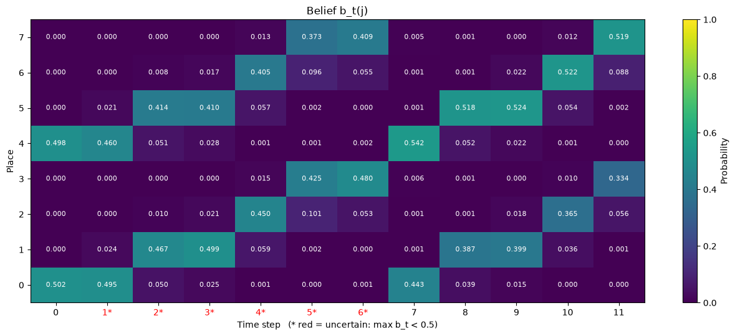
max b_t per step: [0.502, 0.495, 0.467, 0.499, 0.45, 0.425, 0.48, 0.542, 0.518, 0.524, 0.522, 0.519]
uncertain steps : [1, 2, 3, 4, 5, 6]
Uncertainty rule
Uncertain if the most likely place has probability below 0.5.
time step 0 1 2 3 4 5 6 7 8 \
most likely 0 0 1 1 2 3 3 4 5
p 0.502 0.495 0.467 0.499 0.45 0.425 0.48 0.542 0.518
runner-up 4 4 5 5 6 7 7 0 1
p 0.498 0.46 0.414 0.41 0.405 0.373 0.409 0.443 0.387
uncertain False True True True True True True False False
time step 9 10 11
most likely 5 6 7
p 0.524 0.522 0.519
runner-up 1 2 3
p 0.399 0.365 0.334
uncertain False False False
Filter vs single-scan baseline
filter : [0, 0, 1, 1, 2, 3, 3, 4, 5, 5, 6, 7]
baseline: [0, 0, 1, 1, 6, 3, 3, 4, 5, 1, 6, 7]
first disagreement at step 4 (filter 2 with p=0.450, baseline 6 with p=0.405)
steps where they disagree: [4, 9]
Which answer to trust
First disagreement: step 4 (filter 2, baseline 6). Trust the filter. It also uses the “move” message and the earlier belief (step 3: place 1 at 0.499 ahead of its twin 5 at 0.410, so a move gives 2). The baseline sees only this scan, where twins 6 and 2 are nearly tied (0.141 vs 0.155).
Against the true route (evaluation only)
true : [0, 0, 1, 1, 2, 3, 3, 4, 5, 5, 6, 7]
baseline accuracy: 0.83
filter accuracy : 1.00
mean probability on the true place (filter): 0.495
probability on the true place per step: [0.502, 0.495, 0.467, 0.499, 0.45, 0.425, 0.48, 0.542, 0.518, 0.524, 0.522, 0.51

e. Test a mistaken assumption. Increase the scan noise your likelihood assumes, or corrupt selected observed beams with a stated seed. Rerun the same route and compare place accuracy, the mean probability given to the true place, and the number of uncertain steps. If the filter becomes confidently wrong, trace the error to a scan-fit or motion assumption. Finally, propose one extra observation or short movement that would distinguish the most confusing places. Identify the beams or future map place that make your proposal useful.
The posterior is a distribution over possibilities, not a guarantee. If it becomes sharply concentrated on the wrong place, say which assumption caused the overconfidence.
Answer
Each scan: k random beams replaced by random values in [0.5, 4.5] m.
accuracy mean p(true place) uncertain steps \
corrupted beams / scan
0 1.00 0.495 6
3 1.00 0.493 6
5 1.00 0.470 9
8 1.00 0.462 10
12 0.83 0.440 10
wrong steps wrong and not uncertain
corrupted beams / scan
0 [] []
3 [] []
5 [] []
8 [] []
12 [0, 1] [0]
Result
- Up to 8 corrupted beams: accuracy stays 1.00, but p(true place) drops (0.495 → 0.462) and uncertain steps rise (6 → 10).
- At 12 beams, steps 0 and 1 go wrong. Twin places differ by only ~0.015 m in mean error, so random corruption decides between them.
beams (deg): [-55, -50, -45] twin difference (m): [0.087, 0.156, 0.13] sigma = 0.110 m
separation: 2.1 sigma with 1 scan, 4.1 sigma averaging 4 scans
Extra observation
Twins (j, j+4) differ only on beams −55°, −50°, −45° (up to 0.156 m, vs noise σ = 0.11 m): 2.1σ per scan. Proposal: stay put and average 4 scans (4.1σ). Moving doesn’t help, since every place has a twin.

Motion Planning
Code and written answers: Motion_Planning/.

Question 1: Planning for a vehicle that carries people (Mandatory)
A 10×10 grid with plain A* is a fine way to learn path planning. It is not a way to move a laden, passenger-carrying vehicle down a road, because it ignores the one thing that matters most: the vehicle has a heading, and it cannot turn on the spot.
Part A: Fundamentals, applied (research)
a. Define the configuration space for the buggy. How many dimensions, and what are they? How does this differ from the C-space of a point robot, and why does that difference matter for a planner?
b. The buggy has a minimum turning radius set by its wheelbase and max steer angle, compute it from the platform spec. Now: take a path that plain 8-connected grid A* would return between two points with a tight turn between them. Show, concretely, why the buggy cannot execute it.
c. Research Hybrid A*. In your own words, explain how Hybrid A* differs from normal grid-based A* and why it is more suitable for a car-like vehicle such as the buggy.
Part B: Build it
Implement the following entirely in a Jupyter Notebook (.ipynb).
d. Implement a normal 2D grid-based A* planner. Your implementation should allow the user to define the grid size, start position, goal position, and obstacle locations. Visualise the explored nodes and the final path found by A*.
e. Test the planner on a simple road-like environment containing at least one bend and 3–4 static obstacles. Visualise the resulting path and explored states.
f. Check the path from (e) against the minimum turning radius you computed in (b). Mark every turn the buggy could not execute and explain what the planner would have to change to fix it. Optional extension: implement Hybrid A* on the same environment and compare the two paths.
Part C: Planner Design Under Competing Constraints
Suppose two collision-free paths connect the same start and goal:
• Path 1 is shorter, but requires higher curvature and passes closer to obstacles.
• Path 2 is longer, smoother, and maintains a larger clearance from obstacles.
Design a cost function that would allow the buggy to choose between them.
Your answer should discuss how you would combine at least the following terms:
• path length,
• curvature or steering effort,
• obstacle clearance,
• and change in steering between consecutive steps.
Explain what could go wrong if any one of these terms is weighted too heavily, and how the preferred path might change if the buggy were moving at 5 km/h versus 20 km/h.
Answer
[To be added: Part A (a)–(c), Part B (d)–(f), Part C]

Appendix

1. References
Perception Q1
- OpenCV, Changing Colorspaces (colour-space tutorial): https://docs.opencv.org/4.x/df/d9d/tutorial_py_colorspaces.html
- OpenCV, Canny Edge Detection: https://docs.opencv.org/4.x/da/d22/tutorial_py_canny.html
- BFMC track description: https://documentation.boschfuturemobility.com/data/racetrack.html
Perception Q2
- BFMC track and V2X rules: https://regulation.boschfuturemobility.com/data/track.html
- OpenCV, How to Use Background Subtraction Methods: https://docs.opencv.org/4.x/d1/dc5/tutorial_background_subtraction.html
Perception Q4
- University of Washington CSE 571 HW1 (motion and observation models): https://courses.cs.washington.edu/courses/cse571/24sp/assignments/CSE571_24sp_HW1.pdf
Motion Planning Q1
- Lozano-Pérez, T. (1983). Spatial planning: a configuration space approach.

2. Decision log
Perception Q1
- Baseline white threshold R+G+B >= 500, region rows v >= 80, left/right split at column 240, one straight line fitted per side.
- Revised threshold 650, chosen from the brightness gap (seam about 542, paint about 686) and a threshold sweep: at 500 or below the seam is accepted, at 700 or above the paint is rejected.
- Confidence = 1 − 0.5 × (fraction of the row’s boundaries taken from the fitted line, not seen directly). A frame counts as a failure if it is unknown or its error is above 3 px.
- The reference file is read only after predictions exist.
Perception Q2
- Baseline thresholds: thv1 = 0.7, thv2 = 0.3, thv3 = 0.5. When the camera and V2X disagree the baseline says SLOW. The more cautious of the light and person checks wins.
- The revised rule ignores V2X, because an old message cannot be treated as current, and uses only image measurements: red and green lamp pixels, and a dark-blue body colour compared with a road boundary measured on a frame without a person.
- Part (e): seed 42, 20 trials, each trial drops 1–36 frames; a dropped frame keeps the previous decision. The same perturbation is used for baseline and revision.
Perception Q4
- 4.5 m readings are treated as the sensor’s maximum range (the map’s largest value is about 3.09 m) and are interpolated from the two nearest valid beams for the single-scan baseline.
- Mean absolute error is used for both the baseline and the filter, so the two are comparable.
- Likelihood L = exp(−E / 0.15) with E the mean absolute error over 31 beams. The scale 0.15 was chosen as a middle value: 1 makes the scan barely matter, 0.01 lets one noisy scan decide everything.
- Motion model as given (move 0.8 / 0.2, stay 0.9 / 0.1); the starting values were not revised.
- A step is uncertain if the most likely place has probability below 0.5.
- Part (e): seed 42; k random beams per scan are replaced by random values in [0.5, 4.5] m, for k = 3, 5, 8, 12.
- The filter runs on the raw scans (4.5 m beams kept); the flat likelihood makes it tolerant of them.

3. Failure log
Perception Q1
- At threshold 500 the bright seam was taken as a lane edge on missing frames 04–14 (far-row error up to 6.7 px). Fixed by the 650 threshold.
- Cost of the fix: shadow MAE rose slightly (about 0.17 to 0.24 px), likely because 650 rejects soft, dimmed paint pixels.
- Missing frame 013: near row fine, far row 3.9 px off because the estimated centre drifts the wrong way.
- One straight line per side suits straight roads only. No temporal filtering or bird’s-eye view was tried.
Perception Q2
- The exact-colour person test is brittle (another clothing colour would need a tolerance). The road boundary taken from frame 0 can be about 12 px off because the road sways. The leftmost pixel found is the person’s foot, not the whole body.
- The baseline gave unnecessary STOPs on person_score spikes and missed STOPs while the V2X message was old (see the 20-trial table).
- If no lamp is lit the revised rule can only fall back to SLOW.
Perception Q4
- The single-scan baseline fails at steps 4 and 8 (the 4.5 m beams) and ties at step 9 between look-alike places 1 and 5. Interpolation lowers the error but does not change the picks.
- The belief never separates the two laps: it stays split about 50 / 40 between a place and its twin, because the twins differ only on beams −55°, −50°, −45°.
- With threshold 0.5 the uncertainty rule misses step 0 (0.502 against 0.498), a near coin flip.
- With 12 corrupted beams per scan, steps 0 and 1 become wrong.
- With another week: a gap-based uncertainty rule, a robust or mixture likelihood, a particle filter, and averaging several scans on the discriminating beams.
Not attempted: Perception Q3 (bonus); Motion Planning Q2 and Q3.

4. AI usage note
Claude (Claude Code and the Claude desktop app) was used to help write and check the notebooks for Perception Q1, Q2 and Q4 and Motion Planning Q1. Its suggestions were checked against the assignment text and the data. The full chat histories are in the repository folder AI_chat_logs/.
Prompts that shaped Perception Q4 (verbatim, shortened where marked):
- “i’m trying to do the question 4 of the perception part please analyze that in detail(don’t solve anything yet)”
- “can you please make a new ipynb in the same directory and do the plots in that for all the 8 places”
- “use the mean squared difference method - the one with the least mean squared difference is the chosen place”
- “the unusually large reading should be discarded and interpolated using the 2 nearest known(not high) values”
- “for assigning the probabilites please use this” (the likelihood exp(−E/0.15) with E the mean absolute error over 31 beams, taken from a separate AI chat whose history is not included here)
- “uncertainity rule = a step is uncertain if the most likely place has probability below 0.5”
- “now the e part (just below the d part) use seed = 42”
- “okay then everywhere replace mse by mae”
- “please shorten your markdown cells in the entire document”

