**Industrial Internship Report on**

**”QR CODE GENERATOR”**

**Prepared by**

**[Harsh SIngh]**

|  |
| --- |
| *Executive Summary* |
| This report provides details of the Industrial Internship provided by upskill Campus and The IoT Academy in collaboration with Industrial Partner UniConverge Technologies Pvt Ltd (UCT).  This internship was focused on a project/problem statement provided by UCT. We had to finish the project including the report in 6 weeks’ time.  My project was to make a QR CODE GENERATOR  This internship gave me a very good opportunity to get exposure to Industrial problems and design/implement solution for that. It was an overall great experience to have this internship. |

**TABLE OF CONTENTS**

1 Preface 3

2 Introduction 4

2.1 About UniConverge Technologies Pvt Ltd 4

2.2 About upskill Campus 8

2.3 Objective 9

2.4 Reference 9

2.5 Glossary 10

3 Problem Statement 11

4 Existing and Proposed solution 12

5 Proposed Design/ Model 13

5.1 High Level Diagram (if applicable) 13

5.2 Low Level Diagram (if applicable) 13

5.3 Interfaces (if applicable) 13

6 Performance Test 14

6.1 Test Plan/ Test Cases 14

6.2 Test Procedure 14

6.3 Performance Outcome 14

7 My learnings 15

8 Future work scope 16

# Preface

Week1 was report that gave an overview of my week's activities, achievements, difficulties faced, and lessons gained. I've been aiming to grasp the fundamentals of Python, including what Python is, its applications, and the best IDEs for Python development.

Week 2 report gave an overview of my week's activities, achievements, difficulties faced, and lessons gained. I've been aiming to grasp the fundamentals of Python, including what If, If Else & If Elif Else is.

Week 3 report gave an overview of my week's activities, achievements, difficulties faced, and lessons gained. I've been aiming to grasp the fundamentals of Python SEO, and The Python Topics for Data Science

Week 4 report gave an overview of my week's activities, achievements, difficulties faced, and lessons gained. I've been aiming to grasp the knowledge of roadmap for learning python and the relation between NumPy and Panda.

Week 5 report gave an overview of my week's activities, achievements, difficulties faced, and lessons gained. I've been aiming to grasp the knowledge of NumPy and Introduction to Pandas and Numpy Operations.

My project is about making a QR CODE GENERATOR

QR (Quick Response) Codes can be read and understood by mobile devices. Marketers have used this in billboards, magazines, web pages, and any other marketing material. QR codes can provide more information about the product or service without a sweat, and the information quickly goes to the user’s device.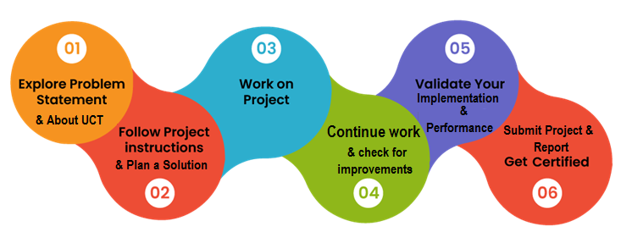

.

# Introduction

## About UniConverge Technologies Pvt Ltd

A company established in 2013 and working in Digital Transformation domain and providing Industrial solutions with prime focus on sustainability and RoI.

For developing its products and solutions it is leveraging various**Cutting Edge Technologies e.g. Internet of Things (IoT), Cyber Security, Cloud computing (AWS, Azure), Machine Learning, Communication Technologies (4G/5G/LoRaWAN), Java Full Stack, Python, Front end**etc.

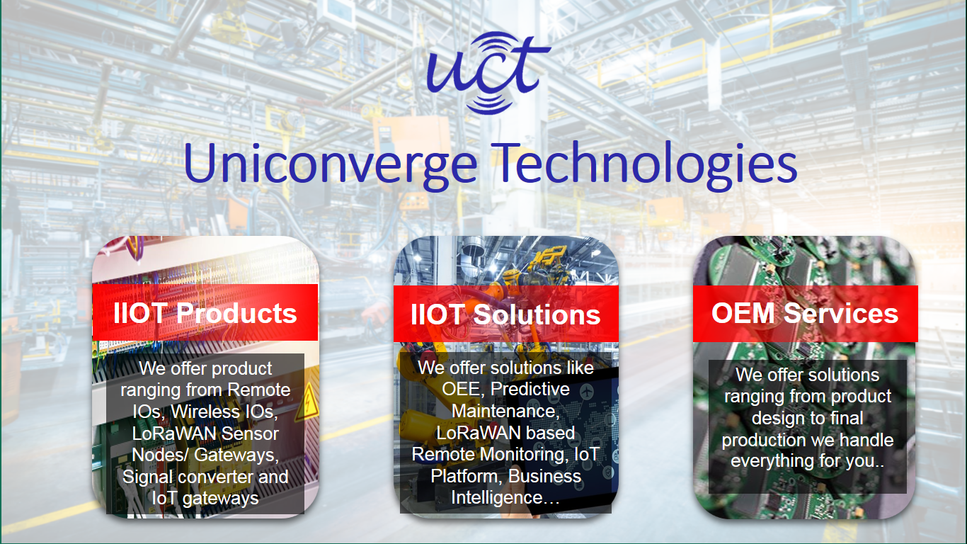

1. UCT IoT Platform **(****)**

**UCT Insight** is an IOT platform designed for quick deployment of IOT applications on the same time providing valuable “insight” for your process/business. It has been built in Java for backend and ReactJS for Front end. It has support for MySQL and various NoSql Databases.

* It enables device connectivity via industry standard IoT protocols - MQTT, CoAP, HTTP, Modbus TCP, OPC UA
* It supports both cloud and on-premises deployments.

It has features to  
• Build Your own dashboard  
• Analytics and Reporting  
• Alert and Notification  
• Integration with third party application(Power BI, SAP, ERP)  
• Rule Engine

 

1. **Smart Factory Platform (****)**

Factory watch is a platform for smart factory needs.

It provides Users/ Factory

* with a scalable solution for their Production and asset monitoring
* OEE and predictive maintenance solution scaling up to digital twin for your assets.
* to unleased the true potential of the data that their machines are generating and helps to identify the KPIs and also improve them.
* A modular architecture that allows users to choose the service that they what to start and then can scale to more complex solutions as per their demands.

Its unique SaaS model helps users to save time, cost and money.

 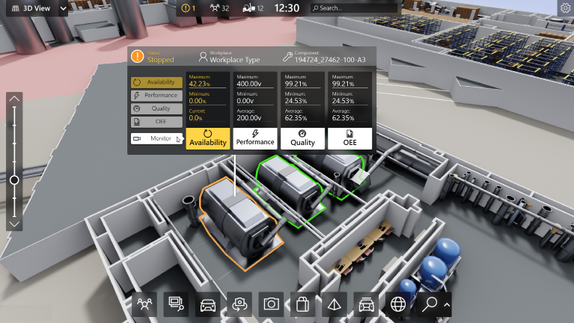

1. 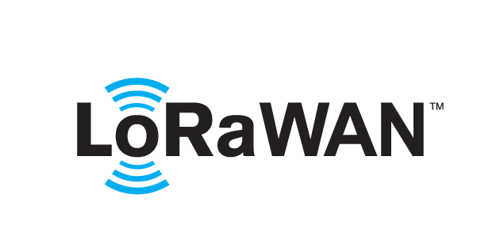 based Solution

UCT is one of the early adopters of LoRAWAN teschnology and providing solution in Agritech, Smart cities, Industrial Monitoring, Smart Street Light, Smart Water/ Gas/ Electricity metering solutions etc.

1. Predictive Maintenance

UCT is providing Industrial Machine health monitoring and Predictive maintenance solution leveraging Embedded system, Industrial IoT and Machine Learning Technologies by finding Remaining useful life time of various Machines used in production process.



## About upskill Campus (USC)

upskill Campus along with The IoT Academy and in association with Uniconverge technologies has facilitated the smooth execution of the complete internship process.

USC is a career development platform that delivers **personalized executive coaching** in a more affordable, scalable and measurable way.



Seeing need of upskilling in self paced manner along-with additional support services e.g. Internship, projects, interaction with Industry experts, Career growth Services

<https://www.upskillcampus.com/>

upSkill Campus aiming to upskill 1 million learners in next 5 year

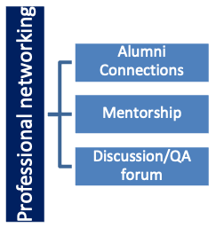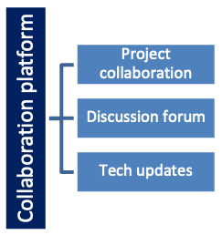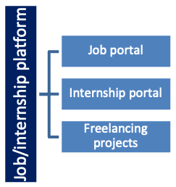

## The IoT Academy

The IoT academy is EdTech Division of UCT that is running long executive certification programs in collaboration with EICT Academy, IITK, IITR and IITG in multiple domains.

## Objectives of this Internship program

The objective for this internship program was to

 ☛ get practical experience of working in the industry.

 ☛ to solve real world problems.

 ☛ to have improved job prospects.

 ☛ to have Improved understanding of our field and its applications.

 ☛ to have Personal growth like better communication and problem solving.

# Problem Statement

QR (Quick Response) Codes can be read and understood by mobile devices. Marketers have used this in billboards, magazines, web pages, and any other marketing material. QR codes can provide more information about the product or service without a sweat, and the information quickly goes to the user’s device.

Basically, QR codes promote interaction and engagement through the mobile phone. This type of marketing strategy enables businesses to transfer information to the user. Nowadays, users are done with anything that’s slow and time-consuming. It’s all about being instant and fast, especially in the world of marketing

# Existing and Proposed solution

In a world where we expect everything at our fingertips, QR codes provide instant interaction between businesses and customers.

QR codes were steadily growing in popularity. However, the pandemic escalated businesses and marketers’ appetite for them, and it’s not hard to see why.

QR codes help to drive traffic to landing pages, share important information and increase engagement with customers.

QR codes have become common in consumer advertising. Typically, a smartphone is used as a QR code scanner, displaying the code, and converting it to some useful form (such as a standard URL for a website, thereby obviating the need for a user to type it into a web browser). QR code has become a focus of advertising strategy since it provides a way to access a brand's website more quickly than by manually entering a URL.

## Code submission

<https://github.com/darkisticharsh/upskill_campusQrcodegenerator>

# Proposed Design/ Model

The pyqrcode module is a QR code generator that is simple to use and written in pure python. The module can automates most of the building process for creating QR codes.

# Performance Test

This is very important part and defines why this work is meant of Real industries, instead of being just academic project.

## Test Plan/ Test CasesTest Procedure

***Installation:***

* **Installing pyqrcode**

“pip install ***pyqrcode***”

The pyqrcode module is a QR code generator that is simple to use and written in pure python. The module can automates most of the building process for creating QR codes.

* **Installing pypng**

“pip install pypng”

PyPNG is pure Python.

* **Installing pypillow**

“pip install pypillow”

Pillow is PIL(Python Image Library). The Python imaging library adds image processing capabilities to your python interpreter. This library provides extensive file format support, an efficient internal representation, and fairly powerful image processing capabilities.

The core image library is designed for fast access to data stored in a few basic pixel formats. It should provide a solid foundation for a general image processing tool.

The core image library is designed for fast access to data stored in a few basic pixel formats. It should provide a solid foundation for a general image processing tool.

* **Installing pyzbar**

“pip install pyzbar”

Pyzbar reads one-dimensional barcodes and QR codes from python 2 and 3 using the zbar library.

* **Import pyqrcode**
* **From pyzbar , import decode**
* **From PIL import Image**
* **Set qr=pyqrcode.create(link)**
* **Set qr=png(The file name, and scale it)**
* **Decode it, and it prints the link in QR Code**

## Performance Outcome

C:\Users\harsh\PycharmProjects\Python\venv\Scripts\python.exe C:/Users/harsh/PycharmProjects/Python/main.py  
https://www.youtube.com/channel/UCgOQYvH8586Ad-1I4skRYNQ  
  
Process finished with exit code 0

# My learnings

In a world where we expect everything at our fingertips, QR codes provide instant interaction between businesses and customers.

QR codes were steadily growing in popularity. However, the pandemic escalated businesses and marketers’ appetite for them, and it’s not hard to see why.

QR codes help to drive traffic to landing pages, share important information and increase engagement with customers.

QR codes have become common in consumer advertising. Typically, a smartphone is used as a QR code scanner, displaying the code, and converting it to some useful form (such as a standard URL for a website, thereby obviating the need for a user to type it into a web browser). QR code has become a focus of advertising strategy since it provides a way to access a brand's website more quickly than by manually entering a URL.

.

# Future work scope

Where a company's discounted and percent discount can be captured using a QR code decoder which is a mobile app or storing a company's information such as address and related information alongside its alpha-numeric text data.

QR codes storing addresses and URLs may appear in magazines, on signs, on buses, on business cards, or on almost any object about which users might want information. Users with a camera phone equipped with the correct reader application can scan the image of the QR code to display text, contact information, connect to a wireless network, or open a web page in the phone's browser.

Starting March 2022, Paytm, PhonePe, Amazon Pay, Google Pay, MobiKwik and other payment apps have to shift to interoperable Quick Response (QR) codes, as per a recent directive from the Reserve Bank of India (RBI).

Typically, after shopping, we either pay our bills at the checkout counter by using our credit or debit cards, or by cash. But increasingly, many of us use mobile wallets and payments apps. But instead of typing out details such as the merchant’s UPI ID and other details, a QR code’s technology is in-built in mobile apps.

Thus, QR codes are generally secure, but the web pages they point or redirect to may not be. It is necessary to take precautions before scanning QR codes to protect against phishing and malware infection threats.

Different perspectives show QR codes are safe to use, but there are many cases where QR codes are considered additional security measures. Some websites are privileged to use QR codes as part of two-step authentication for their sites. After scanning, customers can log in to their accounts, where they may get a prompt to scan a QR code using their mobile banking apps for additional verification.

It can be inferred that the QR code technology itself has no security issues. As long as the user remains smart and vigilant when using the internet, QR codes are perfectly safe. For marketers, QR codes are a convenient and valuable tool for sending customers to campaign landing pages, collecting data, and launching promotions, primarily when used creatively.

Hence making a program that generates QR Code is helpful useful and can make our lives a lot easier.