Mutual Fund Performance, Risk & Investor Analytics Platform
Final Project Report
Data Analyst Internship Capstone Project
Prepared By: Ashutosh Suryawanshi
Date: June 2026

Table of Contents

1. Executive Summary
2. Introduction
3. Problem Statement
4. Project Objectives
5. Data Sources
6. ETL Design and Data Architecture
7. Data Cleaning and Preprocessing
8. Exploratory Data Analysis
9. Performance Analytics
10. Risk Analytics
11. Investor Analytics
12. Fund Scorecard Framework
13. Recommendation Engine
14. Power BI Dashboard
15. Key Findings
16. Limitations
17. Recommendations
18. Conclusion
19. References

- Executive Summary
This project presents the development of a Mutual Fund Performance, Risk and Investor Analytics Platform designed to analyze mutual fund datasets and generate actionable business insights. The platform integrates multiple datasets including NAV history, fund master data, benchmark indices, portfolio holdings, and investor transactions.
The project performs end-to-end data processing, exploratory data analysis, performance evaluation, risk assessment, investor behavior analysis, and dashboard reporting. Key analytical techniques include Alpha-Beta analysis, Sharpe Ratio calculation, Value at Risk (VaR), Conditional Value at Risk (CVaR), Cohort Analysis, SIP Continuity Analysis, and fund recommendation scoring.
The final solution provides investment insights through an interactive Power BI dashboard and supports data-driven decision making for fund managers and investors.

2. Introduction
Mutual funds generate large amounts of financial and transactional data. Effective analysis of this data is essential for evaluating fund performance, understanding investor behavior, and managing portfolio risk.
The objective of this project is to build a comprehensive analytics platform capable of transforming raw mutual fund datasets into meaningful business insights.

3. Problem Statement
Financial institutions face challenges in:
- Tracking fund performance consistently
- Measuring risk-adjusted returns
- Understanding investor retention
- Comparing schemes against benchmarks
- Presenting insights in an accessible format
This project addresses these challenges through data analytics and visualization.

4. Project Objectives
The key objectives were:
- Collect and integrate mutual fund datasets
- Perform data cleaning and preprocessing
- Build a centralized SQLite database
- Analyze fund performance
- Evaluate risk metrics
- Study investor behavior
- Develop a recommendation engine
- Create a Power BI dashboard

5. Data Sources
The project utilizes ten datasets:
- Fund Master Data
- NAV History
- AUM by Fund House
- Monthly SIP Inflows
- Category Inflows
- Industry Folio Count
- Scheme Performance
- Investor Transactions
- Portfolio Holdings
- Benchmark Indices
These datasets provide comprehensive coverage of fund operations, performance, and investor activity.

6. ETL Design and Data Architecture
The ETL pipeline follows the workflow:
Raw CSV Files
→ Data Cleaning
→ Data Validation
→ SQLite Database
→ Python Analytics
→ Power BI Dashboard
The database acts as the central repository for analytics and reporting.

7. Data Cleaning and Preprocessing
The following preprocessing steps were performed:
- Missing value handling
- Duplicate removal
- Date standardization
- Data type correction
- Feature engineering
- Consistency validation
Output datasets include:
- clean_nav.csv
- clean_transactions.csv
- clean_performance.csv

8. Exploratory Data Analysis
EDA was conducted to understand:
- Fund distribution
- Investment patterns
- Transaction behavior
- Benchmark movement
- Portfolio characteristics
Key observations revealed variations in fund performance across categories and differences in investor activity levels.

9. Performance Analytics
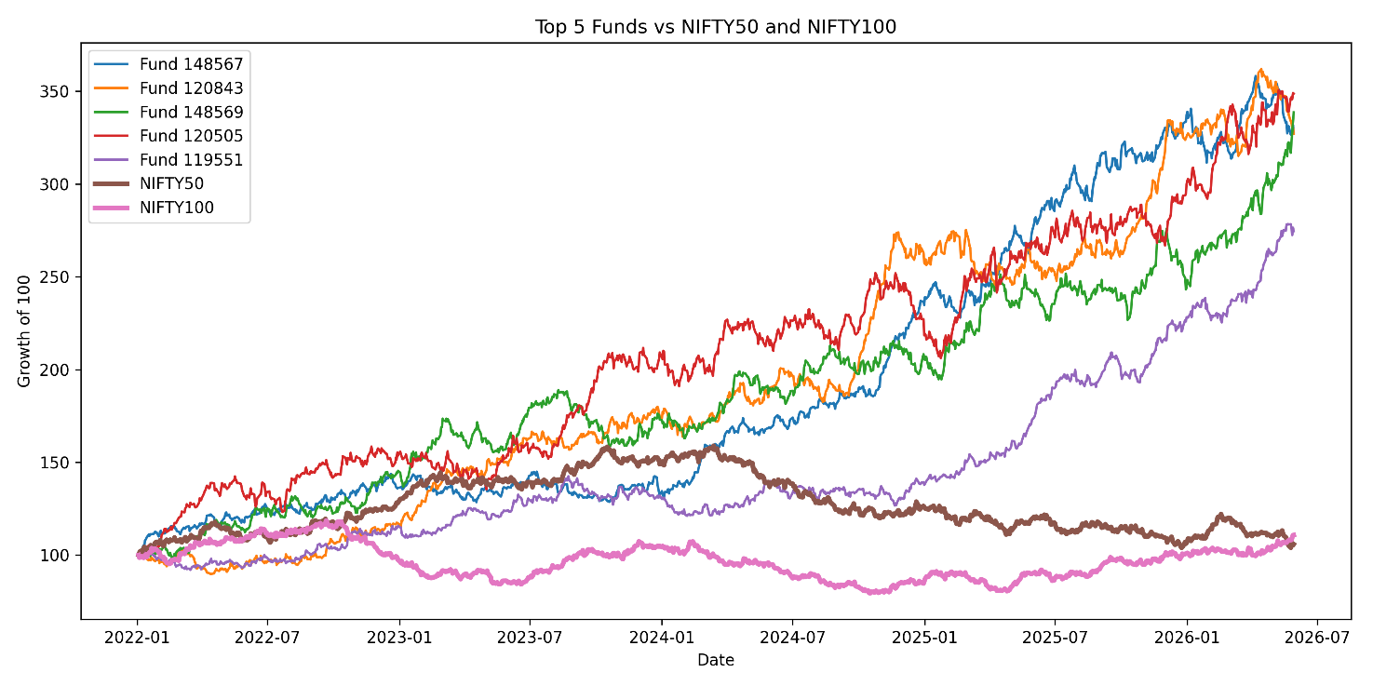
Performance evaluation was conducted using:
Alpha
Measures excess return relative to the benchmark.
Beta
Measures sensitivity to market movements.
Sharpe Ratio
Measures risk-adjusted returns.
Benchmark Comparison
Compares mutual fund returns against market indices.
Results were stored in alpha_beta.csv and visualized through benchmark comparison charts.

10. Risk Analytics
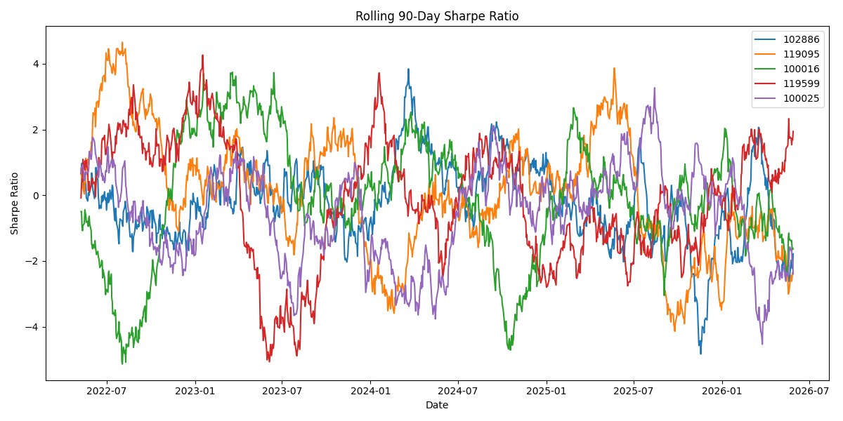
Risk evaluation included:
Value at Risk (VaR)
Estimates potential portfolio loss under normal market conditions.
Conditional VaR (CVaR)
Measures expected loss during extreme market events.
HHI Concentration Analysis
Evaluates portfolio diversification and concentration risk.
Outputs:
- var_cvar_report.csv
- hhi_concentration_report.csv

11. Investor Analytics
Cohort Analysis
Groups investors based on first investment period and tracks retention patterns.
SIP Continuity Analysis
Measures consistency of recurring SIP investments.
These analyses provide insights into investor engagement and long-term retention.

12. Fund Scorecard Framework
A fund scorecard was developed to rank funds based on:
- Performance
- Risk-adjusted returns
- Benchmark comparison
- Stability metrics
Output:
fund_scorecard.csv

13. Recommendation Engine
A Python-based recommendation engine was developed.
Features:
- Fund ranking
- Risk-adjusted scoring
- Investment recommendations
Implementation:
scripts/recommender.py

14. Power BI Dashboard
The project includes an interactive Power BI dashboard with four pages:
- Fund Performance
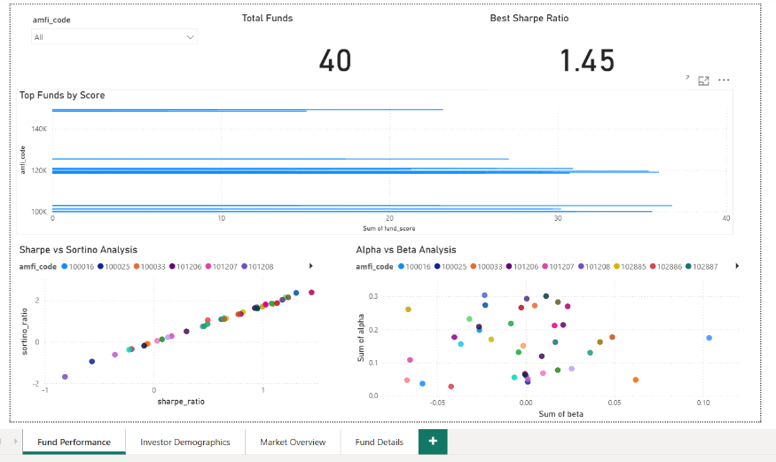
- Investor Demographics
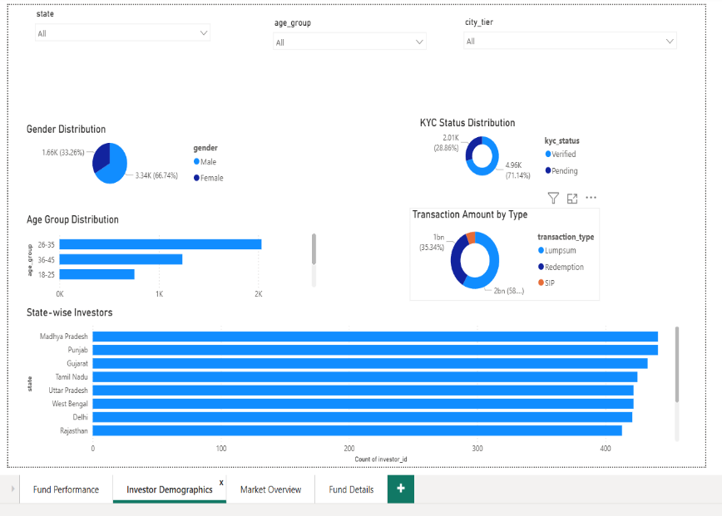
- Market Overview
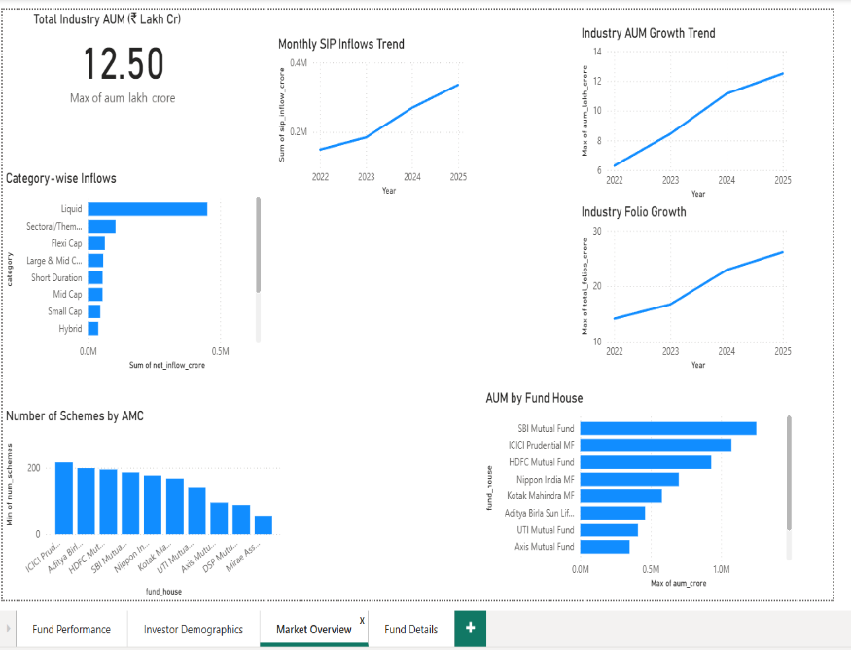
- Fund Details
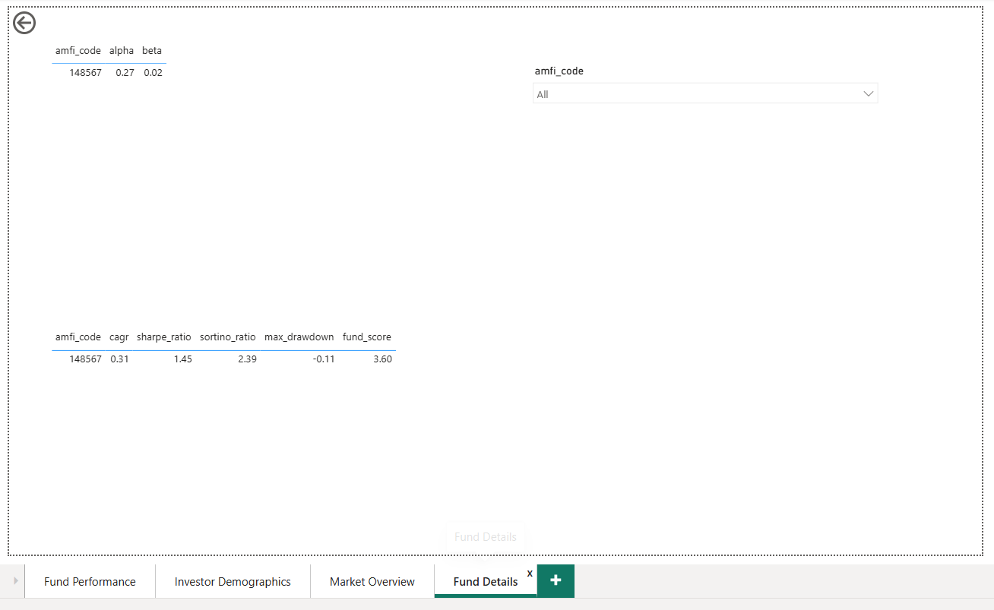

15. Key Findings
- Strong variation exists in fund performance across categories.
- Risk-adjusted metrics provide better evaluation than raw returns.
- Investor retention declines over time.
- SIP continuity is associated with long-term engagement.
- Dashboard reporting improves business visibility.

16. Limitations
- Historical data only
- No live market integration
- Limited predictive modeling
- Simplified recommendation logic

17. Recommendations
- Integrate real-time NAV feeds
- Implement machine learning models
- Enhance investor segmentation
- Deploy cloud-based reporting
- Add predictive risk analytics

18. Conclusion
The project successfully developed a comprehensive Mutual Fund Performance, Risk and Investor Analytics Platform using Python, SQLite and Power BI. The platform integrated multiple datasets, performed advanced analytics, measured investment risk, evaluated investor retention patterns and delivered actionable insights through interactive dashboards. The project demonstrates practical applications of data engineering, financial analytics and business intelligence in the mutual fund industry and provides a strong foundation for future predictive analytics and real-time reporting solutions.
19. References
- AMFI Mutual Fund Data
- Benchmark Index Data
- Power BI Documentation
- Python Pandas Documentation
- SQLite Documentation

