AGENTIC CUSTOMER EXPERIENCE
Intelligent Multi Agent Customer Investigation System
Development Challenges, Production Incidents
and Deployment Issues
FastAPI • LangGraph • Laya • Milvus • Neon Postgres • Streamlit • Groq

1. Introduction
This document records the main technical problems found while developing and deploying the Agentic Customer Experience — Supply Chain Resolution System. The application uses an AI-based workflow to understand customer questions, retrieve order and policy information, and prepare a grounded response.
The project stack recorded in the issue log includes FastAPI, LangGraph, the Laya intent classifier, TF-IDF classification, Milvus Vector Database, Neon PostgreSQL, Streamlit and the Groq API. The backend was deployed on AWS, while the frontend was published through Streamlit Community Cloud.
The purpose of this report is to explain each issue in straightforward technical language: what happened, why it happened, what was changed, and whether the issue was resolved or still requires work.

2. System Components Involved
Component | Purpose in the project
Streamlit | Customer-facing interface for submitting questions and viewing investigation results.
FastAPI | Backend API that receives requests and exposes investigation and workflow endpoints.
LangGraph | Coordinates the multi-step agent workflow.
Laya classifier | Neural intent classifier used to identify the type of customer request.
TF-IDF baseline | Lightweight text-classification baseline used for comparison and fallback.
Milvus ( Zilliz Cloud) | Vector database used to retrieve relevant policy and knowledge documents.
Neon (PostgreSQL) | Stores application data such as orders, workflow records and customer context.
Groq API | Generates more natural responses using verified facts supplied by the application.
AWS | Hosts the backend API and related services.
Langfuse | Used for tracing and observing workflow execution.

3. Development Issues
Development issues were found while integrating the classifier, workflow, database, safety checks and response-generation components.

3.1 Laya model cold-start delay
The first customer request after the backend started could take around 11.5–14 seconds. The model was loading its neural-network checkpoint from disk only when the first request arrived. Later requests were faster because the model was already in memory.
Observed behaviour | Root cause | Change made
First request took about 11,530 ms; warm requests took about 490 ms. | Lazy model loading and checkpoint deserialization during the first request. | Pre-warmed the model during FastAPI startup and added a bounded, thread-safe LRU cache for repeated classifications.

3.2 Classifier disagreement and unreliable confidence
The Laya classifier and the TF-IDF baseline sometimes predicted different intents for the same message. A weak TF-IDF prediction could incorrectly trigger a disagreement and send a normal request to manual review. The project log also records that some incorrect Laya predictions had very high confidence scores.
Recorded evaluation | Result
Live labelled cases | 40
Correct Laya predictions | 18
Accuracy | 45%
Macro F1-score | 0.418
Important limitation | The model's confidence score was not calibrated and should not be treated as a probability of correctness.

Change made: the routing logic was adjusted so that a TF-IDF result below the 60% confidence threshold would be treated as weak evidence rather than automatically vetoing a stronger Laya prediction. Automatic routing was kept disabled by default while classifier reliability remained under review.
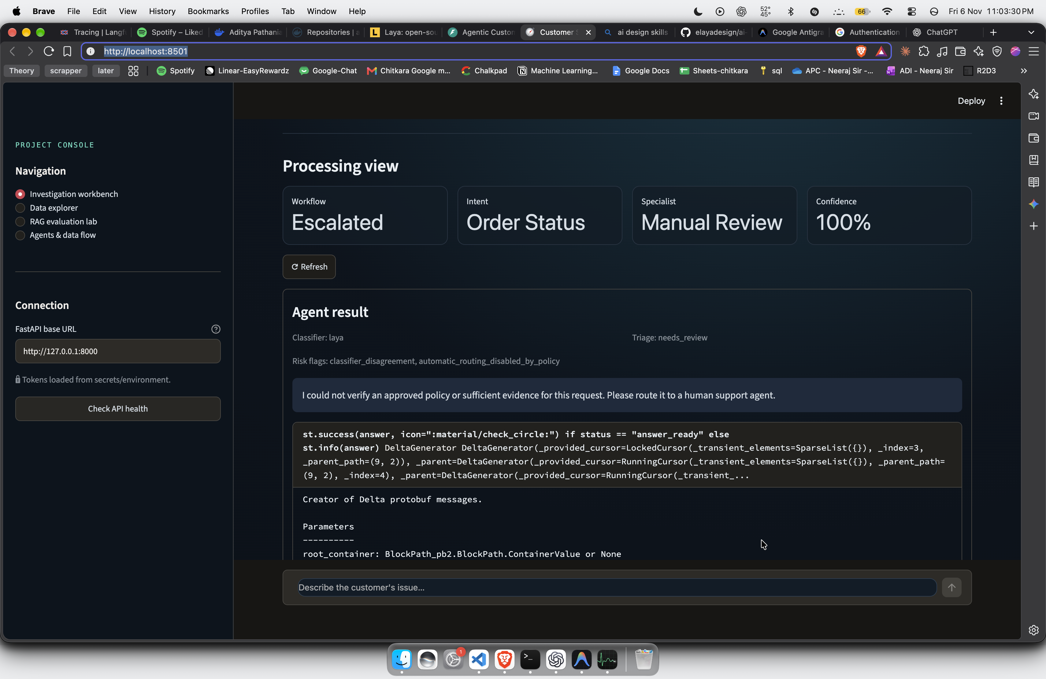

3.3 Multi-turn conversation context was lost
A customer could provide an order ID in one message and then ask a follow-up question without repeating it. The application did not always carry the order ID into the next request because each message was being processed as a new request.
Change made: the application began carrying the active order ID through session state using the chat_last_order_id value. The recorded test sequence checked that the same order remained active across follow-up questions and that a newly supplied order ID replaced the previous one.
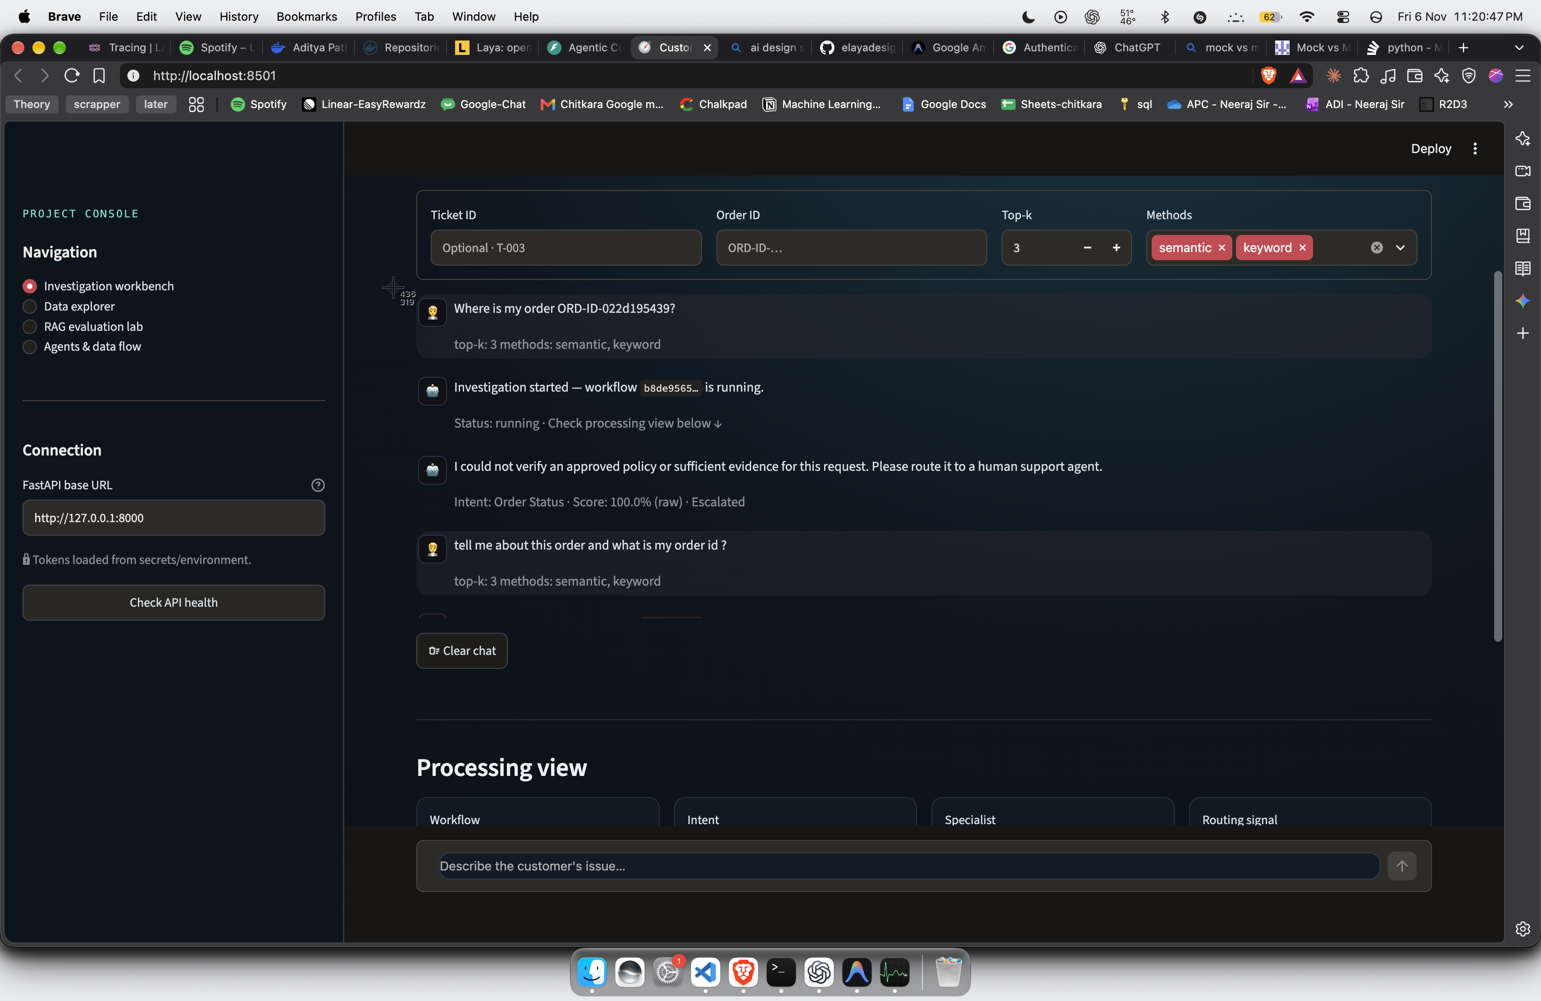
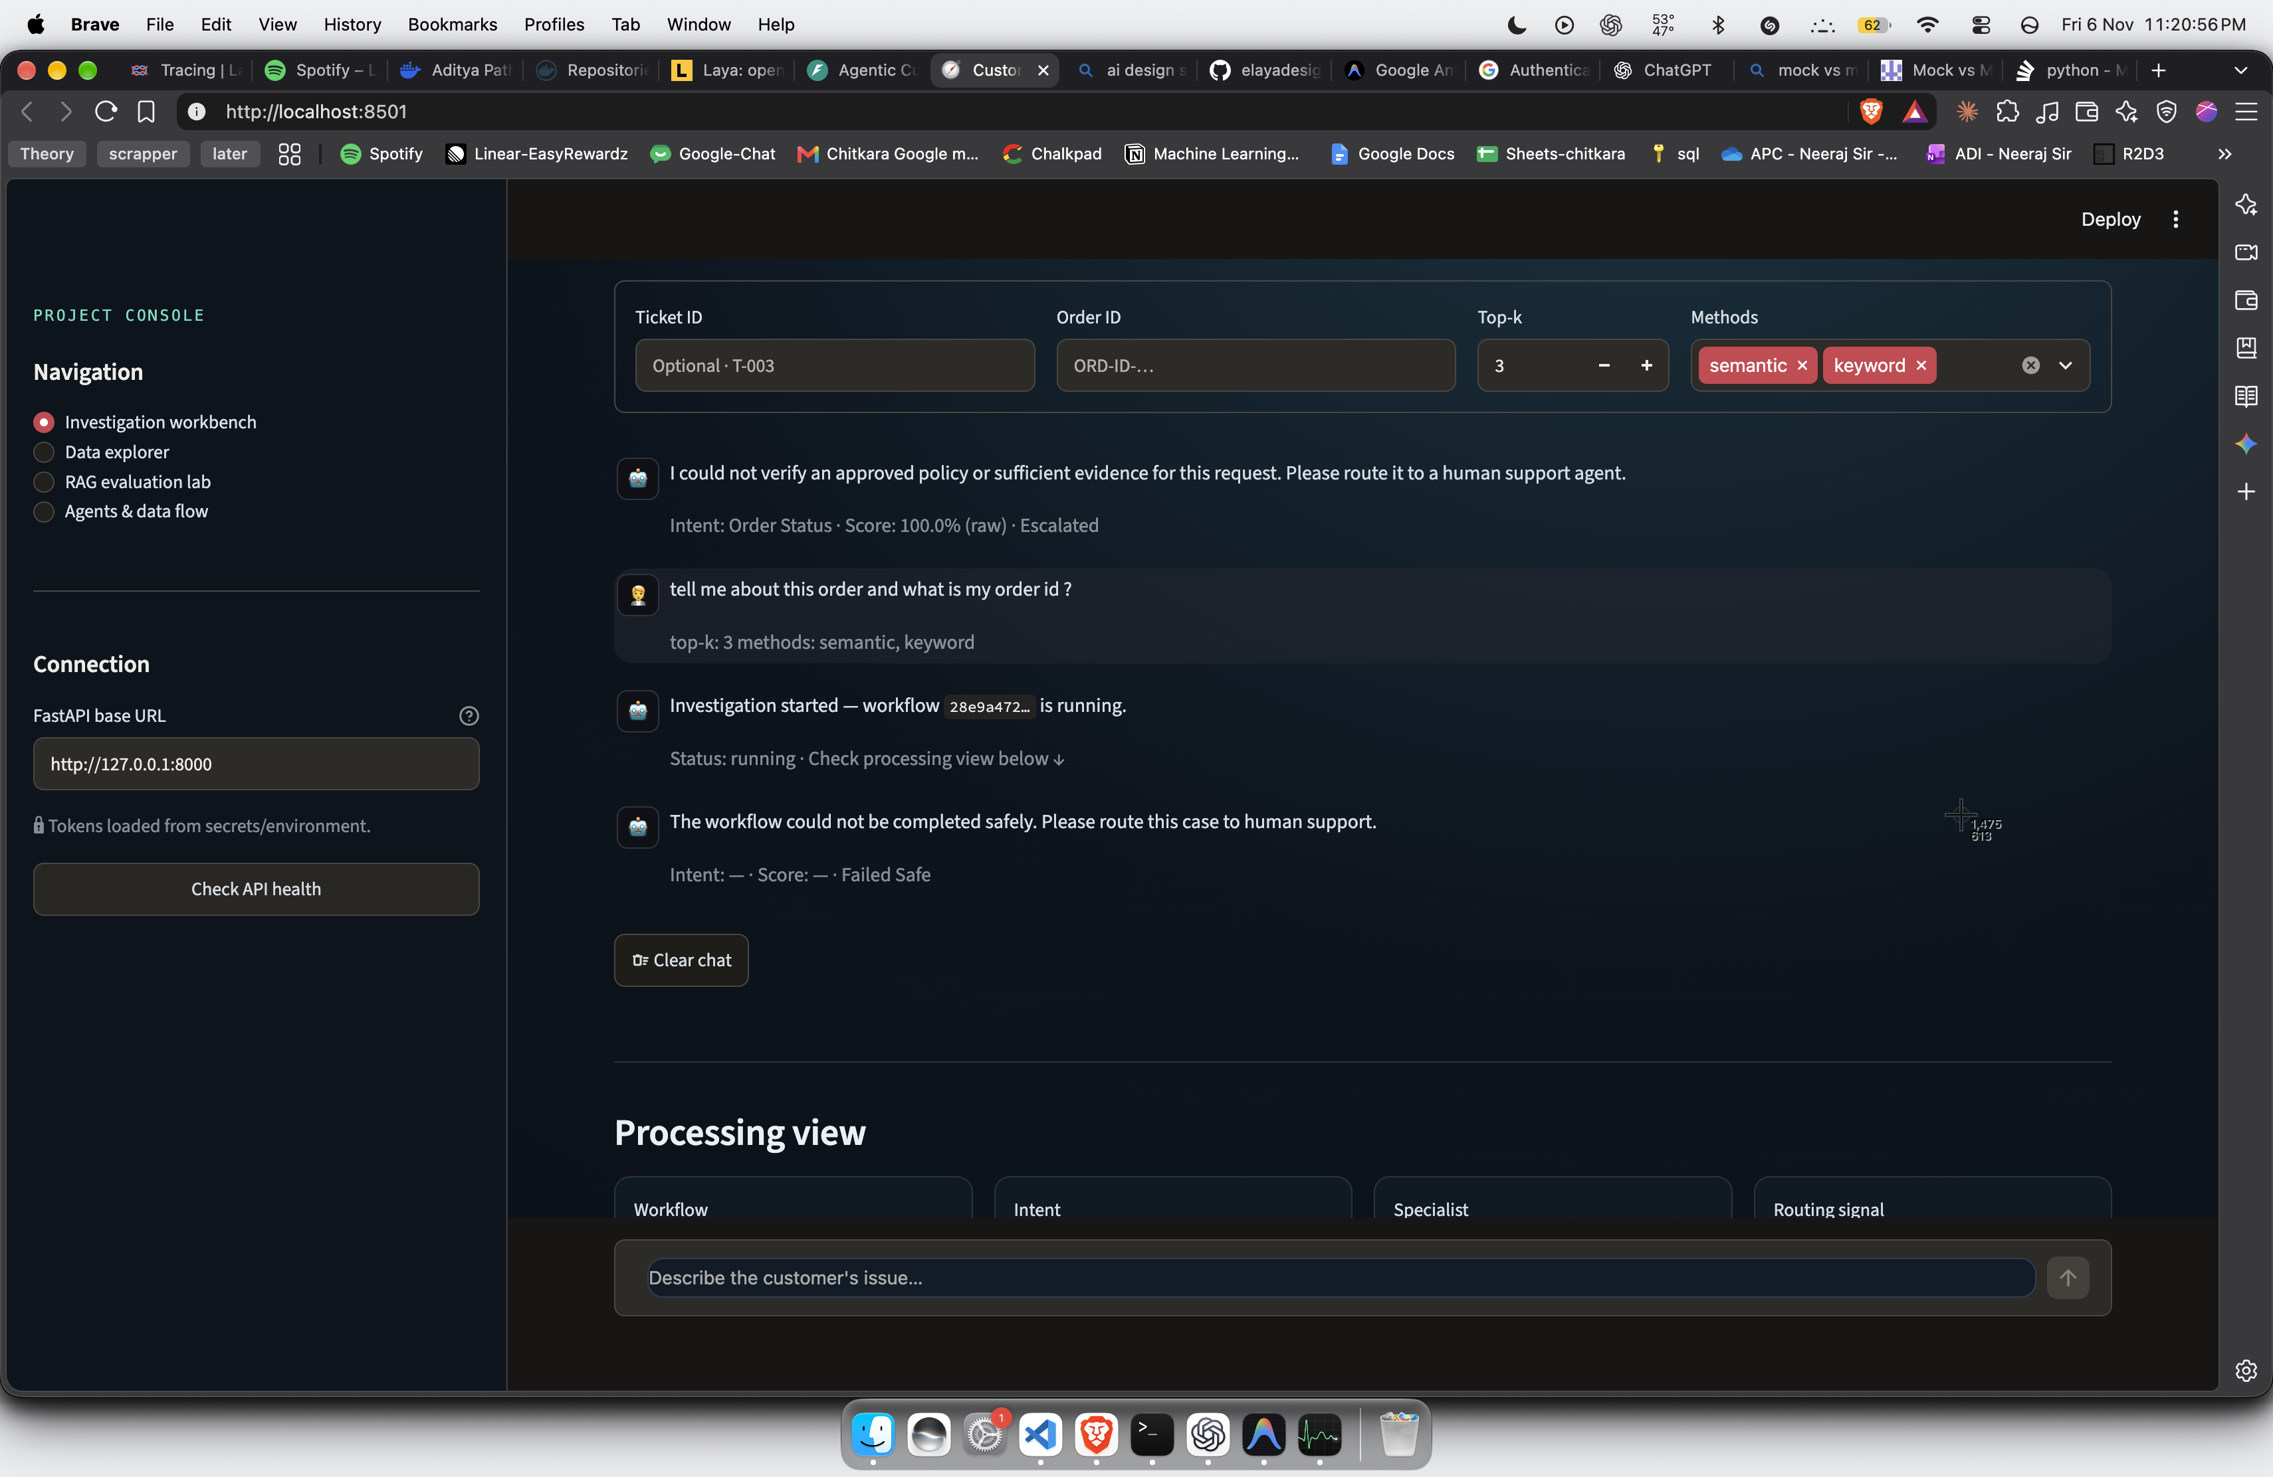
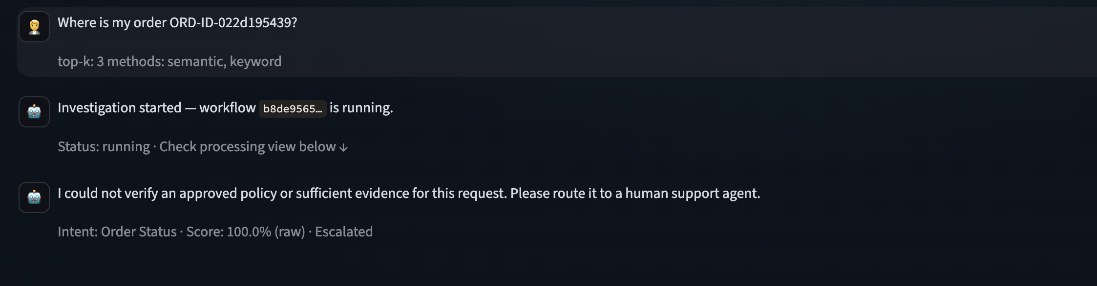

3.4 Worker queue polling delay
Workflow jobs were written to PostgreSQL and then waited for the worker process to discover them. The worker checked for new work every two seconds, which added avoidable waiting time before execution began.
Before | After
The job waited for the worker's two-second polling cycle. | FastAPI BackgroundTasks was used to start graph execution immediately after the request was accepted.

3.5 Safety gate false positives
Some ordinary customer messages, such as “Where is my parcel?” and “Tell me about this order”, were incorrectly flagged as unsafe. This caused valid order questions to be rejected or sent for security review.
The issue log attributes this to overly broad pattern matching and language-model selection for short, ambiguous messages. The checks were adjusted to recognize common e-commerce wording and to use English as the default for short ambiguous messages. Safety checks for genuinely risky requests were not intended to be removed.
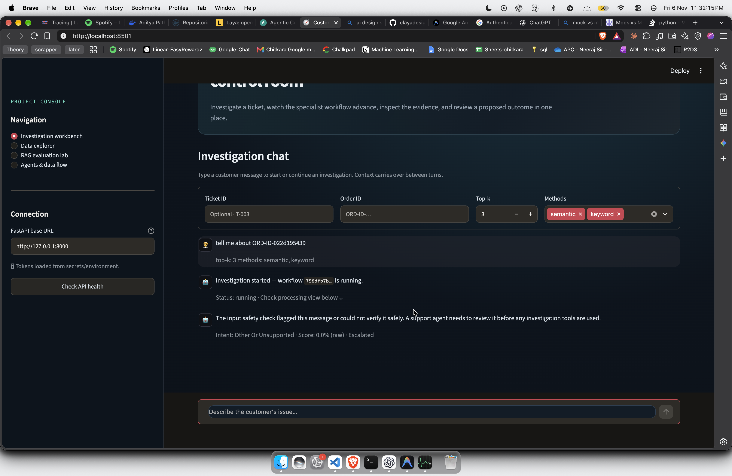

3.6 Groq response rejected by output validation
The initial output validator expected the generated answer to exactly match a deterministic template. Groq could return the same verified facts in more natural wording, but the exact-text comparison rejected it.
Change made: validation became provider-aware. Deterministic templates continued to use strict answer matching, while Groq responses were checked against recorded facts, citation references and safety requirements rather than being forced to reproduce the template word for word.

3.7 Robotic deterministic responses
The first response-generation approach relied on fixed templates. These answers were factual but sounded repetitive and did not handle conversational follow-ups naturally.
Change made: Groq was integrated using the llama-3.3-70b-versatile model. The application sends field-minimized, verified facts rather than raw customer personal information. If the model changes or invents a fact, or if the API fails, the application falls back to a deterministic response.
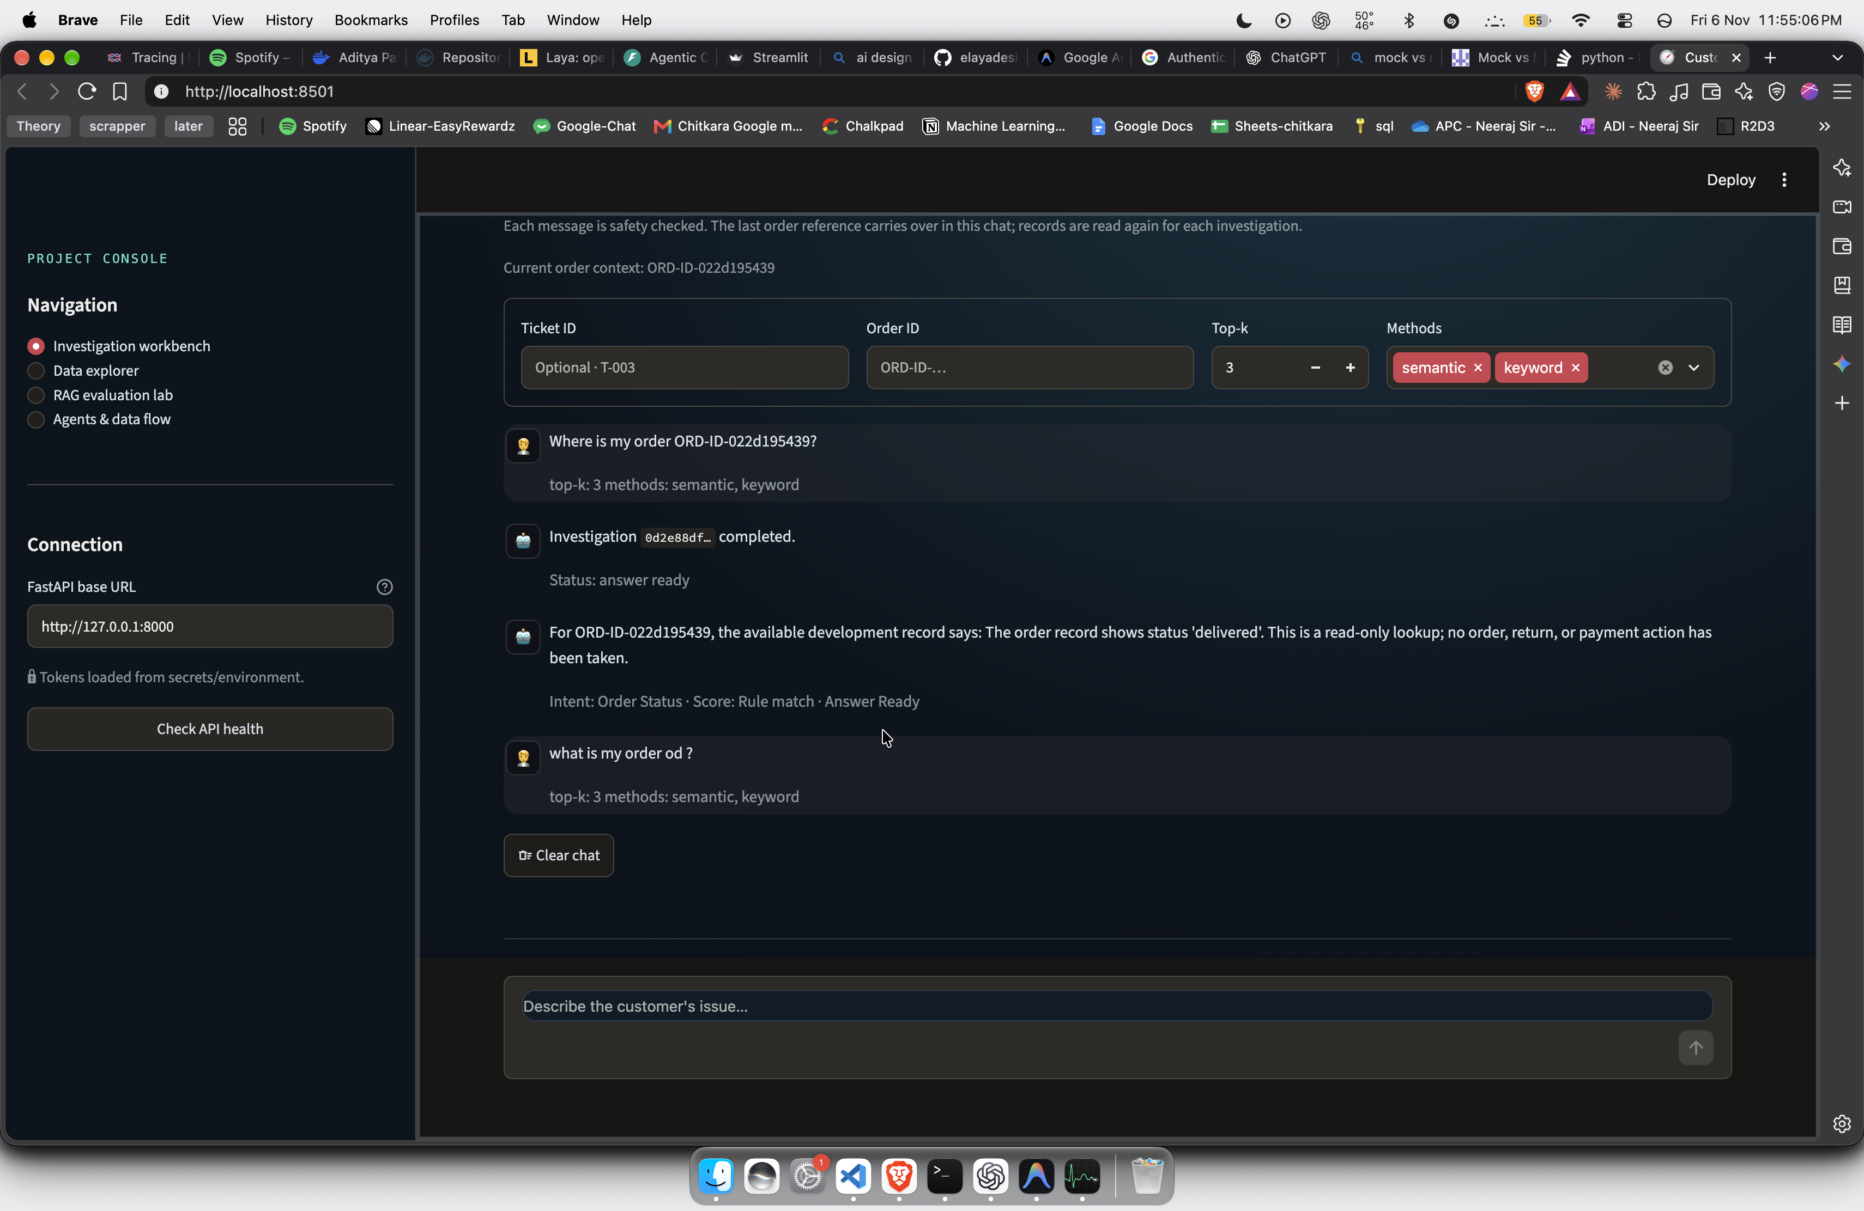

3.8 Database connection overhead and repeated reads
During later debugging, a simple workflow database read was measured at approximately 3.9–10 seconds. The recorded cause was that individual operations opened new database connections. The Streamlit UI also polled multiple endpoints that repeated workflow reads.
The debugging notes identify connection reuse and reducing duplicate reads as the required optimization. The report does not establish that every part of this database optimization was fully completed.

3.9 Frontend import error
The application encountered ModuleNotFoundError: No module named 'frontend'. Python could not resolve the frontend package from the way the application was being started.
Change made: the project added the required package initialization file and adjusted the Python import path.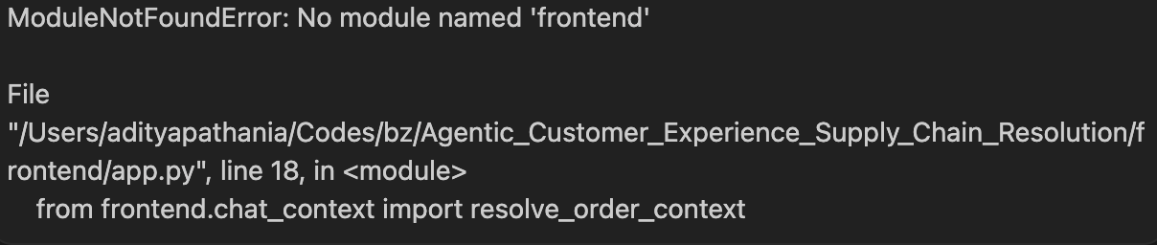

4. Docker and Deployment Issues

4.1 Docker BuildKit I/O error
The Docker build failed with an I/O error involving BuildKit's metadata database. The issue log identified two contributing causes: the Docker virtual disk was under pressure from very large dependencies, and the BuildKit metadata database had become corrupted.
A standard PyTorch installation was pulling in large CUDA-enabled packages even though the deployment was intended to run on CPU infrastructure.
Change made: CPU-only PyTorch was installed explicitly. The Docker BuildKit cache was then cleaned using Docker Desktop's purge option before rebuilding the image.
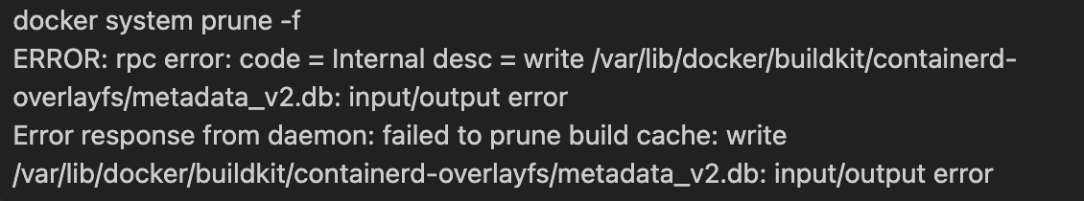

4.2 Docker image was too large
The initial Docker image was approximately 4.5 GB. This made uploading it to Docker Hub slow and caused problems when Render attempted to pull the image.
Optimization | What it removed or changed | Purpose
CPU-only PyTorch | Replaced the large CUDA-enabled PyTorch package with the CPU wheel. | Avoided downloading GPU libraries not needed by the deployment.
Remove package test files and caches | Removed package test directories, .pyc files and local caches from the image. | Reduced unnecessary image contents.
Exclude duplicate model formats | Downloaded the primary model weights while ignoring redundant formats such as ONNX and MsgPack copies. | Avoided storing duplicate model files.
Separate frontend and backend dependencies | The report estimates a smaller image if Streamlit is excluded from the backend container. | Avoided shipping frontend packages with an API-only service.

Metric | Before | After
Docker image size | About 4.5 GB | About 1.2 GB
Docker Hub push time | 45+ minutes | About 8 minutes
Render image pull | Timeout or failure | About 3 minutes

4.3 Laya exceeded Render’s memory limit; moved to AWS EC2
Problem. The Laya model has approximately 421 million parameters. The project estimates its weights alone require about 840 MB at FP16 or 1.68 GB at FP32, before PyTorch, embeddings, FastAPI, and other runtime components. The Render instance used for testing had 512 MB RAM, so it could not reliably load Laya. In a live test, Laya became unavailable and the API fell back to TF-IDF with a confidence score of 0.21. That score was below the routing threshold, so the request correctly remained in manual review.
AWS deployment. To give the model more memory, the investigation API was moved to Amazon EC2, using a C7i-flex large (c7i-flex.large) instance in ap-southeast-2 (Sydney). It has 2 vCPUs and 4 GiB RAM, with an Intel Xeon Sapphire Rapids processor. The server runs Ubuntu 26.04 LTS. AWS instance specifications
Item | Recorded detail
AWS service | Amazon EC2
Instance type | c7i-flex.large
Compute | 2 vCPUs; Intel Xeon Sapphire Rapids
Memory | 4 GiB
Operating system | Ubuntu 26.04 LTS, x86_64
AWS Region | Asia Pacific (Sydney), ap-southeast-2
Runtime | Docker Compose; one FastAPI process loads Laya and MiniLM
Container memory limit | 3 GiB
Why this instance was chosen. Its 4 GiB RAM gives Laya substantially more room than the 512 MB Render instance, allowing the model to run inside the API container instead of falling back because it could not load. Keeping one API process also lets requests share the loaded model.
Verification and observed performance. On EC2, the offline model check loaded Laya without fallback. The first classification, including model loading, took 6.84 seconds; subsequent unseen classifications took about 2 seconds. Container peak memory reached 2,910.5 MiB under the 3 GiB limit. The authenticated HTTPS API also returned successful classification and investigation results. The semantic-plus-keyword batch evaluation completed on EC2; the equivalent Render attempt had returned HTTP 504 after about 31.57 seconds. The Render timeout is a failure threshold, so these results show the batch completed on EC2 but do not establish an exact speedup ratio.
Resolution status. The Render memory-related Laya fallback was addressed for the investigation demo by moving the API to EC2. Memory use is close to the container limit, so this small instance has limited headroom for concurrent requests. Classification quality remains a separate concern: Laya’s confidence is uncalibrated, automatic routing stays disabled, and human review is still required. This is a synthetic-data demonstration deployment, not a production customer-support service.
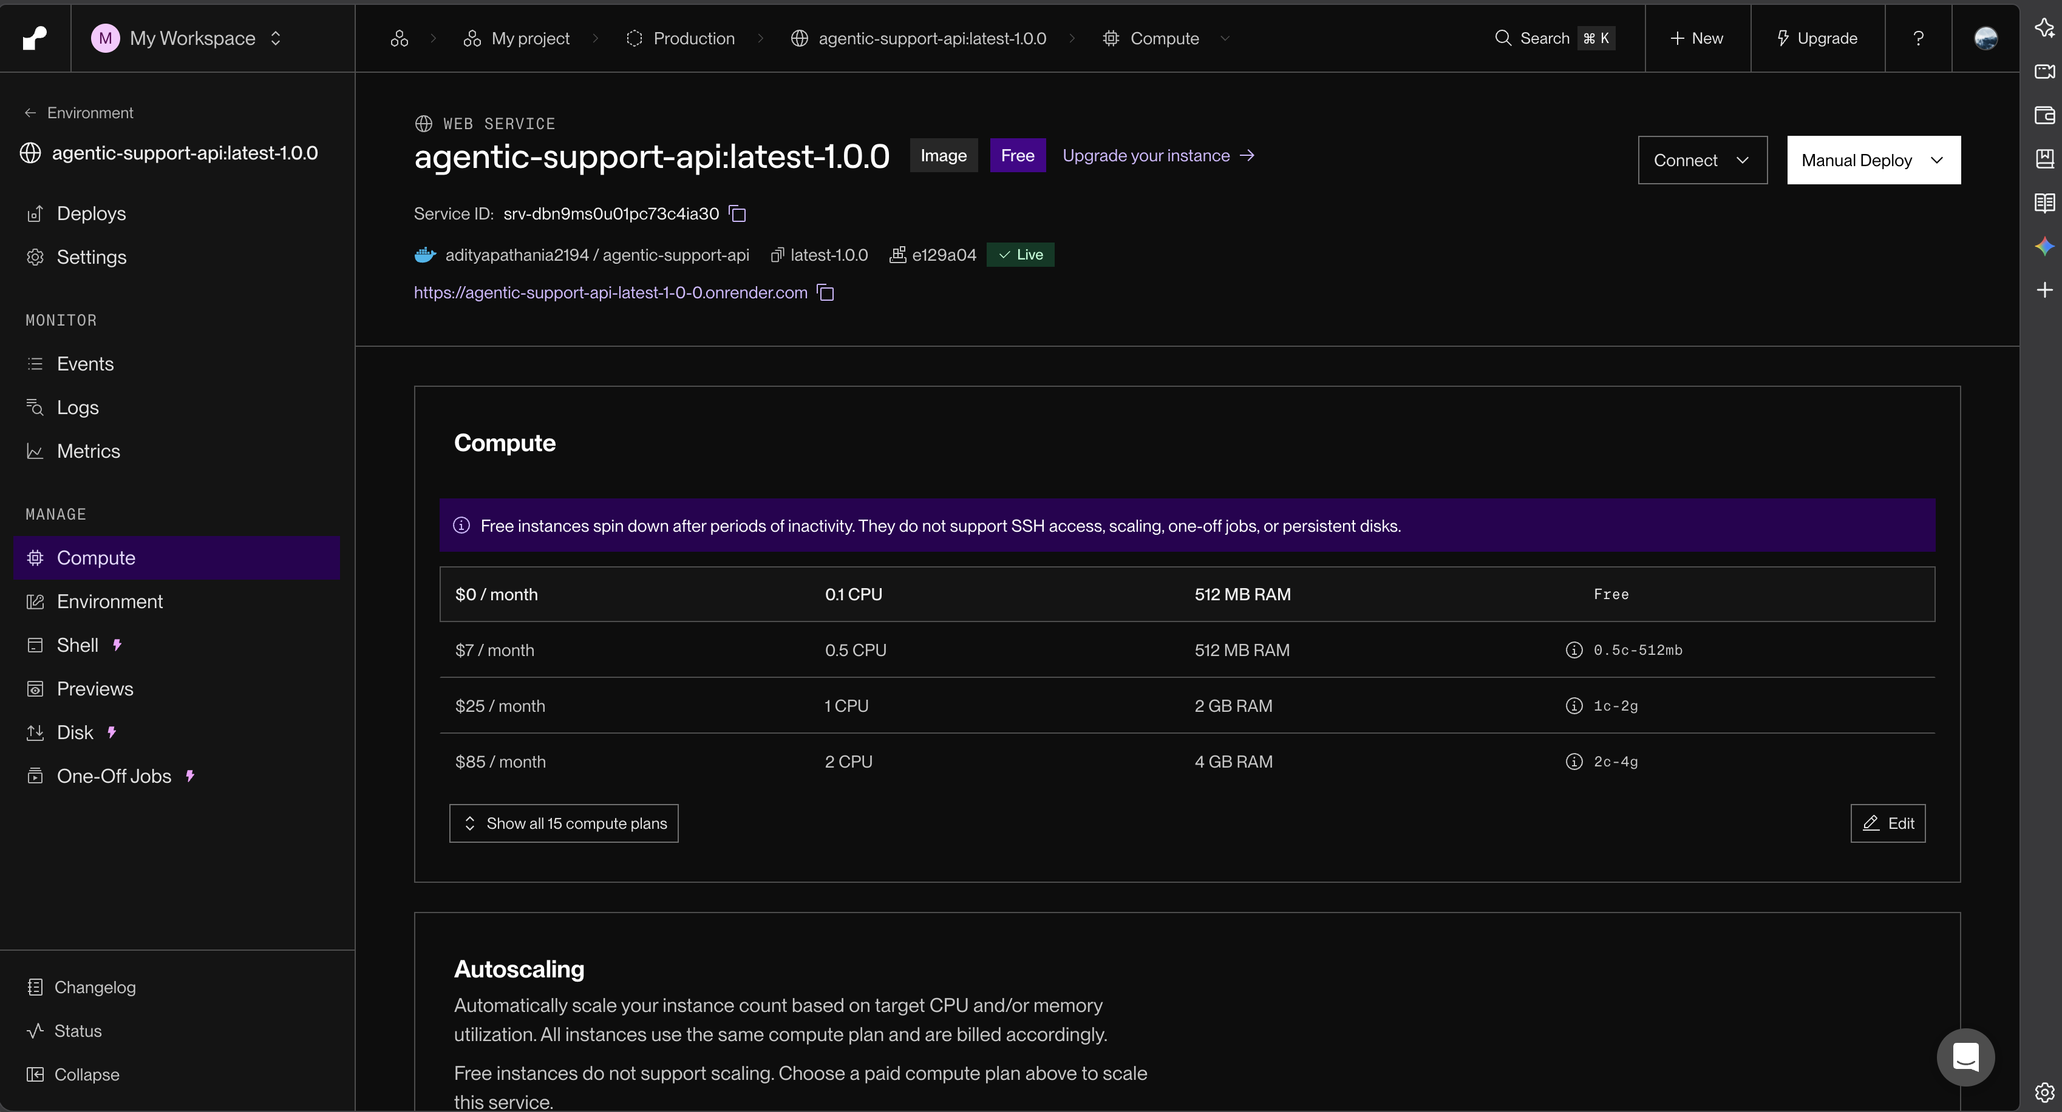
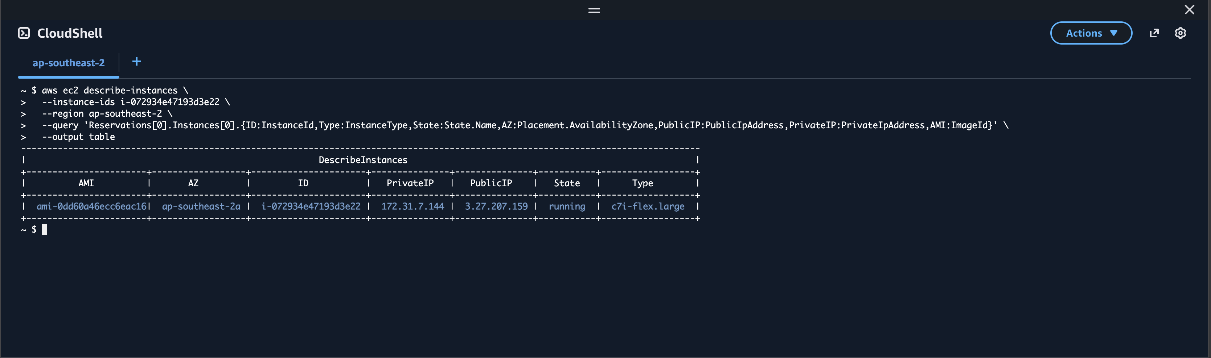
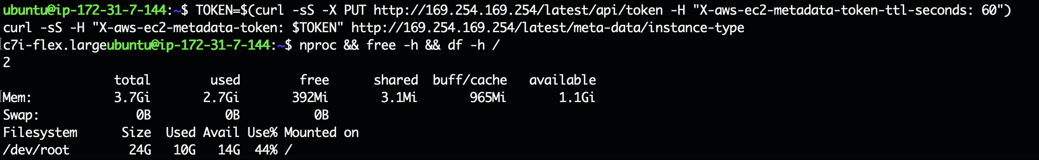

5. Performance Measurements
The project log includes measurements for individual pipeline components. These figures help show which parts of the system were consuming time. They are measurements from the recorded test environment and should not be treated as a guarantee of latency for every deployment.
Component | Cold latency | Warm latency | Optimized latency | Recorded bottleneck
Laya in-process router | 11,530 ms | 490 ms | 0.005 ms (cached) | Model checkpoint loading and serialized global lock.
TF-IDF baseline | 25.6 ms | 1.1 ms | 1.1 ms | Fast, but low-confidence noise could affect routing.
Worker queue polling | 2,000 ms | 2,000 ms | 0 ms (instant task) | Worker's two-second polling interval.
Frontend snapshot polling | 1,500 ms | 1,500 ms | 800 ms | Streamlit fragment polling interval.
In-memory logic | ~1 ms | ~1 ms | ~1 ms | PII masking, rules, drafting and validation were individually very small.

Additional findings in the notes: one semantic retrieval operation took about 11 seconds in the measured environment; two combined evaluation cases took about 14 seconds; and a 12-question serial evaluation exceeded a 30-second deadline. Sequential execution of classification, retrieval, order lookup and customer-context lookup caused delays to add up.

7. Incident Summary
Incident | Problem | Status recorded in issue log | Main corrective action
001 | Laya 11.5-second cold start | Resolved | Startup pre-warm and LRU cache.
002 | Langfuse tracing timeouts | Resolved | Tracing disabled while cloud endpoint was unreachable.
003 | Two-second worker polling delay | Resolved | FastAPI BackgroundTasks.
004 | Classifier disagreement escalated queries | Resolved in routing logic | Ignore low-confidence TF-IDF noise below 60%.
005 | Multi-turn context lost | Resolved | Carry order ID through session state.
006 | Frontend module import error | Resolved | Package initialization and import-path fix.
007 | Docker BuildKit I/O corruption | Resolved | CPU-only PyTorch and BuildKit cleanup.
008 | Docker image approximately 4.5 GB | Resolved | Docker image reduced to approximately 1.2 GB.
009 | Laya memory risk on Render | Monitored | Larger instance or separate Laya service.
010 | Safety gate false positives | Resolved | Improve normal-query matching and language handling.
011 | Output validator rejected Groq | Resolved | Provider-aware validation.
012 | Robotic deterministic responses | Resolved | Groq generation with grounded fallback.
013 | Render startup blocked by APP_ENV | Resolved | Set APP_ENV=local.
014 | Streamlit app inaccessible to public | Resolved | Change visibility to Public and configure Secrets.
015 | Laya OOM and TF-IDF fallback in production | Open | Increase available RAM or separate Laya into a service.

8. Key Engineering Learnings
- Model size must be considered before selecting a deployment platform. A model that loads on a developer's machine may not fit into a small cloud instance.
- Cold-start time and warm-request time should be measured separately. Model pre-warming and caching can improve the first user experience.
- A classifier confidence score is not automatically a calibrated probability. Routing decisions need evaluation data, thresholds and safe handling of uncertainty.
- Multi-turn agents need explicit session or conversation state. A model cannot reliably refer to an earlier order if the application does not pass that context forward.
- LLM-generated wording should not be validated by exact string comparison when the facts are correct but the phrasing differs. Validate facts, citations and safety constraints instead.
- Docker images should contain only the dependencies needed by the service. CPU-only packages and removal of duplicate model files can significantly reduce image size.
- A graceful fallback prevents a service from crashing, but it does not guarantee a useful result. Fallback accuracy and confidence must also be checked.
- Performance should be measured across the full request path, not only the LLM. Database connections, vector retrieval, polling and sequential tasks can dominate response time.

9. Conclusion
The project encountered issues across machine-learning inference, workflow execution, conversational state, database access, safety validation, Docker packaging and cloud deployment. Several issues were corrected through caching, background execution, improved validation, Docker optimization and deployment configuration changes.
The most important remaining concern in the recorded report is the Laya model's memory requirement on Render. The production test showed that the model could not load reliably and the application used the TF-IDF fallback. Classifier evaluation, the updated Milvus index and the Neon customer-context migration also require further verification before their results can be presented as complete.
This report is based on the supplied project issue log and debugging notes. Where the notes describe a proposed fix or an incomplete task, the document labels it as such rather than presenting it as completed.

