Swinburne University of Technology

School of Science, Computing and Engineering Technologies

Contribution Document

Subject code: SWE30003 Unit title: Software Architecture and Design

Assignment number and title: Assignment 3, Project group number: 10
Object-oriented Design (Part 2)

- Time spent (hours): Fill in the time spent on each significant work item in the following table.

Work Item | Member 1 Name: Ashley Jong | Member 2 Name: Daniel Tiong | Member 3 Name: Enoch Chua | Member 4 Name: Norman Ling
Assignment 2 Design Discussion |  | 2
Lessons Learnt from Assignment 2 | 2
Introduction |  | 2
Problem Analysis | 3
Candidate Classes and CRC Cards | 5 | 2
Design Quality and Patterns | 2 |  | 3
Bootstrap Process | 2 |  | 2
Sequence Diagrams |  |  |  | 5
Database Design (ERD) |  |  |  | 3
Execution and Operation |  |  |  | 4
Document Preparation and Compilation |  | 3
Document Formatting |  | 1
Webapp Frontend Implementation | 24 | 6
Webapp Backend Implementation | 6 | 16
System Refinement and Bug Fixing |  | 6

Note: Please adjust and add more rows, as necessary.

Description of contributions (each member provides a brief description of their contributions):

- Ashley Jong: Focused on the Problem Analysis and the architectural design of Candidate Classes, including the creation of the UML Class Diagram and CRC cards. Implemented the user interface, client-side validation and ensuring the visual requirements of the assignment were met.

- Daniel Tiong: Responsible for the Core Backend implementation (API logic, database integration) and the Introduction, Design Discussion and Lessons Learnt sections. Additionally, performed the final code refinement, bug fixing for the website and compiled the final report to ensure consistency.

- Enoch Chua: Assigned to draft the Design Quality and Bootstrap Process sections. However, the authored content lacked specific context to the project and required significant rewriting by other team members to meet requirements. Did not participate in the GitHub repository or technical collaboration workflow despite request.

- Norman Ling: Responsible for the system modelling and operational documentation. Created the Sequence Diagrams for key scenarios and the Database Design (ER Diagram). Authored the Execution and Operation manual, setting up the environment to capture necessary screenshots of the system in action.
- Evidence of collaboration/teamwork on each significant work item (e.g., discussions, mutual revisions and reviews, etc.):

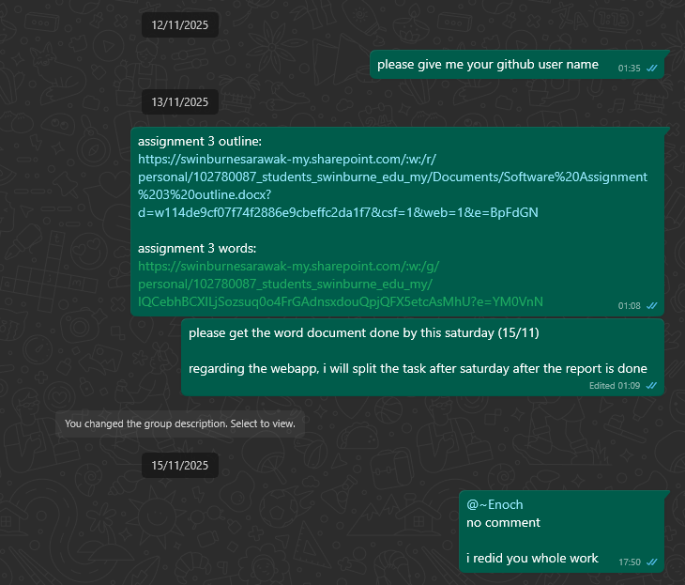

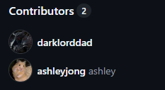

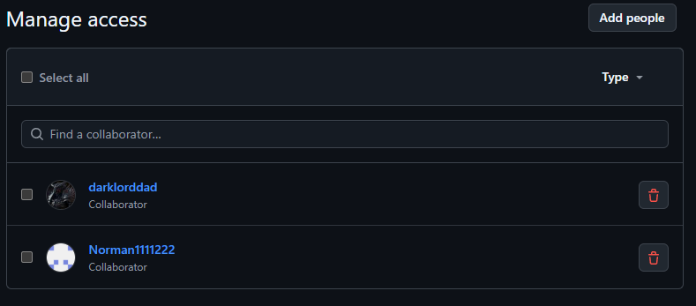
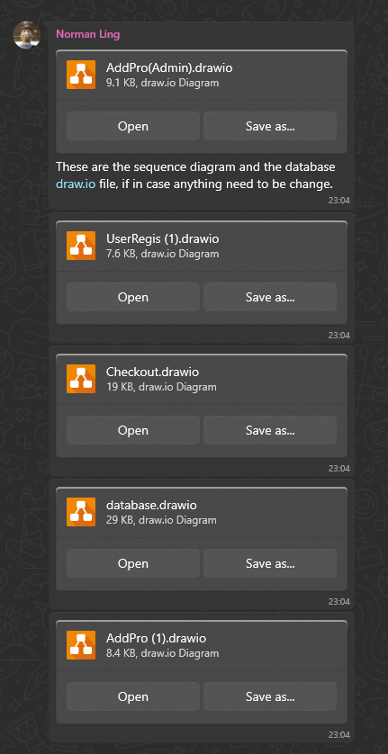

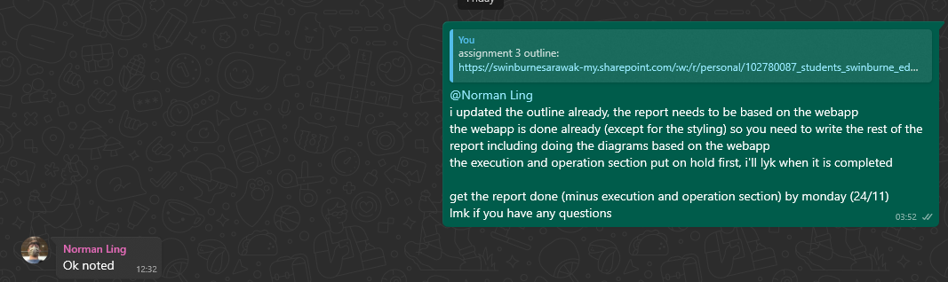

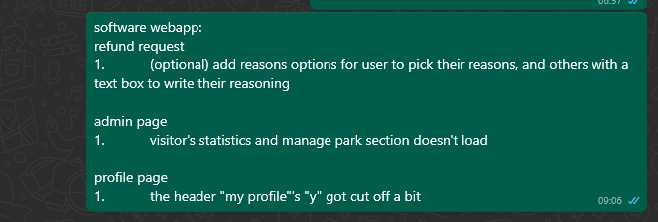

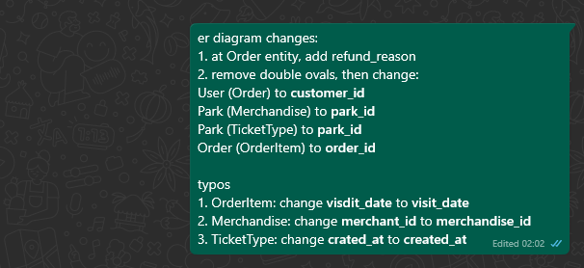

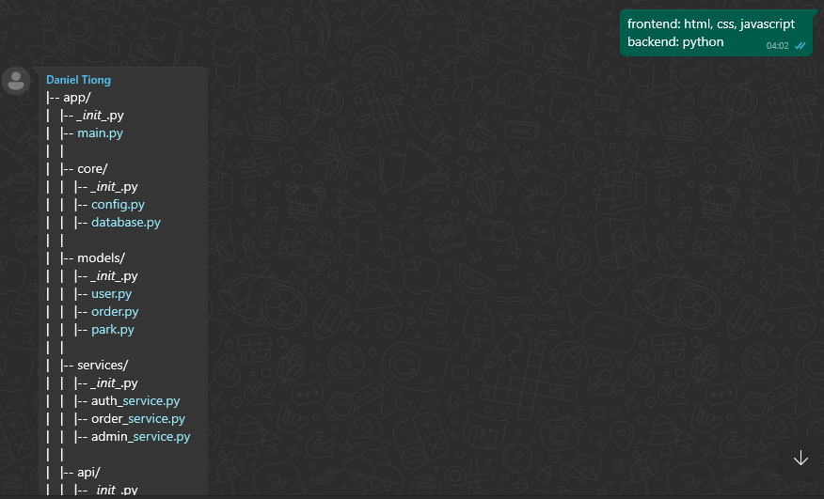

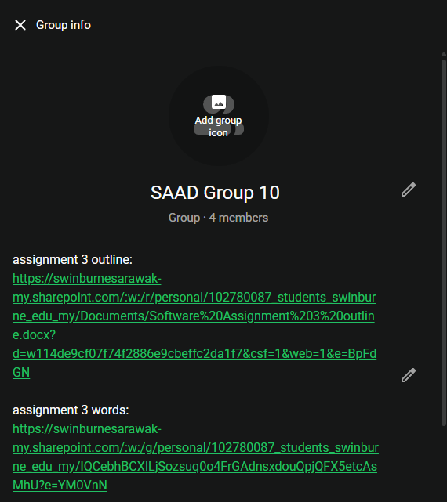

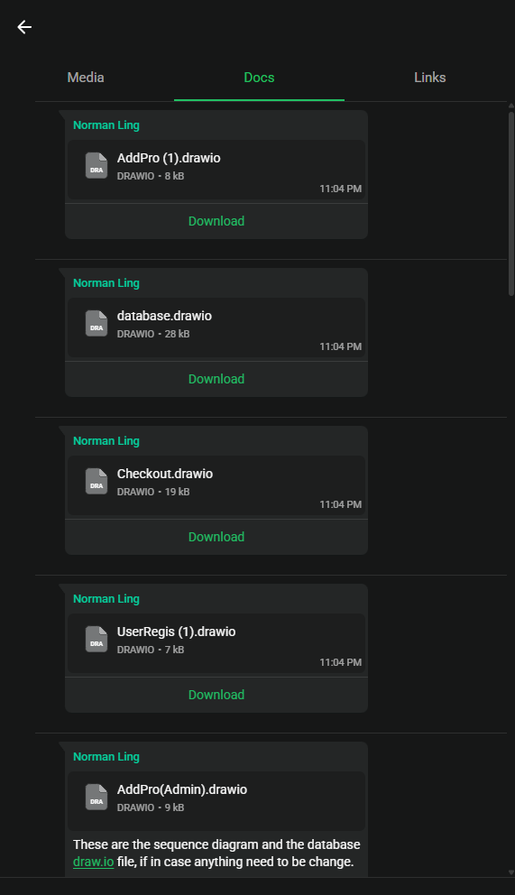

- Signed by all members:

Student ID Name Signature

102780087 Ashley Jong

102777801 Daniel Tiong

104401704 Enoch Chua

104399375 Norman Ling

