SWENG 500

Learning Management System

Domain Model and Class Diagram

Authors: William DiStefano, Kevin Scheib, David Singer, Dawn Viscuso

**Domain Model Noun Results:**

|  |  |  |
| --- | --- | --- |
| NOUNS | RELATIONSHIPS | ATTRIBUTES |
| **User** | Admin registers .. | User_id, fname, lname, mi |
| **Instructor** | Is a User | <inherits from User> |
| **Student** | Is a User | <inherits from User> |
| **Admin** | Is a User | <inherits from User> |
| **Course** | Student takes a …  Admin creates a… | Course_id, course_name, title, descrip, author, create_date, duration, |
| **Lesson** | Course contains a … | Id, title, descrip, objective, |
| **Lesson Content** | Lesson contains …  Instructor uploads … | Id, descript, type(video,document,quiz,…), content_file, lesson_order, |
| Lesson Order | Lesson has a .. |  |
| **Course Catalog** | contains Course …  Student searches … | Catatlog_id, course_id |
| **Student Roster** | Student views …  Instructor manages … | Student_id, course_id, enroll_date |
| **Prerequisite** | Is a course …  Course has a … | Course_id, prereq_course_id, |
| Grade | Quiz produces a …  Student receives a … |  |
| Quiz | Lesson has a … |  |
| **Question** | Quiz contains … | Id, question, options, answer |
| Question options | Question contains … |  |
| Answer | Question has … |  |
| **Certificate** | Student prints a … | Cert_id, text |
| **Bookmark** | Student adds a … | Student_id, Lesson_id, marker <marker is lesson_order_no> |
| **Enrollment History** | Instructor/Student views … | Student_id, course_id, completed_date, status<complete / incomplete>, enroll_date, delete_date, |
| **File** | Content is a … |  |
| video | Falls under lesson content? |  |
| audio | Falls under lesson content? |  |

**Domain Model:**

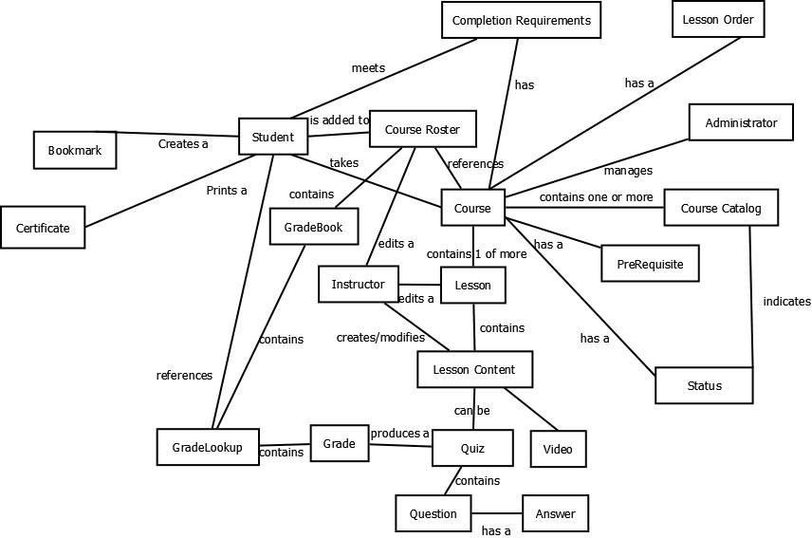

**Class Diagram:**

The team has decided to use CakePHP as a MVC framework for PHP. The class diagram reflects the changes necessary to use the CakePHP framework.

