Block-Level Feasibility of Conformal Calibration on Clinical ECG Data: An Empirical Audit
Working draft for internal review — generated 2026-10-02 from commit d0ff934. Sections marked NOT YET WRITTEN are intentionally empty.

1. Introduction
[NOT YET WRITTEN]

2. Related Work

2.1 Conformal prediction under violations of exchangeability
Split conformal prediction attains finite-sample marginal coverage under a single assumption: that calibration and test points are exchangeable. Barber et al. [1] give the sharpest available account of what happens when that assumption fails, bounding the coverage gap by the total-variation distance between the observed data distribution and its exchangeable counterpart. Their analysis is agnostic to why exchangeability fails, which makes it broadly applicable but leaves the practitioner without a constructive remedy for any particular violation.
A complementary line of work treats specific, structured departures. Weighted conformal prediction handles covariate shift when likelihood ratios are known or estimable [2]; spatially indexed data are addressed in [3]; network dependence in [4]. Bhattacharyya and Barber [5] consider observations belonging to a finite number of groups where group membership determines the covariate shift between training and test distributions — for instance under stratified sampling.
In [5] the data remain exchangeable within each group; what shifts is the mixture over groups. The setting we study is the opposite: the group proportions are stable, but observations within a block are not exchangeable with one another. The vocabulary collides; the problems do not.
Fontana et al. [6] provide the standard unified treatment of the conformal framework and its variants, including the Mondrian (class-conditional) construction of which we use a calibrated variant [7] as a baseline.

2.2 Conformal prediction for hierarchical data
The hierarchical exchangeability problem is solved, and not by us. Lee, Barber and Willett [8] derive a hierarchical form of exchangeability for data organised into groups of repeated measurements, and extend both conformal prediction and jackknife+ [9] to that setting. Their Theorem 1 gives the hierarchical conformal prediction (HCP) threshold
T = Q1−α​k​i​1(K1+1)Nk δs(Zk,i) + 1K1+1 δ+∞,
with coverage at least $1−α$ and, when scores are almost surely distinct, at most $1−α+\frac{2}{K_{1}+1}$. Dunn et al. [10] independently study two-layer hierarchical models and introduce four constructions — pooling CDFs, double conformal, subsampling once, and repeated subsampling — that address the same setting.
Everything in the present paper takes this threshold as given. We do not rederive it, and we claim no credit for it.
Both [8] and [10] are developed as theory, and their empirical sections are regression problems; [8] evaluates on simulated data and a Lorenz-96 system. Neither asks a question that is prior to applying the method at all: given a real clinical dataset and a target error rate, at which grouping — if any — can the guarantee be enforced? The $\frac{1}{K_{1}+1}$ atom at $+∞$ makes this a non-trivial question, because it renders the threshold infinite whenever $α<\frac{1}{K_{1}+1}$.
The authors of [8] state the open question themselves in their discussion, observing that an analyst may choose between many independent groups with few measurements each or few groups with many repeats, and that characterising the pros and cons of this tradeoff is an important question to determine how study design affects inference in this distribution-free setting. Section 5 addresses the most elementary part of that question — whether a finite threshold exists at all for a given design — and the remainder of the paper measures what happens on real clinical data when it does.

2.3 Conformal prediction for multi-label and hierarchical label spaces
Papadopoulos [11] reviews conformal methods for multi-label learning and organises them by output type, guarantee, and where label dependence enters. The review is explicit that the surveyed literature rests on the exchangeability assumption throughout — that is, it treats dependence between labels while assuming independence between samples. Our setting requires the converse.
Maltoudoglou et al. [12] address the computational cost of Label Powerset conformal prediction by pruning label sets whose $p$-values cannot exceed the significance level. Hierarchical multi-label classification without conformal guarantees is well developed [13], as is its application to clinical recommendation [14].
Two recent efforts are close enough to require explicit differentiation. Baheri and Amiri Shahbazi [15] define a conformity function at each of several resolutions and intersect the resulting sets, distributing the miscoverage budget across scales; the operation shrinks sets and pays a Bonferroni-type price in coverage. Our hierarchical closure moves in the opposite direction: it enlarges sets upward along the label taxonomy, and coverage is non-decreasing as a result. Zhang et al. [16] represent prediction sets as nodes in a directed acyclic graph, using coarse labels to implicitly represent their descendants — a downward compression, again opposite in direction to upward closure.

2.4 Uncertainty quantification for ECG and the inter-patient protocol
Strodthoff et al. [17] established the benchmark suite for PTB-XL [18], [19], whose residual architectures inform the backbones used here. Evaluation on heartbeat-level arrhythmia data follows the inter-patient protocol, in which no subject contributes to both training and evaluation [20], [21]; violating this separation inflates reported performance and is the single most common methodological error in the area [22].
Reviews of uncertainty quantification in clinical deep learning [23] and the FUTURE-AI consensus guideline [24] both identify calibrated uncertainty as a prerequisite for deployment, making the requirement a matter of published consensus rather than authorial preference. Conformal prediction specifically in clinical medicine is surveyed in [25], with recent applications to anatomical landmark localisation [26] and multi-label diagnosis coding [27]. Conformal risk control [28] and conformal prediction for time series [29] supply the loss-control and temporal machinery we build on.
None of these works examines whether the exchangeability assumption underlying their conformal guarantees is satisfiable at the grouping level their data actually possess. That question is the subject of this paper.

3. Preliminaries and Notation

3.1 Hierarchical data and blocked exchangeability
Sections 3.1–3.2 restate the framework of Lee et al. [8] for completeness of notation; none of it is claimed as ours.
Let the calibration data consist of $K$ blocks (groups), where block $k$ contains $N_{k}$ observations $Z_{k,1},…,Z_{k,N_{k}}$. Write n=k​Nk for the total number of observations. In our clinical setting a block is a patient and an observation is a single 10-second ECG recording, but the framework is agnostic to what defines a block.
Standard conformal prediction assumes the calibration and test points are exchangeable. Lee et al. [8] show that this fails whenever observations are nested within groups, and introduce hierarchical exchangeability: blocks are exchangeable with one another, and observations are exchangeable within each block, but observations are not exchangeable across the full pooled sample.
Let $s(⋅)$ denote a nonconformity score, fixed independently of the calibration data, and write $s_{k,i}=s(Z_{k,i})$. Let
$$Q_{β}(F)=inf\{t:F(t)≥β\}$$
denote the lower $β$-quantile of a distribution $F$ on $R∪\{+∞\}$.

3.2 Hierarchical conformal prediction (HCP)
Writing $K_{1}$ for the number of calibration blocks, HCP calibrates the threshold as
$$\hat{T} = Q_{1−α}​\left(\sum_{k=1}^{K_{1}}{\sum_{i=1}^{N_{k}}{\frac{1}{(K_{1}+1)N_{k}}}} δ_{s_{k,i}} + \frac{1}{K_{1}+1} δ_{+∞}\right). \text{(1)}$$
Two features of (1) drive everything that follows. First, each block contributes the same total mass $\frac{1}{K_{1}+1}$ regardless of how many observations it contains; within a block that mass is divided evenly across its $N_{k}$ members. Second, a mass of $\frac{1}{K_{1}+1}$ is placed at $+∞$, which is the price of not knowing the test block in advance.
Lee et al. [8, Th. 1] prove the two-sided guarantee
$$1−α ≤ P\{Y_{\text{test}}∈\hat{C}(X_{\text{test}})\} ≤ 1−α+\frac{2}{K_{1}+1} \text{(2)}$$
for a test point drawn from a previously unseen block.

3.3 Label hierarchy
PTB-XL organises diagnoses as a three-level tree: 5 diagnostic superclasses, 23 subclasses, and 44 diagnostic SCP statements. A recording may carry several labels simultaneously, so the target is a set $Y⊆L$ rather than a single class. We write $parent(ℓ)$ for the parent of label $ℓ$ and call a set $C$ upward closed if $ℓ∈C⇒parent(ℓ)∈C$.

4. Problem Formulation
Equation (1) is a complete recipe once $K_{1}$, $\{N_{k}\}$ and $α$ are given. It does not, however, say anything about whether the resulting guarantee carries any information. That is the question we take up.

4.1 When is a non-trivial guarantee possible?
Proposition 1 (feasibility). $\hat{T}<∞$ if and only if
$$α ≥ \frac{1}{K_{1}+1}. \text{(3)}$$
Proof. The finite atoms in (1) carry total mass
k​i​1(K1+1)Nk=k​Nk(K1+1)Nk=K1K1+1.
Let $M=\max_{k,i}s_{k,i}$ and let $\hat{F}$ denote the weighted CDF in (1). Then $\hat{F}(t)≤\frac{K_{1}}{K_{1}+1}$ for every finite $t$, with equality at $t=M$. Since $Q_{1−α}(\hat{F})=inf\{t:\hat{F}(t)≥1−α\}$, the threshold is finite iff $\frac{K_{1}}{K_{1}+1}≥1−α$. $▫$
When (3) fails, $\hat{C}(X)=L$ for every input: the guarantee (2) holds vacuously and conveys nothing.
Corollary 1.1 (independence of $N_{k}$). The right-hand side of (3) does not involve $N_{k}$. Collecting more measurements per block can never restore feasibility, no matter how many are collected.
Corollary 1.2. The minimum number of calibration blocks is $K_{min}(α)=⌈1/α⌉−1$. At $α=0.05$ this is 19 blocks, not 20.
Corollary 1.3 (consistency with split conformal). If $N_{k}=1$ for all $k$ then $K_{1}=n$ and (3) reduces to $n≥1/α−1$, the textbook requirement for split conformal. We verified this numerically as a check on both the derivation and the implementation.
Remark (strictness). An earlier version of this work stated (3) as a strict inequality. That is wrong at the boundary: at $α=\frac{1}{K_{1}+1}$ exactly, the finite mass $\frac{K_{1}}{K_{1}+1}$ equals the level $1−α$, so the infimum is attained at $M$ and the threshold is finite. Simulation at $K_{1}=19,α=0.05$ gives empirical coverage $0.9512≥0.95$. We report the correction because the non-strict form is what makes Corollary 1.3 line up with the standard split-conformal condition — a useful cross-check for readers.

4.2 Multiple dependence sources and crossed designs
Real clinical datasets carry several candidate blocking variables at once: patient, device, operator, site. These need not be nested.
Definition (sufficiency). A partition $Q$ is sufficient for a dependence source with partition $P$ if $P$ refines $Q$, i.e. every $P$-block lies entirely inside a single $Q$-block.
If $Q$ is not sufficient for $P$, then dependent observations are split across different $Q$-blocks and are treated as independent — exactly the error the hierarchical machinery exists to prevent.
Proposition 3 (crossed designs force the join). For $Q$ to be sufficient for both $P_{1}$ and $P_{2}$, it must be coarser than each. The finest such $Q$ is the join $P_{1}∨P_{2}$ in the partition lattice: the connected components of the graph linking two observations whenever they share a $P_{1}$-block or a $P_{2}$-block. This is a standard fact about the partition lattice; we state it because its consequence for conformal calibration is what matters here.
Corollary 3.1. $K(P_{1}∨P_{2})≤min\{K(P_{1}),K(P_{2})\}$, hence
$$α_{min}(P_{1}∨P_{2}) ≥ max\{α_{min}(P_{1}),α_{min}(P_{2})\}.$$
Corollary 3.2 (impossibility). If $K_{1}(P_{1}∨P_{2})<⌈1/α⌉−1$ then no HCP calibration yields a non-trivial guarantee at level $α$ while accounting for both dependence sources. This is a property of the study design, not a shortcoming of any estimator.
Scope of Corollary 3.2. We prove Corollary 3.2 for the HCP/Dunn family. Whether it extends to every distribution-free method whose validity rests on between-block exchangeability remains open. We conjecture that it does, by analogy with the unavoidability of the $n≥1/α−1$ requirement for split conformal, but we do not claim it.

4.3 What the guarantee is about: multi-label targets
For multi-label outputs the notion of coverage must be chosen, not inherited. We use superset coverage
$$P\left(Y_{\text{test}}⊆\hat{C}(X_{\text{test}})\right) ≥ 1−α. \text{(4)}$$
Superset coverage (4) is not a new result. Theorem 1 never touches the structure of the label space; it only requires a fixed scalar score. Setting $s(x,Y)=\max_{ℓ∈Y}s_{ℓ}(x)$ makes $\{Y⊆\hat{C}\}⇔s(x,Y)≤\hat{T}$, so HCP applies unchanged. We present this as method, not contribution.
The substantive question is the label-conditional target
$$P(ℓ∈\hat{C}(X) \left| ℓ∈Y\right) ≥ 1−α, \text{(5)}$$
which does not reduce, and which we take up in §5.3.
Records with $Y=∅$. In PTB-XL, 411 recordings (1.9%) carry no diagnostic superclass. Under (4) these are covered trivially, so including them would inflate measured coverage without evidence. We exclude them from calibration and evaluation and report the exclusion.

5. Methods
This study introduces no new conformal procedure. It audits an existing one — hierarchical conformal prediction (HCP) [8] — on clinical ECG data, using three diagnostics assembled from established results. We state the provenance of each diagnostic where it is introduced, so that the reader can separate the tools we borrow from the findings we report in §8.
Throughout, $K_{1}$ denotes the number of calibration blocks, $N_{k}$ the number of observations in block $k$, n=k​Nk, and $H$ the harmonic mean of the $N_{k}$. We write $ρ(t)$ for the intraclass correlation of the indicator $1\{s≤t\}$ at threshold $t$ — not of the raw score.

5.1 Whether a finite threshold exists, and how precise it is

5.1.1 Existence depends on the number of calibration blocks alone
Proposition 1. The HCP threshold satisfies $\hat{T}<∞$ if and only if $α≥\frac{1}{K_{1}+1}$.
This is an immediate consequence of the location of the $+∞$ atom in Theorem 1 of [8], and we claim nothing beyond restating it in a form that can be checked from metadata. Two consequences matter for the audit. First, the boundary does not involve $N_{k}$: adding observations to existing blocks cannot make an infeasible level feasible. Second, with $N_{k}=1$ for all $k$ it reduces to the familiar split-conformal requirement $n≥⌈1/α⌉−1$.
The inequality is not strict. At exactly $α=\frac{1}{K_{1}+1}$ the threshold remains finite. An off-by-one here silently misreports feasibility for every grouping whose $K_{1}$ sits on the boundary.

5.1.2 Precision under a compound-symmetric model
What follows is not distribution-free. It requires Assumption (A): blocks are independent and identically distributed, and within a block every pair of indicators has the same correlation $ρ(t)$, not depending on $N_{k}$ (compound symmetry).
Rewriting the HCP threshold shows that it is determined by G(t)=1K1k​Fk(t), the unweighted mean of block-level empirical CDFs. Under (A), the standard variance of an unweighted mean of cluster means applies [30]:
$$Var\left(\hat{G}(t)\right) = \frac{σ^{2}(t) [ 1+(H−1)ρ(t) ]}{K_{1}H}, σ^{2}(t)=F(t)\{1−F(t)\}.$$
Under (A) the variance tends to $σ^{2}ρ/K_{1}$ as $N_{k}→∞$. This floor is a property of compound symmetry, not of clustered data in general. If within-block correlation decays with separation — as plausibly holds for consecutive beats within a long Holter record — the mean pairwise correlation can shrink with $N_{k}$ and the floor disappears. We make no claim outside (A).

5.1.3 The equal weighting is imposed, not chosen
The variance above belongs to the block-weighted estimator. The Kish effective sample size describes a different, observation-weighted estimator, and the two coincide only for uniform block sizes:
DEffblock(ρ)=n[1+(H−1)ρ]K1H, DEffpooled(ρ)=1+k​Nk2n−1ρ.
The second expression is the standard clustering design effect for unequal cluster sizes, and comparing design effects under equal versus size weighting of cluster means is established practice in cluster-randomised trials [31], [32]. We use both formulas as given.
What differs in the conformal setting is not the formula but the freedom to choose. In a cluster-randomised trial, equal weighting is an analyst’s choice and is known to be inefficient under unequal cluster sizes; the standard remedy is minimum-variance weighting [31], [32]. In HCP the equal weighting follows from the structure of the threshold itself, and departing from it can break the finite-sample guarantee rather than merely cost efficiency: with $K_{1}=2$ singleton blocks and $α=1/3$, HCP places mass $1/3$ on each calibration score and on $+∞$, giving threshold $max(s_{1},s_{2})$ and coverage exactly $2/3$. Moving the mass to $(2/3,0)$ while keeping $1/3$ on $+∞$ makes the threshold $s_{1}$, and for continuous exchangeable scores the coverage becomes $P(s_{0}≤s_{1})=1/2<2/3$. The practitioner is therefore held to the estimator that cluster-sampling theory identifies as most affected by block imbalance, without access to its usual remedy. We report this as an observation about the setting; we do not prove that equal weights are the only valid choice.
On PTB-XL the two design effects differ by a factor of 15.7 at the recording site level. On strat_fold, whose blocks are nearly uniform by construction, the ratio is 1.000 — an internal check of the computation.

5.1.4 The axis used to organise results
The audit in §8 needs an axis on which datasets with very different block geometry can be compared. We use ${DEff}_{\text{block}}$ evaluated with the threshold-indicator ICC $ρ(t)$. Because $H$ enters only through $(H−1)ρ$, the quantity predicts that dependence is harmless whenever blocks are near-singleton, however strong the within-block correlation; raw $ρ$ alone predicts the opposite. We state this prediction here, before the results.
We use this quantity only as an ordering axis, not as a calibrated effective sample size. Noonan [33] derives a closed-form effective sample size for thresholds under clustering and shows that the correction currently used in the conformal literature is the wrong quantity. Our axis shares its central ingredient — the correlation of threshold indicators rather than of scores — but is a heuristic under Assumption (A), and we defer to that work for the principled quantity.

5.2 Which calibration groupings are admissible
A practitioner choosing a calibration grouping $g$ faces two requirements (Table I).
$g$TABLE I
ADMISSIBILITY CONDITIONS FOR A CALIBRATION GROUPING .
 | Condition | Character
S1 Feasibility | $K_{1}(g)≥⌈1/α⌉−1$ | exact, from Proposition 1
S2 Sufficiency | every declared dependence source is nested within $g$ | exact, given the declaration
S1 alone is insufficient: a grouping can admit a finite threshold while leaving dependence unaccounted for across its blocks. S2 is only as complete as the list of dependence sources supplied to it. It verifies nesting for declared sources; an undeclared source passes vacuously. S2 is therefore a check on the consistency of a stated assumption, not a test of it.
When declared sources are crossed rather than nested, the finest grouping satisfying S2 for all of them is their join in the partition lattice — the connected components of the graph that links two observations whenever they share a block under any declared source. This is standard partition-lattice algebra, and the observation that joining several individually fine groupings can collapse into a giant component has been reported for leakage control [34]. Combined with Proposition 1 it yields a design-level bound that we use as a diagnostic:
Corollary (feasibility under crossed sources). If $K_{1}(P_{1}∨⋯∨P_{m})<⌈1/α⌉−1$, no HCP calibration provides a finite threshold at level $α$ while respecting all $m$ declared sources.
Scope. This is stated for the HCP family only. The difference from the leakage-control setting is one of kind rather than degree: there, a collapsed join degrades a split (fewer folds, higher variance); here, below $1/(K_{1}+1)$ no finite threshold exists at all.
The bound depends on which sources are declared, and that choice cannot be verified from data. We therefore report it as a function of the declared set and never as a property of a dataset. On PTB-XL fold 9, declaring patient_id and site retains $K_{1}=34$ and remains feasible at $α=0.05$, although 31 of those 34 blocks consist solely of records lacking nurse metadata (§8.1); adding device collapses the join to $K_{1}=5$; declaring all four available sources yields a single block. Enumerating all $2^{4}−1$ joins on fold 9 shows that every grouping satisfying S2 for all four sources has $K_{1}=1$, so under that declaration no grouping satisfies S1 and S2 together at any $α∈\{0.01,0.05,0.10,0.20\}$.

5.3 Per-label feasibility on a label hierarchy

5.3.1 Superset coverage reduces exactly to HCP
If the conformity score of a record is taken to be the maximum score over its true labels, superset coverage is a marginal coverage statement about a scalar score, and Theorem 1 of [8] applies verbatim. No new guarantee is obtained; we use the construction because it is the operationally correct way to obtain a superset-valid prediction set.

5.3.2 Per-label guarantees are bounded by the number of blocks carrying the label
That rare classes starve class-conditional calibration is well established for exchangeable data [35]. Under hierarchical dependence the unit that must be counted changes from observations to blocks.
Proposition 4 (necessary condition). A finite per-label HCP threshold for label $ℓ$ at level $α$ requires $α≥\frac{1}{K_{1}(ℓ)+1}$, where $K_{1}(ℓ)$ is the number of calibration blocks containing at least one instance of $ℓ$.
The condition is necessary, not sufficient. Conditioning a test observation on carrying $ℓ$ selects its block with probability proportional to the fraction of $ℓ$-positive observations in that block, whereas a block enters the calibration stratum merely by containing one. Unless that fraction is constant across blocks, test and calibration blocks are not exchangeable, and the rank argument does not deliver $P(ℓ∈\hat{C}∣ℓ∈Y)≥1−α$. The same size-biased selection appears in the analysis of thresholds under clustering [33]. We therefore use Proposition 4 only to rule out guarantees, never to certify them.
Because every block containing a label contains its ancestors, $K_{1}$ is monotone toward the root of the hierarchy, so the necessary condition fails along a frontier in the taxonomy that can be mapped from metadata before any model is trained. Controlling $m$ labels jointly by a union bound raises the requirement to $K_{1}(ℓ)≥⌈m/α⌉−1$ for every $ℓ$.

5.4 Audit protocol
Fig. 1 summarises the protocol. All three diagnostics are computed from metadata alone, before training. The empirical audit in §8 then measures coverage and prediction-set size of naive split conformal (B1) and HCP (B12) on held-out blocks, over 200 random block-level splits per configuration. To rule out the objection that calibration behaviour is an artefact of a weak model, every audit is repeated on three backbones spanning a more than hundredfold range of capacity (0.10 M, 7.2 M and 16.0 M parameters). Diagnostics computed from metadata — $K_{1}$, $K_{1}(ℓ)$ and the join structure — must be identical across backbones, and we report them per backbone as a negative control on the pipeline. PTB-XL fold 10 is never used.
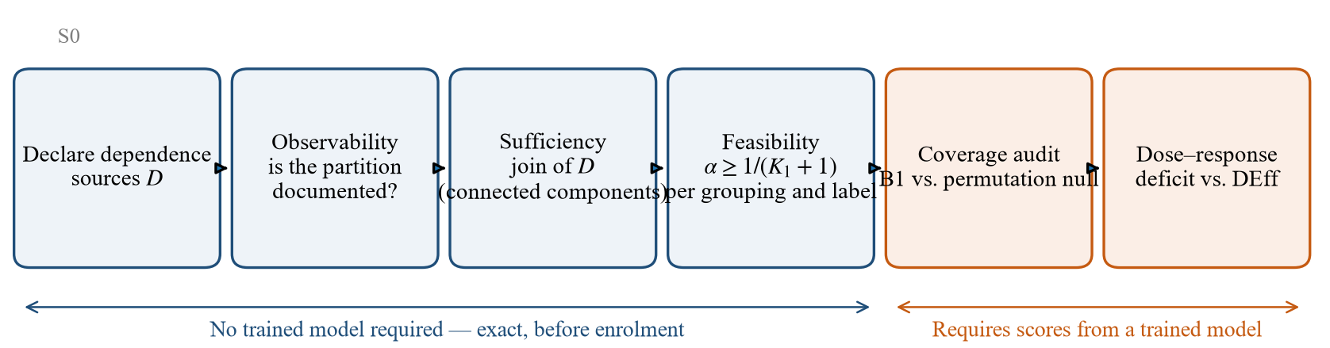
Fig. 1. Audit protocol. The first four steps use metadata only and return exact verdicts before any patient is enrolled or any model trained; the last two require conformity scores from a trained model.

6. Datasets
Throughout this section we distinguish statements about what is documented for a dataset from statements about what is observed in the data. The distinction matters most where the two diverge (§6.4).

6.1 Selection rationale
The three datasets serve logically distinct roles (Table II); they are not replications intended to corroborate one another.
TABLE II
ROLES OF THE THREE DATASETS.
Dataset | Role | Block identifier
PTB-XL | Primary case: patient-level dependence, multi-label targets, label hierarchy | Documented (patient_id)
MIT-BIH | Strong-dependence end of the design-effect axis | Documented (record = subject)
Challenge 2021 | Case study at the limit of observability | Not documented
The first two datasets occupy opposite corners of the space of block geometries. A single dataset, however large, cannot separate a theory that depends on the number of blocks from one that depends on the number of measurements per block, because the two quantities are fixed within it (Table III).
TABLE III
BLOCK GEOMETRY OF THE TWO PRIMARY DATASETS.
 | PTB-XL | MIT-BIH
Block unit | patient | record (subject)
Calibration blocks $K_{1}$ | 958 | 11
Harmonic mean block size $H$ | 1.05 | 1,355
Design effect | 1.02 | 703.93
Two quantities in this table are not properties of the datasets. $K_{1}$ depends on the split design: 958 is half of the 1,917 patients in our fold-9 evaluation subset, and another design would give another value. The design effect $DEff=1+(H−1)ρ$ depends on the model, because $ρ$ is the ICC of conformity scores produced by a particular backbone. Only $H$ is purely structural. The design effect should therefore not be quoted as a characteristic of either dataset.
Challenge 2021 is not used to support any claim of generality. Its role is narrow: to provide a case in which the diagnostic returns a verdict other than “admissible”. A diagnostic that has only ever returned “admissible” has not demonstrated that it discriminates.

6.2 PTB-XL
PTB-XL [18], [19] comprises 21,799 twelve-lead records from 18,869 patients, released under a permissive licence with full metadata. We use the 100 Hz variant, yielding 1,000 samples per 10-second record, band-pass filtered at 0.5–40 Hz.
Label structure. Diagnostic statements map to five non-exclusive superclasses: NORM (9,514), MI (5,469), STTC (5,235), CD (4,898), and HYP (2,649). The 27,765 superclass labels across 21,799 records confirm genuine multi-label structure, with 5,144 records carrying more than one superclass. 411 records (1.9%) carry no diagnostic superclass and are excluded from evaluation rather than assigned a default class.
Block structure. The dataset is only mildly clustered at the patient level: mean 1.155 records per patient, maximum 10, with 88.8% of patients contributing a single record. In total 5,041 records (23.1%) belong to multi-record patients. This mildness is precisely what makes PTB-XL the low-dose end of the design-effect axis.
Additional dependence sources. Beyond patient identity, the metadata exposes three further grouping variables: 51 recording sites (17 records missing), 12 nurses (1,473 missing), and 11 devices (complete). These are crossed rather than nested, which is the empirical basis for the impossibility result of Section 5.2.
Official folds. The published stratified 10-fold split is used unchanged: 17,418 records in folds 1–8, 2,183 in fold 9, and 2,198 in fold 10. No patient crosses a fold boundary. Crucially, human validation differs sharply between folds: 67.0% on average across folds 1–8 (range 64–68%), against 100% on folds 9 and 10. All confirmatory analysis is therefore confined to folds 9–10; fold 10 is reserved and has not been examined.
Demographics. Age is complete for all records (median 62); sex is recorded as 11,354 male and 10,445 female. Note that PTB-XL encodes ages above 89 as the sentinel value 300, affecting 293 records — treating this as a numeric age would corrupt any age-stratified analysis.

6.3 MIT-BIH Arrhythmia Database
The MIT-BIH Arrhythmia Database [36] contains 48 half-hour two-channel recordings at 360 Hz with beat-by-beat cardiologist annotations. Following standard practice we exclude the four paced records (102, 104, 107, 217), leaving 44.
Beat extraction. Annotations are mapped to the five AAMI classes, yielding 100,733 beats. Of these, 40 lie within 128 samples of a recording boundary and cannot yield a complete 256-sample (711 ms) window; they are dropped rather than zero-padded, leaving 100,693 beats.
Channel selection. The MLII lead is selected by name rather than by index. Record 114 stores its channels in the order [V5, MLII], so index-based selection silently substitutes a different lead for that record, with no error raised.
Class distribution. N: 90,087 · S: 2,781 · V: 7,008 · F: 802 · Q: 15. Class Q is degenerate and is reported as such throughout rather than being merged away.
Inter-patient split. We adopt the canonical DS1/DS2 partition (22 records each; 51,000 and 49,693 beats respectively after boundary removal). Across the 44 retained records, sizes range from 1,517 to 3,361 beats with median 2,257 — three orders of magnitude above PTB-XL’s block sizes, which is the property that places MIT-BIH at the high-dose end of the axis.
Known limitation, retained rather than repaired. Records 201 and 202 belong to the same subject and fall on opposite sides of the canonical split. We keep the standard partition for comparability with prior work and state the leak explicitly.

6.4 Challenge 2021 — an observability-limited case
Structure. The PhysioNet/CinC Challenge 2021 collection [37] spans seven non-duplicate source folders containing 66,416 records: ningbo 34,905; georgia 10,344; chapman_shaoxing 10,247; cpsc_2018 6,877; cpsc_2018_extra 3,453; ptb 516; st_petersburg_incart 74. The ptb-xl folder (21,837 records) is excluded as a duplicate of §6.2; the two totals sum to the official 88,253.
Header fields. In a sample of 42 headers drawn from all seven sources, the fields present were #Age, #Sex, #Dx, #Rx, #Hx, and, in five of the seven sources, #Sx. No field documented as a patient identifier was found. This is a sample, not a census, and the header schema is demonstrably not uniform across sources; we therefore claim only that no documented patient identifier appears in a sample spanning every source.
Observability. The patient partition is not observable from the documented metadata: no substantive variable is documented to determine patient membership. This is a statement about documentation, not a theorem; without patient labels it cannot be checked whether the patient partition factors through the available variables.
Repetition is documented while its identifier is not. The official documentation describes the INCART source as “74 annotated ECGs … extracted from 32 Holter monitor recordings.” Multiple records may therefore originate from the same monitoring episode, while the corresponding grouping identifier is not distributed. What is documented is the monitoring episode, not patient identity. The same holds for the excluded ptb-xl folder, whose 21,837 records derive from 18,869 patients in the original release. This closes the most dangerous reading of an unobservable partition — that there is no dependence to worry about. The documentation itself shows that the number of records exceeds the number of independent units, while the identifier needed to form blocks is absent.
Age censoring. Censoring conventions for age differ across sources: CPSC encodes ages above 89 as 92, and PTB-XL uses 300. Sentinel values are never treated as literal ages. We define $\text{age_censored}=1\{\text{age}>89\}$ and use age only where $\text{age}≤89$, with censored records forming a separate category. Averaging 92 and 300 as numbers would corrupt any age-based stratification.
Feasibility on the source partition. The source partition has $K=7$. Since $K_{1}≤K$ for any calibration split, Proposition 1 gives
$$α_{min}^{\text{source}} = \frac{1}{K_{1}+1} ≥ \frac{1}{8}=0.125.$$
If at least one source must be held out for testing, $K_{1}≤6$ and the bound tightens to $α≥1/7≈0.143$. We report the looser bound because it holds for every design. The bound concerns the source partition, not the dataset: it does not imply that no finer observable partition is admissible.
Consequence of unobservability. If the dependence partition $P$ is not observable, a guarantee that holds without knowing $P$ requires a calibration partition coarser than the join of every admissible candidate. If the candidate class were unrestricted it would include the single-block partition, yielding $α≥1/2$; for this dataset that is absurd on domain grounds — it would posit one patient contributing 66,416 ECGs across seven institutions — and we do not apply it. The correct consequence is that $K_{1}$ for the patient partition ceases to be a computable quantity and becomes an assumption about the candidate class, which an author must state. We therefore report no single $α_{min}$ for Challenge 2021.
A modelling prerequisite. The sufficiency condition of §5.2 is defined only under hierarchical exchangeability [8], i.e. when dependence is generated by a latent block structure. If dependence within an institution were continuous — for instance, similarity decaying with proximity of acquisition protocol — no partition $P$ would exist, and sufficiency would be not merely unobservable but ill-posed. The uncertainty is therefore layered: $P$ is unknown, and so is whether a model positing $P$ applies.
What we do not claim. We do not claim that Challenge 2021 cannot be used for conformal prediction, nor that its records are independent, nor that its $α_{min}$ is 0.125 (that bound applies to the source partition only), nor that $α≥1/2$ applies, nor that none of the 66,416 records carries a patient identifier (42 headers were inspected).
Cost of the verdict. All checks above required roughly 0.5 MB of downloads (70 index files and 42 headers) against a 12.6 GB dataset, and were completed before any preprocessing or model training.

7. Experimental Setup

7.1 Backbone
Conformal guarantees are model-agnostic; the backbone affects the size of prediction sets, not their validity. The primary backbone is therefore a deliberately compact 1-D convolutional network (SmallECGNet) with 104,389 parameters for the 12-lead configuration and 101,925 for single-lead. To test whether any finding depends on this choice, every audit is repeated with two 1-D residual networks following the PTB-XL benchmark family [17]: ResNet1D-34 (7,225,733 / 7,220,805 parameters) and ResNet1D-50 (15,969,413 / 15,964,485). The residual networks are trained with Adam (learning rate ${10}^{−3}$), early stopping on validation loss with patience 5, and a maximum of 25 (PTB-XL) or 30 (MIT-BIH) epochs; SmallECGNet weights are reused from the primary study without retraining.
The primary backbone reaches macro-AUROC 0.9016 on PTB-XL and accuracy 0.8690 (balanced accuracy 0.3748, macro-F1 0.3144) on MIT-BIH. The MIT-BIH figures are weak on minority classes; this affects set size and not coverage.

7.2 Splits
PTB-XL. Folds 1–6 for training, fold 7 for validation, fold 9 for calibration and evaluation, split at the patient level and repeated 200–400 times. Folds 8 and 10 are untouched: fold 8 because its label quality differs from fold 9, and fold 10 because it is reserved for a single final confirmatory evaluation.
MIT-BIH. DS1 minus four validation records (124, 205, 215, 230) for training; those four for validation; DS2 split 11/11 at the record level for calibration and evaluation, repeated 200–400 times.

7.3 Conformity scores
For multi-class MIT-BIH we use $s(x,y)=1−{\hat{p}}_{y}(x)$. For multi-label PTB-XL the per-label score is $1−{\hat{σ}}_{ℓ}(x)$, and the record-level score for superset coverage is the maximum over true labels — the construction that, as noted in §5.3.1, reduces exactly to scalar HCP.

7.4 Methods compared
The audit compares two procedures: split conformal prediction calibrated as if records or beats were exchangeable (B1), and HCP calibrated at the block level (B12) [8]. The question is whether a guarantee can be enforced at all, not which hierarchical construction is most efficient; the alternatives of Dunn et al. [10] and non-hierarchical variants such as Mondrian conformal prediction are therefore outside the scope of the comparison.

7.5 Statistical analysis
The procedures are summarised in Table IV. Every resampling step operates on blocks — patients or records — never on individual records or beats, since doing otherwise would reproduce the error this paper analyses.
TABLE IV
STATISTICAL PROCEDURES.
Quantity | Procedure
Coverage and set size | Mean over 200 random block-level splits; 2.5–97.5% range across splits
B1 deficit against the permutation null | Percentile bootstrap (4,000 resamples of split-level coverage), 95% CI; one-sided bootstrap $p$
Multiplicity | Holm–Bonferroni across the three $α$ levels within each backbone
Factorial effects | Percentile bootstrap (3,000 resamples of 400 split-level values), 95% CI
Monotonicity in dependence | Spearman correlation, $p<0.05$
Sensitivity to checkpoint | Agreement of signs between best-validation and last-epoch weights
Friedman and Nemenyi tests are not used. The procedure of Demšar is designed for comparing many classifiers across many datasets, conventionally at least five; with two datasets it is uninformative.

7.6 Reproducibility
All experiments run on CPU (2 threads). Every reported figure is written to a JSON artefact under results/raw/ recording the configuration that produced it. Random seeds are fixed and stated. Dataset caches are written atomically — to a temporary file followed by an atomic rename — so that an interrupted run cannot leave a partially written cache that a later run would silently treat as valid.

8. Results
We report results in the order of the audit: first what can be decided before any model is trained (§8.1), then what a trained model reveals about coverage (§8.2), whether the observed deficit is attributable to dependence (§8.3), how it scales with the design effect (§8.4), and how robust these findings are to the choice of backbone and checkpoint (§8.5).
Throughout, B1 denotes split conformal prediction calibrated as if records (or beats) were exchangeable, and B12 denotes hierarchical conformal prediction (HCP) [8] calibrated at the block level. $K_{1}$ is the number of calibration blocks and $α_{min}=1/(K_{1}+1)$ the smallest error rate at which HCP returns a finite threshold (Proposition 1).

8.1 Feasibility is decided by the partition, not by the model
Granularity. Table V applies Proposition 1 to the PTB-XL calibration fold (fold 9, 2,183 records) under each candidate grouping. Blocking by patient is feasible at every conventional $α$. Every coarser source restricts the admissible range: nurse and device exclude $α=0.05$, and strat_fold admits only $α=0.20$.
TABLE V
FEASIBILITY OF HCP ON PTB-XL FOLD 9 BY GROUPING.
Grouping | Blocks (all folds) | $K_{1}$ | Mean block size | $α_{min}$ | 0.01 | 0.05 | 0.10 | 0.20
patient_id | 18,869 | 1,942 | 1.12 | 0.00051 | ✓ | ✓ | ✓ | ✓
site | 51 | 40 | 54.55 | 0.02439 | — | ✓ | ✓ | ✓
nurse | 12 | 12 | 163.42 | 0.07692 | — | — | ✓ | ✓
device | 11 | 11 | 198.46 | 0.08333 | — | — | ✓ | ✓
strat_fold† | 10 | 8 | 2,179.90 | 0.11111 | — | — | — | ✓
† Applicable only if calibration draws on folds 1–8.
Fig. 2 places every grouping on the feasibility frontier, together with the joins discussed below and the MIT-BIH record partition.
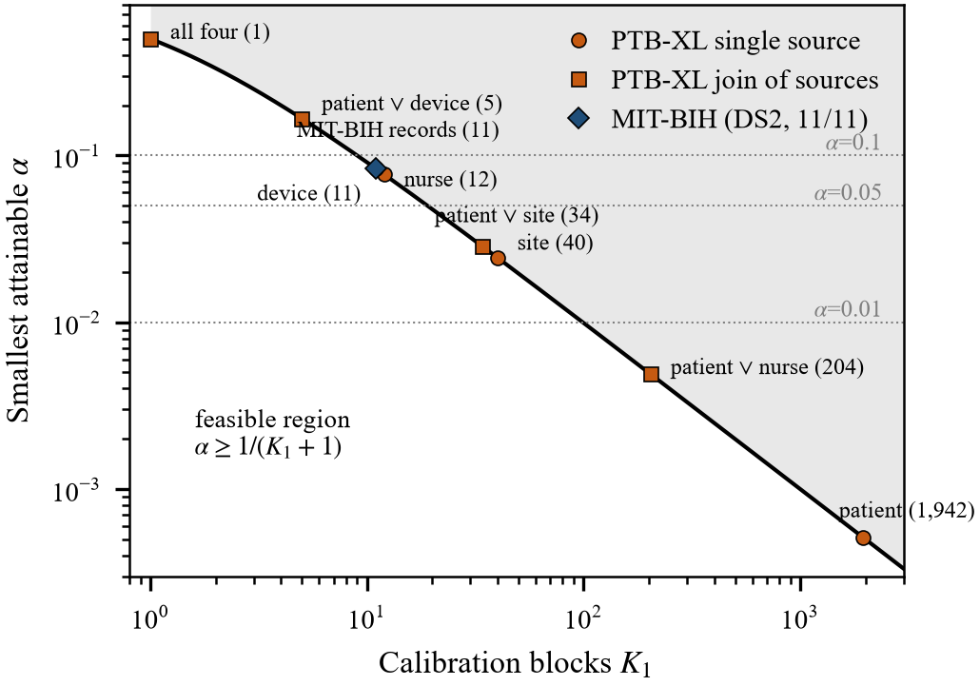
Fig. 2. Feasibility frontier $α_{min}=1/(K_{1}+1)$. Each marker is a calibration grouping on PTB-XL fold 9 (circles: single dependence source; squares: join of sources) or the MIT-BIH record partition (diamond). Values in parentheses are $K_{1}$. A grouping supports a guarantee at level $α$ only if its marker lies below the corresponding dotted line.
The feasibility of site at $α=0.05$ requires qualification. Of the 40 sites in fold 9, 37 occur only among the 223 records whose nurse field is empty; the 1,960 records with complete metadata come from 3 sites. The admissibility of site-level blocking therefore rests on a metadata-incomplete minority that appears to reflect a different collection regime.
Crossed sources. Dependence sources in PTB-XL are crossed rather than nested: 46 patients span more than one site, 247 more than one nurse, and 174 more than one device. Controlling several sources jointly therefore requires their join (connected components), which coarsens rapidly. On all 2,183 records, controlling patient and device leaves $K_{1}=5$ ($α_{min}=0.167$), and controlling all four sources leaves a single block ($α_{min}=0.5$). Restricting to the 1,960 records with complete metadata and enumerating all 15 joins of the four declared sources, 8 satisfy sufficiency (every source nested within the grouping), and all 8 have $K_{1}=1$. If patient, site, nurse, and device are all treated as dependence sources, no admissible calibration grouping exists at any conventional $α$. The conclusion is conditional on that declaration, which cannot be verified from data (§10.5); the collapse of joined partitions into a giant component is itself known [34].
Labels. The bound applies per label when coverage is required conditional on a label (Proposition 4, a necessary condition). Table VI shows how the feasible region shrinks as the PTB-XL hierarchy is refined. At the superclass level every label is feasible. At the finest level, 24 of 44 SCP codes fail the necessary condition at $α=0.05$; 2AVB has a single calibration block. Under a Bonferroni requirement across labels, 43 of 44 codes are infeasible at a family-wise $α=0.05$. Monotonicity along the hierarchy held in all 23 parent–child pairs. The same boundary appears in MIT-BIH, where class Q occupies $K_{1}=2$ records ($α_{min}=0.333$).
$α≥1/(K_{1}(ℓ)+1)$TABLE VI
LABELS FAILING THE NECESSARY CONDITION , PTB-XL FOLD 9, PATIENT BLOCKS.
Level | Labels $m$ | $K_{1}(ℓ)$ range | Fail at 0.01 | Fail at 0.05 | Fail at 0.10 | Fail at 0.05 / $m$
Superclass | 5 | 242–905 | 0 | 0 | 0 | 0
Subclass | 23 | 2–905 | 15 | 6 | 4 | 22
SCP code | 44 | 1–905 | 36 | 24 | 12 | 43
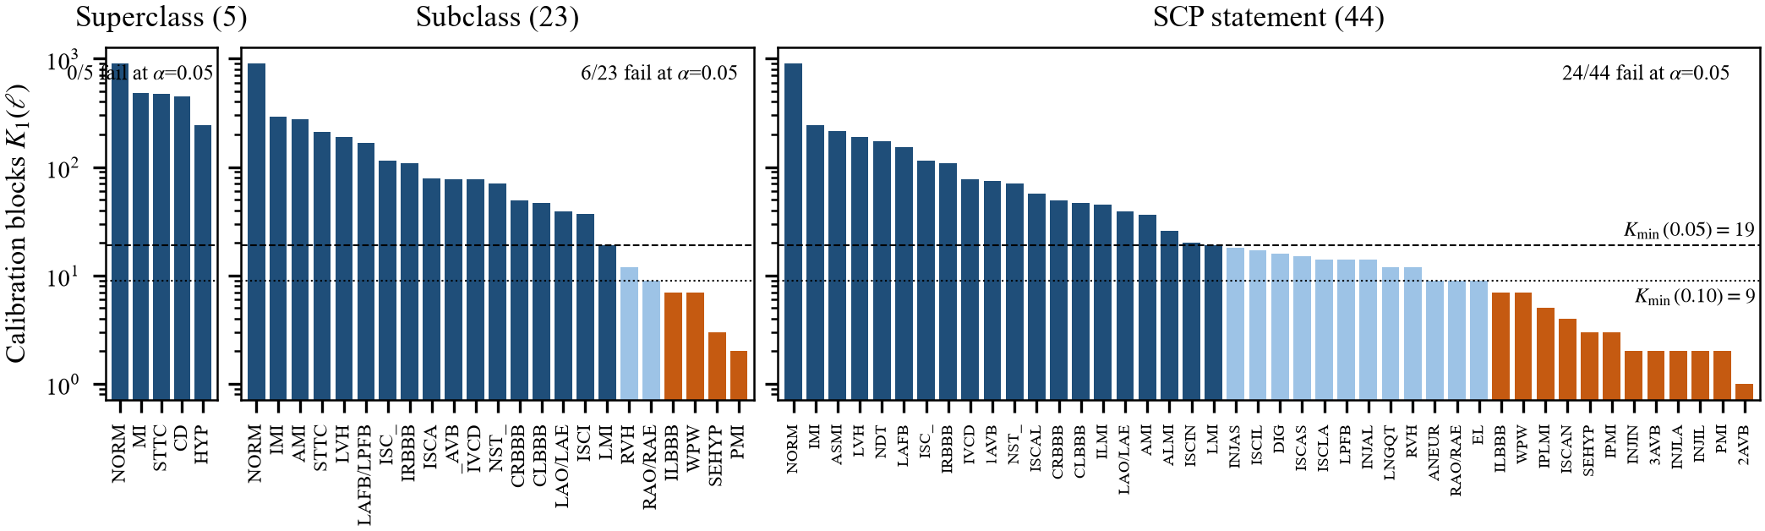
Fig. 3. Calibration blocks carrying each label, by level of the PTB-XL hierarchy (fold 9, patient blocks; log scale). Dashed and dotted lines mark the minimum number of blocks for a finite per-label threshold at $α=0.05$ and $α=0.10$. Dark bars meet the $α=0.05$ requirement, light bars only the $α=0.10$ requirement, and orange bars neither.
None of §8.1 involves a trained model. These verdicts are exact, carry no sampling error, and can be computed before a single patient is enrolled.

8.2 Coverage under block dependence
Table VII and Fig. 4 report coverage and set size on MIT-BIH (beats within records, 22 evaluation records split 11/11, 200 record-level splits) and PTB-XL (records within patients, fold 9 split at patient level, 200 splits), using the primary backbones of the feasibility study.
TABLE VII
COVERAGE (MEAN OVER SPLITS, WITH 2.5–97.5% RANGE ACROSS SPLITS) AND MEAN SET SIZE.
Dataset | $α$ | B1 coverage | B12 coverage | $|C|$ B1 | $|C|$ B12
MIT-BIH | 0.01‡ | 0.9673 [0.9137, 0.9997] | 1.0000 | 2.695 | 5.000
 | 0.05‡ | 0.9398 [0.8045, 0.9974] | 1.0000 | 1.690 | 5.000
 | 0.10 | 0.8851 [0.6887, 0.9788] | 0.9615 | 1.051 | 2.434
 | 0.15 | 0.8279 [0.6151, 0.9602] | 0.9234 | 0.924 | 1.443
 | 0.20 | 0.7764 [0.5542, 0.9462] | 0.8642 | 0.834 | 1.001
PTB-XL | 0.01 | 0.9910 [0.9823, 0.9972] | 0.9912 | 3.769 | 3.788
 | 0.05 | 0.9511 [0.9318, 0.9673] | 0.9510 | 2.741 | 2.742
 | 0.10 | 0.9010 [0.8741, 0.9256] | 0.9002 | 2.248 | 2.240
‡ Below $α_{min}=1/12$: HCP returns the full label set for every test beat.
Three observations follow. First, on MIT-BIH the mean coverage of B1 lies below $1−α$ at every level, by 1.0–2.4 percentage points, while on PTB-XL it lies at or above nominal. Second, the split-to-split range on MIT-BIH is wide enough to contain $1−α$ at every level; with 11 test records, no single split can reveal a deficit of this size, and the comparison of means alone is not a test. Third, B12 coverage must be read together with set size: at $α=0.10$ HCP attains 0.9615 with 2.43 labels out of 5, against 1.05 for B1. Below $α_{min}$ its “perfect” coverage is abstention.
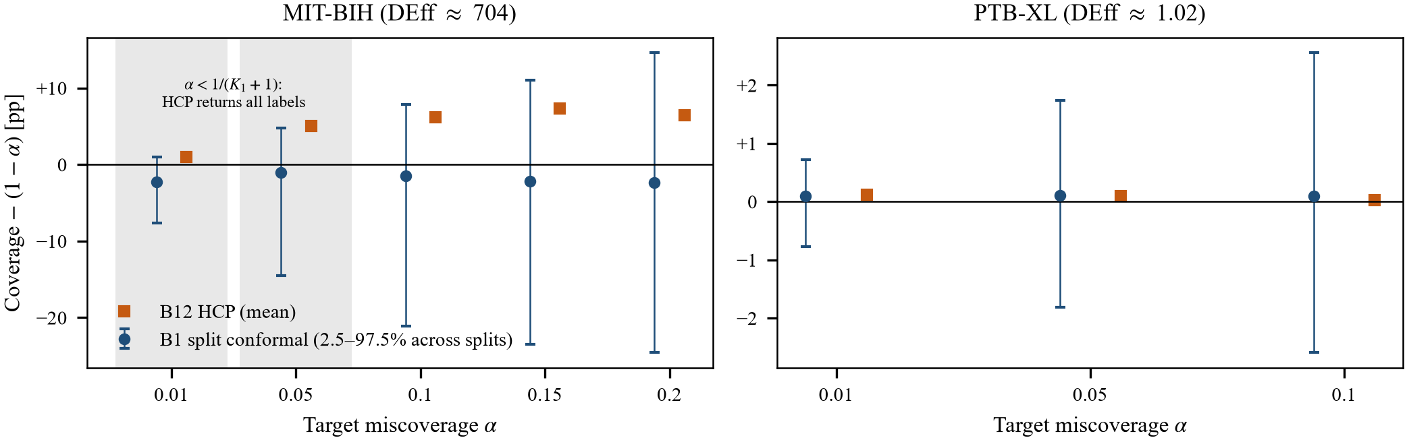
Fig. 4. Coverage minus nominal $1−α$ for split conformal (B1, mean with 2.5–97.5% range across 200 block-level splits) and HCP (B12, mean), primary backbone. Shaded MIT-BIH levels lie below $α_{min}=1/12$, where HCP returns every label. Note the different vertical scales.

8.3 The deficit is attributable to dependence
Permutation null. To test whether B1 under-covers because of dependence, we compared it with a matched null: beat-to-record assignments in DS2 were permuted, preserving $K_{1}=11$, the multiset of block sizes, and the marginal score distribution exactly, while reducing the score ICC from 0.519 to 0.000. The B1 deficit relative to this null is positive at all three feasible levels and significant at each after Holm correction across levels (Table VIII, first row; adjusted one-sided $p≤0.0075$).
TABLE VIII
MIT-BIH: B1 DEFICIT AGAINST THE PERMUTATION NULL, PP [95% CI], WITH THE NUMBER OF LEVELS SIGNIFICANT BY 95% CI AND AFTER HOLM CORRECTION.
Backbone | Score ICC | $α=0.10$ | $α=0.15$ | $α=0.20$ | CI | Holm
SmallECGNet | 0.519 | +1.49 [0.34, 2.71] | +2.21 [0.85, 3.60] | +2.37 [0.79, 3.93] | 3/3 | 3/3
ResNet1D-34 | 0.436 | +1.15 [0.10, 2.23] | +1.02 [−0.16, 2.23] | +0.81 [−0.59, 2.17] | 1/3 | 0/3
ResNet1D-50 | 0.462 | +2.54 [1.25, 3.87] | +3.42 [1.91, 4.98] | +3.18 [1.54, 4.82] | 3/3 | 3/3
The same control shows why the comparison of B12 with B1 is not informative. Under permutation, where no dependence remains, the B12−B1 gap persists at 81–107% of its original size: HCP’s finite-block correction forces it to the $(1−α)(K_{1}+1)/K_{1}$ quantile regardless of dependence. We therefore withdrew “B12 improves on B1” as a criterion (§10.4) and rely on the deficit against the permutation null throughout.
Factorial decomposition. A 2×2 design crossed clustering (original vs. randomised record membership) with block-size balance (balanced vs. imbalanced), at fixed calibration size. Clustering reduced coverage by 1.22, 1.55 and 1.49 pp at $α=0.10,0.15,0.20$, with intervals excluding zero at every level (e.g. $[−1.84,−0.63]$ pp at 0.10). The imbalance effect (−0.44, −0.26, −0.27 pp) and the interaction were not significant at any level. Block-size imbalance, a plausible alternative explanation, does not account for the deficit.

8.4 The deficit tracks the design effect
To vary dependence within a single dataset, a fraction $p$ of MIT-BIH beats was reassigned to random records, with blocks held at a uniform size of 1,355 beats so that imbalance plays no role (11 values of $p$, 300 splits each). The score ICC falls from 0.519 at $p=0$ to 0.0001 at $p=1$. Because blocks are uniform and calibration is subsampled, deficits in this design are smaller than in §8.3 (0.65 pp at $p=0$, $α=0.10$).
Per point, every interval contains zero; the evidence lies in the trend, which is what the pre-registered Spearman criterion tests (Table IX). Within MIT-BIH, deficit increases with ICC at all three levels. Adding PTB-XL as a twelfth point requires a common axis. ICC does not provide one: PTB-XL has a patient-level ICC of 0.352, comparable to a MIT-BIH point with a deficit of 0.35 pp, yet shows no deficit. The design effect $DEff=1+(H−1)ρ$, with $H$ the harmonic mean block size, does: $H=1.05$ gives PTB-XL a DEff of 1.02, against 704 for intact MIT-BIH. We use DEff as a summary axis, not as a sufficient statistic; see [33] for an exceedance-specific design effect. On this axis the combined correlation remains positive and significant (Fig. 5). Because the ICC of Proposition 2 concerns the coverage indicator rather than raw scores, we recomputed the curve with the indicator ICC at a fixed threshold; the conclusion is unchanged.
TABLE IX
SPEARMAN CORRELATION BETWEEN DEPENDENCE AND COVERAGE DEFICIT.
Axis | Points | $α=0.10$ | $α=0.15$ | $α=0.20$
Score ICC, MIT-BIH only | 11 | 0.88 ($p=0.0003$) | 0.78 ($p=0.0045$) | 0.80 ($p=0.0031$)
DEff, MIT-BIH + PTB-XL | 12 | 0.84 ($p=0.0006$) | 0.80 ($p=0.0016$) | 0.85 ($p=0.0005$)
Indicator DEff, MIT-BIH + PTB-XL | 12 | 0.90 ($p<0.0001$) | 0.80 ($p=0.0016$) | 0.71 ($p=0.010$)
The combined correlation is driven by the internal MIT-BIH gradient; PTB-XL serves as a prediction check at the low-dependence end, not as an independent trend (§10.3). PTB-XL’s deficits on this protocol are −0.05, −0.12 and −0.16 pp, i.e. slight over-coverage, with every interval containing zero.
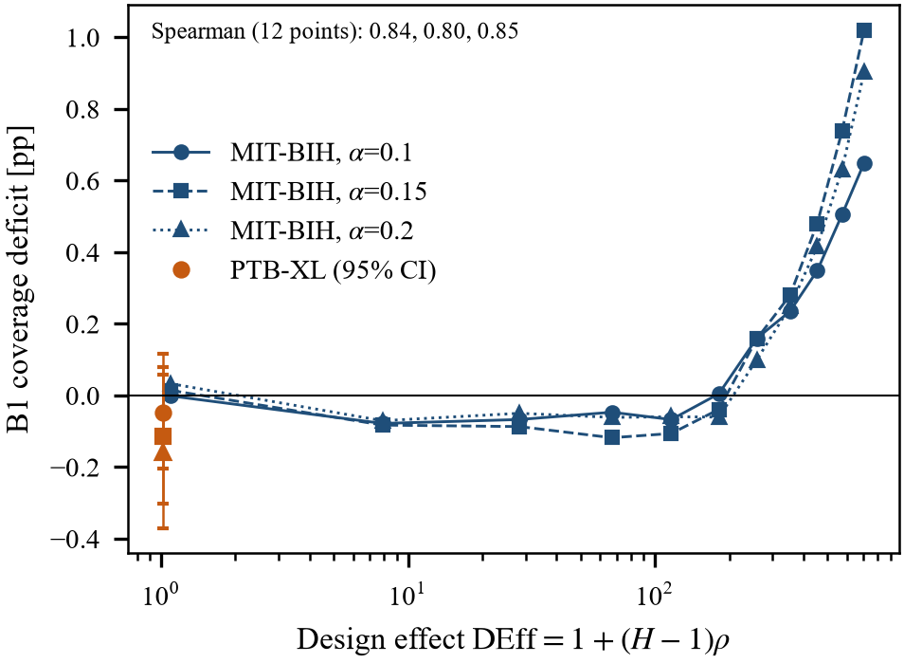
Fig. 5. B1 coverage deficit against the design effect. MIT-BIH points (blue) are obtained by randomly reassigning a growing fraction of beats to other records at a fixed block size; PTB-XL (orange) is the observed patient partition with 95% CI. The annotation gives the Spearman correlation over the 12 points at $α=0.10,0.15,0.20$.

8.5 Robustness to backbone and checkpoint
Backbone. We repeated the audit with two 1-D residual networks of roughly 70- and 155-fold the parameter count of the primary backbone (Table X). Discrimination responded unevenly to capacity: MIT-BIH accuracy rose from 0.869 to 0.926, but balanced accuracy stayed at 0.370–0.376, and PTB-XL macro-AUROC fell slightly from 0.902 to 0.896. $K_{1}(ℓ)$ was identical across backbones on both datasets, as it must be; this serves as a negative control on the pipeline.
TABLE X
DISCRIMINATION BY BACKBONE.
Backbone | Parameters (MIT-BIH / PTB-XL) | MIT-BIH accuracy | MIT-BIH balanced acc. | PTB-XL macro-AUROC
SmallECGNet | 101,925 / 104,389 | 0.869 | 0.375 | 0.902
ResNet1D-34 | 7,220,805 / 7,225,733 | 0.922 | 0.376 | 0.897
ResNet1D-50 | 15,964,485 / 15,969,413 | 0.926 | 0.370 | 0.896
On PTB-XL, B1 attained nominal coverage in all 9 backbone×$α$ cells (mean deficit +0.05 to +0.19 pp above nominal). On MIT-BIH, the permutation test of §8.3 was repeated for each backbone under a criterion fixed beforehand: significance at every feasible $α$ (Table VIII, Fig. 6).
The deficit is positive in all 9 cells. By 95% interval it is significant in 7; after the pre-specified Holm correction across the three levels it is significant at every level for SmallECGNet and ResNet1D-50 (adjusted $p≤0.0075$ and $p=0.0007$), but at none for ResNet1D-34 (adjusted $p=0.050$, $0.095$, $0.127$). The criterion therefore fails for ResNet1D-34. We claim that the direction of the contrast between datasets is invariant to the backbone, but not that its statistical strength is. The mechanical share of the B12−B1 gap under permutation was 75–110% across the three backbones, confirming the withdrawal of that criterion beyond the primary model.
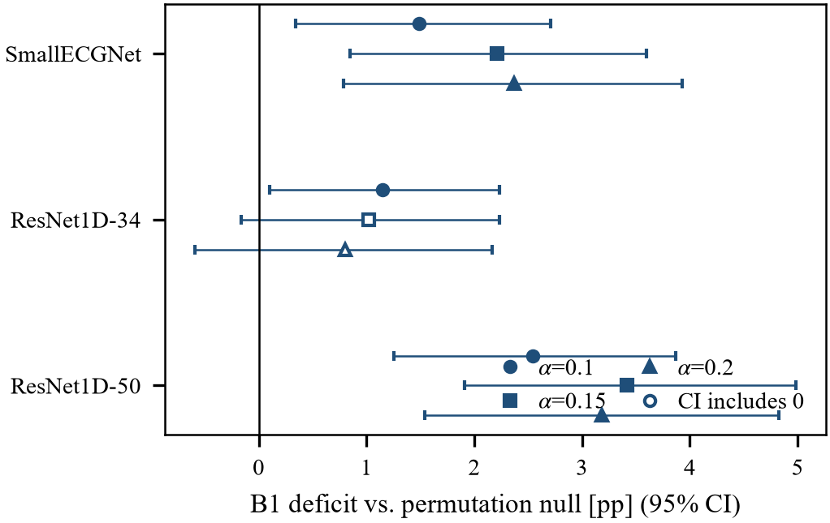
Fig. 6. MIT-BIH B1 coverage deficit against the matched permutation null, by backbone and $α$ (point estimate and 95% bootstrap CI). Open markers denote intervals that include zero.
Checkpoint. The MIT-BIH validation set holds 4 records, and early stopping selected epoch 1 for ResNet1D-50. A pre-registered sensitivity analysis repeated the audit with last-epoch weights for both residual networks on both datasets (MIT-BIH epochs 13 vs. 8 and 6 vs. 1; PTB-XL 14 vs. 9 and 12 vs. 7). The sign of the B1 deficit agreed in all 16 backbone×dataset×$α$ cells, and $K_{1}(ℓ)$ was identical. The magnitude did not agree: it moved by up to 1.8 pp on MIT-BIH, enough to reorder the backbones. Differences in deficit magnitude between backbones are therefore not interpreted.

9. Discussion
[NOT YET WRITTEN]

10. Threats to Validity

10.1 Internal validity
Label provenance. PTB-XL diagnostic statements derive from clinical reports and carry likelihood annotations. Only 64–68% of records in folds 1–8 were validated by a human cardiologist, against 100% in folds 9 and 10. An early version of our feasibility study calibrated on fold 8 and evaluated on fold 9, and reported an apparent 1.43 percentage-point coverage deficit at $α=0.05$. That deficit was an artefact of label-quality shift between folds, not of block dependence. All confirmatory analyses are therefore restricted to folds 9 and 10, both fully human-validated; fold 10 is reserved and has not been examined.
Records without a superclass label. 411 of 21,799 records (1.9%) carry no diagnostic superclass. These are excluded from evaluation rather than assigned a default class, which would fabricate labels.
Channel ordering in MIT-BIH. Record 114 stores its leads in the order [V5, MLII] rather than the conventional [MLII, V5]. Selecting channel 0 by index — the natural implementation — silently trains on a different lead for that record, with no error and no trace in any log. Our loader selects by channel name. We report this because the failure mode is invisible to standard checks.
Boundary beats. 40 of 100,733 AAMI-mappable beats lie within 128 samples of a record boundary and cannot yield a complete 256-sample window. They are dropped rather than zero-padded, leaving 100,693.
Subject overlap in the canonical MIT-BIH split. Records 201 and 202 belong to the same subject and are assigned to DS1 and DS2 respectively by the standard inter-patient partition. This is a mild train/evaluation leak inherent to the canonical split. We retain the split for comparability with prior work and state the leak explicitly rather than silently repairing it.
Preprocessing leakage. All transformations are fitted on training data only and applied within the pipeline.

10.2 Construct validity
Degenerate class. MIT-BIH class Q contains 15 beats in total across DS1 and DS2 — 8 in the training split and 7 in DS2, distributed over only 2 records. Any per-class statistic for Q is uninterpretable. We report per-class $K_{1}(ℓ)$ so that the reader can see the feasibility boundary directly: $K_{1}(Q)=2$ gives $α_{min}=0.333$, far above any error rate of practical interest.
Model quality is not a threat to validity, but is a threat to efficiency. Conformal guarantees are model-agnostic: a weak model widens $|\hat{C}|$ without reducing coverage. Our PTB-XL backbone reaches macro-AUROC 0.9016 against a published benchmark of approximately 0.93, and our MIT-BIH backbone reaches accuracy 0.8690 with balanced accuracy 0.3748 and macro-F1 0.3144 — weak on minority classes. These figures affect the size of reported prediction sets and must not be read as evidence about coverage.
We tested this directly rather than asserting it. On MIT-BIH the audit was repeated with three backbones spanning a 157-fold range in parameter count (101,925; 7,220,805; 15,964,485). Accuracy rose from 0.869 to 0.926, while balanced accuracy stayed at 0.370–0.376. $K_{1}(ℓ)$ is identical across backbones, as it must be, since it depends on the partition alone; this serves as a negative control on the pipeline.
Two readings of the MIT-BIH cells must be kept apart. The point estimate of naive split-conformal coverage lies below $1−α$ in all 15 backbone×$α$ cells, but its interval across splits contains $1−α$ in every one of them: with 11 test records, split-to-split variability swamps a deficit of 1–3 pp. And the observation that HCP “restores” coverage is not evidence at all — below $α=1/12$ HCP returns the full label set, and above it 75–110% of the HCP−B1 gap reappears under a permutation that destroys dependence. The test we rely on is therefore the deficit of B1 against that matched permutation null, re-run for each backbone under a criterion fixed beforehand (significance at every feasible $α$, with Holm correction across levels). The deficit is positive in 9/9 cells and significant in 7/9 by 95% interval. After Holm correction it remains significant at every level for the smallest and largest backbone but at none for ResNet1D-34 (adjusted $p=0.050$, $0.095$, $0.127$). The pre-registered criterion thus fails for one backbone, and we do not claim backbone-invariant significance. On PTB-XL, the same three architectures (104,389; 7,225,733; 15,969,413 parameters) reach macro-AUROC 0.902, 0.897 and 0.896 — the larger models are not better — and in all 9 backbone×$α$ cells naive split conformal attains nominal coverage (deficit $+0.05$ to $+0.19$ pp), as predicted at $DEff≈1$. The direction of the contrast between datasets is invariant to the backbone; its statistical strength on MIT-BIH is not.
Checkpoint selection on a small validation set. The MIT-BIH validation set comprises only 4 records, and its loss is noisy (0.13–0.56 across epochs). Under our pre-specified rule, early stopping selected the epoch-1 weights for the largest backbone. A reviewer may fairly object that this model is under-trained. Before examining any result, we pre-registered a sensitivity analysis: repeat the audit with the last-epoch weights and require that (S-1) whether HCP improves on B1 and (S-2) the sign of the B1 deficit agree at every $α$, and that (S-3) $K_{1}(ℓ)$ be identical. All four trained backbone×dataset pairs pass all three criteria at every $α$ (MIT-BIH: epoch 8 vs 13, 1 vs 6; PTB-XL: 9 vs 14, 7 vs 12). The primary selection rule was not altered. We note that S-1 inherits the mechanical character of the HCP−B1 gap described above; S-2 and S-3 carry the information.
Subgroup definitions are researcher choices. Sensitivity to alternative grouping schemes is examined explicitly.
Randomised recording dates. PTB-XL shifts recording_date by a random offset per patient. Absolute dates are therefore meaningless, while intra-patient intervals are preserved because the offset is constant within a patient. All temporal analysis is restricted to intra-patient intervals; no calendar-based temporal split is performed.

10.3 External validity
Single institution, dated acquisition. PTB-XL was collected at one site between October 1989 and June 1996 on Schiller AG hardware. Device, nurse, and site metadata are available, which is precisely why the dataset supports the block-structure analysis; but the resulting estimates of $ρ$ and $H$ should not be assumed to transfer to modern multi-centre cohorts.
Two datasets, twelve points, one of them external. The dose–response curve in §8 comprises 11 synthetic points generated within MIT-BIH by progressively randomising block membership, plus a single point from PTB-XL. The combined Spearman correlation is therefore driven by the internal MIT-BIH gradient. PTB-XL’s role is a prediction check, not an independent trend: the theory predicts negligible deficit at $DEff≈1$, and PTB-XL — a different modality (12-lead against single-lead), a different task (multi-label against multi-class), and a different block type (patient against record) — lands where predicted. We claim no more than that.
Synthetic weakening of dependence. The MIT-BIH points are produced by randomly reassigning record labels to a fraction $p$ of beats, not by observing cohorts with naturally differing $ρ$. The construction preserves the block-size multiset and the marginal score distribution, and drives ICC from 0.5192 at $p=0$ to 0.0001 at $p=1$; but it is an intervention, not an observation.
Resampling reuses the same 22 records. All MIT-BIH confidence intervals derive from repeated splits of a fixed set of 22 DS2 records. They quantify variability across splits, not across the population of patients. With 22 subjects, generalisation beyond MIT-BIH is correspondingly limited.
Domain specificity. Results are established on ECG. Replication on a non-medical benchmark would be required before claiming framework generality.

10.4 Conclusion validity
Per-point deficits are not individually significant. In the dose–response analysis every per-point confidence interval contains zero. The evidence rests on the monotone trend across points, which is exactly what the pre-registered Spearman criterion tests. Presenting individual points as significant would misstate the result.
Coverage must be read jointly with set size. At $α=0.10$ on MIT-BIH, HCP attains 0.9615 coverage against B1’s 0.8851 — but at an average set size of 2.43 labels out of 5, against B1’s 1.05. Reporting coverage alone would make HCP appear uniformly superior when much of the gain is abstention.
Direction is robust; magnitude is not. The same sensitivity analysis shows that the size of the B1 deficit moves by up to 1.8 percentage points between checkpoints of a single backbone (e.g. $−3.41$ to $−1.70$ pp at $α=0.15$), and that the ordering of backbones by deficit magnitude changes with it. An apparent non-monotone relation between capacity and deficit magnitude, visible in the primary analysis, therefore lies within checkpoint noise. We claim only the direction of the effect.
Boundary cells. Coverage is a discrete proportion, so percentile intervals can end exactly at zero. Three PTB-XL intervals for the B12−B1 difference do so. Our pre-specified rule declares an improvement only when the lower bound is strictly positive, and these cells are classified accordingly; the verdict in them rests on that strictness.
A criterion we pre-registered turned out to be near-vacuous. Our initial test of H0b asked whether HCP improves coverage over naive split conformal. A permutation control showed that at $K_{1}=11$ the $+∞$ atom mechanically forces HCP to the $(1−α)(K_{1}+1)/K_{1}$ percentile — predicted 0.9818/0.9273/0.8727 against observed 0.9819/0.9273/0.8729. Between 81% and 107% of the apparent improvement is mechanical and carries no information about dependence. The criterion is withdrawn; the evidence we report instead is the deficit of naive split conformal against a matched permuted null.
A pre-registered criterion that could not be executed as written. The protocol specified a Spearman correlation between design effect and coverage deviation across datasets. With two datasets, $ρ_{S}$ can only take the values $±1$ and no $p$-value is defined. This is a defect in our own pre-registration. We replaced it with a within-MIT-BIH test over multiple design-effect points, and record the substitution as a deviation.

10.5 Theoretical threats
Assumption (A) is a modelling choice. Propositions 2 and 2′ assume a one-way random-effects model for the score indicator. Proposition 1 and the feasibility results of §5.2–5.3 are distribution-free and do not depend on it. We keep the two classes of claim separated throughout.
A further gap deserves explicit treatment. Proposition 2 is stated for the ICC of the indicator $1\{s≤t\}$, whereas the dose–response analysis is more conveniently computed on raw scores. We therefore recomputed the entire curve using the indicator ICC at a fixed threshold. The conclusion is unchanged: Spearman $+0.90/+0.80/+0.71$, all $p<0.05$, against $+0.84/+0.80/+0.85$ with raw scores. The value of $ρ$ does shift — PTB-XL falls from 0.3525 to 0.19–0.20 — but its design effect remains $≈1.01$ and its position on the curve does not move. The prediction survives on the quantity the theory actually specifies.
Scope of the impossibility result. Corollary 3.2 is proved for the HCP/Dunn family. Whether it holds for every distribution-free method that relies on exchangeability between blocks remains an open question. The collapse of joined partitions into a giant component is not itself new [34]. On PTB-XL, the check is exhaustive only with respect to the declared sources {patient, site, nurse, device}: of the fifteen joins, eight satisfy sufficiency and all eight collapse to a single block. That set cannot be verified from data. Restricting it to {patient, site} yields $K_{1}=34$ on the full calibration fold, and $α=0.05$ becomes feasible — but 31 of those 34 blocks consist solely of 188 records (8.6%) that lack nurse metadata and come from 37 small sites, apparently a different collection regime. Among the 1,960 records with complete metadata, the same restriction gives $K_{1}=3$. Feasibility under {patient, site} therefore rests on a metadata-incomplete minority. We therefore state the result conditionally: if patient, site, nurse, and device are all treated as dependence sources, no admissible calibration grouping exists at any conventional $α$.
Formal proofs require statistical review. All derivations in §5 are to be reviewed by a statistician before submission.

10.6 Researcher degrees of freedom
Our interpretation of the MIT-BIH evidence reversed three times before stabilising. We report the sequence because the alternative — presenting only the final position — would conceal how the conclusion was reached (Table XI).
TABLE XI
SEQUENCE OF INTERIM CONCLUSIONS ON MIT-BIH AND THE CONTROL THAT OVERTURNED EACH.
Stage | Interim conclusion | Overturned by
1 | HCP improves on naive split conformal, confirming H0b | Permutation control: 81–107% of the gap is mechanical
2 | The deficit is driven by block-size imbalance | 2×2 factorial: imbalance significant in 0/3 settings, clustering in 3/3
3 | The deficit increases monotonically with ICC | PTB-XL: $ρ=0.3525$ yet deficit $−0.0012$
4 | The deficit tracks $DEff=1+(H−1)ρ$ | — stands
Every reversal followed the addition of a control, not a reinterpretation of existing data. Stage 2 was an error of ours: it compared results from two analyses with different calibration sizes (approximately 24,800 beats against 16,500) and attributed the difference to block balance.
Two deviations require explicit statement. First, the permutation control was added post hoc, after the pre-registered criterion produced a result we suspected was tautological. It tightened rather than relaxed the analysis: it invalidated a criterion that had supported our hypothesis. Second, the reporting axis was fixed after seeing the data — we tried ICC first and it failed to unify the two datasets. We note that $DEff=1+(H−1)ρ$ was stated as Proposition 2′ before these data were collected, and that the harmonic mean is derived from $Var(\hat{G})$ rather than chosen; but the decision to report on that axis was nonetheless made with the results in view.
A complete deviation log is maintained in the accompanying protocol.

11. Conclusion
[NOT YET WRITTEN]

References
[1] R. F. Barber, E. J. Candès, A. Ramdas, and R. J. Tibshirani, “Conformal prediction beyond exchangeability,” Ann. Statist., vol. 51, no. 2, Apr. 2023, doi: 10.1214/23-aos2276.
[2] L. Lei and E. J. Candès, “Conformal Inference of Counterfactuals and Individual Treatment Effects,” Journal of the Royal Statistical Society Series B: Statistical Methodology, vol. 83, no. 5, pp. 911–938, Nov. 2021, doi: 10.1111/rssb.12445.
[3] H. Mao, R. Martin, and B. J. Reich, “Valid Model-Free Spatial Prediction,” Journal of the American Statistical Association, vol. 119, no. 546, pp. 904–914, Apr. 2024, doi: 10.1080/01621459.2022.2147531.
[4] R. Lunde, E. Levina, and J. Zhu, “Conformal Prediction for Network-Assisted Regression,” Journal of the American Statistical Association, vol. 120, no. 551, pp. 1633–1644, Jul. 2025, doi: 10.1080/01621459.2025.2506198.
[5] A. Bhattacharyya and R. F. Barber, “Group-weighted conformal prediction,” Electron. J. Statist., vol. 20, no. 1, Jan. 2026, doi: 10.1214/26-ejs2506.
[6] M. Fontana, G. Zeni, and S. Vantini, “Conformal prediction: A unified review of theory and new challenges,” Bernoulli, vol. 29, no. 1, Feb. 2023, doi: 10.3150/21-bej1447.
[7] J.-I. Seo, Y. E. Jeon, and Y. Kim, “Calibrated Mondrian conformal prediction for uncertainty quantification in spatial modeling,” Pattern Recognition, vol. 180, Dec. 2026, doi: 10.1016/j.patcog.2026.114113.
[8] Y. Lee, R. Barber, and R. Willett, “Distribution-free inference with hierarchical data,” ACM J. Data Sci., Mar. 2026, doi: 10.1145/3786352.
[9] R. F. Barber, E. J. Candès, A. Ramdas, and R. J. Tibshirani, “Predictive inference with the jackknife+,” Ann. Statist., vol. 49, no. 1, Feb. 2021, doi: 10.1214/20-aos1965.
[10] R. Dunn, L. Wasserman, and A. Ramdas, “Distribution-Free Prediction Sets for Two-Layer Hierarchical Models,” Journal of the American Statistical Association, vol. 118, no. 544, pp. 2491–2502, Oct. 2023, doi: 10.1080/01621459.2022.2060112.
[11] H. Papadopoulos, “Conformal prediction for multi-label learning: a review of methods and guarantees,” Philosophical Transactions of the Royal Society A: Mathematical, Physical and Engineering Sciences, vol. 384, no. 2327, Art. no. 20250071, Aug. 2026, doi: 10.1098/rsta.2025.0071.
[12] L. Maltoudoglou, A. Paisios, L. Lenc, J. Martínek, P. Král, and H. Papadopoulos, “Well-calibrated confidence measures for multi-label text classification with a large number of labels,” Pattern Recognition, vol. 122, Feb. 2022, doi: 10.1016/j.patcog.2021.108271.
[13] W. Huang et al., “HmcNet: A General Approach for Hierarchical Multi-Label Classification,” IEEE Trans. Knowl. Data Eng., vol. 35, no. 9, pp. 8713–8728, Sep. 2023, doi: 10.1109/tkde.2022.3207511.
[14] M. Sun, J. Niu, X. Yang, Y. Gu, and W. Zhang, “CEHMR: Curriculum learning enhanced hierarchical multi-label classification for medication recommendation,” Artificial Intelligence in Medicine, vol. 143, Sep. 2023, doi: 10.1016/j.artmed.2023.102613.
[15] A. Baheri and M. A. Shahbazi, “Conformal prediction across scales: Finite-sample coverage with hierarchical efficiency,” Results in Applied Mathematics, vol. 26, May 2025, doi: 10.1016/j.rinam.2025.100589.
[16] B. Zhang, S. Li, and O. Bastani, “Conformal Structured Prediction,” arXiv:2410.06296, Oct. 2024.
[17] N. Strodthoff, P. Wagner, T. Schaeffter, and W. Samek, “Deep Learning for ECG Analysis: Benchmarks and Insights from PTB-XL,” IEEE J. Biomed. Health Inform., vol. 25, no. 5, pp. 1519–1528, May 2021, doi: 10.1109/jbhi.2020.3022989.
[18] P. Wagner et al., “PTB-XL, a large publicly available electrocardiography dataset,” Sci Data, vol. 7, no. 1, Art. no. 154, May 2020, doi: 10.1038/s41597-020-0495-6.
[19] P. Wagner, N. Strodthoff, R.-D. Bousseljot, W. Samek, and T. Schaeffter, “PTB-XL, a large publicly available electrocardiography dataset,” PhysioNet, ver. 1.0.3, 2022, doi: 10.13026/kfzx-aw45.
[20] F. M. Dias, H. L. M. Monteiro, T. W. Cabral, R. Naji, M. Kuehni, and E. J. d. S. Luz, “Arrhythmia classification from single-lead ECG signals using the inter-patient paradigm,” Computer Methods and Programs in Biomedicine, vol. 202, Apr. 2021, doi: 10.1016/j.cmpb.2021.105948.
[21] Y. Li, R. Qian, and K. Li, “Inter-patient arrhythmia classification with improved deep residual convolutional neural network,” Computer Methods and Programs in Biomedicine, vol. 214, Feb. 2022, doi: 10.1016/j.cmpb.2021.106582.
[22] G. Wang, M. Chen, Z. Ding, J. Li, H. Yang, and P. Zhang, “Inter-patient ECG arrhythmia heartbeat classification based on unsupervised domain adaptation,” Neurocomputing, vol. 454, pp. 339–349, Sep. 2021, doi: 10.1016/j.neucom.2021.04.104.
[23] B. Lambert, F. Forbes, S. Doyle, H. Dehaene, and M. Dojat, “Trustworthy clinical AI solutions: A unified review of uncertainty quantification in Deep Learning models for medical image analysis,” Artificial Intelligence in Medicine, vol. 150, Apr. 2024, doi: 10.1016/j.artmed.2024.102830.
[24] K. Lekadir et al., “FUTURE-AI: international consensus guideline for trustworthy and deployable artificial intelligence in healthcare,” BMJ, vol. 388, Art. no. e081554, Feb. 2025, doi: 10.1136/bmj-2024-081554.
[25] J. Vazquez and J. C. Facelli, “Conformal Prediction in Clinical Medical Sciences,” J Healthc Inform Res, vol. 6, no. 3, pp. 241–252, Sep. 2022, doi: 10.1007/s41666-021-00113-8.
[26] J. Jonkers, F. Coopman, L. Duchateau, G. Van Wallendael, and S. Van Hoecke, “Reliable uncertainty quantification for 2D/3D anatomical landmark localization using multi-output conformal prediction,” Medical Image Analysis, vol. 110, May 2026, doi: 10.1016/j.media.2026.103953.
[27] K. Tangudomkit, S. Chairat, and S. Chaichulee, “Set Prediction for Outpatient Diagnosis Coding with Sparse Mahalanobis Conformal Scoring,” BDCC, vol. 10, no. 7, Art. no. 232, Jul. 2026, doi: 10.3390/bdcc10070232.
[28] A. N. Angelopoulos, “Conformal risk control for non-monotonic losses,” Philosophical Transactions of the Royal Society A: Mathematical, Physical and Engineering Sciences, vol. 384, no. 2327, Art. no. 20250068, Aug. 2026, doi: 10.1098/rsta.2025.0068.
[29] C. Xu and Y. Xie, “Conformal Prediction for Time Series,” IEEE Trans. Pattern Anal. Mach. Intell., vol. 45, no. 10, pp. 11575–11587, Oct. 2023, doi: 10.1109/tpami.2023.3272339.
[30] I. R. White and J. Thomas, “Standardized mean differences in individually-randomized and cluster-randomized trials, with applications to meta-analysis,” Clinical Trials, vol. 2, no. 2, pp. 141–151, Apr. 2005, doi: 10.1191/1740774505cn081oa.
[31] S. M. Kerry and J. Martin Bland, “Unequal cluster sizes for trials in English and Welsh general practice: implications for sample size calculations,” Statist. Med., vol. 20, no. 3, pp. 377–390, Feb. 2001, doi: 10.1002/1097-0258(20010215)20:3<377::aid-sim799>3.0.co;2-n.
[32] D. Zhan, L. Xu, Y. Ouyang, R. Sawatzky, and H. Wong, “Methods for dealing with unequal cluster sizes in cluster randomized trials: A scoping review,” PLoS ONE, vol. 16, no. 7, Art. no. e0255389, Jul. 2021, doi: 10.1371/journal.pone.0255389.
[33] A. Noonan, “The Exceedance Design Effect: Effective Sample Size for Thresholds under Clustering,” arXiv:2608.21262, Aug. 2026.
[34] J. Zheng and G. Xu, “A Symmetric Layer-Union Audit of Component Collapse in Hierarchical Procedural Corpora,” arXiv:2608.08892, Aug. 2026.
[35] T. Ding, A. Angelopoulos, S. Bates, M. Jordan, and R. Tibshirani, “Class-Conditional Conformal Prediction with Many Classes,” in Advances in Neural Information Processing Systems 36, pp. 64555–64576, 2023, doi: 10.52202/075280-2817.
[36] G. B. Moody and R. G. Mark, “MIT-BIH Arrhythmia Database,” PhysioNet, 1992, doi: 10.13026/C2F305.
[37] M. Reyna et al., “Will Two Do? Varying Dimensions in Electrocardiography: The PhysioNet/Computing in Cardiology Challenge 2021,” PhysioNet, ver. 1.0.3, 2022, doi: 10.13026/34va-7q14.

