Android Mobile App Development Project Report

Project Name: GuiWuBen - Personal Belongings Ledger
Course: Mobile Application Development
Mid-term Project Report

Group number | To be filled
Group members | To be filled: name, student ID, email
Project type | Android native mobile application
Current progress | Core CRUD functions, local storage, navigation, sorting, and cost analysis have been implemented.

Contents
1 Introduction
2 Background
3 Project Description
3.1 Functional Module
3.2 Logical Flow
3.3 Technical Description
3.4 Code Architecture
4 App Effect
5 Problems Encountered During Development and Solutions
6 Thoughts and Reflections
7 Task Division
8 Reference Material

1 Introduction
GuiWuBen is an Android mobile application designed as a personal belongings ledger. The app helps users record items they have bought, including the item name, purchase price, and purchase date. Based on these records, the app calculates how long each item has been owned and estimates the average daily cost of use. This makes ordinary consumption records more meaningful: instead of only remembering how much an item cost at purchase time, users can understand whether the item is still providing value over time.
The current version focuses on a complete local experience. Users can add, view, edit, and delete item records, sort items by price or ownership duration, and view an asset summary on the home page. The main feature of the project is the combination of simple asset recording and cost-per-day analysis, which turns a basic list app into a lightweight tool for rational consumption and item management.

2 Background
Many students and young users buy digital products, clothes, bags, stationery, and daily-use items, but they rarely continue to evaluate the value of those purchases after the moment of payment. Existing note apps or spreadsheet apps can record this information, but they are not designed specifically for belongings management. E-commerce order pages show purchase history, but they are separated by platform and usually do not help users calculate usage value.
GuiWuBen targets users who want a simple way to manage personal belongings and review spending decisions. The app is especially suitable for students and young consumers who want to understand whether expensive items are actually used for a long enough time. By recording the purchase date and price, the app automatically turns static purchase information into dynamic value information, such as days owned and daily average cost.

Project Characteristics
Practicality: The app solves a real personal management problem by recording belongings and calculating usage value.
Innovation: Compared with a normal list or note app, GuiWuBen emphasizes daily cost and ownership duration analysis.
User experience: The main workflow is simple: open the home page, tap the add button, enter item information, and save. Editing and deletion are integrated into the item list.
Compatibility: The project uses native Android technologies and supports Android devices from minSdk 26 to targetSdk 36.
Privacy and safety: All records are stored locally through Room Database. The current version does not upload user data to a server.

3 Project Description

3.1 Functional Module
The functional design is organized around the user goal of managing personal belongings. The home page displays saved records and summary information. The add/edit page handles item input. The Room database module stores all item records locally.
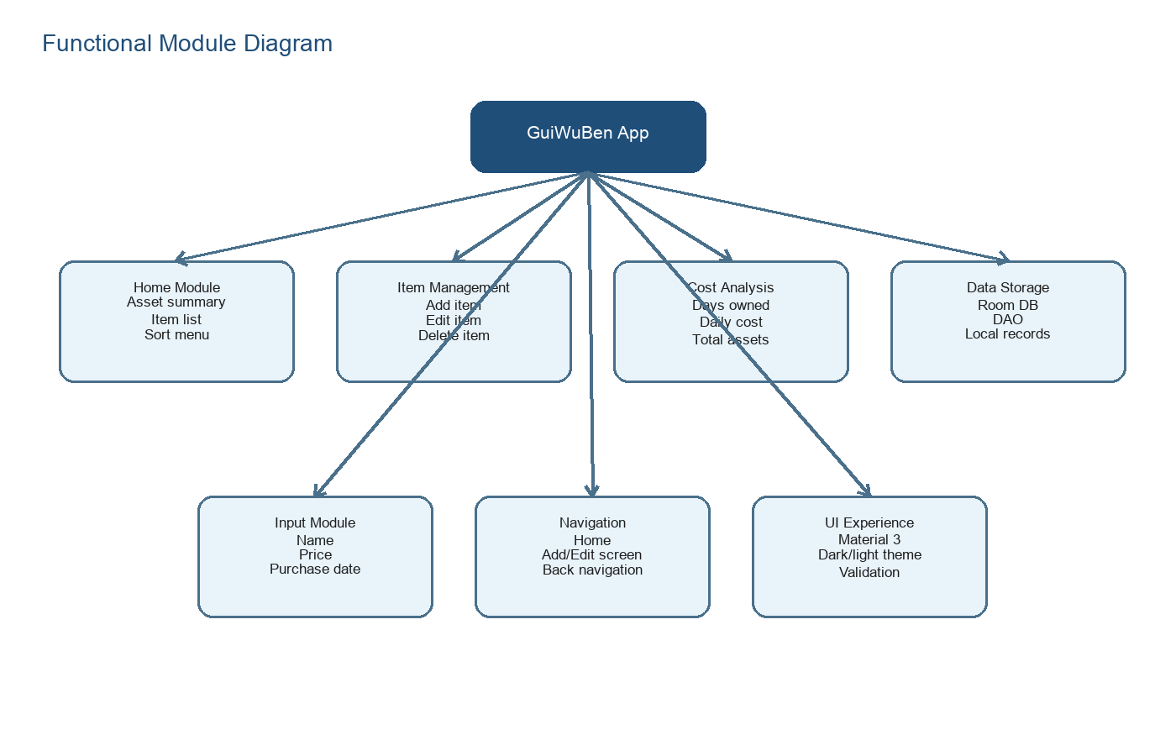
Figure 1: Functional Module Diagram
Home page module | Displays the application title, asset summary, sorting menu, item list, and floating add button.
Item input module | Allows the user to enter item name, purchase price, and purchase date. The date is selected through year, month, and day dropdowns.
Item management module | Supports adding new records, editing existing records, and deleting records from the local database.
Analysis module | Calculates total asset value, total daily cost, days owned, and daily cost for each item.
Sorting module | Supports sorting by default order, price ascending, price descending, ownership duration ascending, and ownership duration descending.
Local storage module | Uses Room Database and DAO methods to persist item records on the device.

3.2 Logical Flow
The logical flow begins when the user opens the app. The app loads saved records from the local Room database and displays them on the home page. From the home page, the user can add a new item, long press an existing item to edit or delete it, or choose a sorting rule from the menu. After the user saves or deletes data, the list is refreshed automatically because the DAO returns data as a Flow.
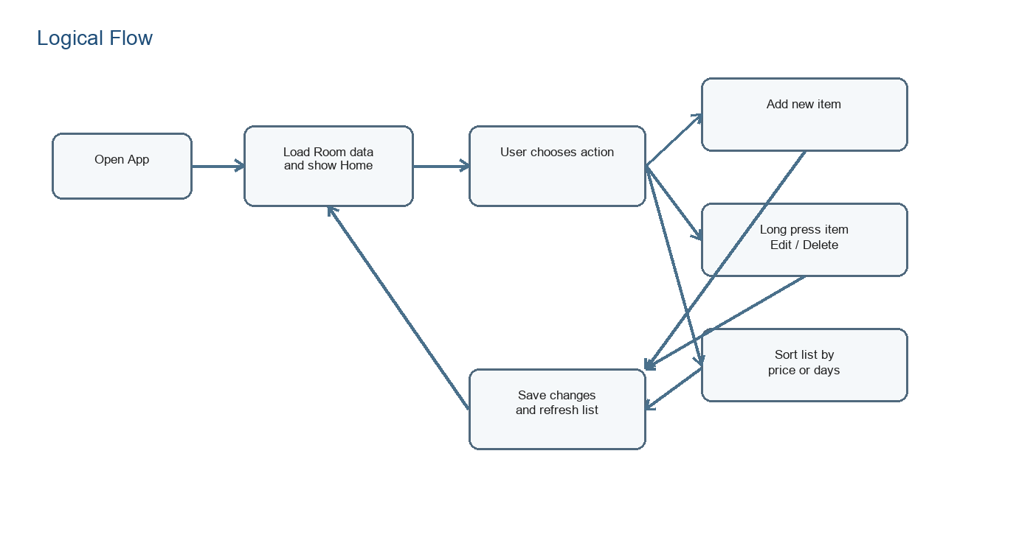
Figure 2: Logical Flow of the Application
1. The app starts and initializes the local Room database.
2. The home page subscribes to all item records through the DAO.
3. The user taps the floating add button to open the add page, or long presses an item to open the management dialog.
4. The add/edit page validates the item name and numeric price before saving.
5. The DAO inserts, updates, or deletes the item record.
6. The home page receives the updated list and recalculates summary data and daily costs.

3.3 Technical Description
The project is implemented as a native Android application using Kotlin and Jetpack Compose. The UI layer is built with Material 3 components. Navigation Compose is used to manage page transitions between the home page and the add/edit page. Room Database is used for persistent local storage, and Kotlin Flow is used so that the UI can react to database changes.
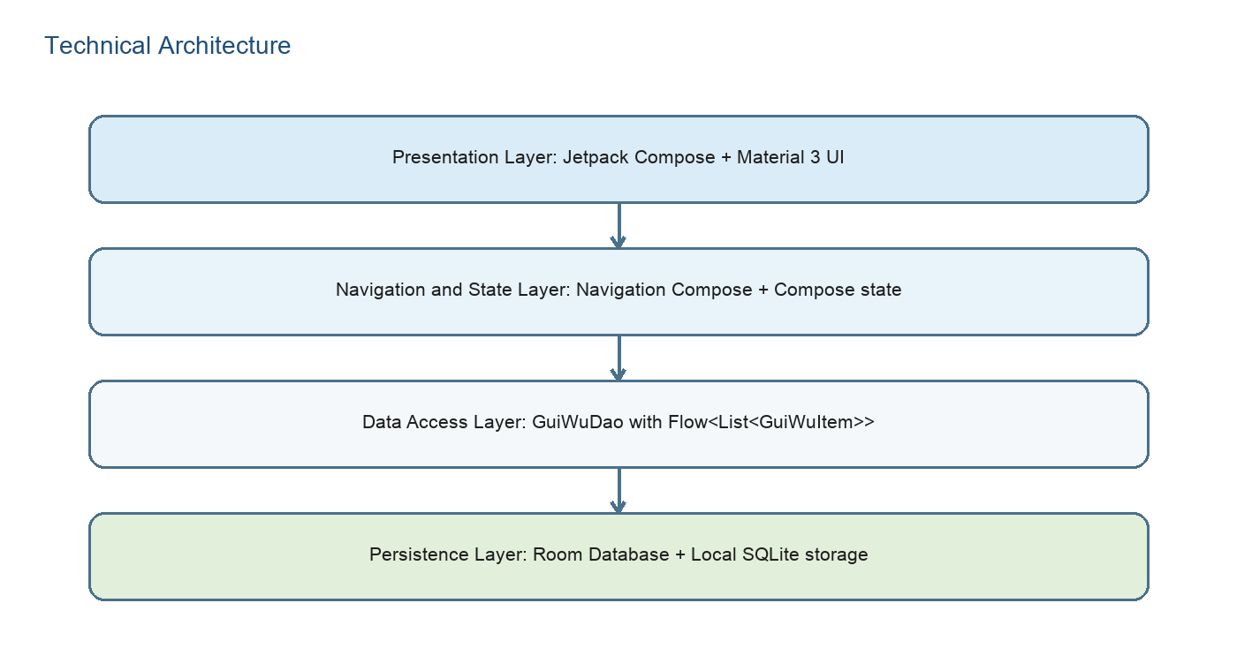
Figure 3: Technical Architecture Diagram
Kotlin | Main programming language used for Android development.
Jetpack Compose | Declarative UI framework used to build the home page, add/edit page, cards, dialogs, and dropdowns.
Material 3 | Provides modern Android UI components such as Scaffold, FloatingActionButton, Card, TopAppBar, DropdownMenu, and AlertDialog.
Navigation Compose | Defines the home route, add item route, and edit item route with back navigation.
Room Database | Stores GuiWuItem records locally through an SQLite-based abstraction.
Kotlin Flow | Provides observable database results so the UI can update after insert, update, or delete operations.
LocalDate and TypeConverter | Stores purchase dates as strings in the database and converts them back to LocalDate objects in Kotlin.

3.4 Code Architecture
The current code is compact and organized around the main activity file. Although the project is still in the mid-term stage, the main classes and composable functions already show a clear relationship between UI, navigation, and data storage. The code avoids large code snippets in this report and instead explains each component by responsibility.
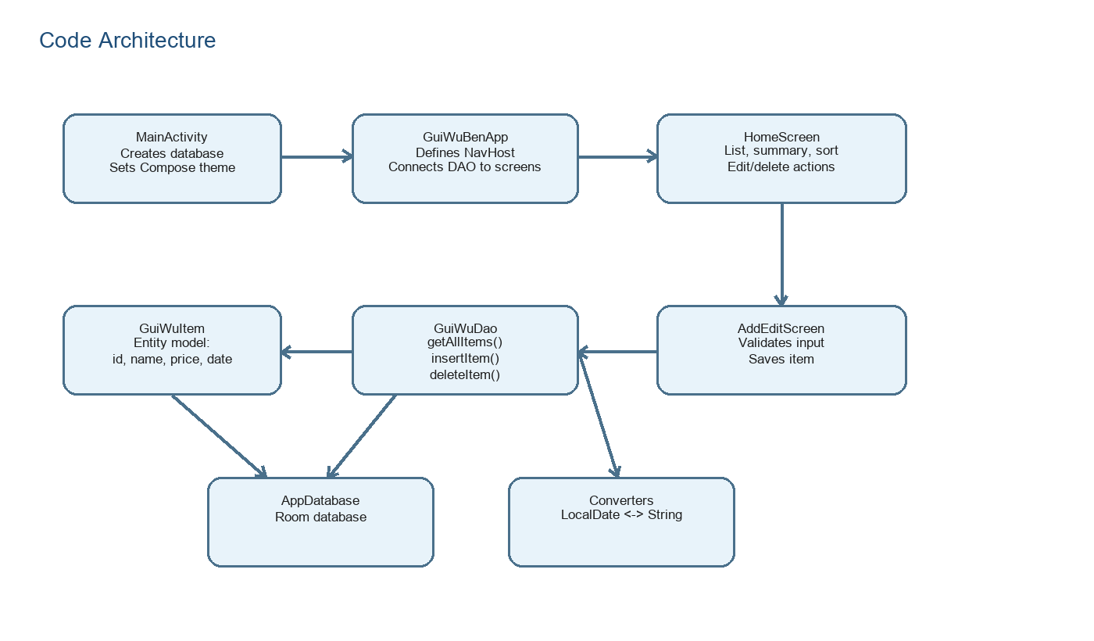
Figure 4: Code Architecture Diagram
MainActivity | Initializes the Room database, creates the DAO, configures light/dark Material theme, and starts the Compose UI.
GuiWuItem | Entity class representing one belonging record. It contains id, name, price, and purchase date.
GuiWuDao | DAO interface for reading all items, inserting or updating an item, and deleting an item.
AppDatabase | Room database class that provides access to GuiWuDao.
Converters | Converts LocalDate values to and from string values so Room can store dates.
GuiWuBenApp | Navigation root that connects the home page and add/edit page.
HomeScreen | Displays records, asset summary, sorting menu, and management dialog.
AddEditScreen | Handles item input, validation, date selection, and save/cancel actions.
DateDropdowns / SimpleDropdown | Reusable date selection UI built with dropdown menus.

Optimization Considerations
User experience optimization: A floating add button gives a clear entry point for adding records, while the top bar provides back navigation on the add/edit page.
Stability optimization: Input validation prevents blank names and non-numeric prices from being saved.
Data consistency optimization: Insert uses REPLACE behavior, so the same save logic can support both adding and editing records.
Algorithm optimization: The app uses simple date difference calculation through ChronoUnit.DAYS and recalculates cost values based on the current date.
Future optimization: A search box and filtering by year, price range, or category can be added to reach a more advanced feature level.

4 App Effect
The following figure summarizes the main implementation effect of the current app. The home screen shows the asset summary and item list. The add/edit screen accepts item information and purchase date. The management dialog supports modification and deletion after the user long presses an item.
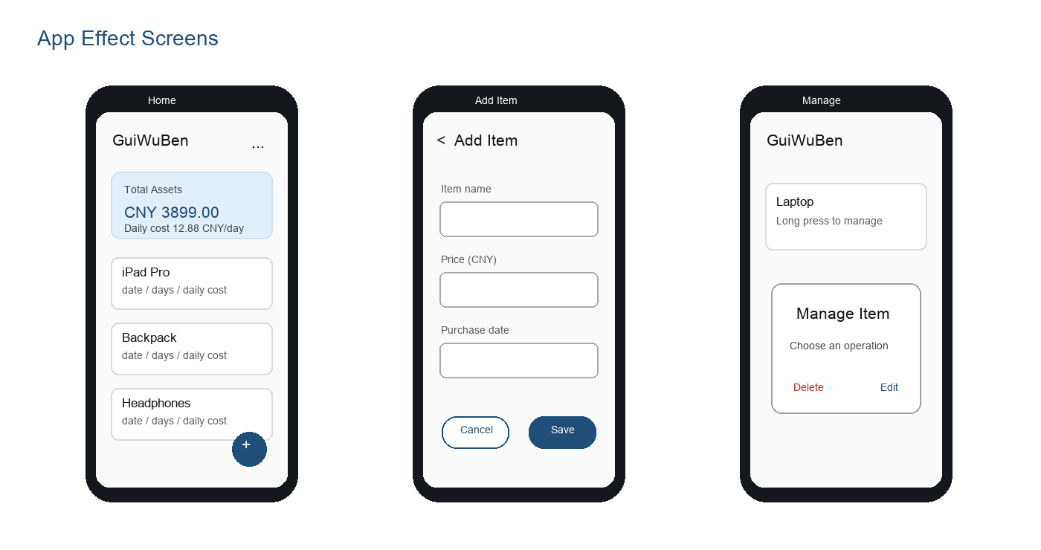
Figure 5: App Effect Screens
Home page: Displays total assets, overall daily cost, item list, sorting menu, and add button.
Add/Edit page: Provides fields for item name, price, and purchase date, with save and cancel actions.
Management dialog: Opens after long pressing an item and allows the user to modify or delete that record.
Theme support: The UI follows the system light or dark theme through Material color schemes.

5 Problems Encountered During Development and Solutions
Problem | Description | Solution
Problem 1: Persistent storage design | Temporary UI state could display records only while the app was running. This was not enough because records must remain after the app is closed. | Room Database was introduced. GuiWuItem became an entity, GuiWuDao was created, and the UI observes database data through Flow.
Problem 2: Date storage in database | Room cannot directly store LocalDate without a conversion strategy. | A TypeConverter was added to convert LocalDate to a string and parse the string back to LocalDate when data is read.
Problem 3: Add and edit workflow | Adding and editing records are similar operations, but they need different page titles and item IDs. | The same AddEditScreen is reused. When itemToEdit is null, the screen creates a new item. When itemToEdit is available, the screen keeps the original id.
Problem 4: User input reliability | If the user enters a blank name or a non-numeric price, the database record would be invalid or calculations would fail. | The save button checks whether the name is not blank and whether the price can be converted to Double. If validation fails, an error message is displayed.
Problem 5: Making value visible | A plain list of item prices does not clearly show long-term value. | The app calculates days owned, daily cost for each item, total asset value, and total daily cost, making the app more useful than a basic list.

6 Thoughts and Reflections
Through this project, the team learned how to turn a simple mobile app idea into a functional Android application. The most important experience is that a useful app does not need to start with many complex functions. It should first solve a clear user problem. GuiWuBen starts from a small but real problem: people often forget whether their purchases are truly worth the money. By recording items and calculating daily cost, the app gives users a concrete way to reflect on spending and item usage.
From a technical perspective, the project helped us understand the relationship between UI, navigation, and persistent data. Jetpack Compose made it efficient to build screens and update UI states, while Room Database provided a reliable way to store structured local data. The project also showed the importance of input validation and navigation design. In the next stage, we plan to improve the app with search, filtering, categories, and possibly visual statistics such as charts.

7 Task Division
The following table can be adjusted according to the final group information. If this project is completed individually, the first row can be kept as the main contribution row and the remaining rows can be deleted.
Member | Student ID | Content | Percentage of contribution (%)
To be filled | To be filled | Requirement analysis; UI design; Room database design; add/list/edit/delete implementation; sorting and cost analysis; report writing. | 100
To be filled | To be filled | Optional: testing, presentation slides, UI polishing, screenshots. | To be filled
Table 1: Group Division of Labor

8 Reference Material
Android Developers. Jetpack Compose documentation.
Android Developers. Room persistence library documentation.
Android Developers. Navigation Compose documentation.
Mobile Application Development Course: Midterm App Design Presentation Requirements.

