Marcus Tane Gen Z • Graphic Design Student
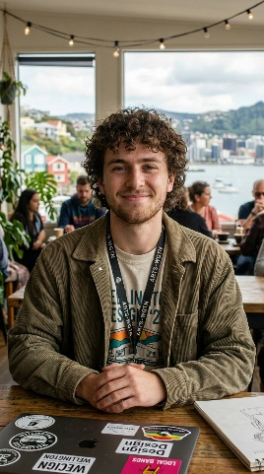  "I need tools that keep up with my creativity, without draining my wallet." |  | AGE 22  GENDER Male  LOCATION Wellington, New Zealand  OCCUPATION Student (part-time barista)  JOB TITLE Graphic Design Student  EDUCATION Bachelor of Design (in progress), Massey University  ANNUAL INCOME ~$14,000 NZD/yr  PERSONALITY Creative, trend-aware, values authenticity

GOALS & MOTIVATIONS  • Source affordable design accessories — drawing tablets, styluses, external drives  • Stay current with creative tools and software peripherals  • Build a functional home workspace on a student budget  • Discover aesthetic items that reflect his personal brand  • Get fast, reliable delivery to meet tight assignment deadlines |  | CHALLENGES & OBSTACLES  • Very limited budget — must balance quality against cost constantly  • Overwhelmed by product choice without expert curation or filters  • Sceptical of cheap tech that may break quickly  • Unsure of correct specs for design-specific peripherals  • Needs strong peer reviews and social proof before purchasing
FRUSTRATIONS  • Hidden shipping costs that inflate the final price at checkout  • Vague or inaccurate product descriptions with missing tech specs  • Long delivery windows when items are needed urgently for Uni  • Sites that aren't mobile-friendly or feel visually outdated |  | SOURCES OF INFORMATION  • Reddit — r/graphic design, r/design tools  • YouTube reviews and tutorial channels  • Instagram and TikTok creative communities  • Student Discord servers and Uni forums  • Word of mouth from classmates and lecturers

