Screenshots

Contents

AWS Console for Mobile 3

aws-1 3

aws-2 4

aws-3 5

TortoiseGit for Windows 6

tor-1 6

tor-2 6

tor-3 7

tor-4 7

tor-5 8

OctoDroid 9

oct-1 9

oct-2 10

oct-3 10

SSH KeyPair Generation 11

key-1 11

key-2 11

Amazon EC2 Instance Creation 12

ec2-1 12

ec2-2 12

ec2-3 12

ec2-4 13

ec2-5 13

ec2-6 14

ec2-7 14

ec2-8 15

Setting up Putty and Encrypted PPK File 16

Stopping and Restarting the EC2 Instance 17

Connecting to the Instance 18

con-1 18

Creating / Removing EBS Volumes 19

ec2-9 19

ec2-10 19

ec2-11 20

ec2-12 20

Managing EBS Volumes 21

ec2-16 21

ec2-17 21

Installing and Configuring Postgres, setting up DB Owner 22

Installing Apache and PHP, and Managing the WebServer 23

pak-1 23

Backup/Restore Test Data 24

bak-1 24

bak-2 24

Writing the Web App 25

# AWS Console for Mobile

## aws-1

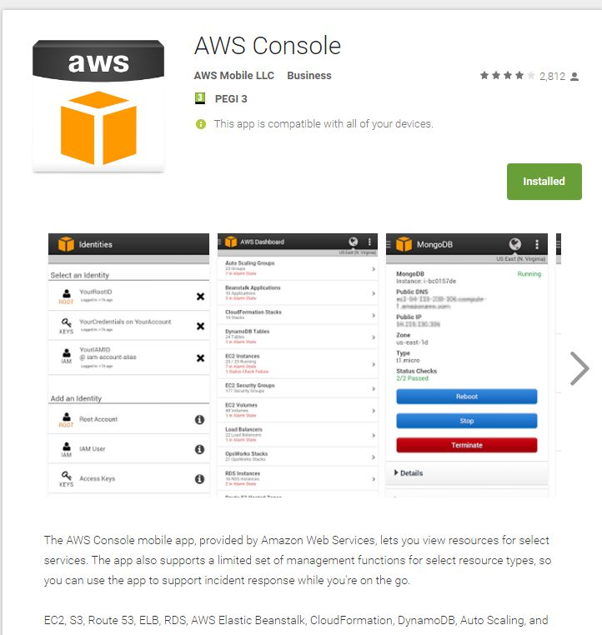

## aws-2

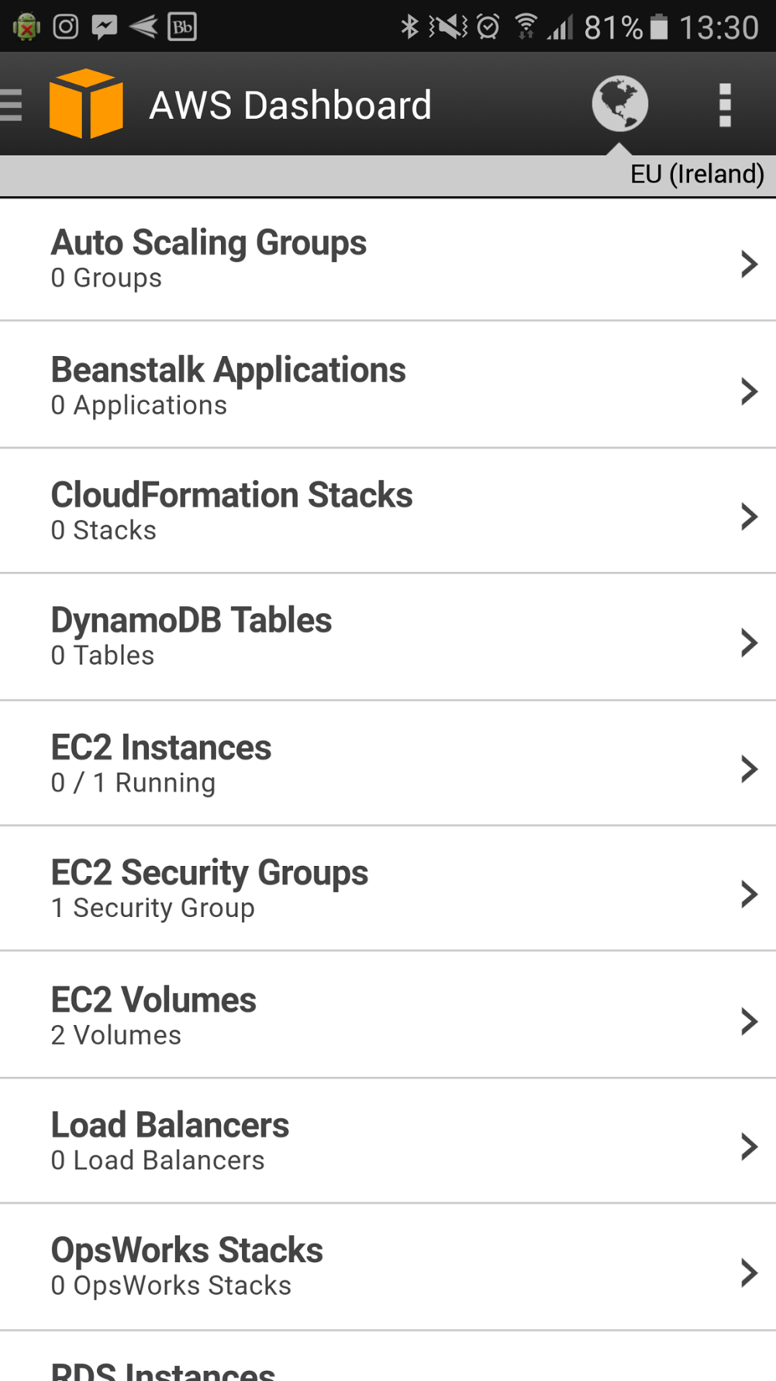

## aws-3

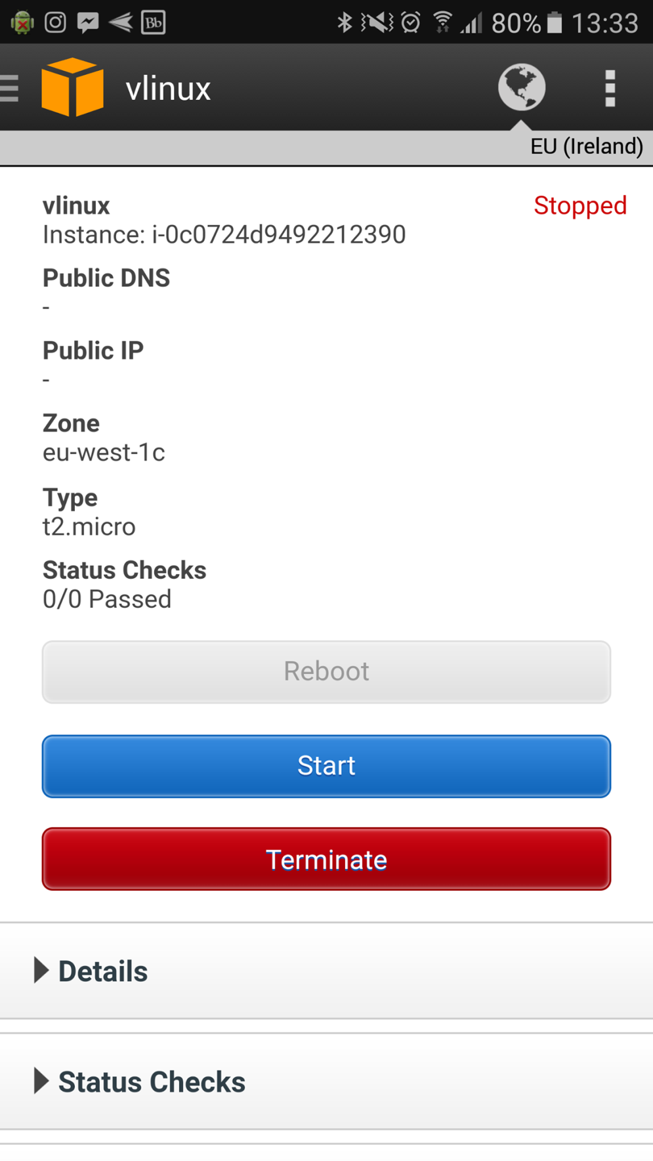

# TortoiseGit for Windows

## tor-1

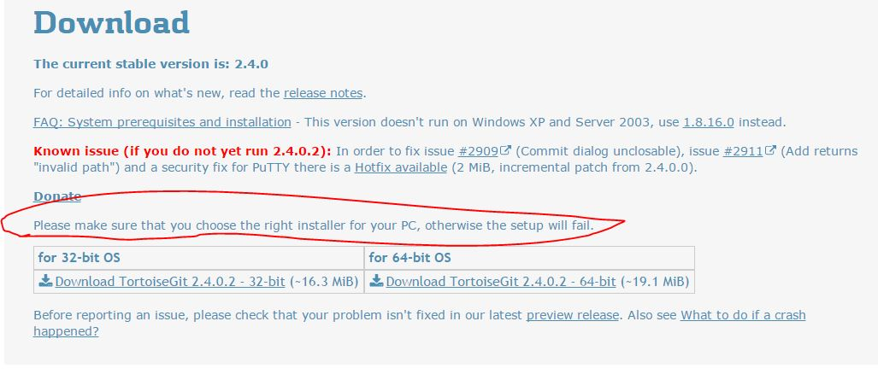

## tor-2

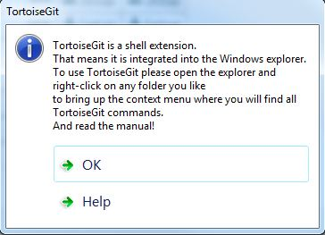

## tor-3

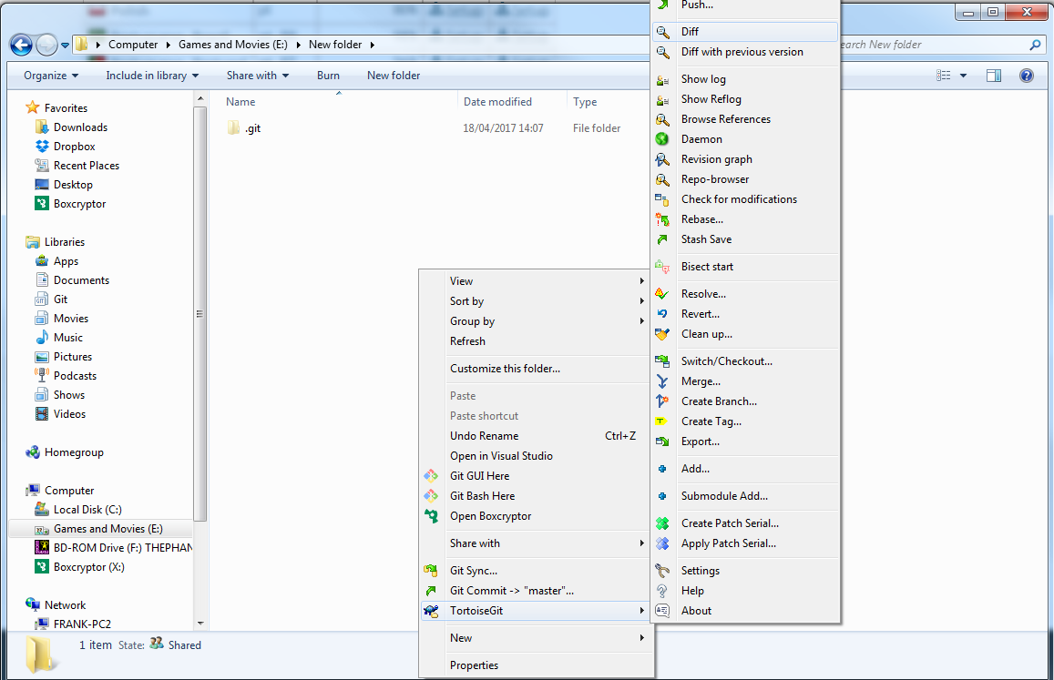

## tor-4

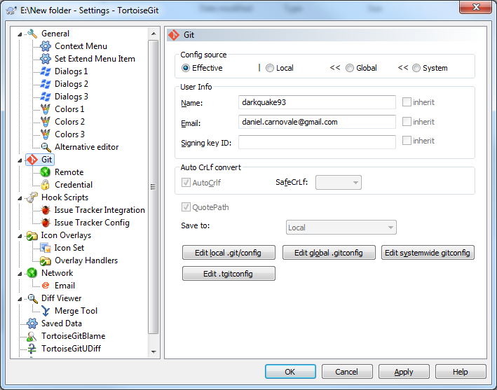

## tor-5

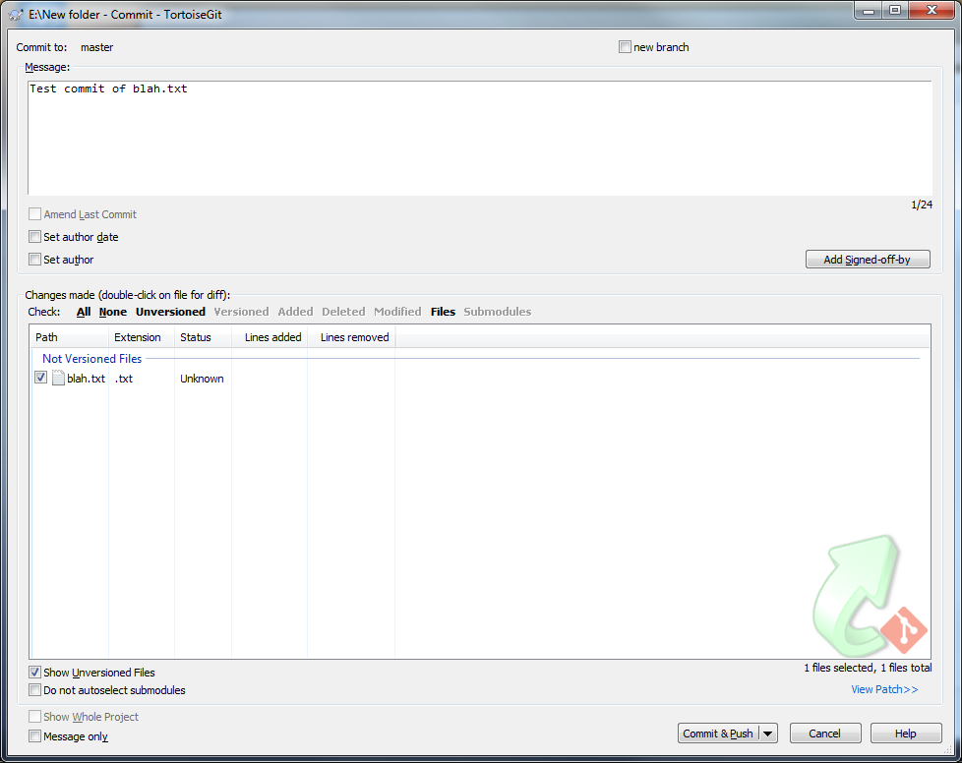

# OctoDroid

## oct-1

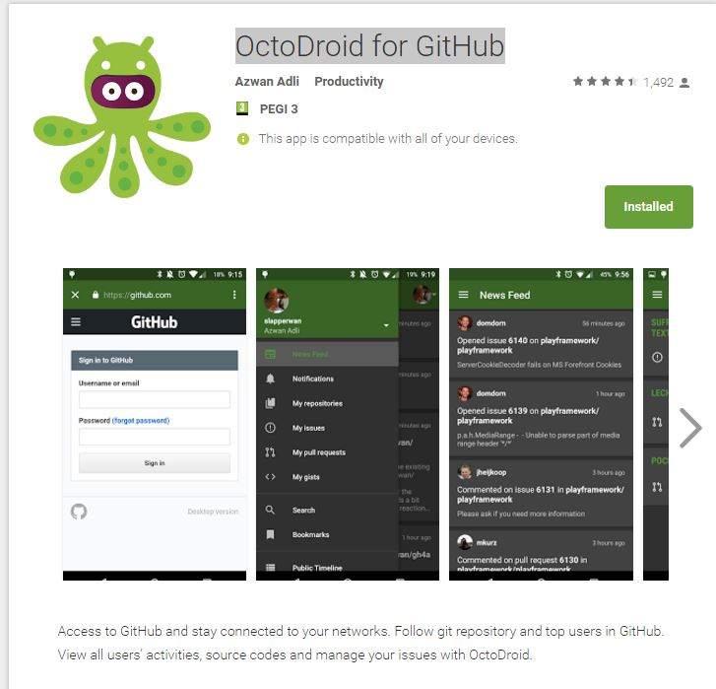

## oct-2

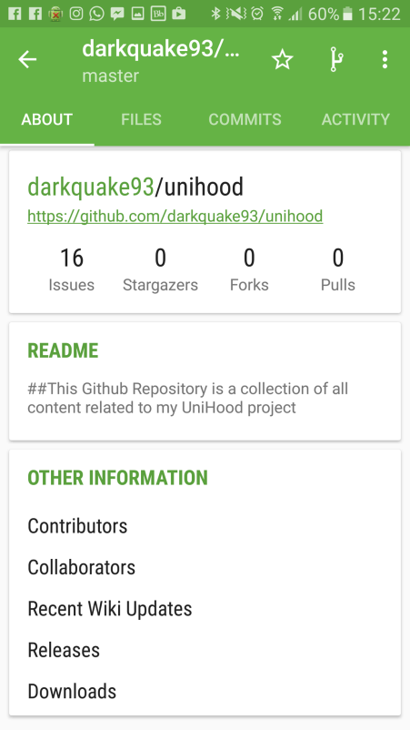

## oct-3

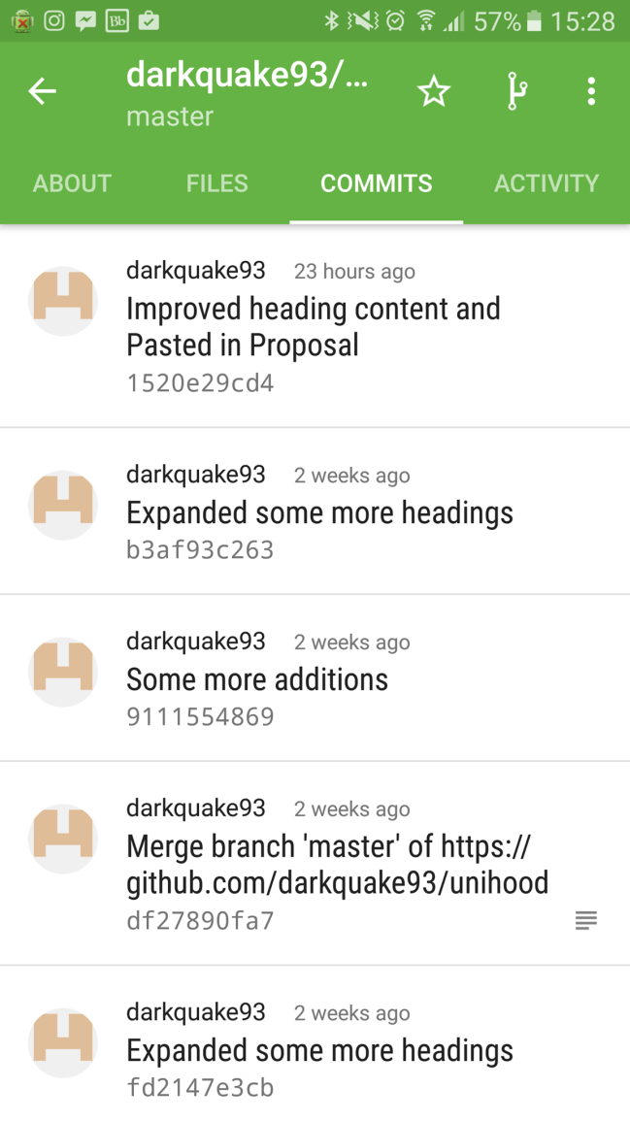

# SSH KeyPair Generation

## key-1

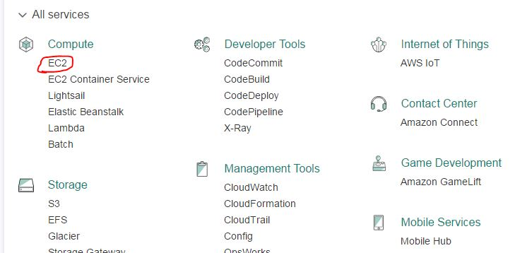

## key-2

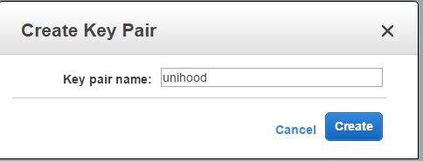

# Amazon EC2 Instance Creation

## ec2-1

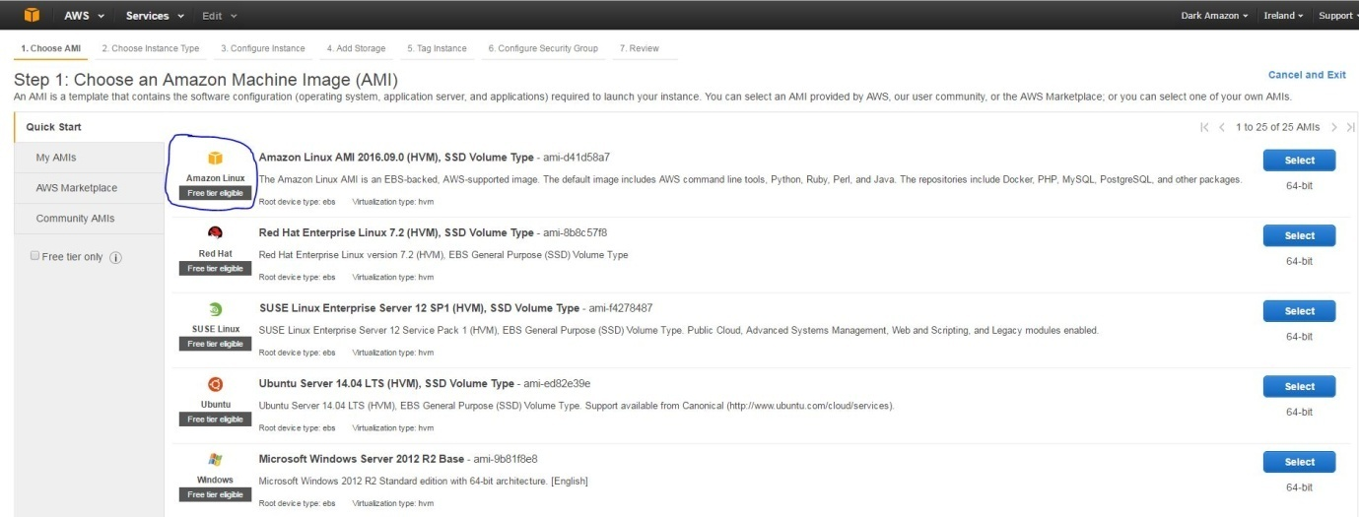

## ec2-2

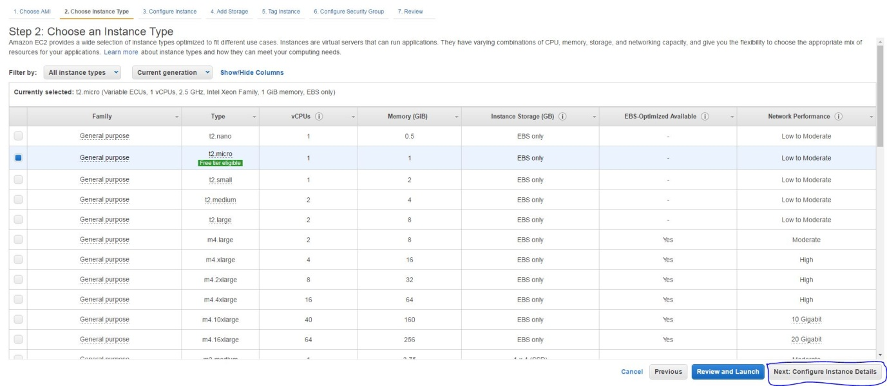

## ec2-3

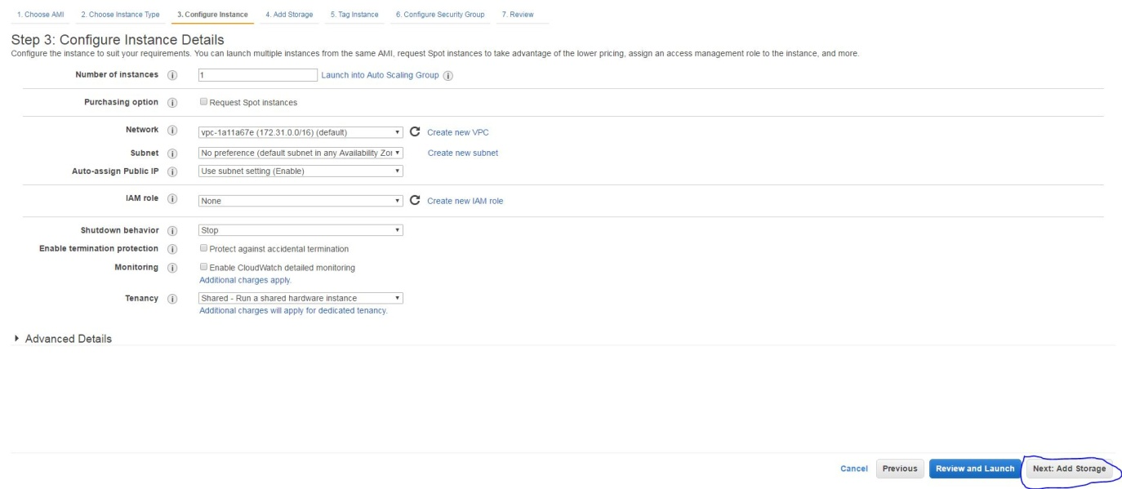

## ec2-4

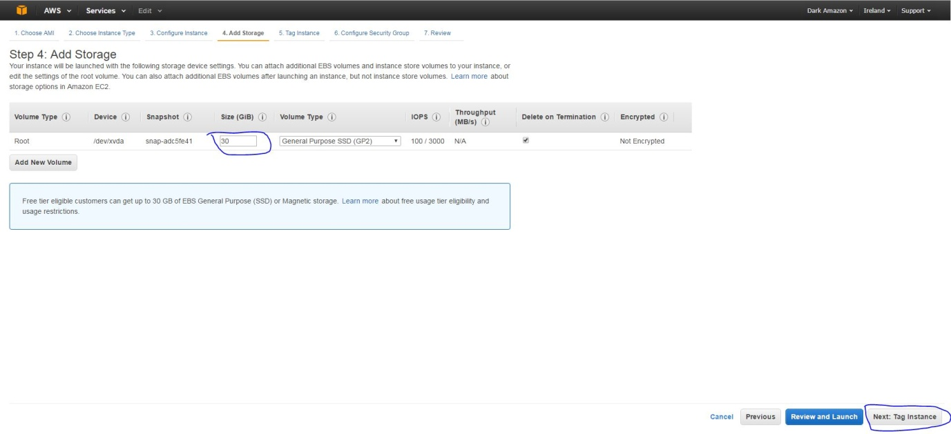

## ec2-5

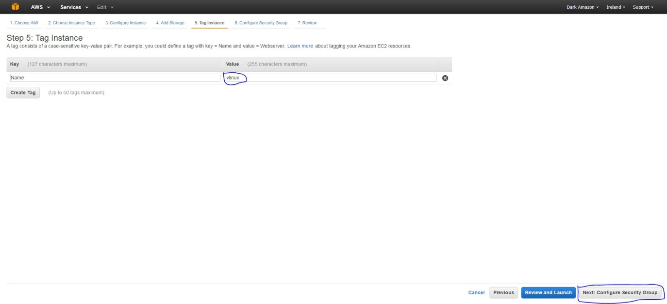

## ec2-6

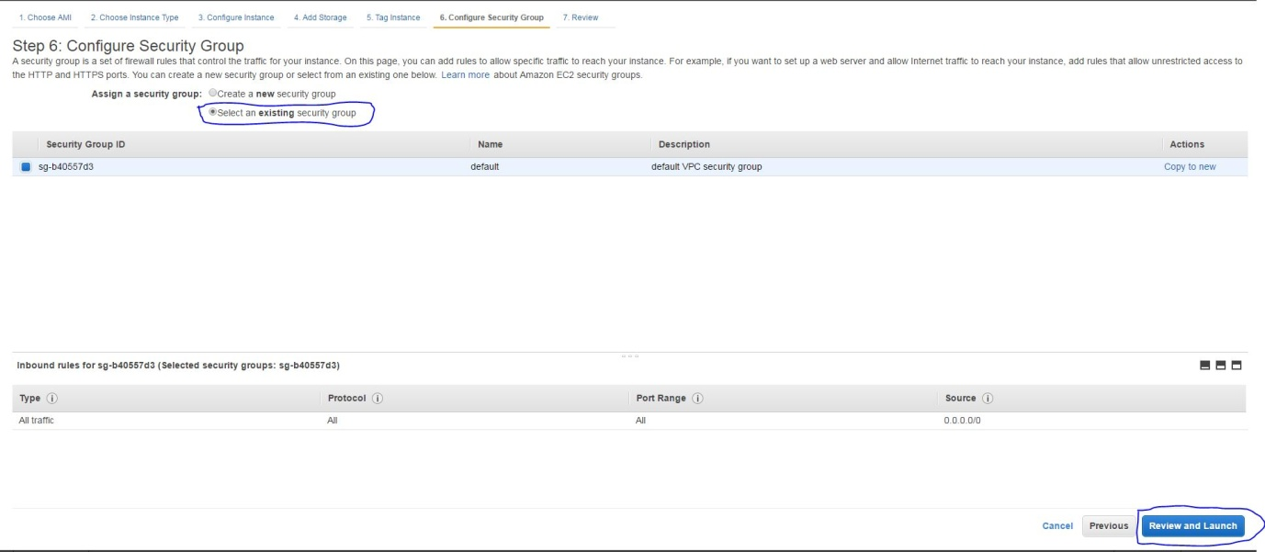

## ec2-7

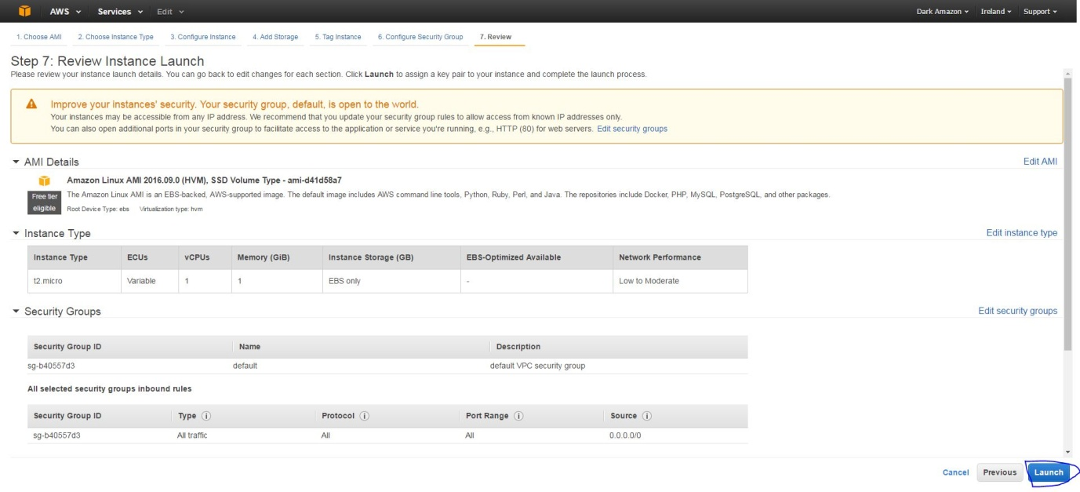

## ec2-8

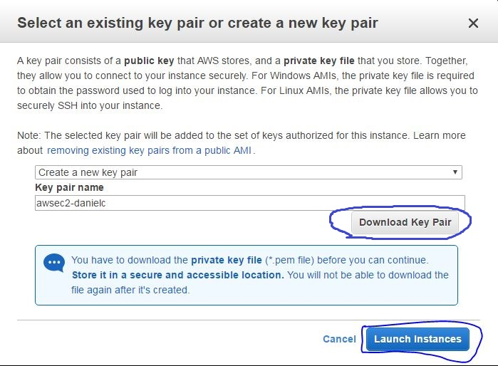

# Setting up Putty and Encrypted PPK File

# Stopping and Restarting the EC2 Instance

1. Optionally download and install the AWS Console Mobile app, I have found this is more responsive than desktop in terms of managing the instance state. More information is under the previous HOWTO : “AWS Console for Mobile”.

Link to app on Google Play Store: <https://play.google.com/store/apps/details?id=com.amazon.aws.console.mobile&hl=en_GB>

1. Log into your AWS account either on Mobile or Desktop into Management Console. Desktop url: https://aws.amazon.com/console
2. Enter the EC2 Instances sub-menu.
3. Select the instance(s) you want to stop.
4. Tap the Stop button, the instance will now perform a Shut Down
5. Similarly, you can tap the Start button if the instance was stopped, in effect having restarted the instance.
6. At any point, call up Instance Settings > Get System Log to verify the state of the instance console

# Connecting to the Instance

## con-1

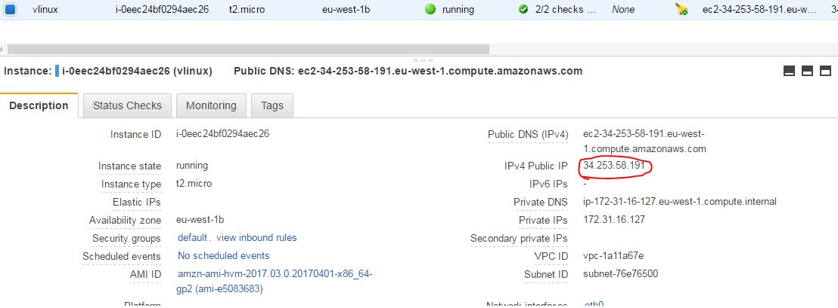

# Creating / Removing EBS Volumes

## ec2-9

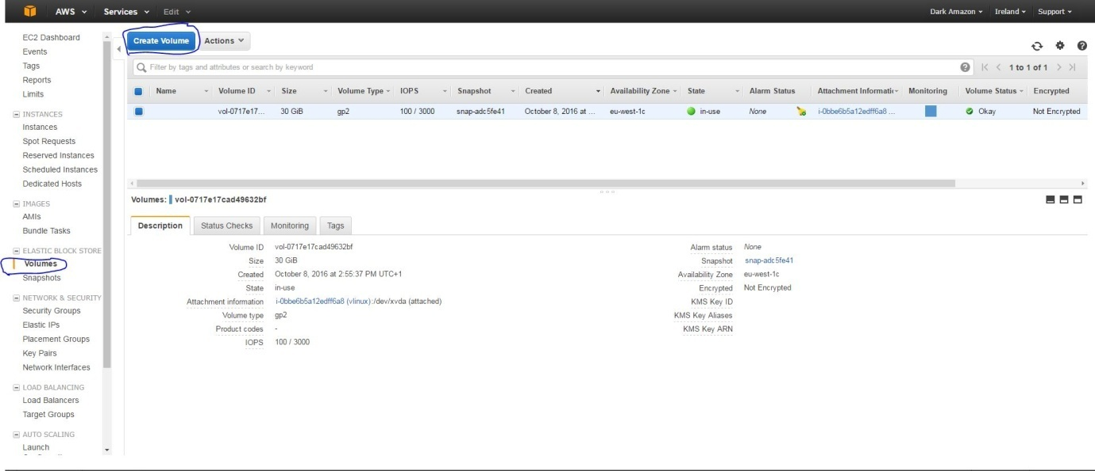

## ec2-10

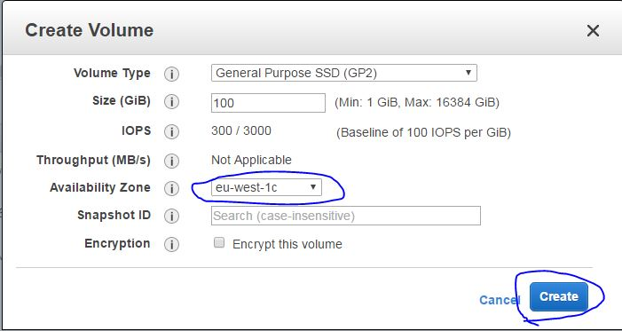

## ec2-11

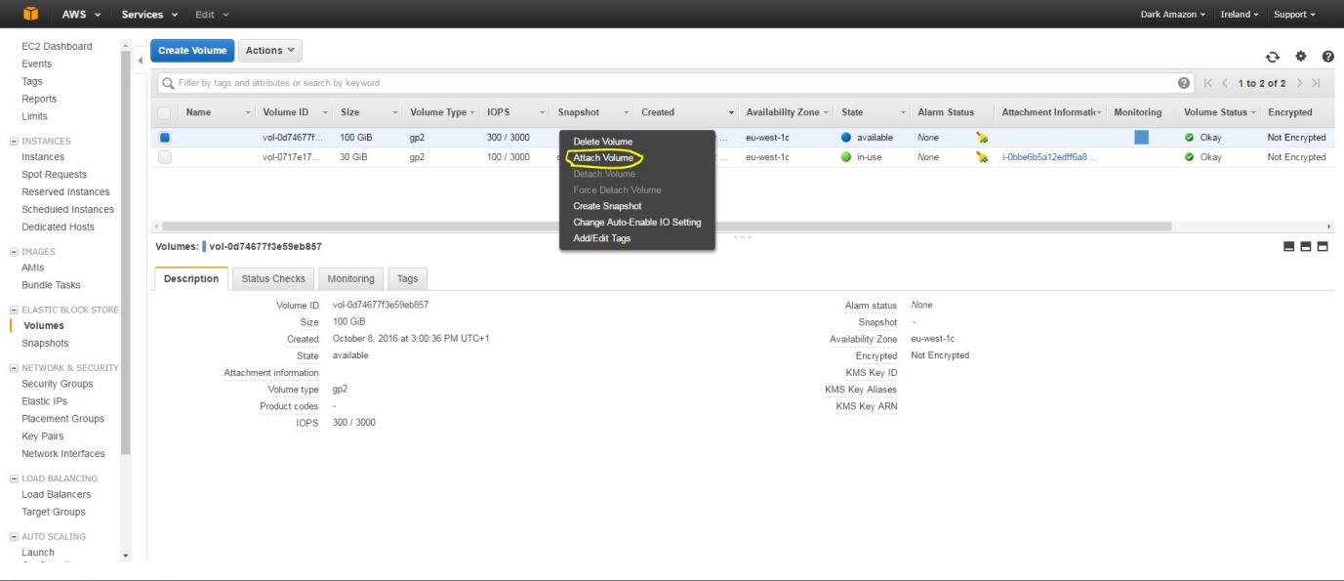

## ec2-12

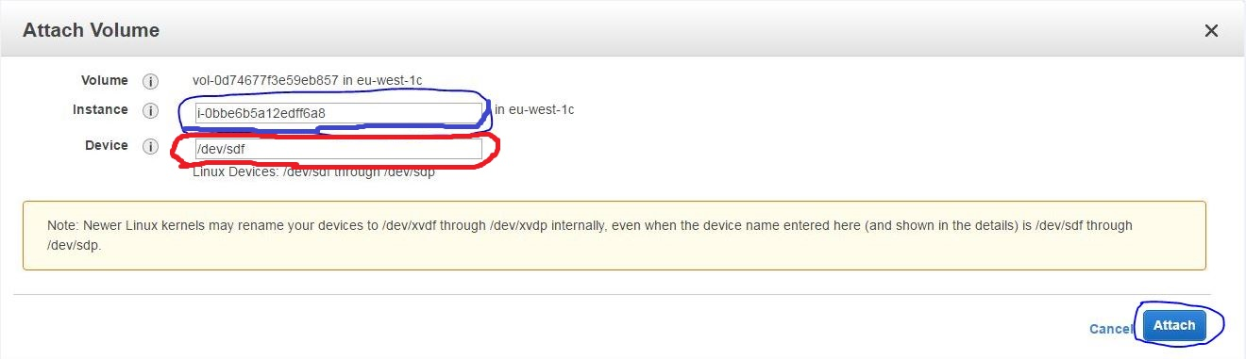

# Managing EBS Volumes

## ec2-16

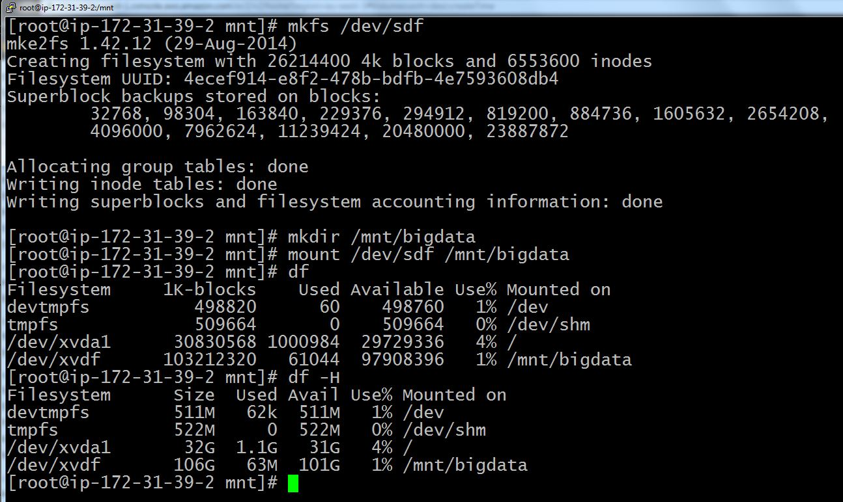

## ec2-17

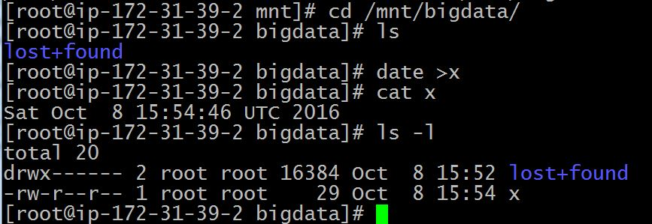

# Installing and Configuring Postgres, setting up DB Owner

# Installing Apache and PHP, and Managing the WebServer

## pak-1

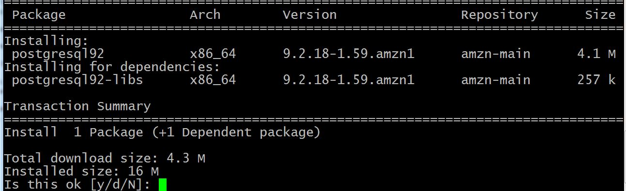

# Backup/Restore Test Data

## bak-1

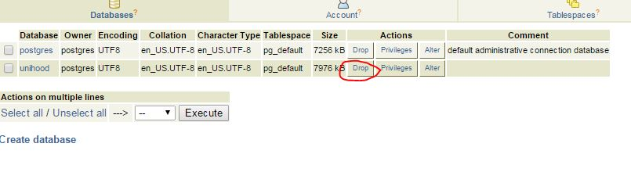

## bak-2

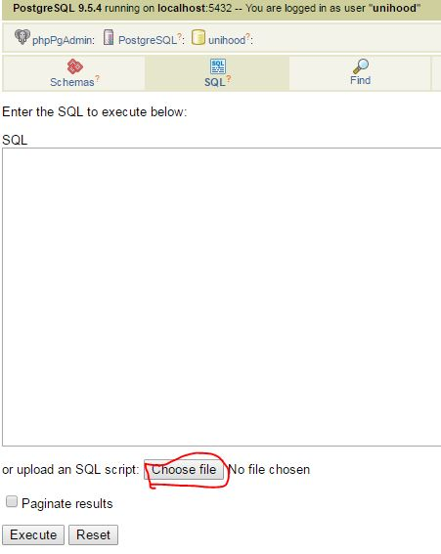

# Writing the Web App