Roll No – 71 Batch – T14 IP Lab

**AIM**: To develop a web application by using HTML Tags. Using Elements, Attributes, Head, Body, Hyperlinks, Formatting Images, Tables, Lists, Frames, Forms, and Multimedia elements.

**Code:**

**Page 1: Survey Sphere (Home Page)**

<!DOCTYPE html>

<html lang=”en”>

  <head>

    <meta charset=”UTF-8” />

    <meta name=”viewport” content=”width=device-width, initial-scale=1.0” />

    <title>SurveySphere</title>

  </head>

  <body>

    <div>

      <h1 align=”center”>Survey Sphere</h1>

      <h2><center>Shape Perspective and drive change!</center></h2>

      <p align=”center”>#makeopinionscount</p>

    </div>

    <hr />

    <div>

      <p><b>Who are we?</b></p>

      <p>

        SurveySphere is a platform for sharing your valuable opinions and

        insights with the world. Join a community of like-minded individuals,

        participate in thought-provoking surveys, and contribute to meaningful

        research that shapes businesses, policies, and society. Your voice

        matters, and at SurveySphere, we amplify it to bring about positive

        change.

      </p>

      <img src=”https://blog.xoxoday.com/content/images/2022/02/survey-rewards.jpg”

        width=”350px”

        alt=”Survey Picture”

      />

    </div>

    <hr />

    <div>Our Works - <a href=”second.html”>Click here</a></div>

    <hr />

    <hr />

    <div>

      <table>

        <tr>

          <th>Survey Topic</th>

          <th>Last Date</th>

          <th>Reach(In Millions)</th>

          <th>Link</th>

        </tr>

        <tr>

          <td>Are Mumbai AC Local luxury or necessity?</td>

          <td>30th July 2023</td>

          <td>23.5</td>

          <td><a href=”ACLocal.html”>Fill Up</a></td>

        </tr>

        <tr>

          <td>Online Gaming Dilemna</td>

          <td>20th July 2023</td>

          <td>10.2</td>

          <td>Survey Closed</td>

        </tr>

      </table>

    </div>

    <hr />

    <p>

      A round of applause for your ontribution in surveys which help individuals

      research interest

    </p>

    <audio controls>

      <source

        src=”mixkit-small-group-cheer-and-applause-518.wav”

        type=”audio/ogg”

      />

      <source

        src=”mixkit-cinematic-transition-swoosh-heartbeat-trailer-488.wav”

        type=”audio/mpeg”

      />

      Your browser does not support the audio element.

    </audio>

    <br/>

    <audio controls>

      <source

        src=”mixkit-cinematic-transition-swoosh-heartbeat-trailer-488.wav”

        type=”audio/mpeg”

      />

      Your browser does not support the audio element.

    </audio>

  </body>

</html>

**Page 2: Survey Fill Up Page**

<!DOCTYPE html>

<html lang=”en”>

<head>

    <meta charset=”UTF-8”>

    <meta name=”viewport” content=”width=device-width, initial-scale=1.0”>

    <title>SurveySphere</title>

</head>

<body>

    <div>

        <h1 align=”center”>Survey Sphere</h1>

        <h2><center>AC Local : A Necessity or Luxury?</center></h2>

        <p align=”center”>#11k responses</p>

      </div>

    <div>

        <form action=”submit”>

            <p>Fill in your opinion</p>

            <label for=””>Name: </label>

            <input type=”text”>

            <br><br>

            <label for=””>Email: </label>

            <input type=”text”>

            <br><br>

            <label for=””>Gender:</label>

            <input type=”radio” value=”Male”>Male

            <input type=”radio” value=”Female”>Female

            <input type=”radio” value=”Transgender”>Transgender

            <input type=”radio” value=”null”>Prefer not to say

            <br><br>

            <label for=””>On a scale of 1 to 10, how essential do you consider the AC local train service?</label><br>

            <input type=”text” placeholder=”Your answer goes here”>

            <br>

            <br>

            <label for=””>Have you noticed any changes in your travel patterns or habits since the introduction of the AC local train service?</label><br>

            <input type=”text” placeholder=”Your answer goes here”>

            <br>

            <br>

            <label for=””>Question 3:</label>

            <input type=”text” placeholder=”Your answer goes here”>

            <br>

            <label for=””>Additional Comments:</label>

            <textarea name=”” id=”” cols=”30” rows=”3” placeholder=”Suggestions”></textarea>

            <br>

            <button type=”submit”>Submit</button>

        </form>

    </div>

</body>

</html>

**Page 3: Surveys List Page**

<!DOCTYPE html>

<html lang=”en”>

<head>

    <meta charset=”UTF-8”>

    <meta name=”viewport” content=”width=device-width, initial-scale=1.0”>

    <title>SurveySphere</title>

</head>

<body>

    <div>

        <h1 align=”center”>Survey Sphere</h1>

        <h2><center>Shape Perspective and drive change!</center></h2>

        <p align=”center”>#makeopinionscount</p>

      </div>

      <div class="contactUs">

        Came Across Disturbing Surveys? -- Mail <a href="mailto:darshilm1010@example.com">Here</a>

      </div>

    <p><b>Survey List Page</b></p>

    <ul>

        <li>

            <b>Ongoing Surveys:</b>

            <ol>

                <li>Is mental Illness really considered an Illness?</li>

                <li>Euthanasia</li>

                <li>Should Uniform Civil Code be implemented in India?</li>

            </ol>

        </li>

        <li><b>Upcoming Surveys: </b>

            <ol>

                <li>Should India have a 2 term limit on presidency like the US? </li>

                <li>Should the voting age be lowered to 16?</li>

            </ol>

        </li>

        <li>

            <b>Completed Surveys</b>

            <ol>

                <li>Social Media and Mental Health.</li>

                <li>Work life balance among urban professionals.</li>

            </ol>

        </li>

    </ul>

</body>

</html>

**Output:**

**Page 1: Homepage (Survey Sphere)**

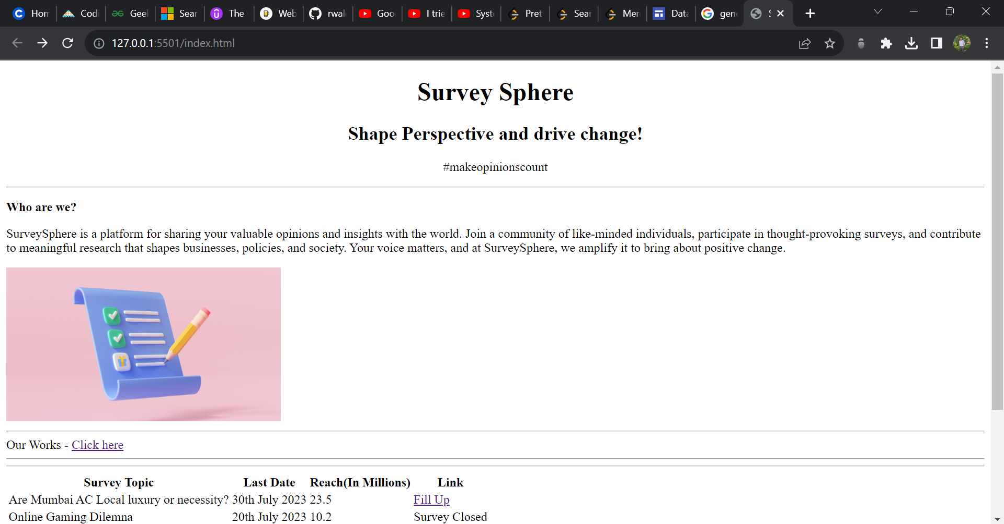

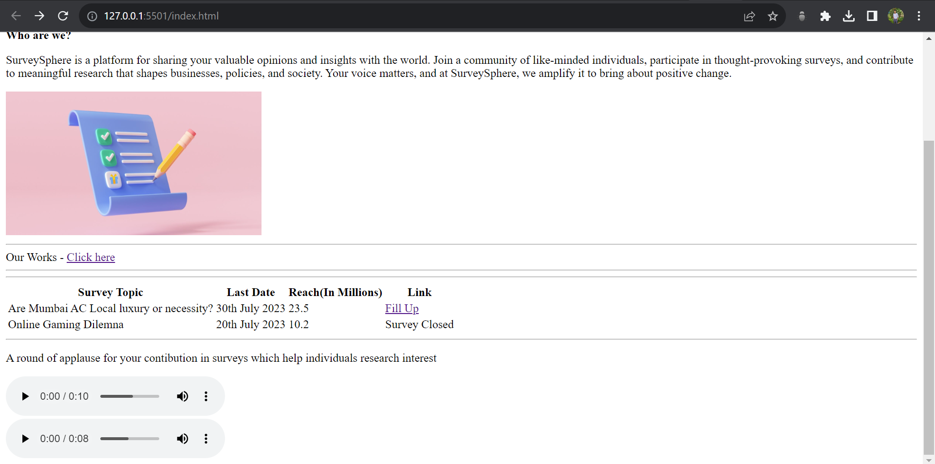

**Page 2: Survey Fill Up**

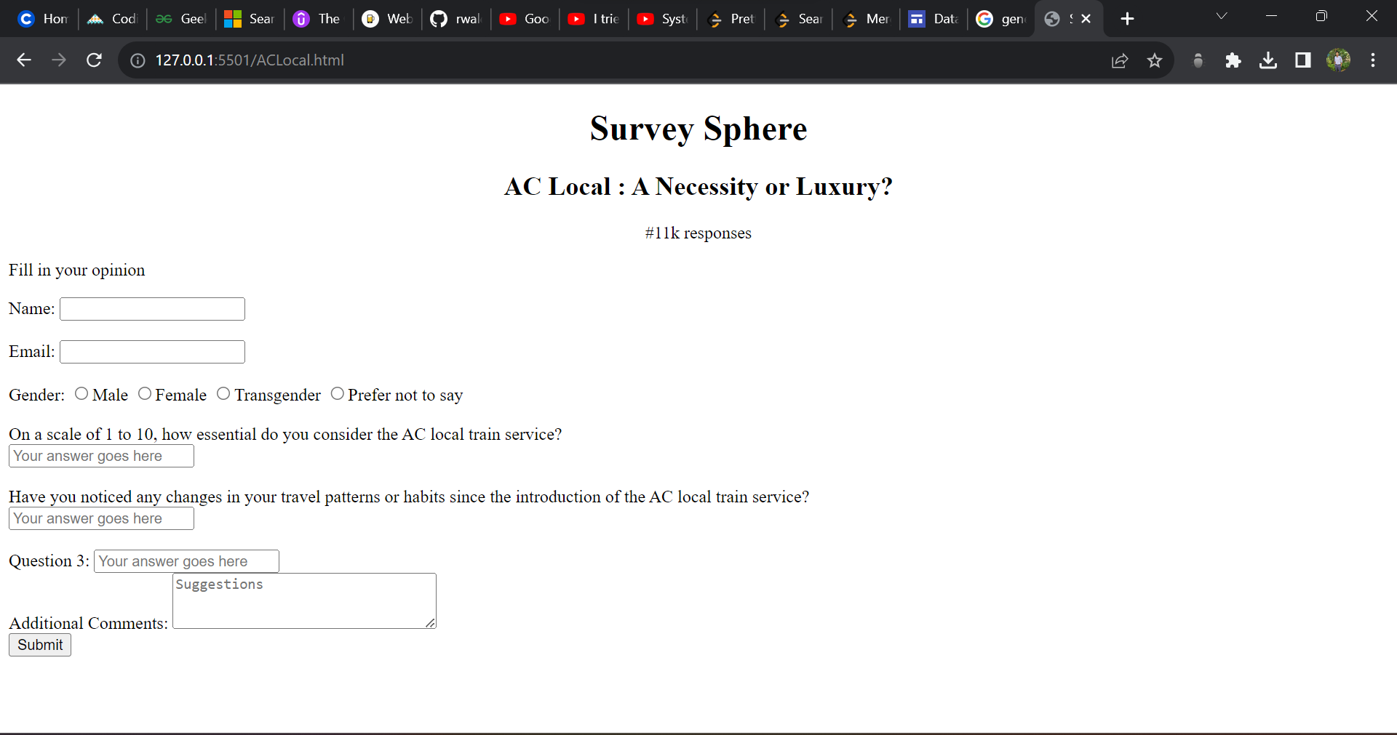

**Page 3: Survey Lists Page:**

