**Roll No – 71 Batch – T14 IP Lab**

**AIM:** Using CSS and CSS3 enhance the web application developed in Assignment #1 Colour, Background, Font, Table, List, CSS3 selectors, Pseudo classes, and Pseudo elements properties should be used to enhance the web pages.

**Code:** Used External, Internal and Inline CSS in different pages.

1.Home Page (External CSS)

<!DOCTYPE html>

<html lang="en">

  <head>

    <meta charset="UTF-8" />

    <meta name="viewport" content="width=device-width, initial-scale=1.0" />

    <title>SurveySphere</title>

    <link

      href="https://fonts.googleapis.com/css2?family=Heebo:wght@500;700&family=Lobster&display=swap"

      rel="stylesheet"

    />

    <link rel="stylesheet" href="style.css" />

  </head>

  <body>

    <section class="landing">

      <nav>

        <h1 id="logo">SurveySphere</h1>

        <ul class="nav-links">

          <li>Home</li>

          <li>Survey Lists</li>

          <li>About</li>

        </ul>

        <button>Contact Us</button>

      </nav>

      <div class="header">

        <div class="heading">

          <h1 class="heading1 headings"><em>Survey Space Ahead</em></h1>

          <h2 class="heading2 headings">Shape Perspective and drive change!</h2>

          <p class="heading3 headings colo">#makeopinionscount</p>

        </div>

        <div>

          <img

            src="customer-survey-concept-illustration_114360-568.avif"

            alt=""

            class="headerimg"

          />

        </div>

      </div>

    </section>

    <div class="ourWorks">

      <h1 class="workheading">

        Have a quick look on our work and

        <span class="green"><em>Upcoming surveys</em></span>

      </h1>

      <button class="workbutton">

        <a href="surveyspage.html" class="letsgo">Lets Go--></a>

      </button>

    </div>

    <div class="reach">

      <h1 class="reachheading">Surveys with Highest Reach</h1>

      <table>

        <tr>

          <th>Survey Topic</th>

          <th>Last Date</th>

          <th>Reach(In Millions)</th>

          <th>Link</th>

        </tr>

        <tr>

          <td>Are Mumbai AC Local luxury or necessity?</td>

          <td>30th July 2023</td>

          <td>23.5</td>

          <td><a href="ACLocal.html">Fill Up</a></td>

        </tr>

        <tr>

          <td>Online Gaming Dilemna</td>

          <td>20th July 2023</td>

          <td>10.2</td>

          <td>Survey Closed</td>

        </tr>

        <tr>

          <td>Renaming Indian Cities</td>

          <td>30th August 2023</td>

          <td>8.2</td>

          <td><a href="ACLocal.html">Fill Up</a></td>

        </tr>

      </table>

    </div>

    <hr />

    <div class="applause">

      <h1>Applause for You</h1>

      <p><strong>A round of applause for your contibution in surveys which help

        individuals research interest

      </strong>

        </p>

<audio class="audio" controls>

        <source

          src="mixkit-small-group-cheer-and-applause-518.wav"

          type="audio/ogg"

        />

        <source

          src="mixkit-cinematic-transition-swoosh-heartbeat-trailer-488.wav"

          type="audio/mpeg"

        />

        Your browser does not support the audio element.

      </audio>

      <!-- <br />

      <audio controls>

        <source

          src="mixkit-cinematic-transition-swoosh-heartbeat-trailer-488.wav"

          type="audio/mpeg"

        />

        Your browser does not support the audio element.

      </audio> -->

    </div>

    <div class="footer">

      <p>Made by Darshil Marathe - <em><a href="https://www.linkedin.com/in/darshil-marathe/">Contact here</a></em></p>

    </div>

  </body>

</html>

External CSS File for page 1:

* {

    margin: 0;

    padding: 0;

    box-sizing: border-box;

  }

nav {

    display: flex;

    align-items: center;

    justify-content: space-between;

    min-height: 10vh;

    padding: 25px 25px;

    background-color: #eaf6f6;

  }

button {

    padding: 9px 25px;

    background-color: rgb(50, 138, 160);

    border: none;

    border-radius: 8px;

    cursor: pointer;

    transition: all 0.3s ease 0s;

  }

  button:hover {

    background-color: rgba(0, 136, 169, 0.8);

  }

  .workbutton:hover{

    background-color: #1052ae;

    color: white    ;

  }

  .nav-links {

    display: flex;

    list-style: none;

  }

  .nav-links li {

    padding-left: 5rem;

    font-size: 1.2rem;

  }

  #logo {

    font-family: "Lobster", cursive;

    font-weight: lighter;

    font-size: 2rem;

  }

  .header{

    display: flex;

    justify-content: space-around;

    margin: 10vh;

  }

  .headerimg{

    width: 35vw;

  }

.heading{

    background-color: #ffffff;

    text-align: center;

    min-height: 50vh;

    padding: 16vh 0;

}

.headings{

    /* margin: 5vh; */

}

.heading1{

    font-size: 4rem;

    padding: 20px;

}

.heading3{

    font-size: 1.6rem;

}

.ourWorks{

    display: flex;

    justify-content: space-around;

    padding: 20vh;

    background-color: #90e1f0;

}

.ourWorks h1{

    width: 35vw;

}

.ourWorks button{

    width: 15vw;

    background-color: #ffffff;

    border: none;

    border-radius: 4px ;

}

.colo{

    color:#006bff;

    font-style: italic;

}

.letsgo{

    text-decoration: none;

    font-size: 1.2rem;

    font-weight: 700;

}

.green{

    color: #e79a2e;

}

.reach h1{

    text-align: center;

    margin-top: 8vh;

    font-size: 2.5rem;

}

.reach table{

    margin: 5vh auto;

    text-align: center;

}

table,th,td

{

      border-bottom: 1px solid black;

    border-collapse: collapse;

}

tr{

    /* background-color: #D6EEEE; */

}

th,td{

    padding: 30px;

    border-color: #1d0d4f;

}

th{

    font-size: 1.5rem;

}

.applause{

    padding: 50px 0;

    /* display: flex;

    justify-content: space-around; */

    background-color: #bfb7f1;

    /* background-color: #e1f2ff; */

}

.applause h1,p{

    text-align: center;

    margin: 4vh;

    font-size: 1.1rem;

}

.applause h1{

    font-size: 2rem;

}

.audio{

}

.footer{

    /* background-color: rgba(0, 0, 0, 0.61); */

    text-align: center;

    /* color: #eaf6f6; */

}

.footer p{

    font-size:20px ;

}

.footer a{

    text-decoration: none;

}

2. Survey Page (INLINE CSS and Internal CSS)

<!DOCTYPE html>

<html lang="en">

<head>

    <meta charset="UTF-8">

    <meta name="viewport" content="width=device-width, initial-scale=1.0">

    <title>SurveySphere</title>

    <link rel="stylesheet" href="style2.css">

    <link

      href="https://fonts.googleapis.com/css2?family=Heebo:wght@500;700&family=Lobster&display=swap"

      rel="stylesheet"

    />

    <style>* {

        margin: 0;

        padding: 0;

        box-sizing: border-box;

      }

      table, th, td {

      border:1px solid rgb(13, 13, 14);

      border-collapse: collapse ;

      }

      input{

        text-align: center;

      }

      textarea{

        background-color: #e6f7f9;

      }

button {

  padding: 9px 25px;

  background-color: rgb(50, 138, 160);

  border: none;

  border-radius: 8px;

  cursor: pointer;

  transition: all 0.3s ease 0s;

}

button:hover {

  background-color: rgba(0, 136, 169, 0.8);

}

</style>

</head>

<body style="background-color: #263159;">

    <section class="landing">

        <nav style="

             display: flex;

            align-items: center;

            justify-content: space-between;

            min-height: 10vh;

            padding: 25px 25px;

            background-color: #eaf6f6;

            margin-bottom: 3vh;">

          <h1 style="font-family: 'Lobster', cursive;

          font-weight: lighter;

          font-size: 2rem;">SurveySphere</h1>

          <ul style="

            display: flex;

            list-style: none;">

            <li style="

            padding-left: 5rem;

            font-size: 1.2rem;">

            Home</li>

            <li style="padding-left: 5rem;

            font-size: 1.2rem;">Survey Lists</li>

            <li style="padding-left: 5rem;

            font-size: 1.2rem;">About</li>

          </ul>

          <button>Contact Us</button>

        </nav>

      </section>

        <form action="#" method="POST">

          <div style="background: beige;

          color: black;

          text-align: center;

          padding: 50px 0;

          width: 80vw;

          margin: auto;"><h2>AC Locals: Luxury or Necessity?</h2></div>

            <div style="  width: 95vw;

            margin: 4vh auto;

            text-align:center;

            font-size: 1.2rem;">

              <table style="  background-color: beige;

              margin: 0%;">

                <tr>

                  <th>Questions</th>

                  <th>Rating(1,2,3,4,5)</th>

                  <th>Answer </th>

                </tr>

                <tr>

                  <td>Name</td>

                  <td></td>

                  <td><textarea id="" cols="50" rows="4"  ></textarea></td>

                </tr>

                <tr>

                  <td>Can AC locals be justified as we face hot and humid climates in India?</td>

                  <td><input type="text" /></td>

                  <td><textarea id="" cols="50" rows="4"  ></textarea></td>

                </tr>

                <tr>

                  <td>Are you aware that air conditioned train is considered as necessity according to glocal standards?</td>

                  <td><input type="text"/></td>

                  <td><textarea cols="50" rows="4"  ></textarea></td>

                </tr>

                <tr>

                  <td>

                   Do you think AC trains end up contributing to the GDP of the nation?

                  </td>

                  <td><input type="text" /></td>

                  <td><textarea cols="50" rows="4"  ></textarea></td>

                </tr>

                <tr>

                  <td>

                   Is the AC local price proper as compared to regular local train?

                  </td>

                  <td><input type="text" onblur="calculates1()"/></td>

                  <td><textarea cols="50" rows="4"  ></textarea></td>

                </tr>

                <tr>

                  <td>Any more suggestions?</td>

                  <td><input type="text"  onblur="calculates5()"/></td>

                  <td><textarea  cols="50" rows="4"  ></textarea></td>

                </tr>

              </table>

              <input style="height: 7vh;

              width: 10vw;

              background-color: rgb(148, 234, 205);

              border-radius:10px;" type="submit" value="Submit" >

            </div>

          </form>

    </div>

</body>

</html>

Page 3: Surveys conducted, ongoing and upcoming: (Internal CSS):

<!DOCTYPE html>

<html lang="en">

  <head>

    <meta charset="UTF-8" />

    <meta name="viewport" content="width=device-width, initial-scale=1.0" />

    <title>SurveySphere</title>

    <link

      href="https://fonts.googleapis.com/css2?family=Heebo:wght@500;700&family=Lobster&display=swap"

      rel="stylesheet"

    />

    <style>

      * {

    margin: 0;

    padding: 0;

    box-sizing: border-box;

  }

button {

  padding: 9px 25px;

  background-color: rgb(50, 138, 160);

  border: none;

  border-radius: 8px;

  cursor: pointer;

  transition: all 0.3s ease 0s;

}

button:hover {

  background-color: rgba(0, 136, 169, 0.8);

}

nav {

    display: flex;

    align-items: center;

    justify-content: space-between;

    min-height: 10vh;

    padding: 25px 25px;

    background-color: #bef3f3;

  }

  .nav-links {

    display: flex;

    list-style: none;

  }

  .nav-links li {

    padding-left: 5rem;

    font-size: 1.2rem;

  }

  #logo {

    font-family: "Lobster", cursive;

    font-weight: lighter;

    font-size: 2rem;

  }

  .surveyshere{

    /* background-color: rgb(193, 243, 226); */

    background-color: azure;

    text-align: center;

  }

  .ongoing,.upcoming,.completed{

    padding: 3rem;

    font-style: italic;

  }

  .contains{

    margin-top: 4vh;

    display: flex;

    justify-content: space-around;

  }

  .survey{

    /* background-color: black ; */

    width: 30vw;

    height: 20vh;

    border-radius: 10px;

    text-align: center;

    padding: 45px;

    font-size: 1.1rem;

    font-weight: 900;

  }

.purple{

    background-color: #bfb7f1  ;

}

.blue{

    background-color: #0ae8f0  ;

}

.darkblue{

    background-color: #56a0eb  ;

}

.green{

    background-color: #66dc90  ;

}

hr{

    border: 1px  solid #bef3f3;

}

.contactUs{

    height: 10vh;

    padding: 20px;

}

    </style>

  </head>

  <body>

    <section class="landing">

      <nav>

        <h1 id="logo">SurveySphere</h1>

        <ul class="nav-links">

          <li>Home</li>

          <li>Survey Lists</li>

          <li>About</li>

        </ul>

        <button>Contact Us</button>

      </nav>

    </section>

    <div class="surveyshere">

        <div class="ongoing">

            <h1>Ongoing Surveys</h1>

            <div class="contains">

                <div class="survey blue">Is mental Illness really considered an Illness?</div>

                <div class="survey green">Euthanasia : Should it be legal?</div>

        </div>

        <div class="contains">

            <div class="survey purple">Should Uniform Civil Code be implemented in India?</div>

            <div class="survey darkblue">Rise of India as Soft Power</div>

    </div>

            </div>

        <hr>

        <div class="upcoming"><h1>Upcoming Surveys</h1>

            <div class="contains">

            <div class="survey green">Should India have a 2 term limit on presidency like the US?</div>

            <div class="survey blue">Should the voting age be lowered to 16?</div>

            </div>

            </div>

        <hr>

        <div class="completed"><h1>Completed Surveys</h1>

            <div class="contains">

            <div class="survey darkblue">Social Media and Mental Health.</div>

            <div class="survey purple">Work life balance among urban professionals.</div>

        </div>

        </div>

    <hr />

    <hr />

    <hr />

    <div class="contactUs">

      Came Across Disturbing Surveys? -- Mail

      <a href="mailto:darshilm1010@example.com">Here</a>

    </div>

  </body>

</html>

**OUTPUT:**

Page 1: Global Survey Home Page

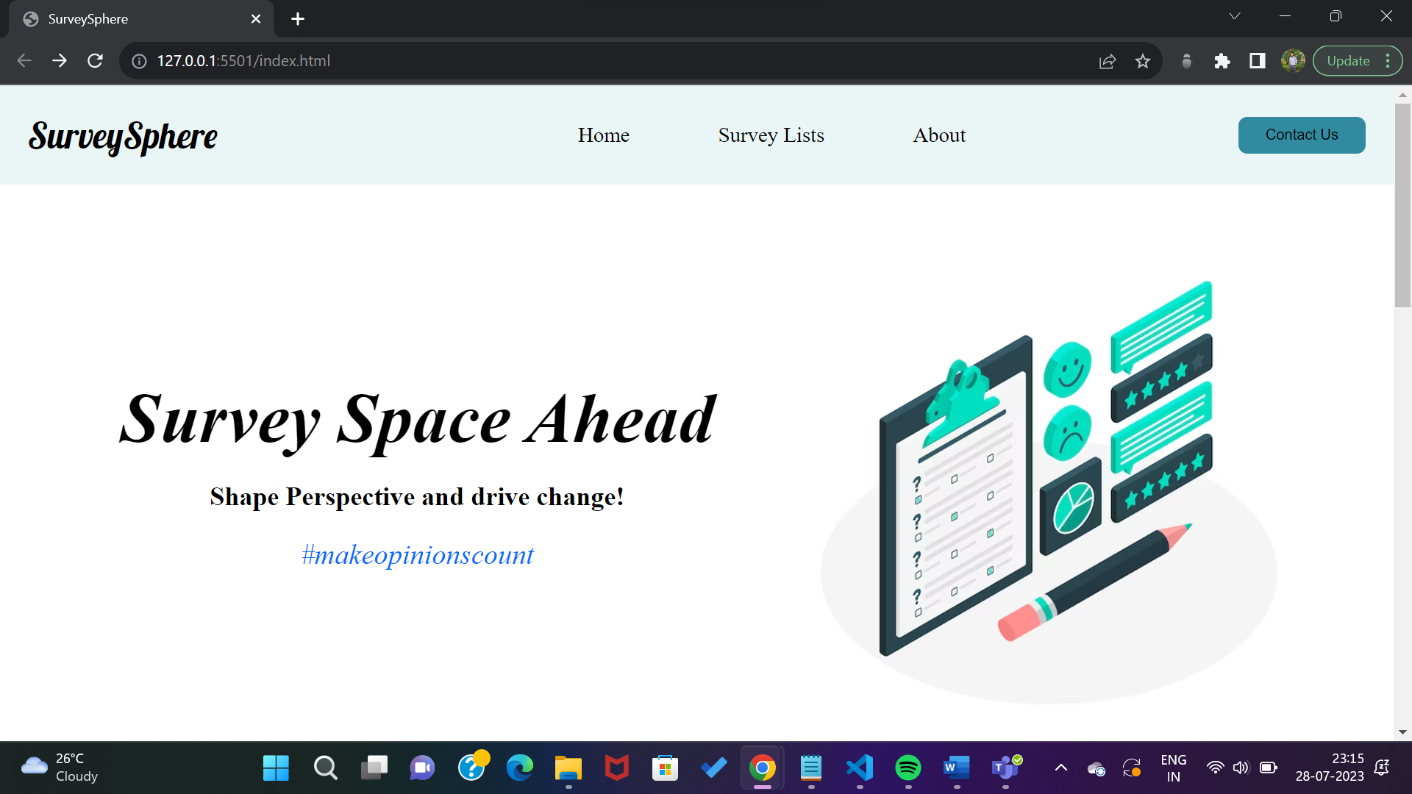

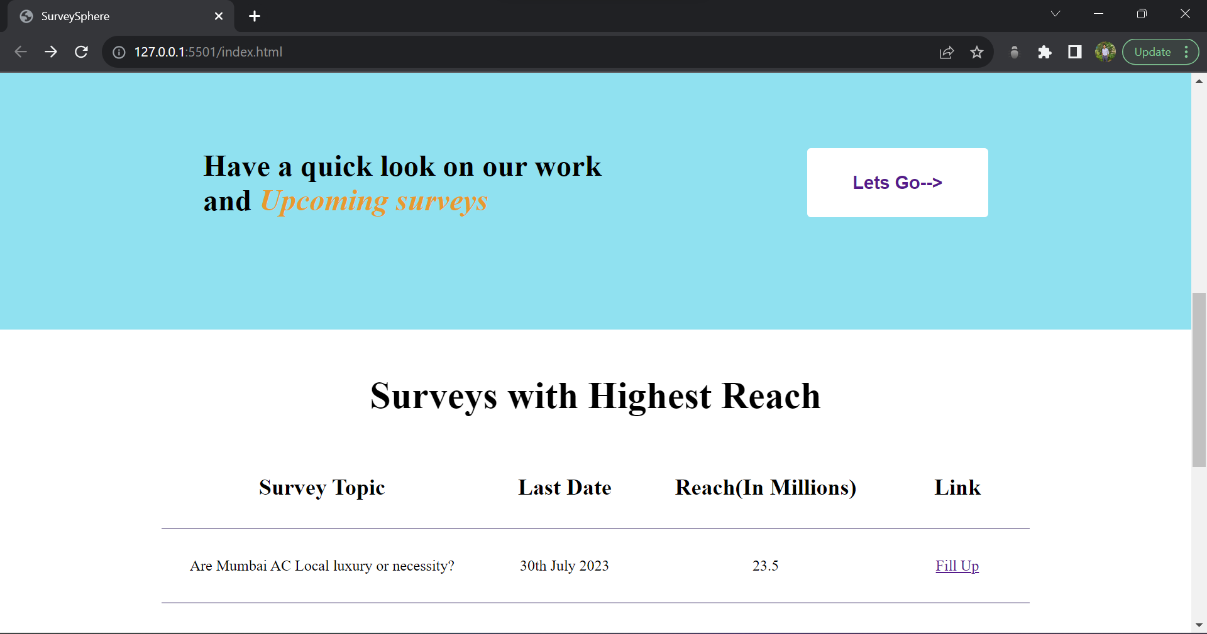

**Pseudo Class** for button: on hover

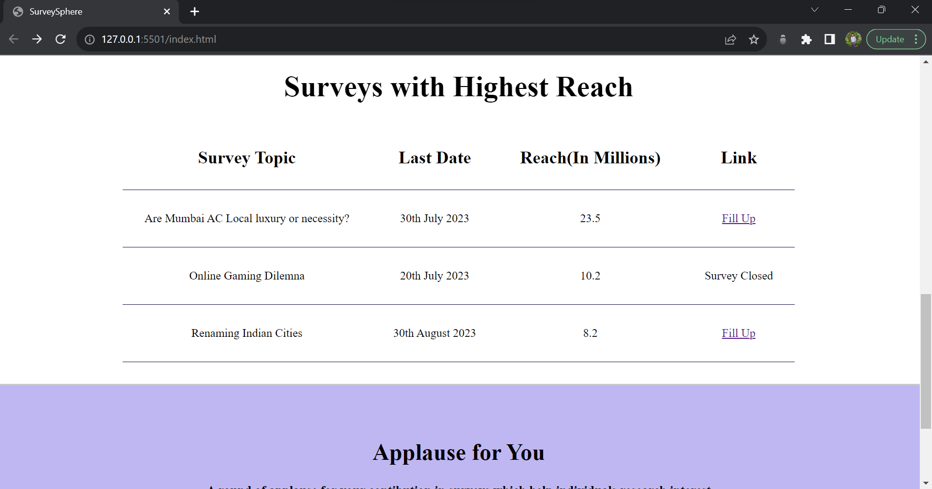

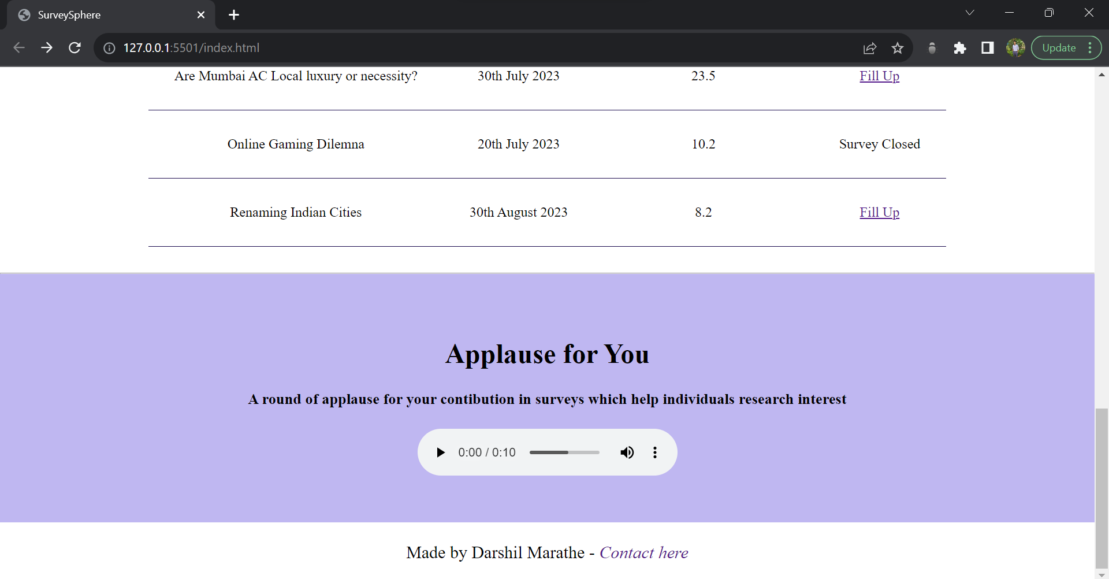

Page 2: Survey Page

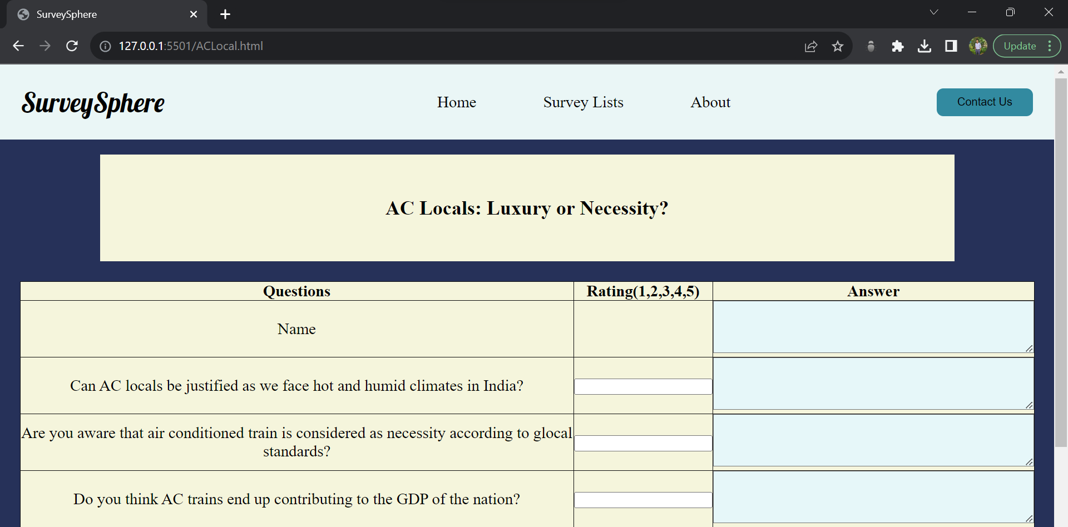 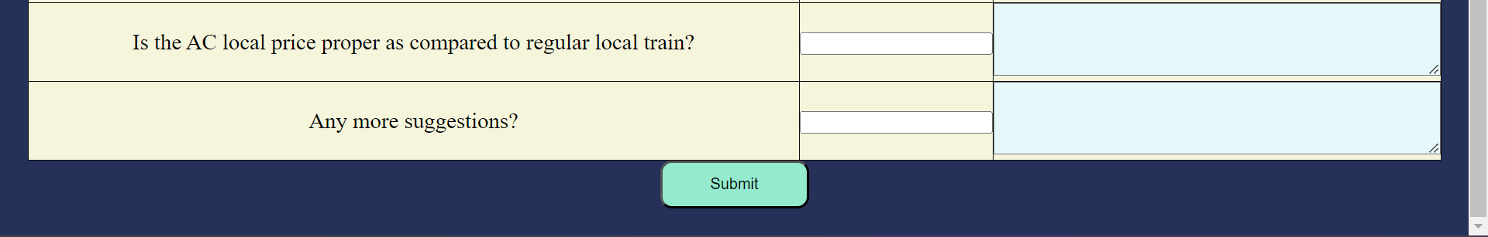

Page 3 : List of Surveys : Ongoing, Upcoming and Completed

