SentinelNet v2
AI-Powered Intrusion Detection System
Project Report

Field | Details
Course | CSE274 - Applied Machine Learning
Names of Students | [Enter student name(s)]
Roll Numbers | [Enter roll number(s)]
Instructor Name | [Enter instructor name]
Department / University | [Enter department / university]
Submission Date | 1 May 2026

2. Abstract
SentinelNet v2 is a production-oriented machine learning project for network intrusion detection using the CICIDS2017 dataset. The project addresses the problem of identifying malicious network traffic at operational scale, assigning risk scores to suspicious events, and presenting results through a Security Operations Center dashboard. The system combines classical machine learning, deep learning, anomaly detection, ensemble learning, explainability, streaming inference, alert generation, and an API-backed React frontend. The final deployment uses weighted scoring for binary attack detection and stacking for multiclass attack classification. On the persisted replay artifacts, the system processed 504,472 streamed rows, produced 85,089 alert rows, achieved a binary ROC-AUC of 0.999858, and sustained approximately 546.42 rows per second during real-time replay. The project demonstrates an end-to-end applied machine learning workflow from raw data ingestion to model serving, monitoring, and alert visualization.

3. Introduction
Background of the Problem
Modern organizations generate large volumes of network traffic, making manual inspection impractical. Intrusion Detection Systems are used to identify malicious behavior such as denial-of-service attacks, port scans, bot activity, brute-force attempts, and web attacks. Traditional signature-based systems are useful for known threats but struggle when attack patterns vary or when traffic volume is high.
Importance and Real-World Relevance
Cybersecurity monitoring is a high-impact application of applied machine learning. A useful system must not only classify traffic, but also produce timely risk signals, explain model behavior, and support analyst workflows. SentinelNet v2 was designed as an operational SOC-style platform rather than only an offline notebook experiment.
Objective
- Build an end-to-end AI-powered Network Intrusion Detection System.
- Train and compare classical ML, deep-learning, anomaly, and ensemble models.
- Replay traffic as a real-time stream and generate risk-scored alerts.
- Expose predictions, metrics, alerts, and health checks through FastAPI.
- Provide a professional React dashboard for SOC monitoring and manual prediction validation.

4. Problem Statement
The project solves a supervised classification problem. Given engineered network-flow features from CICIDS2017, the system predicts whether a flow is benign or malicious and also classifies the predicted attack family. The binary task is BENIGN versus ATTACK. The multiclass task includes attack families such as DoS Hulk, DDoS, PortScan, Bot, SSH-Patator, FTP-Patator, and web attacks.
Problem Aspect | Description
Primary ML Type | Classification
Binary Target | BENIGN or ATTACK
Multiclass Target | Specific attack family or BENIGN
Operational Output | Prediction, confidence, risk score, alert level, and recommended action
End User | Security analyst working in a SOC environment
Table 1. Problem definition for SentinelNet v2.

5. Dataset Description
The project uses CICIDS2017, a widely used cybersecurity dataset containing realistic benign and attack traffic collected from multiple packet capture scenarios. The repository processes multiple raw CSV files from data/raw/ and preserves source-file lineage throughout the pipeline.
Dataset Property | Value
Dataset source | CICIDS2017 network intrusion detection corpus
Raw input location | data/raw/
Processed stream rows | 504,472 held-out replay rows
Selected deployment features | 30
Binary target | label_binary
Multiclass target | label_multiclass
Primary stream artifacts | data/streaming/stream_predictions.csv and stream_predictions_with_alerts.csv
Table 2. Dataset and artifact summary.
Representative Feature Groups
Feature Group | Examples | Purpose
Packet length statistics | packet_length_variance, max_packet_length, min_packet_length | Capture payload and packet-size behavior.
Flow timing | flow_duration, flow_iat_mean, flow_iat_std | Represent temporal behavior of traffic flows.
Forward/backward packet metrics | total_fwd_packets, bwd_packet_length_mean | Measure directional traffic asymmetry.
Window and activity metrics | init_win_bytes_backward, active_mean, active_min | Capture TCP and activity characteristics.
Rolling behavior | rolling_unique_destination_ports_w20 | Detect scanning or repeated behavioral patterns.
Table 3. Feature groups used in the final selected feature set.

6. Data Preprocessing
The preprocessing pipeline converts heterogeneous CICIDS2017 CSV files into model-ready data. It includes schema normalization, missing-value handling, label normalization, scaling, encoding, train/test splitting, and class-imbalance treatment. The pipeline is designed to avoid data leakage by fitting preprocessing and feature-selection steps on training data before applying them to evaluation or streaming splits.
- Missing values and infinity values were cleaned or remediated during Phase 2.
- Outlier-prone network values were handled through robust cleaning and numeric validation.
- Categorical labels were normalized into binary and multiclass target encodings.
- Feature scaling was applied for models sensitive to feature magnitude.
- Class imbalance was addressed using task-specific balancing strategies.
- Train/test indices were persisted to ensure repeatable downstream model evaluation.

7. Feature Engineering and Dimensionality
Phase 5 generated statistical, behavioral, and domain-specific features from raw network-flow columns. Feature selection combined correlation analysis, mutual information ranking, and recursive feature elimination. PCA was also evaluated as part of dimensionality analysis, but the deployment system uses an interpretable selected feature set of 30 engineered features.
Technique | How It Was Used | Outcome
Correlation-based removal | Reduced redundant highly correlated predictors. | Improved stability and reduced duplication.
Mutual information | Ranked features by relationship with labels. | Identified high-signal flow and packet features.
Recursive feature elimination | Ranked features through estimator-guided selection. | Produced final deployment feature subset.
PCA analysis | Measured compressed variance representation. | Supported dimensionality understanding; not used as final serving contract.
Table 4. Feature-selection and dimensionality techniques.
Selected Deployment Features
No. | Feature Name | No. | Feature Name
1 | packet_length_variance | 16 | fwd_iat_std
2 | bwd_packet_length_mean | 17 | flow_iat_std
3 | total_length_of_fwd_packets | 18 | fwd_packet_length_std
4 | bwd_packet_length_max | 19 | rolling_unique_destination_ports_w20
5 | init_win_bytes_backward | 20 | bwd_iat_max
6 | max_packet_length | 21 | forward_payload_efficiency
7 | fwd_packet_length_max | 22 | bwd_iat_total
8 | flow_iat_max | 23 | bwd_iat_mean
9 | fwd_header_length | 24 | total_fwd_packets
10 | flow_duration | 25 | burstiness_score
11 | fwd_packet_length_mean | 26 | active_mean
12 | fwd_iat_mean | 27 | active_min
13 | destination_port | 28 | bwd_iat_min
14 | flow_bytes_per_s | 29 | min_packet_length
15 | flow_iat_mean | 30 | flow_iat_min
Table 5. Final 30 features required by the /predict API.

8. Methodology
SentinelNet v2 follows a layered classification methodology. Classical ML models provide strong tabular baselines, deep-learning models capture nonlinear and sequential patterns, anomaly detectors add novelty sensitivity, and ensemble methods combine these signals into deployment-ready binary and multiclass predictions.
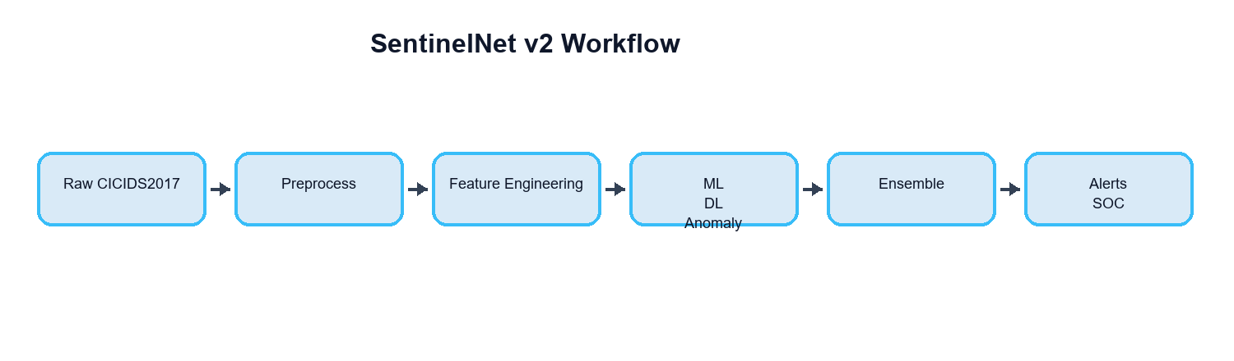
Figure 1. End-to-end SentinelNet v2 workflow.
Model Family | Models Used | Reason for Selection
Classical ML | Logistic Regression, Random Forest, XGBoost, LightGBM | Strong tabular baselines and interpretable feature importance.
Deep Learning | DNN, LSTM, Autoencoder | Capture nonlinear interactions, sequential context, and reconstruction anomalies.
Anomaly Detection | Isolation Forest, One-Class SVM, LOF, Autoencoder scoring | Detect unusual traffic patterns beyond supervised labels.
Ensemble | Soft voting, weighted scoring, stacking | Combine complementary strengths and improve operational robustness.
Table 6. Methodology and model-selection rationale.

9. Implementation Details
The project was implemented as a reproducible Python codebase rather than a single notebook. Each phase has dedicated modules, configuration files, logs, artifacts, and tests. The operational frontend is implemented as a Vite React application connected to the FastAPI backend through an Axios service layer and a local /api proxy.
Category | Tools / Libraries
Core language | Python
Data processing | NumPy, Pandas
Machine learning | Scikit-learn, XGBoost, LightGBM
Deep learning | TensorFlow / Keras
Visualization | Matplotlib, Seaborn, Recharts
Backend API | FastAPI, Uvicorn, Pydantic
Frontend | Vite, React, Tailwind CSS, Axios, React Router
Testing | Pytest
Table 7. Implementation tools and libraries.
Key Runtime Settings
Parameter | Value
Streaming inference batch size | 256
Default API stream limit | 1000
Default API alert limit | 1000
Frontend live scanner batch | 120 rows
API predictor preload | Enabled
Selected binary deployment variant | weighted_scoring
Selected multiclass deployment variant | stacking
Table 8. Important runtime and deployment parameters.

10. Model Evaluation
The classification system was evaluated using confusion matrices, accuracy-oriented classification metrics, ROC curve behavior, and ROC-AUC. Operational replay metrics were also measured because the project is intended for streaming IDS use, not only offline classification.
Metric / Artifact | Reported Result
Binary ROC-AUC | 0.999858
Streamed replay rows | 504,472
Alert rows written | 85,089
Attack alerts | 63,225
Average batch latency | 909.28 ms
Throughput | 546.42 rows/sec
Table 9. Evaluation and replay summary.
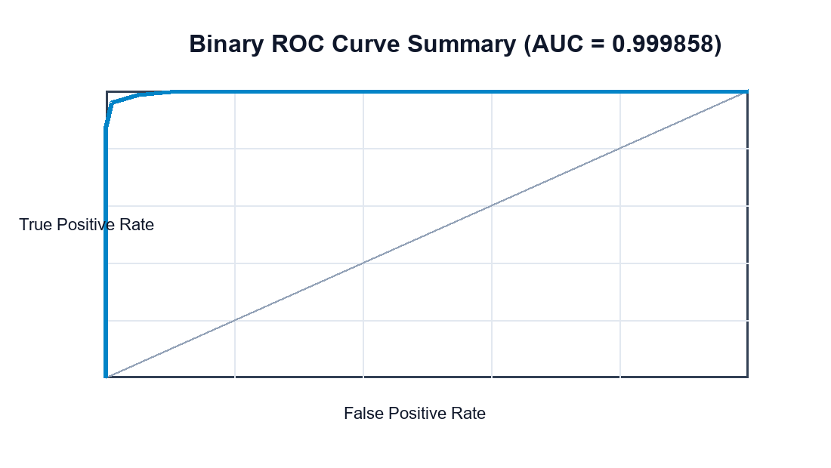
Figure 2. ROC curve summary for binary attack detection.

11. Results and Visualization
The final deployment artifacts show strong attack-detection quality and practical streaming performance. The React SOC dashboard visualizes KPIs, live events, real-time attack alerts, alert distributions, model insights, and system health. The dashboard is connected to real FastAPI responses and does not use fake telemetry.
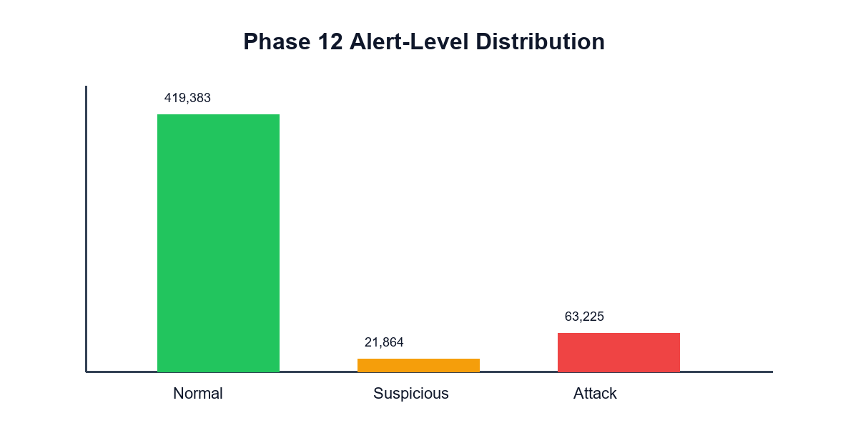
Figure 3. Alert-level distribution from Phase 12.
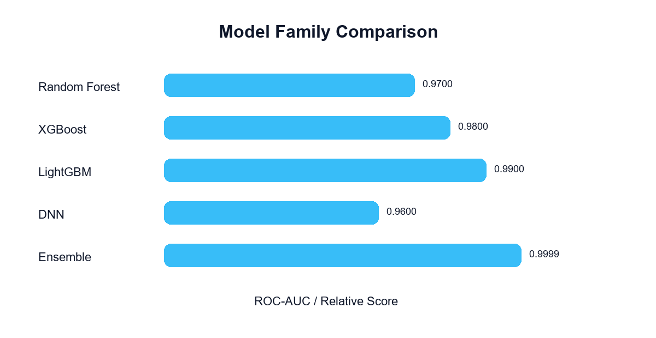
Figure 4. Model-family comparison summary.
Output | Value
Normal rows | 419,383
Suspicious alerts | 21,864
Attack alerts | 63,225
Maximum risk score | 84.67
Dominant attack families | DoS Hulk, DDoS, PortScan
Table 10. Operational alert results.

12. Hyperparameter Tuning
The project uses configuration-driven tuning and benchmarking across model training and deployment. Classical ML models were evaluated through task-specific configurations, ensemble variants were selected by performance metrics, and Phase 15 benchmarked serving parameters for real runtime behavior. The active serving defaults were aligned with the Phase 15 performance recommendations.
- Binary deployment variant selected: weighted_scoring.
- Multiclass deployment variant selected: stacking.
- Recommended streaming inference batch size: 256.
- Recommended API predict batch size: 8.
- Metrics cache speedup observed during benchmarking: 9487.56x.

13. Interpretation and Insights
The model stack learned that packet-length behavior, flow timing, backward packet characteristics, TCP window behavior, and rolling destination port uniqueness are important indicators of malicious traffic. This aligns with real-world network security intuition: denial-of-service, port scanning, brute-force, and web attacks often change packet-size distributions, timing patterns, and repeated connection behavior.
- Risk scoring makes model output more useful for analysts than class labels alone.
- Explainability summaries help identify which features drive decisions.
- Streaming replay demonstrates that the model can be integrated into operational monitoring workflows.
- The React SOC frontend improves usability by separating live predictions from real-time attack alerts.

14. Conclusion
SentinelNet v2 successfully implements a full applied machine learning lifecycle for network intrusion detection. The best deployment setup uses weighted scoring for binary classification and stacking for multiclass attack classification. The project reaches strong binary detection quality with ROC-AUC 0.999858 and provides a complete serving and monitoring stack through FastAPI and React.
Limitations
- The dataset is historical and may not represent every modern attack pattern.
- The /predict API requires all 30 selected deployment features, so raw packet input must be transformed before inference.
- Serialized model artifacts may emit library-version compatibility warnings until re-exported under a standardized environment.
Future Scope
- Add a raw-flow-to-feature transformation endpoint for easier live integrations.
- Expose Phase 16 zero-day, drift, and retraining signals directly in the React dashboard.
- Integrate analyst feedback from continuous-learning queues into automated retraining.
- Deploy the backend and frontend with production authentication, logging, and role-based access control.

15. Appendix
A. FastAPI Startup
uvicorn api.fastapi_app:app --host 0.0.0.0 --port 8000
B. React Frontend Startup
cd sentinelnet-frontend && npm install && npm run dev
C. /predict Contract
The /predict endpoint is defined by Pydantic schemas in api/schemas.py. Each request contains records, and each record contains source_file, optional event_time_utc, and a features object. The service requires all 30 selected features in the selected feature manifest.
D. Suggested Screenshots
- Command Center dashboard.
- Live Feed with Real-Time Attack Alerts.
- Alert Center with filters.
- Model Insights explainability page.
- Inference Lab validation response.

16. References
- Canadian Institute for Cybersecurity. CICIDS2017 Dataset.
- Scikit-learn documentation: classification metrics, preprocessing, and model persistence.
- FastAPI documentation: request validation, Pydantic models, and API routing.
- TensorFlow / Keras documentation for deep-learning model implementation.
- Vite, React, Tailwind CSS, Axios, and Recharts documentation for frontend development.
- SentinelNet v2 repository artifacts and source documentation.

