

**Post-Secondary Student Career Plan**

Choosing to pursue post-secondary education is both a huge investment in both yourself and your future. Currently, the average cost of post-secondary tuition has reached close to $66,000 (4 year program), while the average student can graduate with a debt of close to $20,000+[1]. We at CareerStreams Resources Inc. recognize that with the investment you are making in your future education, you want to be certain that you are making the right choice to prepare yourself for a successful CAREER. CareerStreams Resources Inc. is determined to assist you, our Client, find the education and career path that is best suited for your individual strengths and passions.

The Post-Secondary Student Career Plan has been designed by our expert Career Professionals to help you identify your career fit early on, this way YOU can confidently choose a program or course that best fits your particular strengths and career goals. Our career counsellors have extensive experience in working with post-secondary students and those seeking to improve their professional education, we understand the pressure you as a student are feeling.

Choosing a career path and planning for your future right out of high school can be a daunting task and complex decision for any student, we are here to assist you every step of the way. CareerStreams Resources Inc. has developed our Post-Secondary Student Career Plan to be uniquely tailored for each client to help you recognize your true potential and prepare you for a successful FUTURE. Our goal with the Post-Secondary Student Career Plan is to assist YOU to make an educated and thorough decision about your post-secondary endeavors, our goal is to help you INVEST YOUR TUITION IN YOURSELF, SO YOU CAN INVEST IN YOUR FUTURE!

**The Post-Secondary Student Career Plan includes:**

Step 1 - **Career Interview**- 2 one on one, 1 hour consultations that will consist of information gathering and full Vocational and Education Review. This step allows your career counsellor to find out more about you and what direction you see yourself following.

Step 2- **Career Assessment**- at this step your career counsellor with administer a series of assessments to assist in determining your potential such as talents, strengths, personality, areas of improvement.

* Vocational Assessment
* Interest Inventory
* Aptitude Testing
* Achievement Testing

Step 3- **Career Exploration and Review**- A post assessment review with your Career Counsellor to review the results of the assessments outline career options that may be best suited for your talents and interests.

Step 4- **Specific Career and Education Planning**- At this stage your Career Counsellor will assist you in planning your next step. Post-Secondary options that are best suited for you will be discussed at this stage, your Career Counsellor will assist you in determining your best choice for your post-secondary future.

CareerStreams Resources Inc. also provides ongoing consultation and professional development such as: Interview Preparation, Job Search Training, Personal Branding, and Resume Building for an hourly investment to help better prepare you.

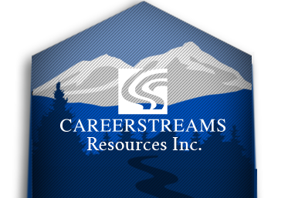

INVEST IN YOURSELF, INVEST IN YOUR FUTURE!

1. Canada.ca Social Development and Employment https://www.canada.ca/en/employment-social-development/programs/post-secondary/cost.html