

**Tribhuvan University**

**Orchid International College**

**A Final year Project Report**

**On**

**E-Novel Recommendation System using Collaborative Filtering Algorithm**

**Under the Supervision of**

**Mr. Diwakar Upadhaya**

**Lecturer**

**Orchid International College**

**Submitted To:**

**Department of Computer Science and Information Technology**

**Orchid International College**

**In partial fulfillment of the requirement for the Bachelor Degree in Computer Science and Information Technology**

**Submitted By:**

**Laxmi Maya Khatri(20806/075)**

**Manisha Kc(20809/075)**

**Ranu Dhungel(20822/075)**

**April,2023**

# D:\B.Sc.CSIT-TU\Miscellaneous Files of BSc.CSIT\Affiliated Colleges\Affiliated Colleges Logos\OIC\OIC_Logo Purple.jpg

# SUPERVISOR’S RECOMMENDATION

I hereby recommend that the report prepared under my supervision by Laxmi Maya Khatri (20806/075), Manisha Kc (20809/075), Ranu Dhungel(20822/075) entitled “ E-Novel with Implementation of Collaborative Filtering Algorithm” in partial fulfillment of the requirements for the degree of B.Sc. in Computer Science and Information Technology be processed for evaluation.

…………………..…….

**Mr. Diwakar Upadhaya**

Project Coordinator, Department of CSIT

Orchid International College

Bijayachowk, Gaushala

******

# LETTER OF APPROVAL

This is to certify that this project prepared by Laxmi Maya Khatri(20806/075), Manisha Kc(20809/075) , Ranu Dhungel(20822/075) entitled “entitled “ E-Novel Recommendation System Using Collaborative Filtering Algorithm” in partial fulfillment of the requirements for the degree of B.Sc. in Computer Science and Information Technology has been well studied. In our opinion, it is satisfactory in the scope and quality as a project for the required degree.

|  |  |
| --- | --- |
| **---------------------------------------------- Diwakar Upadhaya**  Supervisor,  Lecturer,  Orchid International College  Bijayachowk, Gaushala | **---------------------------------------**  **Er.­­ Dhiraj Kumar Jha**  Head of Department,  Orchid International College  Bijayachowk, Gaushala |
| **----------------------------------------------**  **Er. Nipun Thapa**  Internal Examiner,  Full-Time Faculty,  Orchid International Coollege  Bijayachowk, Gaushala | **---------------------------------------**  **External Examiner**  Central Department of Computer Science and IT,  Tribhuvan University,  Kirtipur, Nepal |

# ACKNOWLEDGEMENT

We would like to express our special thanks of gratitude to our teachers Mr. Dhiraj Kumar Jha, Miss Shikha Sharma and Mr. Diwakar Upadhyaya for their able guidance and support for the completion of this report. Our sincere thanks go to our team members who have dedicated their time and effort to make this report. Your generosity and support have made a significant impact on our success.

We would also like to extend our gratitude to Orchid International College for providing us this opportunity. Sincere appreciation to all my friends and colleagues who were directly or indirectly helpful for the completion of this project.

**Laxmi Maya Khatri(20806/075)**

**Manisha Kc(20809/075)**

**Ranu Dhungel(20822/075)**

# ABSTRACT

The E- novel store is an e-commerce and book sales industry in one form. This site contains the pdf content for online novel that allows users to conveniently read at home by using the internet feature which makes it easy to find the books you want, so online bookstore in today’s area of development is extremely rapid.

The algorithm used for this system is User-Based Collaborative Filtering, which is the technique used to predict the items that a user may like on the basis of ratings given to that item by the other users with a similar taste with that of target users.

The main purpose of the project is to provide facilities that can be available in online bookstore. Through this website customer can search the book by its author or title and purchase the pdf for the book by adding it to the cart and finally purchase it using khalti.

***Keywords:*** ***Collaborative-filtering, Recommendation System, E-novel, Laravel, user-based and Item-based***

TABLE OF CONTENTS

[SUPERVISOR’S RECOMMENDATION i](#_Toc133697954)

[LETTER OF APPROVAL ii](#_Toc133697955)

[ACKNOWLEDGEMENT iii](#_Toc133697956)

[ABSTRACT iv](#_Toc133697957)

[LIST OF FIGURES vii](#_Toc133697958)

[LIST OF TABLES viii](#_Toc133697959)

[LIST OF ABBREVIATIONS ix](#_Toc133697960)

[CHAPTER 1: INTRODUCTION 1](#_Toc133697961)

[1.1 Introduction 1](#_Toc133697962)

[1.2 Problem Statement 1](#_Toc133697963)

[1.3 Objectives 1](#_Toc133697964)

[1.4 Scope and Limitations 1](#_Toc133697965)

[1.5 Development Methodology 2](#_Toc133697966)

[1.6 Report Organization 3](#_Toc133697967)

[CHAPTER 2: BACKGROUND STUDY AND LITERATURE REVIEW 4](#_Toc133697968)

[2.1 Background Study 4](#_Toc133697969)

[CHAPTER 3: SYSTEM ANALYSIS 6](#_Toc133697970)

[3.1 Requirement Analysis 6](#_Toc133697971)

[3.1.1 Functional Requirements 6](#_Toc133697972)

[3.1.2 Non-functional Requirements 11](#_Toc133697973)

[3.1.2 Feasibility Analysis 11](#_Toc133697974)

[3.1.2.1 Technical Feasibility 11](#_Toc133697975)

[3.1.2.2 Operational Feasibility 11](#_Toc133697976)

[3.1.3.3 Schedule Feasibility 11](#_Toc133697977)

[3.1.3 Analysis 13](#_Toc133697978)

[3.1.3.1 Object Modelling using Class Diagrams 14](#_Toc133697979)

[3.1.3.2 Process Modelling using Activity Diagrams 15](#_Toc133697980)

[3.1.3.3 Dynamic modelling using State and Sequence Diagrams 15](#_Toc133697981)

[CHAPTER 4: SYTEM DESIGN 16](#_Toc133697982)

[4.1 Architectural Design 16](#_Toc133697983)

[4.1.1 Model View Controller Architecture 16](#_Toc133697984)

[4.2 Study of Algorithms 17](#_Toc133697985)

[4.2.1 Memory-Based Approach 17](#_Toc133697986)

[4.2.2 Cosine-Based Similarity 18](#_Toc133697987)

[4.2.3 Weighted Average 18](#_Toc133697988)

[CHAPTER 5: IMPLEMENATATION 19](#_Toc133697990)

[5.1 Tools Used 19](#_Toc133697991)

[5.2. Database Implementation 21](#_Toc133697992)

[5.3. Algorithm Implementation 22](#_Toc133697993)

[5.3.1 Phase one: Similarity between E-Novel using cosine similarity 24](#_Toc133697994)

[5.3.2. Phase second: Similarity between E-Novel using weighted average 25](#_Toc133697995)

[CHAPTER 6: TESTING 26](#_Toc133697996)

[6.1 Testing 26](#_Toc133697997)

[CHAPTER 7: CONCLUSION AND FUTURE RECOMMENDATIONS 29](#_Toc133697998)

[7.1 Conclusion 29](#_Toc133697999)

[7.2 Future Recommendations 29](#_Toc133698000)

[REFERNCES 30](#_Toc133698001)

[APPENDIX 31](#_Toc133698002)

# LIST OF FIGURES

[Figure 1.1 Agile Methodology 2](#_Toc133832440)

[Figure 3.1: Use Case Diagram 7](#_Toc133832441)

[Figure 3.2 Work Breakdown Structure 12](#_Toc133832447)

[Figure 3.3: Gantt Chart 13](#_Toc133832448)

[Figure 3.4: Class Diagram 14](#_Toc133832449)

[Figure 3.5: Activity Diagram 15](#_Toc133832450)

[Figure 3.6: Sequence Diagram 15](#_Toc133832451)

[Figure 4.1: Model View Controller Architecture 16](#_Toc133832452)

[Figure 5.1: Database Design and Implementation 21](#_Toc133832455)

[Figure 7.1: Home Page 31](#_Toc133832466)

[Figure 7.2: Login Page 31](#_Toc133832467)

[Figure 7.3 Register Page 32](#_Toc133832468)

[Figure 7.4:Popular Novel 32](#_Toc133832469)

[Figure 7.5: Most Liked Novel 33](#_Toc133832470)

[Figure 7.6: Recommended Novel 33](#_Toc133832471)

[Figure 7.7: All Category 34](#_Toc133832472)

[Figure 7.8: Novel Details 34](#_Toc133832473)

[Figure 7.9: Novel Chapters 35](#_Toc133832474)

# 

# LIST OF TABLES

[Table 3.1:Use Case Description for Register 8](#_Toc133476081)

[Table 3.2: Use Case Description for login / signup 8](#_Toc133476082)

[Table 3.3: Use Case Description for Searching Books 9](#_Toc133476083)

[Table 3.4: Use Case Description for Subscription the system 9](#_Toc133476084)

[Table 3.5: Use Case Description for Making Payment 10](#_Toc133476085)

[Table 5.1.1 Development Tools 19](#_Toc133476092)

[Table 1.1.2 Design and Documentation Tools 20](#_Toc133476093)

[Table 5.3:Example 1 22](#_Toc133476095)

[Table 5.4:Example 2 23](#_Toc133476096)

[Table 5.5 Data Dictionary 23](#_Toc133476097)

[Table 6.1:Test Case for User Registration 26](#_Toc133476098)

[Table 6.2:Test Case for User Login 27](#_Toc133476099)

[Table 6.3:Test Case for User Subcription 27](#_Toc133476100)

[Table 6.4:Test Case for User Payment 27](#_Toc133476101)

# LIST OF ABBREVIATIONS

Some of the abbreviations used in our projects shown below:

|  |  |
| --- | --- |
| HTML | Hyper Text Markup Language |
| CSS | Cascading Style Sheet |
| PDF | Portable Document Format |
| PHP | Hypertext Preprocessor |
| ER | Entity Relationship |
| WBS | Work Breakdown Structure |
| MVC | Model View Controller |
| TF-TDF | Term Frequency-Inverse Document Frequency |

# CHAPTER 1: INTRODUCTION

## 1.1 Introduction

The e-novel is a website that is built for enabling readers to browse books and allows them to read conveniently. This system's method is User-Based Collaborative Filtering, which is a technique used to forecast which things a user might like based on ratings given to that item by the other users with a similar taste with that of target users.

## 1.2 Problem Statement

Many people do not have easy access to physical books. A novel reading website could provide a convenient and accessible way for people to read books online. Some people may prefer to read on electronic devices, such as tablets or smartphones, rather than physical books. A novel reading website could provide a platform for these readers to access and purchase e-books. Many people are interested in discovering new books and authors, but may not know where to start. A novel reading website could offer recommendations and personalized book recommendations based on a reader's preferences and reading history. Some people may be hesitant to try new books because of the cost of purchasing physical copies or e-books. A novel reading website could offer a subscription service or free access to a selection of books to help encourage people to try new authors and genres.

## 1.3 Objectives

* To enable users to search for books based on different criteria such as title, author, category, etc.
* To provide user friendly experience of reading books.
* To implement collaborative filtering algorithm for improving the user engagement.

## 1.4 Scope and Limitations

The project goals to build a system that can be used to provide readers free book online, readers to subscribe premium book online, opportunity for new writers, facility of user feedback, features such as search, recommendation, and categorization to help users find the novels they are interested in, Users can read novels online in a user-friendly interface, writers can create an account and upload their own novels for others to read and this website also offers features such as bookmarks, ratings, and reviews to enhance the user experience. This web application is specially made for the audience of Nepal thus the readers of other countries might face problem when buying the premium novels, may have limited storage capacity, which could result in older novels being deleted to make room for new ones, this website may not be able to guarantee the accuracy or quality of the novels uploaded by users.

## 1.5 Development Methodology

We used the development methodology called Agile Methodology in order to build this system. Agile is a method for managing projects and developing software in an iterative manner, with the goal of delivering value to customers faster and with fewer complications. Rather than relying on a single, large launch, agile teams work in smaller, more manageable increments. This allows for continuous evaluation of requirements, plans, and outcomes, enabling teams to respond quickly and effectively to changes as they arise.

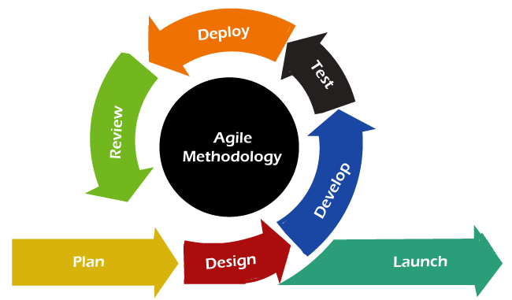

**Figure 1.1 Agile Methodology**

## 1.6 Report Organization

The report of E-Novel with implementation of Collaborative filtering algorithm report organization is divided into six sections.

Chapter 1 is an introductory section that includes the introduction to the project, scope, limitations and development.

Chapter 2 is background research and literature review. This section contains details of completed projects similar to the project under review. A compilation and summary of similar research-based projects or projects that may be related to project. This section describes functions used as information, instruction or to have an effect on the project.

Chapter 3 provides a detailed analysis of the system and the overall project. This section focuses on determining the feasibility of the project and the requirements of the system. This section ensures that the system is valid, the platform is valid, is valid, and the project is valid.

Chapter 4 focuses on the system and how to build it. It examines how the system should be configured, how to get it, and the algorithms that learn and use to ensure smooth and seamless development and a good system.

Chapter 5 gives an overview of how the system was actually built and how it was done with. It shows which tools are used and why, how the algorithm is used, and how the data is used. It also lists approximately QA aspects of the project.

Finally, Chapter 6 gives an idea of the system and the project and how to develop the system.

# CHAPTER 2: BACKGROUND STUDY AND LITERATURE REVIEW

## 2.1 Background Study

There are various researches that has been done on the use of Collaborative Filtering on the online book stores.

In the study done by Izariie in Maharastra, [1] the researchers conducted a study on how online textbook system that allows user to conveniently at home, use the internet feature, find books that they want and save cost. The system was designed to deal with customers on the basis of customer queries regarding information about different types of books. This study concluded that the customers of today are not only attracted because online shopping is convenient but also because they have broader selections, highly competitive prices and extremely simplified navigation for searching regarding the product.

Research in similar system was done in which the ambiguity in choosing the appropriate content in appropriate time was pointed out [2]. The prototype of book store gives a guideline in developing a real system based on user's view. However, the order is still done manually, where the orders are handled by the university bookstore.

Another research that was conducted in similar system in Singapore proposes an online book stores and websites for developing library collections for children. [3]This research focused on a special service called 'School Direct' through which teachers can order items in a discounted price from different publishers. This study suggests on implementing many innovative ideas for promoting reading habits among children.

The research conducted in Malaysia on an online-book ordering system [4] studies the benefit of the system that sells directly to its customers by using secure internet commerce software. The main purpose of this system tends to be providing immediate feedback to customers.

According to Shrwesbury-Gee, the benefits of online ordering have been enthusiastically greeted by a test group of teachers and within this system no manual work is involved, thus saves time and money.

Zhiyang Jia, Yuting Yang, Wei Gao, and Xu Chen developed an application that can create a customized list of recommended tourist attractions for individual users. The process of recommending tourist attractions is based on the collaborative filtering principle, which involves three steps: representing the user's information, identifying similar users, and generating attraction recommendations based on those similar users.

In paper Poonam Sharma, [5] Lokesh Yadav proposed a Movie Recommendation System Using Item based collaborative filtering. Normally basic recommendation system to make recommendations consider one of the following factors; User preference known as content-based Filtering or the preference of similar users known as collaborative filtering.

# CHAPTER 3: SYSTEM ANALYSIS

## 3.1 Requirement Analysis

Therequirement analysis targets on the process of understanding and defining the needs and requirements of a system, product or project. It involves the identification, documentation, and assessment of the stakeholders' needs, goals and constraints, with the aim of determining what the system should do and how it should be implemented. This is a crucial step in the software development life cycle as it helps to ensure that the final product meets the needs of its users and stakeholders. The requirement analysis process typically includes activities such as gathering requirements, defining scope, and performing feasibility studies.

### 3.1.1 Functional Requirements

The functional requirements specify the actions, features or capabilities that a system, product, or project must be able to perform in order to meet the needs and expectations of the project. They describe what the system should do, rather than how it should be implemented.

The functional requirements typically include a description of inputs, outputs, and processes, as well as any constraints or limitations on the system's performance. They serve as a basis for design and development and are used to create the system's functional specification, which provides a detailed description of the system's behavior. Functional requirements should be specific, measurable, and verifiable, and they should clearly define the system's desired behavior.

The following is the use case diagram:

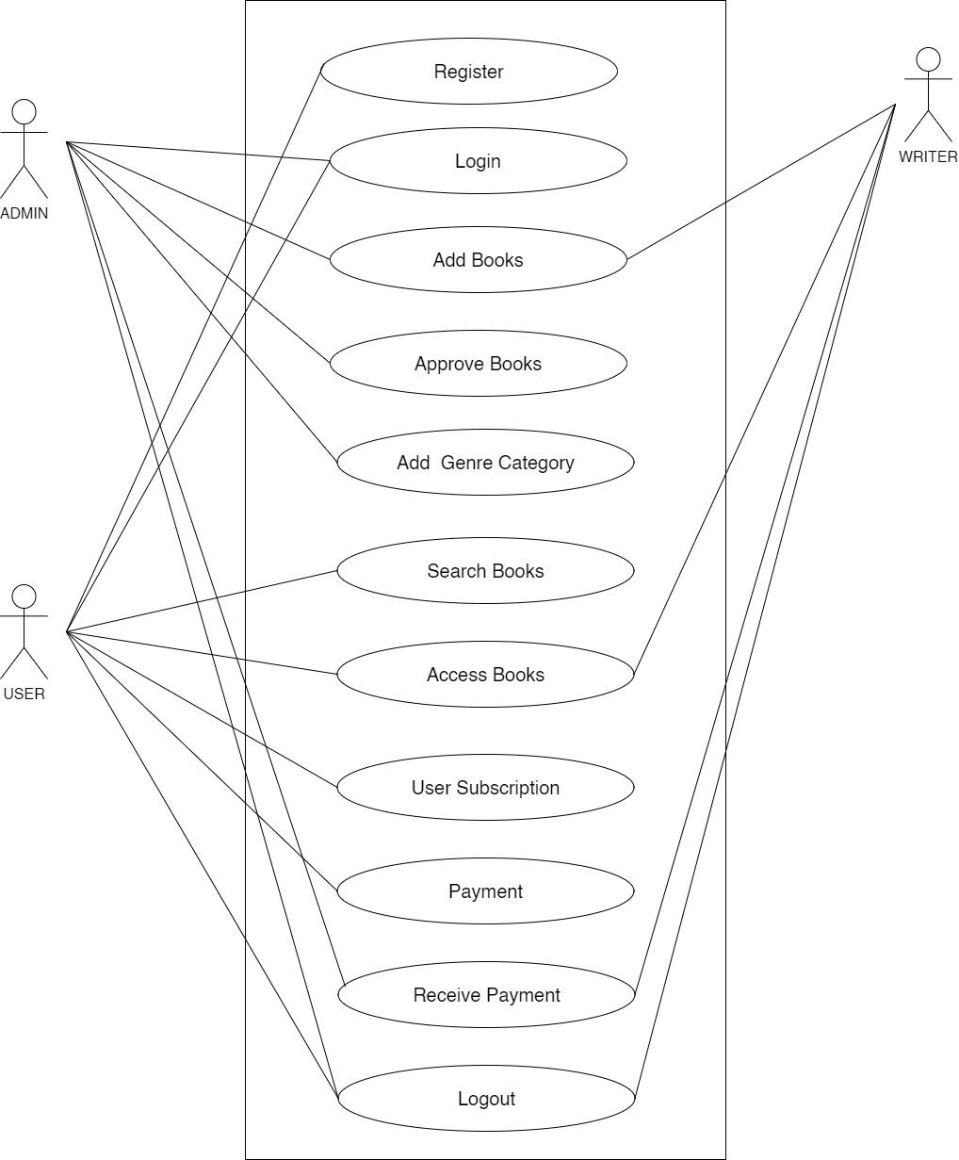

**Figure 3.1: Use Case Diagram**

**Table 3.1: Use Case Description for Register**

|  |  |
| --- | --- |
| Case Name | Register |
| Primary Actor | Admin , User |
| Secondary Actor | None |
| Decription | Register should be done for login the system. |
| Pre-condition | Should not be register. |
| Post-condition | Admin/User is registered . Can access the system. |
| Fail Scenarion | Unable to register. |

**Table 3.2: Use Case Description for login / signup**

|  |  |
| --- | --- |
| Case Name | LogIN / Sign Up |
| Primary Actor | Admin , User |
| Secondary Actor | None |
| Decription | Login should be done to read and subcription the system for read premium books. |
| Pre-condition | Should not be logged in. |
| Post-condition | User is logged in. Can search and read books. |
| Fail Scenarion | Unable to login. |

**Table 3.3: Use Case Description for Searching Books**

|  |  |
| --- | --- |
| Case Name | Search Books |
| Primary Actor | User |
| Secondary Actor | None |
| Decription | Login should be done to search and read books.Users are allowed to view books. |
| Pre-condition | Should not be logged in. |
| Post-condition | User are able to search and view books description. |
| Fail Scenarion | Unable to search or final results. |

**Table 3.4: Use Case Description for Subscription the system**

|  |  |
| --- | --- |
| Case Name | Subcription |
| Primary Actor | User |
| Secondary Actor | None |
| Decription | Login should be done subcribe to read books.User can read and find out their preferred books to read. |
| Pre-condition | User must be logged in. |
| Post-condition | User are able to read the book after subscription. |
| Fail Scenarion | Unable to subscription. |

**Table 3.5: Use Case Description for Making Payment**

|  |  |
| --- | --- |
| Case Name | Make Payment |
| Primary Actor | User |
| Secondary Actor | None |
| Decription | Firstly, Login should be made to view and read books. Payment is done after subcription system. |
| Pre-condition | User should be logged in to subcription the system. |
| Post-condition | User is able to subcription system and make payment |
| Fail Scenarion | Unable to make payment. |

### 3.1.2 Non-functional Requirements

Non-functional requirements are the qualitative and quantitative characteristics or attributes of a system, product, or project that are not directly related to its specific functionalities or features. Unlike functional requirements, which describe what the system should do, non-functional requirements describe how well the system should do it, in terms of aspects such as performance, reliability, security, usability, and maintainability**.**

## 3.1.2 Feasibility Analysis

### 3.1.2.1 Technical Feasibility

The technical analysis concerns with determining how possible a system is from a technical perspective. The project is developed for reading purpose. In order to access this website, the reader needs an internet connection. The main requirement of the system from a developer’s view is a web server capable of handling the content, internet connection, and manpower to handle the website.

### 3.1.2.2 Operational Feasibility

Operational analysis focuses on assessing a system's operational capabilities. In the case of this web-based application, it can be easily managed with basic web browsing skills, and a general-purpose computer is all that's required for efficient operation. Furthermore, the user interface is user-friendly, making the system operationally feasible.

### 3.1.3.3 Schedule Feasibility

The schedule feasibility is in the evaluation of whether a proposed project can be completed within the specified time frame, taking into account the available resources, constraints, and dependencies. It assesses the feasibility of the project's timeline and the ability to meet critical project deadlines.

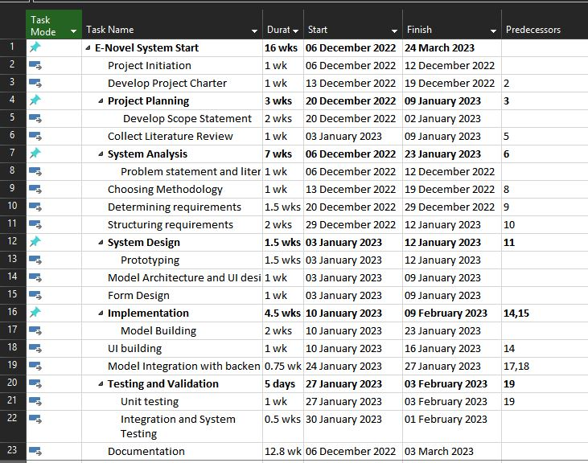

**Figure 3.2 Work Breakdown Structure**

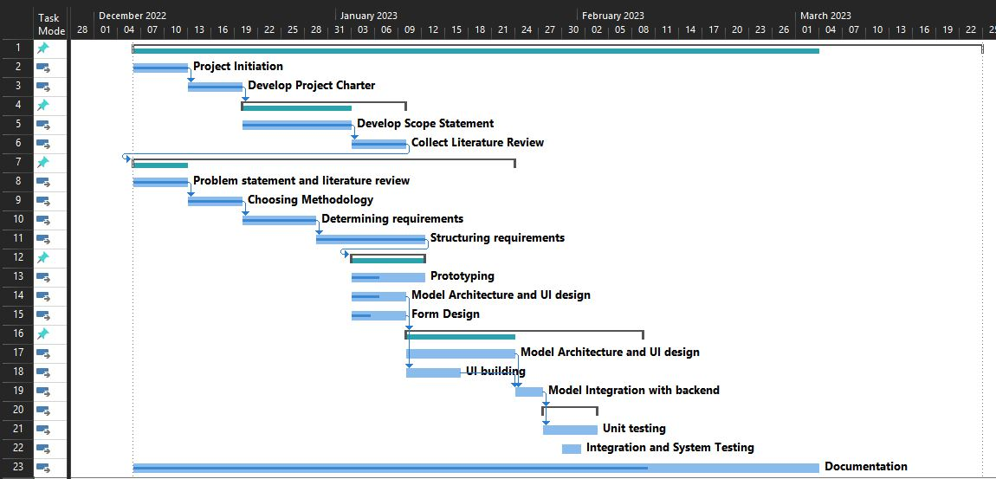

**Figure 3.3: Gantt Chart**

## 3.1.3 Analysis

Analysis is the process of breaking down a complex system, product, or problem into smaller parts to better understand it and identify potential solutions. I`n our project we used the object-oriented approach for the analysis process. It involved the use of class, activity and sequence diagram. The class diagram represents the structure of our system by modeling its classes, attributes and the relation between them. The activity diagram is the graphical representation of our system which shows how the overall system works including user registration to signing out from the system. The sequence diagram is used to represent the working of the algorithm applied to our system. This shows what type of data the algorithm takes as an input and how does it provides the output to the user on the basis of the given input.

### 3.1.3.1 Object Modelling using Class Diagrams

Class Diagram:

**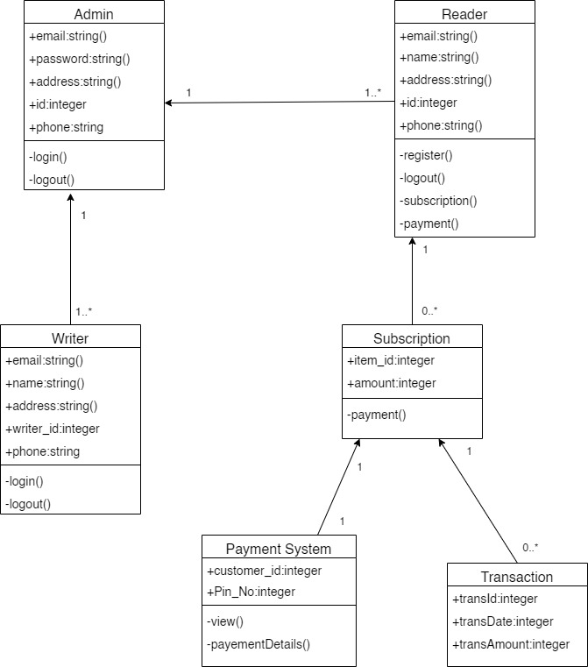**

**Figure 3.4: Class Diagram**

### 3.1.3.2 Process Modelling using Activity Diagrams

Activity diagram:

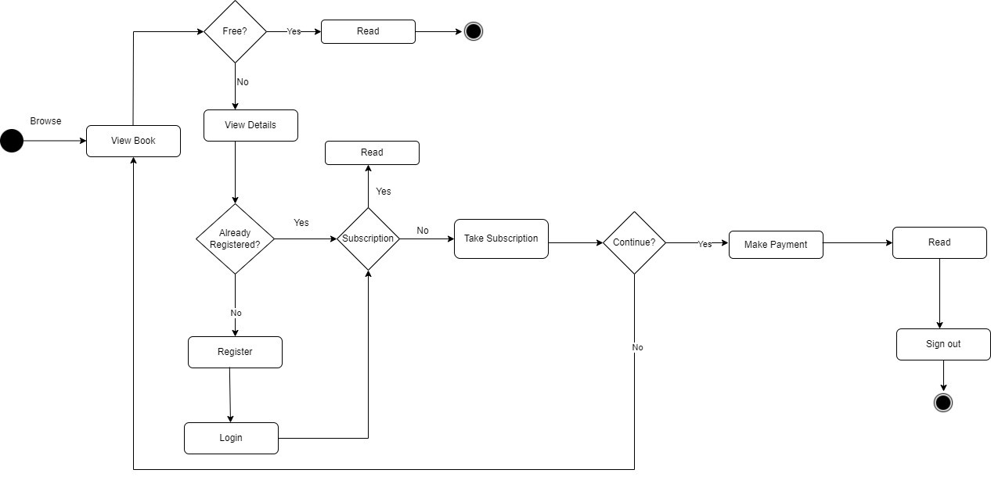

**Figure 3.5: Activity Diagram**

### 3.1.3.3 Dynamic modelling using State and Sequence Diagrams

Sequence Diagram:

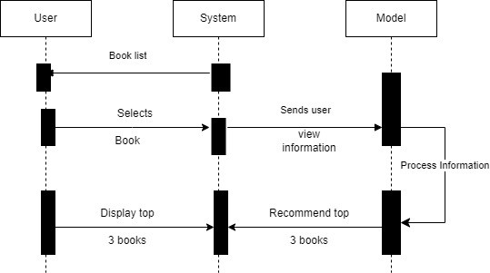

**Figure 3.6: Sequence Diagram**

# CHAPTER 4: SYTEM DESIGN

## 4.1 Architectural Design

### 4.1.1 Model View Controller Architecture

The system has been constructed using the Model-View-Controller architecture. For this particular project, the Model would include information about the books, including their titles, authors, publishers, publication dates, and genres. The View is responsible for presenting this data to the user, including information about their reading progress, such as the number of pages they've read and their bookmarks. Finally, the Controller acts as an intermediary between the Model and the View, managing user actions like searching for a book, selecting a book to read, and navigating through the book's pages.

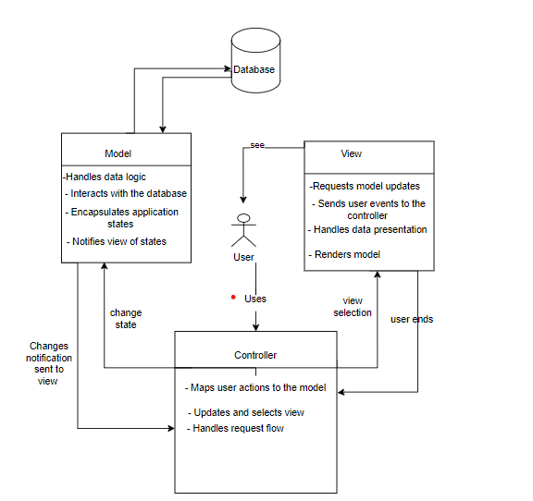

**Figure 4.1: Model View Controller Architecture**

## 4.2 Study of Algorithms

The E-Novel System uses features of Collaborative Filtering to produce efficient and effective recommendations. This website helps to buy and read books online with Search and Recommendation system. The book search system shows book with the similar keyword that the user uses to search the book and the book recommendation system recommends the books that are of user's interest. Recommendation system is used to recommend the products to the end users that are most appropriate. Collaborative filtering us probably the most familiar, most widely implemented and most mature of the technologies. Collaborative filtering can be implemented using memory-based, model- based, hybrid, or deep learning methods. Memory-based approach uses similarity calculation and weighted average rating method. Model based approach develops a model using different data mining, machine learning algorithms to predict users' rating of unrated items. The hybrid approach combines the memory-based and the model-based collaborative filtering algorithms. These overcome the limitations of native collaborative filtering approaches and improve prediction performance. Deep learning technique is a recent method that uses neural and deep-learning techniques. While deep learning has been applied to many different scenarios, it is not effective when used in a simple collaborative recommendation scenario.

### 4.2.1 Memory-Based Approach

The memory-based approach in recommendation systems utilizes user rating data to determine the similarity between users or items. This technique employs neighborhood-based algorithms to compute the similarity between two users or items, generating a prediction for the user through a weighted average of all the ratings. To calculate similarity, various measures such as Pearson correlation and vector cosine-based similarity are used. Although this approach is susceptible to issues arising from sparse data, it remains highly effective due to it**s** explainability, ease of use, ability to integrate new data easily, and good scalability with related items.

### 4.2.2 Cosine-Based Similarity

Cosine similarity is a numerical measure that assesses the similarity between two sequences of numbers. It falls within the range of -1 to 1. To compute cosine similarity, the Euclidean dot product formula can be employed for two non-zero vectors:

The cosine similarity between two n-dimensional attribute vectors A and B can be represented using their dot product and magnitudes. It is calculated as the sum of the product of each component of the vectors divided by the product of their magnitudes. Mathematically, it can be expressed as

where Ai and Bi are components of vector A and B respectively.

### 4.2.3 Weighted Average

A weighted average is a mathematical computation that considers the varying levels of significance of numbers within a dataset. To calculate a weighted average, each number in the dataset is assigned a predetermined weight and is then multiplied by that weight. After this, the final computation is performed by dividing the sum of these weighted values by the total sum of the weights.

# ­­

# CHAPTER 5: IMPLEMENATATION

## 5.1 Tools Used

**Table 5.1.1 Development Tools**

|  |  |
| --- | --- |
| **Tools Used** | **Purpose** |
| HTML | Used to structure the text into chapters, sections, and paragraphs, as well as to create a link to other parts of the book or external resources |
| CSS | used to style the text to make it easier to read, such as by setting the font size and line spacing, adjusting the margins, and choosing appropriate colors and fonts. |
| React JSX | used in this project to display book content, implementing search functionality, creating bookmarks and annotations and implementing responsive design. |
| Laravel | used to implement backend of the application which includes a database that stores information about books, such as author, title, and description |
| Visual Studio Code | used as a text editor for reading and editing code files |
| MySQL | core database of the project is built in MySQL using PHP as PHP offers an easy integration of the MySQL databases. |
| GitHub with Git | used for project versioning and code collaboration within the project team. |

**Table 1.1.2 Design and Documentation Tools**

|  |  |
| --- | --- |
| **Tools Used** | **Purpose** |
| Draw.io | to create diagrams such as use-case diagram, activity diagram, ER diagram, class diagram that can be easily embedded within the text of the book, making it more interactive and engaging for the reader. |
| Microsoft Project | used as the project analysis tool that allowed for the schedule analysis and planning using work breakdown structure and Gantt charts. |
| Microsoft Word | used during the report and proposal preparation for the project. |
| Microsoft PowerPoint | used for preparing the presentation slides during the ­­proposal submission and defense, mid-term defense, and final defense. |

## 5.2. Database Implementation

**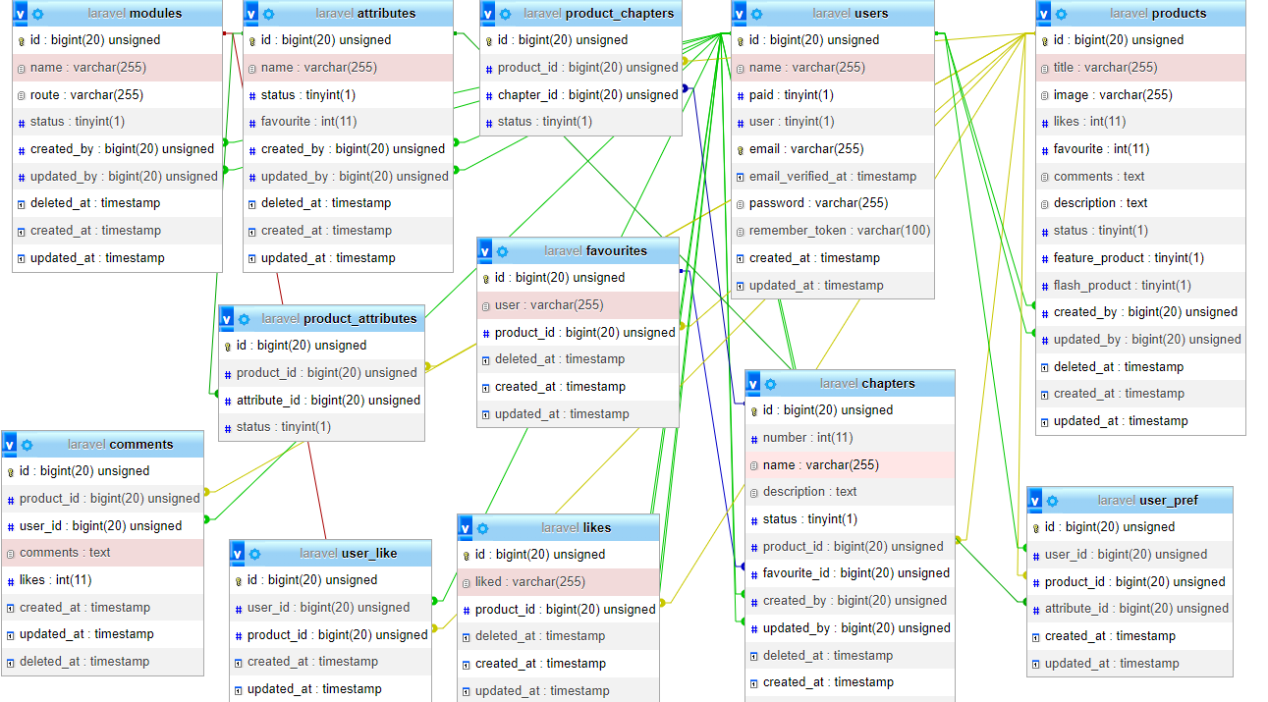**

**Figure 5.1: Database Design and Implementation**

## 5.3. Algorithm Implementation

The collaborative filtering system employs three approaches, namely user-based, item-based, and memory-based to compute recommendations. In this system, determining the similarity between items or users plays a crucial role. Different measures, including Pearson correlation and vector cosine-based similarity, are utilized for this purpose. The algorithm consists of two phases. In the first phase, the system identifies users who possess similar rating patterns as the active user (the user for whom the prediction is being made). The second phase involves utilizing the ratings of these like-minded users, identified in the first phase, to compute a prediction for the active user.

We are provided with a user-item ratings matrix M, containing ratings given by three users (rows) to three items (columns). The ratings range from 1 to 30, with 3 indicating a low rating. Our objective is to determine if 10 users would like the first priority item, which is the highest-rated novel. To achieve this, we consider 30 users as the target users or active users and the target item is the third novel in the list.

**Table 5.3:Example 1**

|  |  |  |  |
| --- | --- | --- | --- |
| Week | Novel 1 | Novel 2 | Novel 3 |
| 10 users | 1 | 2 | 3 |
| 20 users | 2 | 1 | 3 |
| 30 users | 3 | 2 | 1 |

For Another example, consider an e-commerce website that sells books. The User-Item Matrix for this website might look like the following:

**Table 5.4:Example 2**

|  |  |  |  |  |  |
| --- | --- | --- | --- | --- | --- |
|  | Book 1 | Book 2 | Book 3 | Book 4 | Book 5 |
| Reader 1 | 1 | 0 | 1 | 0 | 0 |
| Reader 2 | 0 | 1 | 0 | 1 | 1 |
| Reader 3 | 1 | 1 | 0 | 0 | 1 |
| Reader 4 | 0 | 0 | 1 | 1 | 0 |
| Reader 5 | 1 | 0 | 0 | 0 | 1 |

This example involves a matrix with 5 books and 5 readers, where each cell indicates whether a reader has interacted with a book or not.

Using this User-Item Matrix as input, the collaborative filtering algorithm generates personalized recommendations for each reader based on patterns in the matrix. However, the matrix can become unwieldy and sparse for large websites with many users and items, so techniques like dimensionality reduction and sparsity reduction are used to optimize the matrix and improve the recommendation algorithm's efficiency.

In the context of an online book reading system, a data dictionary is a tool that describes the system's data, including the attributes of users and books, as well as the methods used for similarity computation and recommendation generation, such as cosine similarity and weighted average.

**Table 5.5 Data Dictionary**

|  |  |
| --- | --- |
| **Term** | **Definition** |
| E-Novel | An online platform where users can read books virtually. |
| Cosine similarity | The cosine similarity is a mathematical measure employed to determine how similar two non-zero vectors are by evaluating the cosine of the angle they form. |
| Weighted average | A type of average where each value is multiplied by a weight before being summed and divided by the total weight. |
| Title | The name of the book |
| Author | The person who wrote the book. |
| Book description | A brief summary of the book. |
| Algorithm | A systematic and organized method for resolving an issue or accomplishing a target, typically involving a series of defined steps. |
| Similarity score | A value that measures the degree of similarity between two objects or sets of data. |
| Vector | A mathematical object that has both magnitude and direction. In the context of the online read book system, the vector represents the book's features (e.g., title, author, description) |
| Feature vector | A vector that represents the features of a book. In the online read book system, the feature vector represents the book's title, author, and description. |
| Term frequency | The number of times a term (e.g., a word) appears in a document (e.g., a book). |
| Inverse document frequency | A measure of how much information a term provides across all documents in a collection. |
| TF-IDF | A numerical value used in statistics to determine the importance of a term in a set of documents. |

### 5.3.1 Phase one: Similarity between E-Novel using cosine similarity

The first phase in the implementation of algorithm in the system is the implementation of cosine similarity between the books. Unlike the general approach of using the user view itself for the computation of similarity scores to generate a similarity matrix, this system used the attributes of the books itself to factor into the computation of the similarity matrix.

Here, A and B are two books vector whose similarity scores are to be computed and is the similarity score obtained.

The dot product of the two vectors is then calculated using the above-mentioned formula. There are 6 attributes involved in the similarity calculation so n = 6. Formula simplified as:

Here, If the 6 attributes of 𝐴⃗ is named as 𝑎1, 𝑎2, 𝑎3, 𝑎4, 𝑎5 and 𝑎6 and that of 𝐵⃗⃗ is named as 𝑏1, 𝑏2, 𝑏3, 𝑏4, 𝑏5 and 𝑏6 then the similarity score is computed as:

### 5.3.2. Phase second: Similarity between E-Novel using weighted average

The second one is the implementation of use the predicted view books calculation to find which same category books is to be recommended. The system calculates the weighted average on the basis of book author, title and description using the method. In calculating a weighted average, each score in the data is multiplied by a predetermined weight before the final calculation is made.

Then, is the weight value, is the book item value and is the weight obtained after the computation. For this system, the weight is the similarity score between the books. The item value is provided to the books by the user. So, if we consider *P(c,u)* as the similarity score of books c for user *u,* as the similarity score between the books c and ci, and as the similarity predicted to user u to books the we can rewrite the formula as:

# CHAPTER 6: TESTING

## 6.1 Testing

Software testing involves the process of evaluating and ensuring that a software application or product performs as expected. Testing helps in preventing software bugs, enhancing performance, and reducing development costs. Timely and effective testing is crucial in avoiding harm to a brand’s reputation, frustrated or lost customers, and potential system malfunctions caused by software defects. An effective testing approach should include testing at the API, user interface, and system levels, with a focus on early and automated testing. Some teams also develop their own test automation tools. The Verification and Validation process aims to ensure that a software system meets the required specifications and standards and fulfills its intended purpose. Here, Verification as building the product right and Validation as building the right product.

**Table 6.1:Test Case for User Registration**

|  |  |  |  |  |  |  |
| --- | --- | --- | --- | --- | --- | --- |
| Test Case ID | Test Scenario | Actions | Input | Expected Results | Observed Results | Final Outcome |
| TC-1 | Register new User | 1. Open Register Page 2. Input the name,   email  and password.   1. Click Register button. | Name: Ramesh Shah  Email: [ramesh@gmail.com](mailto:ramesh@gmail.com)  Password: Ramesh1  Confirm Password:  Ramesh1 | Redirect to login page. | User Registered | Pass |

**Table 6.2:Test Case for User Login**

|  |  |  |  |  |  |  |
| --- | --- | --- | --- | --- | --- | --- |
| Test Case ID | Test Scenario | Actions | Input | Expected Results | Observed Results | Final Outcome |
| TC-1 | Login by existing user | 1. Open the login page 2. Input the username and password 3. Click Login button. | Email: Ramesh@gmail.com  Password: Ramesh1 | User login successful | Successful user login | Pass |

**Table 6.3: Test Case for User Subcription**

|  |  |  |  |  |  |  |
| --- | --- | --- | --- | --- | --- | --- |
| Test Case ID | Test Scenario | Actions | Input | Expected Results | Observed Results | Final Outcome |
| TC-1 | User Subscription | 1.Click Subscription button | Click Button | User Subscription is added. | Successful user subscription | Pass |

**Table 6.4:Test Case for User Payment**

|  |  |  |  |  |  |  |
| --- | --- | --- | --- | --- | --- | --- |
| Test Case ID | Test Scenario | Actions | Input | Expected Results | Observed Results | Final Outcome |
| TC-1 | User Payment | 1. Enter the payment id. 2. Resend code | P\_id = 9862230974  Enter OTP:  345627 | The payment is successful | Payment Successful | Pass |

# CHAPTER 7: CONCLUSION AND FUTURE RECOMMENDATIONS

## 7.1 Conclusion

Our team developed a website for E-novel with improved accessibility for administrators and a user-friendly, visually appealing interface for readers. The website is designed to be a web-based application that simplifies the process of searching, viewing, and selecting books. The search engine provides a convenient way for users to search for products, and based on the input provided by users, the search engine refines the products available for reading. Users are also able to view product reviews and write their own reviews.

## 7.2 Future Recommendations

E-novel could enhance their offerings in the future by integrating advanced technology and features. One possibility is to incorporate artificial intelligence to provide personalized recommendations based on a reader's history and preferences. Another option is to use virtual reality technology to create immersive reading experiences or virtual book clubs and author events. The system can also be improved by implementing social reading features and exploring alternative pricing models such as subscription-based services or pay-per-page models for more flexibility and affordability for readers. Overall, there are many ways that E-novel could continue to innovate and improve their offerings in the future.

# REFERNCES

[1]. The article titled "Online Bookshop Management System" was written by Ms. Pragati Bagmare, Ms. Shraddha Girhepunje, and Miss. Priya Bisen is in the IJRASET.

[2]. Sonam Upadhyay, Online Book Store with Recommendation System.

[3]. Zainab Othman, Mazliana Hasnan, Norlena Hasnan,” ONLINE ORDERING BOOK SYSTEM: A CASE STUDY IN MALAYSIA HIGHER INSTITUTE” based on Object Oriented approach.

[4]. Pradeep D. Jadhav, Akshaya P. Kolhe,Musharraf S. syed ,Rutik S. Jalhare, Sheenam M.shaikh, “ONLINE BOOK STORE”

[5]. The paper titled "User Based Collaborative Filtering for Tourist Attraction Recommendation" is authored by Zhiyang Jia, Yuting Yang, Wei Gao, and Xu Chen.

[6] Poonam Sharma, Lokesh Yadav Yadav "Movie Recommendation System Using Item based collaborative filtering”.

[7]. Harris Sufian Bin Ruslan,” Online Book Store System”, based on search and recommendation System.

[8]. Pradeep D. Jadhav1, Akshaya P. Kolhe2, Musharraf S. syed3, Rutik S. Jalhare4, Sheenam M.shaikh. “ONLINE BOOK STORE”.

# 

# APPENDIX

**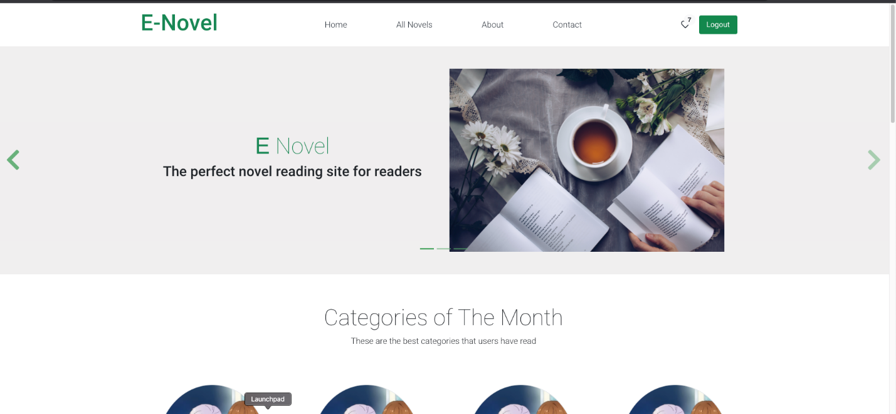**

**Figure 7.1: Home Page**

**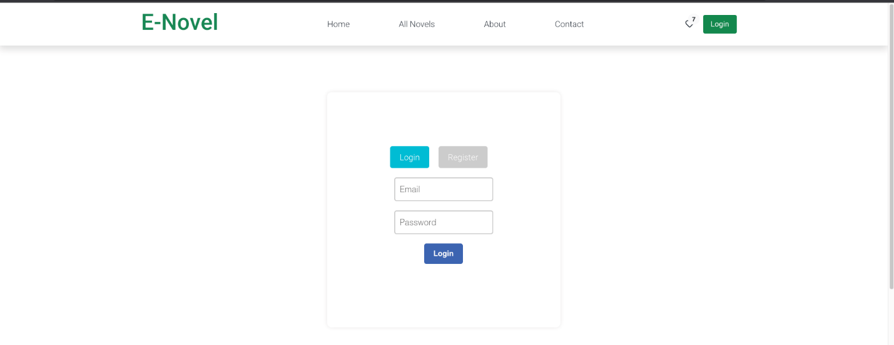**

**Figure 7.2: Login Page**

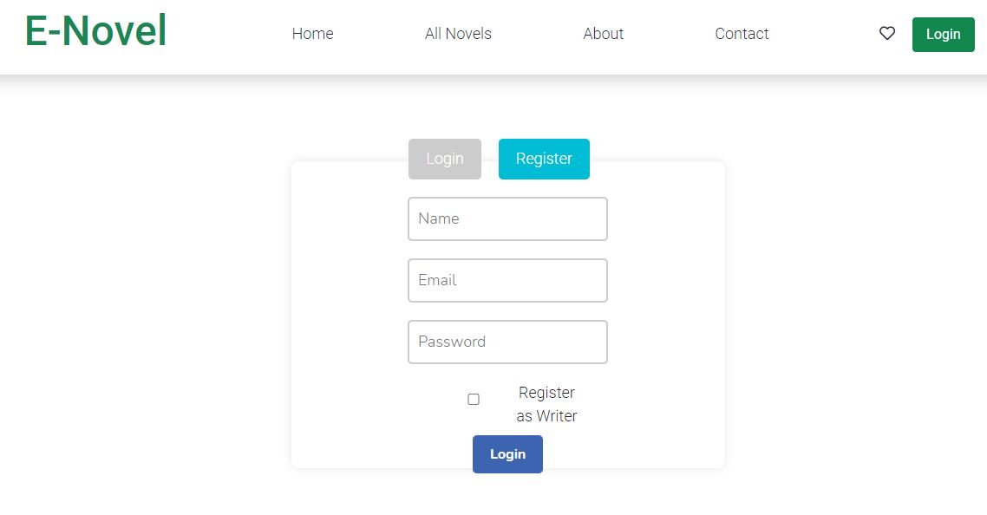

**Figure 7.3 Register Page**

**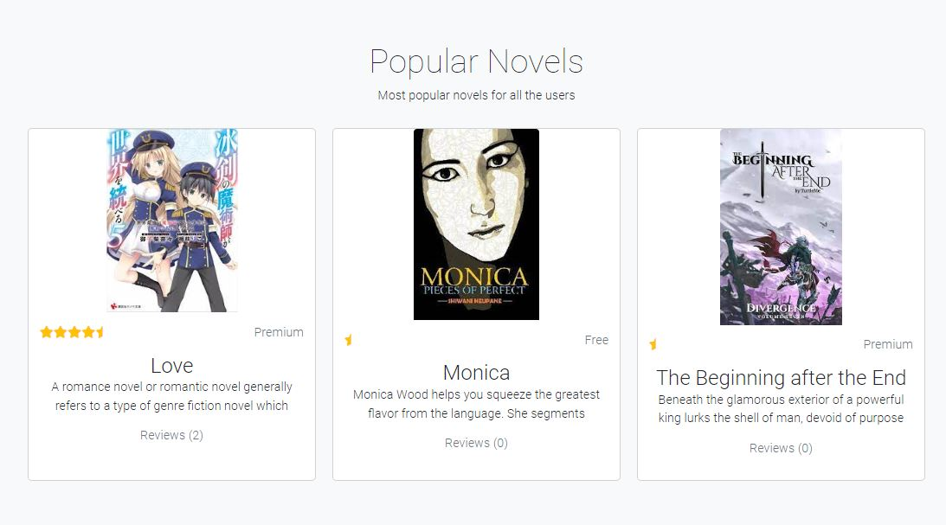**

**Figure 7.4:Popular Novel**

****

**Figure 7.5: Most Liked Novel**

**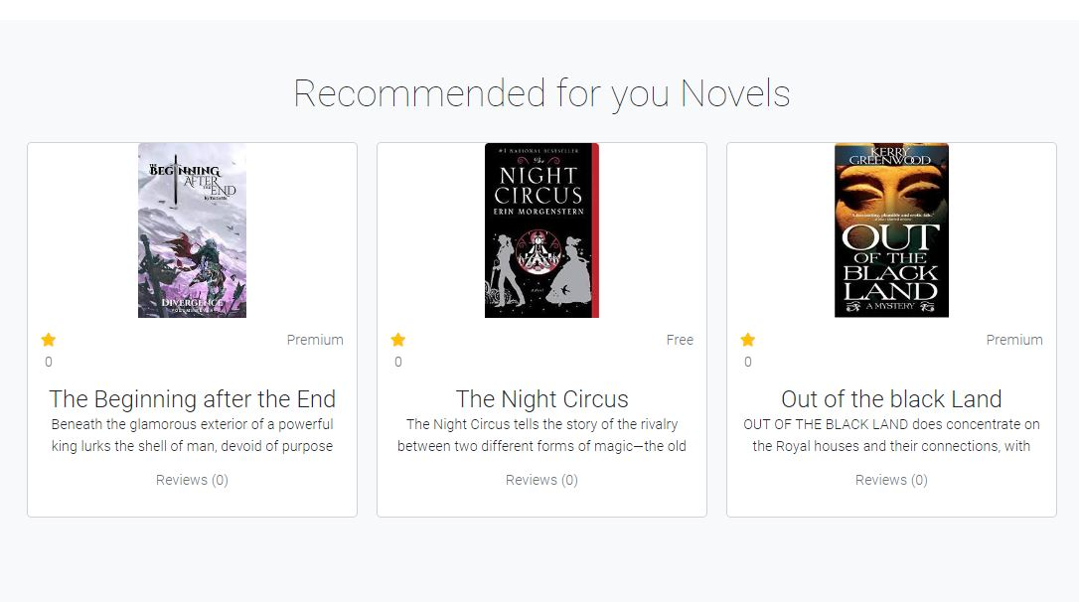**

**Figure 7.6: Recommended Novel**

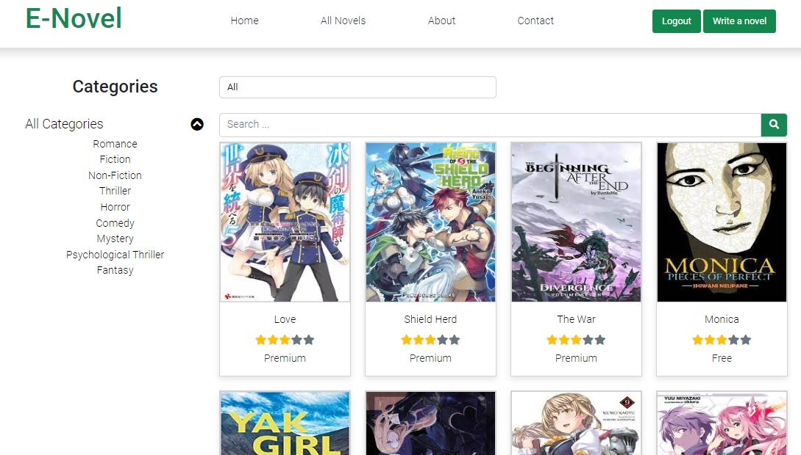

**Figure 7.7: All Category**

**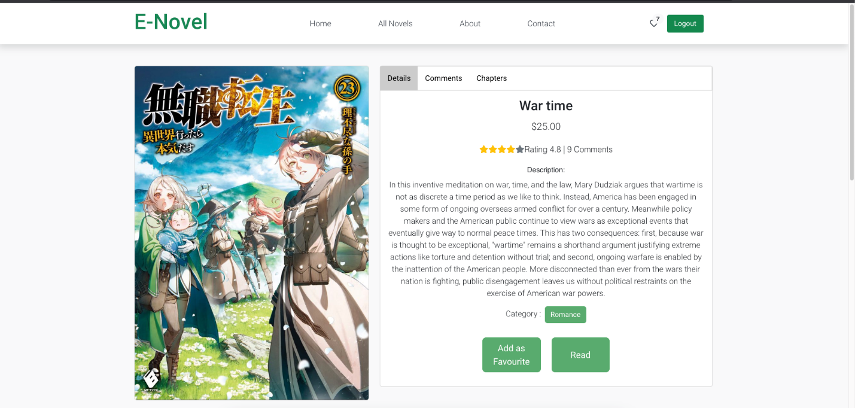**

**Figure 7.8: Novel Details**

**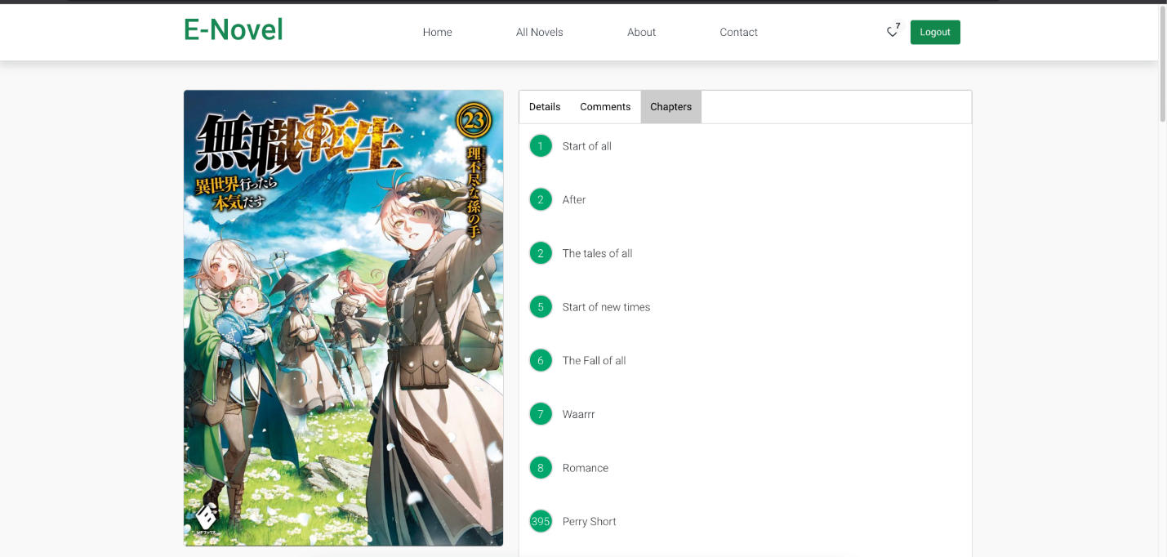**

**Figure 7.9: Novel Chapters**