Jonathan Acierto
11/11/2026
MERN Phase 1 End Project - Screenshots
Login screenshots:
1) Login
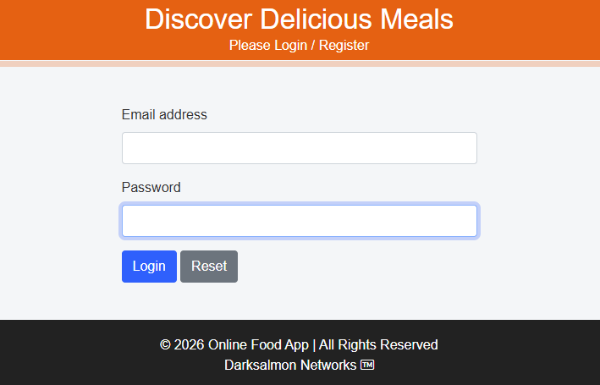

2) Login html field validation fail
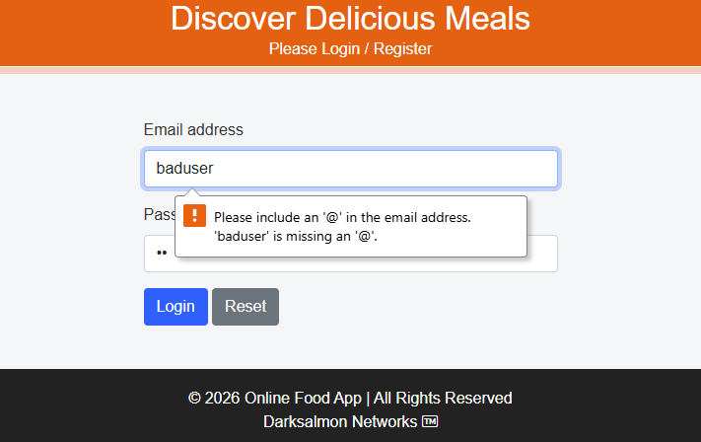
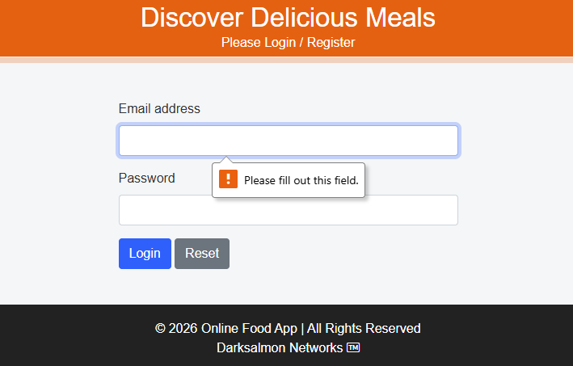

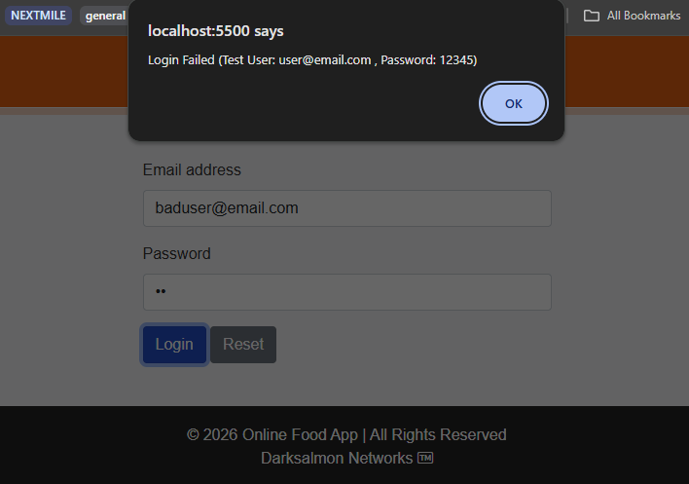
3) Login javascript credential fail (alert with help)
4) Login success forward to Food Ordering page
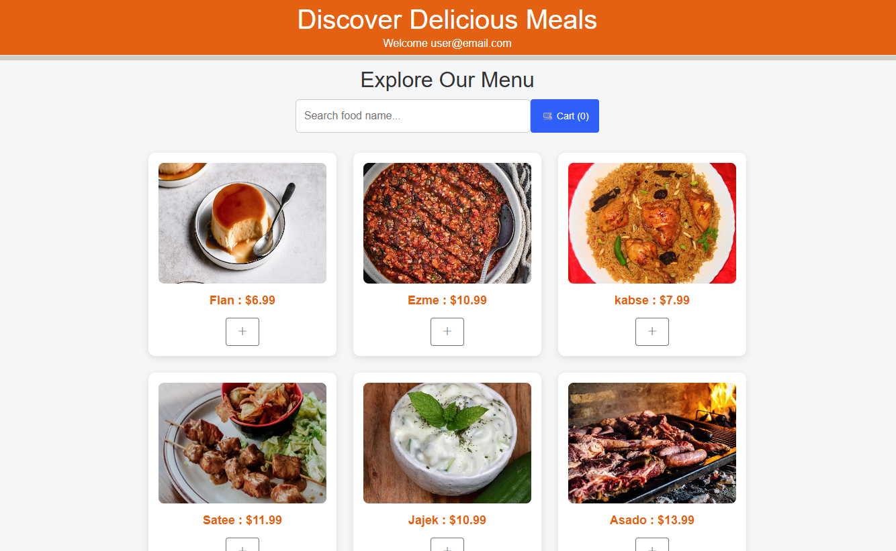

5) Food Ordering page search filter items
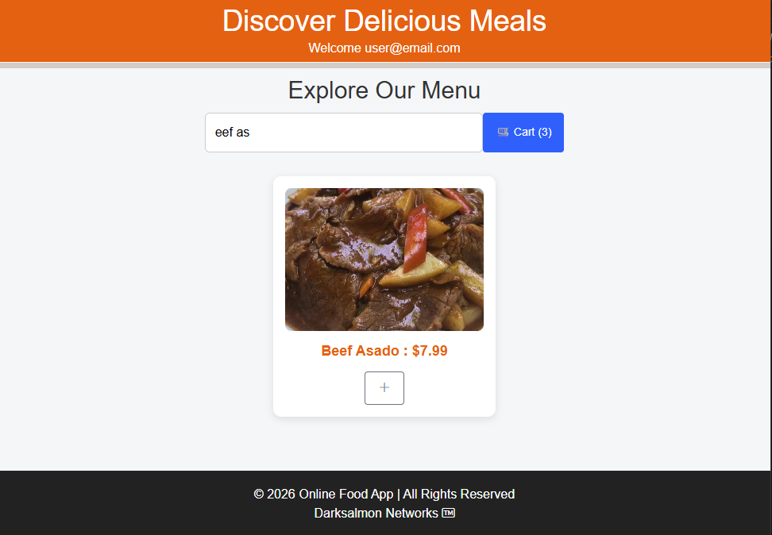

6) Food Ordering empty cart view
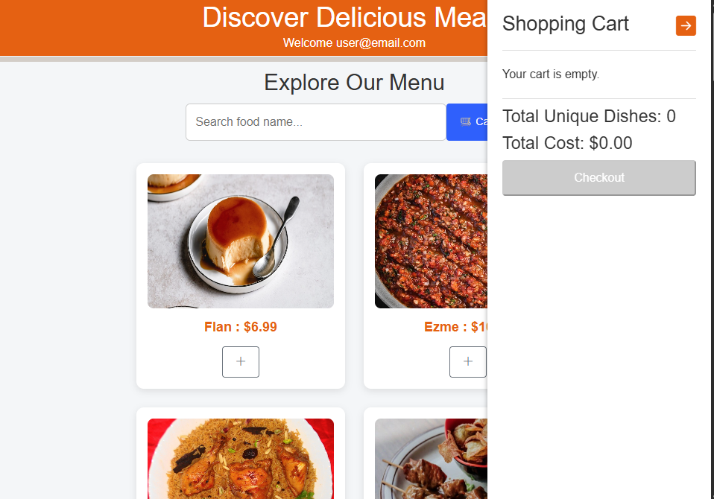

7) Food Ordering cart with items
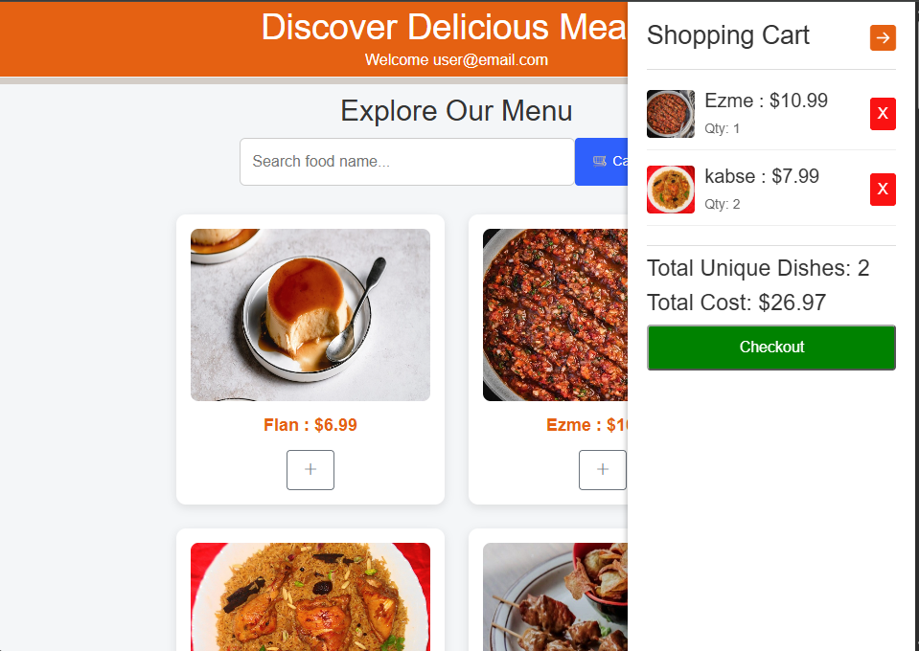

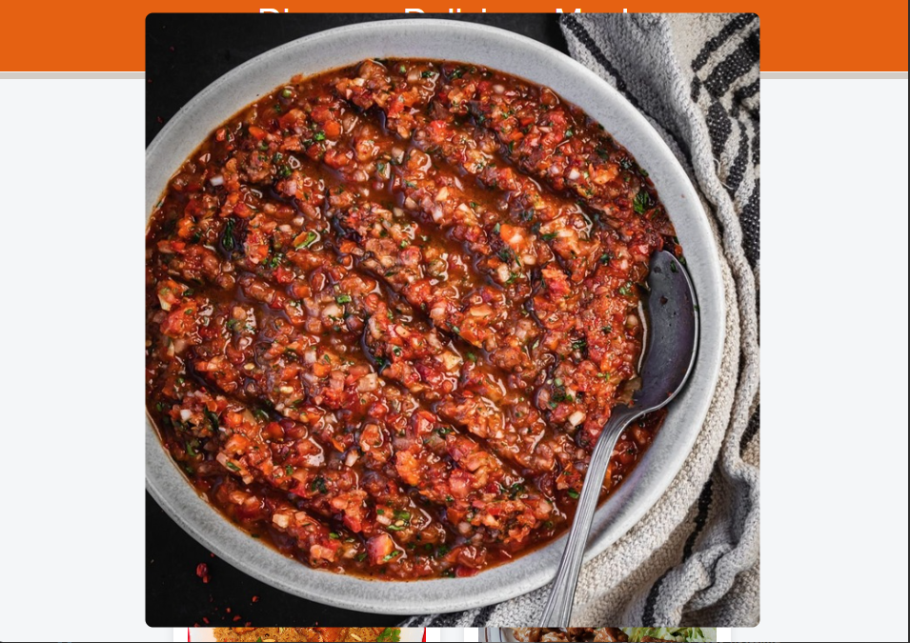
8) Food Ordering click image to enlarge

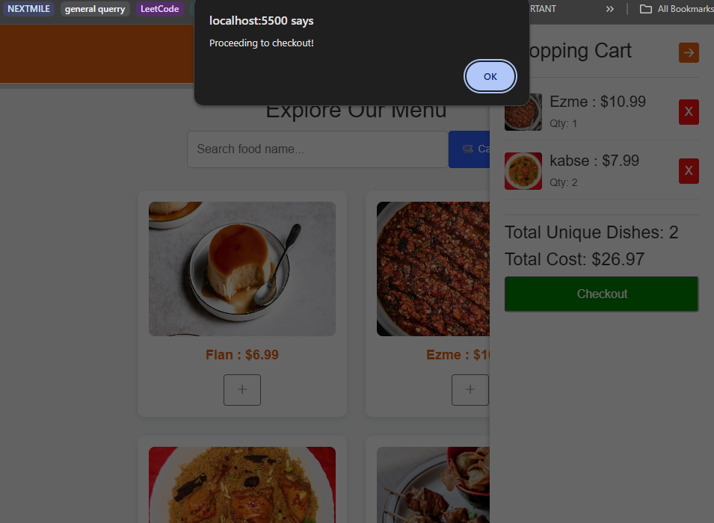
8) Check Out – alert, no functionality yet.

