Develop an application that shows names as a list and on selecting a name it should show the details of the candidate on the next screen with a “Back” button.

create a simple two-screen Android app in Java using Android Studio.

activity_main.xml
<?xml version="1.0" encoding="utf-8"?>
<LinearLayout xmlns:android="http://schemas.android.com/apk/res/android"
android:orientation="vertical"
android:padding="16dp"
android:layout_width="match_parent"
android:layout_height="match_parent">

<ListView
android:id="@+id/listViewNames"
android:layout_width="match_parent"
android:layout_height="match_parent" />

</LinearLayout>

activity_detail.xml

<?xml version="1.0" encoding="utf-8"?>
<LinearLayout xmlns:android="http://schemas.android.com/apk/res/android"
android:orientation="vertical"
android:padding="16dp"
android:gravity="center_horizontal"
android:layout_width="match_parent"
android:layout_height="match_parent">

<TextView
android:id="@+id/textViewDetails"
android:layout_width="wrap_content"
android:layout_height="wrap_content"
android:textSize="20sp"
android:text="Details will appear here" />

<Button
android:id="@+id/buttonBack"
android:layout_width="wrap_content"
android:layout_height="wrap_content"
android:text="Back"
android:layout_marginTop="24dp" />

</LinearLayout>
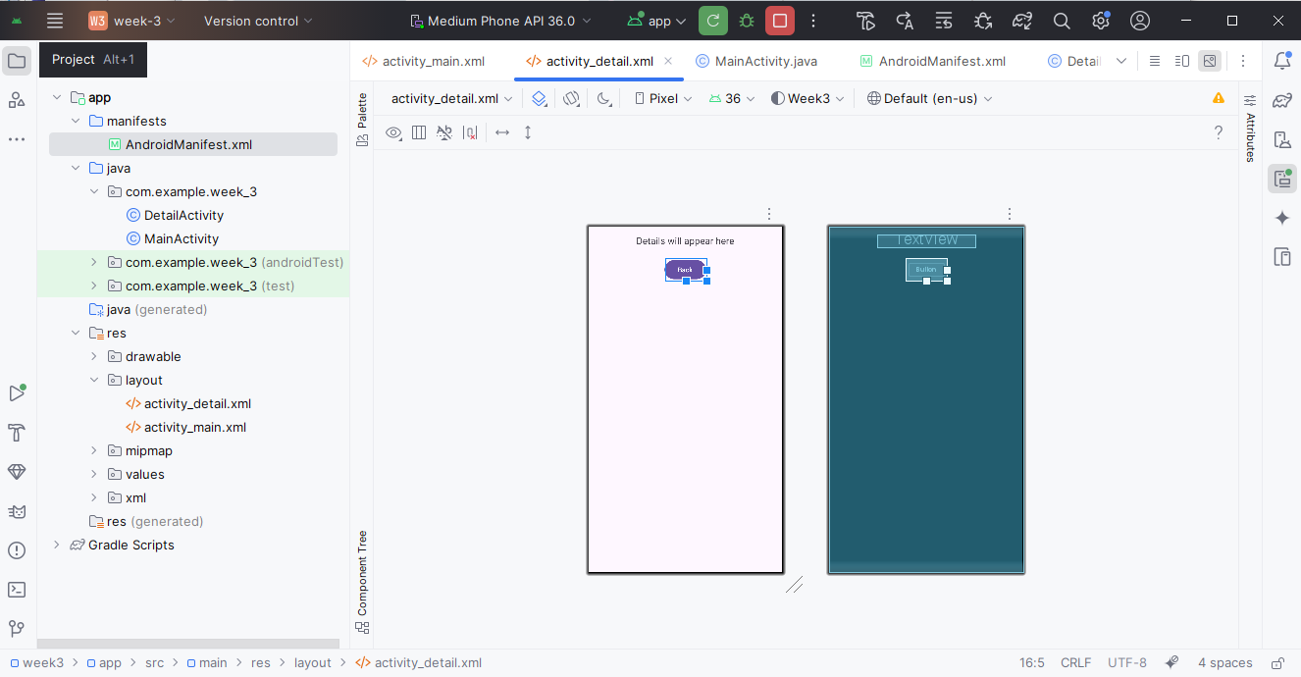
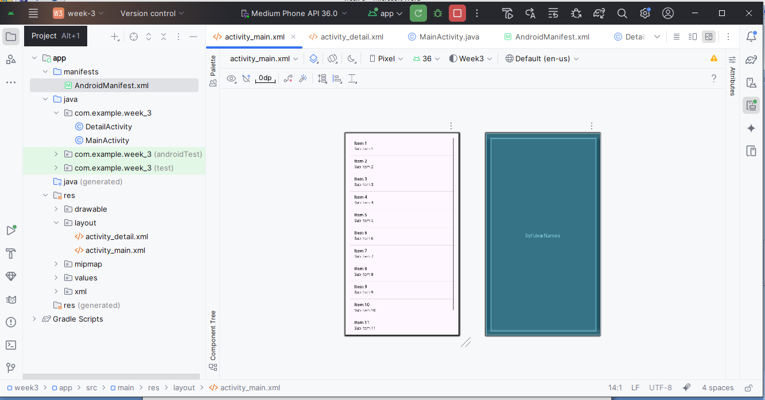

MainActivity.java
java
CopyEdit
package com.example.nameapp;

import androidx.appcompat.app.AppCompatActivity;
import android.content.Intent;
import android.os.Bundle;
import android.widget.AdapterView;
import android.widget.ArrayAdapter;
import android.widget.ListView;

public class MainActivity extends AppCompatActivity {

ListView listViewNames;
String[] names = {"Alice", "Bob", "Charlie", "David"};
String[] details = {
"Alice - Android Developer from NYC",
"Bob - Data Scientist from LA",
"Charlie - UX Designer from Chicago",
"David - QA Engineer from Seattle"
};

@Override
protected void onCreate(Bundle savedInstanceState) {
super.onCreate(savedInstanceState);
setContentView(R.layout.activity_main);

listViewNames = findViewById(R.id.listViewNames);
ArrayAdapter<String> adapter = new ArrayAdapter<>(this, android.R.layout.simple_list_item_1, names);
listViewNames.setAdapter(adapter);

listViewNames.setOnItemClickListener((parent, view, position, id) -> {
Intent intent = new Intent(MainActivity.this, DetailActivity.class);
intent.putExtra("details", details[position]);
startActivity(intent);
});
}
}

DetailActivity.java
java
CopyEdit
package com.example.nameapp;

import androidx.appcompat.app.AppCompatActivity;
import android.os.Bundle;
import android.widget.Button;
import android.widget.TextView;

public class DetailActivity extends AppCompatActivity {

TextView textViewDetails;
Button buttonBack;

@Override
protected void onCreate(Bundle savedInstanceState) {
super.onCreate(savedInstanceState);
setContentView(R.layout.activity_detail);

textViewDetails = findViewById(R.id.textViewDetails);
buttonBack = findViewById(R.id.buttonBack);

// Get passed details from Intent
String detail = getIntent().getStringExtra("details");
textViewDetails.setText(detail);

buttonBack.setOnClickListener(v -> finish()); // Go back to previous screen
}
}

AndroidManifest.xml
xml
CopyEdit
<application
... >

<activity android:name=".DetailActivity" />
<activity android:name=".MainActivity">
<intent-filter>
<action android:name="android.intent.action.MAIN" />
<category android:name="android.intent.category.LAUNCHER" />
</intent-filter>
</activity>

</application>

