**BRAND MANAGEMENT**

1. **Web page duplications:**
2. **Web page duplications:**

URL to check web page duplications **https://www.duplichecker.com/**

**Step-1:** Enter the domain name in search field, click on check plagiarism and consider domain name as input

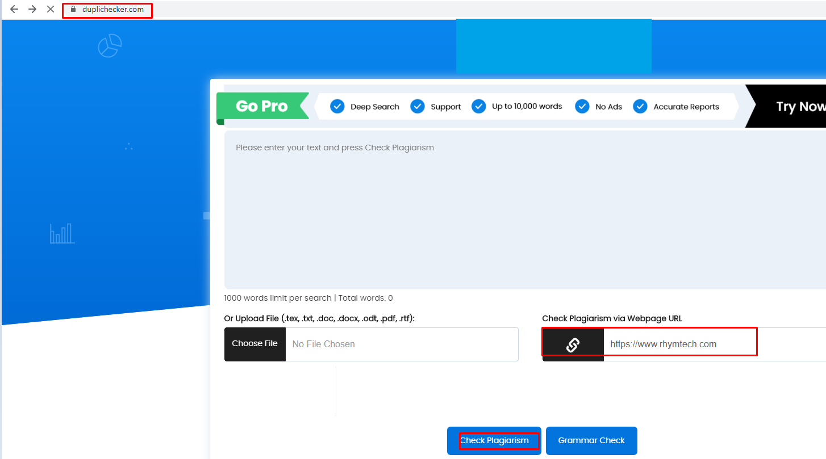

**Step-2:** The output shows both internal and external website duplications

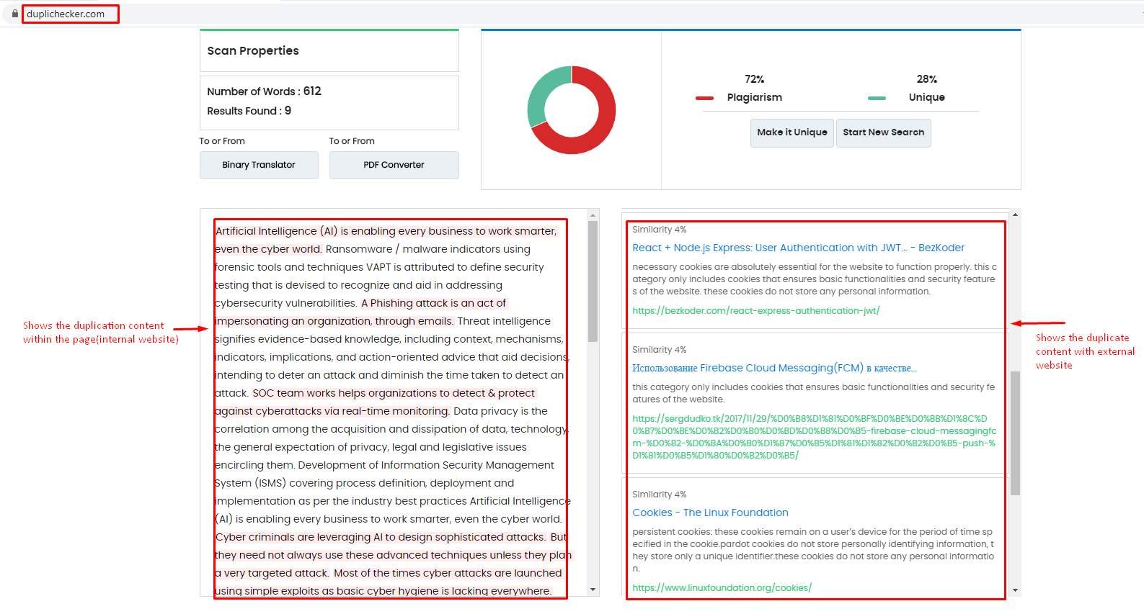

**Step-3:** If the output shows webpage duplications found Consider alert severity as **MEDIUM** and with alert score

**Step-4:** If Output shows no webpage Duplications are Consider alert severity as **INFORMATIONAL** and with alert score **0**

1. **Social Media conversations:**
2. **Social Media discussions:**

URL to check social media conversations [**https://socialbearing.com/**](https://socialbearing.com/)

**Step-1:** Enter the domain name in search field and click on search consider domain name as Input

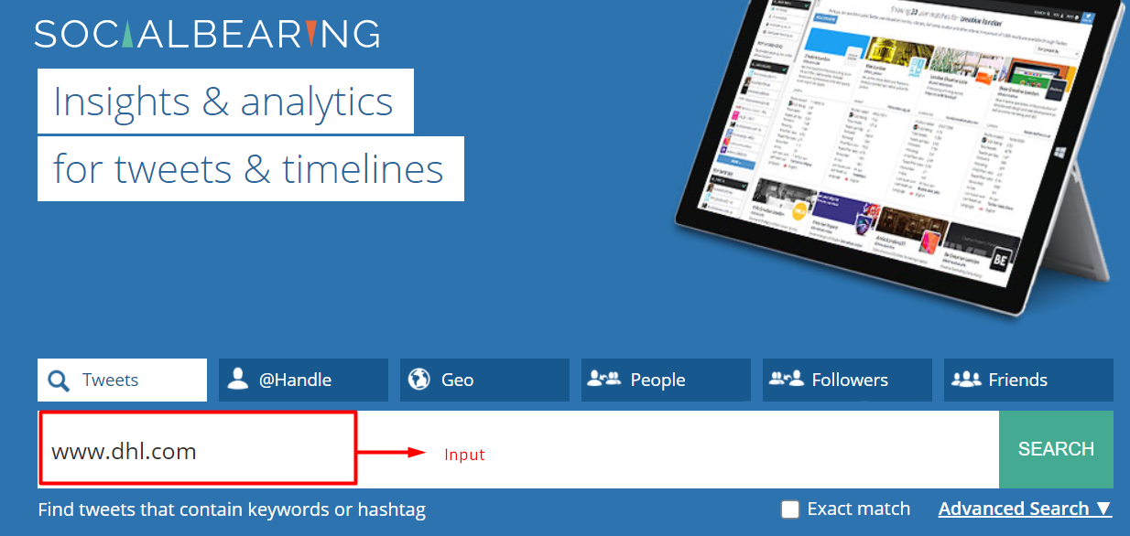

**Step-2:**Check the conversations which are in bad and terrible if they are related to reputation loss Consider alert severity as **MEDIUM** and with alert score **5**

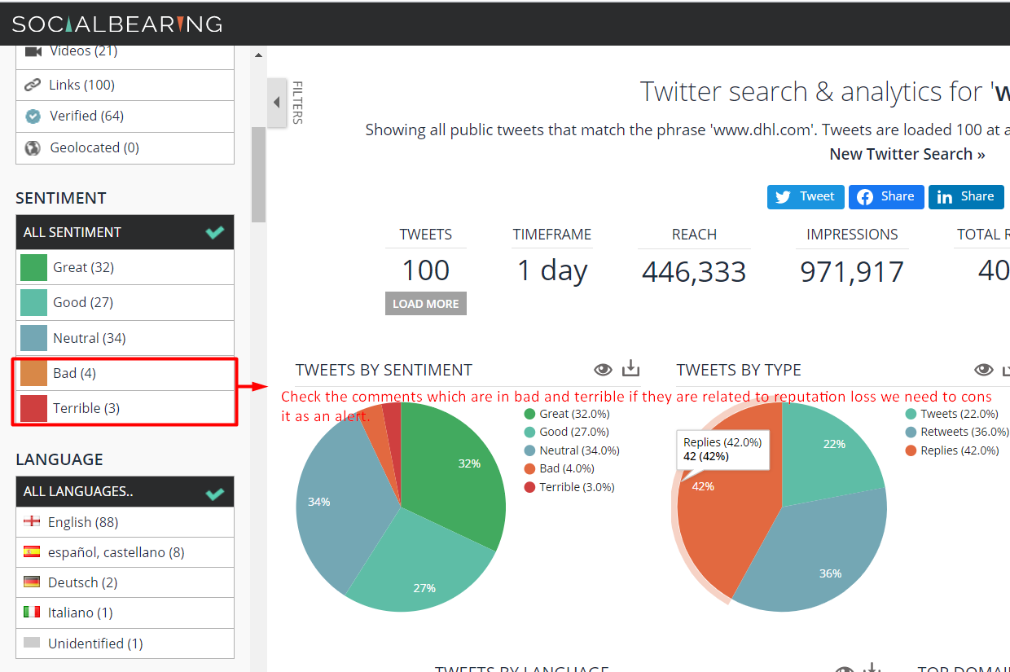

**Step-4:** if there are no negative conversations found Consider alert severity as **INFORMATIONAL** and with alert score **0**

1. **Forum discussions**:
2. **Forum discussions:**

URL to check forum discussions **https://app.brand24.com//**

**Step-1:** Enter the domain name for forum discussions and consider domain name as input

**Step-2:** If negative discussions are found Consider alert severity as **MEDIUM** and with alert score **5**

**Step-3:** if no negative discussions are found Consider alert severity as **INFORMATIONAL** and with alert score **0**

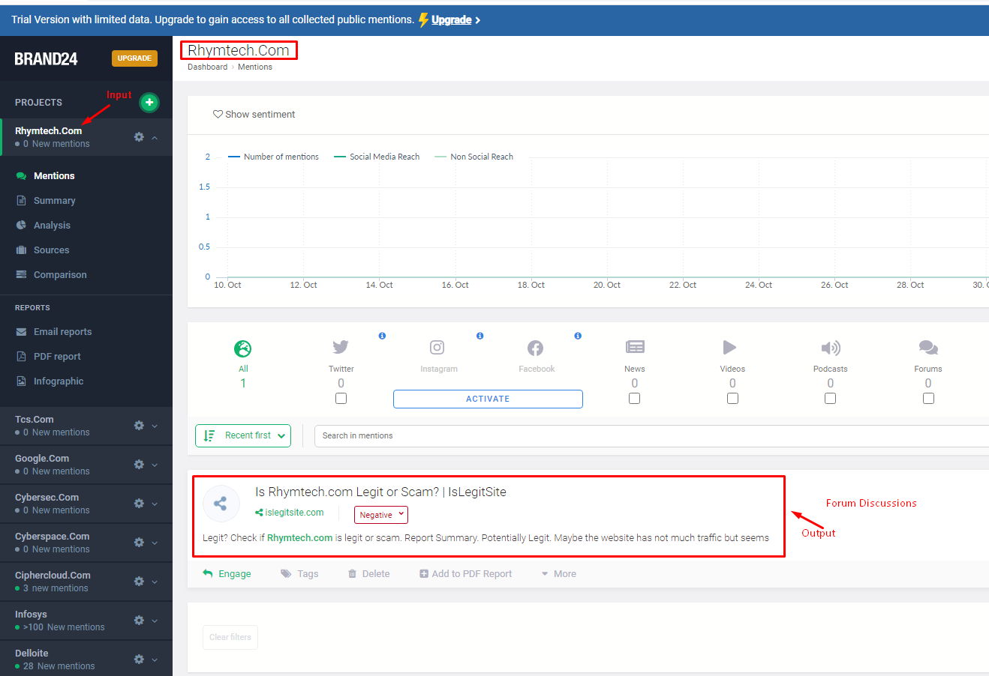

1. **Sentiment Analysis:**

**Tool Pending**