**DNS IMMUNITY**

1. **DNS Health Status:**

URL to Check DMARC, SPF and DKIM MX toolbox **https://mxtoolbox.com**/

1. **DMARC Record:**

**Step-1:** Enter domain name in search field and consider domain name as Input and click on the DMARC Lookup.

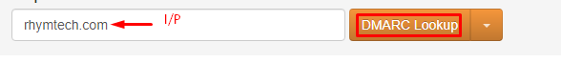

**Step-2:** If the output shows No DMARC Record found then consider alert severity as **MEDIUM** with alert score **5**

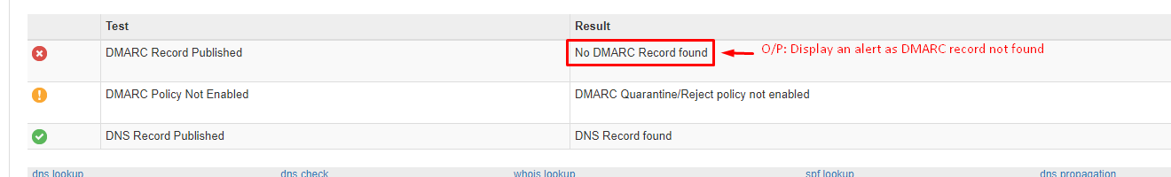

**Step-3:** Enter the domain name in search field consider domain name as Input and click on the DMARC Lookup.

**Step-4:** If DMARC found thenconsider alert severity as **INFORMATIONAL** with alert score **0**

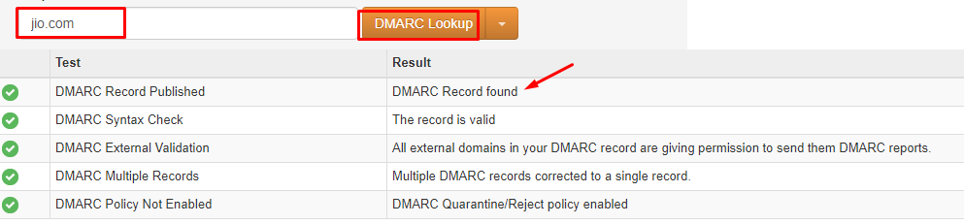

1. **SPF Record:**

**Step-1:** Enter the domain namein search field and consider domain name as input and click on the SPF Record Lookup.

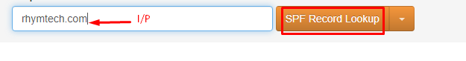

**Step-2:**If the output showsNo SPF record Found or SPF included looks up Found then consider alert severity as **MEDIUM** with alert score **6** .

**Step-3:** Or Else SPF record Found then consider alert severity as **INFORMATIONAL** with alert score **0.**

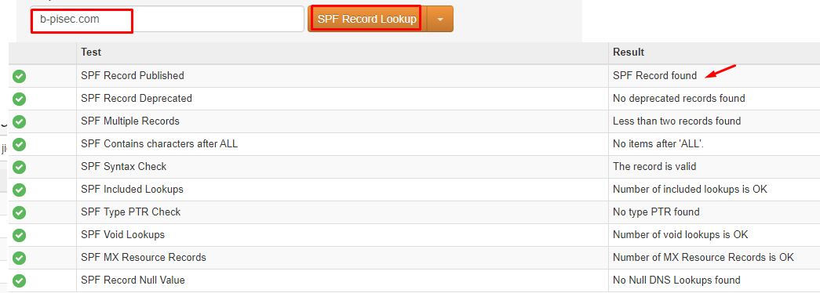

**c. DKIM Validation:**

**Step-1:** Enter the domain name in search field and consider the domain name as Input and click on the DKIM Lookup.

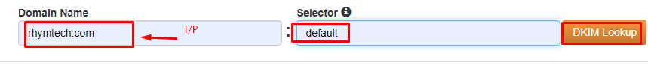

**Step-2**: If output shows No DKIM Record found then consider alert severity as **HIGH** with alert score **7**.

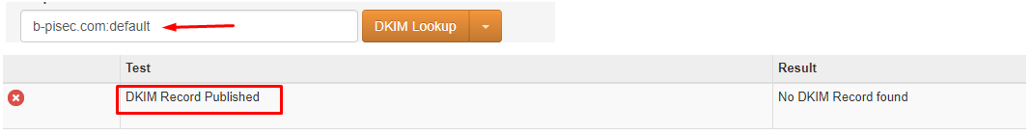

**Step-3:** Enter the domain name in search fieldconsider the domain name as Input and type default in selector and click on the DKIM Lookup.

**Step-4:** If DKIM Record foundthen consider alert severity as **INFORMATIONAL** with alert score **0.**

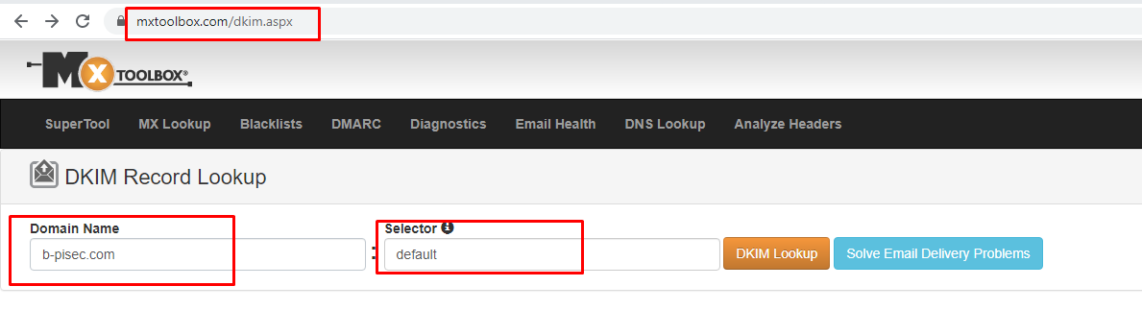



1. **DNS Security Status :**
2. **DNSSEC:**

URL to check DNSSEC **https://viewdns.info/**

**Step-1:** Enter the Domain name and click on Go and Consider the domain name as Input.

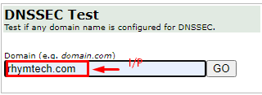

**Step-2:**If output shows NO DNSSEC Record Found then consider alert severity as **MEDIUM** with alert score **6**.

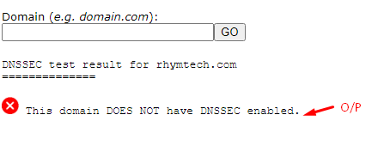

**Step-3:** If output shows DNSSEC Record Found then consider alert severity as **INFORMATIONAL** with alert score **0**.

1. **DNS Zone Transfer**

URL to check DNS Zone Transfer **www.hackertarget.com /zone-transfer/**

**Step-1:** Enter the Domain in the Search Field and click on check external zone Transfer and consider domain name as Input

**Step 2:** If the output shows transfer failed then consider alert severity **LOW** with alert score **3**.

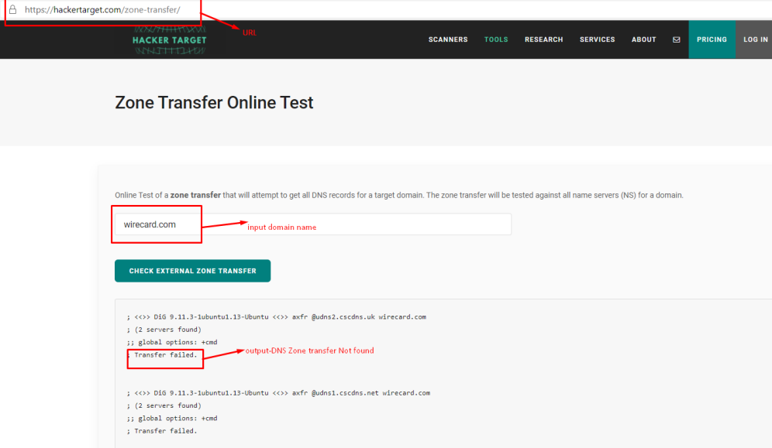

**Step-3:** Or Else If the Transfer found then consider alert severity **INFORMATIONAL** with alert score **0**.

1. **DNS Misconfigurations:**

URL to check DNS Misconfiguration **viewdns.info**

**Step-1:** Enter domain name in search field and click on DNS Report Consider domain name as an Input

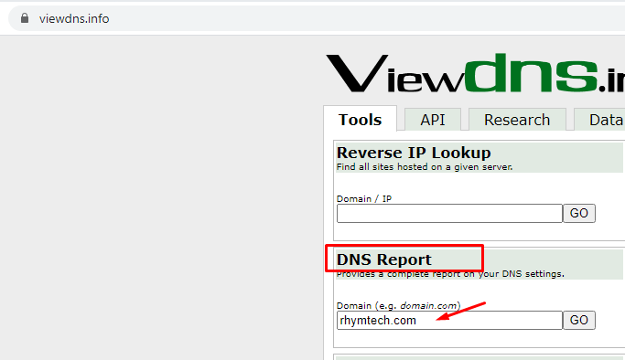

**Consider the Output (warnings) which displayed in result**

**Name Servers:**

1. If Name Servers Misconfigurations Found then consider as alert severity as **LOW** with alert score **3**

Or else you can ignore.

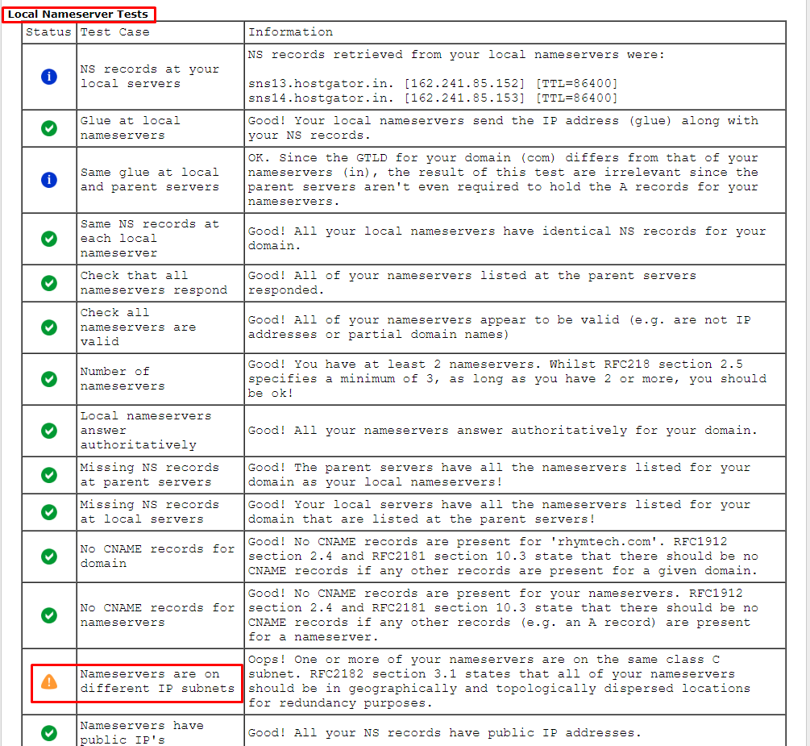

**SOA Servers:**

1. If SOA Misconfigurations Found then considers as alert severity as **LOW** with alert score **3**

Orelse you can ignore.

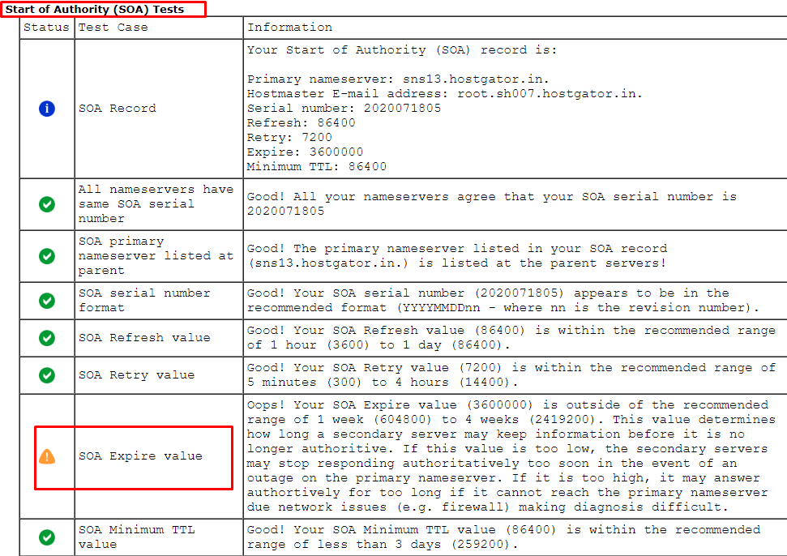

**MX Records:**

1. If MX Records Misconfigurations Found then consider as alert severity as **LOW** with alert score **3**

Or else you can ignore.

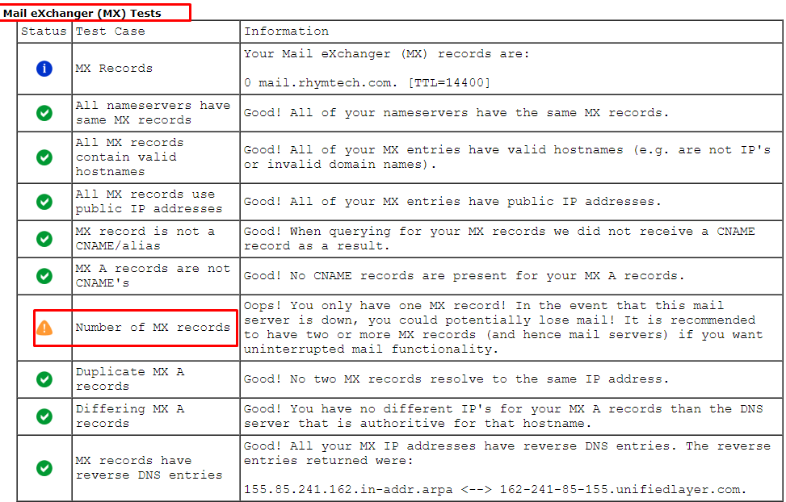

**CNAME:**

1. If CNAME Misconfigurations Found then consider as alert severity as **LOW** with alert score **3**

Orelse you can ignore.



**A Record Configuration:**

1. If A Record Misconfigurations Found then consider as alert severity as **LOW** with alert score **3**

Or else you can ignore.

